**Lab3: Software Project Management**

**Goal**

In this lab you will see how to organize project management processes and activities in Microsoft Project 2016.

**Project management processes and activities**

Planning: development tasks, workflow (timing and sequencing), estimating (effort)

Tracking: progress (active tasks, features/timing), status and estimates (completion)

Collaboration: team work, parallel development, communication, issue tracking

Testing: planning, executing, fixing, tracking, acceptance

**1. Creating your project in MS Project**

Choose **File -> New** andcreate a new project.

This creates a project and the .mpp file, and opens the **Gantt Chart** view. To set project information (start/finish dates, type of project calendar) choose **File -> Info**.

**2. Task Management**

In the **Gantt Chart** view you can organize a task list and workflow.

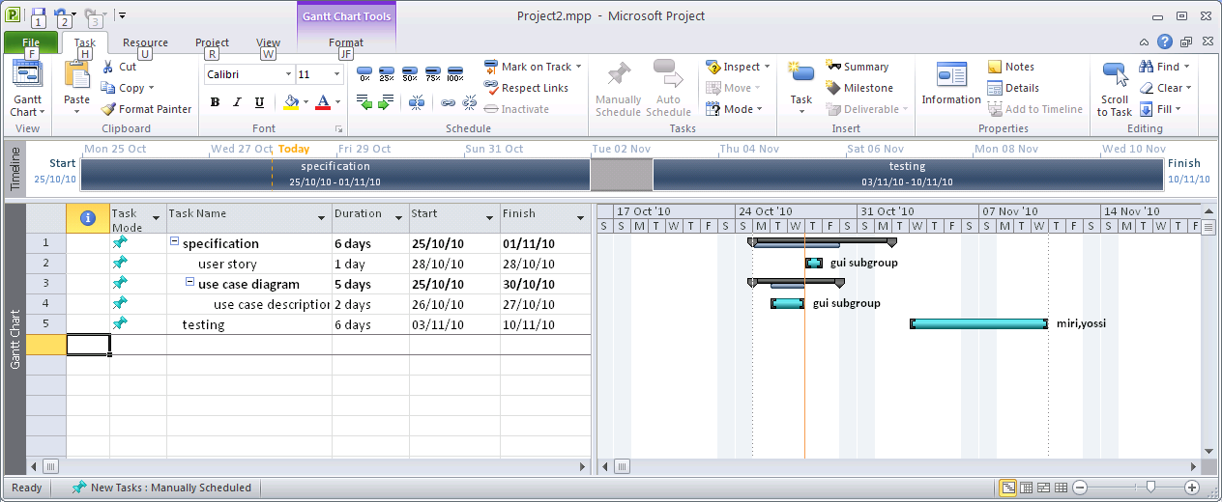

All details of the task (task name, duration, start/finish dates etc.) can be added in the Task List (left part of the **Gantt Chart** view).

You can update progress on task execution by click on the **%** icons in **Task** submenu.

This allows tracking the project progress in the **Gantt chart**.

**Task structure organization**

First we enter the high level task we are going to use. Next I add one more task. To make this task a subtask of the line above click on the  (intend task) icon on the **Task** submenu.

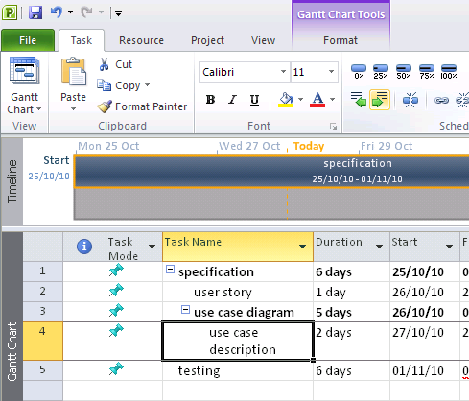

intend task

**Team management**

In the **Resource Usage** view you can organize a list of team members.

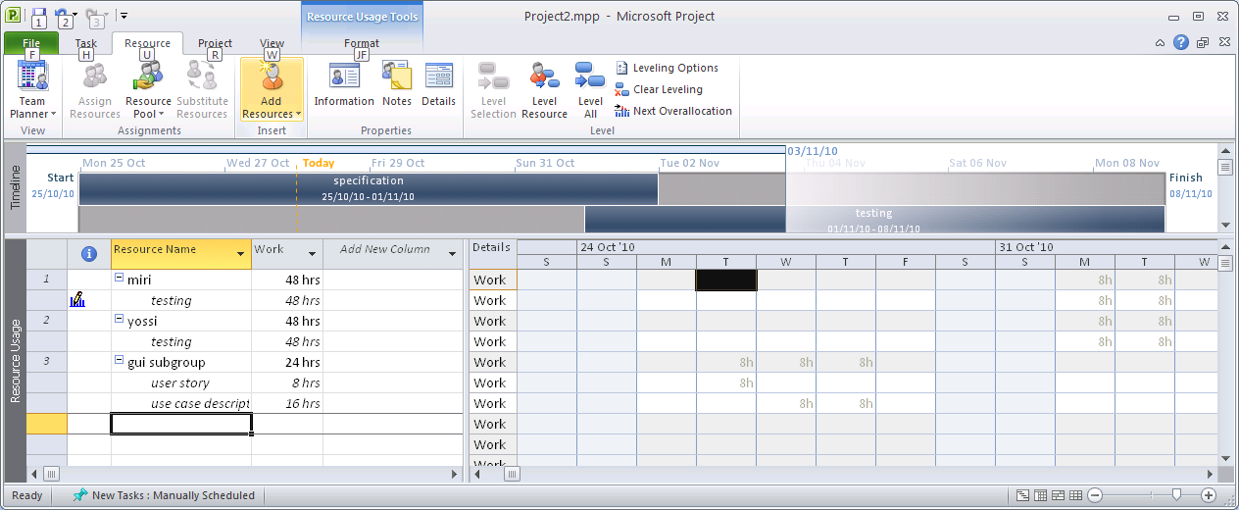

To correspond concrete tasks to team members, use **Team Planner** view.

It is possible also to add a team member directly in the task list in **Gantt Chart** view.

**Task to do:**

1. Perform the project planning for the Braude System you have worked before. Take into account the following information:

* The budget is sufficient for 390 work days (a work day - 8 hours);
* The project duration - 70 days;
* Human resources you define yourself.

1. Use for planning a project the templates (files are in the current folder) and take into account how you are planning:

* Time management;
* Resources;
* Budget;
* Tasks.

**Work on the course project**

In work on your project you will use MS Project 2016 to create your project plan.

Perform the steps described below.

Refer to the entire life-cycle activities. Use all the information you have accumulated until now (including the requirements definition and the design, implementation and testing processes you performed).

**Requirements for the project plan**

1. Time management
   * Plausible timetable including real deadlines of stages/iterations/versions
2. Resources
   * Members of a group
   * Assigning tasks to an appropriated member
3. **Relevant** topics and subtopics like below (see an example on the site):
   * Scope
   * Analysis/Software requirements
   * Design
   * Testing
   * Etc.
4. Task management
   * Every task has to be filled with appropriated details (time, predecessor/successor, owner, etc.)
   * All information from the user story is considered
   * Meaning of stages is understandable from their names and descriptions