Digital Color System
$$Range: \left(R, G, B\right)⟶\left(0-255\right),\left(0-255\right),(0-255)$$
$$Total number of possible colors: 256×256×256=2^{24}$$
 | $$--⟶$$ | $$(26,33,124)$$ | $$--⟶$$ | #1A217C

Pixel Matrix
 |  |  |  | $$--→$$ | FF004C | FF9F00 | FFF700 | 3CFF00
 |  |  |  |  | 00FFD5 | 0099FF | 7A00FF | FF00E1
 |  |  |  |  | FF5E00 | 00FF2A | 00F0FF | 6B00FF
 |  |  |  |  | FFD300 | FF0066 | 00FF99 | FF3300

RGB to GRAYSCALE($R=B=G$)
$$Averaging grayscale = \frac{R+G+B}{3}$$
#6E6E6E | #8A8A8A | #A7A7A7 | #696969
#9C9C9C | #888888 | #7E7E7E | #A0A0A0 | $$--→$$
#747474 | #636363 | #A5A5A5 | #797979
#9B9B9B | #777777 | #888888 | #666666

$$Luminance formula: Gray=0.299R+0.587G+0.114B$$
55 AA DD A8
AE 77 42 66
83 9A AA 3D
C8 58 A7 6A
#555555 | #AAAAAA | #DDDDDD | #A8A8A8
#AEAEAE | #777777 | #424242 | #666666 | $$--→$$
#838383 | #9A9A9A | #AAAAAA | #3D3D3D
#C8C8C8 | #585858 | #A7A7A7 | #6A6A6A

Linear Interpolation

 |  |  |  | $$Q_{1}=78$$ |  |  |  |  | $$Q$$ |  |  |  |  |  |  |  |  |  | $$Q_{2}=200$$
0 | 1 | 2 | 3 | $$X_{1}=4$$ | 5 | 6 | 7 | 8 | $$X=9$$ | 10 | 11 | 12 | 13 | 14 | 15 | 16 | 17 | 18 | $$X_{2}=19$$ | 20 | 21 | 22 | 23 | 24

$$Q=Q_{1}×\frac{\left(X_{2}-X\right)}{\left(X_{2}-X_{1}\right)}+Q_{2}×\frac{\left(X-X_{1}\right)}{\left(X_{2}-X_{1}\right)}$$
$$Q=78×\frac{\left(19-9\right)}{\left(19-4\right)}+200×\frac{\left(9-4\right)}{\left(19-4\right)}=52+66=118$$
Bilinear Interpolation
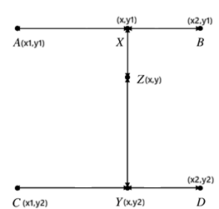
$$Q_{X}=Q_{A}×\frac{\left(X_{B}-X_{X}\right)}{\left(X_{B}-X_{A}\right)}+Q_{B}×\frac{\left(X_{X}-X_{A}\right)}{\left(X_{B}-X_{A}\right)}$$
$$Q_{Y}=Q_{C}×\frac{\left(X_{D}-X_{Y}\right)}{\left(X_{D}-X_{C}\right)}+Q_{D}×\frac{\left(X_{Y}-X_{C}\right)}{\left(X_{D}-X_{C}\right)}$$
$$Q_{Z}=Q_{X}×\frac{\left(Y_{Y}-Y_{Z}\right)}{\left(Y_{Y}-Y_{X}\right)}+Q_{Y}×\frac{\left(Y_{Z}-Y_{X}\right)}{\left(Y_{Y}-Y_{X}\right)}$$

Pixel Shifting and Normalization
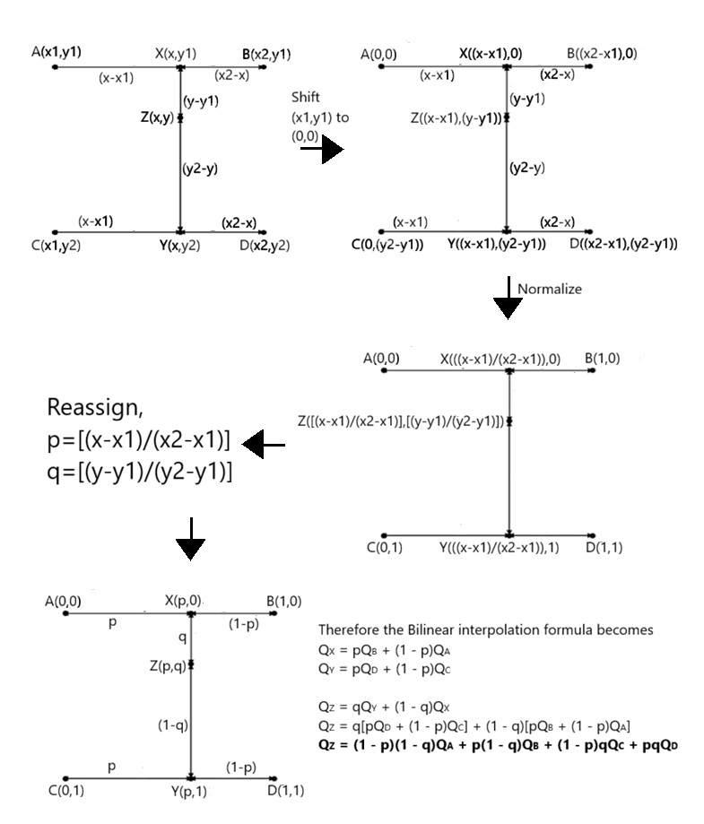

Pixel Mapping For Resizing
Scaling Factors:
$$S_{x}=\frac{{width}_{old}-1}{{width}_{new}-1}$$
$$S_{y}=\frac{{height}_{old}-1}{{height}_{new}-1}$$
To find neighbors of $\left(x_{new},y_{new}\right)$
$$x_{old}=x_{new}×S_{x}$$
$$y_{old}=y_{new}×S_{y}$$
$$x_{1}=\left\lfloor x_{old}\right\rfloor$$
$$x_{2}=min\left(\left(x_{1}+1\right),\left({width}_{old}-1\right)\right)$$
$$y_{1}=\left\lfloor y_{old}\right\rfloor$$
$$y_{2}=min\left(\left(y_{1}+1\right),\left({height}_{old}-1\right)\right)$$
$$Resizing a pixel matrix of (3×4)→(7×6)$$  $$S_{x}=\frac{3-1}{7-1}=\frac{1}{3}$$  $$S_{y}=\frac{4-1}{6-1}=\frac{3}{5}$$  To find neighbors of $\left(4,3\right)$  $$x_{old}=4×\frac{1}{3}=\frac{4}{3}$$  $$y_{old}=3×\frac{3}{5}=\frac{9}{5}$$  $$x_{1}=\left\lfloor \frac{4}{3}\right\rfloor =1$$  $$x_{2}=min\left(\left(1+1\right),\left(3-1\right)\right)=2$$  $$y_{1}=\left\lfloor \frac{9}{5}\right\rfloor =1$$  $$y_{2}=min\left(\left(1+1\right),\left(4-1\right)\right)=2$$  Neighbors,  $$\left(1,1\right),\left(1,2\right),\left(2,1\right),\left(2,2\right)$$ | 