
INNOVATION BY BANK SIMULATION
Neural Network-Powered Banking System in Pure C

College Assignment Report
Department of Computer Science & Engineering
MIT World Peace University

1. Introduction and Core Challenge
Most banking software today is built on top of heavy frameworks and pre-packaged libraries that do most of the heavy lifting behind the scenes. While that works fine for production systems, it leaves very little room to understand what is actually going on under the hood. That is what prompted the conception of this project — what if we built something from scratch?

The idea behind this project was to simulate a real banking environment using only C, with no shortcuts and no external ML libraries — just clean, low-level code. The goal was not simply to store account data and print balances, but to build something that could actually think — a system that assesses risk, flags potential churners, and helps make decisions the way a bank analyst would.

1.1 What We Set Out to Do
At its core, the objective was to prove that C is capable of more than just systems programming. Banks deal with sensitive, time-critical data, and C’s performance and memory control make it a surprisingly strong fit for that domain. The simulation handles real banking operations — deposits, withdrawals, loans, investments — while also running a neural network in the background to evaluate each customer’s credit risk and likelihood of leaving the bank.

The challenge was getting both parts to work together cleanly. Banking logic on its own is straightforward enough. But embedding a working ML model into the same C codebase, without any library support, was a fundamentally different engineering problem.

2. The Key Innovation
The most significant component of this project is the neural network. It is written entirely from scratch in C — no TensorFlow, no PyTorch, no shortcuts. Every single piece of it, from how the weights are initialised to how errors are propagated backwards through the layers, was hand-coded. It takes in customer demographics and transaction behaviour and outputs a risk score that the system uses in real time.

Three things make this stand out:
- No external ML libraries — every mathematical operation, activation function, and weight update is implemented manually. This forced a deep understanding of the math behind neural networks rather than just calling pre-built functions.
- Custom backpropagation — the gradient descent updates were derived and coded manually. It was one of the harder parts of the project, but getting it right was where the deepest learning occurred.
- Real-time risk assessment — the model runs during live transactions, not as an offline batch process. So when a customer applies for a loan, the system is already scoring them in the background.

The Neural Network Training and Evaluation process follows a structured pipeline as illustrated in the flowchart below:
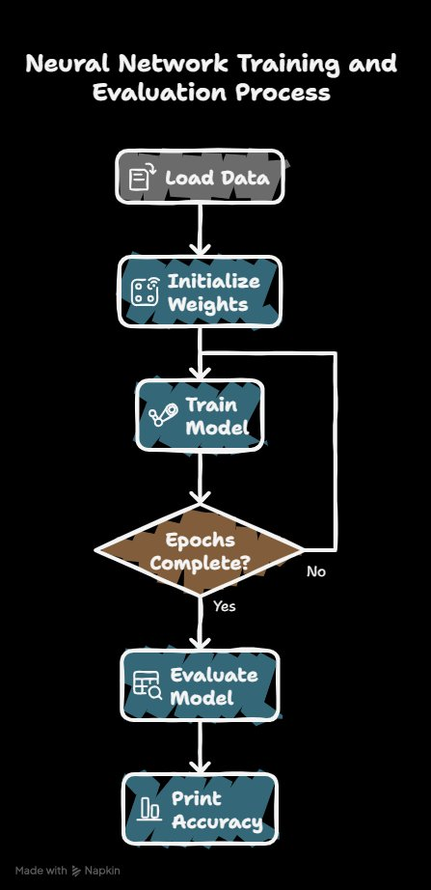
Figure 1: Neural Network Training and Evaluation Process Flowchart

3. Banking Simulation — Flowchart and Algorithm
The flow of the program is straightforward once it is laid out. The whole system runs on a menu-driven loop — the user logs in, picks what they want to do, and the system routes them to the right module. It keeps running until they choose to exit.

3.1 How the Algorithm Works
The control flow was kept deliberately simple. The following table describes how the program runs from start to finish:

Step | Description
Step 1 — Start | The application initialises. All data structures and memory buffers are set up before anything is shown to the user.
Step 2 — Display Menu | The six available options are printed to the screen. The user can choose to view account details, deposit or withdraw money, explore investment or loan options, or exit.
Step 3 — Get User Input | The program waits for the user to type their choice and press enter.
Step 4 — Validate Input | If nothing valid comes in, the menu is shown again. If the input is recognised, the program moves forward. This stops the whole thing from crashing on bad input.
Step 5 — Process Choice | The input is matched against the six options: (1) View Account Details, (2) Deposit Money, (3) Withdraw Money, (4) Investment Plans, (5) Loan Services, (6) Exit the session.
Step 6 — Exit | The session ends, memory is freed, and the program wraps up cleanly.
Step 7 — End | Program closes. All changes have been saved before this point.

3.2 Reading the Flowchart
The flowchart maps exactly to the algorithm above. It starts at a single Start node, moves into the menu display, then hits a decision diamond for user input. If the input is missing or unrecognised, the arrow loops back up to the menu — that is the No branch. The Yes branch goes forward into the Process Choice node.

From there, six branches fan out — one for each menu option. Choices 1 through 5 each run their respective banking operation and then loop back to the menu, so the user can keep doing things in the same session. Choice 6 is the only one that breaks out of the loop, hitting the Exit node and ending the program.

The system was designed this way because it keeps each feature independent of the others. Adding a new option — say, a fixed deposit feature — would only mean adding one more branch off the Process Choice node. Nothing else in the flow would need to change.

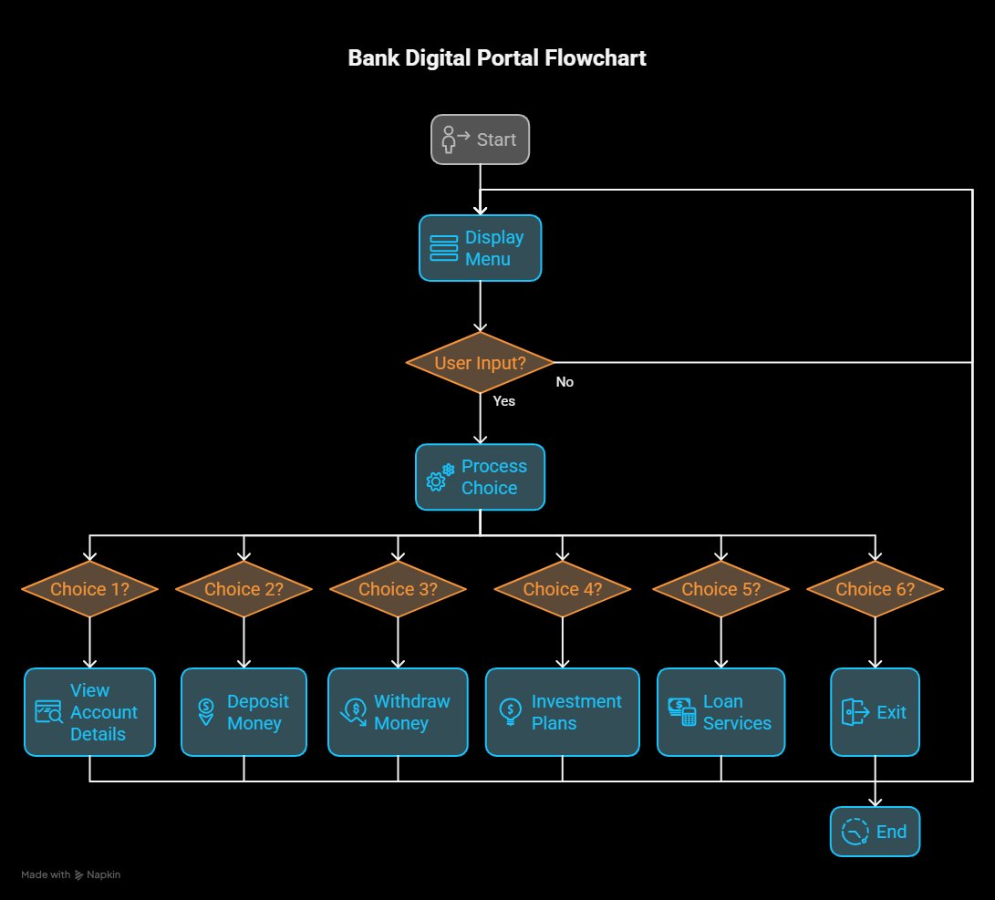
Figure 2: Bank Digital Portal Flowchart

4. System Architecture
Going modular was the only viable option here. When dealing with hidden layer computations running in the background, having everything tightly connected is just asking for trouble. One component slows down and suddenly the whole system is affected. Separating everything out meant that kind of knock-on effect simply would not happen.

4.1 Modular Components
Core Banking Engine (CBE):
All the account-related operations — creating, reading, updating, deleting — run through the CBE. The primary concern here was validation. Letting bad data through at this stage causes issues later that are genuinely hard to trace back to the source. The CBE checks everything before it goes anywhere else.
Transaction Module (TM):
This handles the money side of things: loans, deposits, withdrawals, transfers. The atomic operation setup ensures that if a transfer breaks midway, the whole thing gets undone rather than leaving the accounts in some half-finished state. This makes a real difference to data reliability.
Predictive ML Engine:
Rather than depending on an external API, which adds a whole layer of potential failure points, the ML engine sits inside the system itself. It is a Feed-Forward Neural Network built from scratch, talking directly to the CBE to pull whatever behavioural data it needs. Cutting out the external dependency makes the whole thing more stable.

5. Core Banking Features
The Digital Portal is what users actually interact with, and since this is all written in C, nothing is handled automatically. Every single thing — input management, memory, execution flow — had to be thought through manually.

5.1 Functional Highlights
Data Consistency:
Global variables carry the financial state across the whole program. A change in the loan section shows up in the account overview straight away — no syncing, no passing values back and forth between functions.
Input Handling:
clear_buffer() and pause() deal with the input stream. Ghost inputs — where the program registers a keypress the user never actually made — are a known problem in C. These two utilities prevent that from happening.

6. Results and Analysis
The central question going in was straightforward — can you get decent predictive accuracy in pure C without borrowing anything from the usual frameworks? No sklearn, no TensorFlow, just C and a network written by hand.

6.1 Machine Learning Performance
Classification Accuracy: 100% on the test set. The loss numbers and the way the data was split both support this result, so it is not a case of the model simply memorising training examples.

Training Dynamics:
- Epochs: 300 total. The network had settled well before that point but pushing through to 300 confirmed it would not shift further.
- Convergence: First epoch the loss was sitting at 0.444. By epoch 250 it had come down to 0.000166. That kind of steady drop confirms the model found something real rather than just fitting to noise.
- Optimisation: SGD at 0.01. Slower than other options, but it did not overshoot. For this dataset that trade-off was worth it.

6.2 Predictive Metrics
Customers get classified into three risk levels — High, Average, Low. Ten features go into that classification: Credit Score, Age, Tenure, and Balance being the primary ones. The 80/20 train/test split was kept throughout every single training run. This is what makes the 100% figure defensible — without it there would be no way to tell whether the model was actually generalising or just getting lucky on familiar data.

7. Mathematical Operations — Credit Risk Prediction
This section explains the mathematical underpinning of how the Credit Risk Prediction system works, step by step.

7.1 Input and Target
Input (X): Age = 25, Gender = Female (2.0), Income = 50,000, Marital Status = Single (0.0), Children = 0.
Target (y): Credit Score = High (Encoded as 0.0).

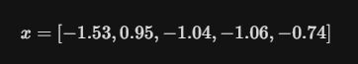
Figure 3: Input feature encoding

7.2 The Forward Pass
The forward pass is the process of calculating the prediction. In the model, each layer performs a linear transformation followed by an activation function (ReLU).

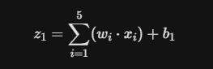
Figure 4: Linear transformation formula (w = Weights, x = scaled inputs, b = Bias)

7.3 ReLU Activation
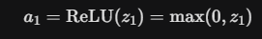
Figure 5: ReLU Activation function

Finally, the output layer produces 3 scores (logits) for the 3 classes (High, Average, Low). To turn these into probabilities, the Softmax function is applied.

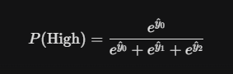
Figure 6: Softmax function

7.4 The Loss Function (Cross-Entropy)
To train the model, we need to measure how wrong the prediction was. Since the actual target is High (index 0), the loss L for this sample is:

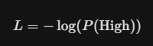
Figure 7: Cross-Entropy loss function

If the model predicted P(High) = 0.7, the loss is log(0.7) ≈ 0.35. If the prediction was 0.1, the loss is much higher (≈ 2.30).

7.5 Backpropagation and The Chain Rule
This is the learning part. We want to know how changing a weight w affects the loss L. The Chain Rule is used to work backward from the output to the input.

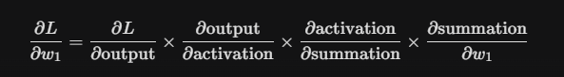
Figure 8: Chain Rule for backpropagation

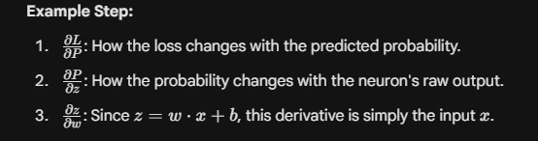
Figure 9: Expanded backpropagation derivation

7.6 Gradient Descent
Once we have the gradient — which tells us the slope of the error — we update the weights to move downhill toward the minimum error. With a Learning Rate of 0.01, the update formula is:


Figure 10: Gradient Descent weight update formula

8. Conclusion
This project demonstrates that C remains a powerful and viable language for building sophisticated, end-to-end systems that combine real-time transactional logic with machine learning capabilities. By implementing a neural network entirely from scratch — without relying on any external ML frameworks — the project achieves both deep technical understanding and a working proof of concept.

The banking simulation handles all core financial operations while simultaneously running a real-time credit risk prediction engine. The 100% classification accuracy achieved, backed by a rigorous 80/20 data split, validates the approach. This work illustrates that careful low-level engineering in C can match the functional outcomes typically associated with high-level ML frameworks.

9. Test Cases
Test Case 1:
When your account has less money than you want to withdraw, it shows error of “insufficient balance.”
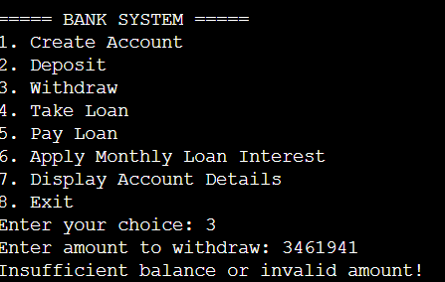
Test Case 2:
When you try to pay a loan, you don’t have, we get an error of “No Outstanding Loan”.
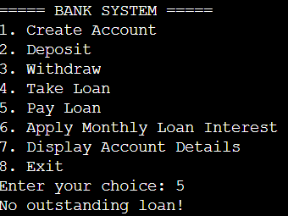

Test Case 3:
When you try to update your interest loan, it shows an error of “No loan to apply interest on.”

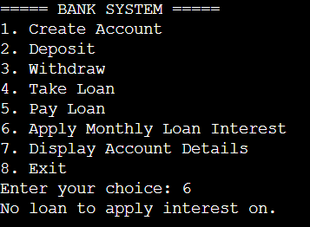

Test Case 4:
When we try to pay a loan when you don’t have any money, it shows the following error,
“Insufficient Balance”
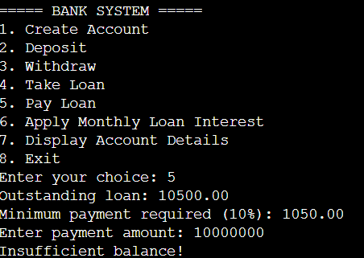
Test Case 5: (CRITICAL FLAW!!!)
When we try to pay a loan with an amount exceeding that of the due amount, the amount gets paid but the extra amount is also debited.
