Room config for minimum phase RIR plot (Spikes close together and decreasing order of magnitude)

Room volume to surface area is constrained by c etc. Thus, taken safe volume of 10 10 10. Best possible receiver source positions I found are [9 9 9] and [9 7 4] respectively. Graph:

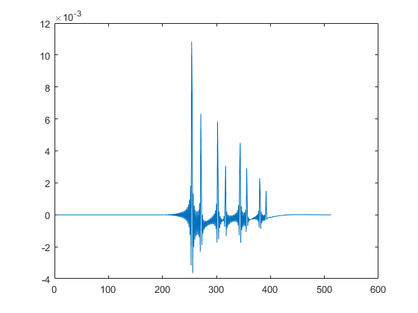

Did not notice any trend. Changing positions even slightly changes plot a lot. Used 9 9 9 for receiver so the reverberated paths are close in time. Room made as large as safely possible so the reflected paths are minimised. The fact that start part is empty cant be helped. If source receiver placed too close, too many spikes appear. Spikes not close by.

Optimal delay for low error 5%

If Ru not re-initialised, the error does not increase much even just after adding noise, However, this might be owing to the fact that the noise we are adding is small. I tried adding noise at just one instance. At index 1000. Error initially shot up to 400% from 5% (5% is error at which Kalman converges if no noise added). Then the decrease in error % was VERY slow. I did reupdate the Ru just to check. The filter **is** still working somewhat as the error keeps going down over iterations. But to give a sense of speed, by program end that is 16000 iterations, error only went down to 60%. Also, I noticed something about epsilon. It looks like the trade-off factor between speed of convergence and accuracy of convergence. Smaller epsilon gives better final estimate but takes long time to estimate. As of now, performance very bad for SNR less than 100 ex. 70. High percentage error. Also, using standard sigma2v and sigma2w of 1e-13 instead of calculating also gives very bad results. Basically, I feel there is something wrong with the parameters I’m using as the filter is not very robust with respect to noise addition.

//Hotfix: I just did an experiment and found that simply skipping back to index 1 after noise has been added, makes the filter work properly even with noise. Basically, just resetting which part of input signal I’m using.

//Error in hotfix: The reason hotfix works is and normally it doesn’t is that without adding any noise, if index number is started at some number like 1000 instead of 1, the converging is very slow. Seems to stop at around 40% error. This is some major issue, I think. The filter should work even if I start index at some random index. If this is fixed, even the noise issue will be resolved.

Cleaning up

Pending

Transmit beam forming for broadband signals

Ongoing