Wide World Importers (WWI) is a wholesale novelty goods importer and distributor operating from the San Francisco Bay area.
As a wholesaler, WWI's customers are mostly companies who resell to individuals. WWI sells to retail customers across the United States including specialty stores, supermarkets, computing stores, tourist attraction shops, and some individuals. WWI also sells to other wholesalers via a network of agents who promote the products on WWI's behalf. While all of WWI's customers are currently based in the United States, the company is intending to push for expansion into other countries.
WWI buys goods from suppliers including novelty and toy manufacturers, and other novelty wholesalers. They stock the goods in their WWI warehouse and reorder from suppliers as needed to fulfil customer orders. They also purchase large volumes of packaging materials and sell these in smaller quantities as a convenience for the customers.
Recently WWI started to sell a variety of edible novelties such as chilli chocolates. The company previously did not have to handle chilled items. Now, to meet food handling requirements, they must monitor the temperature in their chiller room and any of their trucks that have chiller sections.

Power BI Report Instructions :-
- Unzip the attached file
- You will have 1 Fact file(FactSale.csv) and 5 dimension files(DimCity.csv, DimCustomer.csv, DimDate.csv, DimEmployee.xlsx, DimStockItem.csv)
- Please make use of these files and prepare some good important insights for the management for decision making.
- Please use Power BI Desktop to make these insights
- Please follow Power BI standards and best practises
- Overall report model should be sustainable
- Do not use more than 3 report pages.
- Once you finished the development, please share the PBIX file with us.

Report Requirements :-
- Overview –
  - Use Fiscal Year slicer.
  - Create a Field Parameter with Sales Territory and Buying Group and use it.
  - Show KPIs –
    - Number of Sales
    - Total Sales incl Tax
    - Total Profit
    - Total Quantity
    - Total Stock Price
  - Show Total Sales excl Tax and Gross Margin% using a Combo chart with respect to each Sales Territory and each Buying Group. Use the Field parameter to switch the Field values.
Gross Margin% = Total Profit/ Sales excl Tax
  - Show Total Profit distribution by Sales Territory and Buying Group. Use the Field parameter to switch the Field values.
  - Show a Sales Comparison Table where Fiscal Year and Month wise Total Sales is mentioned. Compare the Total Sales value with the Total Sales of Same period Last Year (Show the % Difference also in a separate column).

- Sales & Profit by Region –
  - Use Fiscal Year and Sales Territory as slicers.
  - Show a Map to visualize Total Sales and Total Profit by State Province. It should be clear enough to check which Province/ Sales Territory has highest sales.
  - Show a correlation between Total Sales and Total Profit territory and Fiscal Year wise.
  - Show a table to visualize the Sales distribution across Sales Territory, State Province and Fiscal Year, Month.
Calculate the Yearly Average Total Sales and colour code the monthly values like below
    - If there is no sales value, White
    - If monthly sales value > Yearly Average Total Sales, Green
    - If monthly sales value < Yearly Average, then use Colour gradient of red.
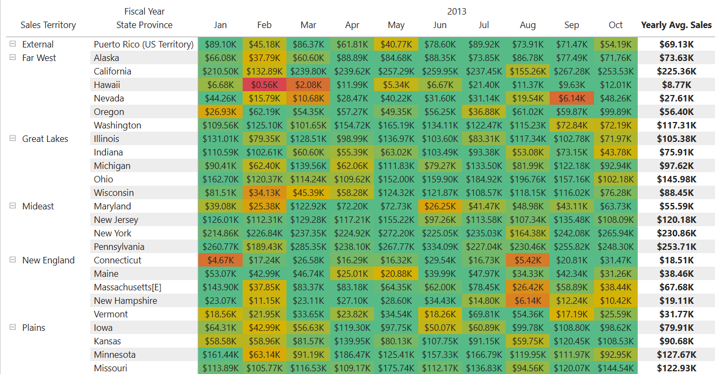

- Detailed Page – Give the name of the page by your own
  - Use it as a Drill Through Page of Sales & Profit by Region
  - User wants to see below details –
    - Top 5 Products sold in the selected Territory and State Province.
    - Top 5 Stocks present in the selected Territory and State Province.
    - Top 3 Employees who brought most of the profit in the selected Territory and State Province.
    - Top buying group and top 5 customers under that buying group in the selected Territory and State Province.

