Mutual Fund Analytics Capstone Project Report
Prepared by: Sagnik Mandal
Project: Bluestock Mutual Fund Analytics Capstone

Executive Summary
This project delivers an end-to-end analytics platform for the Indian mutual fund industry covering ETL pipelines, exploratory data analysis, quantitative performance analytics, interactive Power BI dashboards and advanced risk analytics. The project integrates historical datasets with live NAV information and provides actionable insights for investors and fund managers.

Project Objectives
The primary objectives were to automate data ingestion, clean and standardize datasets, compute advanced fund performance metrics, analyze investor behaviour and build an interactive decision-support dashboard.

Data Quality Assessment
Ten historical datasets and five live NAV datasets were integrated successfully. Duplicate checks returned zero duplicate rows and only limited missing values were observed in year-over-year growth metrics.

Figure 1
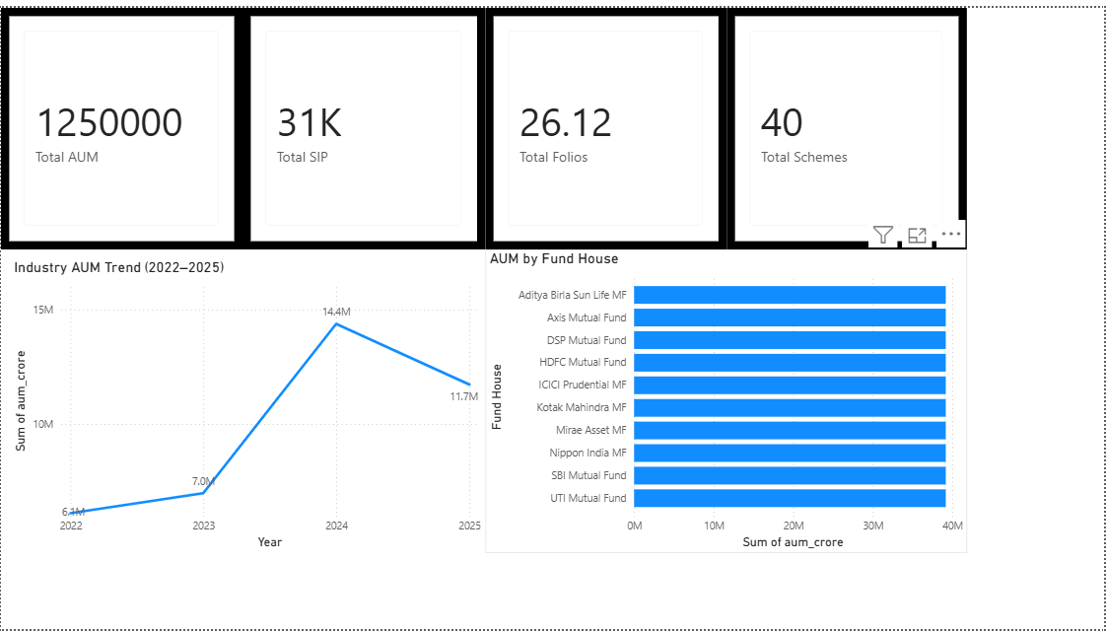
Figure 1: Industry overview dashboard showing ₹12.5 lakh crore AUM, 31K SIP inflows, 26.12 crore folios and 40 schemes.
The figure above contributes to understanding market structure, investor behaviour, risk characteristics and portfolio performance within the mutual fund ecosystem.

Figure 2
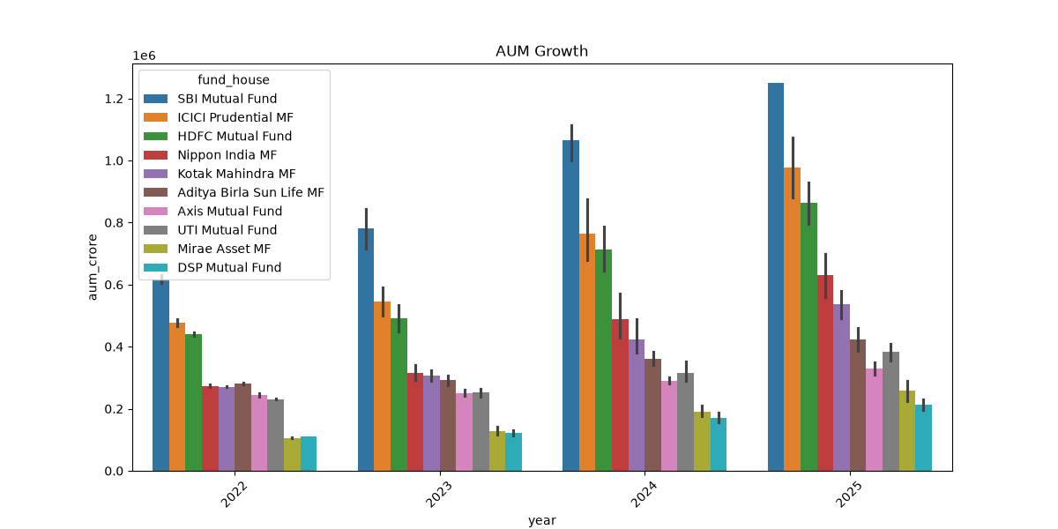
Figure 2: Industry AUM growth across major AMCs from 2022 to 2025.
The figure above contributes to understanding market structure, investor behaviour, risk characteristics and portfolio performance within the mutual fund ecosystem.

Figure 3
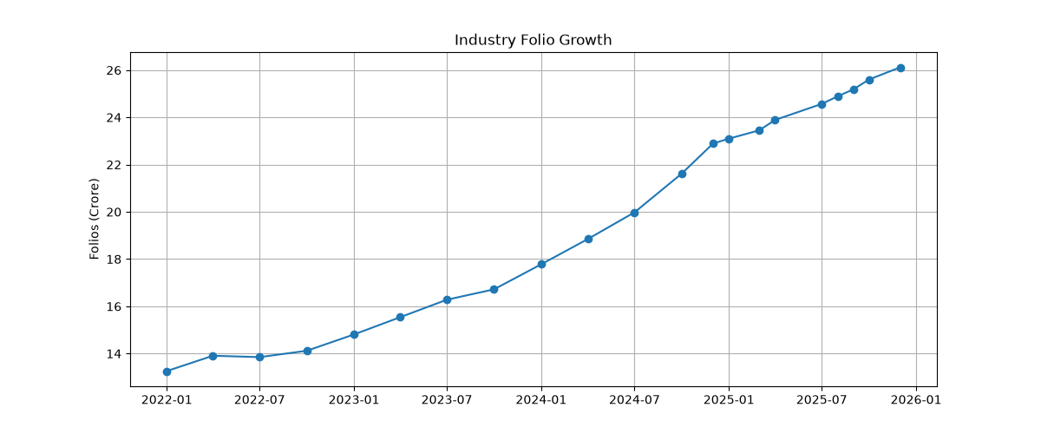
Figure 3: Industry folio growth showing strong retail participation.
The figure above contributes to understanding market structure, investor behaviour, risk characteristics and portfolio performance within the mutual fund ecosystem.

Figure 4
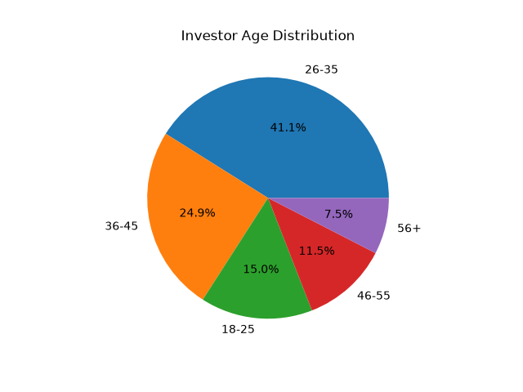
Figure 4: Investor age distribution highlighting dominance of the 26-35 cohort.
The figure above contributes to understanding market structure, investor behaviour, risk characteristics and portfolio performance within the mutual fund ecosystem.

Figure 5
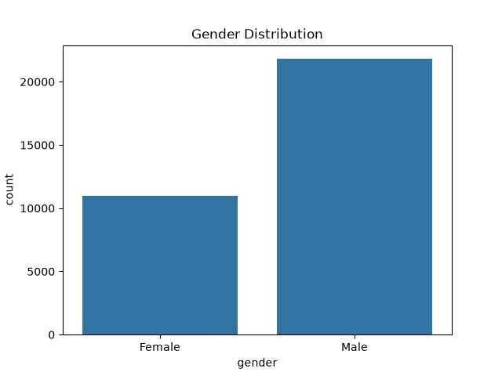
Figure 5: Gender participation analysis.
The figure above contributes to understanding market structure, investor behaviour, risk characteristics and portfolio performance within the mutual fund ecosystem.

Figure 6
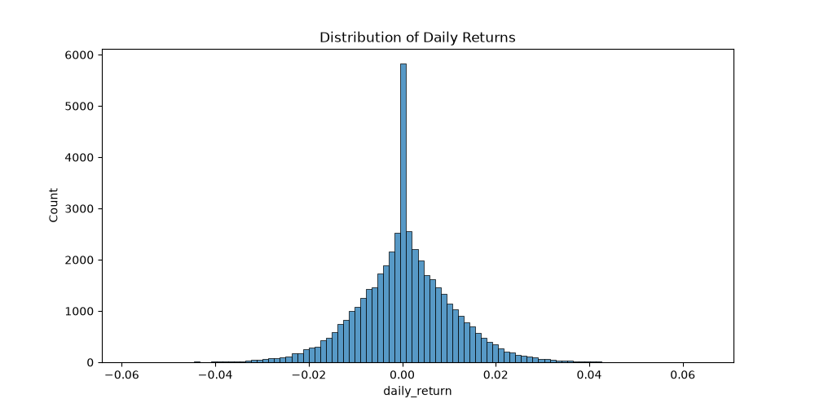
Figure 6: Distribution of daily returns demonstrating approximately normal behaviour.
The figure above contributes to understanding market structure, investor behaviour, risk characteristics and portfolio performance within the mutual fund ecosystem.

Figure 7
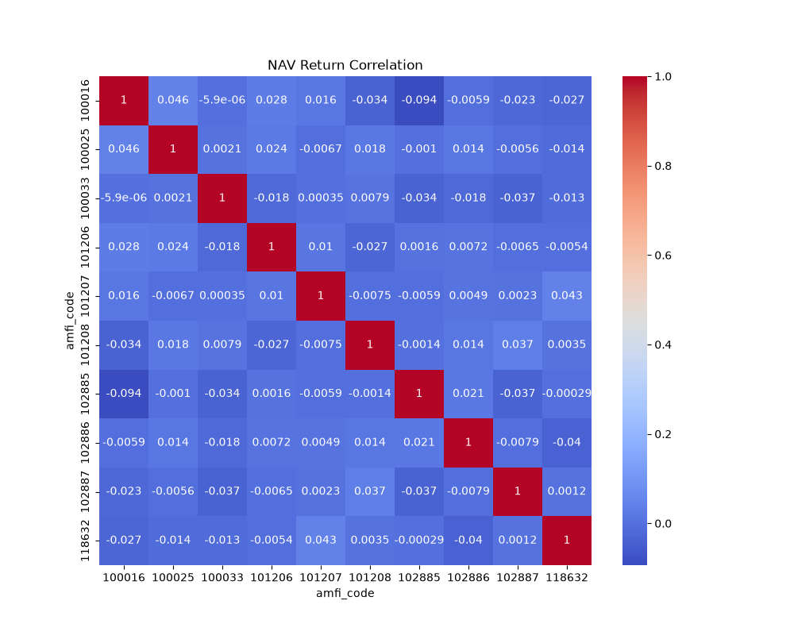
Figure 7: Correlation heatmap across selected schemes.
The figure above contributes to understanding market structure, investor behaviour, risk characteristics and portfolio performance within the mutual fund ecosystem.

Figure 8
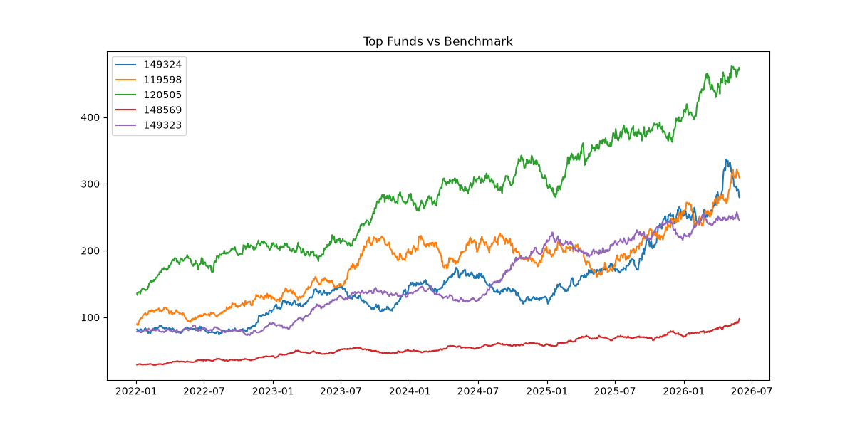
Figure 8: Benchmark comparison of top-performing funds.
The figure above contributes to understanding market structure, investor behaviour, risk characteristics and portfolio performance within the mutual fund ecosystem.

Figure 9
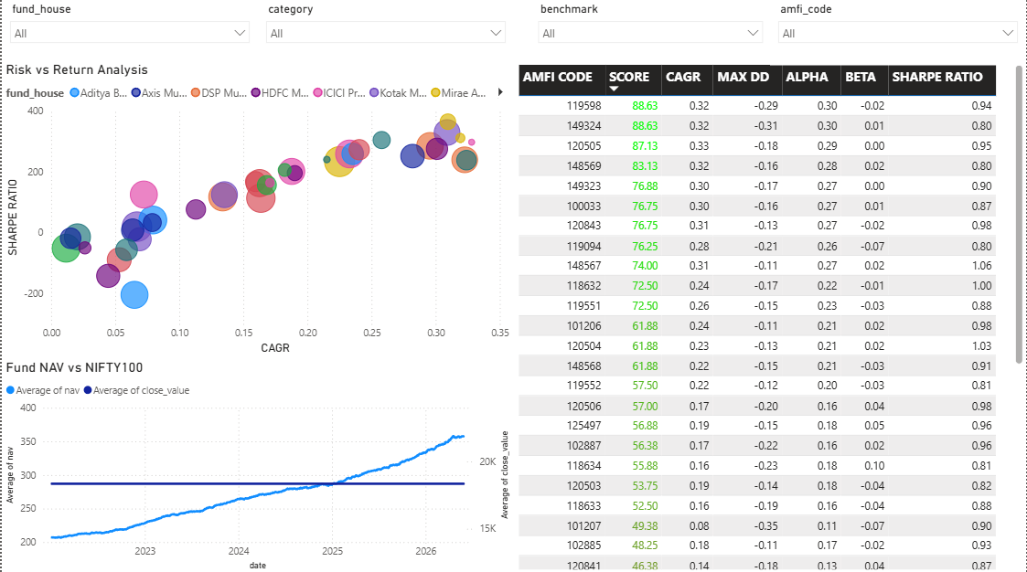
Figure 9: Risk-return dashboard with Sharpe ratio and CAGR analysis.
The figure above contributes to understanding market structure, investor behaviour, risk characteristics and portfolio performance within the mutual fund ecosystem.

Figure 10
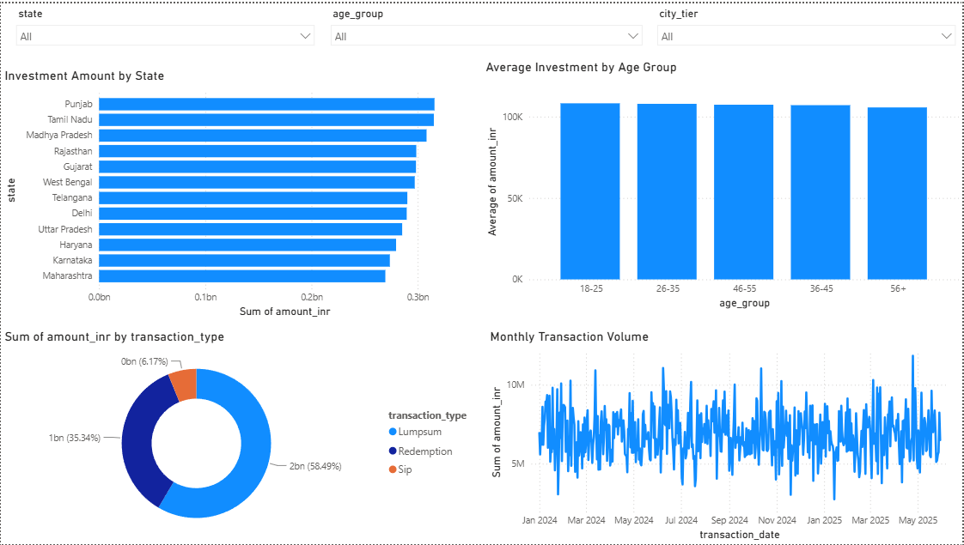
Figure 10: Investor analytics dashboard.
The figure above contributes to understanding market structure, investor behaviour, risk characteristics and portfolio performance within the mutual fund ecosystem.

Figure 11
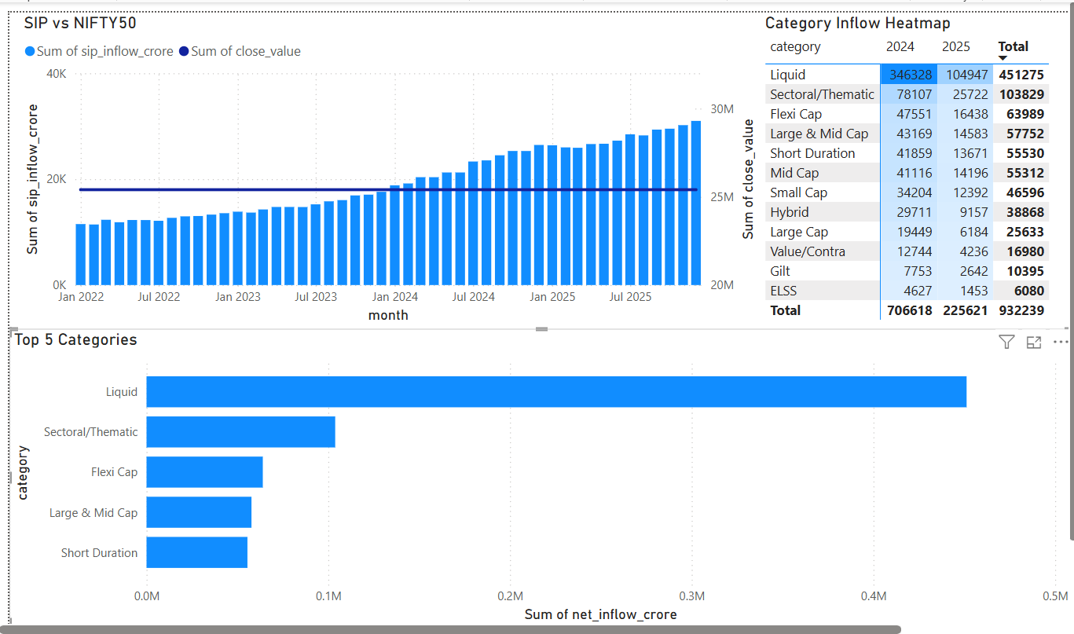
Figure 11: SIP and market trends dashboard.
The figure above contributes to understanding market structure, investor behaviour, risk characteristics and portfolio performance within the mutual fund ecosystem.

Figure 12
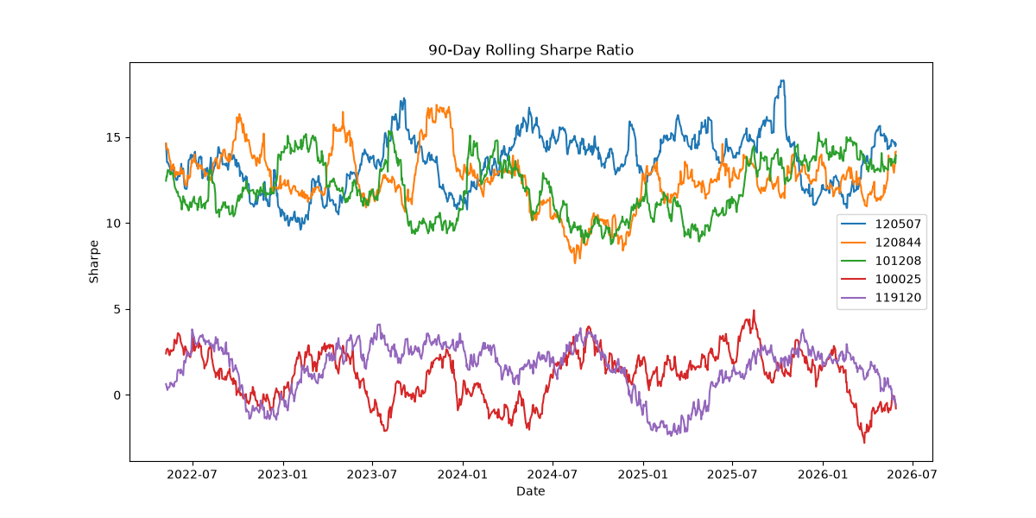
Figure 12: Rolling 90-day Sharpe ratio analysis.
The figure above contributes to understanding market structure, investor behaviour, risk characteristics and portfolio performance within the mutual fund ecosystem.

Figure 13
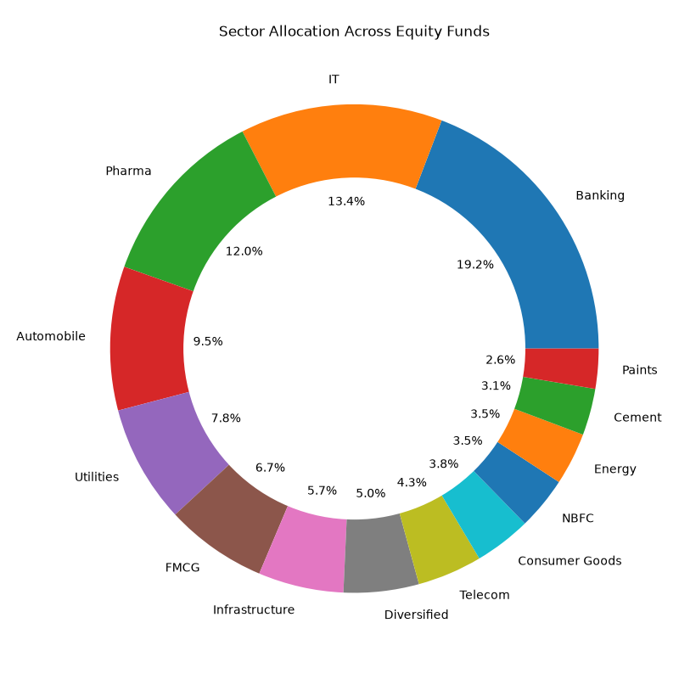
Figure 13: Sector allocation analysis.
The figure above contributes to understanding market structure, investor behaviour, risk characteristics and portfolio performance within the mutual fund ecosystem.

Key Findings
- Investors aged 26-35 account for over 41% of the investor base.
- Industry folios doubled from roughly 13 crore to over 26 crore during the study period.
- Liquid funds attracted the largest category inflows.
- Top-performing funds generated CAGR above 30% with strong Sharpe ratios.
- Rolling Sharpe analysis showed significant changes in risk-adjusted returns across market cycles.

Recommendations
Investors should align investments with risk appetite, monitor drawdowns, diversify sector exposure and maintain SIP continuity for long-term wealth creation.

Conclusion
The project demonstrates a complete production-grade analytics workflow from ingestion to reporting and provides a scalable foundation for future portfolio intelligence systems.

