**AI-Driven Restaurant Ingredient Forecasting and Prediction System for Minimizing Food Wastage**

The food industry, particularly restaurants, faces significant challenges in managing ingredient inventory efficiently. One of the most pressing issues is food wastage, which leads to financial losses and negative environmental impacts. Poor demand forecasting, lack of real-time tracking, and inefficient supply chain management contribute to excessive food spoilage and wastage.

To address this, the AI-Driven Restaurant Ingredient Forecasting and Prediction System for Minimizing Food Wastage leverages machine learning (ML) and predictive analytics to accurately estimate ingredient requirements. This ensures that restaurants stock only what is needed, optimizing inventory and reducing waste.

**The Problems Faced by Restaurants Today**

**(a) High Food Wastage Due to Poor Inventory Management**

* Restaurants often **overestimate or underestimate** ingredient requirements, leading to spoilage or stockouts.
* Perishable items like vegetables, dairy, and meats **have a short shelf life**, and excess inventory results in huge losses.
* Many restaurants do not have an **automated tracking system**, leading to inefficiencies.

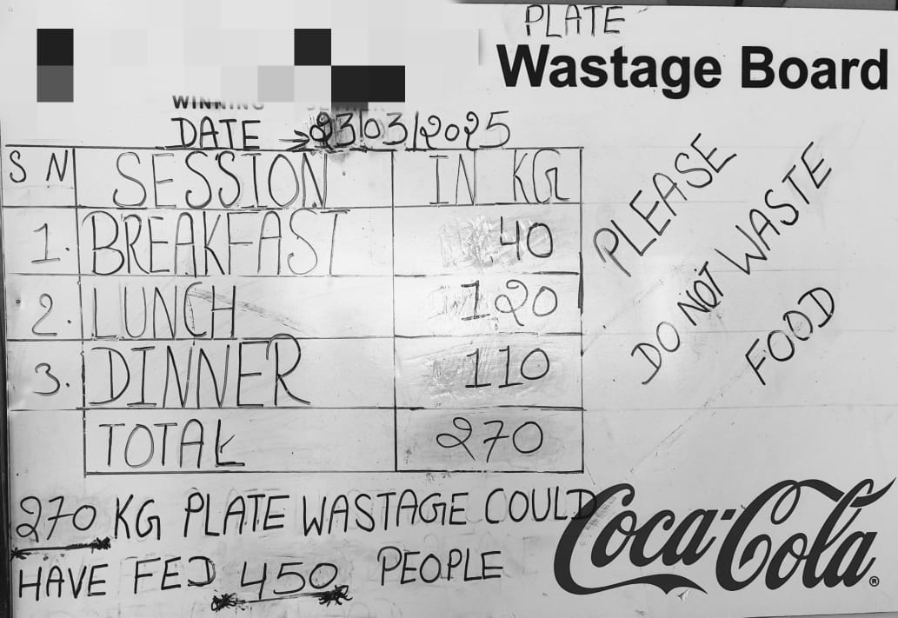

**(b) Unpredictable Customer Demand**

* Demand fluctuates due to **seasonal trends, festivals, and special events**.
* Some ingredients may be required more frequently during peak times, such as holidays and weekends.
* **Manual forecasting methods** are often inaccurate, leading to stock mismanagement.

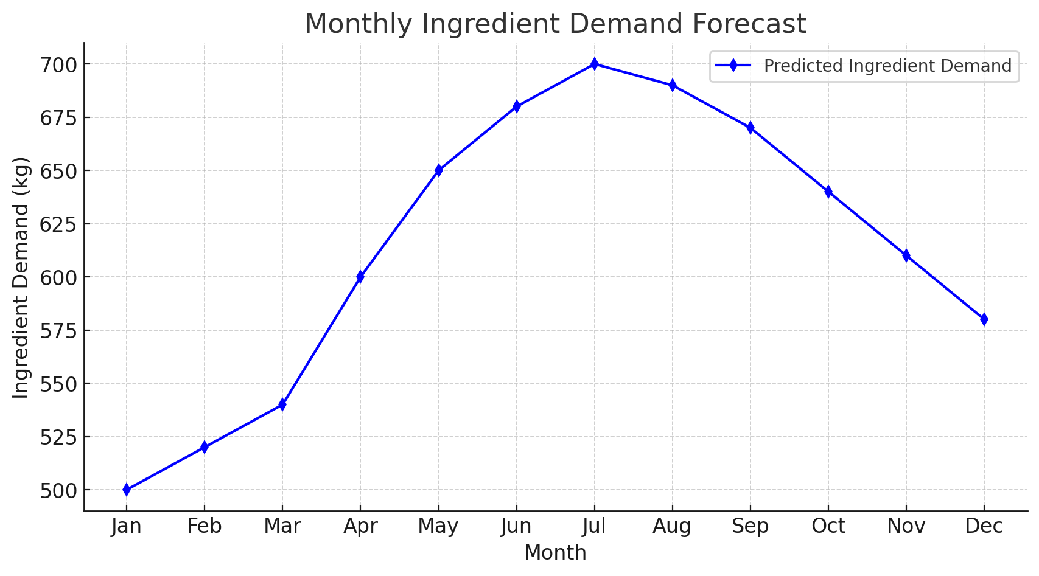

**(c) Inefficient Order and Supplier Coordination**

* Without proper forecasting, restaurants **place last-minute orders**, leading to higher costs.
* Suppliers may not always have the required stock available immediately, causing disruptions.
* **Delayed deliveries** due to unplanned purchasing lead to a lack of essential ingredients.

**(d) Rising Costs and Profitability Concerns**

* Food wastage results in **financial losses**, reducing overall profit margins.
* Higher **operational costs** are incurred in managing excess inventory and storage.
* Restaurants struggle to maintain a **balance between availability and waste reduction**.

**(e) Environmental Impact of Food Wastage**

* Globally, food waste contributes to **environmental pollution** by increasing carbon emissions.
* Excess food disposal in landfills generates **methane**, a greenhouse gas.
* Sustainable food management is becoming a necessity due to environmental concerns.

**How This System Works**

**(a) Data Collection & Input Sources**

The system collects **historical and real-time data** from:

1. **Customer Orders** – What dishes were ordered and how frequently.
2. **Ingredient Usage** – What ingredients were used and their consumption rate.
3. **Public Holidays & Festivals** – To predict customer footfall.
4. **Seasonal Trends** – Variation in demand due to weather conditions.
5. **Supplier Data** – Lead time, availability, and pricing trends.

**(b) Machine Learning-Based Forecasting**

The system applies **AI and predictive analytics** to:

* Identify **patterns in customer demand** over time.
* Analyze **how festivals, weekends, and seasonal factors impact ingredient needs**.
* Forecast **monthly ingredient requirements** using advanced ML models such as **time-series forecasting (ARIMA, LSTM, Prophet, etc.)**.

**(c) Real-Time Inventory Optimization**

* The system **integrates with restaurant inventory databases** to track ingredient stock levels.
* It suggests **reordering strategies**, ensuring that stock is maintained at an optimal level.
* Alerts are generated for **perishable ingredients that need urgent usage**.

**(d) Minimizing Wastage and Cost Reduction**

* The system **recommends portion sizes** and efficient menu planning.
* It ensures **optimal purchasing decisions**, reducing excess inventory.
* AI can provide **alternative ingredient suggestions** in case of shortages.

**(e) Dynamic Supplier Coordination**

* Automated ordering helps **streamline supplier coordination**.
* The system **suggests the best time to restock ingredients** based on price and demand trends.
* Reduces **last-minute emergency purchases**, which are often more expensive.

**Expected impact**

**Reduction in Food Wastage (30-50% Decrease)**

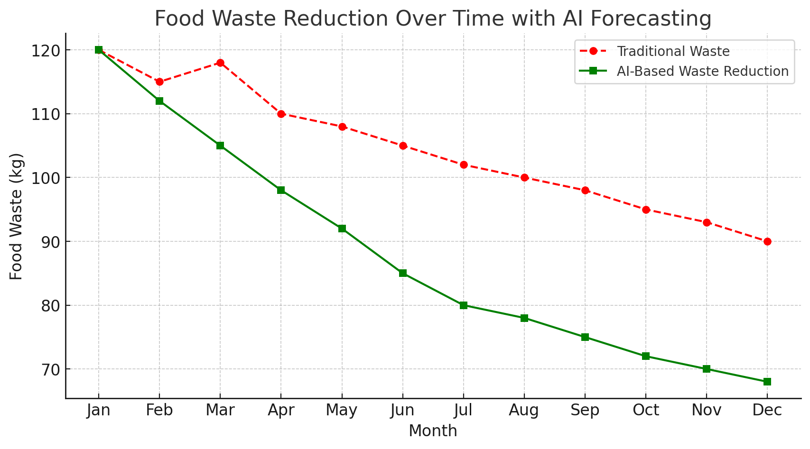

🔹 **Optimized Ingredient Purchasing** – The system will ensure that restaurants **only order the necessary quantity of ingredients** based on predicted demand.  
🔹 **Smart Inventory Utilization** – Helps **prioritize perishable items**, reducing spoilage.  
🔹 **Adaptive Menu Planning** – Restaurants can make **data-driven decisions** to promote dishes that use surplus ingredients.  
🔹 **Sustainability Impact** – Less waste means **reduced landfill contribution and lower methane emissions**, contributing to a **greener environment**.

**Result:** Restaurants can expect **30-50% less food wastage**, translating to both cost savings and environmental benefits.

**Significant Cost Savings (10-25% Reduction in Operational Costs)**

🔹 **Lower Ingredient Costs** – By avoiding unnecessary purchases and reducing emergency restocking, restaurants can **cut procurement expenses**.  
🔹 **Minimized Storage Costs** – Reduced overstocking leads to **lower refrigeration and preservation expenses**.  
🔹 **Optimized Supplier Orders** – The system helps in **placing bulk orders at the right time**, reducing purchase costs.

**Result:** Restaurants can expect **10-25% lower operational costs**, leading to higher profit margins.

**Improved Forecast Accuracy (Up to 85-95%)**

🔹 **AI-Powered Demand Prediction** – The system learns from **historical sales, seasonal trends, and festival footfall** to provide **precise ingredient forecasts**.  
🔹 **Dynamic Adjustments** – Forecasts can be updated in real-time based on **changing trends and external factors** (e.g., weather, local events).  
🔹 **Better Event Planning** – The system can help **predict peak business days**, allowing restaurants to **prepare accordingly**.

**Result:** The AI system can achieve **85-95% forecasting accuracy**, minimizing unexpected ingredient shortages or surpluses.

**Enhanced Customer Experience (Faster Service & Consistency)**

🔹 **No More ‘Out of Stock’ Situations** – Ensures that **popular dishes remain available**, improving customer satisfaction.  
🔹 **Faster Service** – Since ingredients are managed efficiently, chefs can **prepare dishes quicker** without last-minute adjustments.  
🔹 **Consistent Taste & Quality** – The system ensures that **ingredients are always fresh**, maintaining food quality and taste.

**Result:** **Happier customers, better reviews, and increased customer retention.**

**Increased Profitability & Business Growth (5-15% Revenue Boost)**

🔹 Reduced Waste = Higher Profits – Savings from minimized wastage directly increase restaurant profits.

🔹 Data-Driven Decision Making – Owners can adjust menus, pricing, and purchasing strategies based on AI insights.

🔹 Scalability for Chains – The system can handle multiple locations, making it useful for expanding restaurant businesses.

Result: Restaurants can experience a 5-15% increase in revenue through better resource management.

**Lower Carbon Footprint** – Less food waste means **less methane production and reduced environmental damage**.  
🔹 **Ethical Waste Management** – The system can **recommend donation of excess food** instead of disposal.  
🔹 **Compliance with Sustainability Goals** – Helps businesses meet **government regulations and sustainability initiatives**.

**Result:** Restaurants can **reduce their environmental impact**, contribute to food donation programs, and build a **positive brand reputation**