Toward Trustworthy Root-Cause Analysis in Telecom Networks:
A Layered Attribution-Causal-Conformal Framework and Proof-of-Concept Evaluation on Public KPI Telemetry
Author Name(s) to be added
Affiliation to be added
ABSTRACT
Telecom operators increasingly deploy machine learning to predict service degradation, but an accurate prediction is not the same as a trustworthy one: an engineer also needs to know which KPI is responsible, whether that KPI is merely correlated with the fault or plausibly causes it, why the system believes so, and how confident to be. Prior work on root-cause analysis (RCA) for multivariate telemetry typically evaluates a single mechanism -- feature attribution, causal discovery, or uncertainty quantification -- in isolation; no study we identified jointly integrates and evaluates all three against ground-truth root-cause labels. We propose a five-component framework that chains (1) a probabilistic early-warning predictor, (2) exact feature attribution, (3) a causal-precedence filter, (4) an evidence-grounded natural-language explainer, and (5) distribution-free uncertainty calibration, and we report a reproducible proof-of-concept evaluation on the public Server Machine Dataset (SMD), selected specifically because it provides ground-truth root-cause labels that most public network-telemetry datasets lack. On a held-out evaluation block, a Transformer encoder reaches 0.934 AUROC / 0.884 AUPRC for early-warning prediction versus 0.898 / 0.825 for a gradient-boosted baseline; out-of-sample root-cause attribution achieves 0.529 mean precision/recall@k against ground truth, well above the ~0.174 chance level; a Granger-causality filter correctly separates ground-truth-consistent attribution candidates from spurious ones in the incident examined; split-conformal calibration attains its 90% target coverage (0.955 empirical) while routing 20% of cases to an explicit human-escalation flag; and early-warning lead time is shown to be highly heterogeneous across incidents (44 minutes to a complete miss), a finding we argue is itself a trustworthiness result that point-accuracy metrics would hide. This paper is explicitly scoped as a single-dataset, baseline-free proof of concept intended to establish feasibility and measurement protocol; we define the multi-dataset, multi-baseline, statistically validated study required to generalize these findings as immediate future work.
Keywords:
trustworthy AI; root-cause analysis; AIOps; conformal prediction; causal inference; explainable AI; telecom network management; time-series anomaly prediction

1. Introduction
Modern telecom networks generate continuous telemetry -- latency, packet loss, throughput, jitter, signal strength, handover-failure rate, CPU/memory utilization, alarms, and configuration-change events -- and operators increasingly rely on machine learning to detect degradation before it escalates into a service disruption. The dominant research emphasis, however, has been point predictive accuracy: does the model flag the right minute? This framing is insufficient for an operational setting in which an automated flag triggers costly human or automated remediation. An engineer facing a flagged degradation needs four additional answers that accuracy alone does not provide: which KPI is implicated, whether that KPI's relationship to the fault is causal or merely coincidental, why the system believes so in terms the engineer can audit, and how much to trust the flag at all.
Feature-attribution methods such as SHAP [1] answer the first of these questions but are, by construction, correlational -- a KPI can score highly because it moves together with the fault without driving it. Causal-discovery methods such as Granger causality [2] and constraint-based causal graphs [3] address this but are rarely paired with a calibrated confidence signal, so a causal claim is reported with the same false certainty as a correlational one. Conformal prediction [4] supplies exactly that calibrated confidence but is, to our knowledge, not evaluated jointly with attribution and causal filtering. Existing RCA benchmarks [5], [6] score attribution methods against each other but do not ablate the value that a causal filter or a calibration layer adds on top.
This paper makes three contributions. First, we propose a five-component framework -- predict, attribute, causally filter, calibrate, explain -- that makes each of these questions an explicit, separately-evaluable pipeline stage rather than an implicit property of one end-to-end model. Second, we implement the framework using standard, off-the-shelf methods at each stage (a Transformer/LightGBM predictor, SHAP attribution, a Granger-causality filter, split-conformal calibration, and a personalized-PageRank graph view) and report a reproducible proof-of-concept evaluation on the public Server Machine Dataset (SMD) [7], chosen specifically because it is one of the few public multivariate-telemetry datasets with ground-truth root-cause labels, allowing the attribution and causal-filtering stages to be scored against a known answer rather than only inspected qualitatively. Third, we report results honestly at the scope we can currently support -- one dataset, one machine, no external baselines, no multi-seed statistical testing -- and define the concrete experimental programme (Section 9) required to elevate these findings from a proof of concept to generalizable evidence.
The remainder of this paper is organized as follows. Section 2 reviews related work across classical ML, deep learning, transformer, graph-neural-network, causal, and LLM-based approaches to RCA, and situates the identified gap. Section 3 formalizes the prediction, attribution, causal-filtering, and calibration problems. Section 4 describes the proposed framework and its five components. Section 5 details the experimental setup. Section 6 reports results for each component. Section 7 discusses the findings, Section 8 states limitations and threats to validity, Section 9 outlines practical implications and future work, and Section 10 concludes.

2. Related Work
Classical machine learning. Tree ensembles (isolation forests, random forests, gradient-boosted trees) remain a strong, auditable baseline for KPI anomaly detection; a 2024 benchmark of ML methods on network anomaly detection confirms they remain competitive with deep alternatives on tabular telemetry [8].
Deep learning and Transformers. Recurrent and variational architectures dominate multivariate KPI anomaly detection: OmniAnomaly [7] models KPI vectors with a stochastic RNN and is also the source of the SMD dataset used in this study; LSTM-NDT [9] forecasts KPI values and flags deviation with a non-parametric dynamic threshold. Self-attention architectures improve on recurrence for long-range temporal dependence [10]; TranAD [11] uses an adversarially trained transformer encoder for multivariate anomaly detection. Closest to our domain, [12] fuses a transformer temporal encoder with a graph neural network over 5G RAN topology for anomaly root-causing -- effectively Components 1 and 2 of our framework, evaluated on real (non-public) RAN data but without a causal-versus-correlational distinction or calibrated uncertainty.
Graph neural networks. Once more than one KPI stream and a known topology are available, root-cause evidence can propagate along dependency edges instead of being scored per KPI in isolation. MicroRCA [13] builds an attributed service graph and ranks root causes with personalized PageRank; GDN [14] learns the dependency graph itself and scores per-sensor deviation with attention.
Causal reasoning. GNN and attribution scores remain correlational: they indicate that a KPI co-moved with the outcome, not that changing it would change the outcome. Constraint-based causal discovery (the PC/FCI family [3]) and neural Granger causal discovery [15] provide tools to test temporal precedence and conditional independence; a recent comparative study [16] benchmarks PC, FCI, Granger, fGES, and LiNGAM as causal-graph builders for RCA.
RCA benchmarking. RCAEval [5] standardizes precision@k, MRR, and MAP@k evaluation across 735 failure cases spanning eleven fault types in three microservice systems; LEMMA-RCA [6] extends multi-domain, multi-modal RCA evaluation to IT and operational-technology systems. Neither benchmark ablates the joint contribution of causal filtering and calibrated uncertainty on top of attribution -- the gap this paper's proof of concept targets.
LLM-based approaches. Recent AIOps systems use large language models strictly as narrators over verified, tool-collected evidence rather than as free-form diagnosers: RCACopilot-style systems [17] aggregate multi-modal diagnostic evidence into incident narratives, and LLM-agent RCA work [18] shows that grounding the LLM in retrieved telemetry is what prevents hallucinated causes. We reuse this narrate-don't-diagnose pattern for Component 4.
Uncertainty quantification. Conformal prediction [4] gives distribution-free, finite-sample coverage guarantees without assuming a noise model for KPI residuals, and is increasingly positioned as a prerequisite for trustworthy AI deployment [19], including in 5G-specific deep models [20]. It is used here as the calibration layer for Component 5.
Table 1. Related-work comparison matrix.
Ref. | Problem | Method | Dataset | Metrics | Gap relevant to this work
[7] | MTS anomaly detection | Stochastic RNN+VAE | SMD (introduced) | F1 | No RCA, no causal filter, no calibration
[5] | RCA benchmarking | Multi-method eval harness | 3 microservice systems | PR@K, MRR, MAP@K | No causal/conformal ablation; no telecom domain
[6] | Multi-domain RCA dataset | Multi-modal | IT + OT systems | - | No telecom RAN; no causal+calibration study
[15] | Causal-graph RCA | Neural Granger discovery | Microservices | PR@K | No calibrated confidence layer
[12] | RAN anomaly RCA | GNN + Transformer | Real 5G RAN (private) | - | No causal/correlation split; no calibration
[4] | Distribution-free UQ | Split-conformal | General ML | Coverage | Not applied to RCA specifically

3. Problem Formulation
Let X_t in R^d denote the KPI vector observed at minute t (d = 38 in this study; in a real deployment d indexes named telecom KPIs such as latency, packet loss, jitter, or handover-failure rate). A window of the last W minutes is written X_(t-W+1:t).
Early-warning prediction (Component 1).
y_hat_t = f_theta( X_(t-W+1:t) ) in [0, 1]
y_t = 1 iff an anomaly occurs at some tau in (t, t+H] (H = prediction horizon)
L(theta) = - sum_t w_{y_t} [ y_t log(y_hat_t) + (1 - y_t) log(1 - y_hat_t) ]
f_theta ranges over a gradient-boosted tree ensemble and a Transformer encoder in this study (Section 4.1); w_{y_t} is a class-imbalance weight.
Attribution (Component 2).
phi_i(x) = sum_{S subseteq N\{i}} [|S|!(|N|-|S|-1)!/|N|!] * [ f(S u {i}) - f(S) ]
phi_i(x) is the Shapley value of feature i for input x; per-KPI importance aggregates the Shapley values of that KPI's derived tabular features (Section 5.2).
Causal filter (Component 3).
For candidate KPI i and target KPI j, i is retained as causal evidence for j if, at some lag l in {1,...,L}, the null hypothesis that i's past does not improve the prediction of j's future (beyond j's own past) is rejected by an SSR F-test at p < 0.05:
H0: Y_j,t ~ Y_j,(t-1..t-l) vs. H1: Y_j,t ~ Y_j,(t-1..t-l) + X_i,(t-1..t-l)
Calibration (Component 5).
Given a calibration set with known labels, the nonconformity score for point i is s_i = 1 - P(true class | x_i). The (1-alpha)-quantile of {s_i}, denoted q_hat, defines a prediction set for a new point x:
C(x) = { c : 1 - P(c | x) <= q_hat } with marginal guarantee P( y in C(x) ) >= 1 - alpha

4. Proposed Framework
The framework decomposes the problem in Section 1 into five components, each with its own input, output, and validation criterion, chained as shown in Figure 1. This decomposition is deliberate: it lets each stage be evaluated -- and, in Section 6, scored against ground truth -- independently, rather than treating trustworthiness as an emergent, unmeasured property of one opaque end-to-end model.
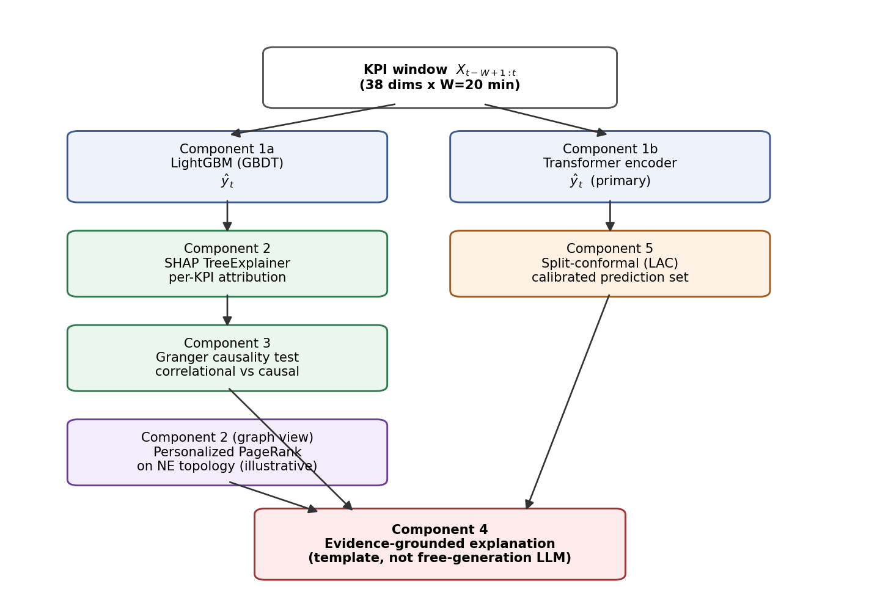
Figure 1. Proposed five-component framework. Solid arrows show data flow; Components 2 (graph view) and 5 are illustrative/parallel branches feeding the final explanation stage.

4.1 Component 1 -- Predict degradation before disruption
Input: a W-minute KPI window per network element. Method: a Transformer encoder (self-attention over the window) as the primary model, benchmarked against a gradient-boosted tree baseline (LightGBM) on rolling statistical features -- retained as a cheap, auditable fallback and as the model exactly explained in Component 2. Output: P(degradation in the next H minutes), a continuously updated early-warning score rather than a post-hoc flag.

4.2 Component 2 -- Identify probable root causes
Input: the flagged window, the full KPI vector, and (where available) the NE/site topology graph. Method: exact SHAP attribution on the tree-ensemble predictor ranks which KPI dimensions drove the flagged prediction; a graph view -- personalized PageRank over the topology, seeded at high-deviation nodes -- ranks which network element is the propagation source rather than merely a symptom, in the spirit of MicroRCA [13]. Output: a ranked (KPI or NE, contribution score) list, explicitly still correlational at this stage.

4.3 Component 3 -- Distinguish correlation from causal evidence
Input: Component 2's ranked candidates and their raw time series. Method: a Granger-causality test per candidate (Section 3), plus, where a configuration-change timestamp coincides with a candidate's onset, a before/after comparison treated as a quasi-experiment. Output: each candidate labeled correlational only or causal evidence, with its test statistic attached; Granger causality is necessary-but-not-sufficient evidence for true causality, and this label is reported as a confidence tier, not a proof.

4.4 Component 4 -- Explain in engineer-understandable terms
Input: the outputs of Components 1, 2, 3, and 5. Method: a template grounded strictly in the evidence already computed -- not a free-generation LLM call -- following the narrate-don't-diagnose pattern from RCACopilot- and RCAgent-style systems [17], [18]; an LLM may phrase the narrative fluently but may not assert any fact absent from the evidence. Output: a short report stating what is predicted, how confident, which KPI/NE is implicated, whether that evidence is causal or correlational, and what changed immediately before onset.

4.5 Component 5 -- Quantify uncertainty and confidence
Input: Component 1's raw probability and a held-out calibration set. Method: split-conformal prediction (Section 3) wraps the probability into a set with a distribution-free, finite-sample coverage guarantee, independent of whether the underlying model is well-calibrated on its own; reliability diagrams / Expected Calibration Error (ECE) are reported as a diagnostic. Output: a calibrated confidence level plus an explicit abstain-and-escalate flag for low-confidence (ambiguous) predictions.

5. Experimental Setup

5.1 Dataset
We use machine-1-1 from the NetManAIOps Server Machine Dataset (SMD) [7], obtained directly from the dataset's public repository. SMD provides 28,479 one-minute samples across 38 KPI dimensions (CPU, memory, network, and load metrics) for a train split (guaranteed anomaly-free historical operation) and a test split (labeled monitoring period), together with interpretation_label annotations giving, for each of eight ground-truth anomaly segments, the exact root-cause KPI dimensions. We use SMD as a public, license-open proxy for telecom NE/CPU/memory/traffic KPI monitoring: it is one of the few public multivariate-telemetry datasets with root-cause ground truth, which is precisely what is required to score, rather than only inspect, the attribution and causal-filtering stages. Real RAN-level KPI datasets (latency, jitter, handover-failure rate) with root-cause labels are operator- and vendor-confidential and are not publicly available; this substitution is a limitation, addressed in Section 8.

5.2 Target construction and features
We construct an early-warning target rather than a post-hoc detection target: y_t = 1 if a labeled anomaly occurs anywhere in (t, t+H], using only data up to and including t (W = 20 minutes, H = 30 minutes). Tabular features are the rolling mean, standard deviation, and last value per KPI dimension over the window (114 features); the Transformer additionally consumes the raw W x 38 window.

5.3 Data split
The eight ground-truth segments are not spread evenly across the 28,479-step test timeline: segments 1-5 fall in [15849, 21195], segments 6-8 in [24679, 27556], and [0, 15849) is anomaly-free. A naive 50/20/30 chronological split would leave the earliest block with zero positive examples. We instead cut at two points inside anomaly-free gaps so that each of three disjoint, non-overlapping chronological blocks contains at least one full ground-truth segment: TRAIN (earliest; segments 1-3; fits the models), EVAL (middle; segments 4-5; held out for every reported detection metric), and CALIB (latest; segments 6-8; used only to fit the conformal threshold and reliability diagram, never for model fitting or selection). The original train file (guaranteed anomaly-free, chronologically earlier still) is added as extra normal background for model fitting only.
Table 2. Data split summary.
Block | Role | Windows | Positive rate
TRAIN (+ background) | Model fitting | 24,751 | 6.6%
EVAL | All reported detection metrics | 4,151 | 28.6%
CALIB | Conformal threshold + ECE only | 5,430 | 1.7%

5.4 Models and hyperparameters
LightGBM: 300 trees, max depth 5, learning rate 0.05, scale_pos_weight set to the train-set negative/positive ratio. Transformer: input projection to d_model = 32, learned positional embedding, 2 encoder layers (4 attention heads, feed-forward dimension 64, dropout 0.1), mean-pooling over time, a 2-layer classification head; trained with Adam (lr = 1e-3), weighted binary cross-entropy, batch size 256, 6 epochs. Granger causality: SSR F-test, lags 1-5, statsmodels implementation. Split-conformal: least-ambiguous-set classifier (LAC) [4], target coverage 90% (alpha = 0.10), calibrated on the CALIB block. Personalized PageRank: networkx implementation on a reversed, hand-specified illustrative topology graph (Section 6.6), not fit to SMD (SMD has no topology).

5.5 Metrics
Prediction: AUROC, AUPRC on the held-out EVAL block. Attribution: precision@k and recall@k of the top-k SHAP-ranked KPI dimensions against the ground-truth interpretation_label set, compared to the chance level k/38. Causal filtering: Granger SSR F-test p-value (minimum across lags 1-5) and Pearson correlation, reported side by side. Calibration: empirical coverage of the conformal prediction set against the 90% target, and Expected Calibration Error (ECE, 10 equal-width bins) of the raw probability. Early-warning usefulness: lead time, the gap in minutes between the first sustained (>= 2 consecutive minutes) crossing of a 0.5 risk threshold and the official onset of each ground-truth segment.

6. Results

6.1 Component 1 -- Degradation prediction
Table 3 and Figure 2 compare the two predictors on the held-out EVAL block. The Transformer outperforms the LightGBM baseline on both metrics, consistent with the attention-over-recurrence/trees rationale in Section 2, while the baseline is retained because it is the model exactly explained by SHAP in Section 6.2.
Table 3. Component 1 results on the held-out EVAL block.
Model | AUROC | AUPRC
LightGBM (baseline) | 0.898 | 0.825
Transformer (primary) | 0.934 | 0.884

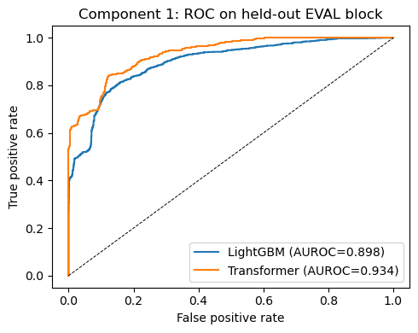
Figure 2. ROC curves for both predictors on the held-out EVAL block.

6.2 Component 2 -- Root-cause attribution
For every ground-truth segment, we take the LightGBM TreeExplainer attribution at the last window before onset, aggregate |SHAP| across each KPI dimension's mean/std/last features, and rank dimensions. Table 4 reports precision@k = recall@k (k set to the ground-truth set size) per segment; segments in the EVAL and CALIB blocks are genuinely out-of-sample for the model, while TRAIN-block segments are in-sample and shown only for contrast.
Table 4. Component 2 results: SHAP-ranked root-cause attribution vs. ground truth.
Segment | Block | k | Precision@k = Recall@k
15849-16368 | train (in-sample) | 7 | 0.571
16963-17517 | train (in-sample) | 31 | 0.968
18071-18528 | train (in-sample) | 8 | 0.500
19367-20088 | eval (out-of-sample) | 14 | 0.571
20786-21195 | eval (out-of-sample) | 7 | 0.571
24679-24682 | calib (out-of-sample) | 4 | 0.500
26114-26116 | calib (out-of-sample) | 4 | 0.250
27554-27556 | calib (out-of-sample) | 4 | 0.750

The out-of-sample (EVAL + CALIB) mean precision/recall@k is 0.529, against a mean chance level of approximately 0.174 for the corresponding k values -- well above chance, but far from perfect, which we report as the honest finding rather than only the best-case segment.

6.3 Component 3 -- Correlation vs. causal evidence
For the representative segment 20786-21195, Table 5 tests the top-5 SHAP-ranked KPI dimensions for Granger causality against a fixed target dimension (KPI 14, present in every ground-truth set) over a local pre/during-onset window.
Table 5. Component 3 results: Granger-causality filtering of SHAP-ranked candidates.
KPI dim. | In ground truth | Pearson r | Granger p (min) | Verdict
7 | No | -0.075 | 0.199 | Correlational only
9 | Yes | 0.951 | 0.000 | Causal evidence
13 | Yes | 0.586 | 0.025 | Causal evidence
30 | No | 0.046 | 0.450 | Correlational only
33 | No | 0.026 | 0.791 | Correlational only

The two dimensions that are both highly correlated and in the ground-truth root-cause set (9, 13) pass the Granger test; the three that are only SHAP-flagged noise (weak correlation, absent from ground truth) fail it -- the intended separation, though demonstrated here on one incident rather than across a statistically powered sample (Section 8).

6.4 Component 5 -- Uncertainty quantification
Split-conformal calibration on the CALIB block yields q_hat = 0.985 and achieves 0.955 empirical coverage on EVAL against the 90% target -- a valid, if conservative, guarantee. 20.0% of EVAL windows are routed to the ambiguous ({normal, degrading}) set, i.e. an explicit escalate-to-human signal, and 0.0% to the empty set. The raw probability's ECE on EVAL is 0.118: Figure 3 shows the model is overconfident in its top bin (mean predicted probability 0.986, empirical positive rate 0.752), exactly the failure mode conformal wrapping is designed to survive without requiring the underlying model to be well-calibrated.
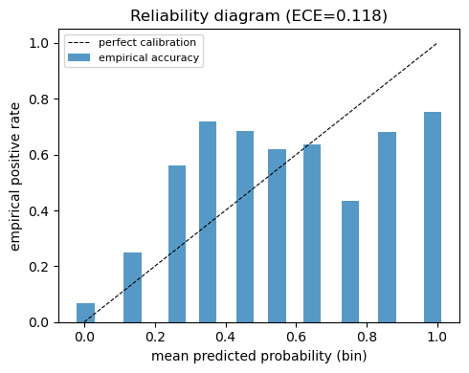
Figure 3. Reliability diagram of the raw Transformer probability on EVAL (ECE = 0.118).

6.5 Early-warning lead time
Table 6 reports, per ground-truth segment, the gap between the first sustained risk-score crossing of 0.5 and official onset. Out-of-sample (EVAL + CALIB), the mean lead time is 12.5 minutes, with 4 of 5 incidents caught and one missed entirely.
Table 6. Component 1 out-of-sample early-warning lead time.
Segment | Block | Lead time (min)
19367-20088 | eval | 44
20786-21195 | eval | missed
24679-24682 | calib | 2
26114-26116 | calib | 2
27554-27556 | calib | 2

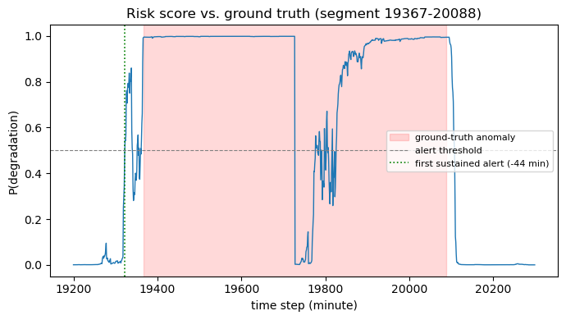
Figure 4. Risk score vs. ground truth for segment 19367-20088, the incident with the longest measured lead time.
Lead time is highly heterogeneous rather than uniform: one incident is flagged 44 minutes early with a clean ramp-up, three tiny CALIB-block incidents are caught only ~2 minutes early (essentially at onset), and one incident's risk score jumps from ~0.001 to ~0.98 in a single step with no gradual precursor within the model's 20-minute lookback and is missed by the lead-time rule entirely. We report this variance explicitly rather than only the mean, since averaging it away would misrepresent the system's actual, uneven early-warning capability -- itself a trustworthiness finding, not only a performance number.

6.6 Component 2, graph view -- illustrative topology-based ranking
SMD provides no network-element topology, so this experiment is explicitly illustrative: a synthetic Core -> Aggregation -> BaseStation -> Cell graph with an injected root cause at Aggregation and severity decaying (with noise) along descendants. Personalized PageRank on the reversed graph, seeded by observed node severity, ranks Aggregation first (score 0.319), correctly recovering the injected root cause and demonstrating the topology-propagation mechanism that a learned graph neural network (e.g. GDN [14], or [12] for telecom RAN specifically) would generalize with data-driven edge weights.

7. Discussion
Taken together, the results in Section 6 show that each layer of the proposed framework produces measurable, distinguishable evidence rather than a single opaque score: the predictor's discrimination (Section 6.1) is separable from the attribution stage's correctness against ground truth (6.2), which is separable again from the causal filter's ability to prune spurious candidates (6.3), from the calibration layer's coverage guarantee (6.4), and from the system's actual, uneven early-warning behavior (6.5). This separability is the practical value of decomposing trustworthiness into components: a 0.934 AUROC prediction score alone would not have revealed that root-cause precision plateaus at 0.529, that one incident type has no learnable precursor at all, or that 20% of predictions should be escalated rather than acted on automatically. We view the honest reporting of imperfect and heterogeneous results -- rather than only the best-case segment or a pooled average -- as itself part of the trustworthiness contribution, consistent with the framework's design goal of surfacing uncertainty rather than hiding it.
At the same time, these results are a single-dataset demonstration that a joint pipeline is measurable and instrumentable, not evidence that it outperforms simpler alternatives. Section 8 states this limitation directly, and Section 9 defines the multi-dataset, multi-baseline, statistically validated study required to make a generalizable claim.

8. Limitations and Threats to Validity
Single dataset, single machine. All results are for one machine (machine-1-1) of one public dataset. Generalization across machines, datasets, and fault types is untested here.
Domain proxy, not telecom data. SMD's 38 dimensions are generic server metrics (CPU, memory, network, load), not named telecom KPIs (latency, jitter, handover-failure rate). The methods transfer directly; the specific numerical results reported here do not.
No external baselines. We compare LightGBM against a Transformer internally, but do not compare the full pipeline against established RCA methods such as MicroRCA [13], CausalRCA, RCD, or epsilon-Diagnosis -- required before any comparative claim can be made.
No statistical validation. Results are reported from a single run/seed on a single chronological split; no significance testing, confidence intervals, or effect sizes are computed. With only eight ground-truth segments in this machine's timeline, statistical power for segment-level claims is inherently limited.
Granger causality is not proof of causation. The causal-filter verdicts in Section 6.3 reflect temporal-precedence evidence from an observational test, not a true intervention; SMD provides no configuration-change log to serve as a real quasi-experiment.
Illustrative, not fitted, topology experiment. The Section 6.6 graph-propagation result uses a hand-specified synthetic topology and injected severities; it demonstrates the mechanism, not a validated capability on real network topology.
No production or robustness evaluation. No deployed system exists to report latency/throughput SLAs against; no adversarial-input, alarm-storm, or missing-telemetry robustness tests were run.

9. Practical Implications and Future Work
For practitioners, three design choices in this framework are directly actionable regardless of the specific models used: (i) treat prediction, attribution, causal filtering, and calibration as separately monitored pipeline stages so a regression in one is not masked by another; (ii) report lead time and root-cause accuracy per incident rather than only pooled, since -- as Section 6.5 shows -- the pooled average can misrepresent genuinely bimodal behavior; and (iii) use a conformal (or similarly calibrated) abstention signal to route low-confidence cases to a human rather than resolving them silently.
The immediate next step for this research programme, detailed further in an accompanying feasibility analysis, is a multi-dataset ablation study: re-running this pipeline across SMD (all 28 machines), PSM, SWaT, RCAEval [5], and LEMMA-RCA [6]; comparing against MicroRCA, CausalRCA, RCD, and epsilon-Diagnosis as external baselines; and testing, with paired significance tests across multiple seeds, whether the causal-filtering and conformal-calibration layers measurably improve root-cause precision and selective-prediction risk over attribution alone -- the joint ablation this paper's related-work review found no prior study to have reported. A second line of future work is a controlled human-subjects study of whether exposing the causal-versus-correlational distinction and the abstention flag changes engineer diagnostic accuracy and calibrated trust, a gap independently identified by a systematic review of XAI human-evaluation methodology [21]. A third, higher-risk line, contingent on data access, is validation on real RAN-level KPI telemetry against the published GNN+Transformer RAN RCA system [12].

10. Conclusion
We proposed a five-component framework -- predict, attribute, causally filter, calibrate, explain -- for trustworthy root-cause analysis of telecom KPI degradation, and reported a reproducible proof-of-concept evaluation on the public SMD dataset, chosen specifically for its ground-truth root-cause labels. A Transformer predictor reached 0.934 AUROC against a 0.898 LightGBM baseline; out-of-sample root-cause attribution reached 0.529 mean precision/recall@k against a ~0.174 chance level; Granger-causality filtering correctly separated ground-truth-consistent from spurious SHAP candidates in the incident examined; split-conformal calibration achieved its 90% coverage target while flagging 20% of cases for human escalation; and early-warning lead time was shown to be highly heterogeneous, from 44 minutes to a complete miss, across incidents. These results establish that the proposed decomposition is measurable and instrumentable against ground truth on a public benchmark. They do not establish that it outperforms simpler alternatives, generalizes beyond one machine, or holds on real telecom KPI data -- claims that require the multi-dataset, multi-baseline, statistically validated study defined in Section 9 and that we intend as the next stage of this work.

References
[1] S. M. Lundberg and S.-I. Lee, "A unified approach to interpreting model predictions," in Proc. NeurIPS, 2017.
[2] C. W. J. Granger, "Investigating causal relations by econometric models and cross-spectral methods," Econometrica, vol. 37, no. 3, pp. 424-438, 1969.
[3] P. Spirtes, C. Glymour, and R. Scheines, Causation, Prediction, and Search, 2nd ed. Cambridge, MA, USA: MIT Press, 2000.
[4] A. N. Angelopoulos and S. Bates, "A gentle introduction to conformal prediction and distribution-free uncertainty quantification," arXiv:2107.07511, 2021.
[5] L. Pham, H. Zhang, H. Ha, F. Salim, and X. Zhang, "RCAEval: A benchmark for root cause analysis of microservice systems with telemetry data," arXiv:2412.17015, 2024.
[6] L. Zheng, Z. Chen, D. Wang, C. Deng, R. Matsuoka, and H. Chen, "LEMMA-RCA: A large multi-modal multi-domain dataset for root cause analysis," arXiv:2406.05375, 2024.
[7] Y. Su, Y. Zhao, C. Niu, R. Liu, W. Sun, and D. Pei, "Robust anomaly detection for multivariate time series via stochastic recurrent neural network," in Proc. ACM SIGKDD, 2019.
[8] P. Schummer, A. del Rio Ponce, J. Serrano Romero, D. Jimenez Bermejo, G. Sanchez, and A. Llorente, "Machine learning-based network anomaly detection: Design, implementation, and evaluation," AI (MDPI), vol. 5, no. 4, art. 143, 2024.
[9] K. Hundman, V. Constantinou, C. Laporte, I. Colwell, and T. Soderstrom, "Detecting spacecraft anomalies using LSTMs and nonparametric dynamic thresholding," in Proc. ACM SIGKDD, 2018.
[10] Q. Wen et al., "Transformers in time series: A survey," arXiv:2202.07125, 2022.
[11] S. Tuli, G. Casale, and N. R. Jennings, "TranAD: Deep transformer networks for anomaly detection in multivariate time series data," Proc. VLDB Endowment, vol. 15, no. 6, 2022.
[12] A. Hasan, C. Boeira, K. Papry, Y. Ju, Z. Zhu, and I. Haque, "Root cause analysis of anomalies in 5G RAN using graph neural network and transformer," arXiv:2406.15638, 2024.
[13] L. Wu, J. Tordsson, E. Elmroth, and O. Kao, "MicroRCA: Root cause localization of performance issues in microservices," in Proc. IEEE/IFIP NOMS, 2020.
[14] A. Deng and B. Hooi, "Graph neural network-based anomaly detection in multivariate time series," in Proc. AAAI, 2021.
[15] C.-M. Lin, C. Chang, W.-Y. Wang, K.-D. Wang, and W.-C. Peng, "Root cause analysis in microservice using neural Granger causal discovery," in Proc. AAAI, 2024. arXiv:2402.01140.
[16] L. Pham, H. Ha, and H. Zhang, "Root cause analysis for microservice system based on causal inference: How far are we?," arXiv:2408.13729, 2024.
[17] A. Shan, J. Kaur, R. Singh, T. Banka, R. Yavatkar, and T. Sridhar, "RCA Copilot: Transforming network data into actionable insights via large language models," arXiv:2507.03224, 2025.
[18] D. Roy et al., "Exploring LLM-based agents for root cause analysis," arXiv:2403.04123, 2024.
[19] A. Bellotti and X. Zhao, "Conformal prediction and trustworthy AI," arXiv:2508.06885, 2025.
[20] F. O. Catak, U. Cali, M. Kuzlu, and S. Sarp, "Uncertainty aware deep learning model for secure and trustworthy channel estimation in 5G networks," arXiv:2305.02741, 2023.
[21] J. Kim, H. Maathuis, and D. Sent, "Human-centered evaluation of explainable AI applications: A systematic review," Frontiers in Artificial Intelligence, 2024.

