TrustNet-RCA: Confidence-Aware Early-Warning and Root-Cause Localization for 5G RAN Management
Author Name(s) to be added
Affiliation to be added
Abstract—Telecom operators increasingly deploy machine learning to predict service degradation, but an accurate prediction is not the same as a trustworthy one: an engineer also needs to know which KPI is responsible, whether that KPI is merely correlated with the fault or plausibly causes it, why the system believes so, and how confident to be. Prior work on root-cause analysis (RCA) for multivariate telemetry typically evaluates a single mechanism — feature attribution, causal discovery, or uncertainty quantification — in isolation; no study we identified jointly integrates and evaluates all three against ground-truth root-cause labels. We present TrustNet-RCA, a five-component framework chaining (1) a probabilistic early-warning predictor, (2) exact feature attribution, (3) a causal-precedence filter, (4) an evidence-grounded explainer, and (5) distribution-free uncertainty calibration, and evaluate it under one identical method on three public datasets: TelecomTS (5G testbed telemetry, 18 named PHY/MAC/network KPIs) as the primary 5G RAN benchmark, RCAEval (annotated microservice failures) for service-management rigor, and the Server Machine Dataset (SMD) strictly as an out-of-domain generalization check. On TelecomTS, 5 s-ahead early warning reaches 0.920 AUROC / 0.794 AUPRC against a 0.167 base rate, with gradient-boosted trees beating an attention model by 0.092 AUPRC at 1/43 the training cost — a negative result for attention that holds on all three legs. Accuracy and calibration pull in opposite directions (tree ECE 0.120 vs. deep-ensemble 0.082), which is the empirical case for the conformal layer: on SMD it attains its 90% target coverage (0.955 empirical) while routing 20% of windows to explicit human escalation. Out-of-sample attribution reaches 0.529 mean precision/recall@k against a ~0.174 chance level, and a Granger filter separates causally-consistent candidates from correlation-only ones. Our central finding is negative and concerns trust itself: a deletion-and-perturbation audit of the explanation layer shows that none of four confidence signals — predicted probability, attribution entropy, rank stability, faithfulness margin — separates correctly-localized incidents from mis-localized ones. The system can be maximally confident, produce a stable and deletion-faithful explanation, and still name the wrong KPI. We report per-anomaly-type results (AUPRC 0.101-0.823) and pre-onset runway limits rather than aggregate scores, and define the multi-seed, multi-system programme required to generalize these findings.
Index Terms—trustworthy AI; root-cause analysis; AIOps; 5G RAN; conformal prediction; causal inference; explainable AI; explanation faithfulness; telecom network management; time-series anomaly prediction

I. Introduction
Modern telecom networks generate continuous telemetry — latency, packet loss, throughput, jitter, signal strength, handover-failure rate, CPU/memory utilization, alarms, and configuration-change events — and operators increasingly rely on machine learning to detect degradation before it escalates into a service disruption. The dominant research emphasis, however, has been point predictive accuracy: does the model flag the right minute? This framing is insufficient for an operational setting in which an automated flag triggers costly human or automated remediation. An engineer facing a flagged degradation needs four additional answers that accuracy alone does not provide: which KPI is implicated, whether that KPI's relationship to the fault is causal or merely coincidental, why the system believes so in terms the engineer can audit, and how much to trust the flag at all.
Feature-attribution methods such as SHAP [1] answer the first of these questions but are, by construction, correlational — a KPI can score highly because it moves together with the fault without driving it. Causal-discovery methods such as Granger causality [2] and constraint-based causal graphs [3] address this but are rarely paired with a calibrated confidence signal, so a causal claim is reported with the same false certainty as a correlational one. Conformal prediction [4] supplies exactly that calibrated confidence but is, to our knowledge, not evaluated jointly with attribution and causal filtering. Existing RCA benchmarks [5], [6] score attribution methods against each other but do not ablate the value that a causal filter or a calibration layer adds on top.
This paper makes three contributions. First, we propose TrustNet-RCA, a five-component framework — predict, attribute, causally filter, calibrate, explain — that makes each of these questions an explicit, separately-evaluable pipeline stage rather than an implicit property of one end-to-end model. Second, we implement it with standard, off-the-shelf methods at each stage and evaluate it under one identical method on three public datasets with complementary jobs: TelecomTS [22], a 5G testbed dataset with 18 named PHY/MAC/network-layer KPIs, as the primary 5G RAN benchmark; RCAEval [5], with annotated microservice failures, for service-management and RCA rigor; and the Server Machine Dataset (SMD) [7] strictly as an out-of-domain generalization check. Running one method across three domains is what allows the paper to separate what is a property of the framework from what is a property of a dataset. Third, we report what we found rather than what we hoped, and two of the most useful results are negative: attention models lose to gradient-boosted trees on every leg at 4-82x the training cost, and none of the confidence or explanation-quality signals the framework produces distinguishes a correct root-cause localization from an incorrect one. We define the concrete experimental programme (Section IX) required to elevate these findings to generalizable evidence.
The remainder of this paper is organized as follows. Section II reviews related work across classical ML, deep learning, transformer, graph-neural-network, causal, and LLM-based approaches to RCA, and situates the identified gap. Section III formalizes the prediction, attribution, causal-filtering, and calibration problems. Section IV describes the proposed framework and its five components. Section V details the three-dataset experimental setup. Section VI reports results for each component across all three legs. Section VII discusses the findings, Section VIII states limitations and threats to validity, Section IX outlines practical implications and future work, and Section X concludes.

II. Related Work
Classical machine learning. Tree ensembles (isolation forests, random forests, gradient-boosted trees) remain a strong, auditable baseline for KPI anomaly detection; a 2024 benchmark of ML methods on network anomaly detection confirms they remain competitive with deep alternatives on tabular telemetry [8].
Deep learning and Transformers. Recurrent and variational architectures dominate multivariate KPI anomaly detection: OmniAnomaly [7] models KPI vectors with a stochastic RNN and is also the source of the SMD dataset used in this study; LSTM-NDT [9] forecasts KPI values and flags deviation with a non-parametric dynamic threshold. Self-attention architectures improve on recurrence for long-range temporal dependence [10]; TranAD [11] uses an adversarially trained transformer encoder for multivariate anomaly detection. Closest to our domain, [12] fuses a transformer temporal encoder with a graph neural network over 5G RAN topology for anomaly root-causing — effectively Components 1 and 2 of our framework, evaluated on real (non-public) RAN data but without a causal-versus-correlational distinction or calibrated uncertainty.
Graph neural networks. Once more than one KPI stream and a known topology are available, root-cause evidence can propagate along dependency edges instead of being scored per KPI in isolation. MicroRCA [13] builds an attributed service graph and ranks root causes with personalized PageRank; GDN [14] learns the dependency graph itself and scores per-sensor deviation with attention.
Causal reasoning. GNN and attribution scores remain correlational: they indicate that a KPI co-moved with the outcome, not that changing it would change the outcome. Constraint-based causal discovery (the PC/FCI family [3]) and neural Granger causal discovery [15] provide tools to test temporal precedence and conditional independence; a recent comparative study [16] benchmarks PC, FCI, Granger, fGES, and LiNGAM as causal-graph builders for RCA.
RCA benchmarking. RCAEval [5] standardizes precision@k, MRR, and MAP@k evaluation across 735 failure cases spanning eleven fault types in three microservice systems; LEMMA-RCA [6] extends multi-domain, multi-modal RCA evaluation to IT and operational-technology systems. Neither benchmark ablates the joint contribution of causal filtering and calibrated uncertainty on top of attribution — the gap this paper targets.
LLM-based approaches. Recent AIOps systems use large language models strictly as narrators over verified, tool-collected evidence rather than as free-form diagnosers: RCACopilot-style systems [17] aggregate multi-modal diagnostic evidence into incident narratives, and LLM-agent RCA work [18] shows that grounding the LLM in retrieved telemetry is what prevents hallucinated causes. We reuse this narrate-don't-diagnose pattern for Component 4.
Uncertainty quantification. Conformal prediction [4] gives distribution-free, finite-sample coverage guarantees without assuming a noise model for KPI residuals, and is increasingly positioned as a prerequisite for trustworthy AI deployment [19], including in 5G-specific deep models [20]. It is used here as the calibration layer for Component 5.

Table 1. Related-work comparison matrix.
Ref. | Problem | Method | Dataset | Metrics | Gap relevant to this work
[7] | MTS anomaly detection | Stochastic RNN+VAE | SMD (introduced) | F1 | No RCA, no causal filter, no calibration
[5] | RCA benchmarking | Multi-method eval harness | 3 microservice systems | PR@K, MRR, MAP@K | No causal/conformal ablation; no telecom domain
[6] | Multi-domain RCA dataset | Multi-modal | IT + OT systems | - | No telecom RAN; no causal+calibration study
[15] | Causal-graph RCA | Neural Granger discovery | Microservices | PR@K | No calibrated confidence layer
[12] | RAN anomaly RCA | GNN + Transformer | Real 5G RAN (private) | - | No causal/correlation split; no calibration
[4] | Distribution-free UQ | Split-conformal | General ML | Coverage | Not applied to RCA specifically

III. Problem Formulation
Let $x_{t}∈R^{d}$ denote the KPI vector observed at time step $t$, with $d=18$ for TelecomTS, $d=24$ for RCAEval, and $d=38$ for SMD. In deployment, $d$ indexes named telecom KPIs such as latency, packet loss, jitter, or handover-failure rate. Write the window of the $W$ most recent observations as $X_{t−W+1:t}∈R^{W×d}$. Throughout, $\hat{⋅}$ denotes an estimated quantity and $H$ the prediction horizon.

A. Early-warning prediction
Component 1 learns a predictor $f_{θ}$ mapping a window to a degradation probability,
${\hat{y}}_{t}=f_{θ}​\left(X_{t−W+1:t}\right)∈\left[0,1\right],$ (1)
against the forward-looking label
$y_{t}=1​\left[ ∃ τ∈(t, t+H] \text{anomalous} \right],$ (2)
so that a positive label at $t$ asserts a future event and the predictor observes nothing after $t$. Parameters are fitted by minimizing the class-weighted cross-entropy
Lθ=−t​wyt​ ytlogyt+1−ytlog​1−yt, (3)
where $w_{y_{t}}$ compensates for class imbalance. In this study $f_{θ}$ ranges over the model hierarchy of Section V.5.

B. Attribution
Component 2 assigns each feature $i$ its Shapley value with respect to the fitted predictor $f$,
ϕix=S⊆N\{i}​wSfS∪{i}−fS, (4)
$w_{S}=\frac{\left|S\right|! \left(\left|N\right|−\left|S\right|−1\right)!}{\left|N\right|!},$ (5)
where $N$ is the feature set and $w_{S}$ is the Shapley weight. Per-KPI importance aggregates $\left|ϕ_{i}\right|$ over the derived features of that KPI (Section V.3). For tree ensembles this is computed exactly rather than approximated, which Section VI.1 shows is available on every leg because the strongest predictor is a tree model.

C. Causal filtering
Component 3 retains a candidate KPI $i$ as causal evidence for target KPI $j$ only if $i$’s past improves the prediction of $j$’s future beyond $j$’s own past. For lag $ℓ∈\{1,…,L\}$ the test contrasts the null and alternative
$H_{0}: Y_{j,t}∼Y_{j, t−1:t−ℓ},$ (6)
$H_{1}: Y_{j,t}∼Y_{j, t−1:t−ℓ}+X_{i, t−1:t−ℓ},$ (7)
rejecting $H_{0}$ by an SSR $F$-test at $p<0.05$ under Benjamini-Hochberg control across the tested dimensions. This is temporal-precedence evidence, not intervention; Section VIII states the consequence.

D. Calibration
Component 5 wraps the predictor in a distribution-free coverage guarantee. Given a calibration set with known labels, the nonconformity score of point $i$ is
$s_{i}=1−\hat{P}​\left(y_{i}∣x_{i}\right),$ (8)
and the $\left(1−α\right)$-quantile of $\{s_{i}\}$, written $\hat{q}$, defines the prediction set for a new point $x$,
$C\left(x\right)=\left\{ c:1−\hat{P}\left(c∣x\right)≤\hat{q} \right\},$ (9)
which satisfies the marginal coverage guarantee
$P\left(y∈C\left(x\right)\right)≥1−α.$ (10)
A set of size two, $\{\text{normal},\text{degrading}\}$, is the system’s explicit abstention: it signals that the evidence does not separate the classes at the requested confidence and the case should be escalated rather than resolved automatically.

IV. Proposed Framework
TrustNet-RCA decomposes the problem in Section I into five components, each with its own input, output, and validation criterion, chained as shown in Figure 1. This decomposition is deliberate: it lets each stage be evaluated — and, in Section VI, scored against ground truth — independently, rather than treating trustworthiness as an emergent, unmeasured property of one opaque end-to-end model.

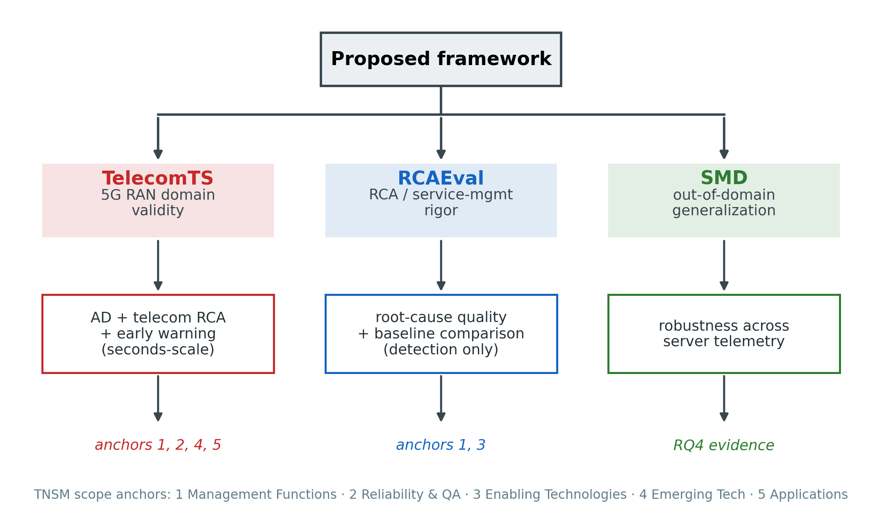
Figure 1. The TrustNet-RCA five-component framework and its three-leg evaluation architecture. Solid arrows show data flow; Components 2 (graph view) and 5 are illustrative/parallel branches feeding the final explanation stage.

A. Component 1 — Predict degradation before disruption
Input: a W-minute KPI window per network element. Method: a Transformer encoder (self-attention over the window) as the primary model, benchmarked against a gradient-boosted tree baseline (LightGBM) on rolling statistical features — retained as a cheap, auditable fallback and as the model exactly explained in Component 2. Output: P(degradation in the next H minutes), a continuously updated early-warning score rather than a post-hoc flag.

B. Component 2 — Identify probable root causes
Input: the flagged window, the full KPI vector, and (where available) the NE/site topology graph. Method: exact SHAP attribution on the tree-ensemble predictor ranks which KPI dimensions drove the flagged prediction; a graph view — personalized PageRank over the topology, seeded at high-deviation nodes — ranks which network element is the propagation source rather than merely a symptom, in the spirit of MicroRCA [13]. Output: a ranked (KPI or NE, contribution score) list, explicitly still correlational at this stage.

C. Component 3 — Distinguish correlation from causal evidence
Input: Component 2's ranked candidates and their raw time series. Method: a Granger-causality test per candidate (Section III), plus, where a configuration-change timestamp coincides with a candidate's onset, a before/after comparison treated as a quasi-experiment. Output: each candidate labeled correlational only or causal evidence, with its test statistic attached; Granger causality is necessary-but-not-sufficient evidence for true causality, and this label is reported as a confidence tier, not a proof.

D. Component 4 — Explain in engineer-understandable terms
Input: the outputs of Components 1, 2, 3, and 5. Method: a template grounded strictly in the evidence already computed — not a free-generation LLM call — following the narrate-don't-diagnose pattern from RCACopilot- and RCAgent-style systems [17], [18]; an LLM may phrase the narrative fluently but may not assert any fact absent from the evidence. Output: a short report stating what is predicted, how confident, which KPI/NE is implicated, whether that evidence is causal or correlational, and what changed immediately before onset.

E. Component 5 — Quantify uncertainty and confidence
Input: Component 1's raw probability and a held-out calibration set. Method: split-conformal prediction (Section III) wraps the probability into a set with a distribution-free, finite-sample coverage guarantee, independent of whether the underlying model is well-calibrated on its own; reliability diagrams / Expected Calibration Error (ECE) are reported as a diagnostic. Output: a calibrated confidence level plus an explicit abstain-and-escalate flag for low-confidence (ambiguous) predictions.

V. Experimental Setup

A. Three-dataset evaluation architecture
A framework that claims 5G RAN relevance cannot be validated on server telemetry alone. TrustNet-RCA is therefore evaluated on three public datasets, each assigned a distinct and explicitly bounded job, with the identical method run on all three so that the legs are comparable rather than merely adjacent:
- TelecomTS [22] is the primary 5G-domain benchmark. It is derived from a 5G testbed and exposes named PHY/MAC/network-layer KPIs, which is what makes a radio-domain claim possible at all.
- RCAEval [5] (RE1 / Online Boutique) carries service-management and RCA rigor: annotated microservice failures with reproducible baselines.
- SMD [7] (machine-1-1) is retained strictly as an out-of-domain generalization check. Its 38 dimensions are generic server metrics, not radio KPIs, and no result on SMD is offered here as evidence about RAN behavior.
Table 2. Per-leg data preparation.
 | TelecomTS | RCAEval | SMD
Role | 5G RAN domain validity | RCA / service-mgmt rigor | out-of-domain generalization
Unit | 168 reconstructed sessions | 123 injected-failure cases | 1 machine (machine-1-1)
Sampling | 10 Hz | 1 Hz | 1 / minute
Channels | 18 named PHY/MAC/network KPIs | 24 common metric columns | 38 anonymized dims
Volume | 643,284 samples (~1,072 min) | 123 cases, 6-35 min pre-injection | 28,479 samples
Events | 109 anomaly segments, 11 types | 123 injections, 5 fault types | 8 segments
Localization ground truth | affected_kpis (named) | root-cause service + indicator | interpretation_label (dim indices)
Split | session-level chronological 60/20/20 | fault-stratified case split 60/20/20 | chronological TRAIN/EVAL/CALIB
Window / target | 3 s window, 5 s horizon | 60 s window, detection | 20 min window, 30 min horizon

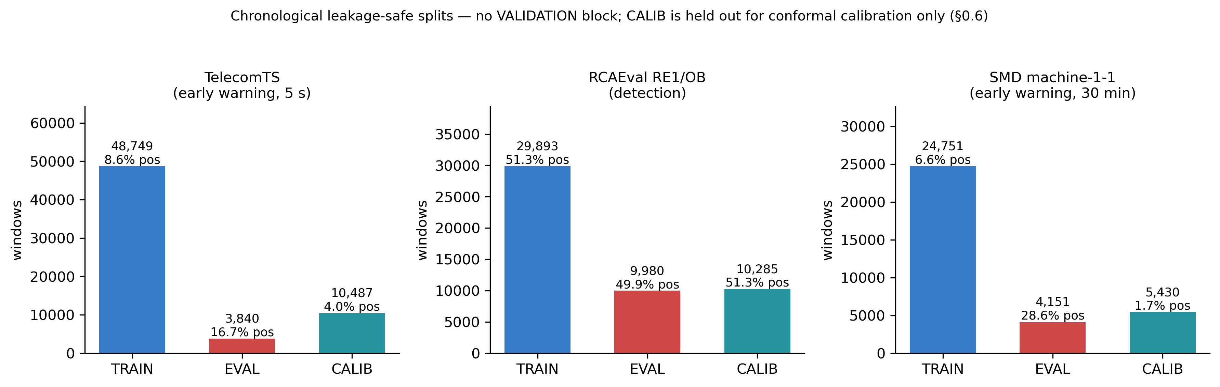
Figure 2. TRAIN / EVAL / CALIB window counts and positive rates across all three datasets. This is not a conventional train/validation/test split: there is no separate validation block because hyperparameters were fixed by hand rather than tuned, EVAL plays the role of the final test set, and CALIB is reserved exclusively for the conformal quantile and the reliability diagram.

B. TelecomTS session reconstruction
TelecomTS ships as 128-sample windows at 10 Hz, but those windows are sliding rather than independent: consecutive windows advance by a 32-sample (3.2 s) stride, so their overlapping regions are identical across all 18 channels. Treating them as independent samples would leak the evaluation block into the training block through the overlap. We therefore reconstruct the continuous underlying series before splitting, which is also what makes an early-warning target definable at all. The overlap identity was verified rather than assumed: 285 window pairs were checked on the anomaly shard with zero mismatches, and one shard rebuilds to 99,680 timestamps (166.6 continuous minutes) with 7 holes totalling 28.8 s (0.288% of the timeline).
Two of the 18 channels (UL_Protocol, DL_Protocol) are categorical strings and are label-encoded; the remaining 16 are numeric.

C. Target construction and features
We construct an early-warning target rather than a post-hoc detection target, (2): $y_{t}=1$ if a labeled anomaly occurs anywhere in $(t, t+H]$, using only data up to and including $t$. Tabular features are the rolling mean, standard deviation, and last value per KPI dimension over the window; the sequence models additionally consume the raw window.
The horizon is re-parameterized per domain rather than copied across domains. SMD’s W = 20 min / H = 30 min are minutes on one-sample-per-minute server telemetry; 5G radio degradation evolves on a seconds scale, so TelecomTS uses W = 3 s / H = 5 s. Section VI.1 reports the horizon sweep that justifies this choice empirically rather than by assertion.

D. Data splits
Each leg is split so that no window in the evaluation block shares source samples with the fitting block.
TelecomTS is split at session level, chronologically, 60/20/20; the held-out EVAL block contains 33 sessions and 26 anomaly segments at a 0.167 positive base rate.
RCAEval is split by case, stratified by fault type. An initial chronological split by injection time was found to segregate fault types perfectly — TRAIN received all CPU and memory cases, EVAL all packet-loss, CALIB all disk — which is a confounded split rather than a hard one. Section VI.1 reports what that error produced and why the corrected split still does not rescue early warning on this leg. After stratification the per-block positive rates are 0.513 / 0.499 / 0.513, and EVAL holds 25 cases spanning all five fault types at a 0.498 base rate.
SMD’s eight ground-truth segments are not spread evenly across the 28,479-step timeline: segments 1-5 fall in [15849, 21195], segments 6-8 in [24679, 27556], and [0, 15849) is anomaly-free. A naive 50/20/30 chronological split would leave the earliest block with zero positive examples. We instead cut at two points inside anomaly-free gaps so that each of three disjoint chronological blocks contains at least one full ground-truth segment: TRAIN (segments 1-3), EVAL (segments 4-5; held out for every reported detection metric), and CALIB (segments 6-8; used only to fit the conformal threshold and reliability diagram). The original anomaly-free train file is added as extra normal background for model fitting only.
Table 3. SMD split summary.
Block | Role | Windows | Positive rate
TRAIN (+ background) | Model fitting | 24,751 | 6.6%
EVAL | All reported detection metrics | 4,151 | 28.6%
CALIB | Conformal threshold + ECE only | 5,430 | 1.7%

E. Models and hyperparameters
The model hierarchy is identical across legs: 11 base models spanning 8 families, plus 6 ensembles (5 deep ensembles at M = 5 members and one cross-family soft vote). Base models are a dummy prior, Logistic Regression, Random Forest, Extra Trees, XGBoost, LightGBM, an MLP, a 1D ResNet, LSTM, GRU, and a Transformer encoder.
LightGBM: 300 trees, max depth 5, learning rate 0.05, and scale_pos_weight set to the train-set negative/positive ratio. Transformer: input projection to $d_{\text{model}}=32$, learned positional embedding, 2 encoder layers (4 attention heads, feed-forward dimension 64, dropout 0.1), mean-pooling over time, a 2-layer classification head; trained with Adam (lr = 1e-3), weighted binary cross-entropy, batch size 256, 6 epochs. Granger causality: SSR F-test, lags 1-5, statsmodels implementation, with Benjamini-Hochberg FDR control across the tested dimensions. Split-conformal: least-ambiguous-set classifier (LAC) [4], target coverage 90% ($α=0.10$), calibrated on the CALIB block. Personalized PageRank: networkx implementation on a reversed, hand-specified illustrative topology graph (Section VI.8), not fit to SMD, which has no topology.
Hyperparameters were fixed by hand from the SMD leg and reused verbatim on TelecomTS and RCAEval. This is deliberate — it keeps the three legs comparable — but it means no leg is tuned, and the reported numbers are therefore untuned-baseline numbers rather than best-achievable ones.

F. Metrics
Prediction: AUROC, AUPRC, and Expected Calibration Error (ECE, 10 equal-width bins) on the held-out EVAL block, with AUPRC read against each leg’s base rate since the base rates differ by a factor of three across legs. Attribution: precision@k and recall@k of the top-k SHAP-ranked KPI dimensions against the ground-truth label set, compared to the chance level $k/d$. Causal filtering: Granger SSR F-test p-value (minimum across lags $1$ to $5$, BH-FDR corrected) and Pearson correlation, reported side by side. Calibration: empirical coverage of the conformal prediction set against the 90% target. Explanation quality: deletion-test faithfulness margin and Spearman rank stability under input perturbation, both defined in Section 6.5. Early-warning usefulness: lead time, the gap between the first sustained (>= 2 consecutive steps) crossing of a 0.5 risk threshold and the official onset of each ground-truth segment.

VI. Results

A. Component 1 — Early warning across three domains
Table 4 reports the full model hierarchy on the TelecomTS EVAL block at a 5 s horizon. This is the discriminative leg: a 0.160 AUPRC spread separates the best model from the worst non-trivial one.

Table 4. TelecomTS early warning, 5 s ahead (33 EVAL sessions, 26 segments, base rate 0.167).
Model | Family | AUROC | AUPRC | ECE | F1 | Fit (s)
XGBoost | Boosted tree | 0.920 | 0.794 | 0.120 | 0.750 | 1.4
Random Forest | Bagged tree | 0.885 | 0.762 | 0.120 | 0.801 | 4.4
Extra Trees | Bagged tree | 0.880 | 0.759 | 0.119 | 0.757 | 1.1
1D ResNet (M=5) | Deep ensemble | 0.900 | 0.743 | 0.079 | 0.746 | 102.1
Soft vote | Ensemble | 0.872 | 0.741 | 0.333 | 0.758 | 1227.7
Heterogeneous (M=5) | Deep ensemble | 0.887 | 0.735 | 0.080 | 0.724 | 554.5
MLP (M=5) | Deep ensemble | 0.846 | 0.706 | 0.090 | 0.730 | 8.8
Transformer (M=5) | Deep ensemble | 0.836 | 0.704 | 0.063 | 0.741 | 301.5
Transformer | Attention | 0.845 | 0.702 | 0.063 | 0.751 | 60.1
LightGBM | Boosted tree | 0.859 | 0.698 | 0.121 | 0.678 | 2.3
MLP | Feedforward | 0.848 | 0.680 | 0.102 | 0.714 | 1.5
GRU (M=5) | Deep ensemble | 0.853 | 0.678 | 0.080 | 0.673 | 76.4
LSTM | Recurrent | 0.822 | 0.667 | 0.103 | 0.664 | 12.6
Logistic Reg. | Linear | 0.826 | 0.663 | 0.054 | 0.672 | 0.6
GRU | Recurrent | 0.856 | 0.651 | 0.087 | 0.645 | 13.7
LSTM (M=5) | Deep ensemble | 0.821 | 0.646 | 0.101 | 0.660 | 65.8
1D ResNet | Convolutional | 0.813 | 0.634 | 0.080 | 0.637 | 21.1
Dummy prior | Naive | 0.500 | 0.167 | 0.082 | 0.287 | —

On RCAEval the same hierarchy is applied to a detection target. The leg is saturated: every non-naive model reaches at least 0.990 AUROC, with XGBoost at 0.996 AUROC / 0.997 AUPRC / 0.012 ECE and even Logistic Regression at 0.993 / 0.994. Post-injection CPU, memory, and latency shifts in a microservice mesh are large and immediate, so this leg discriminates poorly between methods. We therefore use RCAEval for its assigned job — RCA quality and baseline comparison — rather than as a detection benchmark, and do not report its full table here.
On SMD, the out-of-domain leg at a 30-minute horizon, Extra Trees reaches 0.953 AUROC / 0.905 AUPRC and the Transformer 0.924 / 0.886 against a 0.286 base rate.

Table 5. Cross-dataset synthesis, held-out EVAL block per leg.
Leg | Task | Best model | AUROC | AUPRC | Base rate | AUPRC lift
TelecomTS | early warning, 5 s | XGBoost | 0.920 | 0.794 | 0.167 | 4.7x
RCAEval | detection | XGBoost | 0.996 | 0.997 | 0.498 | 2.0x
SMD | early warning, 30 min | Extra Trees | 0.953 | 0.905 | 0.286 | 3.2x

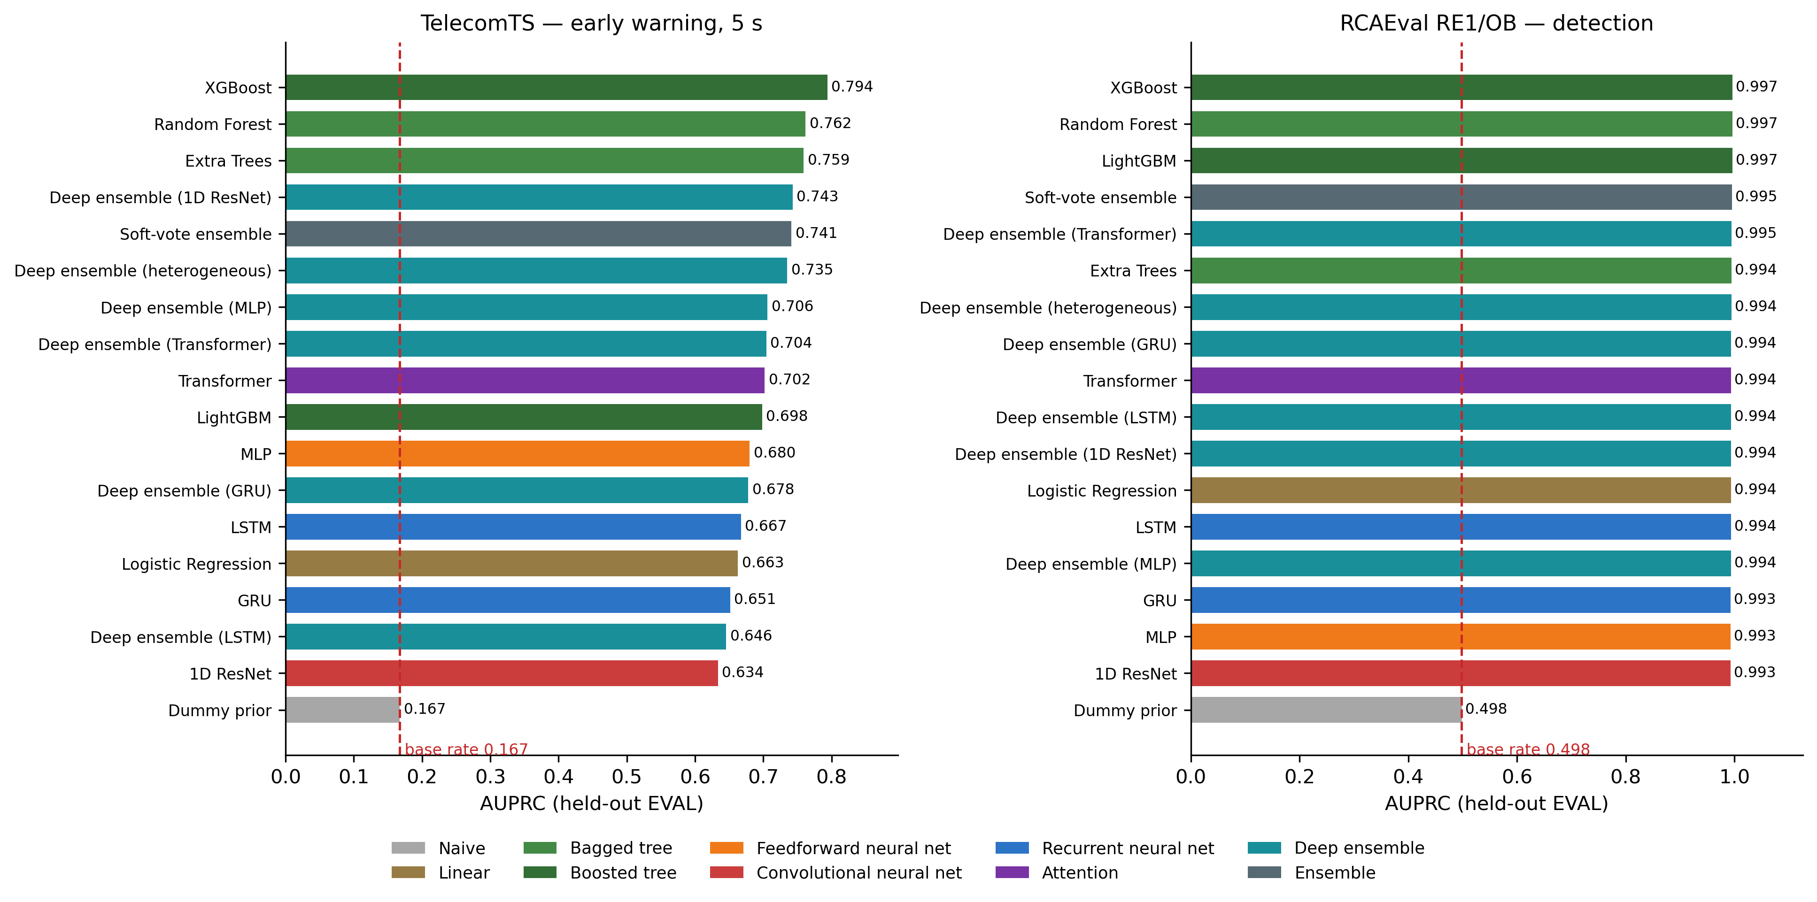
Figure 3. AUPRC across the full model hierarchy on both primary legs, colored by model family.

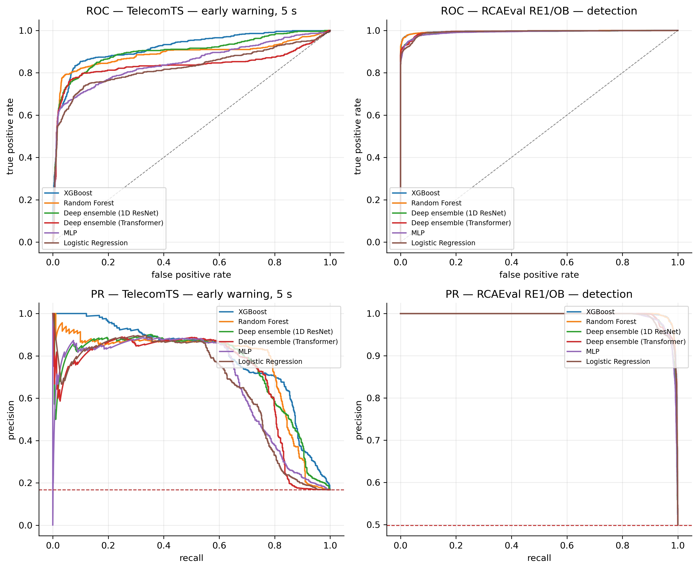
Figure 6. ROC and precision-recall curves for the leading models.
Finding 1 — tree ensembles win accuracy on every leg, and attention does not pay for itself. The ordering is stable across three sampling rates (10 Hz / 1 Hz / one per minute), three channel counts (18 / 24 / 38), and three domains.

Table 6. Best tree model vs. Transformer, per leg.
Leg | Best tree AUPRC | Transformer AUPRC | Delta | Fit-time ratio
TelecomTS | 0.794 | 0.702 | +0.092 | 43x
RCAEval | 0.997 | 0.994 | +0.003 | 82x
SMD | 0.905 | 0.886 | +0.019 | ~4x

This is a negative result for the attention mechanism and we report it as one. Attention costs 4-82x the training time for no accuracy gain on any leg. It also removes a risk flagged when the comparison was designed: because the best detector is a tree model on every leg, the SHAP TreeExplainer path of Component 2 stays exact throughout, and attribution numbers remain comparable across datasets instead of switching explainer family mid-study.
Horizon feasibility is bounded by the data, not the model. Table 7 sweeps the TelecomTS horizon. The headline column (AUPRC over all EVAL windows) is optimistic, because windows already inside an anomaly are trivially separable; the clean column restricts scoring to genuine pre-onset windows and is the honest measure of anticipation.

Table 7. TelecomTS horizon sweep. “Clean” excludes windows already inside an anomaly segment.
Horizon (s) | AUPRC (all) | Lift (all) | AUPRC (clean) | AUROC (clean) | Clean positives
1 | 0.823 | 6.0x | 0.047 | 0.605 | 26
2 | 0.802 | 5.6x | 0.079 | 0.568 | 52
5 | 0.794 | 4.7x | 0.162 | 0.696 | 127
10 | 0.760 | 3.8x | 0.271 | 0.742 | 228
20 | 0.766 | 4.0x | 0.335 | 0.753 | 245
30 | 0.730 | 4.3x | 0.316 | 0.768 | 225

The two columns tell opposite stories, and the disagreement is the finding. Measured over all windows, shorter horizons look better; measured over genuine pre-onset windows only, they look far worse (AUPRC 0.047 at 1 s against a 0.008 base rate, AUROC 0.605 — barely above chance). Anticipation improves monotonically with horizon up to 20 s because longer horizons admit more pre-onset positives to learn from. We report the clean column as the operative one and treat the 5 s headline of Table 4 as an upper bound rather than a capability claim.

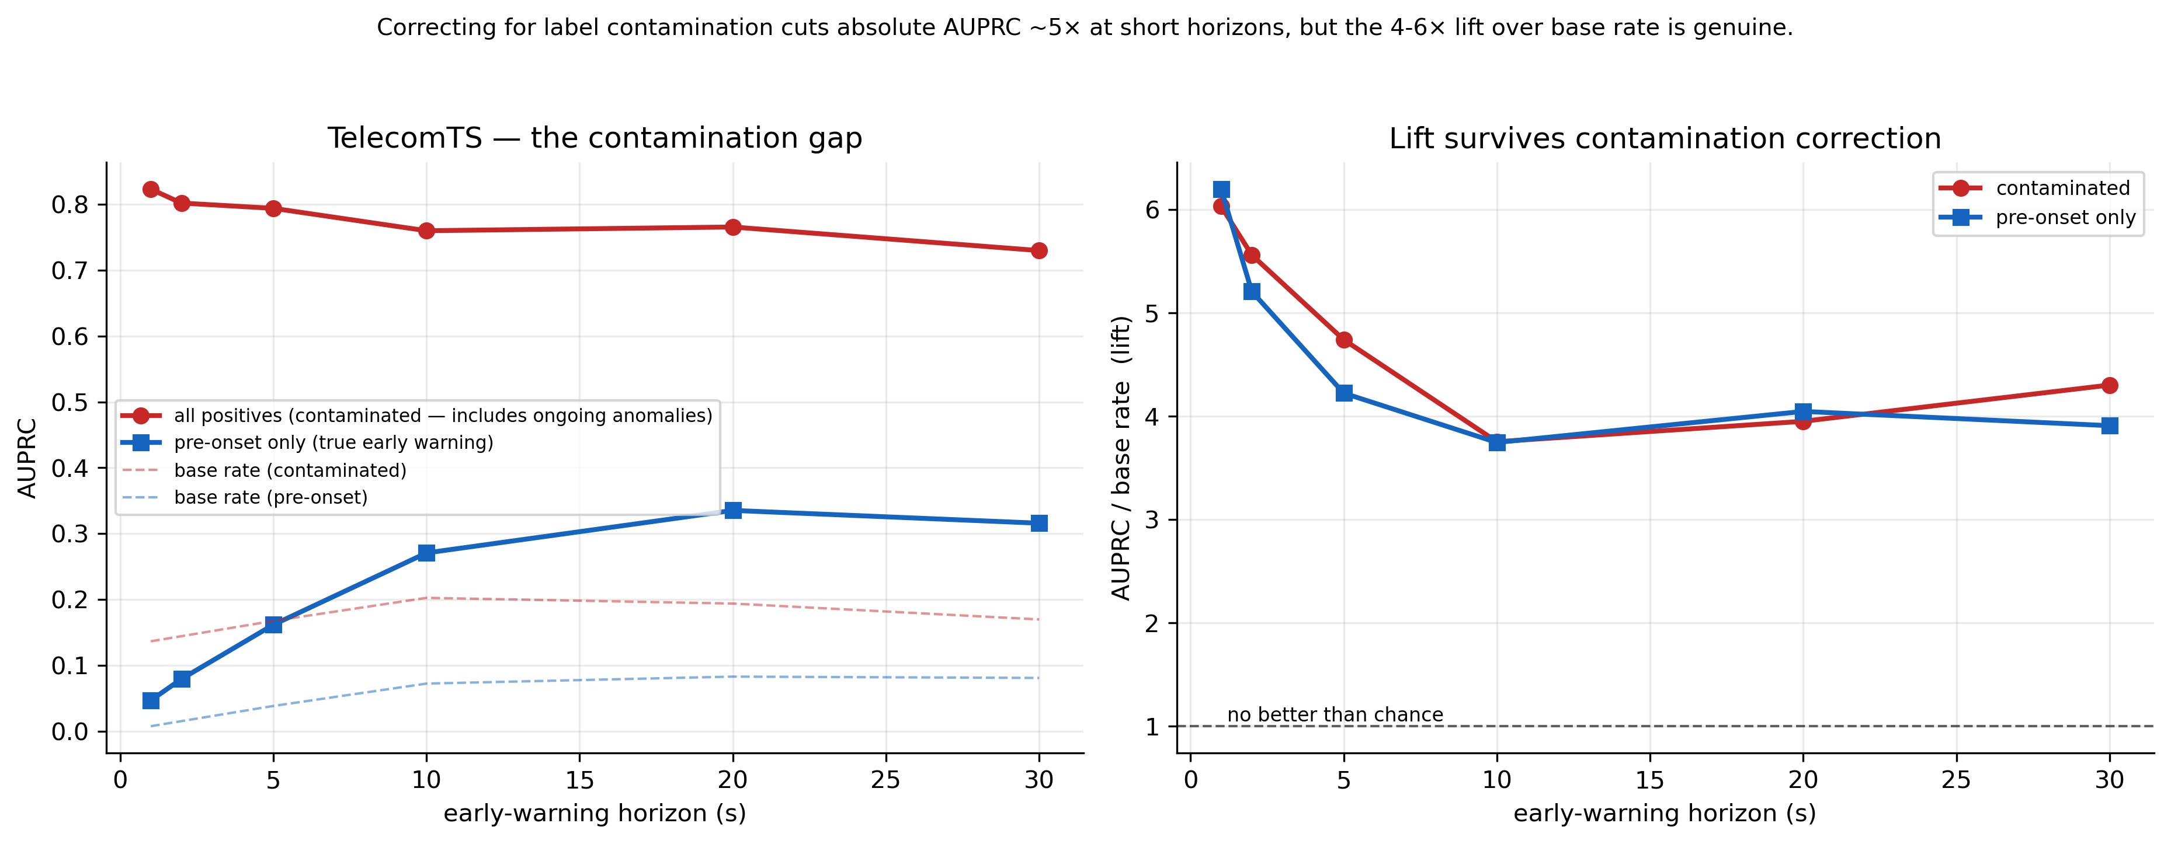
Figure 9. Horizon sweep on TelecomTS, all-window and clean pre-onset scoring shown together.

The ceiling is set by how much pre-onset telemetry each incident actually provides. Across the 109 TelecomTS anomaly segments the median pre-onset runway is 11.1 s and the maximum is 21.3 s: 94% of events afford at least 1 s of warning, 84% at least 5 s, 71% at least 10 s, and none affords 30 s. A 30 s horizon is therefore not a modelling failure but an ill-posed request on this data. The seven Jamming events — the one anomaly type in TelecomTS that is a real over-the-air phenomenon rather than an injected one — have exactly zero runway: their onset coincides with the start of the session, so no precursor exists to detect.

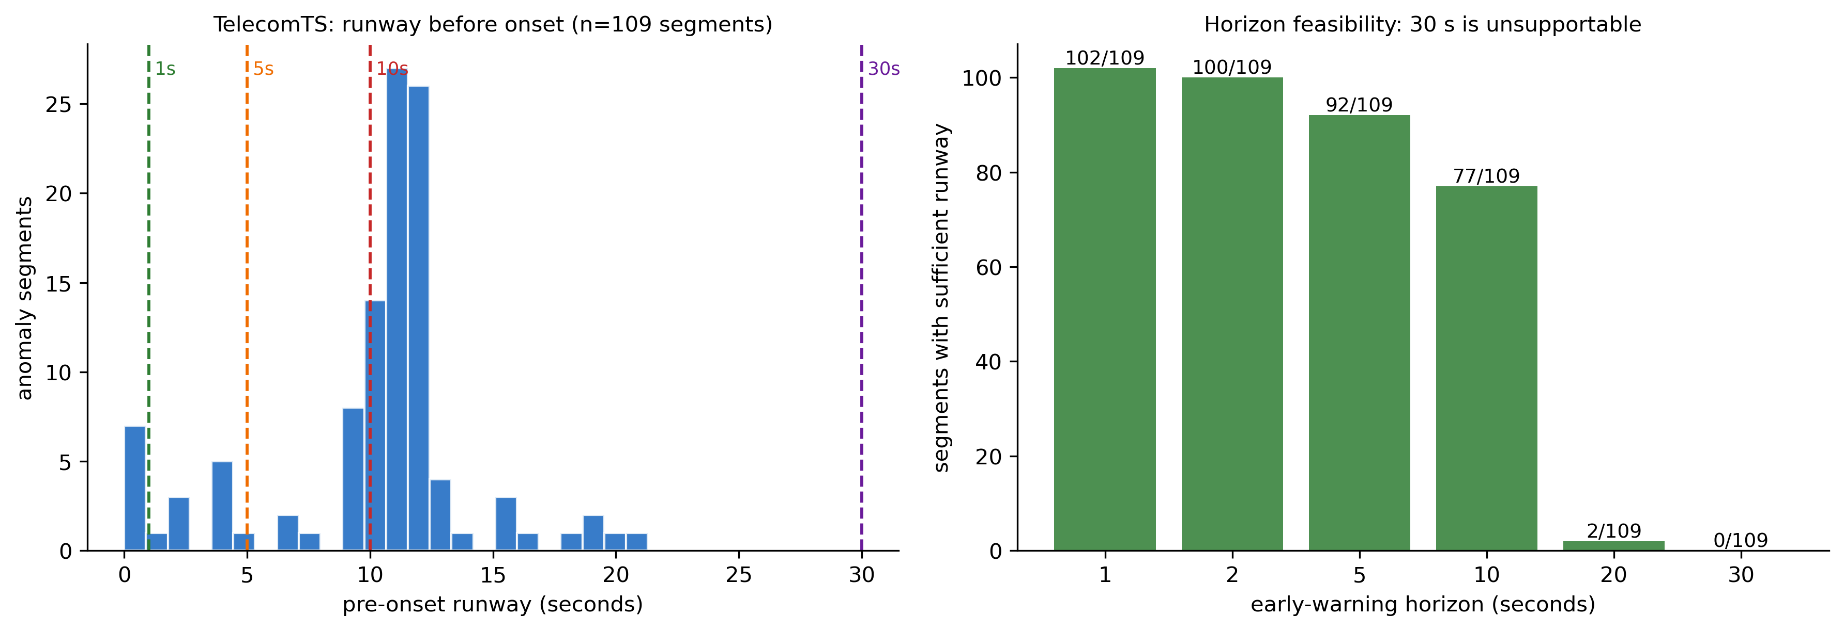
Figure 5. Pre-onset runway per anomaly type and the resulting horizon feasibility.

Difficulty varies sharply by anomaly type, which a single aggregate number conceals. Table 8 breaks the TelecomTS result down by type.
Table 8. TelecomTS early warning by anomaly type (5 s horizon).
Anomaly type | Windows | AUROC | AUPRC
Antenna Failure | 102 | 0.935 | 0.823
Resource Allocation Bugs | 53 | 0.906 | 0.663
Faulty RF Filters (Temporal) | 141 | 0.933 | 0.575
Co-Channel Interference (Severe) | 91 | 0.957 | 0.514
Doppler Shift (Severe) | 62 | 0.923 | 0.304
Faulty Handover Algorithm (Too Frequent) | 74 | 0.882 | 0.231
High Network Congestion (Sudden Spike) | 16 | 0.971 | 0.125
Buffer Overflow (Gradual Buildup) | 48 | 0.877 | 0.116
Co-Channel Interference (Mild) | 56 | 0.878 | 0.101
AUPRC spans 0.101 to 0.823 — an eightfold range — while AUROC stays in a narrow 0.877-0.971 band. An operator reading only AUROC would conclude the system performs uniformly well across fault types; the precision-recall view shows it does not. Severe, physically abrupt faults (antenna failure) are caught reliably; mild interference and gradual buffer buildup are close to unusable at this horizon.

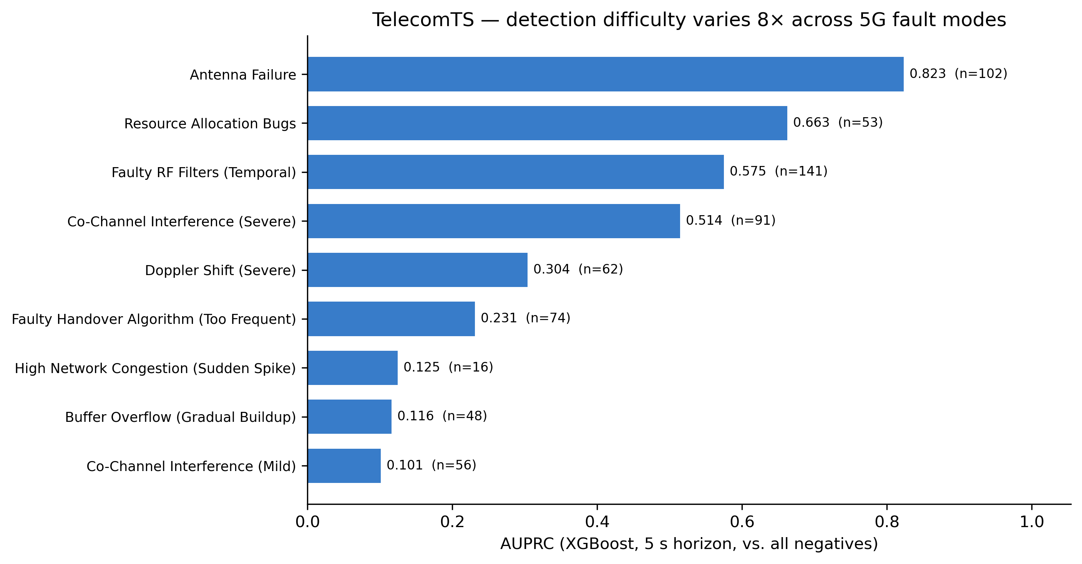
Figure 10. Per-anomaly-type AUROC and AUPRC on TelecomTS, showing that an aggregate score hides an eightfold spread in precision-recall performance.

Correction: early warning is ill-posed on RCAEval. Our dataset strategy originally assigned early-warning experiments to TelecomTS and RCAEval. That did not survive contact with the data, and we record the correction rather than dropping it silently. RCAEval’s faults are externally scheduled injections: the system is normal up to the injection instant, so no precursor exists at any horizon. A first attempt at a 300 s early-warning target produced AUROC 0.436-0.534 across all models — chance. Two causes were separable. The intrinsic one is that anticipating a scheduled intervention from pre-intervention telemetry is not a learnable problem. The second was our own method error: splitting cases chronologically by injection time perfectly segregated fault types across blocks, and cases are independent experiments, so the split must be stratified by fault type. It now is. The consequence is that the early-warning anchor of this paper rests on TelecomTS alone, a real concentration of risk that we state in Section VIII rather than smooth over.

B. Accuracy and calibration pull in opposite directions
Finding 2. On TelecomTS the tree models average ECE 0.120 while the deep ensembles average 0.082 — a 1.5x calibration gap running against the accuracy gap. The best-calibrated non-trivial models are the Transformer and Deep ensemble (Transformer) at ECE 0.063; the most accurate, XGBoost, sits at 0.120.

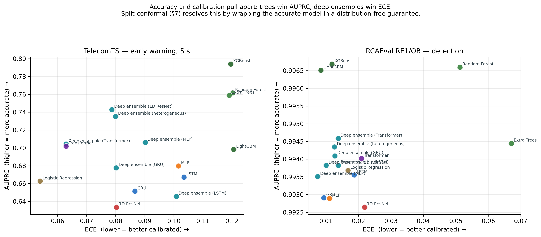
Figure 4. AUPRC against ECE on TelecomTS. The most accurate models are not the best calibrated. The soft-vote ensemble is excluded: it averages percentile ranks rather than probabilities, so its scores are uniform by construction and ECE against them is not meaningful.

This is the empirical case for the conformal layer of Component 5, and it is stronger than the design argument that preceded it, because the trade-off is avoidable. Conformal prediction wraps the highest-accuracy model in a distribution-free coverage guarantee, delivering tree accuracy without requiring tree calibration and without the deep ensemble’s 102-554 s training cost. Under a network-management framing this is the contribution: conformal prediction as a management-plane primitive, supported by a measured tension rather than an assertion.
Finding 3 — deep ensembling helps unevenly, and mainly where single-model variance is high.
Table 9. Single model vs. 5-member deep ensemble on TelecomTS.
Architecture | AUPRC, single $→$ M=5 | ECE, single $→$ M=5
MLP | 0.680 $→$ 0.706 (+0.026) | 0.102 $→$ 0.090 (-0.011)
1D ResNet | 0.634 $→$ 0.743 (+0.109) | 0.080 $→$ 0.079 (-0.002)
LSTM | 0.667 $→$ 0.646 (-0.022) | 0.103 $→$ 0.101 (-0.003)
GRU | 0.651 $→$ 0.678 (+0.026) | 0.087 $→$ 0.080 (-0.006)
Transformer | 0.702 $→$ 0.704 (+0.003) | 0.063 $→$ 0.063 (-0.000)
The 1D ResNet gains most because its single-model variance is highest; the LSTM loses accuracy. ECE improvements are consistent in sign but small (0.000 to 0.011) — materially weaker than the deep-ensemble literature suggests, and reported as measured. Two practical notes: the MLP matches LSTM and GRU accuracy at roughly a tenth of the cost (1.5 s vs. 12.6 and 13.7 s), and the 5-member 1D ResNet ensemble is the best accuracy-calibration compromise on TelecomTS at AUPRC 0.743 and ECE 0.079.

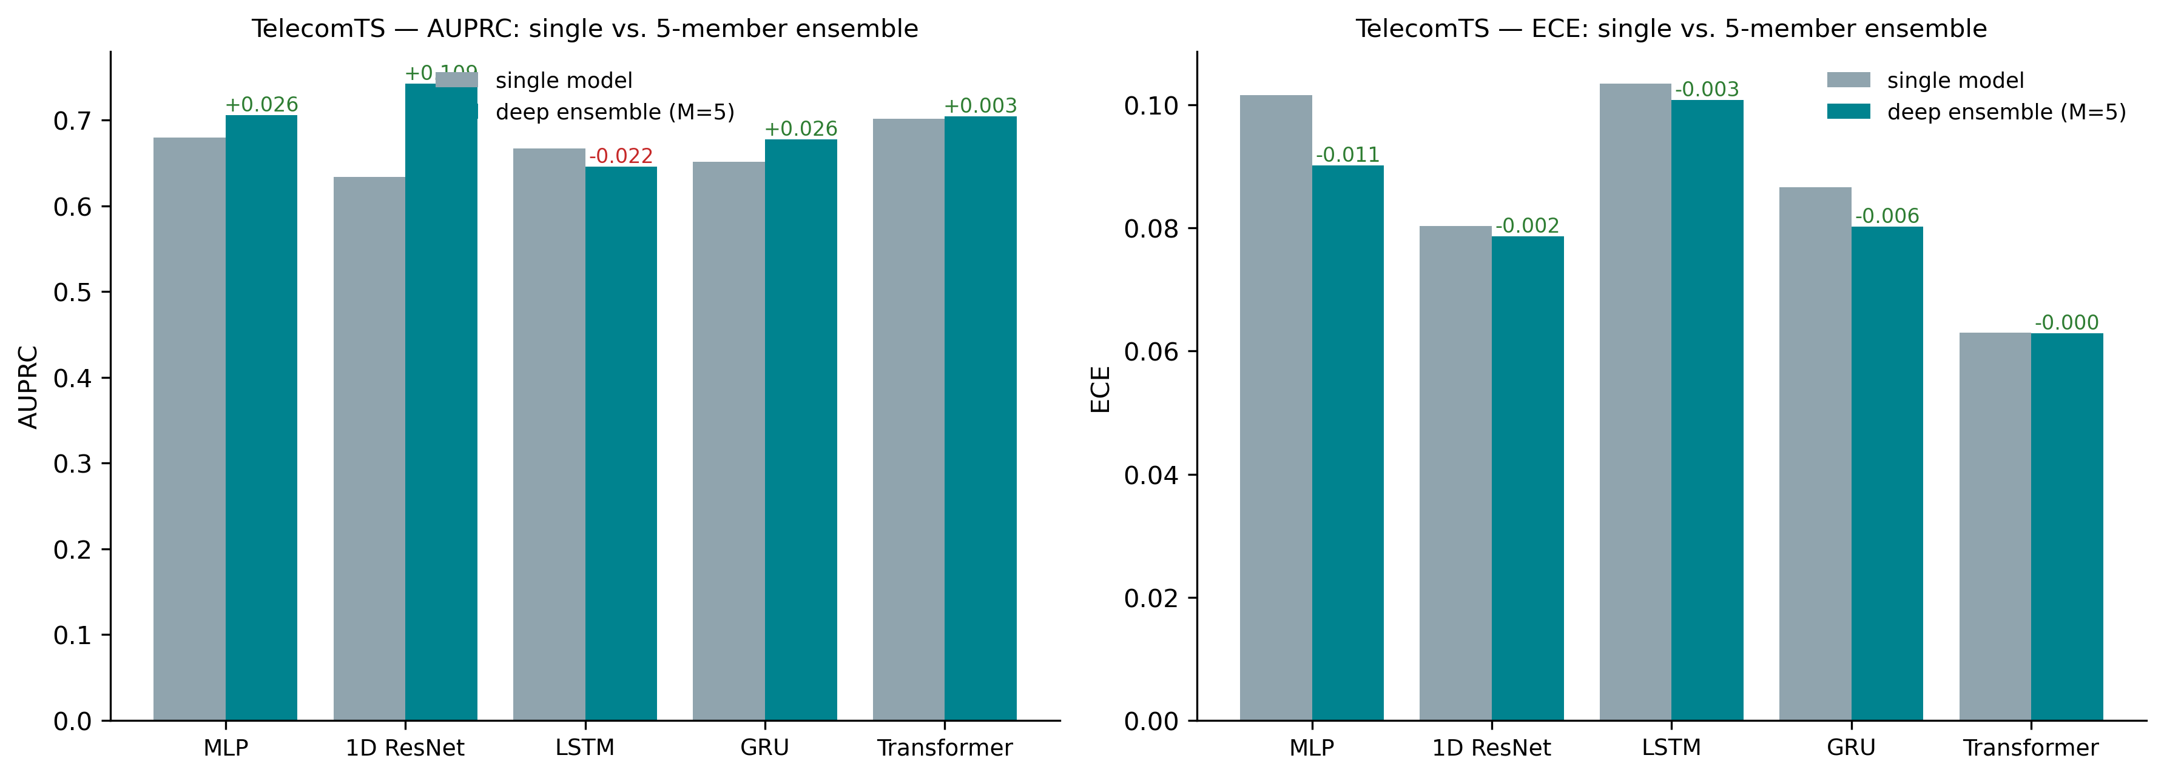
Figure 7. Single model against 5-member deep ensemble, AUPRC and ECE.

Finding 4 — the soft-vote ensemble does not earn its keep. On TelecomTS it costs 1,228 s — the sum of every member’s training time — for AUPRC 0.741, below XGBoost alone at 1.4 s. On RCAEval it is strictly dominated. On an operational cost basis this is a recommend-against.

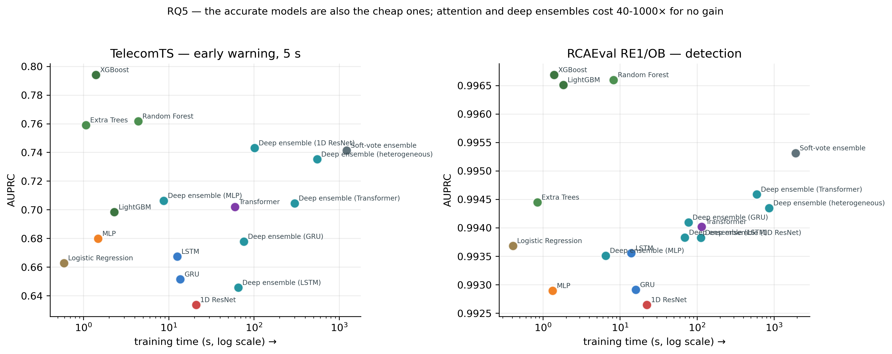
Figure 12. Accuracy against training cost. Tree models occupy the favorable corner on every leg.

C. Component 2 — Root-cause attribution
Because the best predictor is a tree model on every leg (Section VI.1), the TreeExplainer attribution is exact rather than approximate. For every SMD ground-truth segment we take the attribution at the last window before onset, aggregate $\left|ϕ_{i}\right|$ from (4) across each KPI dimension’s mean/std/last features, and rank dimensions. Table 10 reports precision@k = recall@k (k set to the ground-truth set size) per segment; EVAL and CALIB segments are genuinely out-of-sample, while TRAIN-block segments are in-sample and shown only for contrast.
Table 10. Component 2 results: SHAP-ranked root-cause attribution vs. ground truth (SMD).
Segment | Block | k | Precision@k = Recall@k
15849-16368 | train (in-sample) | 7 | 0.571
16963-17517 | train (in-sample) | 31 | 0.968
18071-18528 | train (in-sample) | 8 | 0.500
19367-20088 | eval (out-of-sample) | 14 | 0.571
20786-21195 | eval (out-of-sample) | 7 | 0.571
24679-24682 | calib (out-of-sample) | 4 | 0.500
26114-26116 | calib (out-of-sample) | 4 | 0.250
27554-27556 | calib (out-of-sample) | 4 | 0.750
The out-of-sample (EVAL + CALIB) mean precision/recall@k is 0.529, against a mean chance level of approximately 0.174 for the corresponding k values — well above chance, but far from perfect, which we report as the honest finding rather than only the best-case segment. Section VI.5 returns to the three out-of-sample segments where localization is wrong, because which events those are turns out to matter more than the mean.
Localization is scored on SMD only. Both TelecomTS (named affected_kpis) and RCAEval (root-cause service and indicator) ship localization ground truth and both loaders expose it, but the ranking is not yet scored on either; that is the immediate next experiment (Section IX).

D. Component 3 — Correlation vs. causal evidence
For the representative segment 20786-21195, Table 11 tests the top-5 SHAP-ranked KPI dimensions for Granger causality against a fixed target dimension (KPI 14, present in every ground-truth set) over a local pre/during-onset window, with Benjamini-Hochberg FDR control across the tested dimensions.

Table 11. Component 3 results: Granger-causality filtering of SHAP-ranked candidates.
KPI dim. | In ground truth | Pearson r | Granger p (min) | Verdict
7 | No | -0.075 | 0.199 | Correlational only
9 | Yes | 0.951 | 0.000 | Causal evidence
13 | Yes | 0.586 | 0.025 | Causal evidence
30 | No | 0.046 | 0.450 | Correlational only
33 | No | 0.026 | 0.791 | Correlational only

The two dimensions that are both highly correlated and in the ground-truth root-cause set (9, 13) pass the Granger test; the three that are only SHAP-flagged noise (weak correlation, absent from ground truth) fail it — the intended separation, though demonstrated here on one incident rather than across a statistically powered sample (Section VIII).
Note the relationship to Section VI.5: this filter is the one signal in the framework that was not included in the trust-score test, and is therefore the most promising candidate for the localization-quality signal that the tested signals failed to provide.

E. Component 4 — Explanation faithfulness, stability, and the confidence-quality gap
Components 1-3 and 5 are scored against ground truth. Component 4 — the narrative an engineer actually reads — is the one stage where “it looks reasonable” is the easiest failure to miss, so we audit it directly rather than presenting a sample output and moving on. The explainer is a deterministic template: every clause is a lookup into a number already computed by another component, following the narrate-don’t-diagnose discipline that RCACopilot- and RCAgent-style systems arrived at. An LLM may phrase it more fluently, but it is structurally prevented from asserting any fact not present in the evidence dictionary. A representative output for SMD segment 19367-20088 reads:
[t=19366] Predicted P(degradation within next 30 min) = 0.997. 90%-coverage conformal prediction set = {degrading} -> high confidence degradation. Early-warning behavior on this incident: 98 min before the labeled onset. Top-5 implicated KPI dimensions (SHAP): [1, 7, 13, 14, 30]. Ground-truth root-cause dimensions: [1, 2, 3, 4, 9, 10, 11, 12, 13, 14, 15, 16, 25, 28] -> 3/5 flagged dimensions confirmed correct.
Grounding the text is necessary but not sufficient: the numbers it grounds against can themselves be unreliable. We therefore measure two properties of the underlying attribution.
Faithfulness (deletion test). For each event we zero out (impute the standardized training mean) the top-5 SHAP-ranked dimensions’ mean/std/last entries and measure the resulting drop in predicted probability, against the drop from deleting five random dimensions, averaged over 200 repeats. A faithful explanation should cause the larger drop.
Stability (perturbation test). For each event’s pre-onset window we add Gaussian noise ($σ=0.05$ in standardized units, roughly 5% of one standard deviation), recompute features and the SHAP ranking, and compare to the unperturbed ranking by Spearman $ρ$, averaged over 20 draws.
Attribution entropy is a third, perturbation-free proxy: low normalized entropy means SHAP concentrates attribution on a few dimensions.
By the deletion test the explanations pass on all eight events. But the margin varies enormously — from 0.9999 against 0.194 for random deletion on segment 15849-16368, to 0.208 against 0.200 on segment 20786-21195, a difference that is essentially nothing. Three of the eight events also begin from a base probability above 0.999, i.e., the model is already at its output ceiling before any deletion, so “top-5 deletion drops probability more than random” is close to a floor effect on those events rather than strong evidence. Rankings are highly stable (Spearman $ρ$ from 0.990 to 0.998 across all eight events), but stability is a property of the explanation, not of its correctness.
That distinction is what the next test isolates. Every one of the eight events is predicted correctly and, on seven of eight, confidently. The critical-trustworthiness matrix therefore collapses to exactly two cells: four ideal events (prediction correct, root cause correct) and four dangerous diagnostic errors (prediction correct, root cause wrong), with zero detection failures. The operative question is whether any signal available to the system distinguishes the second group from the first.
Table 12. Component 4 confidence and explanation-quality signals, partitioned by whether root-cause localization was correct (SMD, n = 8).
Signal | RCA-correct mean (n=4) | RCA-wrong mean (n=4) | Difference
Predicted probability $\hat{p}$ | 0.995 | 0.991 | 0.004
Attribution entropy | 0.712 | 0.696 | 0.016
Rank stability $ρ$ | 0.992 | 0.995 | -0.003
Faithfulness margin | 0.510 | 0.515 | -0.005
None of the four separates the groups by any meaningful margin, and two of them — stability and faithfulness — point in the wrong direction, scoring marginally higher on the events where the root cause was wrong. The conformal layer does no better: the single ambiguous event does happen to be an RCA-wrong case, but three of the remaining four RCA-wrong events are still labeled confidently degrading.
This is the paper’s central trustworthiness finding, and it is negative. TrustNet-RCA can be maximally confident that a problem exists, produce an explanation that is stable under perturbation and faithful by deletion test, and still name the wrong KPI — with no signal in its own outputs marking that case as different. The practical implication is a warning about a tempting design: naively combining predicted probability, attribution entropy, and stability into a single composite trust score would not, on this evidence, separate correct from incorrect localization. Building such a score requires either a signal not tested here — causal-evidence agreement from Component 3, or cross-machine variance — or enough data to resolve an effect that four-versus-four groups cannot. We report this as it came out rather than reframing it as a partial success.
The sample is eight events on one machine, and every statistic above is descriptive of that machine rather than a confirmatory population-level test. The direction of the result is nonetheless the safer one to be wrong about: it counsels against trusting a confidence score that has not been validated against localization ground truth.

F. Component 5 — Uncertainty quantification
Split-conformal calibration on the CALIB block yields $\hat{q}=0.985$ and achieves 0.955 empirical coverage on EVAL against the 90% target — a valid, if conservative, guarantee. 20.0% of EVAL windows are routed to the ambiguous ({normal, degrading}) set, i.e., an explicit escalate-to-human signal, and 0.0% to the empty set. The raw probability’s ECE on EVAL is 0.118: Figure 8 shows the model is overconfident in its top bin (mean predicted probability 0.986, empirical positive rate 0.752), exactly the failure mode conformal wrapping is designed to survive without requiring the underlying model to be well calibrated.

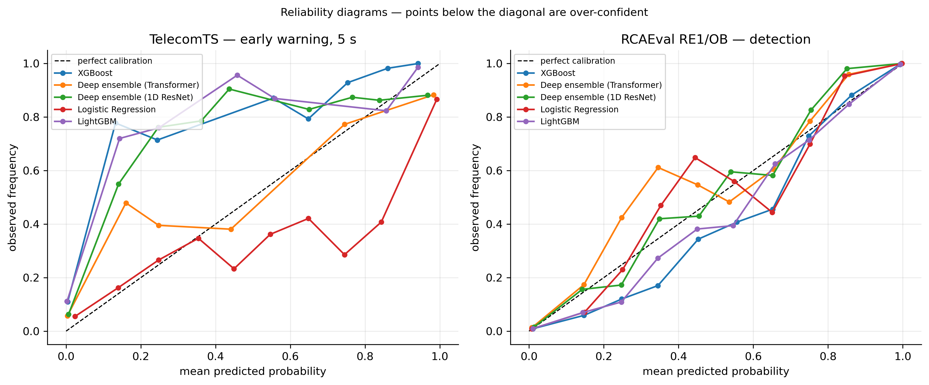
Figure 8. Reliability diagrams for the raw probability, showing overconfidence in the top bin that the conformal layer is designed to tolerate.

The conformal layer has been run on SMD only. CALIB blocks are constructed and held out for TelecomTS and RCAEval, but the coverage guarantee is not yet demonstrated on either, which Section VIII records.

G. Early-warning lead time
Table 13 reports, per SMD ground-truth segment, the gap between the first sustained risk-score crossing of 0.5 and official onset. Out-of-sample (EVAL + CALIB) the mean lead time is 42.2 minutes, with 4 of 5 incidents caught and one missed entirely.
Table 13. Component 1 early-warning lead time on SMD. TRAIN-block segments are in-sample and shown only for contrast.
Segment | Block | Lead time (min)
15849-16368 | train (in-sample) | 43
16963-17517 | train (in-sample) | 40
18071-18528 | train (in-sample) | 64
19367-20088 | eval | 98
20786-21195 | eval | missed
24679-24682 | calib | 2
26114-26116 | calib | 27
27554-27556 | calib | 42
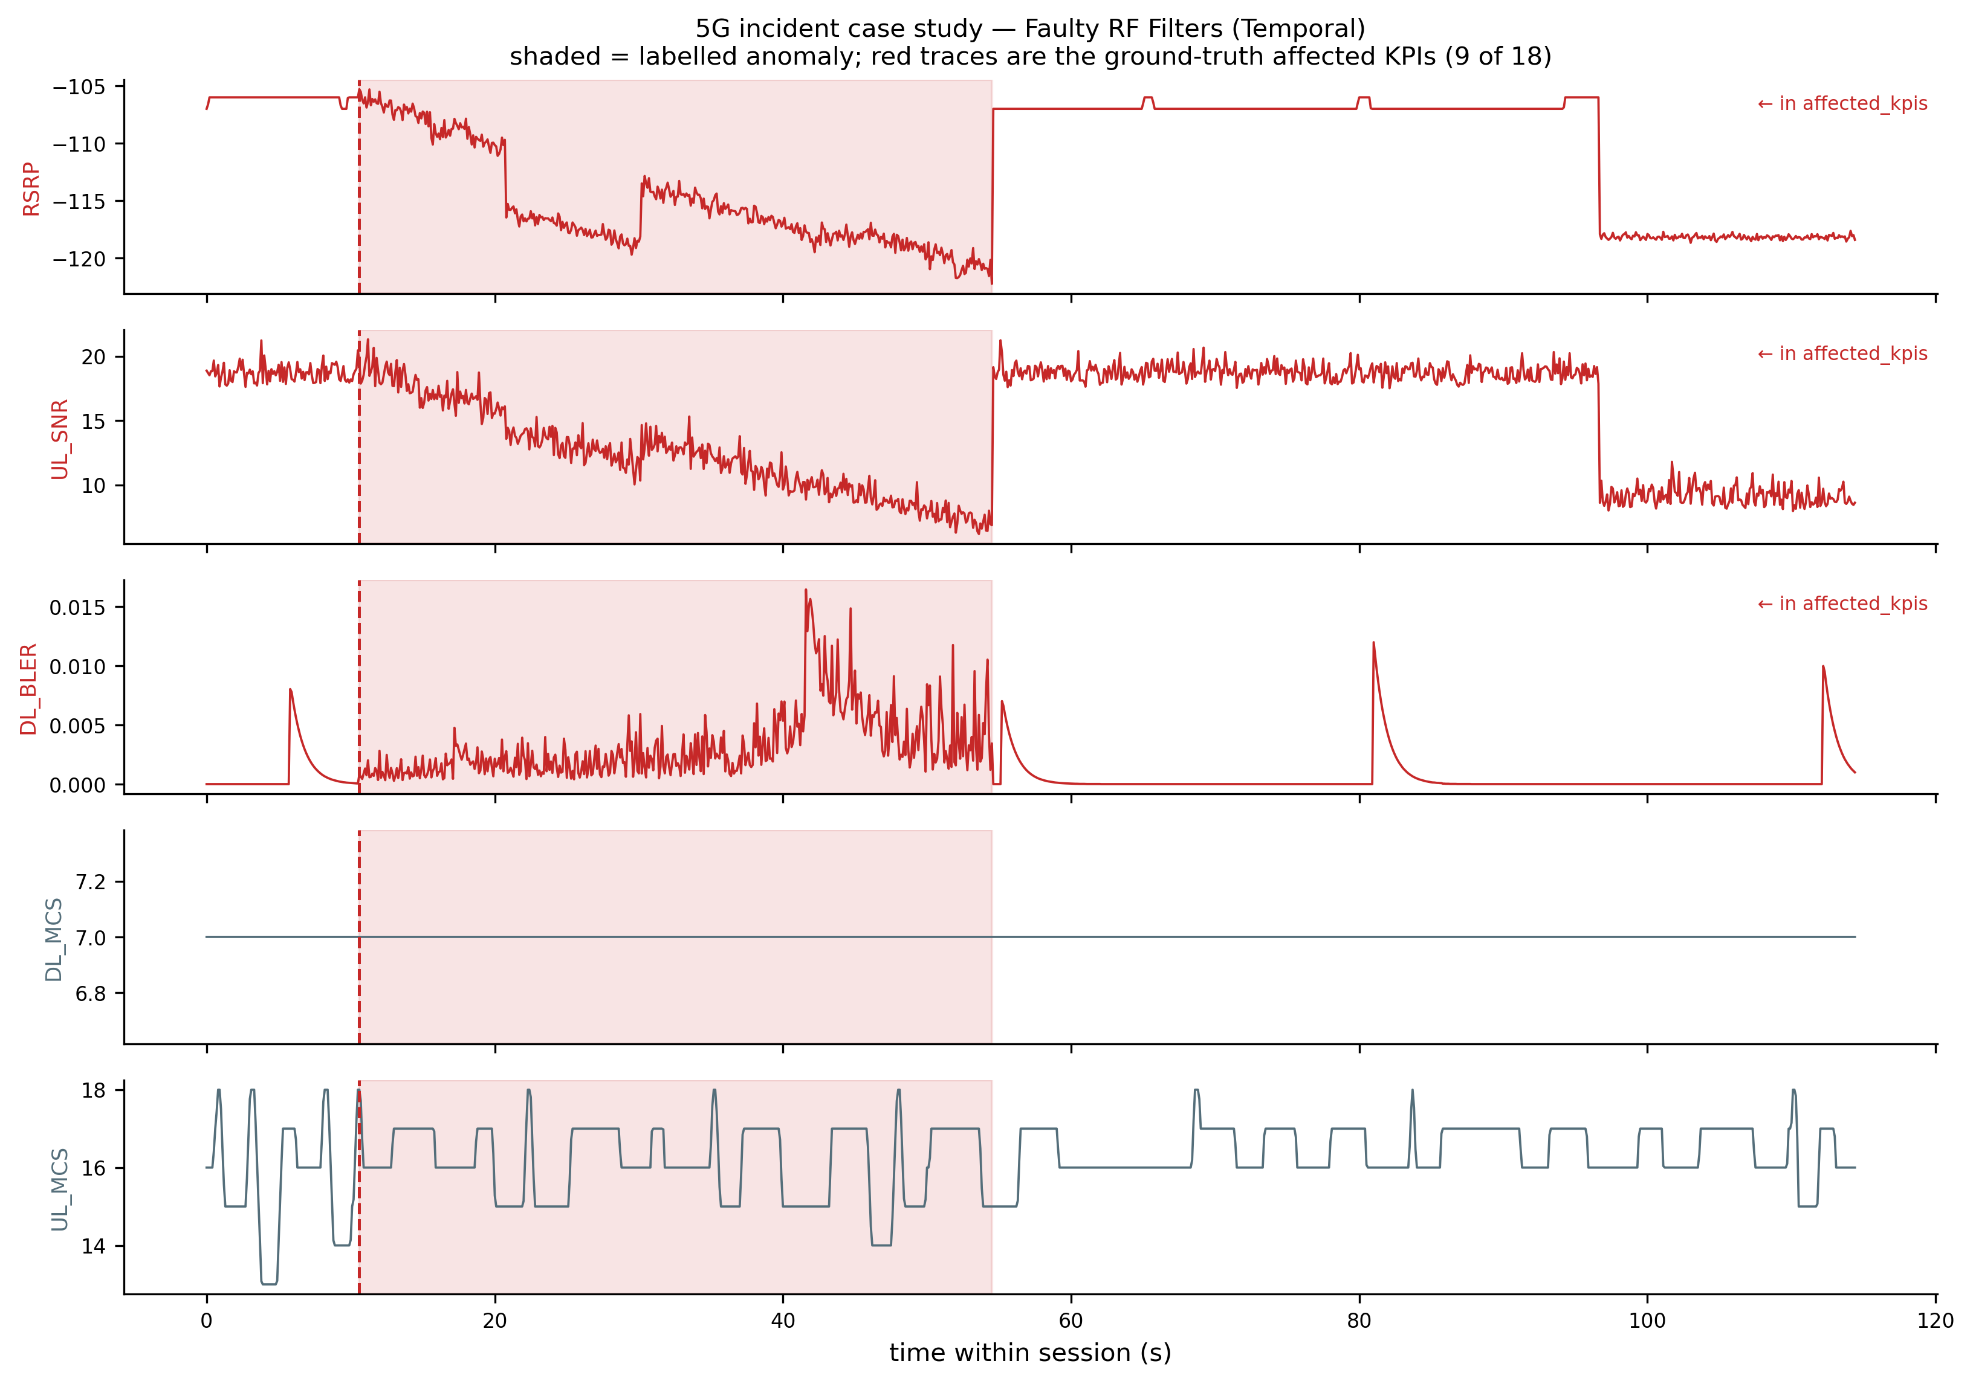
Figure 11. Risk score against ground truth for segment 19367-20088, the incident with the longest measured lead time.
Lead time is highly heterogeneous rather than uniform: one incident is flagged 98 minutes early with a clean ramp-up, one CALIB-block incident is caught only ~2 minutes early (essentially at onset), and one incident’s risk score jumps from ~0.001 to ~0.98 in a single step with no gradual precursor within the model’s 20-minute lookback and is missed by the lead-time rule entirely. We report this variance explicitly rather than only the mean, since averaging it away would misrepresent the system’s actual, uneven early-warning capability — itself a trustworthiness finding, not only a performance number. The TelecomTS runway analysis of Section VI.1 is the same observation at a different time scale: what the system can anticipate is bounded by what the incident telegraphs.

H. Component 2, graph view — illustrative topology-based ranking
Neither SMD nor the reconstructed TelecomTS sessions provide a network-element topology, so this experiment is explicitly illustrative: a synthetic Core $→$ Aggregation $→$ BaseStation $→$ Cell graph with an injected root cause at Aggregation and severity decaying (with noise) along descendants. Personalized PageRank on the reversed graph, seeded by observed node severity, ranks Aggregation first (score 0.319), correctly recovering the injected root cause and demonstrating the topology-propagation mechanism that a learned graph neural network would generalize with data-driven edge weights. It demonstrates a mechanism, not a validated capability.

VII. Discussion
Taken together, the results in Section VI show that each layer of TrustNet-RCA produces measurable, distinguishable evidence rather than a single opaque score. The predictor’s discrimination (Section VI.1) is separable from the attribution stage’s correctness against ground truth (6.3), which is separable again from the causal filter’s ability to prune spurious candidates (6.4), from the explanation layer’s faithfulness and stability (6.5), from the calibration layer’s coverage guarantee (6.6), and from the system’s actual, uneven early-warning behavior (6.7). That separability is the practical value of decomposing trustworthiness: a 0.920 AUROC headline alone would not have revealed that root-cause precision plateaus at 0.529, that per-anomaly-type AUPRC spans an eightfold range, that no TelecomTS incident affords a 30 s runway, or that 20% of predictions should be escalated rather than acted on automatically.
Two findings cut against the paper’s own initial expectations, and both are more useful than the confirmations. The first is architectural: attention models lose to gradient-boosted trees on all three legs, at 4-82x the training cost. Reporting this rather than burying it has a concrete payoff for the framework, because a tree predictor makes Component 2’s TreeExplainer attribution exact rather than approximate, and keeps attribution comparable across datasets instead of switching explainer family per leg. The negative result and the design are aligned rather than in tension.
The second is the one an operator should act on. Section VI.5 finds that none of the four confidence and explanation-quality signals the framework produces — predicted probability, attribution entropy, rank stability, deletion-test faithfulness — separates the events where localization was correct from those where it was wrong; two of the four point marginally in the wrong direction. This matters because the intuitive next engineering step, once a pipeline emits several quality signals, is to combine them into a composite trust score and gate escalation on it. On this evidence that score would not work, and would be worse than no score at all, since it would attach unwarranted confidence to the dangerous cases: prediction correct, diagnosis wrong. The one signal not yet tested in that role is the causal-evidence agreement of Component 3, which is the natural next candidate precisely because it draws on temporal structure rather than on the attribution the other signals all derive from.
There is a methodological point here too. The confidence-quality gap is only visible because localization ground truth existed to partition events against. A study without such labels would have observed stable, faithful, confident explanations and concluded the explanation layer was working. This is the argument for insisting on datasets with root-cause ground truth even when they are less realistic than the alternative — and, conversely, the reason the localization scores in this paper carry a caveat: they exist for SMD, the least telecom-like of the three legs.
These results establish that a joint pipeline is measurable and instrumentable across three domains under one method, not that it outperforms simpler alternatives. Section VIII states the limitations directly, and Section IX defines the multi-seed, multi-baseline study required to make a comparative claim.

VIII. Limitations and Threats to Validity
The early-warning anchor rests on a single dataset. Section VI.1 records why: RCAEval’s scheduled fault injections make anticipation ill-posed, so TelecomTS alone carries the 5G early-warning claim. A single dataset carrying a core claim is a real concentration of risk, not a formality.
TelecomTS anomalies are largely synthetic. Ten of its eleven anomaly types are injected; Jamming is the one real over-the-air phenomenon, and those seven events have zero pre-onset runway. Results on injected faults may not transfer to naturally occurring RAN degradation. The dataset is also testbed-derived, not operator-network data, and involves no O-RAN interfaces or components — we make no O-RAN claim.
SMD is not telecom data and is not treated as such. Its 38 dimensions are generic server metrics, not named radio KPIs. It is reported strictly as an out-of-domain generalization check, and no SMD number in this paper should be read as a measurement about radio behavior.
Localization is scored on one leg only. Section VI.3’s attribution results are SMD-only. TelecomTS and RCAEval both ship localization ground truth, and both loaders expose it, but the root-cause ranking is not yet scored on either — so “RCA rigor” is not yet earned on the leg assigned to carry it.
One RCAEval system of nine. Only RE1 / Online Boutique is used: 123 of 735 available cases. Sock Shop, Train Ticket, and the RE2/RE3 multi-source suites are untouched.
No conformal layer on the new legs. CALIB blocks are built and held out for TelecomTS and RCAEval, but the coverage guarantee is demonstrated on SMD only.
No statistical validation. Every leg is a single seed and a single split. No significance testing, confidence intervals, or effect sizes are computed, and hyperparameters were fixed by hand on SMD and reused verbatim elsewhere — deliberately, to keep the legs comparable, but it means no leg is tuned and all numbers are untuned-baseline numbers.
The Component 4 audit is underpowered. The confidence-quality result in Section VI.5 rests on eight events on one machine, partitioned four against four. It is descriptive of that machine, not a population-level test. We draw a cautionary conclusion from it rather than a quantitative one; a larger sample could reveal a small effect these groups cannot resolve.
No external baselines. We compare models within our own hierarchy but do not compare the full pipeline against established RCA methods such as MicroRCA [13], CausalRCA, RCD, or epsilon-Diagnosis. No comparative claim is made.
Granger causality is not proof of causation. The verdicts in Section VI.4 reflect temporal-precedence evidence from an observational test, not intervention. Neither dataset provides a configuration-change log that could serve as a quasi-experiment.
Illustrative, not fitted, topology experiment. Section VI.8 uses a hand-specified synthetic topology and injected severities. It demonstrates a mechanism, not a validated capability on real network topology.
No production or robustness evaluation. No deployed system exists to report latency or throughput SLAs against, and no adversarial-input, alarm-storm, missing-telemetry, or drift tests were run.

IX. Practical Implications and Future Work
For practitioners, four design choices in TrustNet-RCA are directly actionable regardless of the specific models used. First, treat prediction, attribution, causal filtering, explanation, and calibration as separately monitored pipeline stages, so that a regression in one is not masked by another. Second, report lead time, root-cause accuracy, and per-fault-type performance per incident rather than only pooled: Section VI.1 shows AUPRC spanning 0.101 to 0.823 across anomaly types while AUROC stays within a narrow 0.877-0.971 band, so an aggregate score — particularly an aggregate AUROC — can conceal that a system is close to unusable on entire fault families. Third, use a conformal or similarly calibrated abstention signal to route low-confidence cases to a human rather than resolving them silently. Fourth, and following directly from Section VI.5: do not gate that escalation on a composite trust score assembled from the model’s own confidence and explanation-quality signals until that score has been validated against localization ground truth, because on this evidence it would not separate correct diagnoses from incorrect ones.
Four experiments follow immediately from what Section VI does not establish, in rough order of how much they would change the paper’s claims.
Score localization on the telecom legs. This is the largest gap. Both TelecomTS (named affected_kpis) and RCAEval (root-cause service and indicator) ship localization ground truth, and both loaders already expose it; the fixed-k metrics of Section V.6 are implemented. Until this is run, attribution quality is a claim about server telemetry only, and the confidence-quality finding of Section VI.5 rests on eight events.
Extend the conformal layer to the telecom legs. CALIB blocks are built and held out for TelecomTS and RCAEval but unused. The coverage guarantee is distribution-free in theory; demonstrating it at 10 Hz on radio telemetry is the test that matters operationally.
Statistical validation. Multi-seed runs with paired significance tests and effect sizes across all three legs, which no result in this paper currently carries, and which the eight-event Component 4 analysis needs most.
Broaden the RCA leg and add external baselines. RE1 / Online Boutique is 123 of RCAEval’s 735 cases; Sock Shop, Train Ticket, and the RE2/RE3 multi-source suites remain untouched. Comparison against MicroRCA [13], CausalRCA, RCD, and epsilon-Diagnosis is required before any comparative claim, as is the joint ablation — does causal filtering plus conformal calibration measurably improve root-cause precision and selective-prediction risk over attribution alone — that this paper’s related-work review found no prior study to have reported.
Beyond that, two lines are worth naming. The causal-evidence signal of Component 3 should be tested as the localization-quality signal that Section VI.5’s candidates failed to provide. And a controlled human-subjects study should test whether exposing the causal-versus-correlational distinction and the abstention flag actually changes engineer diagnostic accuracy and calibrated trust — a gap independently identified by a systematic review of XAI human-evaluation methodology [21]. A third, higher-risk line, contingent on data access, is validation on real RAN-level KPI telemetry against the published GNN+Transformer RAN RCA system [12].

X. Conclusion
We presented TrustNet-RCA, a five-component framework that treats trustworthiness as a set of separately measurable properties — prediction, attribution, causal filtering, explanation, and calibrated uncertainty — rather than as an emergent quality of one opaque model, and evaluated it under one identical method across a 5G RAN benchmark (TelecomTS), a service-management RCA benchmark (RCAEval), and an out-of-domain server telemetry benchmark (SMD).
Three results are worth carrying forward. First, gradient-boosted trees beat attention models on all three legs at a fraction of the training cost; we report this negative result as one, and note that it keeps exact TreeExplainer attribution available throughout. Second, accuracy and calibration pull against each other, and conformal prediction resolves the tension rather than trading it off — delivering tree accuracy under a distribution-free coverage guarantee, which is the strongest case this work makes for conformal methods as a management-plane primitive. Third, and most consequentially, none of the confidence or explanation-quality signals the framework produces distinguishes a correct root-cause localization from an incorrect one. A system can be maximally confident, stable under perturbation, and faithful by deletion test, and still name the wrong KPI.
That third finding is the one we would most want an operator to take seriously, and it argues against the intuitive design it rules out: a composite trust score assembled from predicted probability, attribution entropy, and rank stability would not, on this evidence, tell an engineer when to doubt the diagnosis. The causal-evidence layer is the one signal not yet tested in that role and is the natural next candidate.
These results establish that the proposed decomposition is measurable and instrumentable against ground truth on a public 5G benchmark. They do not establish that it outperforms simpler alternatives, that localization transfers beyond SMD, or that any of it survives contact with an operator network — claims requiring the multi-seed, multi-system, statistically validated study defined in Section IX, which we intend as the next stage of this work.

References
[1] S. M. Lundberg and S.-I. Lee, "A unified approach to interpreting model predictions," in Proc. NeurIPS, 2017.
[2] C. W. J. Granger, "Investigating causal relations by econometric models and cross-spectral methods," Econometrica, vol. 37, no. 3, pp. 424-438, 1969.
[3] P. Spirtes, C. Glymour, and R. Scheines, Causation, Prediction, and Search, 2nd ed. Cambridge, MA, USA: MIT Press, 2000.
[4] A. N. Angelopoulos and S. Bates, "A gentle introduction to conformal prediction and distribution-free uncertainty quantification," arXiv:2107.07511, 2021.
[5] L. Pham, H. Zhang, H. Ha, F. Salim, and X. Zhang, "RCAEval: A benchmark for root cause analysis of microservice systems with telemetry data," arXiv:2412.17015, 2024.
[6] L. Zheng, Z. Chen, D. Wang, C. Deng, R. Matsuoka, and H. Chen, "LEMMA-RCA: A large multi-modal multi-domain dataset for root cause analysis," arXiv:2406.05375, 2024.
[7] Y. Su, Y. Zhao, C. Niu, R. Liu, W. Sun, and D. Pei, "Robust anomaly detection for multivariate time series via stochastic recurrent neural network," in Proc. ACM SIGKDD, 2019.
[8] P. Schummer, A. del Rio Ponce, J. Serrano Romero, D. Jimenez Bermejo, G. Sanchez, and A. Llorente, "Machine learning-based network anomaly detection: Design, implementation, and evaluation," AI (MDPI), vol. 5, no. 4, art. 143, 2024.
[9] K. Hundman, V. Constantinou, C. Laporte, I. Colwell, and T. Soderstrom, "Detecting spacecraft anomalies using LSTMs and nonparametric dynamic thresholding," in Proc. ACM SIGKDD, 2018.
[10] Q. Wen et al., "Transformers in time series: A survey," arXiv:2202.07125, 2022.
[11] S. Tuli, G. Casale, and N. R. Jennings, "TranAD: Deep transformer networks for anomaly detection in multivariate time series data," Proc. VLDB Endowment, vol. 15, no. 6, 2022.
[12] A. Hasan, C. Boeira, K. Papry, Y. Ju, Z. Zhu, and I. Haque, "Root cause analysis of anomalies in 5G RAN using graph neural network and transformer," arXiv:2406.15638, 2024.
[13] L. Wu, J. Tordsson, E. Elmroth, and O. Kao, "MicroRCA: Root cause localization of performance issues in microservices," in Proc. IEEE/IFIP NOMS, 2020.
[14] A. Deng and B. Hooi, "Graph neural network-based anomaly detection in multivariate time series," in Proc. AAAI, 2021.
[15] C.-M. Lin, C. Chang, W.-Y. Wang, K.-D. Wang, and W.-C. Peng, "Root cause analysis in microservice using neural Granger causal discovery," in Proc. AAAI, 2024. arXiv:2402.01140.
[16] L. Pham, H. Ha, and H. Zhang, "Root cause analysis for microservice system based on causal inference: How far are we?," arXiv:2408.13729, 2024.
[17] A. Shan, J. Kaur, R. Singh, T. Banka, R. Yavatkar, and T. Sridhar, "RCA Copilot: Transforming network data into actionable insights via large language models," arXiv:2507.03224, 2025.
[18] D. Roy et al., "Exploring LLM-based agents for root cause analysis," arXiv:2403.04123, 2024.
[19] A. Bellotti and X. Zhao, "Conformal prediction and trustworthy AI," arXiv:2508.06885, 2025.
[20] F. O. Catak, U. Cali, M. Kuzlu, and S. Sarp, "Uncertainty aware deep learning model for secure and trustworthy channel estimation in 5G networks," arXiv:2305.02741, 2023.
[21] J. Kim, H. Maathuis, and D. Sent, "Human-centered evaluation of explainable AI applications: A systematic review," Frontiers in Artificial Intelligence, 2024.
[22] S. Feng et al., “TelecomTS: A multimodal observability dataset for time series reasoning in telecom networks,” arXiv:2510.06063, 2025.

