VA_SAGOR
Visual Analytics on the Rise of Sailor Shift and the Oceanus Folk Scene
Project Report — VAST Challenge 2025, Mini-Challenge 1
Visual Analytics (602AA)
Instructor: Prof. Salvatore Rinzivillo
Student: Sagor Howlader — 685068
Repository: https://github.com/Sagorhowlader/va-sailor-shift-analysis
July 2026

1. Description of the Data and the Analytical Goal
The VAST Challenge 2025 Mini-Challenge 1 dataset models the fictional music scene of Oceanus as a single directed multigraph, provided as MC1_graph.json: 17,412 nodes and 37,857 edges. There are five node types — Person, Song, Album, MusicalGroup, and RecordLabel — each carrying attributes such as name, genre, a release_date or written_date (for works), and a boolean notable flag marking charting works or noteworthy people/groups.
Edges fall into two semantically distinct families, and the distinction drives the whole analysis. Creation edges (PerformerOf, ComposerOf, LyricistOf, ProducerOf, MemberOf, RecordedBy, DistributedBy) point from the Person, MusicalGroup, or RecordLabel who did the work to the Song, Album, or group they worked on. Influence edges (InStyleOf, InterpolatesFrom, CoverOf, LyricalReferenceTo, DirectlySamples) point from the newer, derivative work to the earlier work it draws from — the edge reads “source was influenced by target,” the reverse of how “A influenced B” normally reads in English. Getting this direction backwards silently flips every downstream influence calculation, so it is called out explicitly in code comments (see build_sailor_network.py) and re-verified in every export script that touches influence edges.
One real data-quality wrinkle is documented rather than hidden: 67 of the graph’s 7,407 influence edges point directly at a Person or MusicalGroup node (e.g. “in the style of Sailor Shift” rather than “in the style of a specific song of hers”), and those artist nodes carry no date attribute at all. That sliver of influence events therefore cannot be placed on a year-by-year timeline; it is counted in aggregate views but explicitly excluded from every time-based chart, with the exclusion documented in the corresponding script rather than silently dropped.
The analytical goal set by the official brief is to trace how the artist Sailor Shift rose from a small-island musical tradition — Oceanus Folk — to global prominence, to characterize how Oceanus Folk’s influence subsequently diffused through (and drew back from) the wider musical world, and to use that same characterization to identify which other Oceanus Folk artists are best positioned to be the genre’s next breakout stars. The brief decomposes this into three tasks, which the application maps directly onto six linked modules:
Brief task | Question | Module(s)
1. Sailor's profile | Who influenced her? Whom has she influenced? How has she shaped the wider community? | Influence Analysis
2. Spread of Oceanus Folk | Gradual or sudden rise? Which genres/artists were most influenced? What does the genre now draw on? | Genre Diffusion
3. Rising-star profile | Compare 3 artists' rise in popularity/influence; predict 3 future stars | Talent Radar, Career Timeline, Findings & Predictions

To keep the interface responsive over a 17k-node graph, every computationally expensive step — BFS ego-network extraction, PageRank and degree centrality, per-year aggregation — is precomputed once offline in Python using networkx and exported as static JSON. Every filter, slider, and search box the user touches afterward runs as a client-side recomputation over that already-shaped, already-small dataset in Vue, so interaction stays fast without a backend service.

2. Design Choices

2.1 Visual language and colour
The interface uses a flat, white-panel “analytics workspace” aesthetic (slate borders, a single teal accent, a sans-serif type) with a sticky top navigation bar rather than a sidebar, so every module is reachable in one click and the content area gets the full page width for wide charts like the Sankey and the chord diagram. This is a deliberate simplification from an earlier iteration of the project, which used a heavier branded sidebar layout; the visual language was flattened specifically so the data, not the chrome, carries the page.
Colour is used purposefully rather than decoratively, and three different colour strategies are used depending on what the colour needs to communicate:
- Fixed categorical colours for node types and edge types (5 node types, 12 edge types) are hand-picked once and reused identically across every tab and every legend, because these categories are small, stable, and appear everywhere — a colour that means “Song” in one chart has to mean “Song” in every other chart, or the legend stops being trustworthy.
- Generated categorical colours for open-ended sets (genres, the artists a user chooses to compare) come from an ordinal D3 scale over a rainbow interpolator with an explicit domain declared up front, so a colour is never reassigned mid-session as new categories appear in a filtered view.
- A perceptually uniform sequential scale (D3’s viridis) colours the Trend Dashboard’s year-by-genre heatmap, chosen specifically because it remains legible for colour-vision-deficient readers and encodes magnitude (not identity), unlike the categorical scales used elsewhere.

Category | Colour
Person | 4A86E8
Song | F1C40F
Album | E74C3C
MusicalGroup | 2ECC71
RecordLabel | C0392B

Sailor Shift herself is a special case: in every chart where she can appear alongside other artists (the Talent Radar, the Findings predictions), she is drawn in a single fixed colour instead of the generated palette, so she stays visually anchored as the constant reference point no matter which genre, filter, or comparison set is active.

2.2 Shapes, marks, and transformations
Each module uses the mark type best suited to the relationship it shows rather than defaulting to one chart family everywhere: node-link diagrams (circles and lines) for the network structure of who-influenced-whom; a chord diagram (arcs and ribbons) for genre-to-genre flow, because ribbon width reads as “how much” at a glance across a full many-to-many matrix; a Sankey diagram (nodes and flow bands) for artist → genre → target-genre attribution, because it preserves both the individual contributors and their aggregation into a single destination; a radar/spider polygon for multi-attribute artist comparison; line charts for cumulative trends over time; and a heatmap grid for genre × year density.
Two numeric transformations recur across modules and are worth calling out explicitly. First, the Talent Radar’s four metrics (PageRank, degree centrality, style similarity, notable-work count) are each normalized to 0–1 within that genre’s own candidate pool, not globally — comparing a Person’s raw PageRank to a heavily-covered Song’s, or comparing across genres of very different sizes, would be meaningless, so normalization is always pool-relative. Second, every time series in Career Timeline, Trend Dashboard, and Findings & Predictions is shown as a running cumulative sum rather than raw per-year counts, because a rise in popularity is much easier to read from a monotonically climbing curve than from a noisy bar-by-bar sequence — the shape of the curve (flat, then steep) is the pattern the brief actually asks the viewer to notice.

2.3 Interaction affordances
- Universal pan and zoom on every SVG chart (drag to pan, wheel/pinch to zoom), implemented once as a shared attachZoom() utility and reused across all six D3 visualizations, so the interaction gesture never has to be relearned switching modules.
- Click-to-inspect: clicking any node in the Influence Analysis network opens a detail panel with its full attributes.
- Consistent filter vocabulary across modules — the same MultiSelect, RangeSlider, and NodeSearch (name-search-to-zoom) components are reused everywhere rather than each view inventing its own filter widgets.
- User-adjustable score weights in Talent Radar (0–1 sliders per metric) that live-re-rank the scoreboard and reshape the radar polygon, so the scoring formula is inspectable and tunable rather than a fixed black box.
- Cross-widget linking: a click in one D3 module changes what a different widget on the same page shows — detailed in Section 4.
Two layout decisions were made specifically for legibility rather than aesthetics: the Sankey diagram computes its row heights and total canvas height dynamically after layout instead of guessing a fixed size up front, because a fixed height either made low-value flows illegibly thin or clipped high-value flows off the bottom; and the Influence Analysis network graph uses a hybrid force + radial layout — nodes are seeded onto rings by their BFS hop-distance from Sailor Shift and then released into a standard force simulation constrained by d3.forceRadial — so that “how many hops from Sailor” stays visually legible even after the simulation settles nodes into a non-overlapping arrangement.

3. State of the Art
Each visual technique used in this project has an established precedent in either the information-visualization literature or in real, deployed music-industry tools; the project's contribution is less any single novel mark and more the combination of several standard techniques into one set of linked views over a single shared graph.

3.1 Node-link and ego-network views
Force-directed node-link layouts are the standard approach for visualizing network structure, converging nodes into legible clusters by treating edges as springs and nodes as repelling charges (as formalized in the widely used ForceAtlas2 algorithm built for the Gephi network-analysis tool). Restricting a large graph to the neighbourhood of one focal node — an “ego network” — to make an individual’s position in a larger structure explorable is likewise an established technique; egoComp (Liu et al., 2017) is a representative example of visual-comparison work built specifically around ego-networks. The Influence Analysis module’s three tabs (Influenced by / Her Impact / Community Influence) are, structurally, exactly this: three ego-network views centred on Sailor Shift, extended here with a hop-distance-aware radial layout so structural distance from the ego remains readable after the force simulation runs.

3.2 Chord diagrams for genre-to-genre flow
Chord diagrams (popularized by D3’s d3-chord module, itself descended from the Circos genomics visualization) are a standard technique for showing many-to-many flow between a bounded set of categories in a single circular layout. Prior work has applied the same idea specifically to music: the Musicalized project visualizes directed influence between musical genres as a graph, and academic work such as “Music Influence Modeling Based on Directed Network Model” and Stanford’s musical-influence-network ranking study both analyze influence between musical entities as a directed network. The Genre Diffusion module’s Genre-to-Genre chord diagram applies this same technique to a genre × genre adjacency matrix built from every influence edge in the MC1 graph.

3.3 Genre-space mapping
The best-known real-world attempt to map the space of musical genres is Every Noise at Once, built by Glenn McDonald at Spotify: an algorithmically generated scatter-plot of thousands of genres positioned by their aggregate audio characteristics. This project addresses a related but distinct question with a different data source — rather than mapping genres by how they sound, the Genre Diffusion module maps them by who draws influence from whom, which is exactly the relationship the MC1 graph’s influence edges encode.

3.4 Sankey diagrams for attribution
Sankey diagrams are the standard technique for showing how a quantity is attributed across intermediate categories on its way to a destination (originating in flow diagrams of energy and material balances, and implemented in D3 via the d3-sankey library used in this project). The Top Influenced Artists sub-tab applies this directly: individual artists flow into the genres they work in, which flow into the single genre currently selected for inspection.

3.5 Radar charts for multi-attribute scouting
Radar (spider) charts are the standard way to compare an individual against several quantitative axes at once, and are heavily used in real sports-analytics scouting products — Opta’s player radars and tools such as FBCharts and PFF’s draft-evaluation charts all compress six-to-ten statistics per athlete into one scannable polygon so a coach or scout can compare candidates without reading raw tables. The Talent Radar module borrows this exact convention, substituting PageRank, degree centrality, style similarity, and notable-work count for the athletic statistics, with Sailor Shift standing in for the “league benchmark” player a scout would compare prospects against.

3.6 Predictive artist-discovery platforms
Commercial A&R analytics platforms such as Chartmetric and Soundcharts are the closest real-world analogue to this project’s Findings & Predictions module: both score artists on cross-platform growth signals specifically to flag likely breakout acts before they chart. Chartmetric, for instance, assigns artists a daily 1–10 score derived from signals mined across the career histories of over ten million artists. The Findings module addresses the same problem — who is next — but its score is fully transparent: the exact formula (a weighted blend of the same four radar metrics plus a “recent output momentum” term) is shown in the UI with its weights, rather than being a proprietary black-box index.
Where the tools above each solve one piece of this problem in isolation — a genre map, a flow diagram, a player radar, a growth score — this project’s contribution is wiring several of them together as linked views over one shared graph, so that a pattern spotted in one chart (e.g. a genre gaining reciprocal influence in the chord diagram) can be drilled into immediately in another (which artists are carrying that influence, in the Sankey) without leaving the page or re-deriving the filter state by hand.

4. Detailed Description of the Visualizations and Their Interaction

4.1 Influence Analysis (Task 1)
A single reusable NetworkTab component is mounted three times against three different precomputed subgraphs — Influenced by (what fed into Sailor's work), Her Impact (who her work fed into, plus her collaborators), and Community Influence (a generic 2-hop neighbourhood). The custom D3 layout is a hybrid force + radial simulation: nodes are seeded onto concentric rings by BFS hop-distance from Sailor before the force simulation runs, and a d3.forceRadial constraint keeps them from drifting off their ring as the simulation settles — so hop-distance from Sailor remains visually legible (distance from the centre = distance in the graph) even in the final, decluttered layout, which a plain force-directed layout does not guarantee.
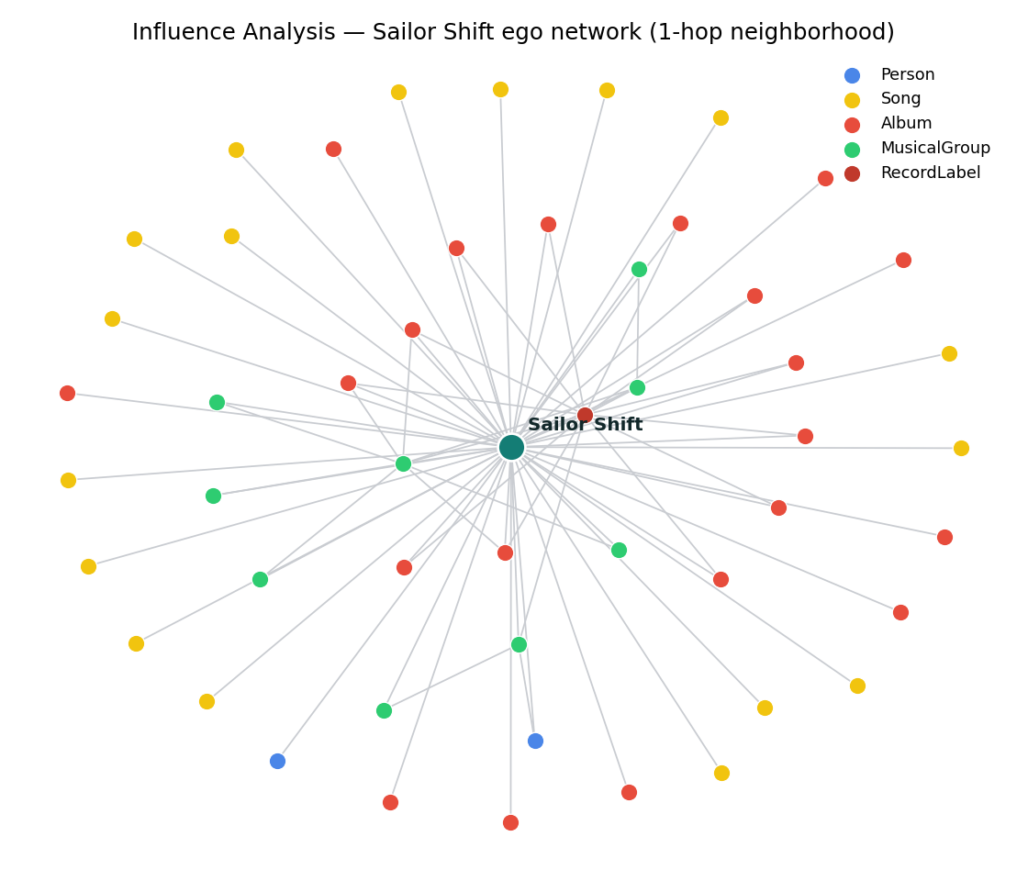
Fig. 1 — Sailor Shift's 1-hop ego network (Influence Analysis), coloured by node type. The full in-app view additionally reaches 2 hops and lets the user limit the depth shown.
Filters available: node type (multi-select), edge type (multi-select), a tri-state “notable” radio filter, genre (multi-select), a release-year range slider, and a network-depth slider that limits how many hops from Sailor are drawn. A name-search box zooms and highlights a specific node on selection. Clicking any node opens a detail panel with its full attributes, and a Summary Statistics sub-tab recomputes counts-by-type and most-connected nodes over the exact same filtered node/edge set — functioning as a second, linked view of the current filter state rather than an independent widget.

4.2 Genre Diffusion (Task 2)
Three D3 sub-tabs share one underlying whole-graph export of every influence edge in the dataset. Influence Trend plots, per year, the number of unique works influencing a chosen genre, filterable by source-work type. Genre to Genre aggregates every influence edge into a full genre × genre adjacency matrix and renders it as a chord diagram, with two independent range sliders — one for a “pre–Sailor Shift fame” window and one for “post” (the fame year, 2028, is a fixed reference point) — so a before/after comparison is a filter change, not a separate chart.
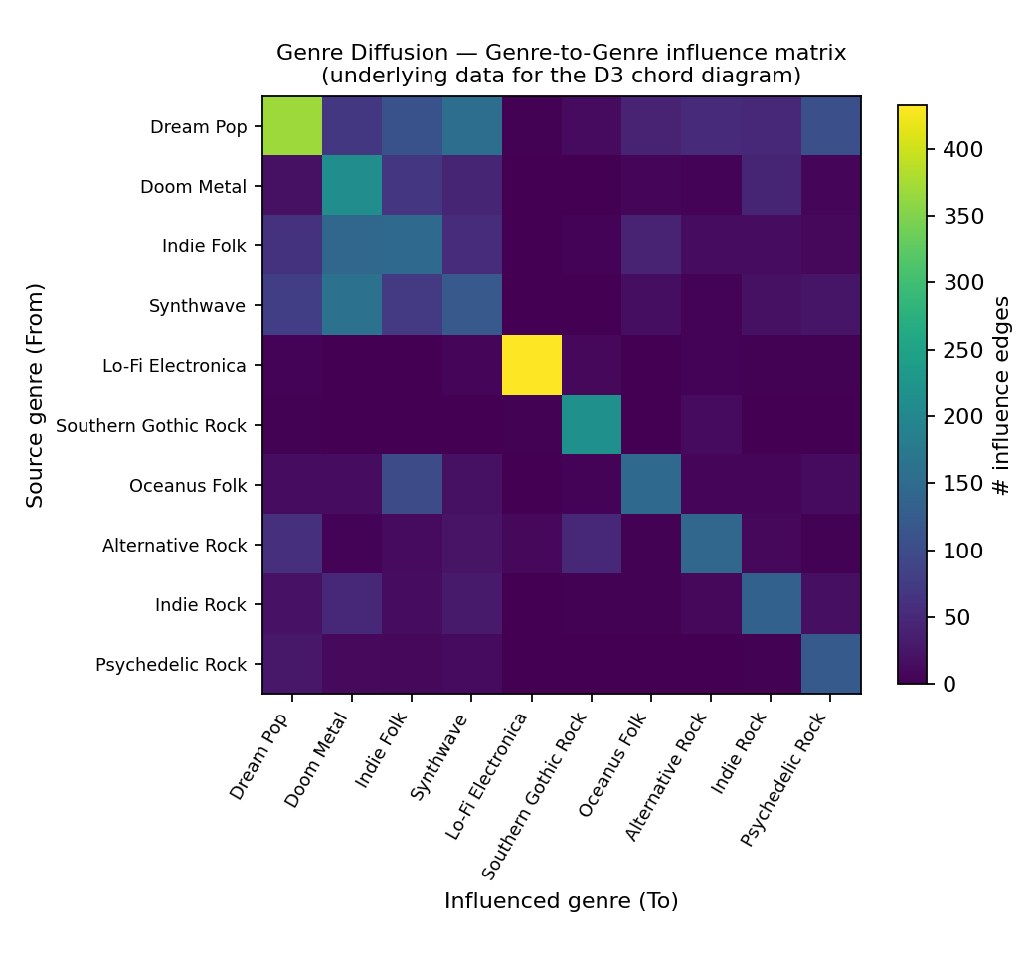
Fig. 2 — The genre-to-genre influence matrix underlying the chord diagram (top 10 genres by total edge volume). Row = source genre, column = influenced genre.
This is where the project’s custom D3 module explicitly drives another widget rather than only responding to filters: clicking a genre’s arc in the chord diagram sets the Top Influenced Artists sub-tab’s selected genre and switches the active tab to it, so the two charts read as one connected exploration — “which genre is this?” in the chord diagram flows directly into “who, specifically, is behind that influence?” in the Sankey. The Sankey itself (Top Influenced Artists) traces Artist → Genre → selected-genre flow for the Top-N most-influential artists, with its row heights and total canvas height computed dynamically after layout so neither low-value nor high-value flows become illegible.

4.3 Talent Radar and Trend Dashboard (Task 3)
Talent Radar computes four per-genre metrics for every artist — PageRank and degree centrality (networkx, over the whole graph), style similarity (share of an artist’s total output that falls in this genre), and notable-work count — each normalized 0–1 within its genre’s own candidate pool. Sailor Shift is deliberately excluded from the ranked candidate pool (an “emerging artist” tool that always ranks the reigning superstar first is not useful) but her metrics are still computed and shown as a fixed radar baseline. A Scoreboard table and a D3 radar chart share state, and weights on all four metrics are user-adjustable via sliders, live-re-ranking the table.
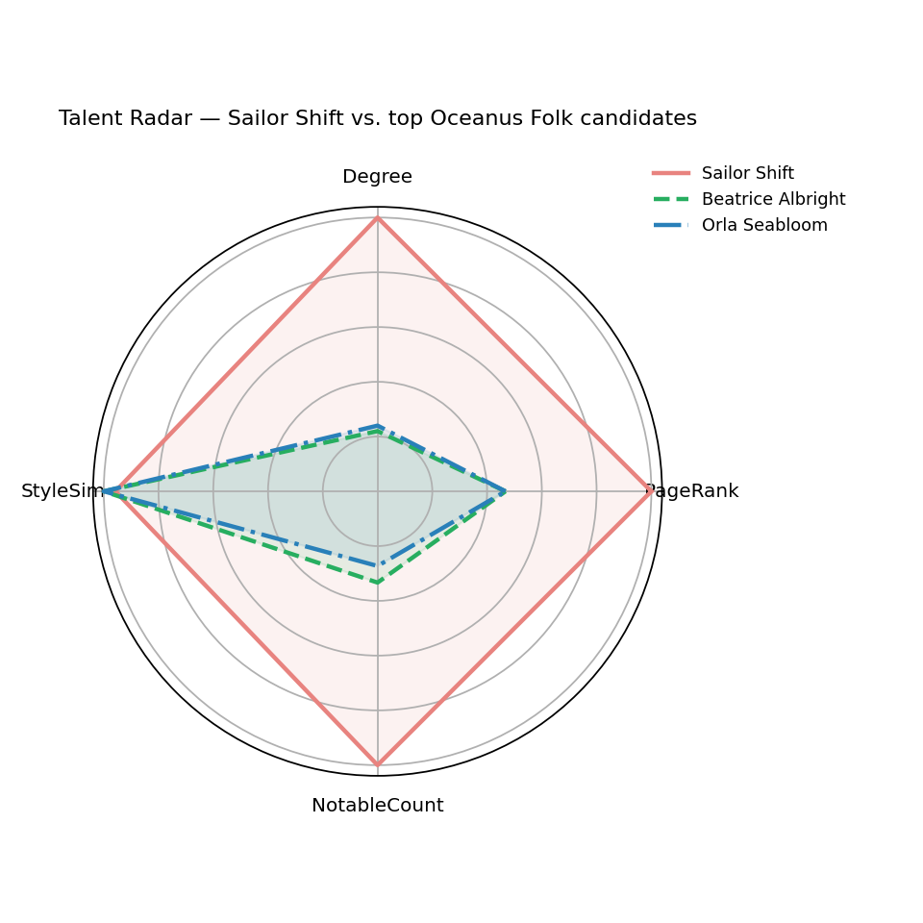
Fig. 3 — Talent Radar comparing Sailor Shift against two top-ranked Oceanus Folk candidates on the four scoring axes.
This module contains the project’s second explicit cross-widget link: clicking a row in the Scoreboard table toggles that artist onto the D3 radar chart and switches the view to it, so the table and the chart function as one linked comparison tool (up to four artists at once) instead of two separate widgets that merely draw from the same data. Trend Dashboard, a supporting module for Task 2/3 context, aggregates raw Song/Album counts by genre and year directly from node attributes (no edges needed) into a viridis-scaled Yearly Heatmap and a Cumulative Curve, with a Song/Album layer toggle and CSV export.

4.4 Career Timeline (Task 3.1)
Directly answers the brief’s request to “compare the careers of three artists.” The user searches up to three artists into three slots (defaulting to Sailor Shift and two of her ex-bandmates from Ivy Echoes, who took visibly different post-band paths); two cumulative line charts plot Output (distinct Song/Album releases per year) and Influence Received (incoming influence edges on that artist’s catalogue per year) side by side, sharing one fixed-order colour scale, plus a Career Summary table (first active year, total works, peak-output year, total influence received).
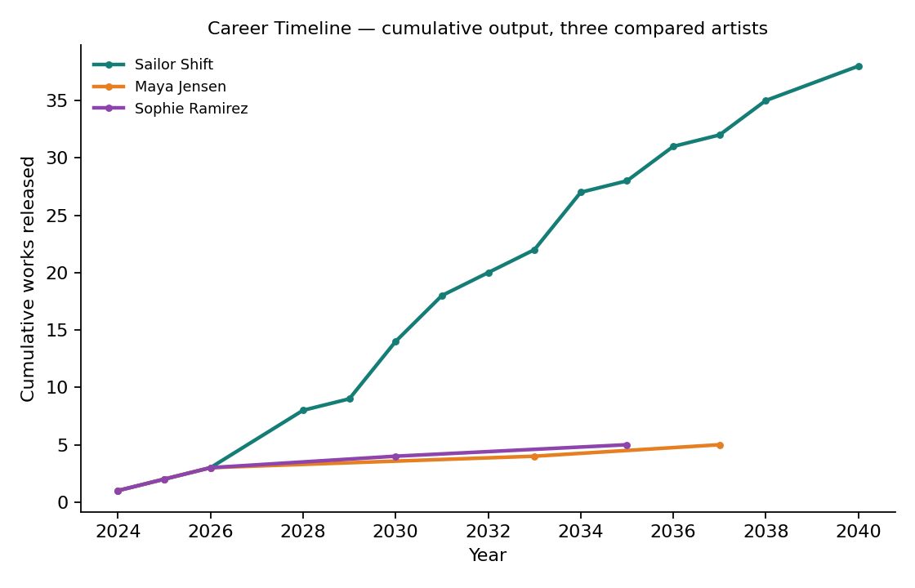
Fig. 4 — Cumulative output for Sailor Shift versus two former bandmates, computed directly from the Career Timeline module's export. Sailor's trajectory visibly diverges after her documented 2028 breakout.

4.5 Findings & Predictions (Task 3.2)
Rather than a hand-picked answer, the three predicted “next Oceanus Folk stars” are computed live from the same data the rest of the app already exposes: finalScore = 0.6×radarScore + 0.4×recentOutputMomentum, where recentOutputMomentum is the share of an artist’s total output released in the dataset’s final five years — rewarding candidates who are both well-scored and still actively releasing, the same shape Sailor’s own output took right after her breakout. The top three are shown with an auto-generated, per-candidate rationale sentence built from their actual numbers (not template text), alongside a cumulative-output chart of just those three artists. The weights are displayed in the UI as an inspectable modelling choice rather than a hidden constant.

5. Use Case Example: An Analytical Task
Task: “Has Oceanus Folk’s relationship with the rest of the music world become more reciprocal since Sailor Shift’s rise, and who is carrying that exchange today?” This task cannot be answered from any single chart in the application; it requires moving through four modules via the linked-view interactions described above.
- Step 1 — Genre Diffusion → Genre to Genre: set the “pre-fame” range to 1980–2028 and the “post-fame” range to 2028–2040. Comparing the two resulting chord diagrams shows Oceanus Folk’s arc gaining thicker, more numerous ribbons to and from other genres after 2028 — direct visual evidence of increased reciprocal exchange, not just outbound influence.
- Step 2 — click the Oceanus Folk arc: the app jumps to Top Influenced Artists, pre-filtered to Oceanus Folk, surfacing exactly which artists (from other genres) are the largest individual contributors of inbound influence.
- Step 3 — Talent Radar: search for one of those top contributing artists, click their Scoreboard row to overlay them on the radar chart against Sailor Shift, and compare their PageRank/StyleSim/NotableCount profile shape to hers.
- Step 4 — Career Timeline: add that same artist alongside Sailor Shift and compare their cumulative output and influence-received curves — does their trajectory show the same late steep climb that marks Sailor’s own breakout, or a flatter, more gradual rise?
- Step 5 — Findings & Predictions: check whether that artist already appears in the data-backed top-3 shortlist, and read the auto-generated rationale explaining why (or why not) their numbers currently place them there.
This walk-through touches four of the six modules and crosses both of the project’s explicit cross-widget links (chord → Sankey, table → radar), which is the specific behaviour it was designed to support: a single coherent analytical path through the data rather than six independently browsable charts that happen to share a colour palette.

