Jerry M. Vargas

INTERACTIVE PROGRAMMING AND TECHNOLOGIES 1

IT263

**What is PHP?**

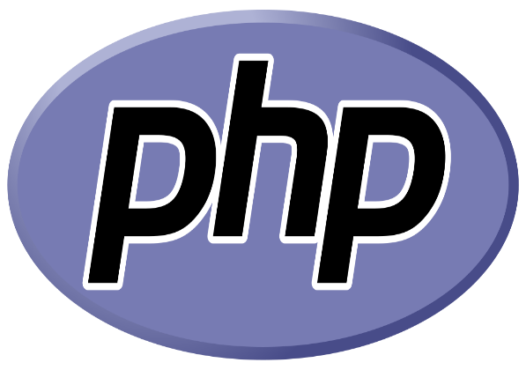

**What does PHP stand for?**

PHP means – (Personal Home Page), but it now stands for the recursive backronym PHP**: Hypertext Pre-processor.**

The first part of this definition means that PHP code can be interspersed with HTML, making it simple to generate dynamic pieces of Web pages on the fly. As a scripting language, PHP code requires the presence of the PHP processor. PHP code is normally run in [plain-text scripts](http://www.nusphere.com/php/php_syntax.htm) that will only run on PHP-enabled computers (conversely programming languages can create standalone binary executable files, a.k.a. programs). PHP takes most of its syntax from C, Java, and Perl. It is an open source technology and runs on most operating systems and with most Web servers.

* It is powerful enough to be at the core of the biggest blogging system on the web (WordPress)!
* It is deep enough to run the largest social network (Facebook)!
* It is also easy enough to be a beginner's first server side language!

**History**

PHP was written in the C programming language by Rasmus Lerdorf in 1994 for use in monitoring his online resume and related personal information.  For this reason, PHP originally stood for "Personal Home Page". Lerdorf combined PHP with his own Form Interpreter, releasing the combination publicly as PHP/FI (generally referred to as PHP 2.0) on June 8, 1995. The acronym was formally changed to PHP: HyperText Preprocessor, at this time