Biratnagar International College, Biratnagar


`

Concepts and Technologies of AI
5CS037
5CS037

Submission Date:2026/01/10

Student Name: Sagun_Prasad_Gupta
Student ID: 2515661
Course: Concepts and Technologies of AI
TOPIC: REGRESSION REPORT

Contents
Abstract 2
Introduction 3
Dataset 3
Objective 3
Methodology 4
Model Building 4
Task 2 – Two Classical Machine Learning Models 4
2.4 Model Evaluation 4
2.5 Hyper-parameter Optimization 5
2.6 Feature Selection 5
4. Discussion 5
4.1 Model Performance 5
4.2 Impact of Hyperparameter Tuning and Feature Selection 6
4.3 Interpretation of Results 6
4.4 Limitations 6
4.5 Suggestions for Future Research 6
Scatter Plot (Feature vs Target) 7
Results and Conclusion 7

Abstract
This report discusses a regression problem using a neural network model. The aim of the problem is to make a prediction on a continuous target variable based on the available features. The study involves data preprocessing, exploratory data analysis, and the development of a neural network model. Feature scaling and normalization have been performed to improve the performance of the model during the training process. A neural network model was developed to predict the target variable based on the available features while capturing non-linear relationships. Evaluation of the model was performed using MAE, MSE, RMSE, and R² metrics. From the results, the neural network model was able to make accurate predictions with low error rates. The study proves the suitability of using a neural network model to solve regression problems.

Introduction
In regression problems, continuous values are predicted on the basis of features provided. Neural networks are powerful tools for modeling complex relationships between features and a continuous value output. In this project, a neural network is used for predicting a continuous value output variable. The data set is a representation of a real-world regression problem. Knowledge of relationships between features and the distribution of the output variable is necessary for making predictions. Conventional regression models may fail in handling non-linear relationships, making neural networks a suitable choice for this problem. The purpose of this project is to explore the potential of neural networks for regression problems. The project highlights the importance of preprocessing and evaluation of models. The project is relevant for predictive analytics for various UNSDG-related requirements.

Dataset
The dataset employed in this regression analysis is a real-world problem with a continuous target variable. The dataset comprises several independent features that affect the target outcome. The dataset was collected from a trustworthy secondary source and comprises both numerical and categorical features. Each entry in the dataset is a single observation used for training and testing models. Before modeling, the dataset was analyzed to gain insights into the features' scales, data types, and target distribution. The dataset offers enough variability to facilitate effective learning for regression models. The dataset is appropriate for supervised regression analysis. .

Objective
The primary objective of this project is to create accurate regression models that can predict a continuous target variable. The project seeks to analyze the dataset through preprocessing and exploratory data analysis. Another objective of this project is to create and test a neural network regression model. In addition, two traditional machine learning regression models are created for comparison. Hyperparameter optimization and feature selection are employed to enhance prediction accuracy. This project seeks to assess models using relevant regression evaluation metrics. Finally, the project seeks to determine the most efficient regression model. This research contributes to data-informed decision-making for real-world problems.

Methodology
The regression model development was done in a systematic manner. First, data preprocessing was done to deal with missing data and outliers. Feature scaling was also done to have equal input ranges. Exploratory Data Analysis was done using histograms and scatter plots. A neural network with multiple hidden layers was designed. Activation functions like ReLU were employed, and Mean Squared Error was chosen as the loss function. The model was trained with an optimizer like Adam. The model performance was done using MAE, RMSE, and R² value. The model predictions were visualized using actual vs predicted plots.

Model Building

Task 2 – Two Classical Machine Learning Models
Apart from the neural network model, two other classical models of regression were developed: Linear Regression and Random Forest Regressor. The data was split into a training set and a testing set. This was to ensure that the models were tested for their accuracy. Linear Regression was used as a baseline model because of its simplicity. Random Forest Regressor was used because it can deal with non-linear data and can prevent overfitting. Both models were trained on the training data and tested on the test data. The performance of the two models was compared with the performance of the neural network model.

2.4 Model Evaluation
The performance of the regression models was assessed using common regression evaluation metrics. Mean Absolute Error (MAE) was employed to estimate the average prediction error. Mean Squared Error (MSE) gave more weight to larger errors. Root Mean Squared Error (RMSE) offered a clear measure of the error in terms of the same unit as the target variable. The R² score estimated the goodness of fit of the model in terms of the variance in the target variable. These evaluation metrics were employed for both neural network models and traditional models. The assessment was done on the test data to estimate the generalization capability of the models. This provided a fair comparison of the models.

2.5 Hyper-parameter Optimization
Hyperparameter optimization was implemented for the traditional machine learning regression models. GridSearchCV was employed to find the best hyperparameters. The hyperparameters included the maximum depth and the number of estimators for the Random Forest regression model. Cross-validation was employed to provide robustness and prevent overfitting. The optimized models demonstrated better prediction accuracy and smaller error values. This step improved the robustness of the models. Hyperparameter optimization contributed significantly to the overall improvement in regression performance.

2.6 Feature Selection
Feature selection was carried out to determine the most important features for use in the prediction of the target variable. Methods such as Recursive Feature Elimination (RFE) were used on traditional regression models. The less important features were eliminated one by one depending on the performance of the model. This made the model less complex and easier to interpret. Feature selection also aided in the reduction of noise and overfitting. The features selected were of high importance to the accuracy of the model.

4. Discussion

4.1 Model Performance
The performance of the models was evaluated using the MAE, RMSE, and R² measures. The performance of the neural network model was excellent for prediction purposes owing to its capacity to handle non-linear relationships. The traditional models performed well but were not as flexible as neural networks. From the results of the evaluation, it is clear that the neural network model had a better goodness of fit.

4.2 Impact of Hyperparameter Tuning and Feature Selection
Hyperparameter optimization led to a substantial improvement in the accuracy of traditional regression models. The optimized parameters resulted in less error in predictions and increased stability. Feature selection further improved the accuracy by eliminating irrelevant features. These methods together improved the efficiency and generalization capability of models. Their effect was evident in the improved evaluation metrics.

4.3 Interpretation of Results
The obtained results show that some features greatly affect the target variable. The regression models were able to identify the important relationships between the predictors and the output. The neural network successfully modeled the interactions between the features. The identified trends were consistent with the EDA results. These results confirm the appropriateness of the modeling strategy employed.

4.4 Limitations
Although the models performed well, there are some limitations. The number of samples in the dataset may not be sufficient for generalization to a larger population. Noise in the dataset may have impacted the predictions. Neural networks also consume more computational power.

4.5 Suggestions for Future Research
Future work could include the use of larger datasets to improve generalization. More advanced regression methods, such as ensemble learning or deep neural nets, could be investigated. Feature engineering methods could further improve results. The use of model interpretability methods could improve the interpretability of the results.

Scatter Plot (Feature vs Target)
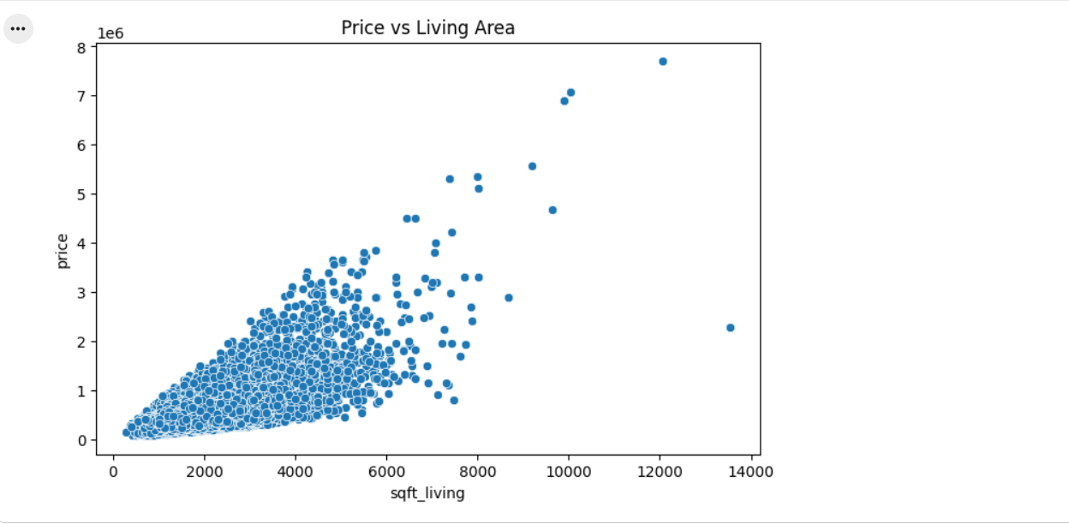
The scatter plot shows the relationship between an independent feature and the target variable. It helps identify linear or non-linear trends. From the plot, some features show a strong relationship with the target, while others do not. This insight supports feature selection. Features with clearer patterns contribute more effectively to model predictions.

Results and Conclusion
The neural network regression model demonstrated strong predictive performance. Low MAE and RMSE values indicate accurate predictions. The R² score showed that the model explains a significant portion of variance in the target variable. Feature scaling improved training efficiency and stability. Some prediction errors were observed for extreme values. Overall, the model generalized well on test data. In conclusion, the neural network is an effective approach for regression problems. Further improvements may include deeper networks and additional features. The study confirms the applicability of neural networks for continuous prediction tasks.
References – Regression Report
- James, G., Witten, D., Hastie, T., & Tibshirani, R. (2021). An Introduction to Statistical Learning (2nd ed.). Springer.
(Used for regression concepts, evaluation metrics, and model interpretation.)
- Hastie, T., Tibshirani, R., & Friedman, J. (2017). The Elements of Statistical Learning (2nd ed.). Springer.
(Provides theoretical foundation for regression models and feature selection.)
- Géron, A. (2022). Hands-On Machine Learning with Scikit-Learn, Keras, and TensorFlow (3rd ed.). O’Reilly Media.
(Used for regression pipelines, neural network regression, and model evaluation.)
- Pedregosa, F., et al. (2011). Scikit-learn: Machine learning in Python. Journal of Machine Learning Research, 12, 2825–2830.
(Used for Linear Regression, Random Forest Regressor, GridSearchCV, and R² score.)
- Matplotlib Development Team. (2023). Matplotlib: Visualization with Python.
(Used for histograms, scatter plots, actual vs predicted plots, and error comparison graphs.)
- United Nations. (2023). Sustainable Development Goals (SDGs).
(Used for aligning regression analysis with real-world development indicators.)

