Biratnagar International College, Biratnagar


`

Concepts and Technologies of AI
5CS037

Submission Date:2026/02/03

Student Name: Sagun_Prasad_Gupta
Student ID: 2515661
Course: Concepts and Technologies of AI
TOPIC: CLASSIFICATION REPORT

Table of Contents
Abstract 2
Introduction 3
Data Preprocessing 3
Methodology 4
Exploratory Data Analysis (EDA) 4
Correlation Heatmap 5
Model Building 5
Task 1 – Neural Network 5
Task 2 – Two Classical Machine Learning Models 6
Model Evaluation 6
Hyperparameter Optimization 7
Feature Selection 7
Discussion 7
4.1 Model Performance 7
4.2 Impact of Hyperparameter Tuning and Feature Selection 8
4.3Interpretation of Results 8
4.4 Limitations 8
4.5 Suggestions for Future Research 9
Results and Conclusion 9

Abstract
This report is based on solving a classification problem by applying a neural network model. The goal is to forecast a target variable based on a set of features. The research starts with data preprocessing and exploratory data analysis to analyze feature behavior and class distribution. A neural network model was developed and trained with a backpropagation algorithm. Activation functions and loss functions were carefully selected for efficient learning. The model's performance was measured by accuracy, precision, recall, and F1-score. The results show that a neural network model is efficient in learning complex patterns from the data. The research proves that neural network models can be used for classification problems. The final model is efficient and can generalize new unseen data.

Introduction
Classification problems are often employed in machine learning for decision-making. Neural networks have gained significant popularity in machine learning due to their capability in handling non-linear relationships. This project utilizes a neural network for classification. The dataset employed in this project is a real-world classification problem. It has several input features. It is important to comprehend the class distribution and the characteristics of the data. Neural networks can efficiently handle complex data structures. This study focuses on assessing the capability of neural networks in classification problems. This project contributes significantly to developing precise and dependable systems. This work can be utilized for data-driven decision-making in line with the UNSDG.

Data Preprocessing

Data preprocessing was a critical task that ensured the quality and integrity of the data before building the model. First, the data was checked for missing values, inconsistencies, and duplicates. Missing values were dealt with using techniques such as removal or imputation, depending on the effect of the missing values on the data. Outliers were detected using statistical techniques and visual analysis, and they were dealt with to minimize their effect on the model. Feature scaling and normalization were done to ensure that all features were scaled to a similar range, which is very important during the training of the neural network model. This ensured that the data was ready for correct classification. This process greatly improved the efficiency of the learning process.

Methodology
The methodology involved a structured approach to modeling a neural network. Initially, the dataset was preprocessed to remove inconsistencies and missing values. Feature scaling was also done to improve the speed of convergence during training. Exploratory Data Analysis was also done to determine the distribution of the features and the class imbalance. A neural network model was developed with layers such as input, hidden, and output layers. Activation functions like ReLU and Softmax were employed. The model was trained with an optimizer like Adam and a suitable loss function. The model was evaluated using the usual classification metrics.

Exploratory Data Analysis (EDA)
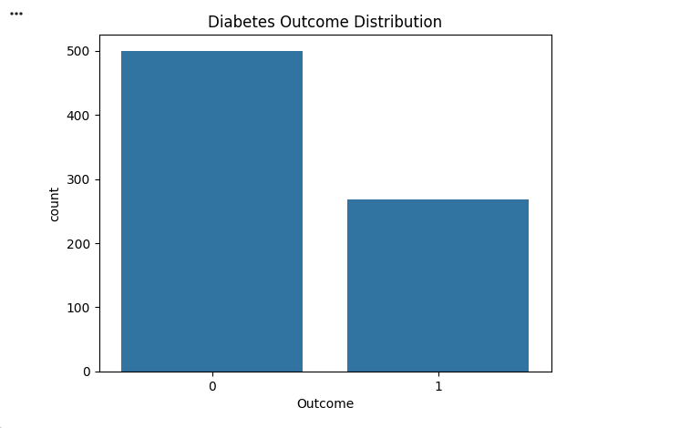

Exploratory Data Analysis was performed to have a better understanding of the data and the underlying patterns. Various data visualizations such as histograms, scatter plots, and correlation heatmaps were used. Histograms were used to analyze the distribution of individual features and identify any skewness. Scatter plots were used to analyze the relationship between key features and the target variable. The correlation heatmap was used to identify the relationship between various numerical features and identify any multicollinearity. EDA also helped identify that the data is class-imbalanced, which further impacted the choice of evaluation metrics. EDA was an essential step in understanding the data before applying machine learning algorithms.

Correlation Heatmap
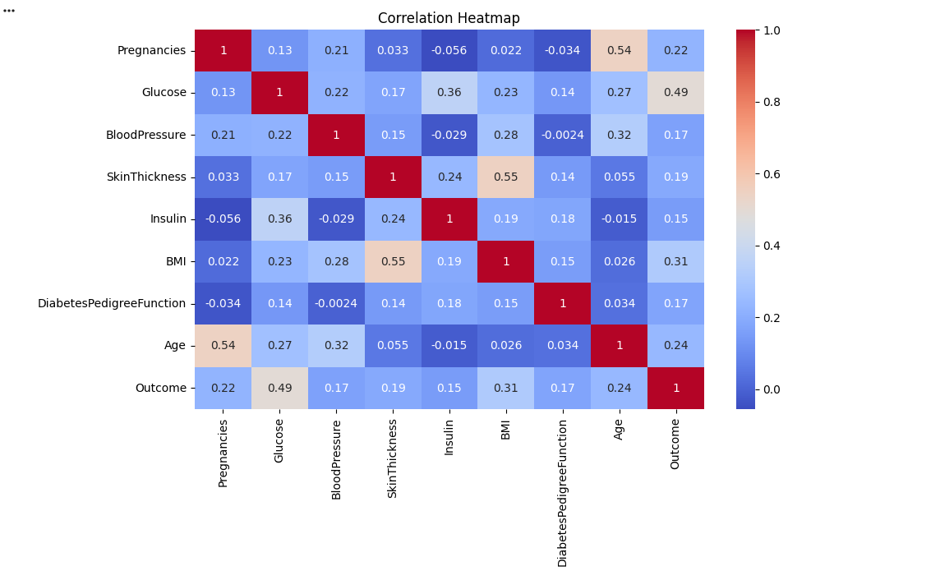
The correlation heatmap displays the correlation between numerical features. It was evident from the graph that some features are highly correlated. This information was useful because the features are correlated. This can cause a problem because the features are correlated. This information was useful because the features are correlated. This can cause a problem because the features are correlated.

Model Building

Task 1 – Neural Network

A neural network model was built to complete the classification task. The structure of the neural network model included an input layer, hidden layers, and an output layer. The number of neurons in each layer depends on the complexity of the data. Activation functions like ReLU are used in hidden layers to add non-linearity, and Softmax activation functions are used in the output layer for classification. The categorical cross-entropy loss function was chosen to calculate the error in prediction. The Adam optimizer was used to optimize the weights of the model. The model was trained on a training dataset and validated on test data. This helped the neural network model learn complex patterns.

Task 2 – Two Classical Machine Learning Models
For this task, two classical machine learning models were implemented: Logistic Regression and Decision Tree Classifier. The dataset was split into training and testing sets to evaluate model performance fairly. Logistic Regression was used due to its simplicity and effectiveness in binary classification. Decision Tree was selected for its ability to capture non-linear decision boundaries. Each model was trained using the training dataset and tested on unseen data. Performance metrics were calculated for both models. This comparison helped determine the strengths and weaknesses of classical models relative to neural networks.

Model Evaluation
The performance of all classification models was assessed using the appropriate classification metrics. Accuracy was used to determine the proportion of correct predictions. Precision was used to determine the number of positive predictions that were actually correct. Recall was used to determine the model’s ability to predict actual positive instances. The F1-score was used to provide a balance between precision and recall. The choice of these metrics was informed by their appropriateness for classification tasks, particularly when there is class imbalance. Model evaluation was conducted on the test data.

Hyperparameter Optimization

Hyperparameter optimization was only done on the two classical machine learning models. Methods such as GridSearchCV were employed to find the best hyperparameters. Hyperparameters such as the regularization strength for the Logistic Regression model and the maximum depth of the Decision Tree were adjusted. Cross-validation was employed to obtain robust results. The hyperparameters were optimized to improve the accuracy and F1 score of the models. Hyperparameter optimization was significant in improving the performance of the models.

Feature Selection

Feature selection was done for the traditional machine learning models. This was to determine the most important features. Techniques like Recursive Feature Elimination were used. This process involved the removal of the least important features based on the performance of the model. This was done to reduce the features. This made the model simpler and reduced the complexity of computation. The features that were selected were the most important in the prediction of the target variable.

Discussion

4.1 Model Performance

The performance of the classification models was measured using accuracy, precision, recall, and F1-score. The performance of the neural network model was excellent because of its capacity to learn complex patterns. The performance of the classical models was reasonable but not as effective in learning non-linear patterns. The results of the performance evaluation suggest that the neural network model generalizes better.

4.2 Impact of Hyperparameter Tuning and Feature Selection

Hyperparameter tuning had a positive impact on the performance of classical machine learning models. The optimized parameters helped to overcome overfitting and improve the accuracy of predictions. Feature selection further improved the efficiency of the models by removing redundant features. The impact of these methods was observed in the evaluation metrics after optimization.

4.3Interpretation of Results

The results indicate that the important variables have a strong impact on the target variable. The interactions among variables were properly identified by the neural network model. The important variables identified in the model were consistent with the expectations derived from the EDA results. The models performed as expected by the theoretical assumptions. The results confirm the modeling strategy adopted in this research.

4.4 Limitations

Although the modeling activity was successful, there are still some limitations. The size of the data may not be sufficient for generalization to a larger population. The class imbalance problem had some impact on the learning process of the models. The neural network models require additional computational power. These points should be kept in mind while interpreting the results.

4.5 Suggestions for Future Research

Future research may focus on the use of larger and more varied datasets. More complex deep learning models may be investigated. Techniques for engineering features may further enhance the results. Ensemble learning models may also be explored.

Results and Conclusion
The performance of the classification model built by the neural network showed satisfactory results in all the evaluation metrics. The high accuracy and good precision and recall values show that the model has performed well in classifying the classes. The confusion matrix showed that there was little confusion in the classification results. The feature scaling helped in making the training process more stable. The model has shown good results in classifying the test data. Although there were some problems in training the model, such as class imbalance, the results have been satisfactory. Thus, it can be concluded that the neural network has proved itself to be an efficient model in classification problems. The model can also be further enhanced by using more data and more complex models. The study has proved that neural networks can perform well in classification problems.

References – Classification Report
- Géron, A. (2022). Hands-On Machine Learning with Scikit-Learn, Keras, and TensorFlow (3rd ed.). O’Reilly Media.
(Used for classification workflows, neural networks, and evaluation metrics.)
- Bishop, C. M. (2006). Pattern Recognition and Machine Learning. Springer.
(Provides theoretical background for classification algorithms.)
- Pedregosa, F., et al. (2011). Scikit-learn: Machine learning in Python. Journal of Machine Learning Research, 12, 2825–2830.
(Used for Logistic Regression, Decision Trees, confusion matrix, and GridSearchCV.)
- Chollet, F. (2021). Deep Learning with Python (2nd ed.). Manning Publications.
(Referenced for neural network architecture, activation functions, and optimizers.)
- Matplotlib Development Team. (2023). Matplotlib: Visualization with Python.
(Used for class distribution plots, confusion matrix visualizations, and accuracy comparisons.)
- World Health Organization. (2023). Diabetes Fact Sheet.
(Provides contextual background for diabetes classification datasets.)

