# CRM APPLICATIONS FOR SCHOOLS AND COLLEGES

# 1 INTRODUCTION

1.1 OVERVIEW

CRM application are software tools designed to help businesses manage and analyze

Interactions with their customers and potential customers. Thes applications typically include

Capabilities such as tracking customer interactions across multiple channels,automaticaly

Repetitive workflows,and generating reports and analytics to inform customer engagement

Strategies.CRMapplications are used by sales,marketing and customer service team to

Improve communication,better unterstand the needs of customers,and ultimately drive

Customer loyality and retention.They can be deployed as cloud-based software as a service

Or as on-premise software installations.

1.2 Purpose

Crm software help organisation consolidate customer data from various channels,

Such as email,phone,social media,and web forms,into a centralized database.this helps

Businesses to better understand customer preference,behaviour and needs and creat

More personalized and relevant experiences for their customer.advanced crm application

Offen features like predictive analytics,reporting,and forecasting,wich help businesses

identify ,trends,uncover insighta,and make data-driven decisions.

# 2 problem definition and design thinking

2.1 empathy map

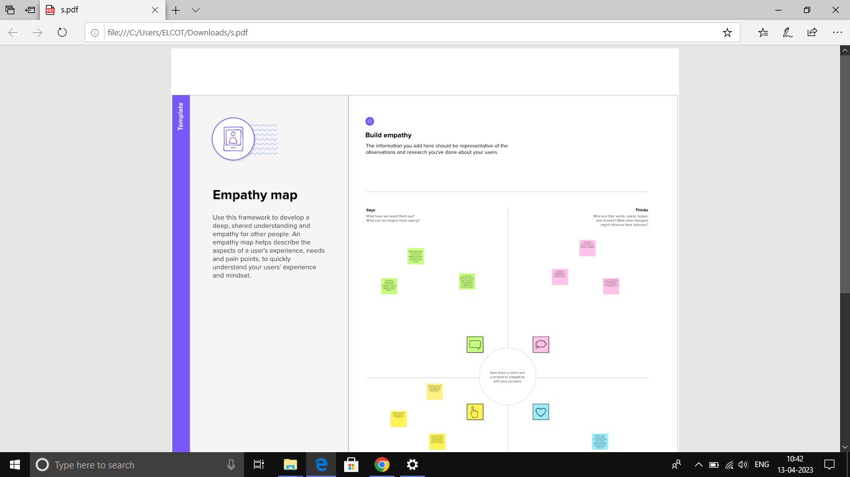

2.2 identiation and brainstorming map

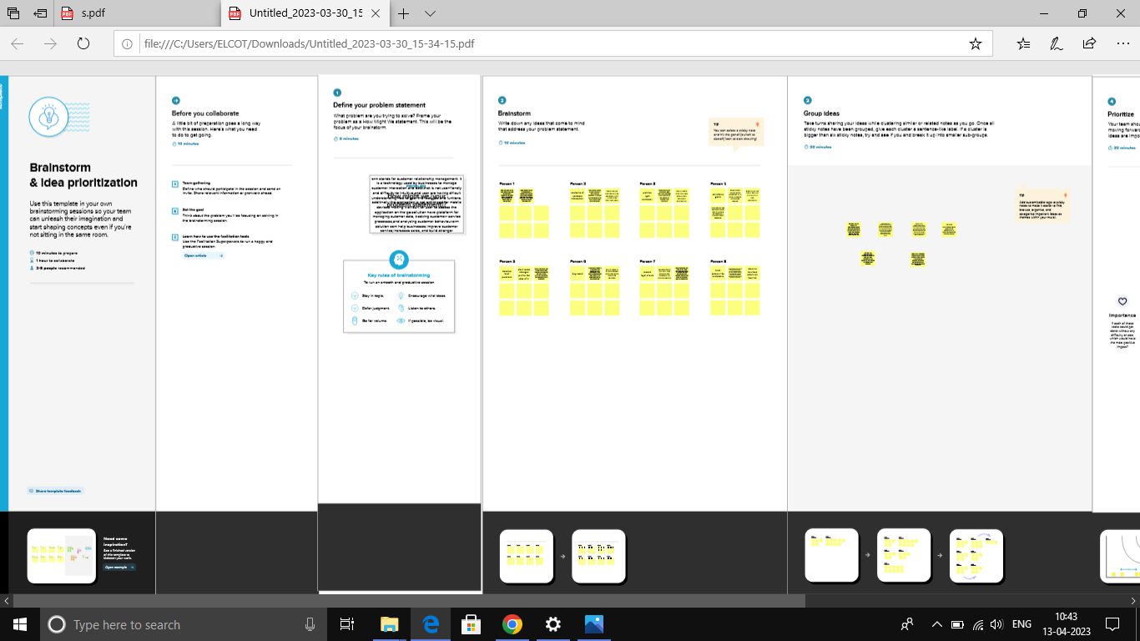

RESULT

|  |  |  |  |  |  |
| --- | --- | --- | --- | --- | --- |
| Object 1 | Field in the object  |  |  | | --- | --- | | Field lable | Tada table | | Parent name | Text [80] | |
| Object 2 | |  |  | | --- | --- | | Field lable | Tata table | | Parents name | Text [80] | |
| Object 3 | |  |  | | --- | --- | | Field lable | Data type | | School name | Text [80] | |

# 3.2 ACTIVITY AND SCREEN SHORT

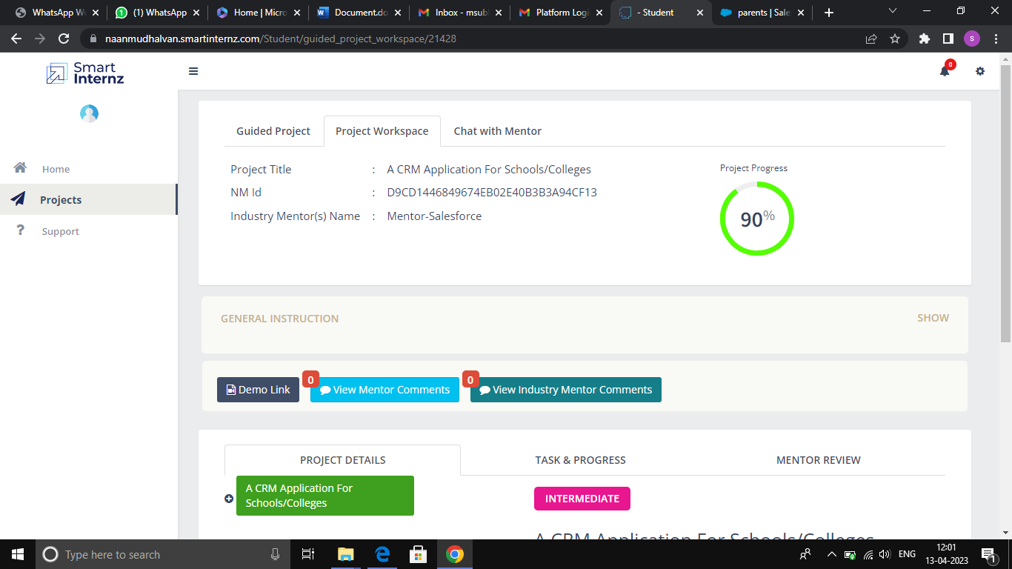

# 4 TRAILHEAD PROFILE BUBLIC URL

TEAM LEADER - <https://trailblazer.me/id/msubha>

TEAM MEMBER 1 – <http://trailblazer.me/id/parameshwari12>

TEAM MEMBER 2 –http://trailblazer.me/id/pitchammal24

TEAM MEMBER 3 -http://trailblazer.me/id/jothi07

# 5 ADVANDAGES AND DISADVANDAGE Advandages

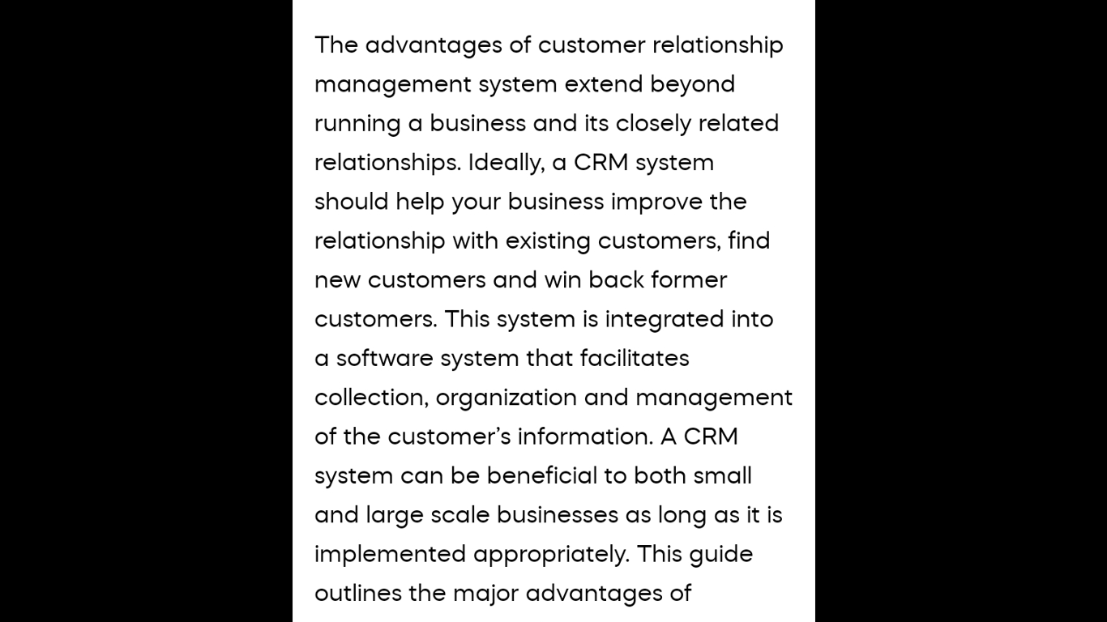

Disadvandages and solution

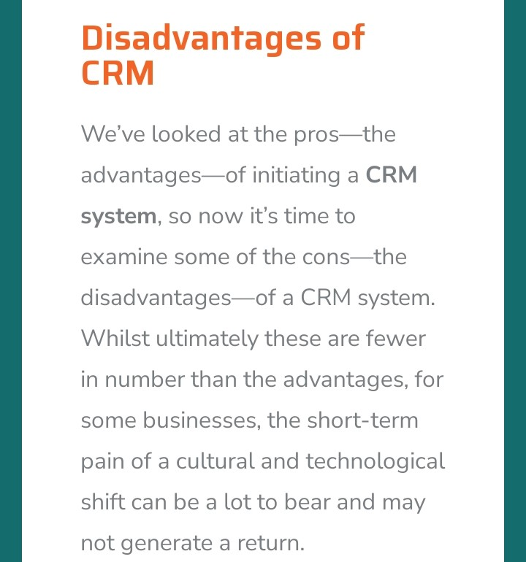

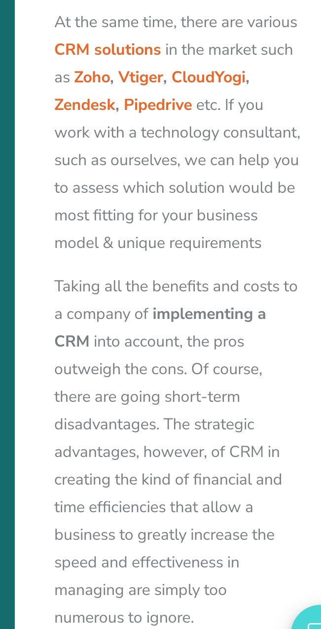

# 6 APPLICATION

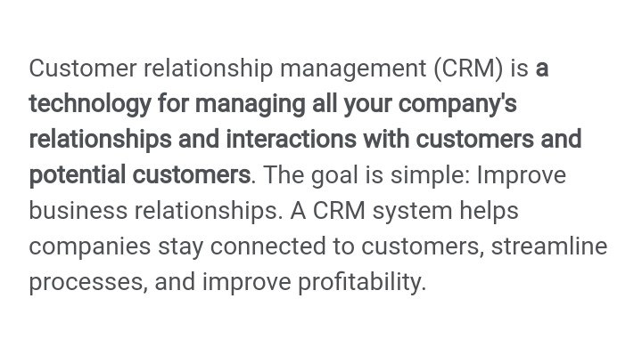

# 7 CONCLUSION

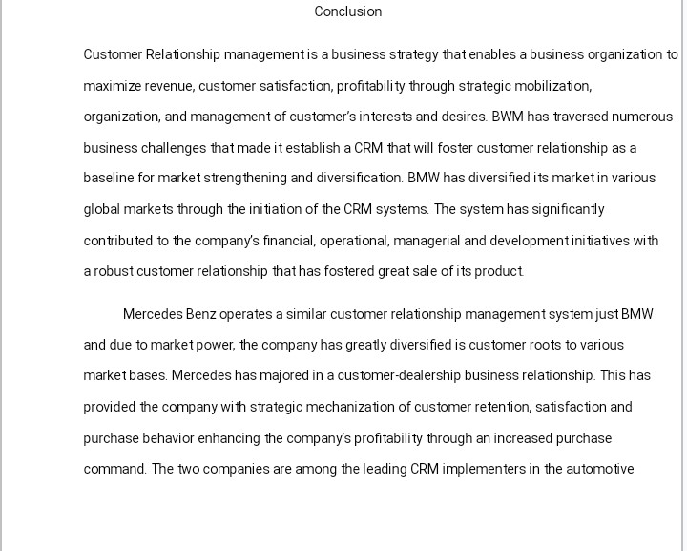

# 8 FUTURE HOPE

