**Call For Code 2019 – DSA_K_Riders**

**Project Title**

*Risk mitigation mechanism tool for disaster preparedness and relief*

**Project Description**

*When we brainstorm to identify some area where we can contribute in the various phases of Disaster Management - forecast/prediction, preparedness, evacuation, relief aid distribution and reconstruction. We discover that latest technology - satellite and GIS system are working pretty well in forecasting and prediction. Even we can integrate with last time owl project to overcome the hurdle of communication.*

*Based on our research and study we have identified that human being, animals and vehicles are massively impacted during the time of evacuation and getting relief. Timely supply of relief materials like water, food, clothes and medicines are badly impacted. That result to death of human beings, animal. Communication and known routes are disrupted and easily reachable routes turns distinct. Sometime after following a route, people need to reverse back and it seems that they have lost route and get panic. All volunteers are also unaware of all the terrains in affected area, so it is also difficult to organize and work with collaboration. This project is to address the problem in all type natural disasters.*

*The project comprises of 3 parts –*

*Part 1#*

* *Organizing the volunteers*
* *Forming team with foreign and local volunteers with translator and key skills*
* *Providing necessary safety gears for their own safety*
* *Identifying the relief materials based on the type of disaster*

*Part 2#*

* *Identifying the safe shelters and evacuating the evacuees*
* *Suggesting of resources based on the populations*
* *Suggesting optimal routes to be followed for evacuation avoiding crowd rush and panic*

*Part 3#*

* *Deployment of team on the relief activities*
* *Suggesting optimal route*
* *Suggesting means of transport to reach the disaster zone*
* *Continuous and uniform supply of resources and aid*

*Explain the project using the Architectural diagram (Must)*

*In the below diagram, in part# 1, we are trying to organize the volunteers with the help of survey or some app. Whoever is volunteering shall need to submit the survey and provide their details and based on those details team will get formed and if there is any last moment retire hurt, available volunteers can refill the gap. We are trying to build a community of humanitarian people who are ready to volunteers and provide then opportunity. The part# 1 dashboard provides a view in which the volunteers can check for vacancy and contact the team lead or coordinator, and even the coordinator can check for available volunteers with necessary skillset. Part# 2 is to move the evacuees to safer shelters.*

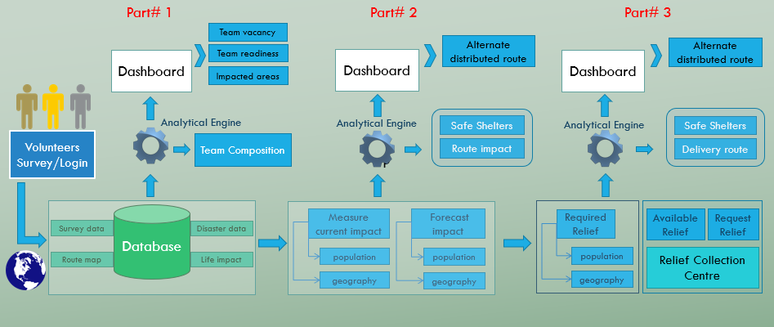

*Attach any demo video if is available of project*

**Current Problem -**

*Now a day, as soon as a natural disaster is forecasted, government officials and volunteers get deployed to measure and monitor the impact and intensity. Volunteers need to reach the location faster and primary goal shall be to shift people, cattle and park vehicles to some safer location. The intensity and timing are always badly estimated and communication is also impacted. Due to this problem, they couldn’t reach to safer shelter within time and many people and animal loss their life, vehicles also get damaged with water or fire.*

* ***What is the problem?*** 
  + *Inorganized & unoptimized disaster preparedness and volunteering activities*
* ***Who has this problem?***
  + *Disaster affected lives*
  + *Unorganized and ill-equipped volunteers*
* ***Why should this problem be solved?***
  + *Save life of evacuees*
  + *Suggesting timely guidance and support*
* ***How will I know this problem has been solved?***
  + *Reduction in death toll*
  + *Save animals, vehicles*
  + *Availability of sufficient relief aids with timely alert*

**Solution Description -***The solution to the above problem is to create a web app or survey through google form to capture information related to volunteers. When natural disaster occurs, we can classify the volunteer to be local or not. Volunteers can form team but local guidance position will be left vacant or any key skills required for the team will be left vacant as per Team owners request. Alert of the vacancy will get notified in the dashboard of part# 1. Also, we can incorporate the need of volunteers with certain composition for certain type of disaster. We can also provide guidelines based on the type of disaster to the team so that team are equipped with necessary gears and facility through a checklist. When disaster is supposed to hit or well before hitting or just on hitting based on the forecast, the evacuees need to be evacuated and let them reach to the safer shelters following certain route and vehicles/cattle are required to be relocated to safer location. Relief aid accumulated across the globe via shall reach a centre or warehouse and from there follow a route on road/water/air can reach to the evacuees based on their presence.*

**Included Components -**

*The elements and IBM Cloud services that we are planning to use are IBM Object Storage, R Studio, Shiny, Python, SQL Query*

**Featured Technologies -**

*Different kind of technologies we are planning to use in our project*

*Google Forms, google sheet, R Studio, Shiny, Mapbox or OpenStreetMap, Google Earth, Python, IBM Cloud*

**Architecture Diagram -**

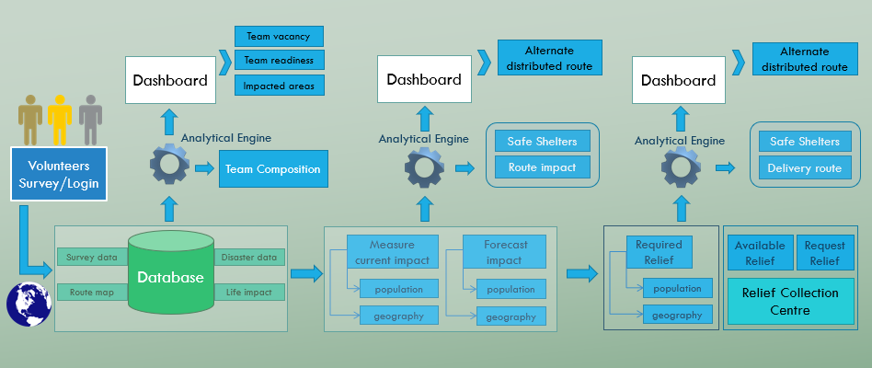

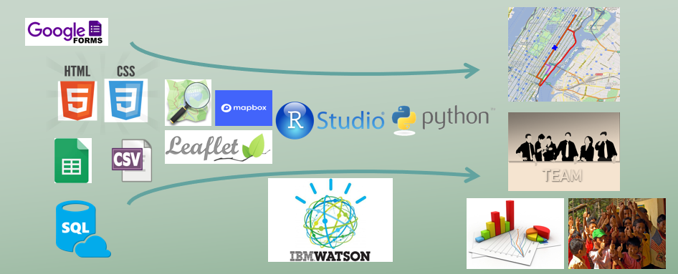

**Steps -**

* *Detailed steps to setup your project (Include screenshots/video link if possible)*
* *Deployed Application Link*

**Yet to be published**

**Results -**

*Currently, the project is in ideation phase. We did some basic mathematical programming and some sample data collection is in progress to know the ground reality of the scope of the project.*

*Team members –*

*KUNTAL CHAKRABORTY (698772)*

*RAHUL SAHA (434520)*

*ANIRUDDHA BOSE (179041)*

*JOYDEEP MUKHERJEE (774759)*