Ex. No. : 1 Date:

Register No.: 231701045 Name: P. Sahaana

Bresenham’s Line Algorithm, Midpoint Circle

Algorithm, and Midpoint Ellipse Algorithm AIM:

To implement:

* Bresenham’s Line Drawing Algorithm
* Midpoint Circle Drawing Algorithm
* Midpoint Ellipse Drawing Algorithm

And draw geometric shapes on the screen.

Procedure:

1. Initialize graphics mode using suitable graphics libraries (e.g., OpenGL in C++, turtle or matplotlib in Python).
2. For each algorithm:

o Accept user input for coordinates or radius. o Implement the plotting logic using the respective algorithm. o Plot the pixels on the screen.

Program:

import matplotlib.pyplot as plt

def plot_point(x, y): plt.plot(x,

y, 'bo')

def bresenham_line(x1, y1, x2, y2):

dx = abs(x2 - x1) dy = abs(y2 - y1) x, y = x1, y1 sx = 1 if x2 > x1 else -1 sy = 1 if y2 > y1 else -1 if dx > dy:

err = dx / 2.0 while x != x2:

plot_point(x, y) err -= dy

if err < 0: y += sy err += dx x += sx else:

err = dy / 2.0 while y != y2: plot_point(x, y) err -= dx if err <

0: x += sx err += dy y += sy

plot_point(x, y)

def midpoint_circle(xc, yc, r):

1. = 0 y = r p = 1 - r while x <= y:

for a, b in [(x, y), (y, x), (-x, y), (-y, x), (-x, -y), (-y, -x), (x, -y), (y, -x)]: plot_point(xc + a, yc + b) x += 1

if p < 0: p += 2*x + 1 else: y -= 1

p += 2*(x - y) + 1

def midpoint_ellipse(rx, ry, xc, yc): x, y = 0, ry rx2, ry2 = rx**2, ry**2 p1 = ry2 - (rx2 * ry) + (0.25 * rx2) dx = 2 * ry2 * x dy = 2 * rx2 * y

while dx < dy: for a, b in [(x, y), (-x, y), (x, -y), (-x, -y)]:

plot_point(xc + a, yc + b) x += 1

dx = 2 * ry2 * x if p1 < 0:

p1 += dx + ry2 else:

1. -= 1 dy = 2 * rx2 * y

p1 += dx - dy + ry2

p2 = (ry2 * (x + 0.5)**2) + (rx2 * (y - 1)**2) - (rx2 * ry2)

while y >= 0: for a, b in [(x, y), (-x, y), (x, -y), (-x, -y)]:

plot_point(xc + a, yc + b)

y -= 1 dy

= 2 * rx2 * y if p2 > 0: p2 -= dy + rx2

else:

x += 1 dx

= 2 * ry2 * x p2 += dx - dy + rx2

plt.figure(figsize=(8, 8)) bresenham_line(10, 10, 100, 50) midpoint_circle(100, 100, 40) midpoint_ellipse(60, 30, 200, 200) plt.gca().set_aspect('equal', adjustable='box') plt.grid(True) plt.show()

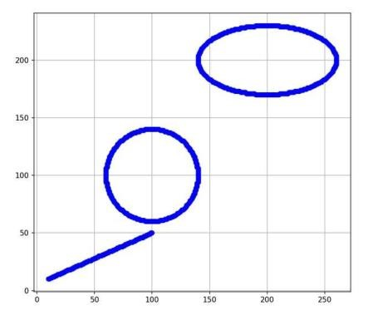

Result:

Thus, the line, circle, and ellipse were successfully drawn using Bresenham's and Midpoint algorithms.