Ex. No. : 2 Date:

Register No.: 231701045 Name: P. Sahaana

Scan Conversion of Polygon and Area Filling using Flood-Fill Algorithm AIM:

To implement: 1. Scan conversion (drawing) of a polygon.

2. Flood-fill algorithm to fill the polygonal area in a graphics window.

Procedure:

Polygon Scan Conversion:

1. Input the number of vertices and their coordinates.
2. Connect the vertices in order to draw polygon edges using line drawing algorithms.

Flood-Fill Algorithm:

1. Select a point inside the polygon as the seed point.
2. Recursively check neighboring pixels.
3. Replace target color with fill color if conditions match.

Program:

import matplotlib.pyplot as plt import

numpy as np

from collections import deque

width, height = 300, 300 canvas = np.ones((height, width, 3), dtype=np.uint8) * 255 # White canvas

def draw_polygon(vertices): for

i in range(len(vertices)): x1, y1 = vertices[i]

x2, y2 = vertices[(i+1)%len(vertices)]

8 .

bresenham_line(x1, y1, x2, y2)

def bresenham_line(x1, y1, x2, y2): dx = abs(x2 - x1) dy =

abs(y2 - y1) x, y = x1, y1 sx = 1 if x2 > x1 else -1 sy = 1 if y2 > y1 else -1 if dx > dy:

err = dx / 2 while x != x2: canvas[y, x] = [0, 0, 0]

err -= dy if err < 0: y += sy err += dx x += sx canvas[y, x] = [0, 0, 0] else: err = dy / 2 while y !=

y2: canvas[y, x] = [0, 0,

0] err -= dx if err < 0: x += sx err += dy y += sy

canvas[y, x] = [0, 0, 0]

'''def flood_fill(x, y, target_color, fill_color): if x < 0 or x >= width or y < 0 or y >= height: return if not np.array_equal(canvas[y, x], target_color): return canvas[y, x] = fill_color

flood_fill(x+1, y, target_color, fill_color) flood_fill(x-1, y, target_color, fill_color) flood_fill(x, y+1, target_color, fill_color)

flood_fill(x, y-1, target_color, fill_color)

'''

def flood_fill_iter(x, y, target_color, fill_color): target =

np.array(target_color, dtype=np.uint8) fill = np.array(fill_color, dtype=np.uint8)

if x < 0 or x >= width or y < 0 or y >= height: return if not np.array_equal(canvas[y, x], target):

return

q = deque([(x, y)]) while

q:

cx, cy = q.popleft() if cx < 0 or cx >= width or cy < 0 or cy >= height:

9 .

continue if np.array_equal(canvas[cy,

cx], target): canvas[cy, cx] = fill_color q.append((cx+1, cy))

q.append((cx-1, cy))

q.append((cx, cy+1))

q.append((cx, cy-1))

# Main Execution

vertices = [(50, 50), (250, 50), (200, 200), (100, 250), (50, 150)]

draw_polygon(vertices) flood_fill_iter(150, 100, [255, 255, 255], [255, 0, 0])

plt.imshow(canvas) plt.title("Polygon Fill using Flood-

Fill Algorithm") plt.axis('off') plt.show()

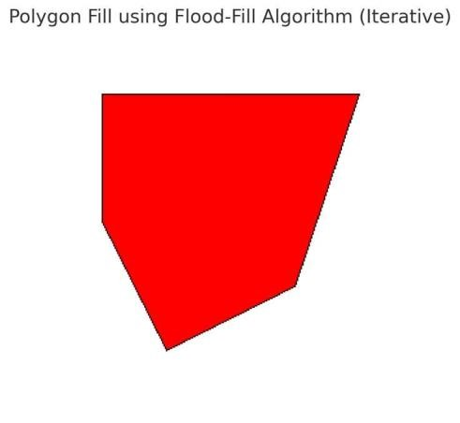

Result:

A polygon will be drawn and filled with red color using the flood-fill algorithm.

1 .