  - DIA-GLY3
  - CLINICAL STUDY REPORT
  - GLY-301 Added to Metformin Versus Placebo Added to Metformin in Adults With Type 2 Diabetes
  - Version 1.0 Draft | 8 November 2026
  - Educational Simulated Clinical Trial
  - Disclaimer
  - This report describes a fully simulated clinical trial developed for educational and professional portfolio purposes. All participant data, treatment assignments, efficacy results, and safety findings are fictional. The results do not constitute evidence of clinical efficacy or safety in actual patients and should not be used to guide clinical decisions.

1. Executive Summary
DIA-GLY3 was a simulated, 26-week, randomized, double-blind, placebo-controlled, parallel-group Phase III clinical trial evaluating the efficacy and safety of GLY-301 added to metformin compared with placebo added to metformin in adults with type 2 diabetes mellitus.
A total of 478 participants were randomized equally between the two treatment groups (239 participants per arm). The Full Analysis Set included all randomized participants, and the Safety Analysis Set included all participants who received study treatment.
The primary efficacy endpoint was change in glycated hemoglobin (HbA1c) from baseline to Week 26. Week-26 HbA1c measurements were missing for 96 participants (20.1%). Missing outcomes were addressed using treatment-specific multiple imputation under a missing-at-random assumption, followed by analysis of covariance.
The adjusted treatment difference in HbA1c change (GLY-301 minus placebo) was −0.558 percentage points (95% CI: −0.811 to −0.305; p = 0.00001974), favoring GLY-301.
Key secondary efficacy analyses also favored GLY-301. The adjusted odds ratio for achieving HbA1c below 7% at Week 26 was 2.697 (95% CI: 1.638–4.443; p = 0.0001174). The adjusted treatment difference in fasting plasma glucose change was −12.398 mg/dL (95% CI: −21.039 to −3.756; p = 0.005105), while the adjusted difference in body-weight change was −1.593 kg (95% CI: −1.870 to −1.315; p < 0.0001).
A supportive mixed model for repeated measures analysis yielded a Week-26 HbA1c treatment difference of −0.575 percentage points (95% CI: −0.801 to −0.349), consistent with the primary analysis. A missing-not-at-random sensitivity analysis identified a tipping point of +1.34 percentage points under the specified delta-adjustment scenario, at which the primary treatment comparison was no longer statistically significant at the two-sided 5% level.
Safety analyses identified a higher incidence of treatment-emergent adverse events in the GLY-301 group (46.4%) than in the placebo group (34.3%). Hypoglycemia was reported in 15.9% and 3.8% of participants, respectively. Serious treatment-emergent adverse events occurred in 2.9% of GLY-301 participants compared with 0.8% of placebo participants.
Overall, GLY-301 demonstrated statistically significant improvements in glycemic efficacy in this simulated study. However, the increased incidence of hypoglycemia and other adverse events prevents an unqualified conclusion of a favorable benefit–risk profile.
All study data, treatment effects, and safety findings are simulated for educational and portfolio purposes. They do not constitute evidence of efficacy or safety in actual patients.

2. Study Design and Analysis Populations
DIA-GLY3 was designed as a simulated, 26-week, randomized, double-blind, placebo-controlled, parallel-group Phase III clinical trial evaluating GLY-301 as an add-on therapy to metformin in adults with type 2 diabetes mellitus.
Participants were randomized in a 1:1 ratio to receive either GLY-301 plus background metformin or placebo plus background metformin. Randomization was stratified according to baseline HbA1c level (<9% versus ≥9%).
The primary efficacy endpoint was change in HbA1c from baseline to Week 26. Key secondary efficacy endpoints included achievement of HbA1c below 7%, change in fasting plasma glucose, and change in body weight at Week 26.
The Full Analysis Set comprised all 478 randomized participants, with 239 participants assigned to each treatment group. The primary efficacy analysis followed a treatment-policy estimand strategy, retaining observed outcomes following rescue medication use or treatment discontinuation.
The Safety Analysis Set comprised all 478 participants who received at least one dose of study treatment. Safety outcomes were summarized according to actual treatment received.
Safety assessments included treatment-emergent adverse events, serious adverse events, hypoglycemia, treatment exposure, and treatment adherence. Recorded hypoglycemia episodes were evaluated from the first dose of randomized study treatment through 30 days after the last dose, consistent with the study Protocol and Statistical Analysis Plan.
All trial participants, treatment assignments, clinical measurements, and adverse events were simulated. No real patients participated in the study.
3. Statistical Methods
3.1 General Considerations
Efficacy analyses were performed using the Full Analysis Set, comprising all 478 randomized participants. Safety analyses were performed using the Safety Analysis Set, comprising all 478 treated participants.
Unless otherwise specified, treatment effects were expressed as GLY-301 minus placebo. All statistical tests were two-sided, with a significance level of 0.05.
3.2 Primary Efficacy Analysis
The primary endpoint, change in HbA1c from baseline to Week 26, was analyzed using analysis of covariance (ANCOVA), with randomized treatment, baseline HbA1c, and baseline HbA1c stratification group as explanatory variables.
Missing Week-26 outcomes were addressed using treatment-specific multiple imputation under a missing-at-random assumption. Predictive mean matching was performed separately within treatment groups using 50 imputations, 20 iterations, and five donors.
ANCOVA was fitted to each completed dataset, and treatment estimates and standard errors were combined using Rubin's rules.
Imputation trace plots were visually inspected for evidence of systematic drift. Such diagnostics do not establish the validity of the missing-at-random assumption.
3.3 Key Secondary Efficacy Analyses
Achievement of HbA1c below 7% at Week 26 was evaluated using logistic regression, adjusting for treatment, baseline HbA1c, and baseline HbA1c stratum. Responder status was derived from the multiply imputed HbA1c outcomes, and adjusted log-odds estimates were combined using Rubin's rules.
Change in fasting plasma glucose from baseline to Week 26 was evaluated using ANCOVA, adjusting for randomized treatment, baseline fasting plasma glucose, and baseline HbA1c stratum. Missing outcomes were addressed through treatment-specific multiple imputation under the missing-at-random assumption.
Change in body weight from baseline to Week 26 was evaluated using ANCOVA, adjusting for randomized treatment, baseline body weight, and baseline HbA1c stratum. All participants had observed Week-26 body-weight measurements; therefore, no imputation was required.
The four efficacy endpoints were evaluated using the planned fixed-sequence hierarchical testing procedure, with progression to the next hypothesis conditional on statistical significance of the preceding endpoint.
3.4 Supportive Longitudinal Analysis
A mixed model for repeated measures (MMRM) was used to analyze HbA1c change from baseline across Weeks 4, 8, 12, 18, and 26.
The MMRM included treatment, categorical visit, treatment-by-visit interaction, baseline HbA1c, baseline HbA1c-by-visit interaction, and baseline HbA1c randomization stratum as fixed effects. An unstructured covariance matrix modeled within-participant correlations. Kenward–Roger degrees-of-freedom adjustment was applied.
The analysis used observed post-baseline measurements under a missing-at-random assumption.
3.5 Missing-Not-at-Random Sensitivity Analysis
A delta-adjustment sensitivity analysis evaluated departures from the missing-at-random assumption.
Positive delta values were added to imputed Week-26 HbA1c changes for GLY-301 participants with missing outcomes. Observed outcomes and placebo imputations were unchanged.
The primary ANCOVA model was refitted under each scenario, and estimates were combined using Rubin's rules. A refined analysis used delta increments of 0.01 percentage points to identify the first tested scenario in which the two-sided p-value reached or exceeded 0.05.
3.6 Safety Analyses
Safety endpoints were summarized descriptively by treatment group.
Adverse events were summarized by occurrence, system organ class, event term, maximum severity, seriousness, and assessed relationship to study treatment. Participants were counted once within each applicable participant-level category.
Hypoglycemia was summarized by participant incidence, event frequency, recorded severity level, external assistance, and recurrence. Events occurring from the first dose of randomized study treatment through 30 days after the last dose were included in the safety summaries, consistent with the study Protocol and Statistical Analysis Plan.
Treatment exposure and adherence were summarized using descriptive statistics.
No formal hypothesis testing was performed for the safety comparisons.
3.7 Statistical Programming and Validation
Statistical analyses were conducted using R. Simulated raw data were transformed into simplified SDTM-style and ADaM-style datasets for analysis and reporting.
Dataset integrity, statistical consistency, and output-file checks were performed. One dosing-period-only hypoglycemia timing check was flagged because 12 events occurred after the last dose; a separate investigation confirmed that all 12 occurred within the recorded 30-day safety follow-up window.
The datasets and validation procedures were developed for educational purposes and do not represent a fully CDISC-compliant regulatory submission.
4. Participant Disposition
Table T14.1.1. Participant Disposition — Randomized Population
Disposition | GLY-301 (N=239) | Placebo (N=239)
Randomized | 239 (100.0%) | 239 (100.0%)
Full Analysis Set | 239 (100.0%) | 239 (100.0%)
Safety Analysis Set | 239 (100.0%) | 239 (100.0%)
Completed planned treatment | 208 (87.0%) | 212 (88.7%)
Discontinued study treatment | 31 (13.0%) | 27 (11.3%)

All 478 randomized participants were included in both the Full Analysis Set and Safety Analysis Set. Planned study treatment was completed by 208 participants (87.0%) in the GLY-301 group and 212 participants (88.7%) in the placebo group. Study treatment was discontinued by 31 participants (13.0%) receiving GLY-301 and 27 participants (11.3%) receiving placebo. Overall, treatment completion was similar between groups. These figures describe study-treatment disposition and do not necessarily represent completion of all study assessments or post-treatment safety follow-up.
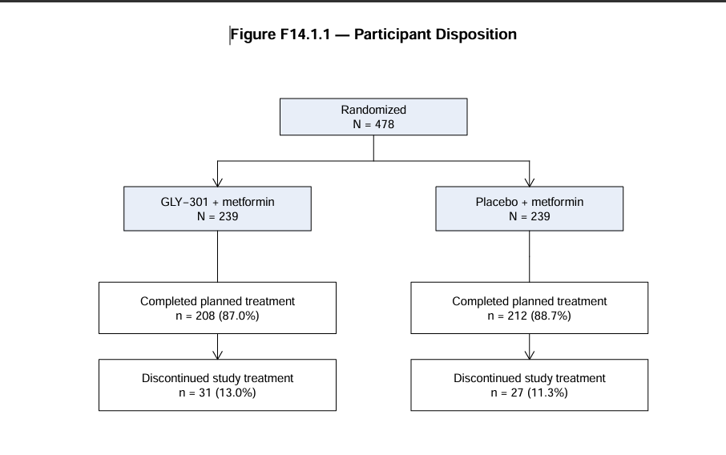
Figure F14.1.1 — Participant Disposition by Randomized Treatment Group
A total of 478 participants were randomized equally between GLY-301 plus metformin (n = 239) and placebo plus metformin (n = 239). All randomized participants were included in both the Full Analysis Set and Safety Analysis Set.
In the GLY-301 group, 208 participants (87.0%) completed planned study treatment, compared with 212 participants (88.7%) in the placebo group. Study treatment was discontinued by 31 participants (13.0%) in the GLY-301 group and 27 participants (11.3%) in the placebo group.
Treatment completion and discontinuation are distinguished from overall study completion.

Table T14.1.2. Demographic and Baseline Characteristics — Full Analysis Set
Characteristic | Placebo (N=239) | GLY-301 (N=239)
Age (years), mean (SD) | 46.29 (16.80) | 46.32 (16.46)
Female, n (%) | 113 (47.3%) | 107 (44.8%)
Male, n (%) | 126 (52.7%) | 132 (55.2%)
BMI (kg/m²), mean (SD) | 30.92 (4.73) | 30.62 (4.84)
Baseline HbA1c (%), mean (SD) | 8.72 (0.65) | 8.73 (0.68)
HbA1c <9%, n (%) | 161 (67.4%) | 161 (67.4%)
HbA1c ≥9%, n (%) | 78 (32.6%) | 78 (32.6%)
Baseline FPG (mg/dL), mean (SD) | 205.74 (31.84) | 201.40 (33.73)
Baseline body weight (kg), mean (SD) | 87.49 (15.90) | 88.06 (17.59

Note: Continuous variables are summarized as mean (standard deviation), and categorical variables as number (percentage). Percentages are based on the treatment-specific Full Analysis Set (N = 239 per group). BMI = body mass index; FPG = fasting plasma glucose; HbA1c = glycated hemoglobin. All data are simulated.
Baseline demographic and clinical characteristics were generally comparable between treatment groups. Mean age was approximately 46 years in both groups, and the distribution of sex was similar. Mean baseline HbA1c was 8.72% in the placebo group and 8.73% in the GLY-301 group. Randomization stratification resulted in identical distributions of baseline HbA1c categories across treatment groups, with 67.4% of participants having HbA1c below 9% and 32.6% having HbA1c of 9% or higher. Baseline BMI, fasting plasma glucose, and body weight were also broadly similar between groups. These findings indicate no substantial descriptive baseline imbalances in the characteristics summarized.
Table T14.1.3 — Assessment of Selected Eligibility Criteria (Full Analysis Set)
Criterion | GLY-301 (N=239) | Placebo (N=239)
Age outside 18–75 years | 0 (0.0%) | 0 (0.0%)
Baseline HbA1c outside 7.5–10.5% | 0 (0.0%) | 0 (0.0%)
BMI outside 20–45 kg/m² | 0 (0.0%) | 0 (0.0%)
At least one evaluated eligibility violation | 0 (0.0%) | 0 (0.0%)
Source: outputs/tables/T14_1_3_partial_protocol_compliance.csv. Percentages use the treatment-group denominator (N=239).
All 478 randomized participants satisfied the three evaluated baseline eligibility criteria: age between 18 and 75 years, baseline HbA1c between 7.5% and 10.5%, and BMI between 20 and 45 kg/m². No violations of these criteria were identified in either treatment group.
This assessment was limited to eligibility criteria that could be evaluated using the available simulated baseline data. Other potential protocol deviations, including prohibited medication use, visit-window violations, and other eligibility or procedural violations, were not comprehensively assessed. Accordingly, this table represents a partial protocol compliance assessment rather than the complete major protocol deviations summary originally planned in the Statistical Analysis Plan (SAP). The absence of violations among the evaluated criteria should not be interpreted as evidence that no protocol deviations occurred during the trial.

5. Primary efficacy results
Table T14.2.1. Change in HbA1c from baseline to Week 26 — Full Analysis Set
Parameter | Placebo + metformin | GLY-301 + metformin
Randomized participants, n | 239 | 239
Week-26 observed, n | 196 | 186
Week-26 missing, n (%) | 43 (18.0%) | 53 (22.2%)
Baseline HbA1c, mean (SD), % | 8.72 (0.65) | 8.73 (0.68)
Week-26 HbA1c, mean (SD), % | 8.00 (1.40) | 7.47 (1.43)
Observed change, mean (SD), percentage points | −0.69 (1.27) | −1.23 (1.26)
Adjusted difference (GLY-301 − placebo) | — | −0.558
95% confidence interval | — | (−0.811, −0.305)
Two-sided p-value | — | 0.00001974
Note: Descriptive means and SDs at Week 26 are based on observed outcomes; the adjusted treatment contrast uses multiple imputation. The p-value is reported numerically rather than as <0.0001. All results are simulated.
Interpretation. The simulated data suggest a larger HbA1c reduction in the GLY-301 arm. The primary treatment contrast excludes zero and meets a two-sided 5% significance threshold. This permits progression to the next hypothesis in the planned hierarchical testing sequence, contingent on the prespecified analysis and its assumptions.
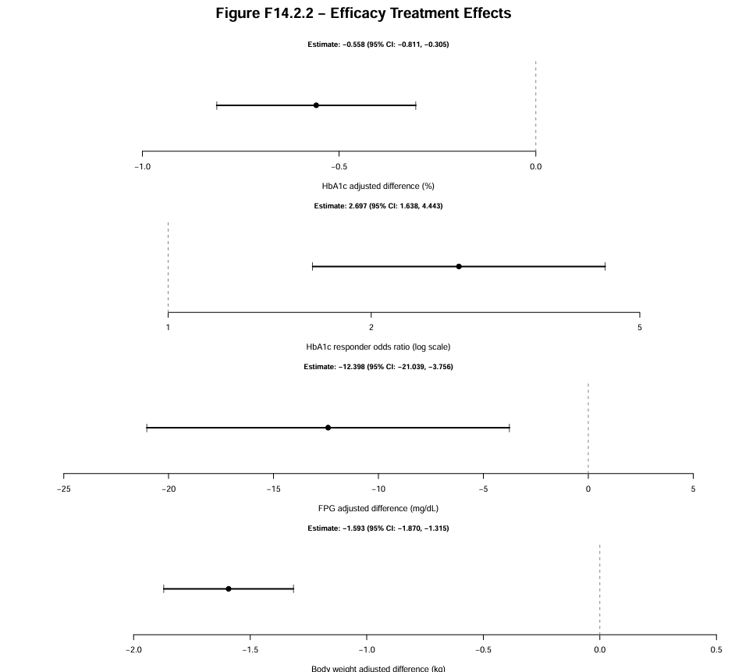
Figure F14.2.2 — Forest Plot of Primary and Secondary Efficacy Treatment Effects
Figure F14.2.2 summarizes the treatment effects of GLY-301 plus metformin compared with placebo plus metformin across the primary and secondary efficacy endpoints at Week 26.
GLY-301 demonstrated a greater reduction in HbA1c, with an adjusted treatment difference of −0.558 percentage points (95% CI: −0.811 to −0.305). The odds of achieving the prespecified HbA1c response were higher in the GLY-301 group (odds ratio: 2.697; 95% CI: 1.638 to 4.443).
GLY-301 was also associated with greater reductions in fasting plasma glucose (−12.398 mg/dL; 95% CI: −21.039 to −3.756) and body weight (−1.593 kg; 95% CI: −1.870 to −1.315).
All four confidence intervals excluded their respective null values, supporting treatment effects favoring GLY-301 across the evaluated efficacy endpoints.

5. Quality Control and Data Validation
Dataset integrity and statistical consistency checks were conducted to evaluate the reliability and reproducibility of the simulated clinical trial analyses.
The ADaM-style datasets passed 18 of 18 initial validation checks. Eight SDTM-style domains were generated and underwent initial record-count and identifier checks.
The final dataset integrity audit passed all 16 checks, including participant uniqueness, treatment allocation, dataset record counts, missing Week-26 HbA1c values, and adverse-event identifier consistency.
The statistical consistency audit passed 14 of 15 checks. The remaining check flagged 12 hypoglycemia episodes occurring after the last treatment dose. A separate investigation confirmed that all 12 occurred within the recorded 30-day post-treatment safety follow-up period. Four additional safety-window checks passed.
Six efficacy output files passed checks for existence, nonempty contents, and column availability. These file-level checks do not independently establish the numerical correctness of every estimate.
The simulated raw data were used to generate simplified SDTM-style and ADaM-style datasets through separate transformation pathways. The project does not implement the conventional raw-to-SDTM-to-ADaM data lineage.
Although the completed checks support internal consistency and reproducibility, they do not constitute comprehensive regulatory validation or establish CDISC compliance.
6. Analysis Completion Status
The following statistical analyses were completed for the simulated DIA-GLY3 clinical trial:
- Primary efficacy analysis of HbA1c change from baseline to Week 26 using multiple imputation and ANCOVA.
- Key secondary efficacy analyses of HbA1c responder status, fasting plasma glucose change, and body-weight change.
- Supportive longitudinal analysis of HbA1c change using a mixed model for repeated measures.
- Missing-not-at-random delta-adjustment sensitivity analysis, including a refined tipping-point assessment.
- Descriptive safety analyses of treatment-emergent adverse events, serious adverse events, hypoglycemia, treatment exposure, and adherence.
- Dataset integrity, statistical consistency, safety-window, and efficacy output-file quality-control checks.
The statistical programming and reproducibility checks were completed for the educational simulation. Final clinical reporting remains subject to document consistency review and confirmation of relevant protocol and Statistical Analysis Plan definitions.
7. Reproducibility and Source Outputs
All statistical programming was conducted using R. The project was organized into scripts for trial simulation, dataset creation, statistical analyses, table and figure generation, and quality control.
The principal analysis scripts included:
- Primary efficacy: 09_primary_efficacy.R and 10_create_primary_tlf.R
- HbA1c responder analysis: 11_responder_analysis.R
- Fasting plasma glucose: 12_fpg_analysis.R
- Body weight: 13_weight_analysis.R
- MMRM: 14_mmrm_analysis.R and 14a_mmrm_figure.R
- MNAR sensitivity: 15_mnar_sensitivity.R
- Safety analyses: 16_safety_analysis.R and 16a–16f safety summary scripts
- Quality control: 17_final_qc_audit.R, 17b_statistical_consistency_qc.R, 17c_hypoglycemia_followup_qc.R, and 17d_final_efficacy_qc.R
Analysis outputs were saved in the outputs/tables/, outputs/figures/, outputs/diagnostics/, and outputs/qc/ directories.
The primary efficacy analysis generated pooled model estimates, diagnostic trace plots, and Table T14.2.1. Secondary and supportive efficacy analyses generated Tables T14.2.2–T14.2.6 and the longitudinal MMRM figure. Safety analyses generated Tables T14.3.1–T14.3.6.
The project includes reproducibility and quality-control records documenting the completed analysis workflow.
All datasets and outputs were generated from simulated data. The programming framework was designed to demonstrate clinical statistical analysis and reporting rather than regulatory submission readiness.

8. Key secondary efficacy: HbA1c responder at Week 26
Responder status was defined as HbA1c <7% at Week 26. Observed proportions use available Week-26 values. Missing outcomes were addressed by deriving responder status from the 50 treatment-specific multiply imputed HbA1c changes, with baseline HbA1c added to the completed change scores. An adjusted logistic regression model included treatment, baseline HbA1c, and baseline HbA1c stratum; log-odds estimates were pooled using Rubin’s rules.
Table T14.2.2. HbA1c <7% at Week 26 — Full Analysis Set
Parameter | Placebo | GLY-301
Randomized, n | 239 | 239
Observed Week-26 values, n | 196 | 186
Missing Week-26 values, n | 43 | 53
Responders among observed, n | 45 | 78
Observed responder rate | 23.0% | 41.9%
Mean responder rate across MI datasets | 22.0% | 40.7%
Adjusted odds ratio (GLY-301 vs placebo) | — | 2.697
95% confidence interval | — | 1.638–4.443
Two-sided p-value | — | 0.0001174

Interpretation. In this simulated trial, the adjusted odds of achieving HbA1c <7% at Week 26 were higher with GLY-301 than placebo (OR 2.697; 95% CI 1.638–4.443; p=0.0001174). The odds ratio must not be interpreted as a risk ratio. Observed and multiply imputed rates are descriptive; the adjusted odds ratio is the inferential comparison.
Multiplicity. The primary endpoint (p=0.00001974) and first key secondary endpoint (p=0.0001174) each met the two-sided 0.05 threshold under the planned fixed-sequence hierarchy. Testing may proceed to fasting plasma glucose, conditional on final confirmation of the SAP and assumptions.
Limitations. The responder analysis used responder status derived from multiply imputed continuous HbA1c outcomes rather than a separately specified binary imputation model. The MAR assumption remains untestable, and the MNAR sensitivity analysis was conducted for the primary continuous HbA1c endpoint rather than specifically for responder status. All findings are derived from fictional simulated data and do not establish clinical efficacy.
Source outputs: programs/R/11_responder_analysis.R; outputs/tables/T14_2_2_observed_responders.csv; outputs/tables/T14_2_2_logistic_results.csv; outputs/diagnostics/responder_imputed_rates.csv.
9. Key Secondary Efficacy: Change in Fasting Plasma Glucose at Week 26
Table T14.2.3 — Change in fasting plasma glucose from baseline to Week 26
Full Analysis Set (FAS) · Simulated DIA-GLY3 trial

Parameter | Placebo | GLY-301
Participants | 239 | 239
Week 26 observed, n | 196 | 186
Week 26 missing, n | 43 | 53
Baseline FPG, mean (SD), mg/dL | 205.74 (31.84) | 201.40 (33.73)
Week 26 FPG, mean (SD), mg/dL | 183.38 (48.25) | 167.25 (53.35)
Change from baseline, mean (SD), mg/dL | −22.37 (40.92) | −33.79 (42.65)
Adjusted treatment difference, mg/dL | — | −12.398
95% CI, mg/dL | — | (−21.039, −3.756)
P-value | — | 0.005105

Fasting plasma glucose (FPG) was evaluated as the second key secondary efficacy endpoint in the Full Analysis Set (N = 478). At Week 26, FPG measurements were available for 196 participants in the placebo group and 186 participants in the GLY-301 group.
The observed mean (SD) change from baseline was −22.37 (40.92) mg/dL in the placebo group and −33.79 (42.65) mg/dL in the GLY-301 group.
An analysis of covariance (ANCOVA), adjusting for baseline FPG and baseline HbA1c stratum, was performed using 50 treatment-specific multiple imputations under a missing-at-random assumption.
The adjusted treatment difference (GLY-301 minus placebo) was −12.40 mg/dL (95% CI: −21.04 to −3.76; p = 0.0051), favoring GLY-301.
The result met the two-sided 0.05 significance threshold within the planned fixed-sequence hierarchical testing procedure, following statistically significant findings for the primary HbA1c endpoint and the first key secondary HbA1c responder endpoint.
These results were generated from simulated clinical trial data and do not represent evidence of efficacy in actual patients.
10. Body Weight Efficacy Results
Table T14.2.4 — Change in body weight from baseline to Week 26
Full Analysis Set · Simulated trial
Parameter | Placebo | GLY-301
Participants, n | 239 | 239
Week-26 observed, n | 239 | 239
Week-26 missing, n | 0 | 0
Baseline weight, mean (SD), kg | 87.49 (15.90) | 88.06 (17.59)
Week-26 weight, mean (SD), kg | 87.10 (15.89) | 86.08 (17.65)
Change from baseline, mean (SD), kg | −0.39 (1.57) | −1.98 (1.52)
Adjusted treatment difference, kg | — | −1.593
95% CI, kg | — | (−1.870, −1.315)
P-value | — | < 0.0001

Note: The adjusted treatment difference was estimated using ANCOVA with treatment, baseline body weight, and baseline HbA1c stratum. No imputation was required because all Week-26 body-weight measurements were available.
Participants receiving GLY-301 experienced a greater reduction in body weight from baseline to Week 26 than participants receiving placebo.
The adjusted treatment difference (GLY-301 minus placebo) was −1.593 kg (95% CI: −1.870 to −1.315; p < 0.0001), based on an ANCOVA model adjusting for baseline body weight and baseline HbA1c stratum.
All 478 randomized participants had observed Week-26 body-weight measurements; therefore, no missing-data imputation was required.
The result met the two-sided 0.05 significance threshold in the planned fixed-sequence hierarchical testing procedure. Although statistically significant, the clinical importance of the estimated weight reduction cannot be established from statistical significance alone.
All results were generated from simulated clinical trial data.
11 Hierarchical Testing Summary
Endpoint | Adjusted treatment effect | 95% CI | P-value
HbA1c change | −0.558 percentage points | −0.811 to −0.305 | 0.00001974
HbA1c responder | OR 2.697 | 1.638 to 4.443 | 0.0001174
FPG change | −12.398 mg/dL | −21.039 to −3.756 | 0.005105
Body-weight change | −1.593 kg | −1.870 to −1.315 | < 0.0001

12. Supportive Efficacy Analysis: Mixed Model for Repeated Measures (MMRM)
12.1 Statistical Methods
A supportive analysis of change in HbA1c from baseline was performed using a mixed model for repeated measures (MMRM) in the Full Analysis Set. The MMRM included treatment, categorical visit, treatment-by-visit interaction, baseline HbA1c, baseline HbA1c-by-visit interaction, and baseline HbA1c randomization stratum as fixed effects. An unstructured covariance matrix modeled within-participant correlations. Kenward–Roger degrees-of-freedom adjustment was applied.
The model was estimated using available observed post-baseline measurements under a missing-at-random (MAR) assumption, without explicit imputation. Kenward–Roger degrees-of-freedom adjustment was applied. Adjusted treatment differences (GLY-301 minus placebo) were estimated at each visit, with corresponding two-sided 95% confidence intervals and nominal p-values.
12.2 Results
Table T14.2.5. MMRM Adjusted Treatment Differences in HbA1c Change from Baseline
Visit | Adjusted Difference | 95% Confidence Interval | Nominal P-value
Week 4 | −0.224 | (−0.282, −0.166) | <0.0001
Week 8 | −0.336 | (−0.421, −0.252) | <0.0001
Week 12 | −0.449 | (−0.564, −0.334) | <0.0001
Week 18 | −0.552 | (−0.709, −0.395) | <0.0001
Week 26 | −0.575 | (−0.801, −0.349) | <0.0001
Note: Negative treatment differences favor GLY-301. P-values are nominal and have not been adjusted for multiple comparisons across visits.

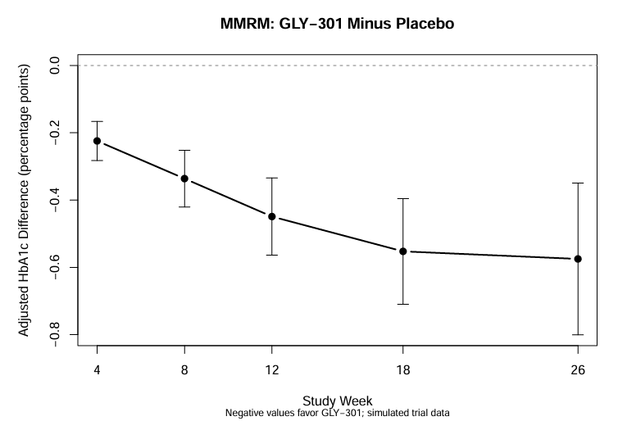
Figure F14.2.1. Adjusted Treatment Differences in HbA1c Change from Baseline by Visit (MMRM)
The figure presents adjusted GLY-301 minus placebo differences in HbA1c change from baseline at Weeks 4, 8, 12, 18, and 26. Vertical error bars represent two-sided 95% confidence intervals, and the dashed horizontal line represents no treatment difference.
Negative values favor GLY-301. The treatment difference increased in magnitude over the study period, with the largest estimated difference observed at Week 26. All findings are based on simulated clinical trial data.
The MMRM analysis demonstrated consistently greater reductions in HbA1c with GLY-301 compared with placebo across all post-baseline visits. The estimated treatment difference increased in magnitude from −0.224 percentage points at Week 4 to −0.575 percentage points at Week 26.
At Week 26, the adjusted treatment difference was −0.575 percentage points (95% CI: −0.801 to −0.349; p < 0.0001).
12.3 Comparison with the Primary Analysis
The supportive MMRM Week-26 estimate (−0.575 percentage points) was consistent with the primary multiple-imputation ANCOVA estimate (−0.558 percentage points). Both analyses favored GLY-301, with confidence intervals excluding zero.
These findings support the consistency of the primary efficacy conclusion under alternative statistical models relying on the MAR assumption. A missing-not-at-random sensitivity analysis was subsequently conducted to evaluate the robustness of the primary efficacy conclusion under departures from the MAR assumption. The methods and findings are presented in Section 13.
All findings are derived from simulated clinical trial data and do not constitute evidence of actual clinical efficacy.
13. Sensitivity Analysis: Missing-Not-at-Random Assumptions
13.1 Statistical Methods
A delta-adjustment sensitivity analysis was conducted to evaluate the robustness of the primary Week-26 HbA1c treatment comparison to departures from the missing-at-random (MAR) assumption.
The analysis reused the 50 multiply imputed datasets generated for the primary efficacy analysis. For participants randomized to GLY-301 with missing Week-26 HbA1c outcomes (n = 53), positive delta adjustments were added to their imputed changes from baseline. The SAP-prespecified delta values were 0.00, 0.20, 0.40, 0.60, 0.80, and 1.00 HbA1c percentage points. Additional exploratory scenarios evaluated delta values of 0.25, 0.50, 0.75, 1.50, and 2.00. Observed outcomes and imputed placebo outcomes were left unchanged.
For each delta scenario, the primary analysis of covariance (ANCOVA) model was refitted, adjusting for treatment, baseline HbA1c, and baseline HbA1c stratification group. Estimates and standard errors were combined across imputations using Rubin's rules.
The objective was to assess the sensitivity of the primary treatment conclusion to progressively less favorable assumptions regarding missing outcomes in the GLY-301 group.
13.2 Results
Table T14.2.6. MNAR Delta-Adjustment Sensitivity Analysis of HbA1c Change at Week 26

Delta Adjusted Difference 95% Confidence Interval P_value
0.00 -0.5577888 -0.8106571 -0.30492049 1.974377e-05
0.20 -0.5135061 -0.7665551 -0.26045705 8.289850e-05
0.25 -0.5024354 -0.7555983 -0.24927244 1.173581e-04
0.40 -0.4692233 -0.7228924 -0.21555422 3.230895e-04
0.50 -0.4470820 -0.7012250 -0.19293895 6.176396e-04
0.60 -0.4249406 -0.6796660 -0.17021520 1.153331e-03
0.75 -0.3917286 -0.6475293 -0.13592781 2.808213e-03
0.80 -0.3806579 -0.6368704 -0.12444532 3.728906e-03
1.00 -0.3363751 -0.5944983 -0.07825195 1.082686e-02
1.50 -0.2256683 -0.4903563 0.03901966 9.442510e-02
2.00 -0.1149615 -0.3886144 0.15869142 4.090937e-01

Note: Delta values of 0.00, 0.20, 0.40, 0.60, 0.80, and 1.00 were prespecified in the SAP. Other delta values were evaluated as additional exploratory sensitivity scenarios. Positive delta adjustments were applied only to imputed Week-26 HbA1c outcomes in the GLY-301 group. Negative treatment differences favor GLY-301. All p-values are two-sided.
The delta = 0 scenario reproduced the primary efficacy estimate (−0.558 percentage points), confirming consistency between the primary analysis and the sensitivity analysis implementation.
The estimated treatment benefit decreased progressively with increasing positive delta adjustments. All six SAP-prespecified scenarios retained statistical significance at the two-sided 0.05 level, including delta = +1.00 (p = 0.01083). Among the additional exploratory scenarios, the treatment comparison was no longer statistically significant at delta = +1.50 (p = 0.09443). A refined tipping-point analysis using increments of 0.01 percentage points showed that statistical significance was retained at delta = +1.33 (p = 0.04903) but was lost at delta = +1.34 (p = 0.05107).
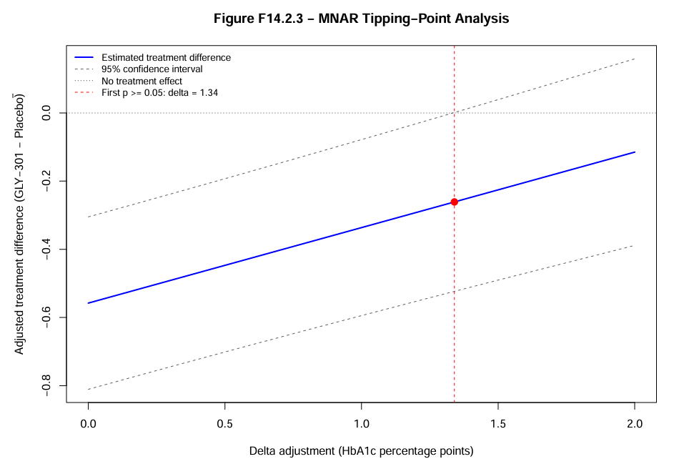
Figure F14.2.3 — MNAR Delta-Adjustment Sensitivity Analysis and Tipping Point
Figure F14.2.3 illustrates the sensitivity of the estimated treatment effect to departures from the Missing at Random (MAR) assumption under the specified MNAR delta-adjustment scenario.
At δ = 0, the adjusted treatment difference was −0.558 HbA1c percentage points (95% CI: −0.811 to −0.305), favoring GLY-301. As the delta adjustment increased, the estimated treatment benefit progressively diminished.
The first nonsignificant result on the refined delta grid occurred at δ = +1.34 HbA1c percentage points (p approximately 0.051), compared with p approximately 0.049 at δ = +1.33. Thus, the tipping point was identified between these two evaluated values.
These findings indicate that the primary efficacy conclusion remained statistically significant under smaller departures from MAR but was no longer statistically significant under sufficiently unfavorable missing-data assumptions. The tipping point is specific to the simulated missing-data mechanism and the delta-adjustment scenario evaluated; it does not establish the actual distribution of unobserved outcomes.

13.3 Interpretation and Refined Tipping-Point Assessment
The MNAR delta-adjustment sensitivity analysis demonstrated that the estimated treatment benefit decreased progressively as increasingly unfavorable outcomes were assumed for GLY-301 participants with missing Week-26 HbA1c measurements.
Statistical significance was maintained for delta adjustments up to +1.00 percentage point in the initial scenario analysis. A refined tipping-point analysis using increments of 0.01 percentage points identified delta = +1.34 as the first value on the evaluated grid at which the two-sided p-value exceeded 0.05. This represents a grid-based tipping point rather than an exact continuous threshold.
At delta = +1.34, the adjusted treatment difference was −0.261 percentage points (95% CI: −0.523 to 0.001; p = 0.0511).
These results indicate that the primary efficacy conclusion remained statistically significant under smaller departures from MAR but was no longer statistically significant when the imputed Week-26 HbA1c changes among GLY-301 participants with missing outcomes were increased by approximately 1.34 percentage points.
The tipping point represents a hypothetical sensitivity threshold under the specified asymmetric delta-adjustment scenario, rather than an estimate of the true missing-data mechanism. The results are based entirely on simulated clinical trial data.
Overall, the analysis provides additional information about the robustness and limitations of the primary efficacy conclusion under departures from the MAR assumption.
14. Safety Results
14.1 Overall Summary of Treatment-Emergent Adverse Events
The safety analysis included all 478 participants who received study treatment, comprising 239 participants in the GLY-301 group and 239 participants in the placebo group. Safety analyses were conducted according to actual treatment received.
Table T14.3.1. Overall Summary of Treatment-Emergent Adverse Events — Safety Analysis Set
Category | Placebo (N=239) | GLY-301 (N=239)
Any TEAE | 82 (34.3%) | 111 (46.4%)
Treatment-related TEAE | 40 (16.7%) | 39 (16.3%)
Mild TEAE | 62 (25.9%) | 82 (34.3%)
Moderate TEAE | 26 (10.9%) | 26 (10.9%)
Severe TEAE | 5 (2.1%) | 13 (5.4%)
Any serious TEAE | 2 (0.8%) | 7 (2.9%)
TEAE leading to treatment discontinuation | 0 (0.0%) | 0 (0.0%)
TEAE leading to dose interruption | 12 (5.0%) | 12 (5.0%)
Note: Values represent the number and percentage of participants experiencing at least one event in each category. Participants are counted once per category but may appear in multiple categories. Percentages use the treatment-specific safety population as the denominator. All data are simulated.
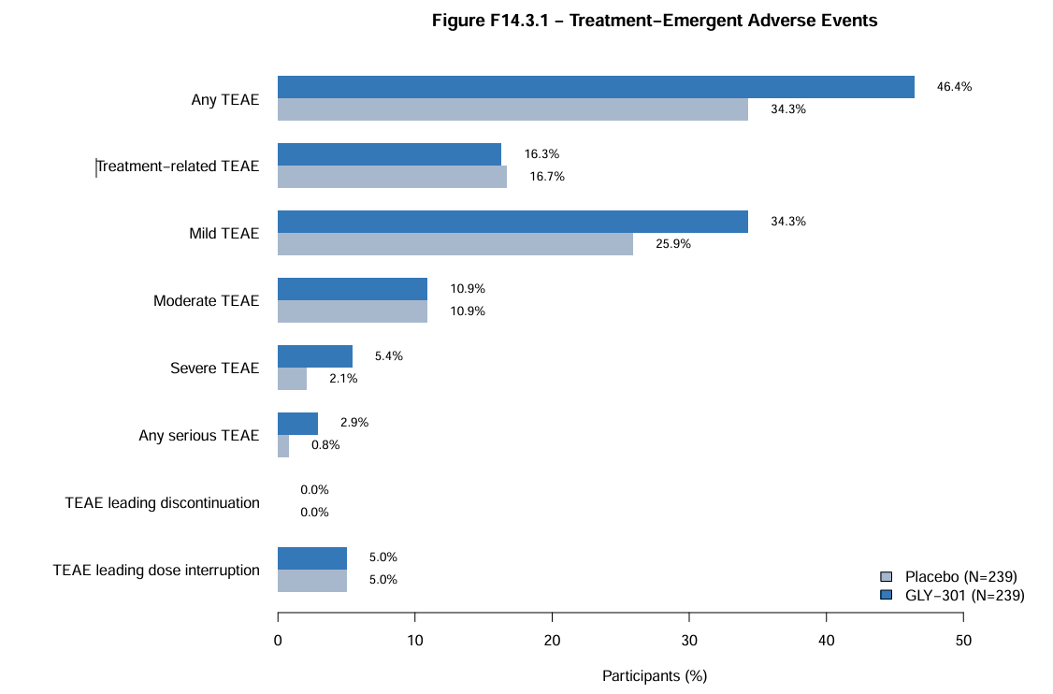
Figure F14.3.1 — Incidence of Treatment-Emergent Adverse Events by Treatment Group
Figure F14.3.1 presents the incidence of treatment-emergent adverse events (TEAEs) by randomized treatment group in the Safety Analysis Set (N = 478).
At least one TEAE was reported in 111 of 239 participants (46.4%) receiving GLY-301 and 82 of 239 participants (34.3%) receiving placebo. Severe TEAEs occurred in 13 participants (5.4%) in the GLY-301 group and 5 participants (2.1%) in the placebo group. Serious TEAEs were reported in 7 participants (2.9%) and 2 participants (0.8%), respectively.
The incidence of treatment-related TEAEs was similar between groups (16.3% versus 16.7%), and no TEAEs leading to treatment discontinuation were recorded in either group.
These results are descriptive. The observed differences should not be interpreted as statistically significant or causally attributable to treatment without further analysis. Safety categories are not mutually exclusive.
Overall, 111 participants (46.4%) in the GLY-301 group experienced at least one treatment-emergent adverse event (TEAE), compared with 82 participants (34.3%) in the placebo group.
The proportion of participants experiencing treatment-related TEAEs was similar between treatment groups (16.3% versus 16.7%, respectively).
Mild TEAEs were more frequently reported in the GLY-301 group (34.3%) than in the placebo group (25.9%), whereas moderate TEAEs occurred in 10.9% of participants in each group.
Severe TEAEs occurred in 13 participants (5.4%) receiving GLY-301 and 5 participants (2.1%) receiving placebo. Serious TEAEs were reported in 7 participants (2.9%) and 2 participants (0.8%), respectively.
No TEAEs leading to treatment discontinuation were recorded in either treatment group. TEAEs leading to dose interruption occurred in 12 participants (5.0%) in each group.
These descriptive findings indicate a numerically higher overall incidence of TEAEs, severe TEAEs, and serious TEAEs in the GLY-301 group. Further examination of event types, seriousness, severity, and clinical relevance is required before drawing conclusions regarding the comparative safety profile of GLY-301.
14.2 Treatment-Emergent Adverse Events by System Organ Class and Event Term
Treatment-emergent adverse events were summarized by system organ class (SOC) and event term using the Safety Analysis Set. Participants experiencing multiple events within the same SOC or event term were counted once within the corresponding category.
Table T14.3.2. Treatment-Emergent Adverse Events by System Organ Class and Event Term — Safety Analysis Set
System Organ Class / Event Term | Placebo (N=239) | GLY-301 (N=239)
Gastrointestinal disorders | 27 (11.3%) | 46 (19.2%)
Diarrhea | 10 (4.2%) | 26 (10.9%)
Nausea | 17 (7.1%) | 23 (9.6%)
Infections and infestations | 39 (16.3%) | 45 (18.8%)
Nasopharyngitis | 15 (6.3%) | 19 (7.9%)
Urinary tract infection | 25 (10.5%) | 26 (10.9%)
Nervous system disorders | 37 (15.5%) | 39 (16.3%)
Dizziness | 20 (8.4%) | 19 (7.9%)
Headache | 17 (7.1%) | 22 (9.2%)
Note: Values are numbers and percentages of participants experiencing at least one TEAE in the specified category. Participants may contribute to more than one SOC or event term. All data are simulated.
Gastrointestinal disorders were reported more frequently in the GLY-301 group than in the placebo group (19.2% versus 11.3%). The difference was primarily associated with a higher incidence of diarrhea (10.9% versus 4.2%), while nausea occurred in 9.6% and 7.1% of participants, respectively.
Infections and infestations were reported in 18.8% of participants receiving GLY-301 and 16.3% receiving placebo. Urinary tract infections occurred at similar frequencies (10.9% versus 10.5%), whereas nasopharyngitis was reported in 7.9% versus 6.3%, respectively.
Nervous system disorders occurred in 16.3% of participants in the GLY-301 group and 15.5% in the placebo group. Headache was numerically more frequent with GLY-301 (9.2% versus 7.1%), while dizziness occurred at similar frequencies (7.9% versus 8.4%).
Overall, gastrointestinal disorders, particularly diarrhea, contributed to the observed difference in adverse-event incidence between treatment groups. These findings are descriptive and should be interpreted alongside adverse-event severity, seriousness, and treatment exposure.
14.3 Treatment-Emergent Adverse Events by Maximum Severity
Treatment-emergent adverse events were summarized according to the maximum severity experienced by each participant during the study. Participants reporting multiple TEAEs were classified according to their most severe event, ensuring mutually exclusive severity categories.
Table T14.3.3. Treatment-Emergent Adverse Events by Maximum Severity — Safety Analysis Set
Maximum Severity | Placebo (N=239) | GLY-301 (N=239)
Any TEAE | 82 (34.3%) | 111 (46.4%)
Mild | 51 (21.3%) | 72 (30.1%)
Moderate | 26 (10.9%) | 26 (10.9%)
Severe | 5 (2.1%) | 13 (5.4%)
Note: Values represent numbers and percentages of participants. Each participant with at least one TEAE is counted once according to their maximum reported severity. Percentages are calculated using the treatment-specific Safety Analysis Set as the denominator. All data are simulated.
Among participants receiving GLY-301, 72 (30.1%) experienced TEAEs of maximum mild severity, 26 (10.9%) experienced TEAEs of maximum moderate severity, and 13 (5.4%) experienced TEAEs of maximum severe severity.
In the placebo group, the corresponding counts were 51 (21.3%), 26 (10.9%), and 5 (2.1%), respectively.
The incidence of maximum mild-severity TEAEs was higher in the GLY-301 group than in the placebo group (30.1% versus 21.3%). The incidence of maximum moderate-severity TEAEs was identical between groups (10.9%). Maximum severe-severity TEAEs occurred more frequently in participants receiving GLY-301 (5.4%) compared with placebo (2.1%).
Overall, the higher incidence of TEAEs in the GLY-301 group was accompanied by a numerically higher incidence of both mild and severe events. These descriptive findings warrant further examination of serious adverse events and their clinical characteristics.
Severity and seriousness represent distinct adverse-event classifications; a severe event is not necessarily a serious adverse event.
14.4 Serious Treatment-Emergent Adverse Events
Serious treatment-emergent adverse events (SAEs) were summarized by treatment group, system organ class, event term, severity, and assessed relationship to study treatment. Analyses were performed using the Safety Analysis Set.
Table T14.3.4. Serious Treatment-Emergent Adverse Events — Safety Analysis Set
System Organ Class / Event Term | Placebo (N=239) | GLY-301 (N=239)
Any serious TEAE | 2 (0.8%) | 7 (2.9%)
Gastrointestinal disorders — Diarrhea | 0 (0.0%) | 3 (1.3%)
Gastrointestinal disorders — Nausea | 1 (0.4%) | 2 (0.8%)
Infections and infestations — Nasopharyngitis | 0 (0.0%) | 1 (0.4%)
Nervous system disorders — Dizziness | 0 (0.0%) | 1 (0.4%)
Nervous system disorders — Headache | 1 (0.4%) | 0 (0.0%)
Note: Values represent numbers and percentages of participants experiencing at least one serious TEAE in the specified category. Percentages use the treatment-specific Safety Analysis Set as the denominator. All data are simulated.
Serious TEAEs were reported in 7 participants (2.9%) receiving GLY-301 and 2 participants (0.8%) receiving placebo.
In the GLY-301 group, the most frequently reported serious TEAEs were diarrhea (3 participants, 1.3%) and nausea (2 participants, 0.8%). Nasopharyngitis and dizziness were each reported as serious TEAEs in one participant (0.4%).
In the placebo group, serious TEAEs comprised one case of nausea (0.4%) and one case of headache (0.4%).
All seven serious TEAE records in the GLY-301 group were classified as severe. In the placebo group, one serious TEAE was classified as moderate and one as severe.
Three serious TEAEs in the GLY-301 group were assessed as related to study treatment, whereas four were assessed as not related. Neither of the two serious TEAEs in the placebo group was assessed as treatment-related.
Overall, the GLY-301 group showed a numerically higher incidence of serious TEAEs, with gastrointestinal events representing the largest proportion. Although the number of serious events was small, these findings constitute a potential safety signal requiring consideration in the overall benefit–risk evaluation.
The descriptive analysis does not establish a causal relationship between GLY-301 and serious adverse events. The specific criteria underlying the seriousness classification were not available in the analysis dataset.
14.5 Hypoglycemia
Hypoglycemia was evaluated as a safety endpoint using the Safety Analysis Set. Recorded hypoglycemia episodes were summarized by treatment group, hypoglycemia level, requirement for external assistance, and recurrence. Participant-level incidence was calculated using the number of participants experiencing at least one episode in each category.
Table T14.3.5. Summary of Recorded Hypoglycemia — Safety Analysis Set
Category | Placebo (N=239) | GLY-301 (N=239)
Any hypoglycemia | 9 (3.8%) | 38 (15.9%)
Level 1 hypoglycemia | 6 (2.5%) | 30 (12.6%)
Level 2 hypoglycemia | 3 (1.3%) | 7 (2.9%)
Level 3 hypoglycemia | 0 (0.0%) | 2 (0.8%)
Required external assistance | 0 (0.0%) | 2 (0.8%)
Total hypoglycemia episodes | 9 | 46
Note: Values are numbers and percentages of participants, except for total hypoglycemia episodes, which represents the number of recorded events. Participants may appear in multiple hypoglycemia categories. All data are simulated.
Hypoglycemia Observation Window
Hypoglycemia episodes were evaluated from the first dose of study treatment through the recorded 30-day post-treatment safety follow-up period.
Of the 55 recorded hypoglycemia episodes, 43 occurred during the dosing period and 12 occurred after the last dose but within the safety follow-up period.
In the GLY-301 group, 35 episodes occurred during treatment and 11 during post-treatment follow-up. The corresponding numbers in the placebo group were 8 and 1, respectively.
All 55 episodes occurred within the recorded safety observation window. The participant-level incidence of hypoglycemia therefore remained 38 participants (15.9%) in the GLY-301 group and 9 participants (3.8%) in the placebo group when the full observation window was considered.
One episode classified as Level 3 hypoglycemia and requiring external assistance occurred during post-treatment follow-up.
These findings highlight the importance of specifying the observation window when interpreting hypoglycemia incidence. The hypoglycemia summary includes all recorded episodes occurring from the first dose of study treatment through the end of the 30-day post-treatment safety follow-up period. This observation window was verified against the simulated event dates and participant-level follow-up records. The observation window was consistent with the study Protocol and the clarified Statistical Analysis Plan.
Hypoglycemia was reported in 38 participants (15.9%) receiving GLY-301 compared with 9 participants (3.8%) receiving placebo, corresponding to an absolute difference of approximately 12.1 percentage points.
Level 1 hypoglycemia was the most frequently recorded category, affecting 30 participants (12.6%) in the GLY-301 group and 6 participants (2.5%) in the placebo group. Level 2 hypoglycemia occurred in 7 participants (2.9%) and 3 participants (1.3%), respectively.
Level 3 hypoglycemia was recorded in 2 participants (0.8%) receiving GLY-301 and none receiving placebo. Two GLY-301 participants (0.8%) experienced hypoglycemia requiring external assistance; no such episodes were recorded in the placebo group.
A total of 46 hypoglycemia episodes were recorded in the GLY-301 group compared with 9 in the placebo group. Recurrent hypoglycemia, defined for this summary as two or more recorded episodes in the same participant, occurred in 7 participants receiving GLY-301 and none receiving placebo.
Among recorded episodes, mean glucose concentrations were 57.7 mg/dL in the GLY-301 group and 58.8 mg/dL in the placebo group. Median concentrations were 59.5 mg/dL and 63.1 mg/dL, respectively.
Overall, hypoglycemia was more frequently recorded among participants receiving GLY-301, including recurrent episodes and events classified as Level 3. These descriptive findings represent an important potential safety concern and should be considered alongside the observed glycemic efficacy benefits in the overall benefit–risk assessment.
Hypoglycemia classifications are based on the recorded study data. The hypoglycemia classification criteria and observation window were defined in the study Protocol and Statistical Analysis Plan. Clinical interpretation remains limited by the simulated nature of the data.
14.6 Treatment Exposure and Adherence
Treatment exposure and adherence were evaluated in the Safety Analysis Set, comprising 239 participants in each treatment group. Treatment duration was summarized in days, while adherence was summarized as a percentage and categorized as below 80%, 80–100%, or above 100%.
Table T14.3.6. Treatment Exposure and Adherence — Safety Analysis Set
Measure | Placebo (N=239) | GLY-301 (N=239)
Treatment duration (days)
N | 239 | 239
Mean (SD) | 172.1 (32.7) | 168.6 (38.6)
Median | 183.0 | 183.0
Minimum, maximum | 29.0, 183.0 | 29.0, 183.0
Treatment adherence (%)
N | 239 | 239
Mean (SD) | 93.6 (8.2) | 93.3 (8.7)
Median | 93.4 | 92.9
Minimum, maximum | 71.8, 109.8 | 66.7, 109.8
Adherence category
Below 80% | 12 (5.0%) | 14 (5.9%)
80–100% | 178 (74.5%) | 167 (69.9%)
Above 100% | 49 (20.5%) | 58 (24.3%)
Note: Continuous variables are summarized using descriptive statistics. Adherence categories are presented as numbers and percentages of participants. All data are simulated.
Mean treatment duration was 168.6 days (SD 38.6) in the GLY-301 group and 172.1 days (SD 32.7) in the placebo group. Median treatment duration was 183 days in both groups, corresponding to the maximum recorded treatment duration.
Mean treatment adherence was comparable between treatment groups, at 93.3% (SD 8.7) for GLY-301 and 93.6% (SD 8.2) for placebo. Median adherence was 92.9% and 93.4%, respectively.
Most participants had adherence values between 80% and 100%, including 167 participants (69.9%) in the GLY-301 group and 178 participants (74.5%) in the placebo group. Adherence below 80% was recorded in 14 participants (5.9%) and 12 participants (5.0%), respectively.
Adherence values above 100% were recorded in 58 participants (24.3%) receiving GLY-301 and 49 participants (20.5%) receiving placebo. These values were retained as generated and were not capped at 100%. Their interpretation depends on the adherence calculation and simulation rules, which should be documented before finalizing the report.
Overall, treatment duration and adherence were broadly comparable between groups. The numerically higher incidence of adverse events and hypoglycemia in the GLY-301 group occurred despite a slightly shorter mean treatment duration. These descriptive findings do not establish whether treatment exposure contributed to the observed safety differences.
14.7 Available Laboratory and Vital-Sign Measurements
Table T14.3.7 Summary of Available Laboratory and Vital-Sign Measurements
Full Analysis Set · Observed data · Values presented as n; mean (SD)
Measurement | Treatment | Baseline | Week 26 | Change from baseline
HbA1c (%) | GLY-301 | 239; 8.73 (0.68) | 186; 7.47 (1.43) | 186; −1.23 (1.26)
 | Placebo | 239; 8.72 (0.65) | 196; 8.00 (1.40) | 196; −0.69 (1.27)
FPG (mg/dL) | GLY-301 | 239; 201.40 (33.73) | 186; 167.25 (53.35) | 186; −33.79 (42.65)
 | Placebo | 239; 205.74 (31.84) | 196; 183.38 (48.25) | 196; −22.37 (40.92)
Body weight (kg) | GLY-301 | 239; 88.06 (17.59) | 186; 86.36 (18.21) | 186; −2.06 (1.50)
 | Placebo | 239; 87.49 (15.90) | 196; 86.64 (15.97) | 196; −0.41 (1.62)
Values are n; mean (SD). Changes from baseline were calculated using paired observations. Participants with missing Week 26 measurements were excluded from the observed-change summaries. No imputation was performed. This descriptive table is not a comprehensive laboratory safety evaluation.
Descriptive summaries of available laboratory and vital-sign measurements are presented in Table T14.3.7.
At Week 26, the observed mean change in HbA1c was −1.23 percentage points in the GLY-301 group and −0.69 percentage points in the placebo group. Corresponding mean changes in fasting plasma glucose were −33.79 mg/dL and −22.37 mg/dL, respectively. Mean body-weight changes were −2.06 kg in the GLY-301 group and −0.41 kg in the placebo group.
These descriptive findings are consistent with the direction of the primary and secondary efficacy analyses. However, the summaries are based on observed measurements and do not account for missing Week 26 outcomes through multiple imputation.
The simulated laboratory and vital-sign datasets contained HbA1c, fasting plasma glucose, and body weight only. Consequently, other laboratory safety parameters and vital signs, such as hematology, renal and hepatic function, blood pressure, and heart rate, could not be evaluated. No conclusions regarding these unmeasured safety domains can be drawn.

14.8 Overall Safety Summary
The safety analysis included all 478 treated participants, with 239 participants in each treatment group.
Treatment-emergent adverse events were reported in 46.4% of participants receiving GLY-301 and 34.3% receiving placebo. The higher incidence in the GLY-301 group was accompanied by a greater frequency of gastrointestinal disorders, particularly diarrhea (10.9% versus 4.2%).
Treatment-related TEAEs occurred at similar frequencies in the two groups (16.3% for GLY-301 versus 16.7% for placebo). However, severe TEAEs were reported more frequently with GLY-301 (5.4% versus 2.1%).
Serious TEAEs occurred in 7 participants (2.9%) receiving GLY-301 and 2 participants (0.8%) receiving placebo. Three serious TEAEs in the GLY-301 group were assessed as treatment-related, compared with none in the placebo group.
Hypoglycemia was more frequently recorded in the GLY-301 group, affecting 38 participants (15.9%) compared with 9 participants (3.8%) in the placebo group. Recurrent hypoglycemia was observed in 7 participants receiving GLY-301 and none receiving placebo. Two GLY-301 participants experienced events classified as Level 3 hypoglycemia.
Treatment exposure and adherence were broadly comparable between groups, with mean adherence exceeding 93% in both treatment arms.
Taken together, the simulated safety results identify increased hypoglycemia incidence, gastrointestinal adverse events, and numerically higher serious and severe adverse-event incidence as potential safety concerns associated with GLY-301.
These findings must be considered alongside the demonstrated improvements in glycemic efficacy. Given the descriptive nature of the safety analyses and the limited number of serious adverse events, definitive conclusions regarding comparative safety or causality cannot be established.
The overall benefit–risk assessment should therefore consider both the magnitude of glycemic benefit and the observed safety findings, with particular attention to hypoglycemia and serious gastrointestinal events.
15. Discussion and Benefit–Risk Assessment
15.1 Overview of Study Findings
DIA-GLY3 was a simulated, randomized, double-blind, placebo-controlled Phase III clinical trial evaluating GLY-301 as an add-on treatment to metformin over 26 weeks in participants with type 2 diabetes mellitus.
A total of 478 participants were randomized equally between GLY-301 and placebo.
In this simulated trial, GLY-301 was associated with statistically significant improvements in glycemic control compared with placebo. However, safety analyses identified higher incidences of hypoglycemia, gastrointestinal adverse events, and serious treatment-emergent adverse events in the GLY-301 group
15.2 Interpretation of Efficacy Findings
The primary analysis demonstrated an adjusted between-group difference in HbA1c change from baseline to Week 26 of −0.558 percentage points (95% CI: −0.811 to −0.305; p = 0.0000197), favoring GLY-301.
The primary analysis used multiple imputation under a missing-at-random assumption, followed by analysis of covariance adjusting for baseline HbA1c and randomization stratum.
The key secondary analyses supported the primary finding.
Participants receiving GLY-301 had higher odds of achieving HbA1c below 7% at Week 26 compared with placebo (adjusted odds ratio: 2.697; 95% CI: 1.638–4.443; p = 0.000117).
GLY-301 also demonstrated a greater reduction in fasting plasma glucose, with an adjusted between-group difference of −12.40 mg/dL (95% CI: −21.04 to −3.76; p = 0.00510).
Body weight decreased more with GLY-301 than placebo, with an adjusted between-group difference of −1.59 kg (95% CI: −1.87 to −1.32; p < 0.001).
The supportive mixed model for repeated measures analysis yielded a Week 26 treatment difference of −0.575 percentage points (95% CI: −0.801 to −0.349), consistent with the primary analysis.
The missing-not-at-random sensitivity analysis indicated that the primary treatment effect remained statistically significant under progressively unfavorable assumptions about missing HbA1c outcomes in the GLY-301 group. The first evaluated delta value yielding a nonsignificant result was +1.34 percentage points, illustrating the sensitivity of the conclusion to sufficiently large departures from the missing-at-random assumption.
Collectively, the primary, secondary, and supportive analyses demonstrated consistent improvements in glycemic outcomes with GLY-301 in the simulated dataset. However, interpretation of the primary treatment effect remains dependent on the missing-data assumptions, as illustrated by the MNAR tipping-point analysis.
15.3 Interpretation of Safety Findings
The safety findings revealed several differences between treatment groups.
Overall treatment-emergent adverse events occurred in 46.4% of participants receiving GLY-301 and 34.3% receiving placebo.
Gastrointestinal disorders were more frequent with GLY-301 (19.2% versus 11.3%), particularly diarrhea (10.9% versus 4.2%).
Severe TEAEs occurred in 5.4% of GLY-301 participants compared with 2.1% of placebo participants. Serious TEAEs were reported in 2.9% and 0.8%, respectively.
Hypoglycemia represented an important potential safety concern. At least one episode was recorded in 15.9% of participants receiving GLY-301 compared with 3.8% receiving placebo. Two GLY-301 participants experienced Level 3 hypoglycemia, and seven experienced recurrent episodes.
Despite these differences, treatment duration and adherence were broadly comparable between groups. Mean treatment adherence exceeded 93% in both arms.
The safety comparisons were descriptive, and the limited number of serious events restricts the strength of conclusions regarding their clinical significance and relationship to treatment.
15.4 Benefit–Risk Assessment
The principal benefits observed with GLY-301 were improved HbA1c control, a higher likelihood of achieving the HbA1c target of below 7%, reduced fasting plasma glucose, and greater weight reduction compared with placebo.
These benefits were supported by consistent results across the primary, secondary, and supportive efficacy analyses.
However, the observed benefits must be balanced against the higher incidence of hypoglycemia and gastrointestinal adverse events, together with the numerical increase in serious and severe TEAEs.
The occurrence of Level 3 hypoglycemia and treatment-related serious adverse events in the GLY-301 group is particularly relevant to the benefit–risk evaluation.
Although the simulated trial demonstrated statistically significant efficacy benefits, the available safety findings do not support an unqualified conclusion that GLY-301 has a favorable overall benefit–risk profile. In particular, the higher incidence of hypoglycemia, including events requiring external assistance, and the numerical imbalance in serious treatment-emergent adverse events warrant careful consideration. Because the safety comparisons were descriptive and the dataset was simulated, these observations cannot establish a causal relationship or support a definitive clinical benefit–risk determination.
A definitive benefit–risk determination would require additional information regarding the clinical consequences of serious events, the protocol-defined hypoglycemia classifications, and the potential implications of longer-term exposure.
15.5 Study Limitations
Several limitations should be considered when interpreting the findings.
First, DIA-GLY3 is a fully simulated clinical trial. The results illustrate statistical methods and clinical reporting workflows and do not constitute evidence of actual treatment efficacy or safety.
Second, approximately 20% of Week 26 HbA1c measurements were missing. Although multiple imputation and sensitivity analyses were performed, conclusions depend partly on assumptions about missing data.
Third, the study duration was limited to 26 weeks, preventing evaluation of long-term treatment effects.
Fourth, safety analyses were primarily descriptive, and the relatively small number of serious adverse events limits interpretation of between-group differences.
Finally, the analysis datasets were developed for educational and portfolio purposes using simplified clinical data structures rather than fully validated regulatory submission standards.
15.6 Overall Conclusion
In this simulated Phase III trial, GLY-301 added to metformin demonstrated statistically significant improvements in glycemic control compared with placebo added to metformin.
The efficacy findings were supported by secondary endpoints, longitudinal analyses, and missing-data sensitivity analyses.
However, GLY-301 was associated with numerically higher incidences of hypoglycemia, gastrointestinal adverse events, and serious treatment-emergent adverse events.
Consequently, the simulated results demonstrate evidence of efficacy but do not establish a definitively favorable benefit–risk profile.
The study illustrates the importance of integrating efficacy, safety, missing-data sensitivity, and clinical interpretation when evaluating treatment effects in randomized clinical trials.

