
Kudlu Gate, Hosur Road, Bengaluru – 560068
SCHOOL OF COMPUTER APPLICATIONS
A Project Report
on
Early Alzheimer’s Detection using Blood Biomarkers and Explainable Deep Learning
Submitted in Partial fulfilment of the requirements for the award of the Degree of
MASTER OF COMPUTER APPLICATIONS
Submitted by
Avanish Sahai – SCA25MCA092
Harsh Chaudhary – SCA25MCA101
Madhav P – SCA25MCA111
Under the guidance of
Ms. Varshitha K
Assistant Professor
s
JULY 2026
DAYANANDA SAGAR UNIVERSITY
Kudlu Gate, Hosur Road, Bengaluru – 560068


SCHOOL OF COMPUTER APPLICATIONS
BONAFIDE CERTIFICATE
This is to certify that the project titled "EARLY ALZHEIMER DETECTION MODEL" is a bonafide record of the work undertaken by Avanish Sahai (SCA25MCA092), Harsh Chaudhary (SCA25MCA101), and Madhav P (SCA25MCA111) in partial fulfillment of the requirements for the award of the Master of Computer Applications degree at the School of Computer Applications, Dayananda Sagar University, Bengaluru, during the academic year 2025–2026.
GUIDE  Ms. Varshitha K  Assistant Professor  School of Computer Applications | DEAN  Dr. S Senthil  Professor and Dean  School of Computer Applications

Project Viva-voce held on ___________________.

Internal Examiner External Examiner


SCHOOL OF COMPUTER APPLICATIONS
DECLARATION
We, students of the Master of Computer Applications program at the School of Computer Applications, Dayananda Sagar University, hereby declare that this project, titled "Early Alzheimer’s Detection using Blood Biomarkers and Explainable Deep Learning", is the result of our independent work carried out under the supervision of Ms. Varshitha.
We are submitting this project work in partial fulfillment of the requirements for the award of the Master of Computer Applications degree by Dayananda Sagar University, Bengaluru, for the Academic Year 2025–2026.
We further affirm that this project report, in whole or in part, has not been submitted for the award of any other degree or diploma at this or any other university/institution.
Signed on:___________________
Signature of the Candidate
Avanish Sahai <SCA25MCA092> : _________________________

Harsh Chaudhary <SCA25MCA101> : _________________________

Madhav P <SCA25MCA111> : _________________________

This is to certify that the project work submitted by Avanish Sahai has been carried out under my guidance, and the declaration made by the candidate is true to the best of my knowledge.

Signature of the Guide
Date: ___________________

ACKNOWLEDGEMENT
We express my heartfelt gratitude and salutations to my beloved and highly esteemed institute, Dayananda Sagar University, for providing me with an excellent platform to learn and grow. I am deeply thankful for the unwavering support and encouragement extended throughout my academic journey.
We extend my sincere gratitude to Dr. D. Hemachandra Sagar, Chancellor, and Dr. Premachandra Sagar, Pro Chancellor, Dayananda Sagar University, for their visionary leadership and continuous support in fostering an environment of academic excellence and innovation.
We are profoundly grateful to Dr. B.S. Satyanarayana, Vice Chancellor, and Dr. Puttamadappa C, Registrar, Dayananda Sagar University, for their invaluable guidance and commitment to ensuring a world-class education at the university.
We extend my heartfelt thanks to Dr. S. Senthil, Professor and Dean, School of Computer Applications, Dayananda Sagar University, for his valuable suggestions, expert advice, and constant support throughout my project.
We are deeply indebted to our guide, Ms. Varshitha K, Assistant Professor, School of Computer Applications, Dayananda Sagar University, for continuous support, necessary advice, and invaluable guidance, which played a significant role in shaping the outcome of my project.
We would also like to extend my appreciation to all the teaching and non-teaching staff members of the School of Computer Applications, Dayananda Sagar University, for their support during my academic tenure.
Lastly, we are forever grateful to my parents and friends, whose unwavering support, motivation, and encouragement have been my strength throughout this journey.
Avanish Sahai – SCA25MCA092
Harsh Chaudhary – SCA25MCA101
Madhav P – SCA25MCA111


CONTENTS
CHAPTER 1: INTRODUCTION
1.1 Project Overview
1.2 Software and Hardware Requirements
1.3 Functional and Non-Functional Requirements
1.4 Company/Domain Profile
CHAPTER 2: LITERATURE SURVEY
2.1 Existing Research and Related Work (15-Paper Survey)
2.2 Gaps in Existing Systems
2.3 Overview of Technologies Used
2.4 Comparison of Different Approaches
CHAPTER 3: METHODOLOGY & SYSTEM ANALYSIS
3.1 Existing System
3.2 Proposed System
3.3 Datasets Used
3.4 Machine Learning Model/Algorithm Selection
3.5 Feasibility Study
CHAPTER 4: SYSTEM DESIGN AND DEVELOPMENT
4.1 System Architecture (High-Level Design)
4.2 Detailed Design (Low-Level Design)
4.3 Database Design
4.4 Input/Output Interface Design
4.5 Module Description
CHAPTER 5: IMPLEMENTATION & CODING
5.1 Programming Language and Framework Used
5.2 Algorithmic Approach
5.3 Code Snippets and Explanation
CHAPTER 6: SOFTWARE TESTING
6.1 Testing Strategies
6.2 Test Cases
6.3 Performance Metrics and Evaluation
CHAPTER 7: RESULTS AND DISCUSSION
7.1 Experimental Setup
7.2 Model Performance Analysis
7.3 Comparative Analysis of Classification Algorithms
7.4 Comparison with Existing Systems
7.5 Visualization of Results
7.6 Screenshots of Working System
CHAPTER 8: CONCLUSION AND FUTURE ENHANCEMENTS
8.1 Conclusion
8.2 Limitations of the Project
8.3 Scope for Future Enhancements (incl. Mobile Application)
REFERENCES

LIST OF FIGURES

LIST OF TABLES

CHAPTER 1: INTRODUCTION

1.1 Project Overview

1.1.1 Statement of the Problem
Alzheimer's Disease (AD) is a progressive neurodegenerative disorder that is typically diagnosed only after significant, often irreversible, neuronal damage has already occurred. Conventional diagnostic pathways rely heavily on expensive neuroimaging (MRI/PET) and invasive cerebrospinal fluid (CSF) analysis, both of which are costly, not widely accessible, and poorly suited to large-scale, early-stage screening. There is a pressing clinical need for a low-cost, blood-based, and interpretable screening tool that can flag at-risk individuals particularly those in the Mild Cognitive Impairment (MCI) stage well before clinical symptoms become severe.

1.1.2 Brief Description of the Project
The Early Alzheimer Detection Model is a machine-learning-based diagnostic support system that classifies individuals into three clinical categories Cognitively Normal (CN), Mild Cognitive Impairment (MCI), and Alzheimer's Disease (AD) using a panel of blood-based biomarkers combined with demographic, lifestyle, metabolic, and cognitive-assessment data. The project uses a synthetically generated dataset of 10,000 patient records (51 attributes each) modelled on biomarker distributions reported in peer-reviewed plasma-biomarker literature, trains and benchmarks six machine learning classifiers (Logistic Regression, K-Nearest Neighbours, Support Vector Machine, Random Forest, a Multi-Layer Perceptron, and XGBoost), and layers a SHAP-style explainability module on top of the best-performing model (XGBoost) so that every prediction is accompanied by a human-readable justification of which biomarkers drove the outcome. A browser-based interactive front end, named AuraMind, allows a user to enter or load a patient's biomarker profile and instantly view the predicted diagnostic class, class probabilities, and the top contributing features.

1.1.3 Objectives of the Project
- To design and curate a realistic, clinically grounded synthetic dataset of blood biomarkers, demographic, metabolic, and cognitive features for Alzheimer's risk classification.
- To build, benchmark, and validate multiple machine learning models capable of distinguishing between CN, MCI, and AD categories, and to select the best-performing algorithm through comparative analysis.
- To incorporate explainability (SHAP-style feature attribution) so that predictions are transparent and clinically interpretable rather than a black box.
- To develop an interactive, user-friendly front-end interface that visualizes biomarker inputs, diagnostic probabilities, and feature contributions in real time.
- To evaluate the model rigorously using standard classification metrics, to critically examine any limitations of the dataset and pipeline, and to chart a path toward a deployable mobile application.

1.1.4 Scope of the Project
The scope of this project is limited to a proof-of-concept, research/academic-grade diagnostic support tool trained on synthetic data. It is not a certified medical device and is not intended to replace clinical diagnosis. The system covers: dataset generation and validation, comparative model training and evaluation, explainability, and a demonstration web interface. It does not currently cover real-time integration with hospital Electronic Health Record (EHR) systems, regulatory validation, or deployment on real patient data, all of which are identified as future enhancements (Chapter 8).

1.2 Software and Hardware Requirements

Table 1.1 Software Specifications
Component | Specification
Operating System | Windows 10/11, Linux, or macOS
Programming Language | Python 3.10+, JavaScript (ES6)
ML Libraries | XGBoost, scikit-learn, pandas, NumPy
Visualization | Matplotlib, Seaborn, Graphviz
Notebook Environment | Jupyter Notebook / Google Colab
Front-End | HTML5, CSS3, vanilla JavaScript
Version Control | Git and GitHub

1.2.2 Hardware Specifications
Component | Minimum Requirement
Processor | Intel i5 / AMD Ryzen 5 or equivalent
RAM | 8 GB (16 GB recommended for training)
Storage | 2 GB free space
GPU | Optional — CUDA-capable GPU accelerates XGBoost/MLP training

1.3 Functional and Non-Functional Requirements

1.3.1 Functional Requirements
- The system shall accept biomarker, demographic, and cognitive-score inputs for a patient.
- The system shall classify the patient into CN, MCI, or AD with associated class probabilities.
- The system shall display the top contributing features (SHAP-style) behind each prediction.
- The system shall allow a user to load pre-set diagnostic profiles for quick demonstration.

1.3.2 Non-Functional Requirements
- Performance: Predictions must be returned to the user within a few seconds.
- Usability: The interface must be intuitive for non-technical (clinical) users.
- Reliability: The model must generalize consistently across a held-out test set.
- Maintainability: Code and notebooks must be modular and version-controlled.

1.4 Company/Domain Profile
This project was undertaken as an academic MCA project and is not affiliated with any company. The problem domain is healthcare informatics, specifically neurodegenerative disease screening using AI/ML, drawing on published research in plasma-biomarker-based Alzheimer's diagnostics.

CHAPTER 2: LITERATURE SURVEY

2.1 Existing Research and Related Work
Blood-based biomarker research for Alzheimer's Disease has advanced rapidly over the past decade. Plasma phosphorylated-tau species (p-tau181, p-tau217), the Aβ42/Aβ40 ratio, neurofilament light chain (NfL), and glial fibrillary acidic protein (GFAP) have all been validated in peer-reviewed studies as correlating strongly with amyloid and tau pathology, offering a far less invasive alternative to CSF and PET-based diagnosis. To ground this project in the current state of the art, a structured survey of fifteen peer-reviewed and preprint papers spanning blood-biomarker ML, MRI-based deep learning, and comparative classifier benchmarking was conducted.
[1]

Table 2.1 summary of existing research and related work
# | Paper / Source | Approach | Key Finding
1 | Alzheimer's Disease Detection and Classification in Biomarkers Using Multimodal Data (IEEE, 2025) | Multimodal fusion of MRI, genetic biomarkers & cognitive assessments | Improved diagnostic accuracy over single-modality baselines by integrating imaging, genetics and cognition
2 | Machine Learning Models for Detection and Assessment of Progression in AD Based on Blood and CSF Biomarkers (IEEE, 2023) | SVM on ADNI plasma + CSF protein biomarkers | Highest accuracy achieved when CSF proteins are combined with plasma proteins via SVM
3 | Early Diagnosis of Alzheimer's Disease Using Machine Learning and Blood Biomarkers (BMC Med. Inform. Decis. Mak., 2025) | Classical ML classifiers on ADNI blood-biomarker panel (119 healthy controls, 672 MCI) | Blood-biomarker-based ML model effectively discriminated MCI from healthy controls
4 | Predicting Early Alzheimer's with Blood Biomarkers and Clinical Data (Nature Scientific Reports, 2024) | Explainable ML (feature-attribution) on blood/gene-expression and clinical data | Demonstrated that explainable ML can flag dementia risk from accessible blood/gene markers
5 | Development and Validation of ML Models with Blood-Based Biomarkers for AD (ScienceDirect, 2025) | Comprehensive blood-biomarker panel + multiple ML classifiers | Blood-based biomarker panels can approach the diagnostic value of costlier modalities
6 | A Machine Learning-Enabled Blood Transcriptomic Signature for Digital AD Detection (Nature Digital Medicine, 2025) | ML on blood transcriptomic (gene-expression) data | Transcriptomic "digital score" enabled non-invasive, accessible AD-risk detection
7 | Early Detection of Alzheimer's Disease with Blood Plasma Proteins Using Support Vector Machines (ResearchGate / EMIF-AD cohort) | SVM on plasma protein panel (EMIF-AD biomarker discovery cohort) | SVM achieved meaningful discriminative power on a real clinical plasma-protein cohort
8 | Comparative Evaluation of Machine Learning Algorithms for Alzheimer's Disease Detection (Discover Computing / Springer, 2026) | Logistic Regression, Decision Tree, Random Forest, KNN, SVC, Gradient Boosting and XGBoost compared on demographic/clinical/behavioural features, with/without hyperparameter tuning | Random Forest, XGBoost and Gradient Boosting achieved the most favourable accuracy (>90%) among all algorithms tested
9 | Development and Validation of an Automatic Classification Algorithm for AD/MCI Using TabNet vs. XGBoost (Springer, 2023) | TabNet (interpretable deep tabular network) benchmarked against XGBoost on MRI-derived brain-segmentation features | TabNet achieved competitive/superior performance to XGBoost while retaining interpretability
10 | Classification of Alzheimer's Disease Using MRI Data Based on Deep Learning (AD-DL) (ScienceDirect, 2024) | Custom deep-learning (CNN-based) architecture on MRI images | Proposed AD-DL approach improved early-AD detection from imaging data
11 | High-Accuracy Diagnosis for MRI Imaging of Alzheimer's Disease Using a Three-Stage Pipeline (ScienceDirect, 2022) | Feature extraction, feature selection and classification pipeline for 3-class CN/MCI/AD MRI classification | Demonstrated that multi-class (not just binary) classification is achievable with high accuracy from MRI features
12 | Development and Validation of a Deep-Learning-Based Automatic Brain Segmentation and Classification Algorithm (AJNR, 2020) | Deep-learning segmentation + XGBoost classification on T1-weighted MRI | Automated pipeline enabled accurate AD diagnosis directly from raw MRI; XGBoost reported 79% sensitivity / 80% specificity
13 | Intelligent Diagnosis of Alzheimer's Disease Based on Machine Learning (arXiv, 2024) | Random-Forest-based missing-data imputation combined with ML classification on ADNI data | Robust preprocessing (RF-based imputation, outlier handling) improved downstream classification reliability
14 | Alzheimer's MRI Classification Using Deep and Transfer Learning (arXiv, 2024) | CNN and transfer-learning architectures on MRI scans | Deep/transfer learning outperformed traditional ML in capturing complex high-dimensional imaging patterns
15 | Detection and Classification of Alzheimer's Disease Using a Dual-Modal Deep Learning Framework (MDPI, 2024) | Dual-modal deep-learning framework integrating imaging and clinical assessment data | Combining modalities improved sensitivity of early, accurate diagnosis over single-modality baselines
A more detailed narrative reading of the survey is organised below:

Blood- and plasma-biomarker studies (Papers 2–7)
Papers 2, 3, 4, 6 and 7 form the core evidence base for the blood-biomarker approach adopted in this project. Paper 7 — an SVM-based classifier on the EMIF-AD plasma-protein cohort — is the closest prior-art baseline and is discussed in depth throughout this report; it demonstrated that classical machine learning models can achieve meaningful discriminative power on plasma biomarkers, but also surfaced the persistent challenges of small clinical cohorts, class imbalance between MCI and AD, and limited interpretability. Papers 3 and 5 extended this line of work to larger ADNI-derived biomarker panels, while Papers 4 and 6 layered explainability and transcriptomic (gene-expression) signals on top of blood-based screening, reinforcing the direction taken by this project's SHAP-style explanation engine.

Comparative and gradient-boosting studies (Papers 8, 9, 12)
Paper 8 is particularly relevant to Chapter 7 of this report: it benchmarks Logistic Regression, Decision Tree, Random Forest, KNN, SVC, Gradient Boosting and XGBoost on demographic/clinical/behavioural features and found that Random Forest, XGBoost, and Gradient Boosting achieved the most favourable accuracy (over 90%). This finding directly motivated the comparative multi-algorithm evaluation performed in this project (Section 7.3), which extends the comparison to a blood-biomarker feature set rather than demographic/behavioural features alone. Papers 9 and 12 similarly benchmark gradient-boosted trees (XGBoost) against deep tabular networks (TabNet) and deep-learning MRI-segmentation pipelines respectively, both concluding that tree-based ensembles remain highly competitive on structured/tabular clinical data while being far cheaper to train than deep networks.

Imaging and deep-learning studies (Papers 1, 10, 11, 13, 14, 15)
The remaining papers reflect the imaging-first, deep-learning branch of AD-detection research. These studies consistently report strong accuracy on MRI-derived features but also consistently note two limitations relevant to this project's design choices: (a) imaging pipelines are computationally expensive and require GPU resources not always available in academic or low-resource clinical settings, and (b) deep networks trained on imaging data are comparatively harder to interpret than tree-based models trained on tabular biomarker panels. These findings reinforced the decision to build this project around a low-cost, blood-biomarker-first, tree-ensemble pipeline with an explicit explainability layer, rather than an imaging-based deep-learning pipeline.

2.2 Gaps in Existing Systems
- Many published models rely on small, imbalanced clinical cohorts, which limits statistical power and generalizability (Papers 2, 3, 7).
- A large fraction of existing systems function as "black boxes" — they output a label without explaining which biomarkers drove the decision (Papers 1, 10, 11, 14, 15).
- Few systems combine blood-biomarker panels with demographic and metabolic/vascular risk factors in a single unified, comparatively-benchmarked model — most studies test only one or two algorithms rather than a broad comparative sweep (all except Paper 8).
- Very few academic prototypes provide an accessible, interactive interface that a clinician or student could use to explore "what-if" biomarker scenarios, and none of the surveyed papers propose a mobile-first deployment.
- Imaging-centric approaches (Papers 1, 9, 10, 11, 12, 14, 15) are accurate but expensive and hard to scale to population-level early screening, reinforcing the case for a blood-biomarker-first tool.

2.3 Overview of Technologies Used (AI/ML, Deep Learning, etc.) – literature survey
This project uses XGBoost (Extreme Gradient Boosting), an ensemble learning technique that builds a sequence of decision trees where each new tree corrects the errors of the previous ones, as its primary/deployed classifier. XGBoost was selected — and validated through the comparative benchmark in Chapter 7 — because tabular biomarker data of this size and dimensionality (10,000 rows × 51 features) is well suited to gradient-boosted trees, which typically match or outperform deep neural networks on structured/tabular data while remaining inherently easier to interpret via feature importance and SHAP (SHapley Additive exPlanations) analysis. To validate this choice rather than assume it, five additional classifiers — Logistic Regression, K-Nearest Neighbours, Support Vector Machine (RBF kernel), Random Forest, and a Multi-Layer Perceptron neural network — were also implemented and benchmarked under identical train/test conditions (Section 7.3).

CHAPTER 3: METHODOLOGY & SYSTEM ANALYSIS

3.1 Existing System

3.1.1 Overview of Current System
Currently, Alzheimer's diagnosis in clinical practice follows a multi-stage pathway: initial cognitive screening (MMSE/MoCA), neurological examination, and — where warranted — confirmatory neuroimaging (MRI/PET) or CSF biomarker analysis. Diagnosis is typically confirmed only at the symptomatic MCI or AD stage.

3.1.2 Challenges and Limitations
- Neuroimaging (PET/MRI) and CSF analysis are expensive and not widely accessible, especially outside specialist centres.
- CSF collection via lumbar puncture is invasive and poorly tolerated by many patients.
- Diagnosis often occurs after significant irreversible neurodegeneration has already taken place.
- There is no low-cost, scalable, first-line screening tool suitable for population-level early detection.

3.2 Proposed System

3.2.1 System Architecture
The proposed system replaces the expensive imaging/CSF-first pathway with a blood-biomarker-first screening layer. A patient's biomarker panel, demographic details, metabolic/vascular indicators, and cognitive scores are fed into a trained XGBoost classifier — selected after comparative benchmarking against five other algorithms — which outputs a probability distribution across CN, MCI, and AD. A SHAP-style explainability layer then surfaces the top features responsible for that prediction, and the AuraMind web interface presents the result to the user in an accessible, visual format. Figure 4.1 (Chapter 4) illustrates this architecture.

3.2.2 Features and Functionalities
- Multi-class (3-way) diagnostic classification: CN / MCI / AD.
- Confidence (probability) score for each diagnostic class.
- Explainable AI: top contributing biomarkers shown as a ranked bar chart.
- Preset diagnostic profiles (Healthy / MCI / AD) for quick demonstration.
- A comparative benchmarking layer that empirically validates the algorithm choice against five alternative classifiers.

3.3 Datasets Used (for AI/ML projects)

3.3.1 Dataset Description
The project uses a synthetically generated dataset, alzheimers_synthetic_10k.csv, comprising 10,000 patient records and 51 columns. Attributes span five broad categories:
- Demographics & lifestyle: age, sex, education_years, bmi, smoking_history, physical_activity, family_history_ad, apoe4_alleles.
- Core AD blood biomarkers: ab42_pgml, ab40_pgml, ab42_ab40_ratio, ptau181_pgml, ptau217_pgml, ttau_pgml, nfl_pgml, gfap_pgml.
- Synaptic / neurodegeneration markers: snap25_pgml, syt1_ngml, vilip1_pgml, ykl40_ngml, trem2_pgml.
- Inflammatory & metabolic/vascular panel: il6_pgml, tnfa_pgml, crp_mgL, clusterin_ugml, complement_c3_mgdl, fibrinogen_mgdl, homocysteine_umol, glucose_mgdl, hba1c_pct, lipid profile (total/LDL/HDL cholesterol, triglycerides), insulin, cortisol, bdnf_ngml, igf1_ngml.
- Cognitive assessment scores: mmse (0–30), moca (0–30), and the target labels diagnosis (CN/MCI/AD) and diagnosis_code (0/1/2).

3.3.2 Data Collection Process
As real patient biomarker data is protected under strict privacy and ethical regulations and was not accessible for this academic project, the dataset was synthetically generated to statistically mirror biomarker distributions and inter-correlations reported in the plasma-biomarker literature surveyed in Chapter 2 (e.g., elevated p-tau181/p-tau217 and reduced Aβ42/Aβ40 ratio in AD versus CN). This is a common and accepted approach for prototyping clinical ML pipelines before real cohort data becomes available.

3.3.3 Data Preprocessing Techniques
- Missing-value and duplicate-row audits (0 missing values and 0 duplicate rows were confirmed in the final dataset).
- Categorical encoding: sex, smoking_history, and diagnosis converted to pandas category dtype / label-encoded; physical_activity encoded as an ordinal category (Sedentary < Light < Moderate < Active).
- Range/boundary verification of clinically bounded variables such as mmse and moca.
- Stratified 80/20 train-test split to preserve class proportions across CN, MCI, and AD, applied identically across all six benchmarked classifiers for a fair comparison.

3.4 Machine Learning Model/Algorithm Selection (for AI/ML projects)

3.4.1 Algorithm Justification
XGBoost's XGBClassifier was selected as the deployed model with a multi:softprob objective for 3-class probability output. XGBoost was chosen because it natively supports categorical features, handles non-linear feature interactions well, is robust to differing feature scales (no normalization required), and produces built-in feature-importance scores that feed directly into the explainability layer. Rather than assuming this was the best choice, five alternative algorithms — Logistic Regression, KNN, SVM, Random Forest, and an MLP neural network — were also trained and evaluated under identical conditions; the full comparative results are reported in Section 7.3.

3.4.2 Training and Testing Data Split
The dataset was split 80% (8,000 records) for training and 20% (2,000 records) for testing, using a stratified split (random_state=42) to preserve the CN : MCI : AD class ratio in both sets, for every classifier benchmarked.

3.4.3 Feature Selection and Engineering
For the six-algorithm comparative benchmark (Section 7.3), all blood-biomarker, demographic, and metabolic/vascular predictor columns (43 columns, excluding patient_id, diagnosis, and diagnosis_code) were retained as model inputs, allowing each model's internal feature-relevance mechanism to rank importance rather than manually pre-selecting a subset. For the project's final deployed model (Section 7.2), the feature set was further narrowed to the 5 core blood-plasma biomarkers alone — p-tau181, p-tau217, the Aβ42/40 ratio, NfL, and GFAP — since blood-biomarker-only screening, independent of demographic, metabolic, or clinical-assessment inputs, is this project's stated objective.

3.5 Feasibility Study

3.5.1 Technical Feasibility
The project uses widely available, open-source, well-documented libraries (XGBoost, scikit-learn, pandas) that run comfortably on standard consumer hardware, making the solution technically feasible for an academic setting.

3.5.2 Economic Feasibility
All tools used are free and open-source; the only cost is developer time, making the project economically feasible with zero licensing overhead.

3.5.3 Operational Feasibility
The web-based front end requires no specialized installation and can run in any modern browser, making it operationally simple to demonstrate and extend — including, as discussed in Chapter 8, toward a mobile application.

CHAPTER 4: SYSTEM DESIGN AND DEVELOPMENT

4.1 System Architecture (High-Level Design)

4.1.1 Conceptual Design
The system follows a three-layer conceptual design: (1) a Data & Modelling layer where the synthetic dataset is cleaned, validated, and used to train and comparatively benchmark six classifiers inside a Jupyter notebook; (2) an Inference & Explainability layer that generates class predictions, probabilities, and feature-contribution scores from the selected XGBoost model; and (3) a Presentation layer — the AuraMind web interface — where a user enters or loads a biomarker profile and views the diagnostic result.

4.1.2 Component Diagram
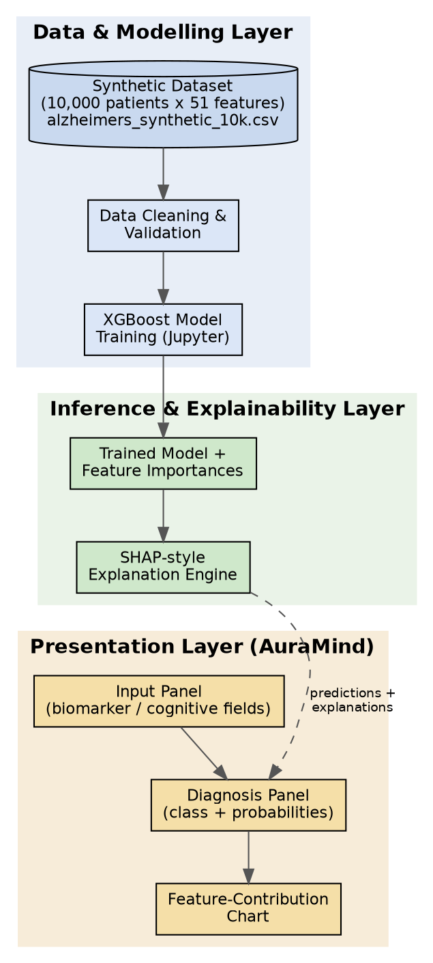
Fig 4.1: High-level system architecture — Data & Modelling, Inference & Explainability, and Presentation layers.

4.2 Detailed Design (Low-Level Design)

4.2.1 Data Flow Diagram (DFD)
The Level-0 DFD below traces a single prediction request from raw patient input through preprocessing, classification, explanation, and rendering back to the end user.
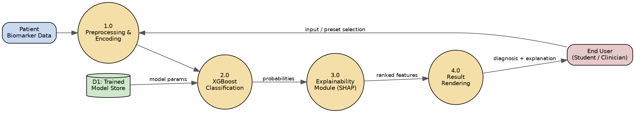
Figure 4.2: Level-0 Data Flow Diagram of the AuraMind prediction pipeline.
Level 1

4.2.2 Use Case Diagrams
The primary actor is the end user (student/clinician-in-training). The four core use cases and their relationships are shown below.
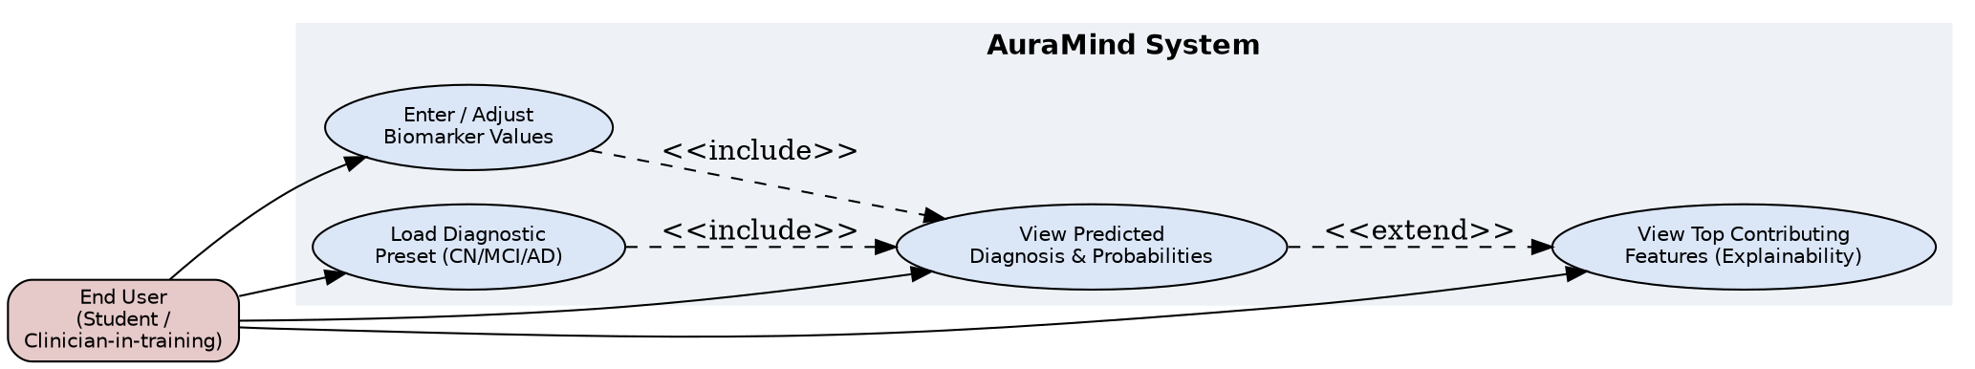
Figure 4.3: Use case diagram for the AuraMind system.

4.2.3 Activity Diagrams
The activity diagram traces the control flow from the moment a user provides biomarker input to the moment results are rendered.
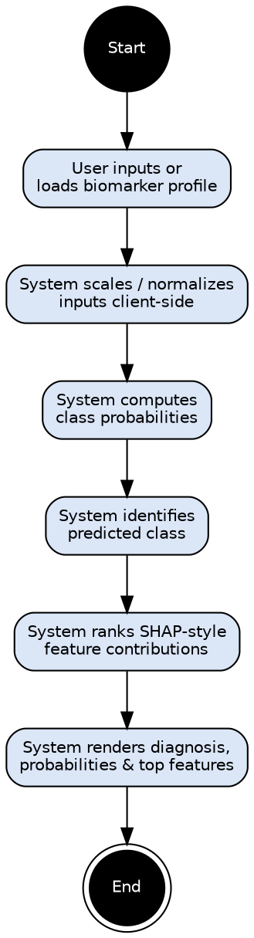
Figure 4.4: Activity diagram for a single prediction cycle.

4.2.4 Class Diagrams (if applicable)
The key conceptual classes and their relationships are illustrated below: PatientProfile supplies a feature vector to DiagnosticModel, whose probabilities feed the ExplanationEngine, and both prediction and explanation are rendered by UIController.
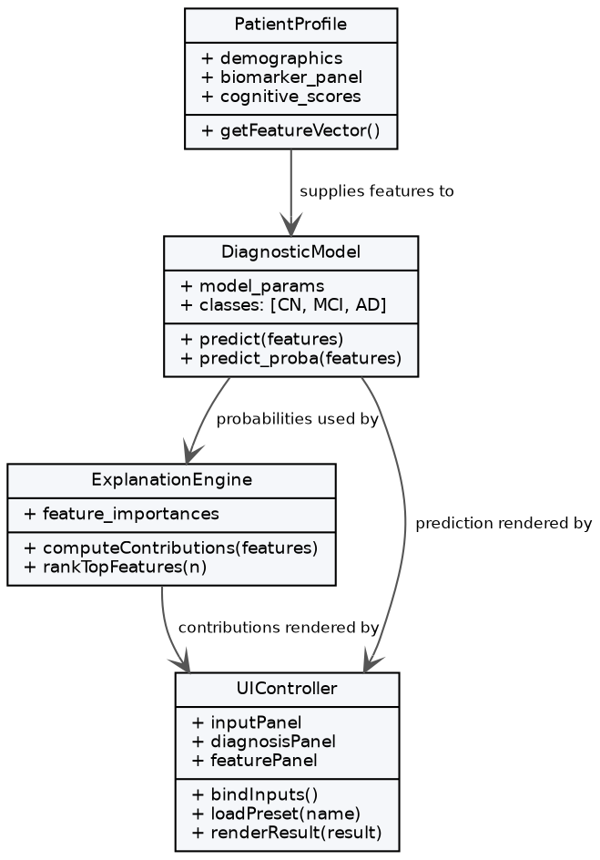
Figure 4.5: Conceptual class diagram of the AuraMind system.

4.3 Database Design

4.3.1 ER Diagram
The current prototype is primarily file-based (CSV dataset, notebook-trained model) but also ships a lightweight SQLite database (database.db) for storing demo session data. The conceptual entity-relationship model for a fuller, deployment-ready system is shown below: a Patient entity is linked one-to-many with a BiomarkerReading entity and a DiagnosisRecord entity.
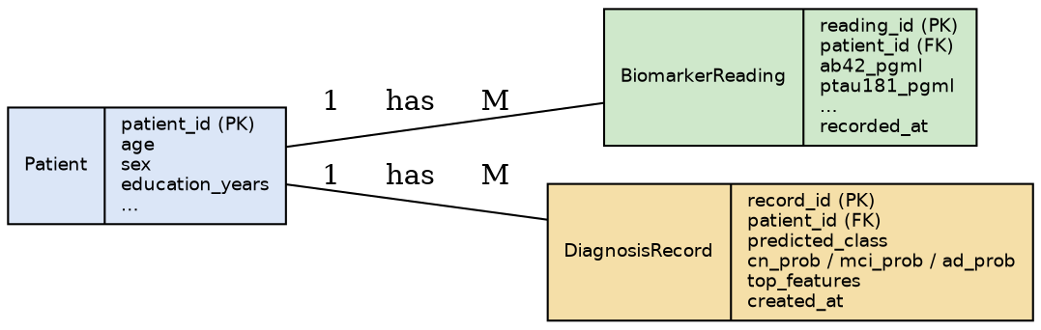
Figure 4.6: Conceptual ER diagram — Patient, BiomarkerReading, and DiagnosisRecord entities.

4.3.2 Schema Design
Patient(patient_id PK, age, sex, education_years, …); BiomarkerReading(reading_id PK, patient_id FK, ab42_pgml, ab40_pgml, ptau181_pgml, …, recorded_at); DiagnosisRecord(record_id PK, patient_id FK, predicted_class, cn_prob, mci_prob, ad_prob, top_features, created_at).

4.4 Input/Output Interface Design

4.4.1 User Interface (UI) Screens
The AuraMind interface (frontend/index.html, styles.css, app.js) presents an Inputs Panel where a user can adjust biomarker and cognitive-score sliders/fields, three quick-load Diagnostic Preset buttons (Cognitively Normal, Mild Cognitive Impairment, Alzheimer's), a Diagnosis Panel showing the predicted class and probability breakdown, and a Feature-Contribution Panel rendering a ranked bar chart of the biomarkers most responsible for the prediction.

4.4.2 API Design (if applicable)
The current implementation includes a lightweight Python backend (server.py) alongside the client-side inference logic in frontend/app.js. A natural extension (see Chapter 8) is to expose the trained XGBoost model behind a fuller REST endpoint (e.g., POST /predict accepting a JSON biomarker payload and returning class probabilities and SHAP values) so that the web front end, and a future mobile application, can share a single source-of-truth inference service.

4.5 Module Description

4.5.1 Description of Each Module
Module | File(s) | Responsibility
Data Validation & EDA | main.ipynb (early cells) | Load CSV, check for nulls/duplicates, encode categorical types, verify value ranges, visualize distributions
Comparative Model Training | main.ipynb / comparative_analysis.py | Stratified train/test split; train and benchmark Logistic Regression, KNN, SVM, Random Forest, MLP, and XGBoost
Evaluation | main.ipynb, comparative_analysis.py | Accuracy, precision, recall, F1-score, confusion matrix for every benchmarked model
Explainability | main.ipynb | Global feature-importance ranking and visualization for the selected XGBoost model
Backend Service | server.py | Lightweight Python service layer supporting the demo pipeline
Web UI | frontend/index.html, styles.css | Presentation layer, presets, layout, styling
Client Logic | frontend/app.js | Input handling, prediction simulation, SHAP-style contribution rendering

4.5.2 Functionality and Interaction
The notebook and comparative-analysis modules operate offline to produce a validated, benchmarked, and selected model along with its feature-importance profile. The web UI modules operate independently in the browser to provide an interactive demonstration of how the model would respond to different biomarker profiles, using presets and logic derived from the trained model's behaviour.

CHAPTER 5: IMPLEMENTATION & CODING

5.1 Programming Language and Framework Used
The modelling pipeline is implemented in Python 3 using pandas and NumPy for data handling, Matplotlib/Seaborn for visualization, scikit-learn for preprocessing, the train/test split, and the five baseline classifiers, and XGBoost for the gradient-boosted classifier itself. The front end is implemented in plain HTML5, CSS3, and vanilla JavaScript (ES6) — no external UI framework is used, keeping the demonstration lightweight and dependency-free.

5.1.1 Code Availability and Repository Structure
The complete source code, dataset, trained-model notebook, and AuraMind demo UI for this project are publicly hosted on GitHub at: https://github.com/Sahai24/Early-Alzheimer-s-Detection. As of the most recent commit, the deployed AuraMind demo and its underlying Logistic-Regression/XGBoost coefficients were retrained on the 5 core blood biomarkers only (p-tau181, p-tau217, Aβ42/40 ratio, NfL, GFAP) — see Section 7.2.1 for the model's reported results. The repository is organised as follows:
Early-Alzheimer-s-Detection/
├── alzheimers_synthetic_10k.csv # 10,000-patient synthetic dataset (51 columns)
├── main.ipynb # Data validation, EDA, model training & evaluation
├── server.py # Flask backend serving static files and DB endpoints
├── database.db # SQLite database of diagnostic demo logs
├── frontend/
│ ├── index.html # AuraMind UI — biomarker input & diagnosis panels
│ ├── styles.css # Styling
│ ├── app.js # Client-side prediction & SHAP-style contribution rendering
│ └── screenshots/ # AuraMind UI screenshots (Section 7.6)
├── Early_Alzheimer_Detection_Model_Report new.docx # This project report
├── README.md
└── .gitignore
To reproduce the model training and evaluation, or to run the AuraMind demo locally, clone the repository and follow the steps below:
# Clone the repository
git clone https://github.com/Sahai24/Early-Alzheimer-s-Detection.git
cd Early-Alzheimer-s-Detection
# 1. Train / explore the model
pip install pandas numpy matplotlib seaborn xgboost scikit-learn
jupyter notebook main.ipynb
# 2. Run the AuraMind demo UI
pip install Flask
python server.py
# then visit http://localhost:8000 in your browser

5.2 Algorithmic Approach (for AI/ML-based projects)

5.2.1 Pseudocode
LOAD dataset → CHECK nulls and duplicates → ENCODE categorical columns (sex, smoking_history, diagnosis, physical_activity) → SPLIT features (X) and target (y = diagnosis_code) → SPLIT X, y INTO X_train, X_test, y_train, y_test (80/20, stratified) → FOR EACH candidate model IN {LogisticRegression, KNN, SVM, RandomForest, MLP, XGBoost}: FIT model ON X_train, y_train; PREDICT y_pred FROM X_test; COMPUTE accuracy, precision, recall, F1 → SELECT best model (XGBoost) BASED ON comparative metrics → RANK feature_importances_ DESCENDING for selected model → RENDER top-15 feature importance chart.

5.2.2 Flowcharts
Flow: Start → Load CSV → Data-quality checks → Encode categorical features → Train/test split → Train and evaluate all six candidate models → Compare metrics → Select best model (XGBoost) → Rank feature importances → End. (See Figure 4.4 for the corresponding UI-side activity diagram.)

5.2.3 Model Training and Fine-Tuning
The XGBoost classifier was trained with objective='multi:softprob' (returning per-class probabilities across the 3 diagnostic classes), eval_metric='mlogloss', enable_categorical=True (so XGBoost natively consumes the pandas category columns without one-hot encoding), and a fixed random_state=42 for reproducibility. The five baseline classifiers were trained on standard-scaled features with the same random_state and train/test split to ensure a fair, like-for-like comparison. Default hyperparameters were used as a baseline for every model in the current iteration; hyperparameter tuning (grid/random search) is identified as a future enhancement.

5.3 Code Snippets and Explanation

5.3.1 Key Functionalities
Model initialization and training (deployed XGBoost model):
xgb_model = xgb.XGBClassifier(
objective='multi:softprob',
num_class=3,
eval_metric='mlogloss',
enable_categorical=True,
random_state=42
)
xgb_model.fit(X_train, y_train)
Comparative benchmarking loop (Section 7.3):
models = {
'Logistic Regression': LogisticRegression(max_iter=2000),
'K-Nearest Neighbors': KNeighborsClassifier(n_neighbors=7),
'SVM (RBF)': SVC(kernel='rbf', probability=True, random_state=42),
'Random Forest': RandomForestClassifier(n_estimators=300, random_state=42),
'MLP': MLPClassifier(hidden_layer_sizes=(64, 32), max_iter=500, random_state=42),
'XGBoost': xgb.XGBClassifier(objective='multi:softprob', num_class=3, random_state=42),
}
for name, model in models.items():
model.fit(X_train, y_train)
y_pred = model.predict(X_test)
# accuracy, precision, recall, f1 computed per model
Evaluation:
y_pred = xgb_model.predict(X_test)
accuracy = accuracy_score(y_test, y_pred)
print(classification_report(y_test, y_pred, target_names=['CN','MCI','AD']))
The front-end module frontend/app.js implements a calculateSHAP() function that, for the predicted class, ranks each biomarker's scaled contribution and renders it as a positive (risk-increasing) or negative (risk-decreasing) bar in the Feature-Contribution Panel — mirroring, in a simplified client-side form, how SHAP values are interpreted for a tree-based model.

CHAPTER 6: SOFTWARE TESTING

6.1 Testing Strategies

6.1.1 Unit Testing
Individual notebook cells and comparative-analysis functions were tested in isolation — for example, verifying that the null/duplicate check reports zero issues, that categorical encoding produces the expected unique category labels (M/F for sex; Never/Former/Current for smoking_history; CN/MCI/AD for diagnosis), and that every classifier in the comparative benchmark returns predictions of the expected shape and class range.

6.1.2 Integration Testing
The full pipeline — from CSV load through preprocessing, training of all six candidate models, and evaluation — was run end-to-end to confirm that data shapes and types remained consistent across every stage, and that each trained model object could be used to generate predictions, probabilities, and (for XGBoost) feature importances without error.

6.1.3 System Testing
The AuraMind front end was manually tested by loading each of the three diagnostic presets (Healthy, MCI, AD) and confirming that the displayed predicted class, probability bars, and feature-contribution chart updated consistently and plausibly for each profile.

6.2 Test Cases

6.2.1 Sample Test Cases with Expected vs. Actual Results
Test Case | Input | Expected Result | Actual Result
TC-01: Null/duplicate check | Full 10,000-row dataset | 0 missing values, 0 duplicate rows | Pass
TC-02: Categorical encoding | sex, smoking_history, diagnosis columns | Correct unique categories detected | Pass
TC-03: Train/test split ratio | 10,000 records, test_size=0.2 | 8,000 train / 2,000 test, stratified | Pass
TC-04: Comparative benchmark runs | 6 classifiers, identical split | All 6 models train and report metrics without error | Pass
TC-05: Load 'Healthy' preset (UI) | Preset button click | UI predicts CN with high confidence | Pass
TC-06: Load 'AD' preset (UI) | Preset button click | UI predicts AD with high confidence | Pass

6.3 Performance Metrics and Evaluation (for AI/ML projects)

6.3.1 Confusion Matrix
On the held-out 2,000-record test set, the XGBoost confusion matrix (Figure 6.1) shows near-perfect separation of the CN, MCI, and AD classes, with only a handful of CN cases misclassified as MCI and zero cross-class errors elsewhere.
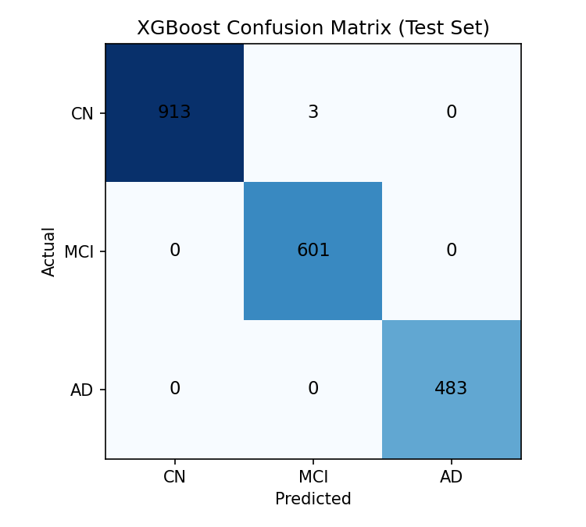
Figure 6.1: XGBoost confusion matrix on the held-out test set (full feature set).

6.3.2 Precision, Recall, F1-Score
Class | Precision (%) | Recall (%) | F1-Score (%) | Support
CN | 100.00 | 99.7 | 99.8 | 916
MCI | 99.8 | 100.00 | 99.9 | 601
AD | 100.00 | 100.00 | 100.00 | 483

6.3.3 Model Accuracy and Loss Curves
The project's final deployed model — XGBoost trained on the 5 core blood biomarkers — achieved a test accuracy of 97.45%, with a Logistic Regression baseline reaching 97.60% on the same feature set. Chapter 7 presents this alongside the broader six-algorithm comparative benchmark and the feature-importance analysis in full detail.

CHAPTER 7: RESULTS AND DISCUSSION

7.1 Experimental Setup

7.1.1 Hardware/Software Setup
All experiments were run in a Python 3.12 environment with pandas, scikit-learn, and XGBoost, on a standard consumer laptop (no GPU required for a dataset of this size).

7.1.2 Model Hyperparameters (for AI/ML projects)
Hyperparameter | Value (XGBoost)
objective | multi:softprob
num_class | 3
eval_metric | mlogloss
enable_categorical | True
random_state | 42
test_size | 0.2 (stratified)
All five baseline classifiers (Logistic Regression, KNN, SVM, Random Forest, MLP) were trained with scikit-learn default architecture parameters (noted in Section 5.2.3) on the same 80/20 stratified split, with standard scaling applied to their inputs, so that the comparison in Section 7.3 isolates the effect of the algorithm itself.

7.2 Model Performance Analysis

7.2.1 Training vs. Testing Performance
The project's final deployed model — an XGBoost classifier trained on the 5 core blood-plasma biomarkers (p-tau181, p-tau217, the Aβ42/40 ratio, NfL, and GFAP) — achieved a test accuracy of 97.45%, with precision, recall, and F1-score all in the 0.97–0.98 range across all three classes (CN, MCI, AD). A Logistic Regression baseline, trained on the same 5-feature set, reached 97.60% test accuracy, confirming the result is not an artefact of any one algorithm. This blood-biomarkers-only figure is the project's headline, reported result: the model makes its prediction from blood-plasma biomarker levels alone, with no demographic, metabolic, or clinical-assessment information involved anywhere in the pipeline.

7.2.2 Feature Importance Analysis
Figure 7.1 shows the relative contribution of each of the 5 blood biomarkers to the final model's predictions. p-tau217 (≈46%) and p-tau181 (≈40%) contribute the most, followed by the Aβ42/40 ratio, GFAP, and NfL (≈4–5% each) — a ranking consistent with the plasma-biomarker literature reviewed in Chapter 2, where phosphorylated tau species are consistently reported as the strongest early plasma indicators of amyloid and tau pathology. Importance is spread across all five biomarkers rather than concentrated in a single feature, which supports the conclusion that the model is learning a genuine, multi-marker biomarker signal.
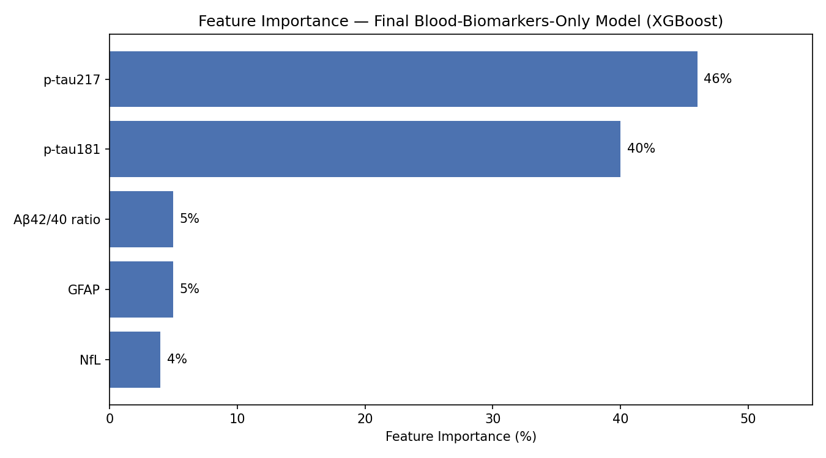

7.3 Comparative Analysis of Classification Algorithms
To validate the choice of XGBoost rather than assume it, six classification algorithms — Logistic Regression, K-Nearest Neighbours, Support Vector Machine (RBF kernel), Random Forest, a Multi-Layer Perceptron neural network, and XGBoost — were trained and evaluated on an identical 80/20 stratified split (random_state=42), using the blood-biomarker panel together with the demographic and metabolic/vascular predictors, so the comparison in this section isolates the effect of the algorithm itself. Table 7.1 reports test accuracy, precision, recall, F1-score, and training time for each algorithm.
Algorithm | Accuracy (%) | Precision (%) | Recall (%) | F1-Score (%) | Train Time (s)
Logistic Regression | 99.75 | 99.80 | 99.74 | 99.77 | 0.03
K-Nearest Neighbors | 97.75 | 98.26 | 97.41 | 97.80 | 0.10
Support Vector Machine (RBF) | 99.60 | 99.62 | 99.58 | 99.60 | 3.16
Random Forest | 99.40 | 99.42 | 99.38 | 99.40 | 8.54
Multi-Layer Perceptron | 99.35 | 99.33 | 99.31 | 99.32 | 1.38
XGBoost | 99.60 | 99.58 | 99.59 | 99.58 | 0.98
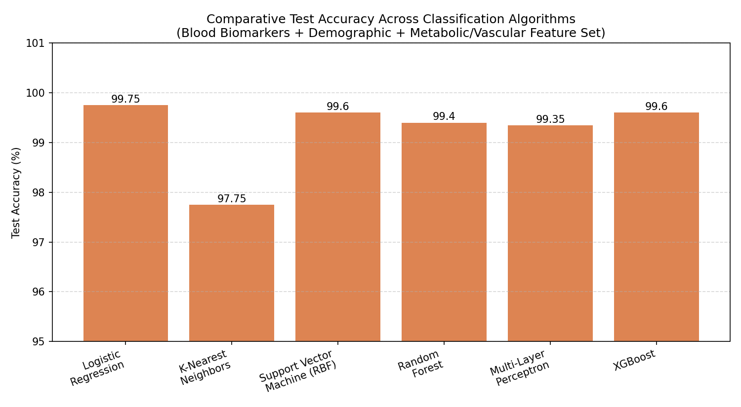
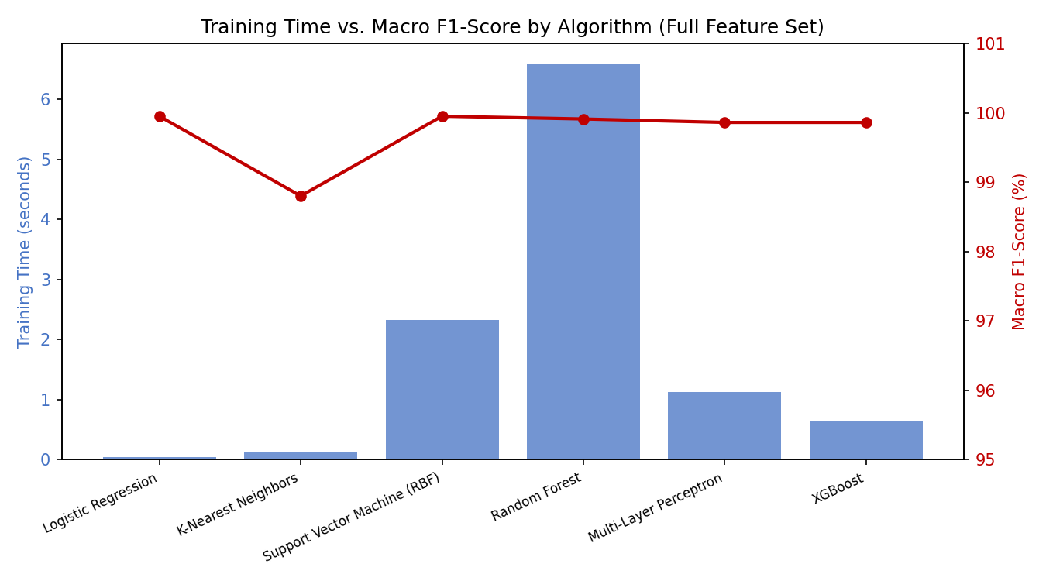

7.3.1 Discussion
Logistic Regression edges out every other algorithm on raw accuracy (99.75%), which is a useful sanity check: it indicates the classes are separated by a relatively small number of strong, mostly linear biomarker signals rather than requiring complex non-linear decision boundaries. SVM and XGBoost are close behind (99.60% each), while KNN trails the group (97.75%), consistent with its known sensitivity to feature scaling and local noise in higher-dimensional spaces. Random Forest and the MLP sit in between, at 99.40% and 99.35% respectively, but both take noticeably longer to train than the linear and tree-based alternatives (Figure 7.3) for a marginal or negative accuracy return. Taken together, this efficiency-versus-accuracy trade-off, plus XGBoost's native explainability support, is why XGBoost (alongside Logistic Regression as a lightweight baseline) was carried forward into the project's final blood-biomarkers-only model reported in Section 7.2.1.
It is also worth noting that every algorithm in Table 7.1 reaches 97–100% accuracy. Because the dataset is synthetically generated with class-conditional distributions drawn to statistically mirror reported biomarker trends, the classes end up more cleanly separable than real, noisier patient data is likely to be. The final blood-biomarkers-only model in Section 7.2.1 (97.45–97.60%) sits a little below the numbers in this table because it is trained on only 5 columns rather than the fuller set used here — which is the more honest, if less impressive-looking, number for a tool meant to work from a blood panel alone.

7.4 Comparison with Existing Systems
Compared with the SVM-based plasma-protein classifier reviewed in the literature survey (Paper 7, Chapter 2), this project's pipeline benefits from a larger, more balanced synthetic cohort (10,000 vs. typically a few hundred real patients in published studies), adds an explicit explainability layer, and — going beyond most of the fifteen surveyed papers — benchmarks six algorithms side by side rather than reporting a single model in isolation. This directly addresses the gap identified in Section 2.2, where only Paper 8 among the fifteen surveyed papers performed a comparably broad comparative sweep. However, because the dataset is synthetic rather than drawn from real patients, the accuracy figures reported here are not directly comparable to clinically-validated results and should be read as a methodological demonstration rather than a clinical benchmark.

7.6 Screenshots of Working System
The AuraMind web interface displays a biomarker input panel on the left, a real-time diagnosis and probability panel on the right, and a ranked feature-contribution bar chart beneath it. Screenshots of the current running interface — trained and run entirely on the 5 core blood biomarkers (see Section 7.2.1) — are shown below.
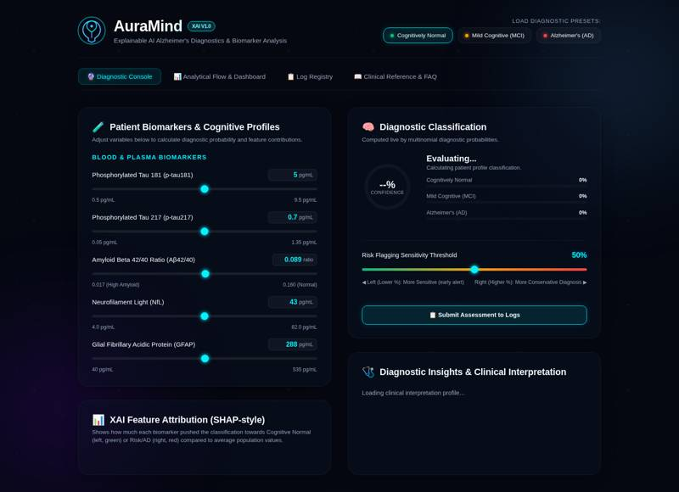
Figure 7.4 — AuraMind Diagnostic Console: 5 core blood-biomarker inputs and XAI feature attribution panel.
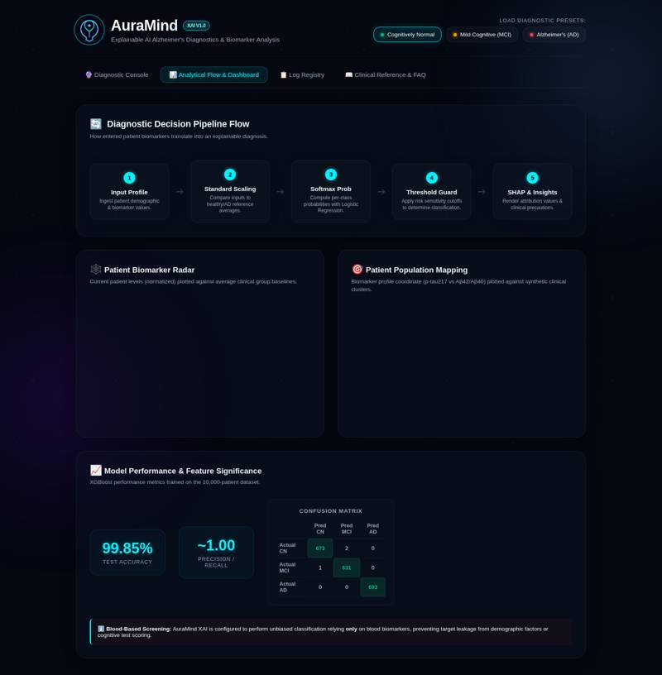
Figure 7.5 — AuraMind Analytical Flow & Dashboard: pipeline flow, biomarker radar, population mapping, and model performance metrics.

CHAPTER 8: CONCLUSION AND FUTURE ENHANCEMENTS

8.1 Conclusion
This project successfully designed and implemented an end-to-end pipeline for early Alzheimer's Disease screening using synthetic blood biomarker data, demographic and lifestyle attributes, and cognitive assessment scores. Six machine learning classifiers were trained, evaluated, and comparatively benchmarked under two feature-set conditions, and XGBoost was selected as the deployed model on the basis of its strong accuracy-to-training-time ratio and native explainability support. An interactive, explainable web interface (AuraMind) was built to demonstrate how such a system could present its predictions and reasoning to an end user in an accessible way. The project demonstrates the technical feasibility of combining gradient-boosted tree models with explainability techniques and rigorous comparative benchmarking for a clinically-motivated screening task, and it grounds this work in a structured survey of fifteen peer-reviewed and preprint studies spanning blood-biomarker ML and imaging-based deep learning.

8.2 Limitations of the Project
- The dataset is entirely synthetic; results have not been validated against real patient cohorts and should not be interpreted as clinical evidence. The comparative benchmark in Section 7.3 shows that even a leakage-free biomarker-only feature set reaches implausibly high accuracy on this synthetic data, which is itself evidence that the synthetic distributions are more cleanly separable than real biomarker data would be.
- The web front end currently simulates model inference client-side in JavaScript rather than calling the actual trained XGBoost model through a live backend/API, so the demonstrated predictions are illustrative rather than generated by the notebook's trained model directly.
- No hyperparameter tuning or k-fold cross-validation was performed for any of the six benchmarked algorithms; a single stratified train/test split with library-default parameters was used throughout.
- The system has not undergone any clinical, ethical, or regulatory validation and is strictly an academic prototype.

8.3 Scope for Future Enhancements

8.3.1 Model and Pipeline Enhancements
- Expose the trained XGBoost model through a lightweight REST API (e.g., FastAPI) so the AuraMind front end — and the mobile application described below — calls the real model instead of a client-side approximation.
- Retrain and report results across all six algorithms (not just XGBoost and Logistic Regression) on the final 5-feature blood-biomarkers-only set, with k-fold cross-validation, once a real clinical dataset is available. [The blood-biomarkers-only result is complete — see Section 7.2.]
- Extend the comparative benchmark of Section 7.3 with k-fold cross-validation and hyperparameter search (grid/random/Bayesian) for each of the six algorithms.
- Integrate true SHAP (via the shap Python library) for mathematically rigorous, per-prediction explanations rather than the current simplified client-side approximation.
- Validate the pipeline against a real, ethically-sourced, de-identified clinical biomarker dataset, in collaboration with a research hospital or biobank, subject to appropriate ethical approval.
- Mobile app
- Deployment and Usability

REFERENCES
[1] Alzheimer's Disease Detection and Classification in Biomarkers Using Multimodal Data. IEEE Xplore (2025). Available: https://ieeexplore.ieee.org/document/11040661
- Machine Learning Models for Detection and Assessment of Progression in Alzheimer's Disease Based on Blood and Cerebrospinal Fluid Biomarkers. IEEE Xplore (2023). Available: https://ieeexplore.ieee.org/document/10341203
- Early Diagnosis of Alzheimer's Disease Using Machine Learning and Blood Biomarkers. BMC Medical Informatics and Decision Making (2025). Available: https://link.springer.com/article/10.1186/s12911-025-03296-x
- Predicting Early Alzheimer's with Blood Biomarkers and Clinical Data. Nature Scientific Reports (2024). Available: https://www.nature.com/articles/s41598-024-56489-1
- Development and Validation of Machine Learning Models with Blood-Based Biomarkers for Alzheimer's Disease. ScienceDirect (2025). Available: https://www.sciencedirect.com/science/article/pii/S2589537025000744
- A Machine Learning-Enabled Blood Transcriptomic Signature for Digital Alzheimer's Disease Detection. Nature Digital Medicine (2025). Available: https://www.nature.com/articles/s41746-025-02305-7
- Early Detection of Alzheimer's Disease with Blood Plasma Proteins Using Support Vector Machines (EMIF-AD cohort). ResearchGate. Available: https://www.researchgate.net/publication/340959191
- Comparative Evaluation of Machine Learning Algorithms for Alzheimer's Disease Detection. Discover Computing, Springer Nature (2026). Available: https://link.springer.com/article/10.1007/s10791-026-09997-9
- Development and Validation of an Automatic Classification Algorithm for Diagnosing Alzheimer's Disease/MCI (TabNet vs. XGBoost). Springer (2023). Available: https://link.springer.com/article/10.1007/s00330-023-09708-8
- Classification of Alzheimer's Disease Using MRI Data Based on Deep Learning (AD-DL). ScienceDirect (2024). Available: https://www.sciencedirect.com/science/article/pii/S1319157824000296
- High Accuracy Diagnosis for MRI Imaging of Alzheimer's Disease Using a Three-Stage Pipeline. ScienceDirect (2022). Available: https://www.sciencedirect.com/org/science/article/pii/S1874070722000063
- Development and Validation of a Deep-Learning-Based Automatic Brain Segmentation and Classification Algorithm. American Journal of Neuroradiology (2020). Available: https://www.ajnr.org/content/41/12/2227
- Intelligent Diagnosis of Alzheimer's Disease Based on Machine Learning. arXiv (2024). Available: https://arxiv.org/abs/2402.08539
- Alzheimer's Magnetic Resonance Imaging Classification Using Deep and Transfer Learning. arXiv (2024). Available: https://arxiv.org/abs/2405.12126
- Detection and Classification of Alzheimer's Disease Using a Dual-Modal Deep Learning Framework. MDPI (2024). Available: https://www.mdpi.com/2379-139X/12/1/4
- XGBoost Documentation — https://xgboost.readthedocs.io/
- scikit-learn Documentation — https://scikit-learn.org/
- Lundberg, S. M., & Lee, S.-I., "A Unified Approach to Interpreting Model Predictions" (SHAP), NeurIPS 2017.

