**SAHAKARYA**

**Team Name** – SAHAKARYA  
 **Team Leader’ name** – K. RAMYA SREE  
  
**Team Leader’ email id** -ramyasree0907@gmail.com

**Solution Brief Overview** –   
  
Our idea is about, In the COVID 19 pandemic situation, Mainly one of the community is   
  
effecting i.e., Labours who are migrated from other states are facing problem for their   
  
survival needs. Sudden announcement of lockdown left them unprepared for it.

Contrary and uncoordinated government orders caused confusion (Ex: Delhi migrants)  
  
All the above factors lead to their mass exodus from urban areas to their homes often by foot due to   
  
suspension of Transport facilities and if Transpotation facility is available then there is high chance of   
  
spreading corona virus and they are suffering for food and shelter.  
  
To help them, a mobile CHATBOT application is proposed, so by using this chatbot they can request   
  
through this app for their essential needs like food, shelter . so that we connect to nearby Donars or   
  
Ngos to help them.  
  
To develop the proposed CHATBOT Application , IBM services like Watson Assistant, Database,slack   
  
and Here location services are used . IBM Watson Assistant is used to build, train and deploy   
  
conversational interactions. The proposed CHATBOT plays a vital role in helping the families of   
  
migrated labours during the time of crises.  
  
**Working Model  
  
Solution description-**In implement the idea, IBM services like Watson Assistant, Database, slack and in addition external   
  
source HERE location services are used to develop application for labour migrants and here we   
  
created a chatbot that is used to communicate with the user and donar. The conversion process is   
  
like if the user type hi then it responds like hello I’m community cooporation chatbot how can I help   
  
you, If user needs food then chatbot shares location where the food is available for user. so in this   
  
chatbot where the response is given according to the intends, entities and dialogues which are   
  
imported in the chat-bot . so this is how the communication process goes on in the chat-bot. Firstly   
  
we log in to an IBM cloud then by creating a Watson assistant, imported intends i.e input given by   
  
the user ,entities nothing but out puts given to the chatbot and then go to the dialog by adding   
  
nodes in that and the chatbot is ready for the communication between user and the Donar.after   
  
that preview link to copy and run the application the user’s essential needs are provided within a   
  
time by Donar and take less time to help by servicing their needs by social servicing Donars. As per   
  
our knowledge, the is no application like this so we have developed this application, and this   
  
application is our contribution to the benefit of society and it falls under the category of community   
  
cooporation.  
  
**Solution Architecture-**

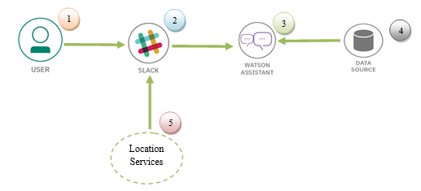  
In the solution architecture, IBM sevices like Watson assistant, Data source,   
  
slack and Location services are used to develop chatbot to help the labour migrants  
  
The user visits a website with the SAHAKARYA chatbot and asks a question.

* + The Slack Integrated with Watson Assistant hosted in IBM Cloud.
  + Watson Assistant uses natural language understanding and machine learning to extract entities and intents of the user question.
  + The SAHAKARYA FAQ is sourced from trusted CDC data.
  + Slack communicate with the user for helping there essentional needs
  + Location services connected with slack and shares loction to user
  + Data sources stores the external data for sending Watson assistant
  + IBM Cloud Function calls the SAHAKARYA API to get statistics.
  + Watson Assistant replies to the user inquiry  
    .
  + The Slack web server displays the chat answer to the user.

1. **IBM Cloud Services/Systems** –  The List of IBM Services used in this solution
   * IBM Watson Assistant
   * DATA SOURCE
   * NODE-Red Slack Integration
   * HERE Location Services