Car Price Predictor-GUI

Project Structure:

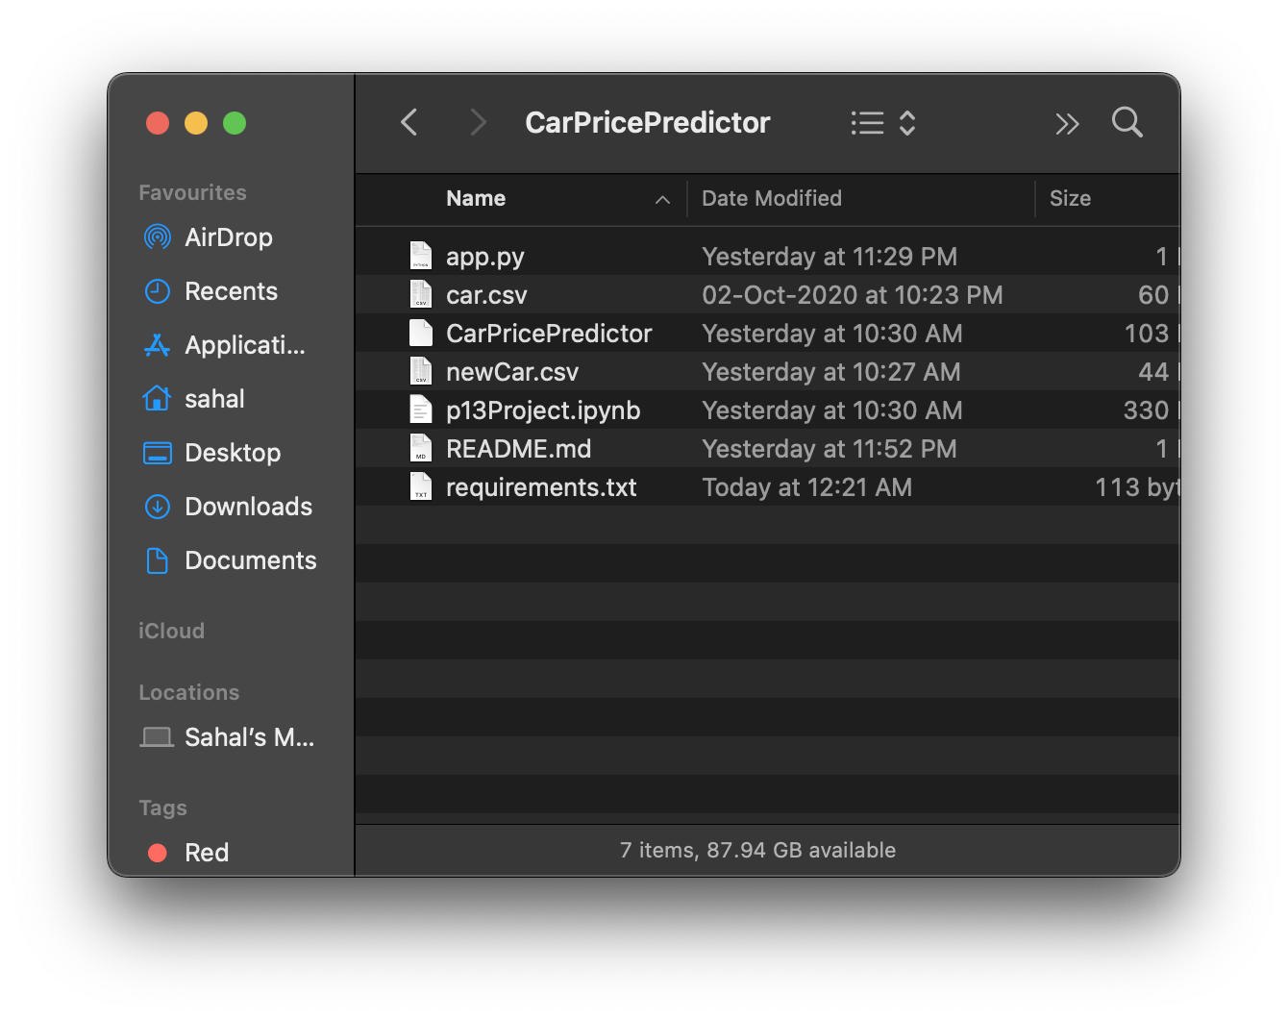

App.py:

import streamlit as st

import joblib

import pandas as pd

import numpy as np

model=joblib.load(open('CarPricePredictor','rb'))

car=pd.read_csv('newCar.csv')

st.title('Car Price Predictor')

st.subheader('Select the details')

col1, col2, col3, col4 = st.columns(4)

with col1:

companies=sorted(car['company'].unique())

company = st.selectbox("Company:", companies)

with col2:

car_models=sorted(car[car.name.str.startswith(company)]['name'].unique())

car_model = st.selectbox("Model:", car_models)

with col3:

years=sorted(car['year'].unique(),reverse=True)

year = st.selectbox("Year:", years)

with col4:

fuels=car['fuel_type'].unique()

fuel_type = st.selectbox("Fuel Type:", fuels)

driven = st.number_input('Kilometres travelled:')

if st.button('Predict'):

if not car_model or not company or not year or not driven or not fuel_type:

st.warning('Select Properly')

else:

st.balloons()

prediction=model.predict(pd.DataFrame(columns=['name', 'company', 'year', 'kms_driven', 'fuel_type'],

data=np.array([car_model,company,year,driven,fuel_type]).reshape(1, 5)))

prediction=prediction[0].astype(str)

st.text('₹ ' + prediction)

NewCar.csv:

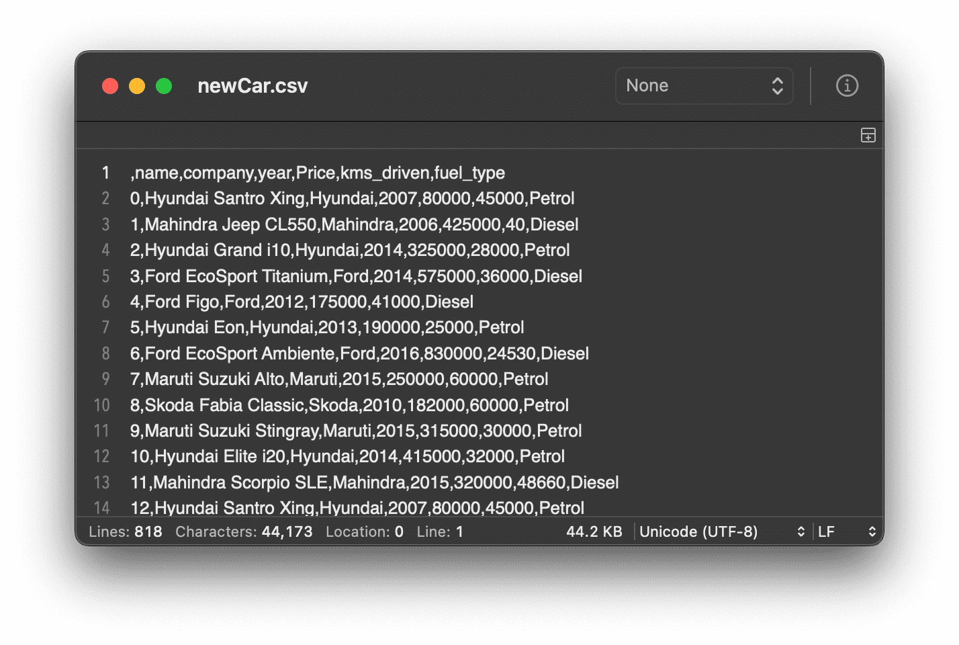

Requirements.txt:

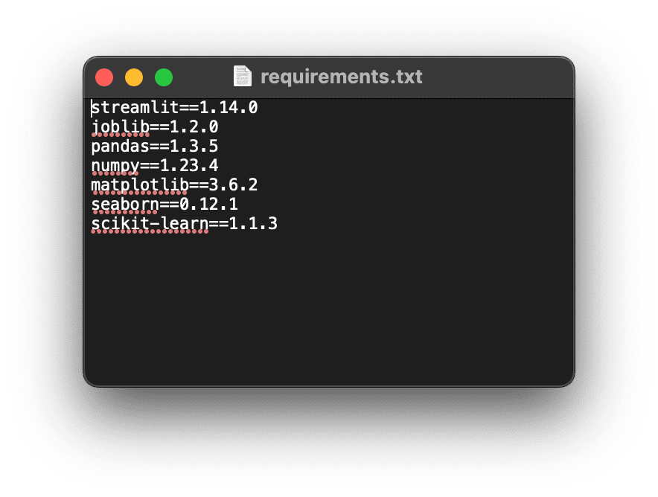

Readme.md:

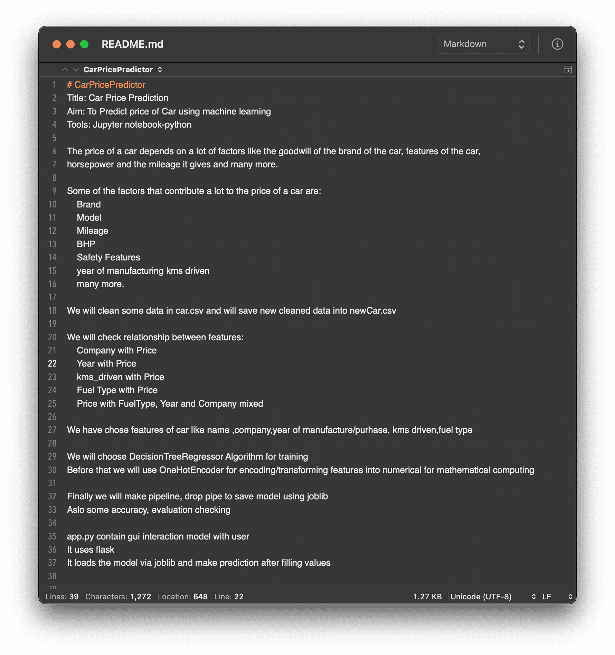

Output:

