Project 1: Static Foundations
Feedback for Sahan Kumarage's portfolio
Student: Sahan Kumarage Course: CSC 436, Fall 2026 Reviewed at: 50b10e7
Repo: github.com/Sahan2004-06/CSC436 (Project 1 folder) Live: nimble-capybara-2af565.netlify.app

Grade: 80 / 100
Category | Points | Earned | One line
Semantic HTML | 20 | 18 | The most thorough markup in the class; one validator error and four links that go nowhere useful
CSS layout | 25 | 22 | 693 lines with tokens, Flexbox everywhere and three real Grids; all of it inline in the HTML, desktop-first
Responsive design | 15 | 13 | No horizontal scroll at any width, a real drawer, three breakpoints; overflow-x: hidden hides whatever might slip
JavaScript interaction | 15 | 14 | Scroll spy, drawer with Escape and focus return, tag filter with active state; all vanilla, all verified
Repository and deployment | 15 | 6 | The entire site in one commit at 7:34 PM on the due date; a README that describes a repo that does not exist
Content and polish | 10 | 7 | Real bio with a real voice; zero images, a 2025 date in 2026, project links to a profile
Total | 100 | 80 | Excellent code. The repository around it is where the points went, and where the brief has a warning.

How this review was made
Your instructor reviewed this project with Claude (Anthropic's AI) as a second set of eyes. Claude cloned the repo, read the whole 1,178-line file, loaded the live site at phone, tablet and desktop widths, ran the W3C validator, opened and closed the mobile drawer, clicked every filter button, scrolled to test the scroll spy, compared the live HTML to the repo byte for byte, and read the README against the code. Every note and every point in this document was read and approved by your instructor. Same standard, same rubric, just more time spent looking at your code than one human has in a grading week.

The short version
The site is very well built. The markup has aria-labelledby on every section, role="list" where a reset would otherwise strip semantics, aria-expanded and aria-controls on the hamburger, a role="group" filter bar, and one h1. The CSS has a token block, twenty Flexbox rules, three Grids including an auto-fit gallery, clamp() type, and a prefers-reduced-motion block. The JavaScript has three interactions and every one of them works: Claude opened the drawer, filtered to Python and got the right two cards, scrolled to Projects and watched the nav light up.
Then there is the repository. Two commits, three minutes apart, at 7:34 PM on the due date. The first one is the whole site: 1,178 lines in one file. The brief, in bold, says a single last-minute commit containing the whole project loses repository points and triggers an academic integrity review. Your instructor will follow up on the second part. This review handles the first.
The README makes it worse, not better. It describes index.html at the repo root, says Netlify will find it automatically, says the CSS is mobile-first, and counts four sections. The repo has Project 1/Personal Project 1.html, no index.html, three max-width queries, and five sections. The README is a good document about a different repository.

What Claude measured
Check | Result
Horizontal scroll at 375 / 768 / 1024 / 1280 px | None at any width
W3C HTML validator | 1 error: aria-label on a plain div (line 760)
Heading order | h1 > h2 > h3, no skipped levels
Semantic elements | header, 2 nav, main, 5 section, 4 article, footer
Mobile drawer | Opens with 4 links, aria-expanded and label flip, closes on link tap and Escape
Filter: python / all | 2 / 4 cards, active class moves correctly
Scroll spy | Highlights Projects when scrolled there; never reaches Contact (last section is shorter than the viewport)
Console errors | 0
Images on the page | 0
Links: project "GitHub" | 3, all to your profile, not a repository
Links: "Live" on the Static Foundations card | href="#"
Live HTML vs repo file | Identical
Files in repo | 2: Project 1/README.md, Project 1/Personal Project 1.html
Commits | 2, both on Sep 15 between 7:34 PM and 7:37 PM; the first is the entire site
README claims vs repo | index.html at root (no), mobile-first (no), 4 sections (5)

The site at three widths
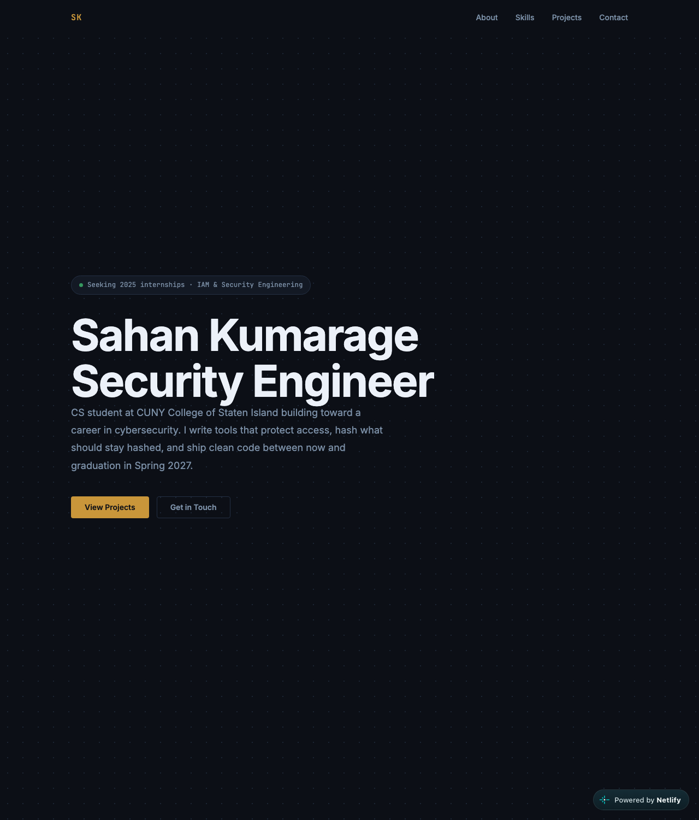
Desktop, 1280px. Full-viewport hero with a fixed nav.
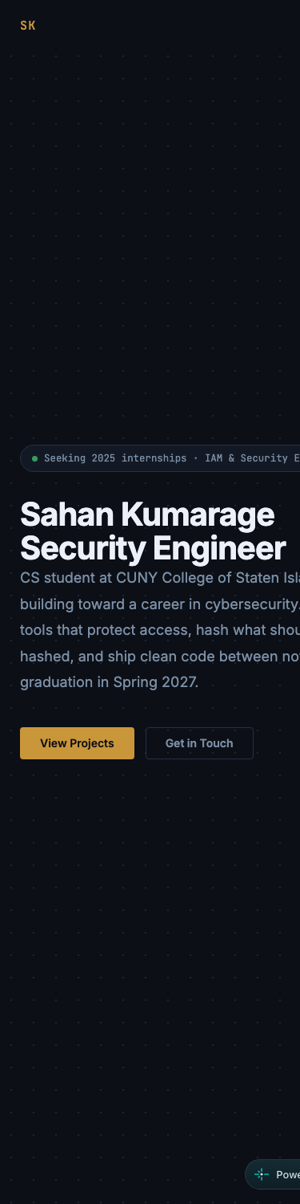  Phone, 375px. Hamburger, stacked buttons, no horizontal scroll. | 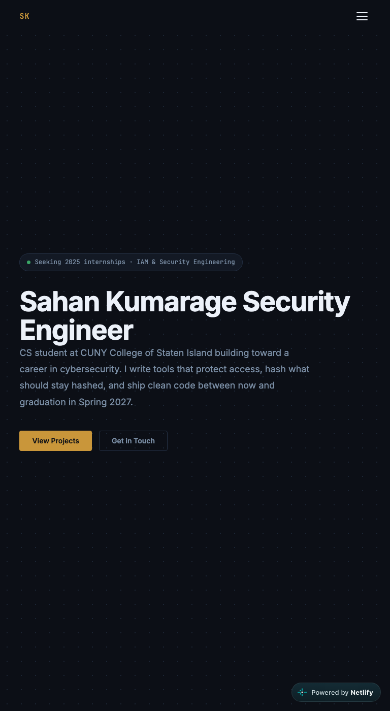  Tablet, 768px.

Semantic HTML: 18 / 20

What is working
- This is the most careful markup submitted so far. header > nav with aria-label, a real ul > li > a with role="list" so the CSS reset does not strip list semantics, a hamburger button with aria-expanded and aria-controls, every section labelled by its own heading via aria-labelledby, article for each project card, a role="group" on the filter bar, a second nav in the footer with its own label, rel="noopener noreferrer" on every external link. One h1 with the role in a span (line 765). A meta description. The validator finds one thing in 1,178 lines.

What to change
- The one validator error. Line 760: a div with aria-label. A div has no role, so ARIA says it cannot carry a label. Either give it role="status" (which is what it is) or drop the attribute; the visible text already says it.
- Four links go nowhere useful. The three project "GitHub" links all point at your profile, not the project. If PassGuard and HashVault have repos, link them. If they do not yet, say "coming soon" instead of linking. And the "Live" link on the Static Foundations card is href="#"; you are already on it, so link the section or drop the link.
- Small: the mobile drawer is a div with role="dialog". A dialog traps focus and has a name; yours is really a second nav. A nav with aria-label="Mobile navigation" is the honest element and needs no role.

CSS layout: 22 / 25

What is working
- A real design system: 14 tokens for color, type, width and radius (lines 18 to 32), used consistently. Twenty Flexbox rules doing layout: the nav, hero actions, skills cards, stat cards, project card headers, the footer (copyright left, links right, wrapping under 768px). Three Grids: the About two-column, a nested 2 by 2 stat grid, and repeat(auto-fit, minmax()) for projects. clamp() on headings. A prefers-reduced-motion block that zeroes every animation. Zero !important outside that block.

What to change
- Everything is in one file. 693 lines of CSS and 107 lines of JavaScript live inside Personal Project 1.html. It works, but the brief was called Static Foundations for a reason: index.html, style.css, script.js is the foundation. It is also what your own README says the structure is. Split them.
- Desktop-first, while the README says mobile-first. All three width queries are max-width (lines 657, 680, 693). The brief asked for mobile-first. Either flip the queries or fix the README; right now they disagree.
- overflow-x: hidden on body (line 52). Claude turned it off at four widths and nothing overflowed, so you do not need it. Delete it. If something ever does overflow, you want to see it, not hide it.

Responsive design: 13 / 15

What is working
- No horizontal scroll at 375, 768, 1024 or 1280. The hero stacks its buttons under 480px, the About grid drops to one column, the projects grid goes from two columns to one, the footer stacks and centers, and the nav collapses to a drawer that Claude opened and closed. 100svh on the hero, which is the correct unit for phones with a moving address bar. This is a responsive site.

What to change
- Desktop-first (see CSS). The brief asked for the other direction, and your README claims the other direction.
- overflow-x: hidden is a safety net you do not need. Remove it and you will know for certain the layout holds.

JavaScript interaction: 14 / 15

What is working
- Three interactions, all verified. The scroll spy (lines 1081 to 1102) toggles a .scrolled class on the nav and moves .active to the link for the section at the top of the viewport, with a passive listener. The drawer (1110 to 1147) flips aria-expanded and the label, animates the bars, closes on link tap and on Escape, and returns focus to the button, which most professional sites do not bother with. The tag filter (1156 to 1174) moves the active class and toggles .hidden by splitting data-tags. use strict. Zero console errors.

What to change
- "Contact" never lights up. The scroll spy marks a section active when its top passes 80px, but the Contact section is shorter than the viewport, so the page cannot scroll far enough for that to happen. Claude scrolled to the bottom and "Projects" stayed active. The usual fix: if the page is scrolled to the bottom, activate the last section.
- Small: the hamburger animation writes inline transform and opacity from JS (1118 to 1120). You already toggle .open on the drawer; toggle it on the button too and let CSS animate the bars. Behavior in JS, appearance in CSS.
- On the "explain every line" rule. There is no AI log with this submission, and the code is polished enough that the question will come up. Be ready to explain these five in office hours: why rect.top <= 80 picks the current section (1089); what { passive: true } does on 1101; how aria-controls and aria-expanded work together on the toggle; what tags.split(" ").includes(selected) returns on 1170; and what scroll-padding-top: var(--nav-h) on line 42 fixes.

Repository and deployment: 6 / 15

What is working
- The live site matches the repo file byte for byte, and loads in a private window. The README has a title, a description, run instructions, the live URL, and a requirements table, which is more than the brief asked for.

What to change
- The whole site is one commit. 68cf4f1, "Added Project 1.", 1,257 lines across two files at 7:34 PM on September 15. Three minutes later, a README URL fix. That is the history. The brief said, in bold: "A single last-minute commit containing the whole project will lose repository points and triggers an academic integrity review." This is that case. The repository points are handled here; the review is your instructor's.
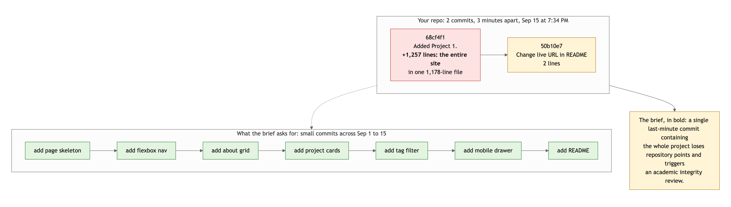
Diagram 1. Your two commits (top) against the history the brief describes (bottom).
- The README describes a different repository. It says the structure is /index.html and /README.md. It says to import the repo into Netlify and "Netlify finds index.html automatically." It says the CSS is mobile-first. It says there are four sections. The actual repo is a Project 1/ folder containing Personal Project 1.html (spaces in both names) and no index.html at all, so Netlify could not have deployed it the way the README describes; the live site had to be uploaded some other way. The queries are max-width. There are five sections. A README that does not match its repo is worse than a short one, because a reader trusts it.
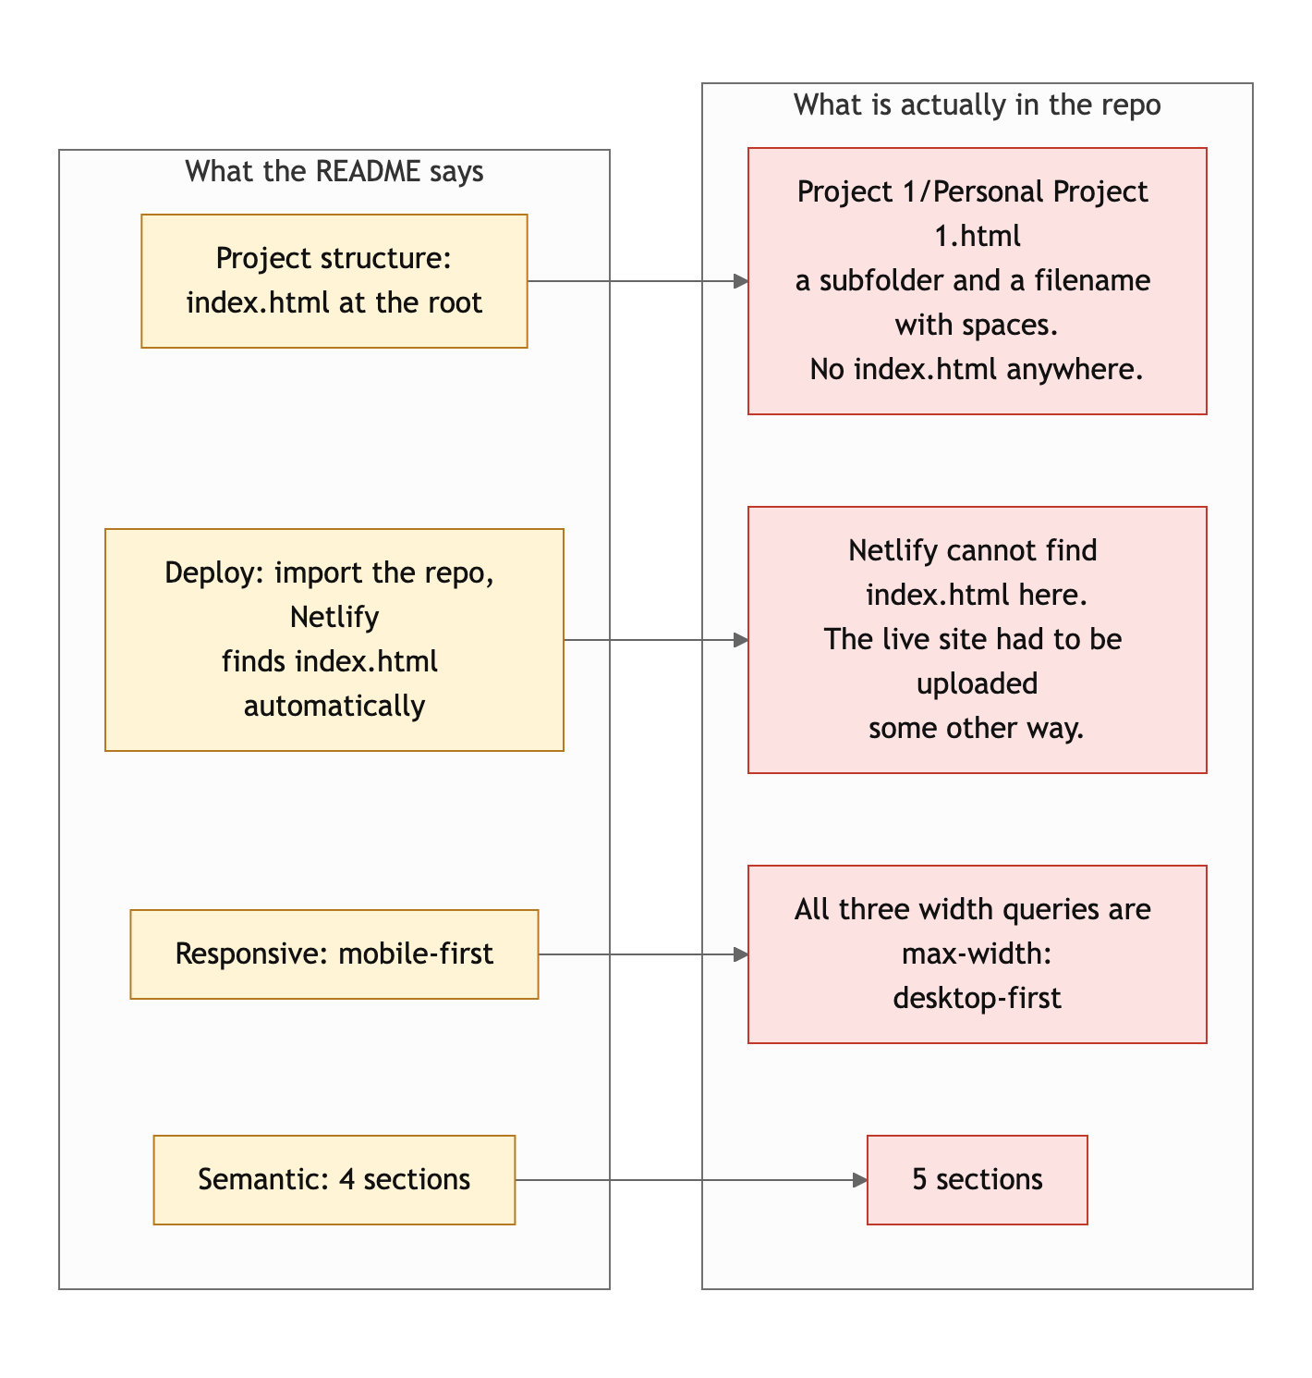
Diagram 2. Four claims in the README and what the repo actually contains.
- Rename and reconnect. Move the file to index.html at the repo root (or set the Netlify base directory to Project 1 and name the file index.html there), connect Netlify to the repo, and every push will deploy. That is what the brief asked for, and it is what your README already says you did.

Content and polish: 7 / 10

What is working
- The bio is real and it has a voice: self-funding a degree through food-service work, Network+ in progress, the D.C. corridor as a target, Sri Lankan cricket and Dune Messiah. The stat cards turn that into something scannable. The design is consistent from the monospace eyebrow to the gold accent. Nothing here is placeholder text.

What to change
- Zero images. The brief asked for real text and images that fit the theme, and the page has none. A headshot in the About grid and a screenshot per project card would fill the two places that are visibly waiting for them.
- "Seeking 2025 internships" in a site graded in September 2026 (line 762). The status pill is the first thing a recruiter reads. Keep it current.
- The project links go to a profile and a #. A recruiter who clicks "GitHub" on PassGuard and lands on your profile page assumes the project does not exist.

Your next three moves
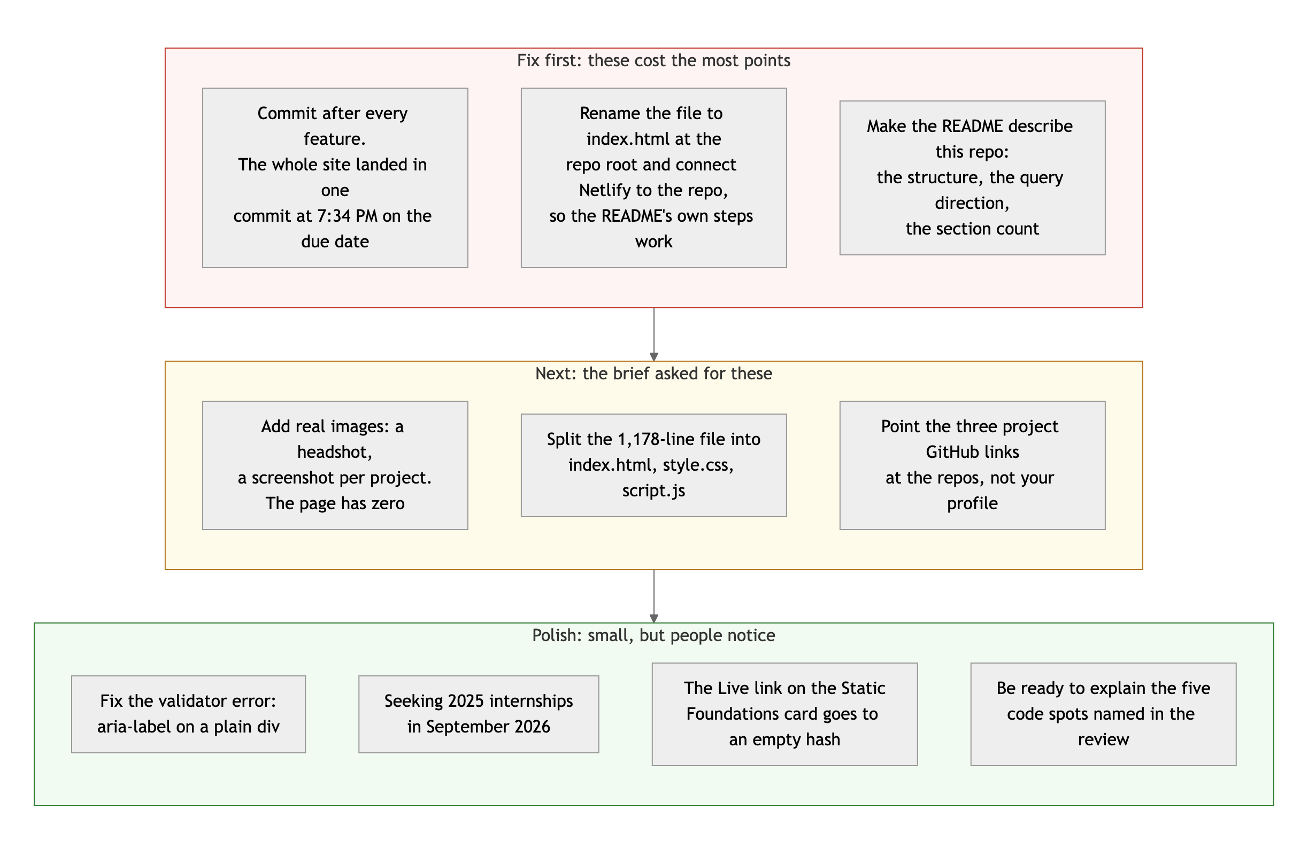
Diagram 3. Priority order. Top row first: it is where the points are.
- Make the repo match the README, then make it deploy. index.html at the root, style.css and script.js beside it, Netlify connected to the repo. That is three commits right there, which is already more history than you have.
- Commit as you go on Project 2. Ten to twenty commits over two weeks. The brief's warning about a single commit is the one rule in this course with an integrity consequence attached.
- Add images and fix the four links. A headshot, four screenshots, three real repo URLs. Then the content matches the quality of the code.

The code in this file is strong. Make the repository around it just as honest, and be ready to walk through the five spots above.
This review lives in a pull request on your repo. It only adds feedback files and does not touch your code. Merge it, close it, or just read it. Questions go to office hours or the Brightspace board.

