Part A - Cross-Validation Charts
The following charts show per-fold test accuracy for all k-fold cross-validation experiments. In each fold the train and test roles are switched so that every sample is evaluated exactly once as a test sample. The dashed green line marks the mean accuracy; the shaded band shows +/- one standard deviation. Five-fold CV was used for the Custom CNN; three-fold CV for VGG16 and ResNet50 due to the higher computational cost of two-phase transfer learning per fold.
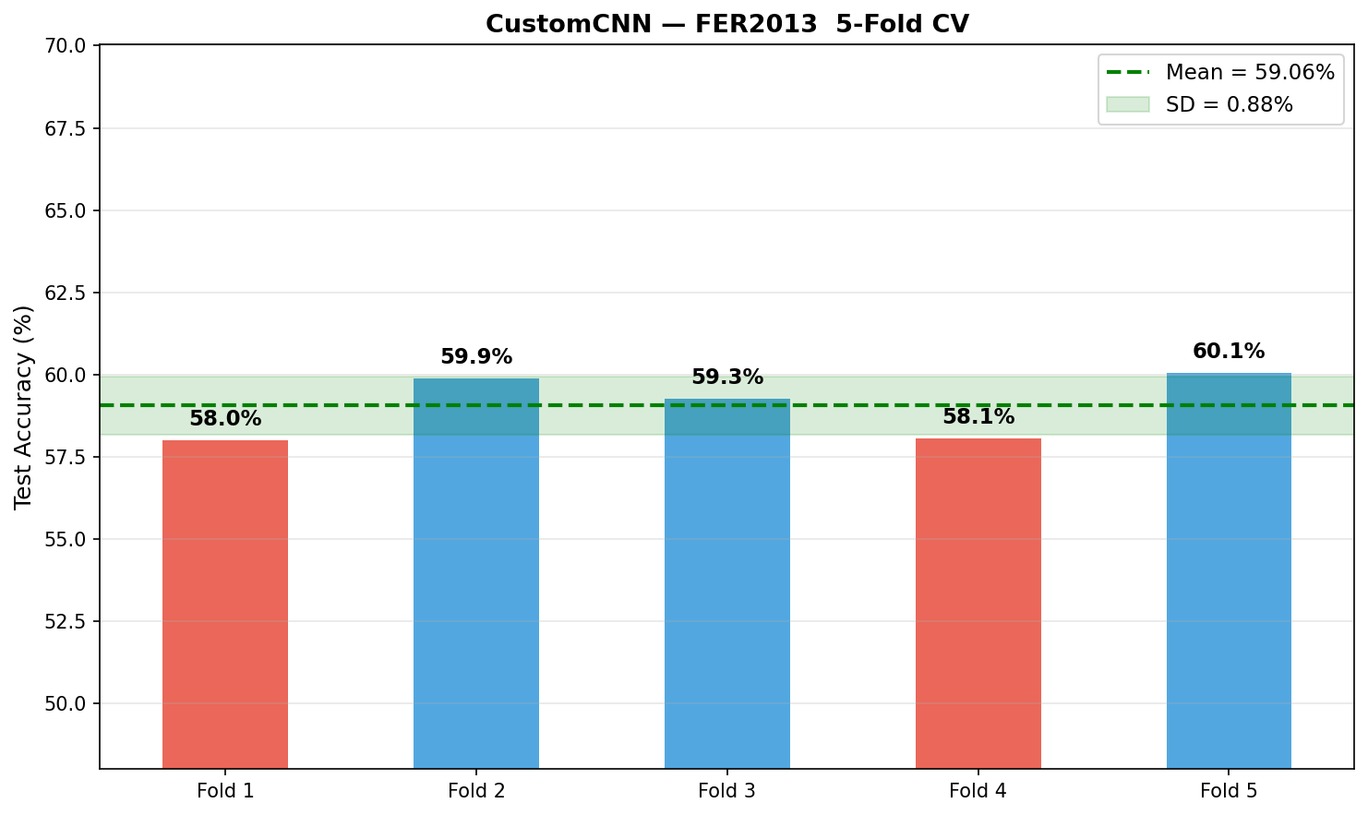 | 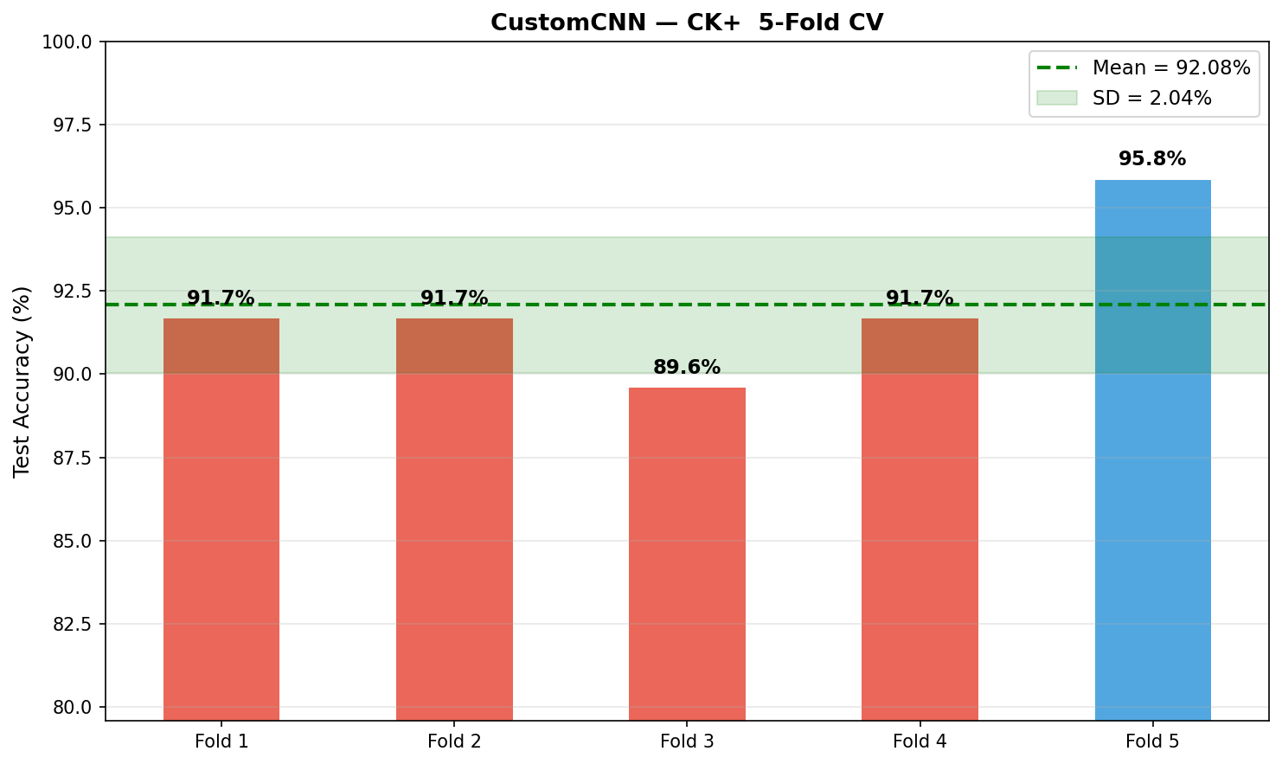
Figure A1: Custom CNN - 5-Fold CV on FER2013. Mean: 59.06% +/- 0.88%. | Figure A2: Custom CNN - 5-Fold CV on CK+. Mean: 92.08% +/- 2.04%.

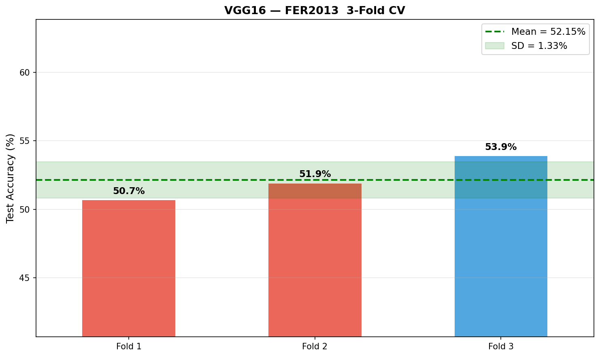 | 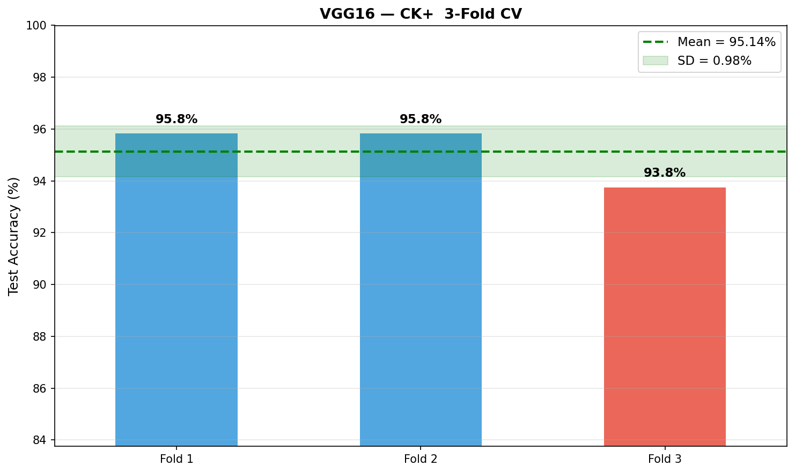
Figure A3: VGG16 - 3-Fold CV on FER2013. Mean: 52.15% +/- 1.33%. | Figure A4: VGG16 - 3-Fold CV on CK+. Mean: 95.14% +/- 0.98%.

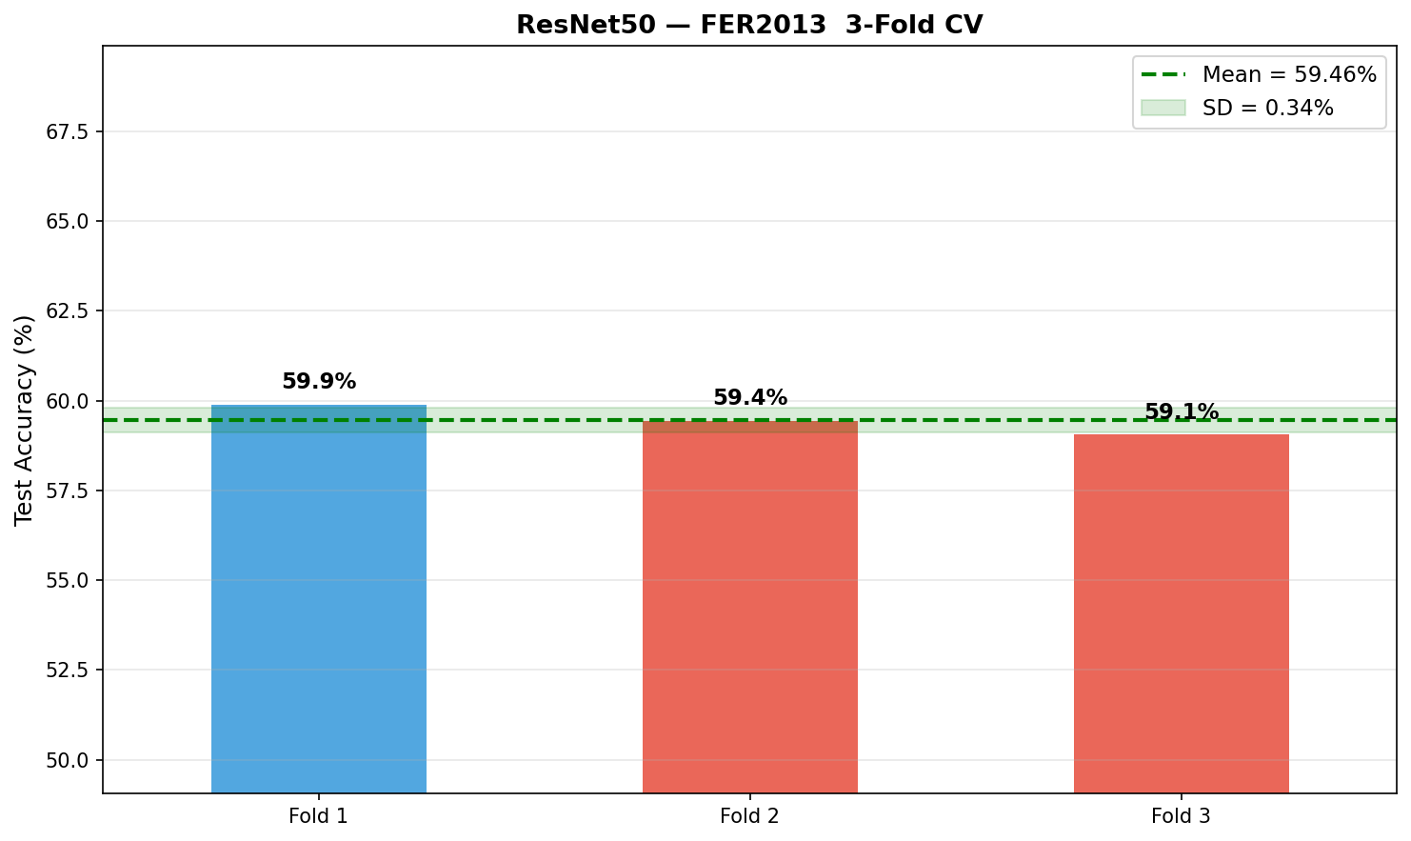 | 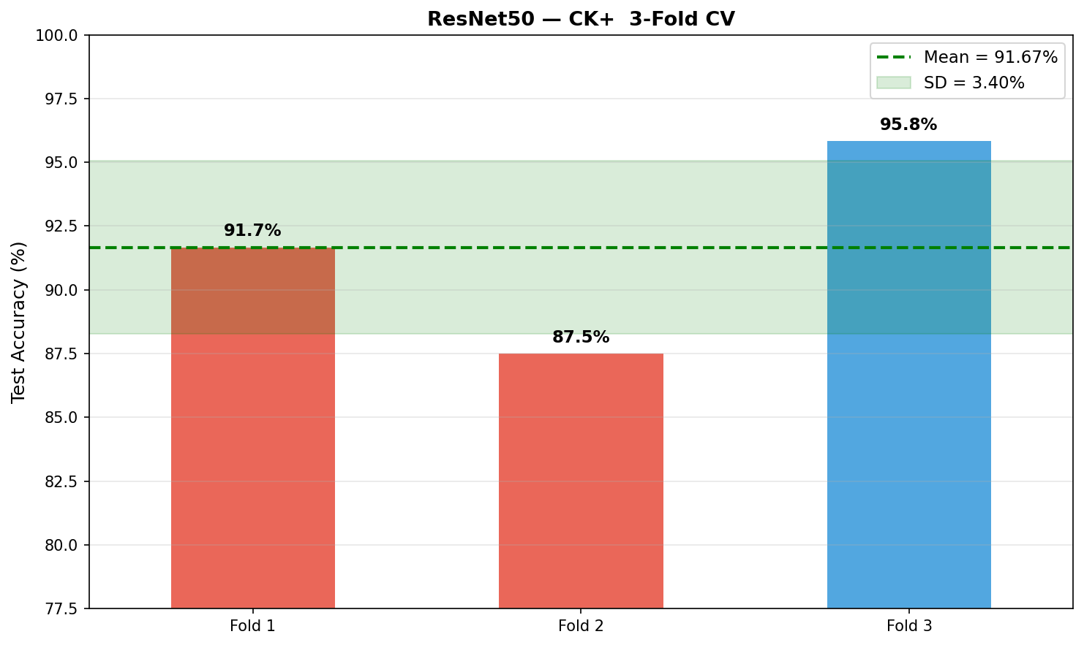
Figure A5: ResNet50 - 3-Fold CV on FER2013. Mean: 59.46% +/- 0.34%. | Figure A6: ResNet50 - 3-Fold CV on CK+. Mean: 91.67% +/- 3.40%.

Part B - Key Code Sections (train.py and crossval.py)
The following extracts cover the most important parts of the implementation: data preprocessing, model architectures, two-phase transfer learning, and k-fold cross-validation. Full source files are available in the project folder.
B1: Data Preprocessing - Separate Generators per Model (train.py lines 92-158)
A critical design decision was to use separate ImageDataGenerator instances for each architecture. VGG16 and ResNet50 require their own preprocess_input functions (ImageNet mean subtraction, BGR conversion) rather than simple [0,1] rescaling. Using rescale=1./255 with a pre-trained model degrades performance significantly.
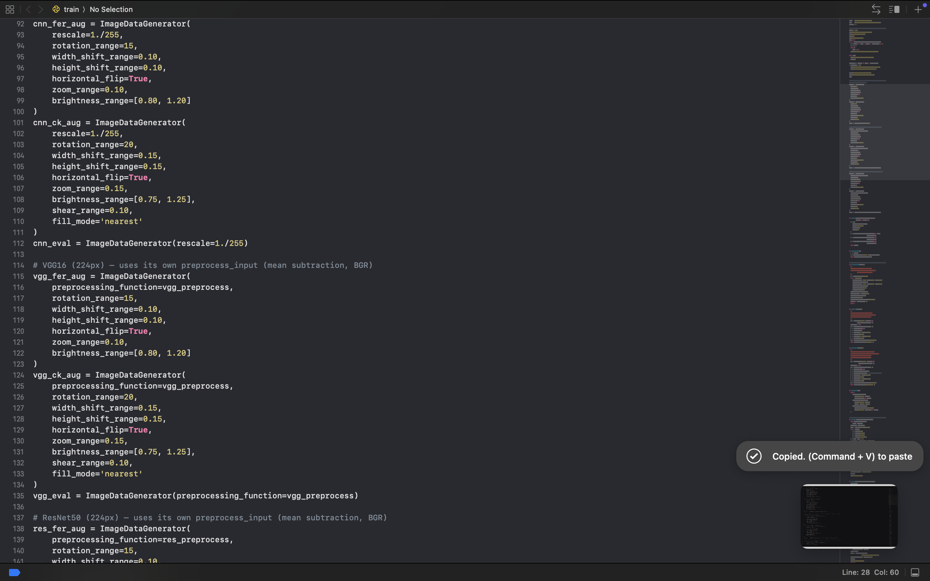
B2: Custom CNN Architecture (train.py lines 185-205)
Built entirely from scratch with no pre-trained weights. Three convolutional blocks with increasing filter depth (32->64->128), BatchNormalization after each Conv layer, MaxPooling for spatial downsampling, and Dropout for regularisation. Global Average Pooling replaces Flatten to reduce parameter count and overfitting.
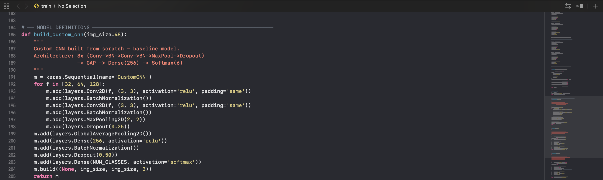
B3: VGG16 Two-Phase Transfer Learning (train.py lines 208-225, 444-463)
Phase 1 freezes the entire VGG16 base and trains only the custom head. Phase 2 unfreezes the top 8 layers of VGG16 and fine-tunes at a very low learning rate (1e-5) to prevent catastrophic forgetting of ImageNet features.
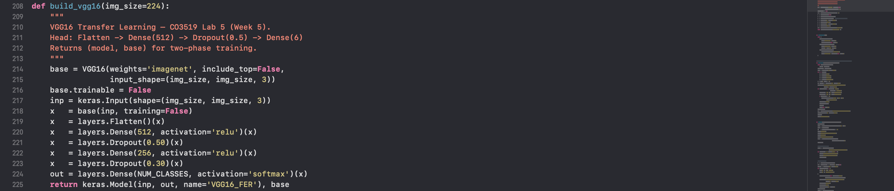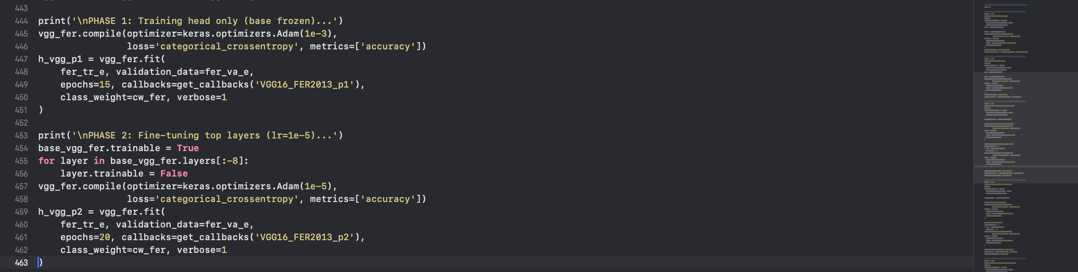
B4: ResNet50 Two-Phase Transfer Learning (train.py lines 228-247, 504-533)
ResNet50 uses GlobalAveragePooling instead of Flatten (unlike VGG16), and unfreezes the top 30 layers in Phase 2 (more than VGG16's 8) due to the residual architecture having more task-adaptable layers. BatchNormalization after GAP is added to stabilise the transition from the convolutional features to the dense head.
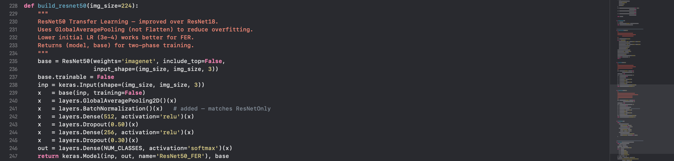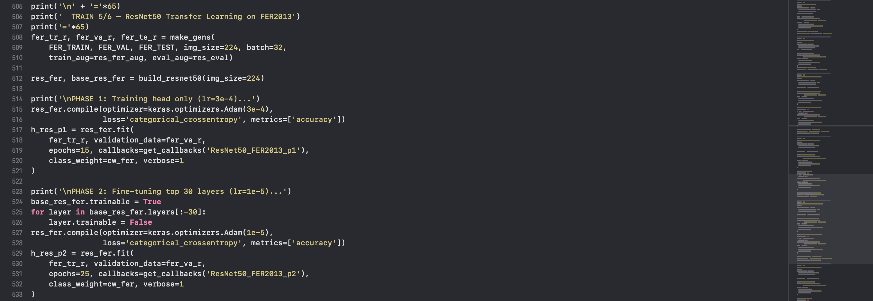
B5: FoldSequence - File-Based Generator for CV (crossval.py lines 92-141)
Loading all 224px images into RAM for VGG16/ResNet50 CV would require ~9.8GB (16,200 images x 224x224x3x4 bytes). FoldSequence is a custom Keras Sequence that reads images from disk on-the-fly, making large-model CV memory-feasible.

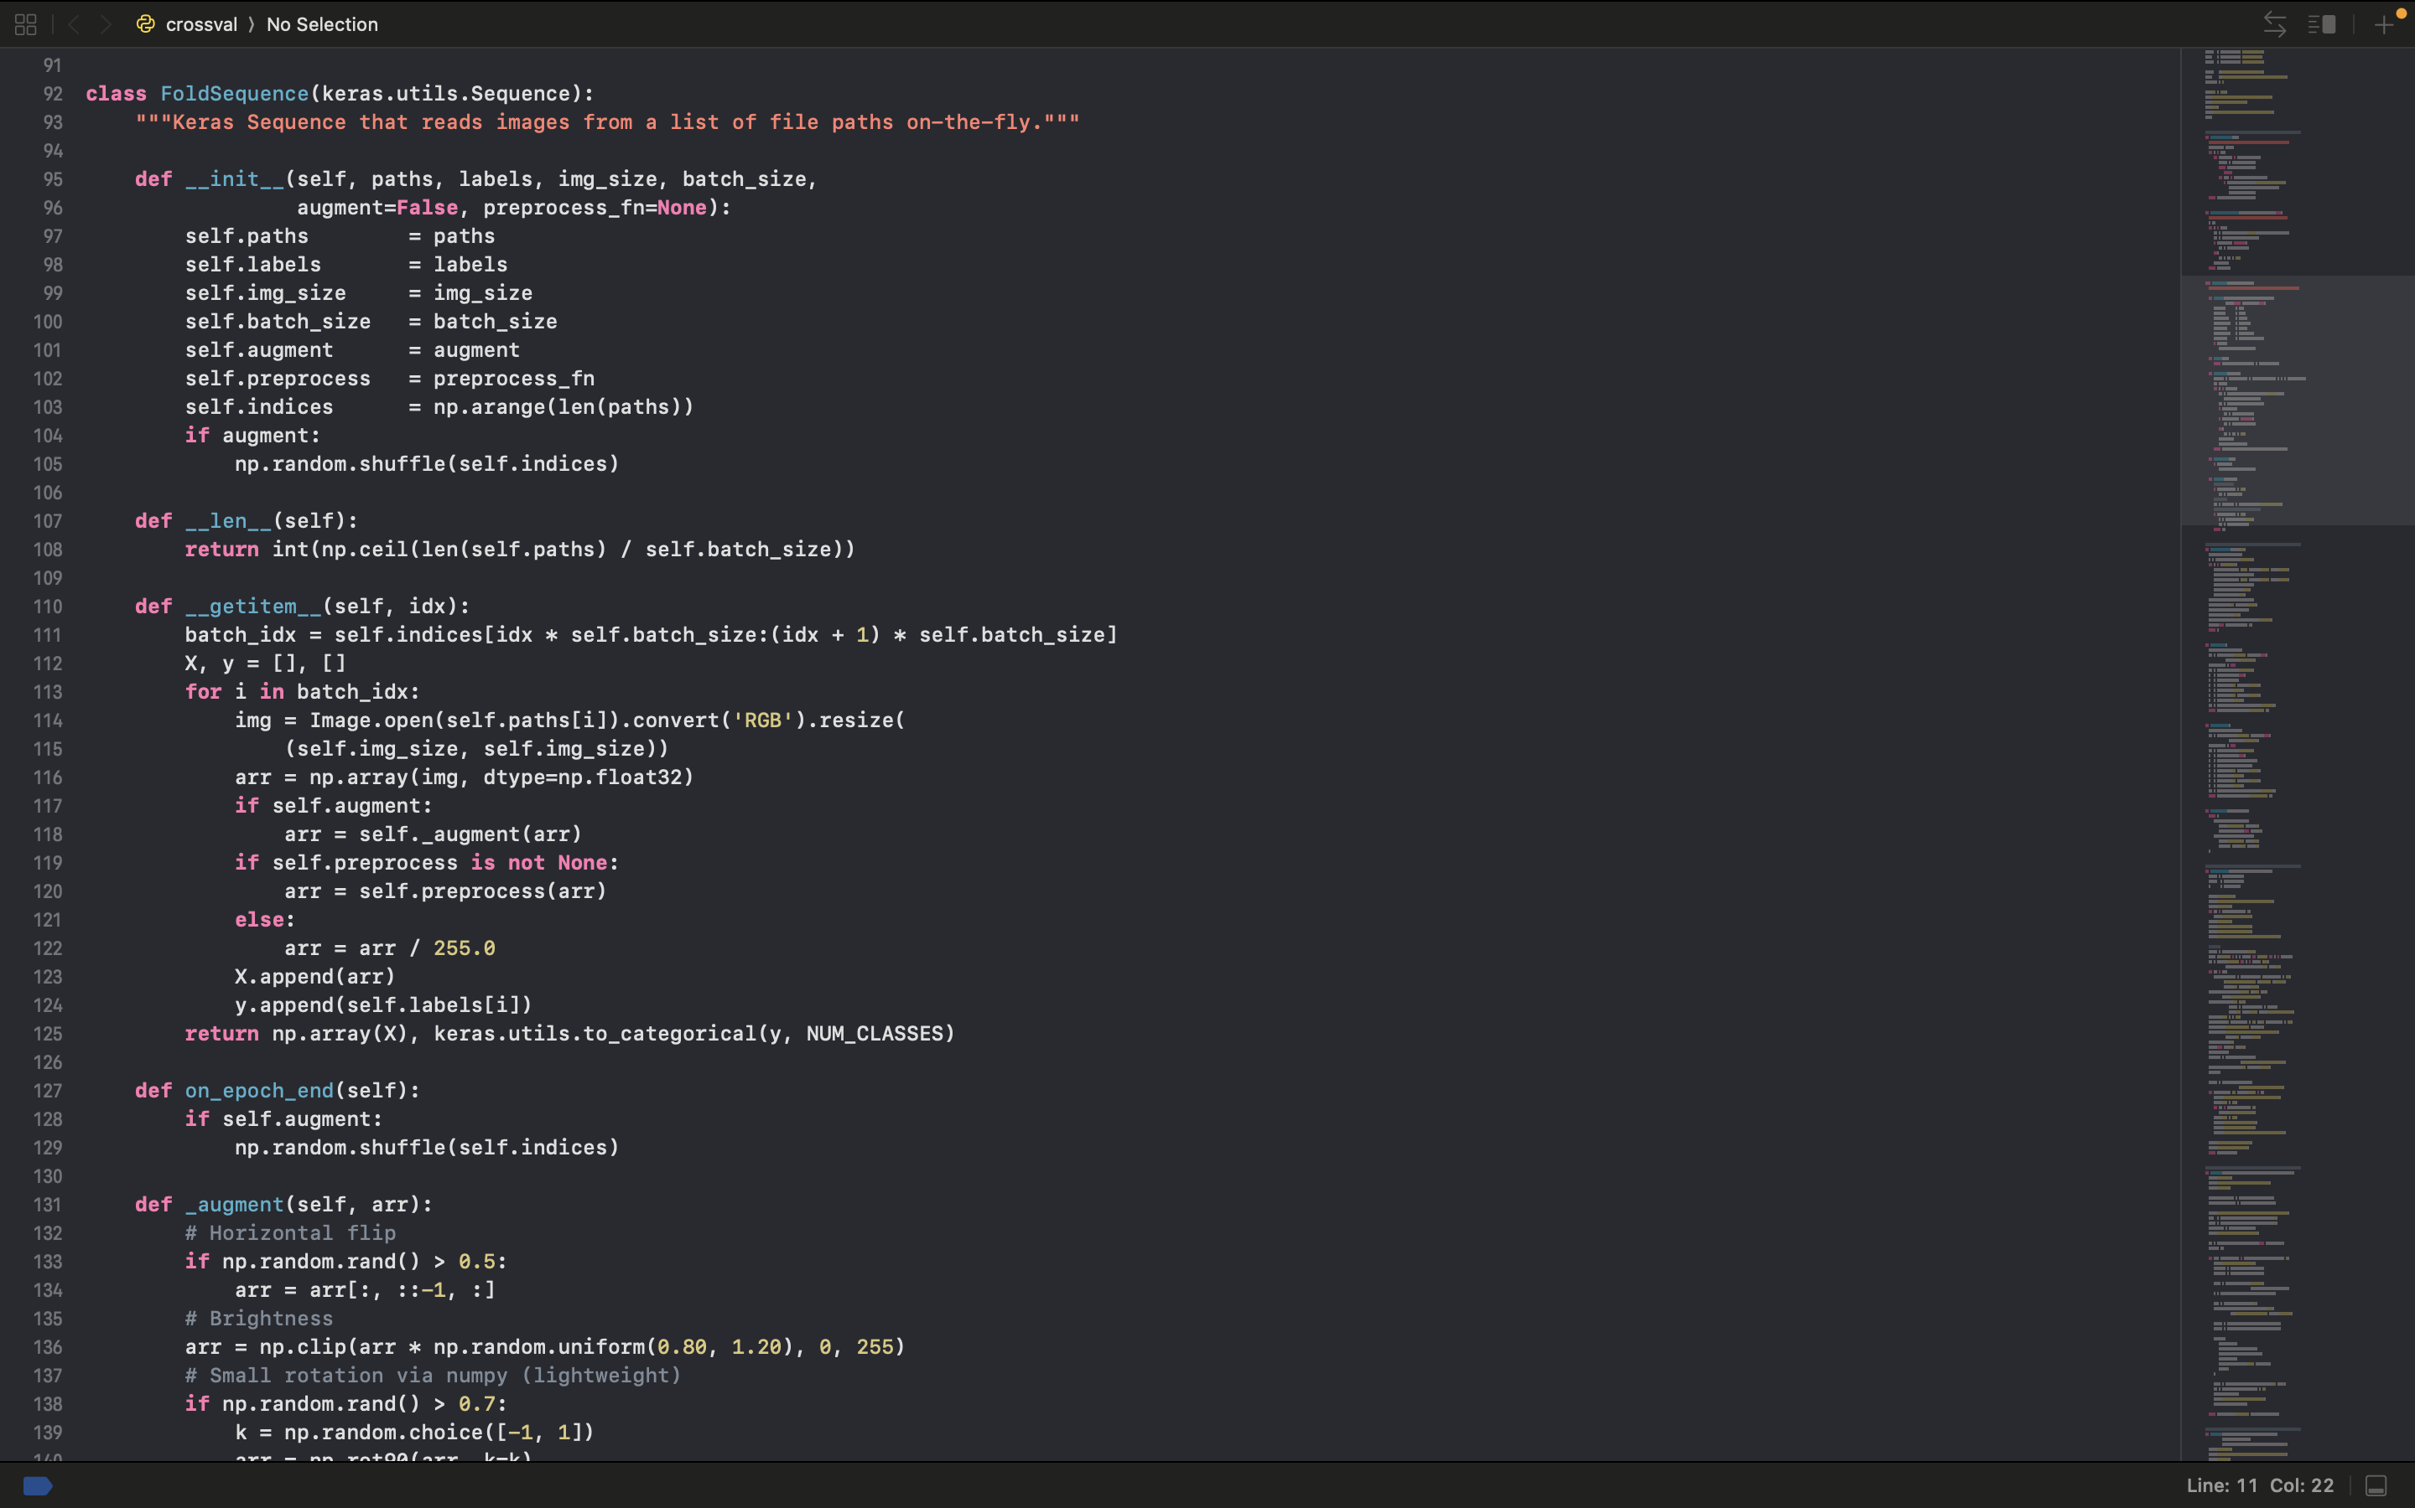
B6: K-Fold CV Loop - Train/Test Switching Mechanism (crossval.py lines 339-384)
StratifiedKFold splits the data into k folds whilst preserving class proportions in each fold. In each iteration, one fold becomes the test set and the rest train the model - the roles switch every fold ensuring every sample is tested once.
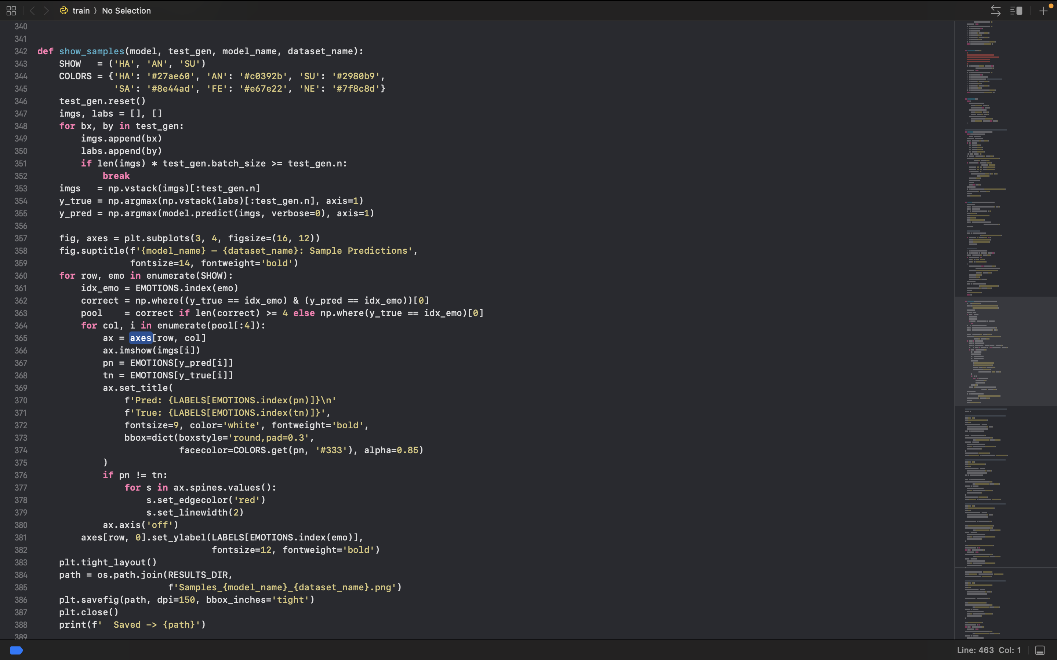

B7: Training Callbacks - Early Stopping and LR Reduction (train.py lines 250-261)
Early stopping monitors validation accuracy and restores the best weights if performance stops improving. ReduceLROnPlateau halves the learning rate when validation accuracy plateaus, allowing finer optimisation near convergence.
