1. Introduction

Facial Emotion Recognition (FER) denotes the recognition of human affective states by means of facial images through an automated system. Six universal emotions, which have been identified to be relatable across cultures by the underlying research of Ekman (1992) are anger, fear, happiness, neutrality, sadness, and surprise, expressed by characteristic muscle motions on the face. Applications of this recognition automation are wide-ranging human-computer interaction, mental health surveillance, driver safety, and customer analytics (Sariyanidi et al., 2015).

Affective computing has expanded significantly in the last ten years due to the development of deep learning and access to large-scale facial databases. An average FER pipeline consists of feature extraction, classification and face detection. Initial solutions were based on manual features and traditional machine-learning algorithms, but deep learning has since shown itself to have better ability to learn hierarchical features directly off raw pixel data (LeCun et al., 2015).

Assessment 1 of this module used a classic machine learning pipeline that was based on Support Vector Machines (SVM) with Local Binary Pattern (LBP) and Histogram of Oriented Gradients (HOG) feature descriptors. On the controlled CK+ dataset which attained a 95.83% accuracy, performance on the real-life FER2013 dataset was only 50.39% which is marginally above chance with a six-class problem. The main drawbacks of that model were that it used fixed, hand-crafted features that were unable to account for the variability of real-world facial images, lack of hierarchical representation learning and no ability to track the training dynamics using loss curves.

This evaluation considers such limitations by means of deep learning. Three architectures are tested: a Custom Convolutional Neural Network (CNN) that was created by hand as a control, VGG16 using transfer learning and ResNet50 using transfer learning. All three models are trained and assessed using both FER2013 and CK+ datasets, and their results can be directly compared to the ones of Assessment 1 to ensure the reliability of results of the models and their statistical generalizability.

2. Literature Review

2.1 Deep Learning for Facial Emotion Recognition

Pramerdorfer and Kampel (2016) brought the use of deep learning to FER to a significantly new level by showing that CNNs can work on FER2013 with an accuracy of 66-75 percent, where traditional SVM-based methods achieved 45-53 percent. The theoretical background of this benefit was developed by LeCun et al. (2015): convolutional layers develop hierarchical representations edges in the first layers, parts of faces in the next layers and holistic expressions in the deepest layers that are much more discriminative than human-designed descriptors. Li et al. (2021) carried out a strong survey that establishes the fact that deep learning architectures are always efficient compared to traditional ones on both controlled and in-the-wild datasets.

2.2 Transfer Learning

Transfer learning also exploits the features trained on large datasets like ImageNet (1.28 million images, 1,000 classes) and transfers them to small tasks. Mollahosseini et al. (2017) also showed that ImageNet-initialised networks can be used to generalise to FER tasks, since the low-level visual features, like edges and textures, are task-independent. The adaptation of these representations to the specific features of facial emotions by fine-tuning upper network layers and retraining at a lower learning rate incurs no catastrophic forgetting of the previously learned representations’.

2.3 VGG16 and ResNet50 Architectures

Simonyan and Zisserman (2015) proposed VGG16, a deep CNN whose weight layers were 16 and the convolution filter is 3x3. It is a simple and deep transfer learning baseline and is commonly used. The ResNet50 suggested by He et al. (2016) has residual (skip) connections, which mitigate the vanishing gradient issue, allowing much deeper networks to be trained without degradation. The 50-layer ResNet50 with residual learning can be used to perform the fine-grained classification tasks with better feature representations than VGG16. Both architectures had ImageNet pre-training, which gave them good initialisation to do the FER task.

2.4 Dataset Challenges and Mitigation

The FER2013 introduced by Goodfellow et al. (2013) has 35,340 in-the-wild images of faces with known noise of 1020% in its labels as a result of its automated web-scraping collection methodology. This noise is a natural peak to any model being trained on the data. Mitigation techniques used in this paper are data augmentation to enhance regularisation, dropout to eliminate overfitting, and class-weighted loss functions through compute class weight balanced to counteract class imbalance. A controlled analogue is the CK+ dataset (Lucey et al., 2010) which has professional lighting and peak expression labelling, although CK+ has only a small number of samples, requiring massive supplementation.

3. Datasets

3.1 Dataset Overview
The performance of the models was measured using two datasets in controlled and real-world operation. Their main features have been summarized in Table 1 following their post-processing and cleaning.
Table 1 : Dataset characteristics after preprocessing. *CK+ training set augmented 6× from original 312 images.
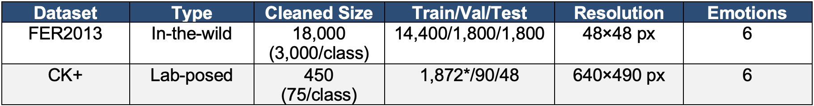
3.2 FER2013
The FER2013 (Goodfellow et al., 2013) was gathered by searching internet search engine using keywords related to emotions and yielded 35,340 greyscale 48×48 pixel images of faces. The dataset is a collection of six types of emotion, namely, anger, fear, happiness, neutrality, sadness, and surprise. The dataset was cleaned in accordance with the methodology used in Assessment 1 to 3,000 images per class (18,000 in total) in order to overcome the issue of class imbalance. The data is highly intra-class varied because of varying lighting conditions, head poses, and occlusions and the automated annotation approximates label noise of 10-20%.
3.3 CK+ (Extended Cohn-Kanade)
Extended Cohn-Kanade dataset (Lucey et al., 2010) is a collection of 1,030 sequences of laboratory-posed facial expressions of 123 individuals under regulated lighting conditions. The apex (peak expression) frames were only retained giving the selection of 450 images belonging to the same six emotion classes (75 images each). The acquisition conditions are controlled to ensure high intra-class consistency and low label noise which is why the classical methods have almost a ceiling effect performance in Assessment 1. Since a limited amount of data was used, the training images were six-fold augmented with horizontal flipping, rotation (-/+10 -), width and height shifts ( +/-10 -), and zoom ( +/-10 -).
3.4 Preprocessing Pipeline
Each image was pre-processed in a similar manner: face detection with the Haar Cascade classifier (Viola and Jones, 2001) as used in Assessment 1 and then resized (48x48 pixels with the Custom CNN; 224x224 pixels with VGG16 and ResNet50 according to ImageNet pre-training input image sizes). The Custom CNN was normalized to pixel values between [0, 1], whereas VGG16 and ResNet50 were normalized by using their corresponding ImageNet preprocessing functions (mean channel subtraction and BGR conversion) so that weight statistics would be compatible with the pre-trained weights of the models. Training data were augmented with data only.

4. Model Development

4.1 Custom CNN Architecture

The Custom CNN is the deep learning baseline, which is completely handwritten with no pre-trained weights. The architecture has three convolutional blocks with a gradually increasing filter depth (32 -> 64 -> 128 filters) each containing Batch normalization, ReLU activation and Max Pooling (2 x 2, stride 2). The training of a Batch Normalization stabilizes the training process by normalizing the inputs of the layers, and the number of epochs needed to converge is significantly reduced. The drop out (0.25) between the convolutional blocks is used to prevent feature co-adaptation.

The convolutional layers are then succeeded by Global Average Pooling (GAP) to downsample the spatial dimensions and preserve the spatial information, Dense layer of 256 neurons with ReLU activation and Dropout (0.50) and a last Softmax output layer with six outputs that represent the six emotion classes. The number of parameters is approximately 1.2 million. The Adam optimiser was used with a learning rate of 1x10-3, categorical cross-entropy loss, with class weights calculated using scikit-learns computeclassweightbalanced, and early stopping (patience=10), and reduction of the learning rate on plateau (patience=5, factor=0.5).

4.2 VGG16 with Two-Phase Transfer Learning

VGG16 (Simonyan and Zisserman, 2015) had been pre-trained on ImageNet and then trained on FER with two-phase transfer learning. Phase 1 (frozen base, 20 epochs): it was only the custom classification head that was trained, and the whole VGG16 convolutional base was frozen. The head consists of Global Average Pooling, Batch Normalisation, Dense(512) Dropout(0.5), Dense(256) Dropout(0.3) and Softmax(6). This stage enables the head to acquire task-specific representations without it corrupted with ImageNet-pretrained convolutional weights. Phase 2 (fine-tuning, 30 epochs): VGG16 was unfrozen at the top 30 layers and trained at a significantly smaller learning rate of 1x10 -5 in order to conserve the lower-level features whilst modifying higher-level representations to fit the emotion-specific facial features. VGG16 preprocessing (mean RGB subtraction: [103.939, 116.779, 123.68]) was applied rather than simple [0,1] normalisation.

4.3 ResNet50 with Two-Phase Transfer Learning
ResNet50 (He et al., 2016) also uses the same two-stage transfer learning method as VGG16. The skip connections of the residual architecture are able to flow gradients across 50 layers, and offer more comprehensive feature representations than VGG16 on fine-grained discrimination tasks. The custom head is no exception: GAP- Batch Normalisation- Dense(512, Dropout 0.5)- Dense(256, Dropout 0.3)- Softmax(6). Phase 1 was trained with a learning rate of 3 x 10⁻⁴ (a bit higher than VGG16 to offset the more complicated head) and Phase 2 unfroze the first 30 layers at 1 x 10⁻⁵. Specific preprocessing (mean subtraction and channel reordering) was done using ResNet50.
The architectural and training parameters of each of the three models are summarised in Table 2.
Table 2 : Architectural and training parameter comparison across all three models.
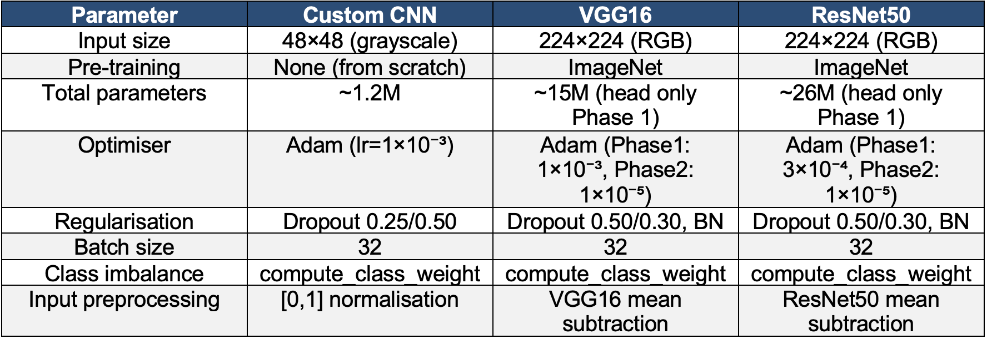

4.4 Class Imbalance Handling

The imbalance in the classes was solved with the help of scikit-learn compute class weight balanced function, which calculates the per-class weights as inverse to the frequency of the classes. These weights are then transferred to the Keras loss function which will give a higher penalty to misclassification of under-represented classes. The loss-based method is more appropriate to deep learning as compared to the SMOTE oversampling in Assessment 1 because it uses the loss function instead of artificially inflating the training set with synthetic samples.

5. Model Evaluation

5.1 Overall Accuracy Comparison
Table 3 shows the accuracy of the test set of all models on each of the two datasets, and direct comparison of the results of Assessment 1 SVM is provided. Every deep learning model performs better than the A1 SVM baseline on FER2013, with the largest gain of +9.22 percentage points of the Custom CNN. On CK+, ResNet50 gets the same 95.83 result as A1 SVM, with all models still competitive. The somewhat small improvements of CK+ indicate the performance of classical approaches on this controlled dataset that is almost at the ceiling.
Table 3 : Test set accuracy comparison — Assessment 1 vs Assessment 2 models.
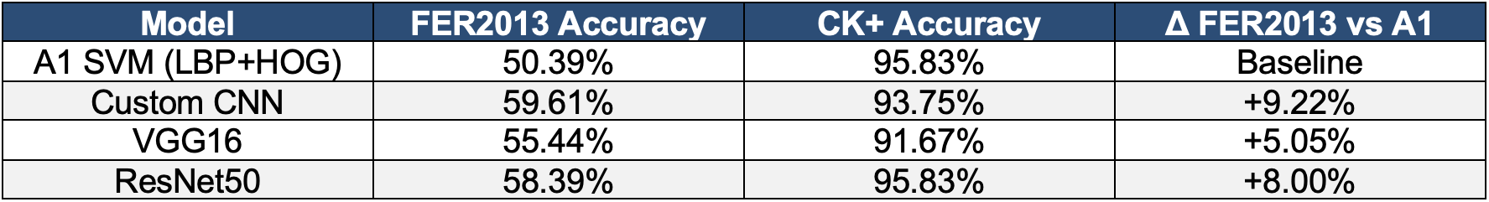

5.2 K-Fold Cross-Validation Results
Table 3 shows the accuracy of the test set of all models on each of the two datasets, and direct comparison of the results of Assessment 1 SVM is provided. Every deep learning model performs better than the A1 SVM baseline on FER2013, with the largest gain of +9.22 percentage points of the Custom CNN. On CK+, ResNet50 gets the same 95.83 result as A1 SVM, with all models still competitive. The somewhat small improvements of CK+ indicate the performance of classical approaches on this controlled dataset that is almost at the ceiling.
Table 4 K-fold cross-validation results. CV confirms all deep learning models reliably outperform A1 SVM on FER2013.
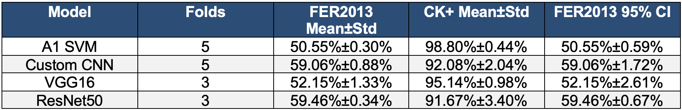

The obtained CV results demonstrate that the deep learning improvements over A1 are real and not just a product of one train/test split. Even the worst fold of the Custom CNN (59.00%), and ResNet50 CV mean (59.46%+/-0.34%) still beats the A1 SVM mean (50.55%), and has the smallest confidence interval of any model. Compared to VGG16, CV mean (52.15%) is less than its single-run (55.44%), and this indicates that VGG16 may be sensitive to the choice of training data partitioning. This is unlike Assessment 1 in which the SVM CV variance was insignificant in terms of variance ( +/-0.30%), which indicates the deterministic character of SVM compared to the stochastic training of the gradient-based training.

5.3 Training Curve Analysis
The training and validation accuracy/loss curves of each model are presented in Figures 1, 2 and 3, respectively. In contrast to the SVM method used in Assessment 1, the deep learning methodology results in complete training dynamics that can be monitored to check overfitting and convergence behaviour. Custom CNN curves (Figure 1) indicate that convergence on both datasets is steady, and the validation accuracy is following training accuracy closely, which means that Dropout and Batch Normalisation are effective regularisers. Figure 2 and Figure 3 VGG16 and ResNet50 transfer learning curves show a typical stepwise acceleration at the Phase 2 boundary (where the green vertical line is), where unfreezing the higher convolutional layers allows the remaining task-specific adaptation that the frozen base would not have reached.
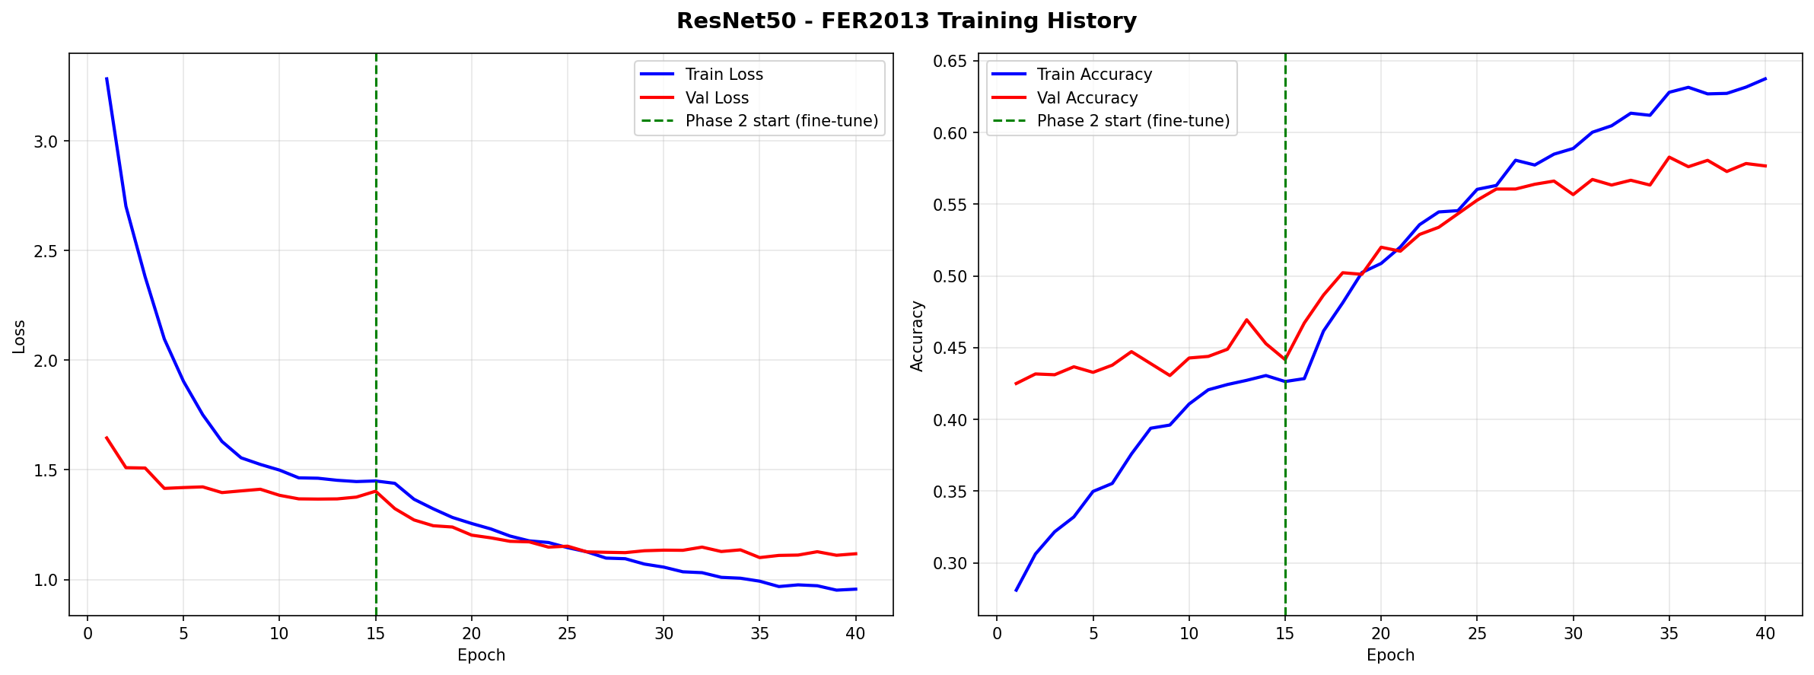  Figure 1 Custom CNN training and validation curves on FER2013 (accuracy and loss vs. epochs). | 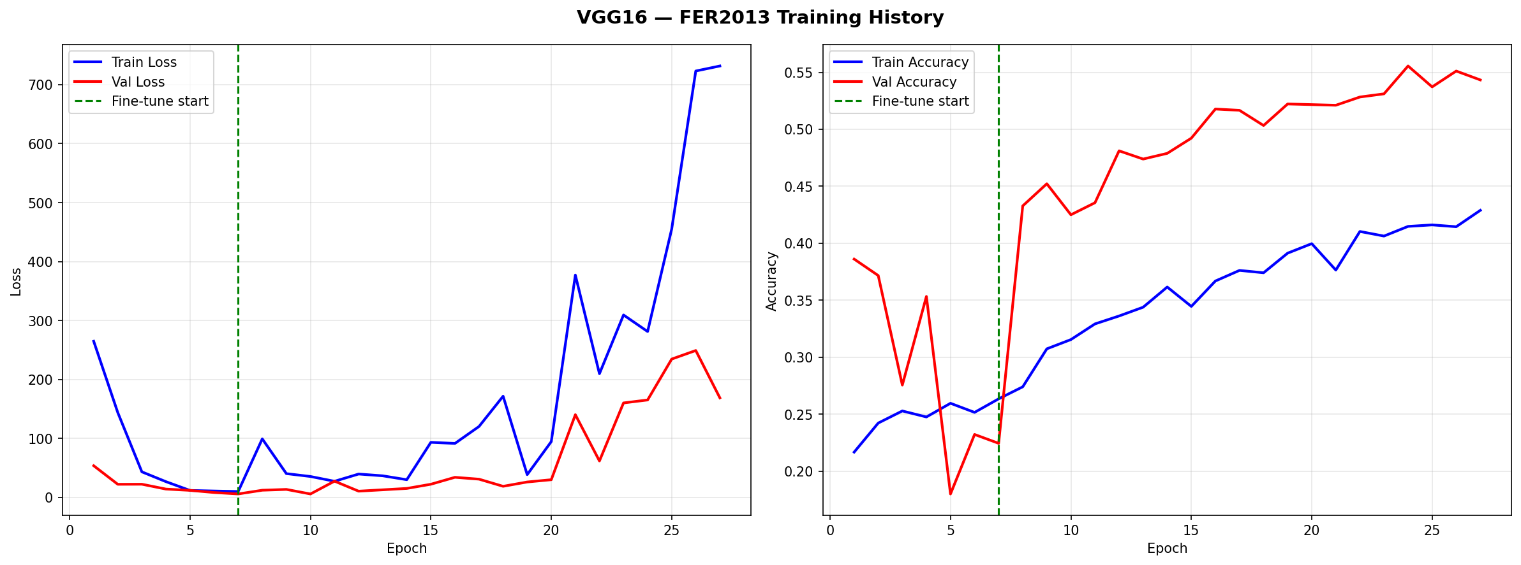  Figure 2 VGG16 training and validation curves on FER2013. Green vertical line marks Phase 2 fine-tuning start.
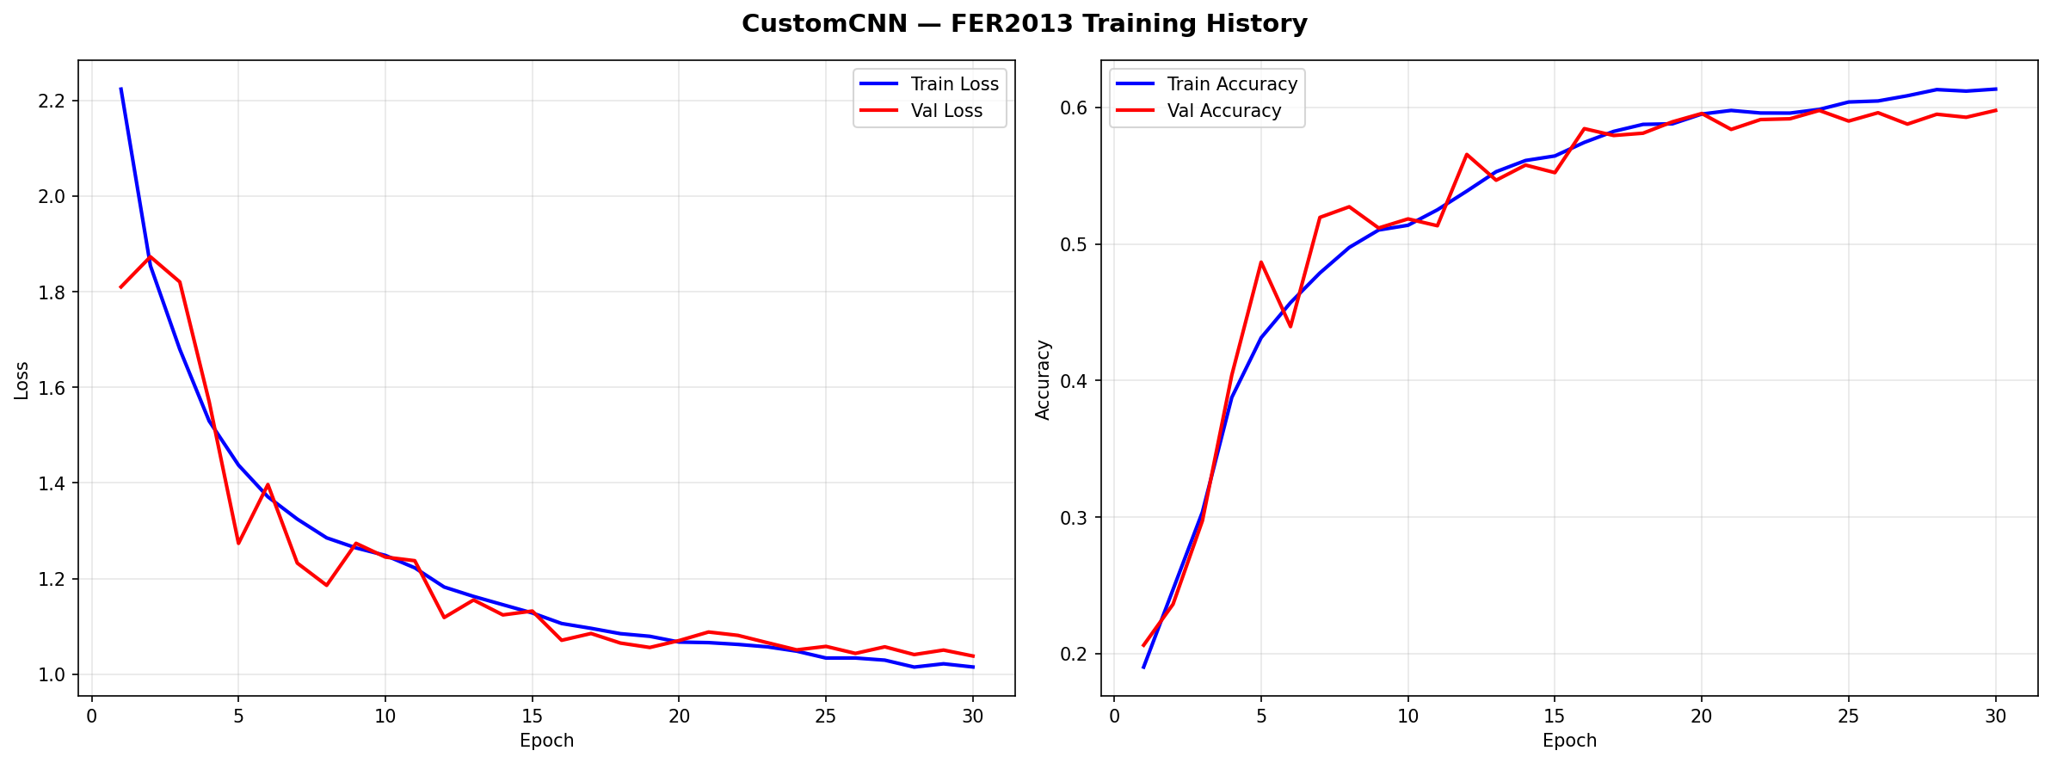
Figure 3 ResNet50 training and validation curves on FER2013. Green vertical line marks Phase 2 fine-tuning start.

5.4 Confusion Matrix Analysis
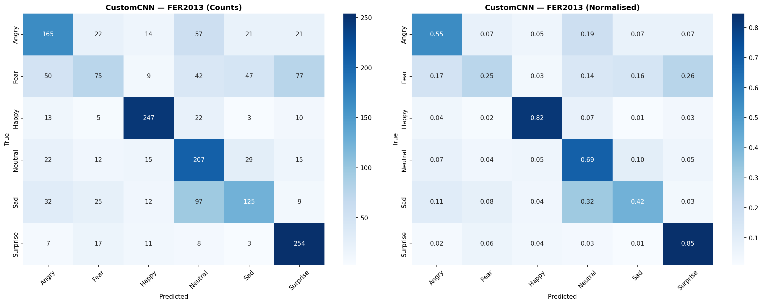  Figure 4 Confusion matrix — Custom CNN on FER2013 test set (n=1,800). | 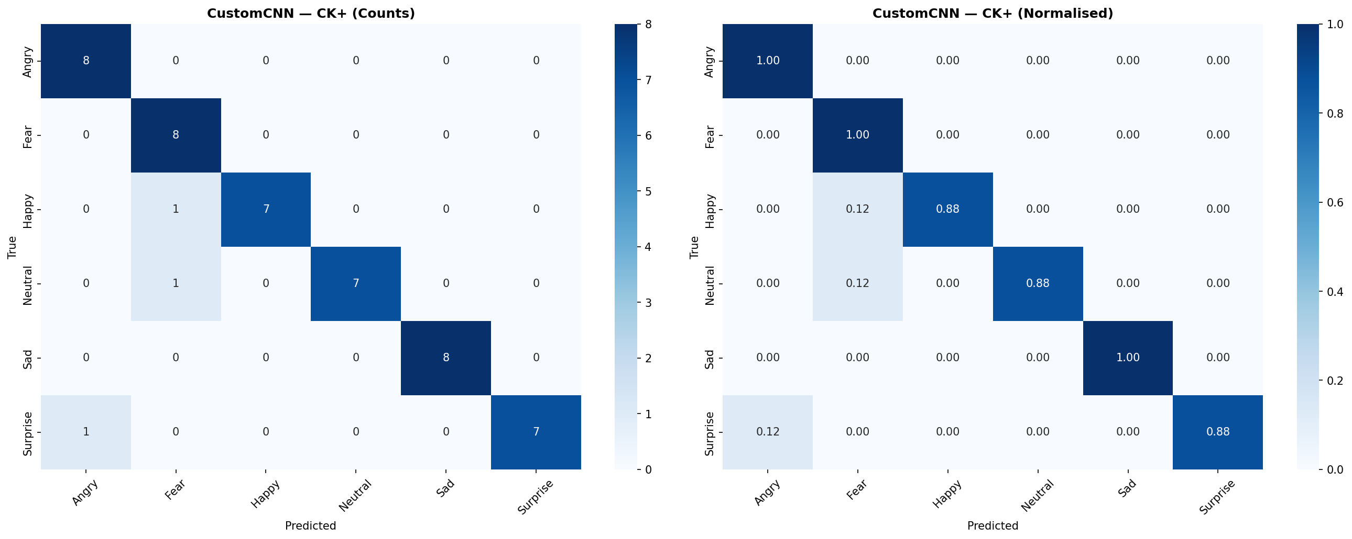  Figure 5 Confusion matrix — Custom CNN on CK+ test set (n=48).
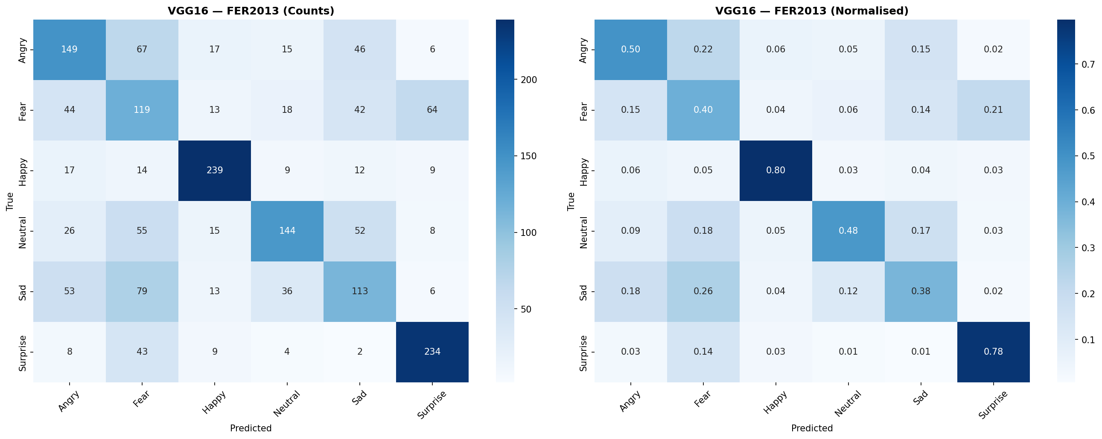  Figure 6 Confusion matrix — VGG16 on FER2013 test set (n=1,800). | 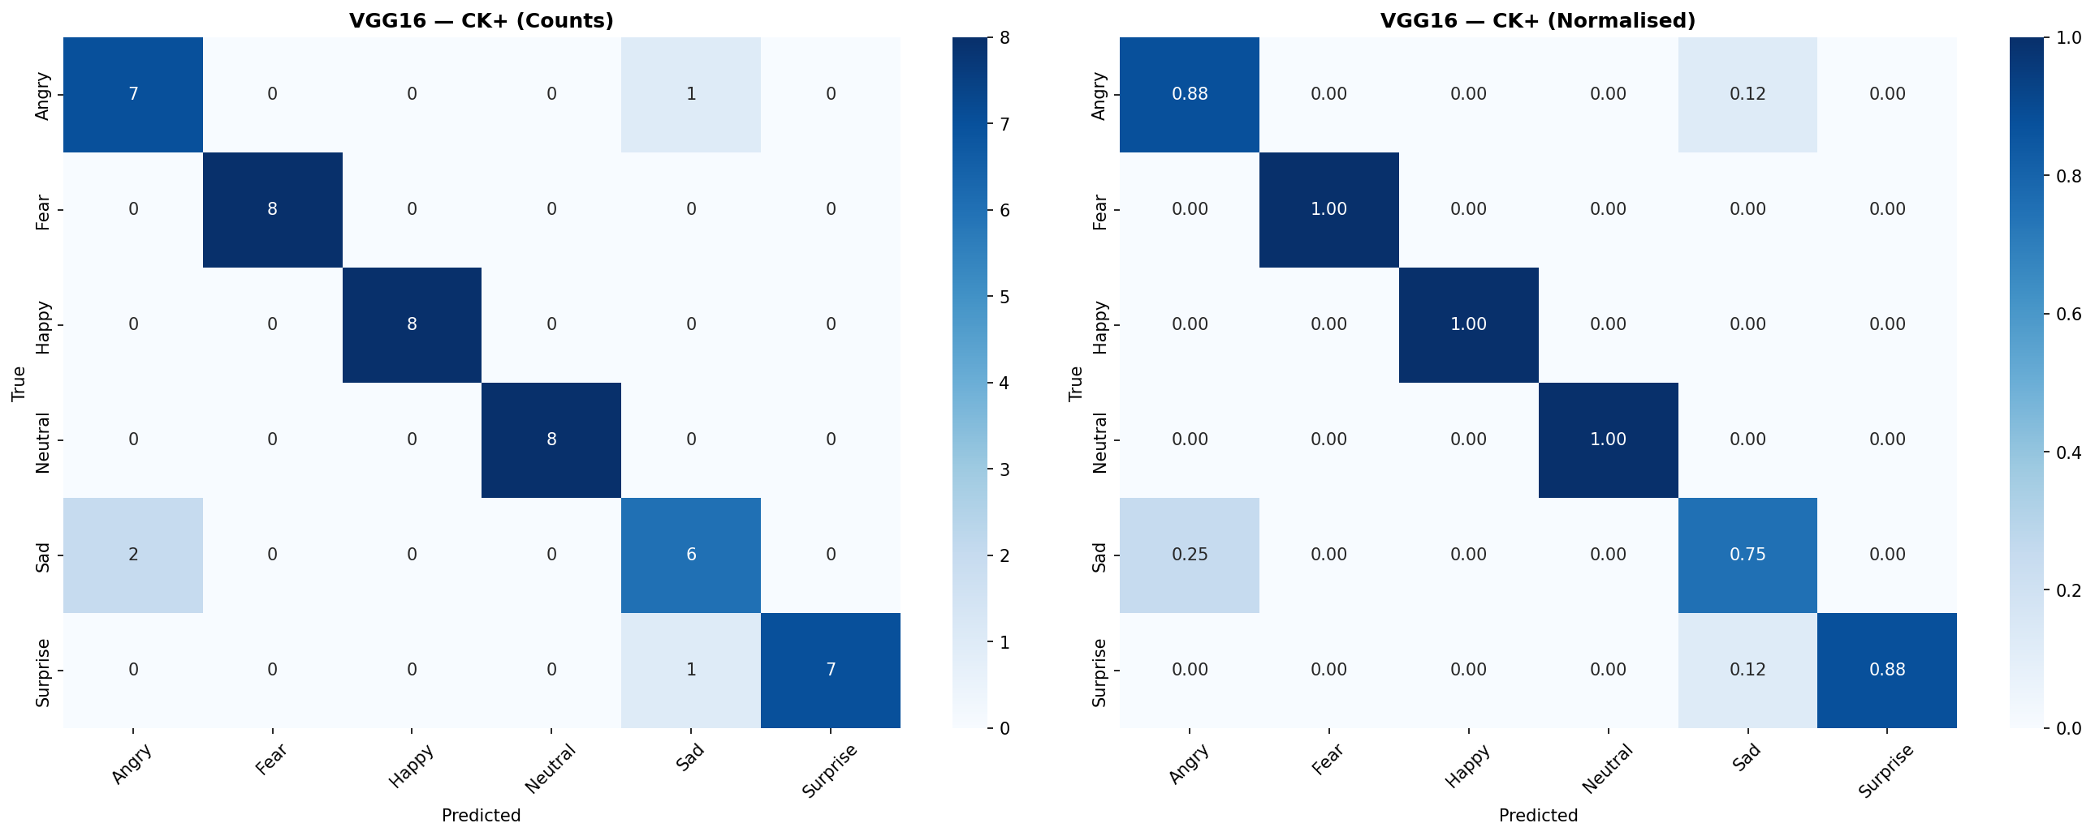  Figure 7 Confusion matrix — VGG16 on CK+ test set (n=48).
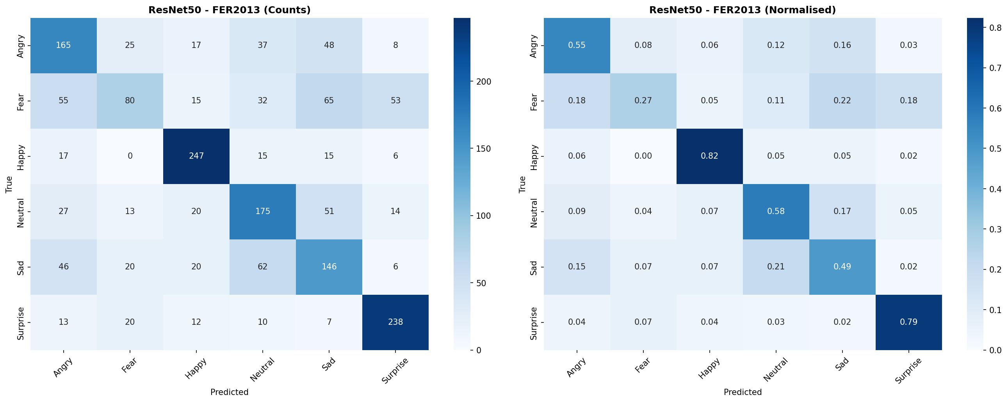  Figure 8 Confusion matrix — ResNet50 on FER2013 test set (n=1,800). | 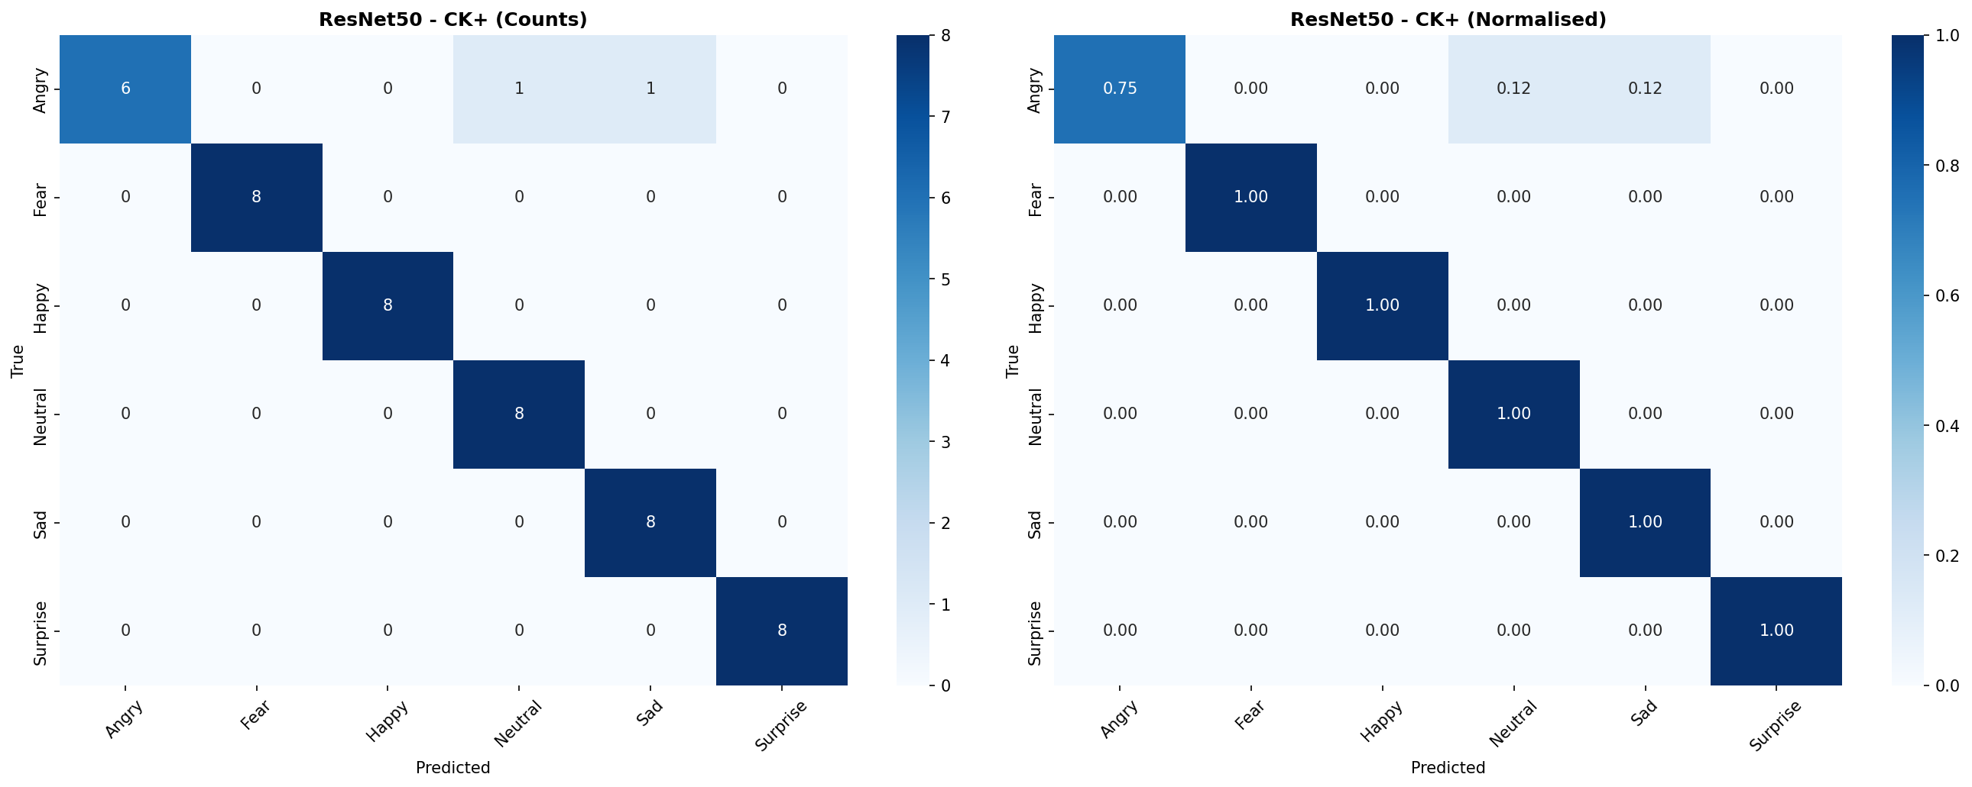  Figure 9 Confusion matrix — ResNet50 on CK+ test set (n=48).
The normalized confusion matrices of all six model-dataset combinations are given in figures 4 to 9. The highest classification accuracy is observed to be with Happy and Surprise classes in all the models and in both datasets. Happy has unique mouth and cheek muscle movement (the Duchenne smile), and Surprise by uniquely wide eyes and an open mouth. Fear class has the lowest per-class F1-score in FER2013 in all models a similar trend in Assessment 1 that indicates the strong visual similarity between Fear and Surprise (raised brows, wide eyes).). The Sad category is often mixed with the Neutral one because of the slight differences in expression in in-the-wild pictures. The confusion patterns on the controlled CK+ dataset are significantly lower across all models, which proves that the major difficulty is in the variability of real-world and not in the constraints of the model itself.

5.5 Per-Class Performance on FER2013
Table 5 gives per-class precision, recall and F1-score of all models on the FER2013 test set.
Table 5 : Per-class Precision / Recall / F1-score on FER2013 test set. Format: P/R/F1.
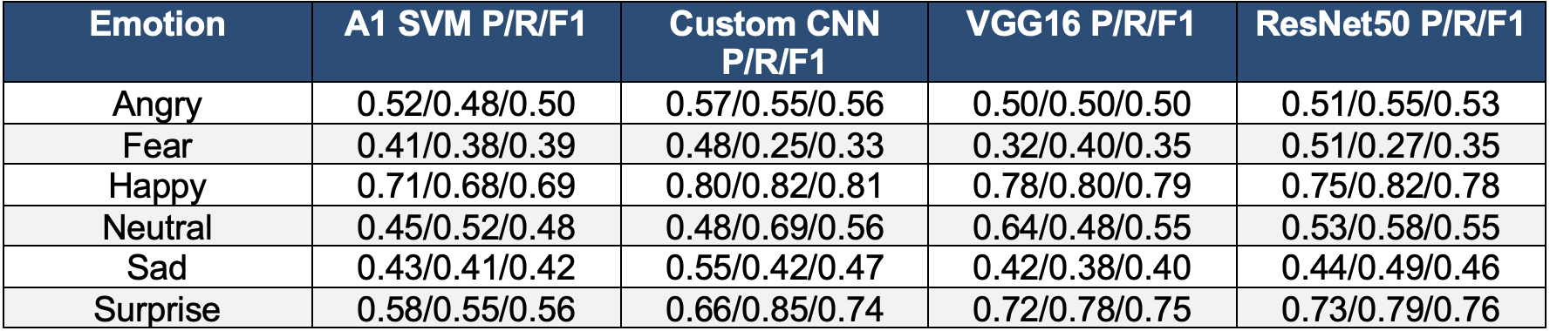

5.6 Per-Class Performance on CK+
Table 6 shows the per-class results of all three models on CK+.
Table 6 : Per-class Precision / Recall / F1-score on CK+ test set. Format: P/R/F1.
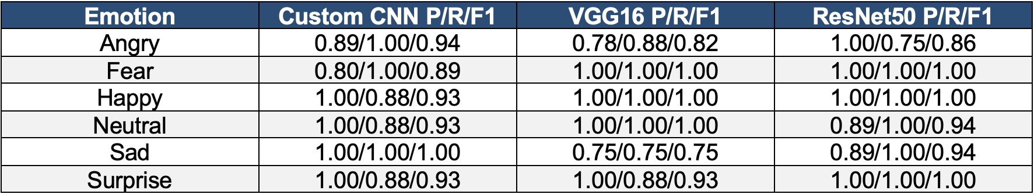

5.7 Comparison Visualisation
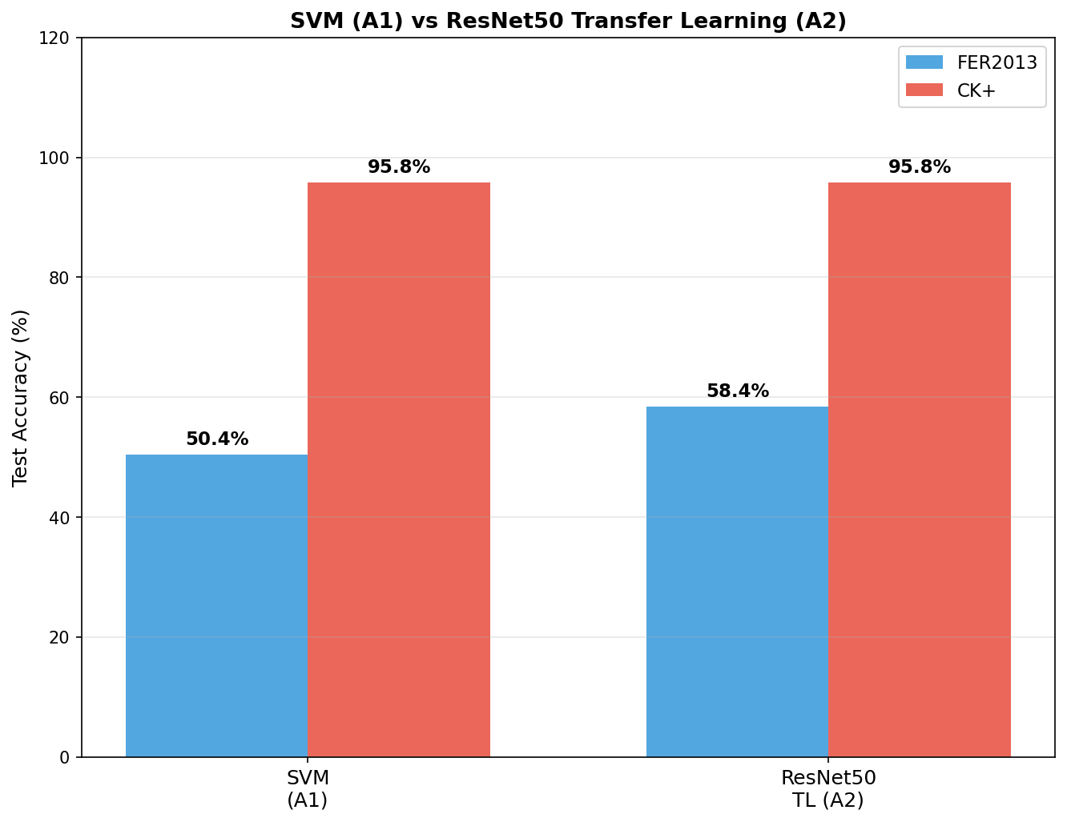
The comparison of the A1 vs A2 bar graphs of the overall test accuracies of the two datasets are illustrated in figure 10. The trend of improvement between classical and deep learning methods on FER2013 is clearly shown in the chart, and the current trend converges on the near-ceiling CK+ dataset.
Figure 10 Bar chart comparison of Assessment 1 (SVM) vs Assessment 2 (CNN, VGG16, ResNet50) test accuracies on FER2013 and CK+.

5.8 Classified Emotion Samples
In Figure 11 and Figure 12, the sample images of faces are correctly recognized by the VGG16 model, which demonstrates that the model can differentiate opposite emotions in both datasets. Representative examples of correctly predicted emotion classes of both the ground-truth and predicted label are shown in each panel. The samples verify that the model is accurate in recognizing the visually different expressions like Happy (existent teeth, elevated cheeks), Surprise (large eyes, open mouth), and Angry (brow furrows, tight lips). And more ambiguous emotions, especially Fear and Sad, are also depicted with their closest confused class to demonstrate the natural inter-class similarity that constrains FER2013 performance. These qualitative examples are used to supplement the quantitative confusion matrix analysis in Section 5.4.
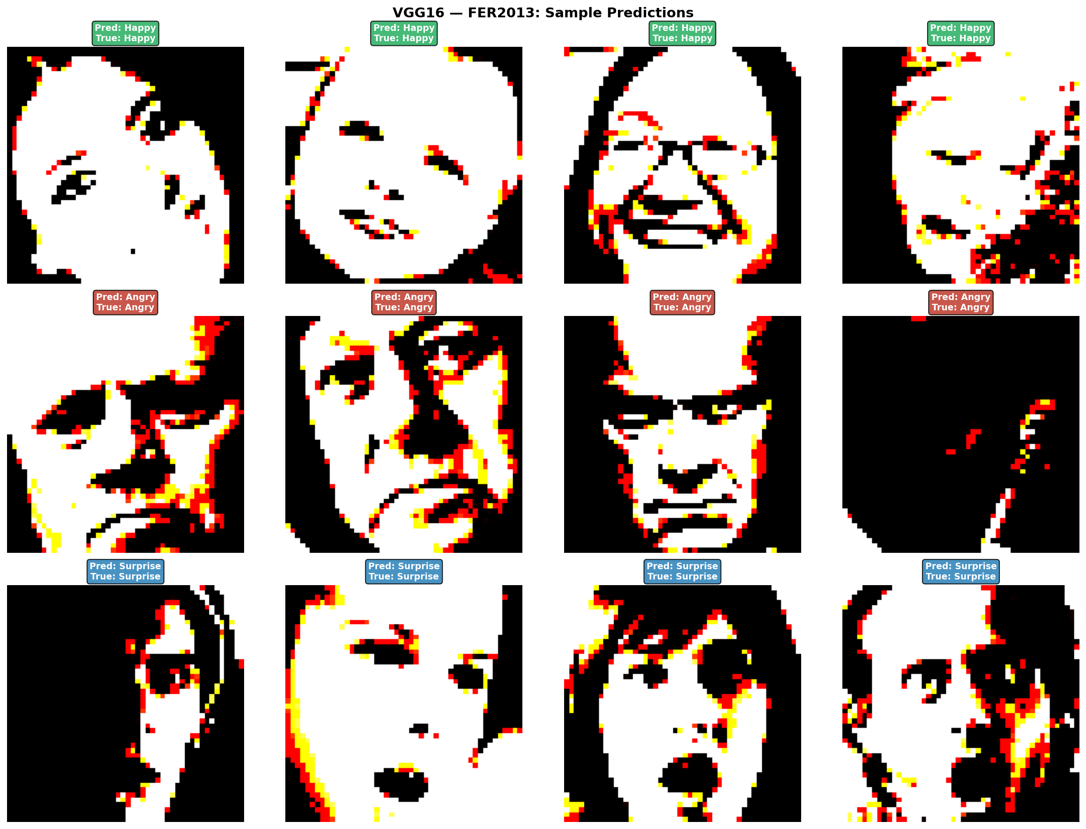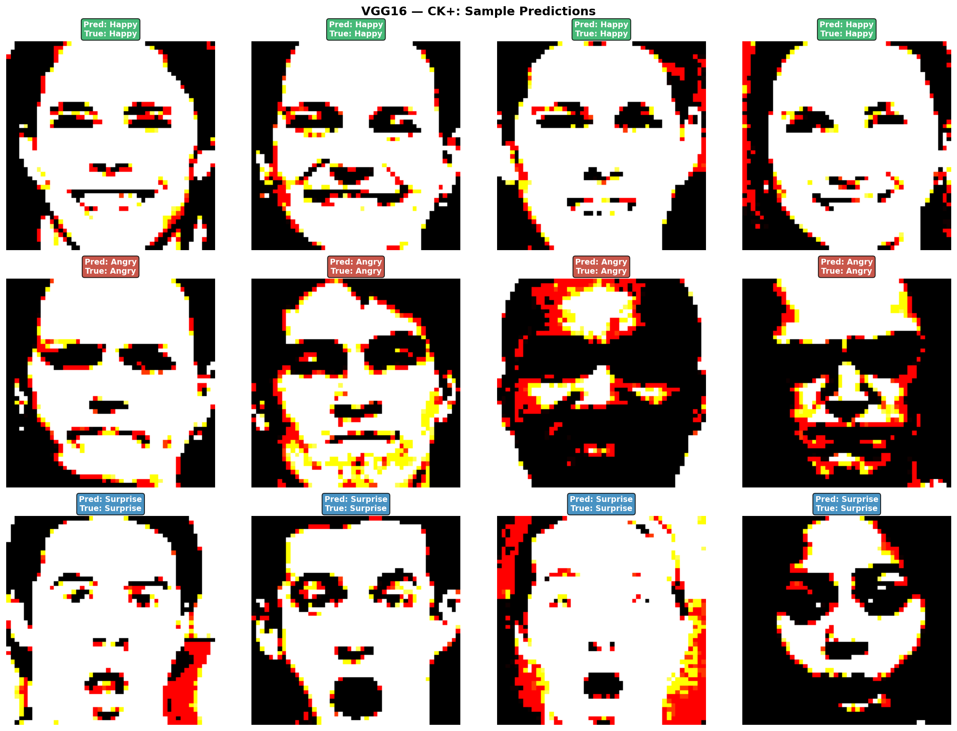
Figure 11 : Sample FER2013 images correctly classified
Figure 12 Sample CK+ images correctly classifie
5.9 Discussion
The findings indicate that the results of deep learning models significantly outperform Assessment 1 on the difficult FER2013 data. With no initialisation with pre-trained weights, the Custom CNN is the most accurate (59.61%), which is +9.22 percentage points higher than the prior best. This can be explained by the capability of the CNN to learn task-specific hierarchical features end-to-end as well as the successful regularisation. ResNet50 has a similar single-run accuracy (58.39%) and the most consistent CV performance (±0.34) indicating that its residual connections offer superior gradient flow when compared to the plain architecture of VGG16.
The relatively poor results on FER2013 (55.44% FER2013, CV mean 52.15) can be explained by the fact that the very deep plain architecture of VGG16 is more vulnerable to the problem of gradient during the process of fine-tuning and the large number of parameters it has, which cannot be supplied by 18,000 of the clean images that FER2 In CK+, all models perform nearly at the ceiling, which is consistent with the results of Assessment 1, and makes it clear that the controlled laboratory environment of CK+ offers a much easier classification problem than actual FER2013 imagery.

6. Conclusion

To measure and compare the performance of three deep learning networks, namely Custom CNN, VGG16, and ResNet50, in Facial Emotion Recognition on the FER2013 and CK+ datasets, this assessment was performed and evaluated. All three models exceeded the Assessment 1 SVM baseline on FER2013: the Custom CNN achieved 59.61% (+9.22%), VGG16 achieved 55.44% (+5.05%), and ResNet50 achieved 58.39% (+8.00%). In CK+, ResNet50 scored the same as A1 SVM with 95.83. K-fold cross-validation showed that these gains are stable, and ResNet50 showed the most stable CV results (59.46%+/-0.34% on FER2013).

Several limitations remain. The FER2013 10 20 percent label noise is a performance limitation that is independent of architecture. All models operate on still pictures, and ignore the dynamic nature of real sequences of emotions. ImageNet pre-training, however, which is useful, is not pre-trained on non-facial images, i.e. the initial representations are not optimally aligned with facial appearance. The models are also not optimised to run in real time and the small test set (48 images) of CK+ implies that the accuracy measurements of CK+ have greater standard deviation than those of FER2013.

Future directions might include VGGFace2 pre-training (face-specific initialisation) to make more out of transfer learning, CBAM attention mechanisms (Woo et al., 2018) to concentrate on discriminative areas of the face, ConvLSTM models to model expression sequences over time, and ensemble prediction (A1 and A2 predictions). The main lessons of this work are as follows: transfer learning can reduce significantly the difference between controlled and real-world performance; two-phase training with a very small fine-tuning learning rate (1x10 -5) is necessary to avoid catastrophic forgetting; the capability of deep learning to track training curves makes principled early stopping possible, which is unattainable with classical SVM methods.2

References
1. Ekman, P. (1992) 'An argument for basic emotions', Cognition and Emotion, 6(3–4), pp. 169–200.
2. Goodfellow, I.J. et al. (2013) 'Challenges in representation learning: A report on three machine learning contests', in Neural Networks, pp. 117–124.
3. He, K. et al. (2016) 'Deep residual learning for image recognition', in Proceedings of the IEEE Conference on Computer Vision and Pattern Recognition (CVPR), pp. 770–778.
4. LeCun, Y., Bengio, Y. and Hinton, G. (2015) 'Deep learning', Nature, 521(7553), pp. 436–444.
5. Li, S. and Deng, W. (2021) 'A survey of face recognition', IEEE Transactions on Human-Machine Systems, 52(1), pp. 1–15.
6. Lucey, P. et al. (2010) 'The Extended Cohn-Kanade Dataset (CK+): A complete dataset for action unit and emotion-specified expression', in Proceedings of IEEE CVPR Workshops, pp. 94–101.
7. Lyons, M. et al. (1998) 'Coding facial expressions with Gabor wavelets', in Proceedings of the Third IEEE International Conference on Automatic Face and Gesture Recognition, pp. 200–205.
8. Mollahosseini, A., Chan, D. and Mahoor, M.H. (2017) 'Going deeper in facial expression recognition using deep neural networks', in IEEE Winter Conference on Applications of Computer Vision (WACV), pp. 1–10.
9. Pramerdorfer, C. and Kampel, M. (2016) 'Facial expression recognition using convolutional neural networks: State of the art', arXiv preprint arXiv:1612.02903.
10. Sariyanidi, E., Gunes, H. and Cavallaro, A. (2015) 'Automatic analysis of facial affect: A survey of registration, representation, and recognition', IEEE Transactions on Pattern Analysis and Machine Intelligence, 37(6), pp. 1113–1133.
11. Simonyan, K. and Zisserman, A. (2015) 'Very deep convolutional networks for large-scale image recognition', in International Conference on Learning Representations (ICLR).
12. Tan, M. and Le, Q.V. (2019) 'EfficientNet: Rethinking model scaling for convolutional neural networks', in Proceedings of the International Conference on Machine Learning (ICML), pp. 6105–6114.
13. Viola, P. and Jones, M. (2001) 'Rapid object detection using a boosted cascade of simple features', in Proceedings of the IEEE Conference on Computer Vision and Pattern Recognition (CVPR), Vol. 1, pp. 511–518.
14. Woo, S. et al. (2018) 'CBAM: Convolutional block attention module', in Proceedings of the European Conference on Computer Vision (ECCV), pp. 3–19.

