Assignment 01: Energy Efficiency and Renewable Energy in Sri Lanka's Tourism Sector

Introduction
Sri Lanka, a nation renowned for its pristine beaches, lush landscapes, and rich cultural heritage, heavily relies on its burgeoning tourism sector for economic growth and foreign exchange earnings. However, the rapid expansion of this sector, coupled with increasing energy demands, presents significant challenges related to environmental sustainability and energy security. This assignment aims to analyze the energy consumption patterns within Sri Lanka's tourism industry, assess the associated environmental impacts, and propose practical, sustainable engineering and technological solutions focused on renewable energy transition and enhanced energy efficiency. The analysis will integrate relevant data, charts, and tables, linking the proposed solutions to Sri Lanka's national development priorities and the broader Sustainable Development Goals (SDGs), thereby demonstrating the application of engineering knowledge to address real-world development challenges within a Sri Lankan context.

Energy Demand and Environmental Impact in Sri Lanka's Tourism Sector
To contextualize the energy landscape, the following table presents key national energy statistics relevant to Sri Lanka's development:

Metric | Value | Source
Total Annual Electricity Demand (2024) | ~14,150 GWh | [1]
Expected Annual Demand Growth | 4.9% | [1]
Tourism Sector Electricity Share (2015) | ~34% | [2]
Current Renewable Energy Share (mid-2025) | ~58.74% | [3]
Cost of Power Interruptions to Tourism (2026 est.) | USD 1.2 Million/year | [4]
National RE Target (by 2030) | 70% of electricity generation | [9]
National Carbon Neutrality Target | 2050 | [9]
Sri Lanka's total annual electricity demand is approximately 14,150 gigawatt-hours (GWh), with an anticipated annual increase of 4.9% [1]. The tourism sector, a significant contributor to the national economy, accounts for a substantial portion of this energy consumption. While precise up-to-date figures for the tourism sector's electricity utilization are continuously evolving, a 2015 modeling study indicated that the sector consumed around 34% of the total electricity demand [2]. Given the post-pandemic recovery and projected growth in tourism, this percentage is likely to have increased, placing further strain on the national grid and energy resources.

The heavy reliance on conventional energy sources, predominantly fossil fuels, for electricity generation in Sri Lanka contributes significantly to greenhouse gas (GHG) emissions and other environmental externalities. As of mid-2025, approximately 58.74% of Sri Lanka's electricity was supplied by renewable sources, with the remainder still dependent on fossil fuels [3]. This energy mix is visually represented in Figure 1.

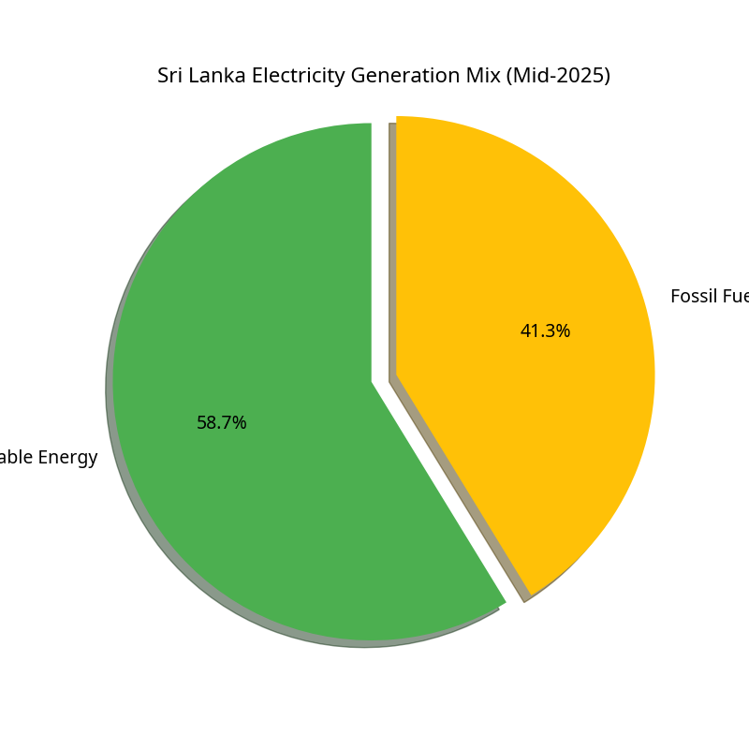

This dependence on fossil fuels not only exacerbates climate change but also exposes the tourism sector to volatile global fuel prices and energy supply disruptions. Power interruptions, both scheduled and unscheduled, have tangible economic consequences, costing registered tourism establishments an estimated USD 1.2 million annually [4]. This highlights the urgent need for a robust and sustainable energy infrastructure within the sector.

Proposed Renewable Energy and Energy Efficiency Solutions
To mitigate the environmental impact and enhance the energy security of Sri Lanka's tourism sector, a multi-faceted approach integrating renewable energy adoption and stringent energy efficiency measures is imperative. These solutions must be socially acceptable, economically viable, and technologically advanced, aligning with the nation's sustainable development aspirations.

1. Solar Photovoltaic (PV) Systems
Solar PV systems represent one of the most promising renewable energy solutions for the Sri Lankan tourism sector, given the country's abundant solar insolation. Hotels and resorts can significantly reduce their reliance on grid electricity by installing rooftop solar panels or integrating PV systems into existing infrastructure, such as car park canopies. Figure 2 illustrates a typical solar farm installation in Sri Lanka.

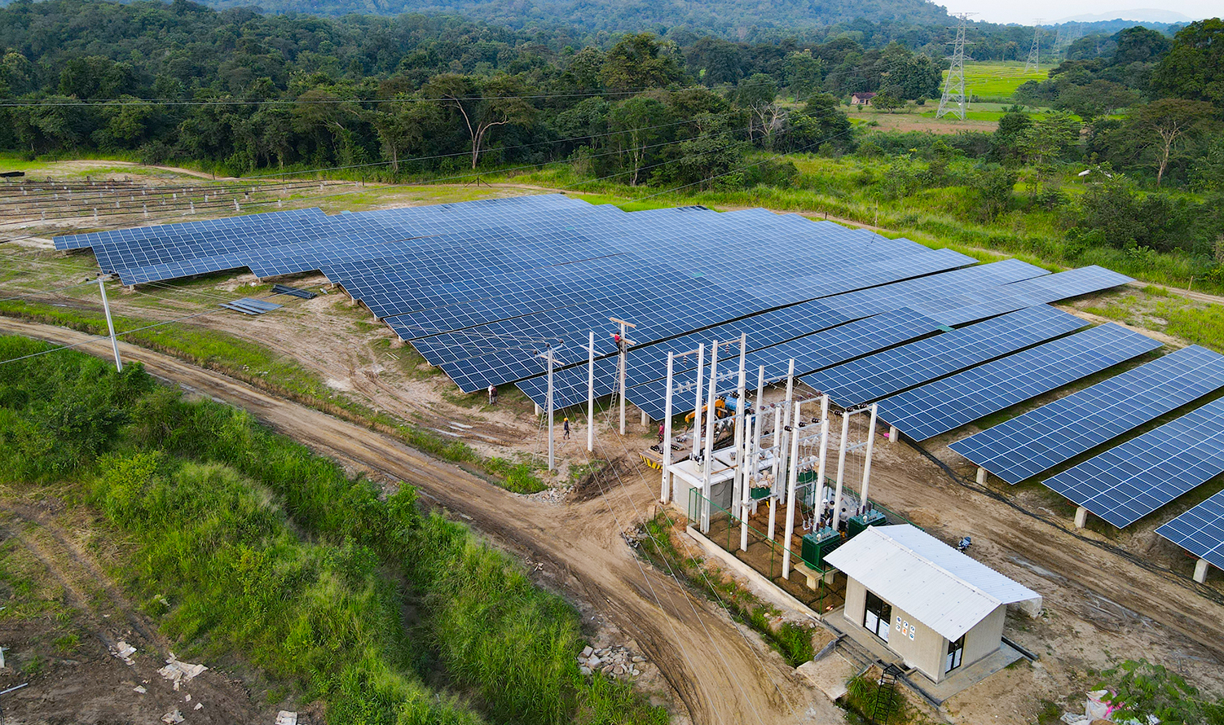

A notable example is Jetwing Hotels, a pioneer in sustainable hospitality in Sri Lanka. The group invested over USD 1 million in 2024 to expand its solar PV installations by 1.6 megawatts (MW), bringing its total capacity to 2.6 MW. This expansion is projected to increase the proportion of electricity demand met by solar power from 8% to 24% [5]. Such investments not only reduce operational costs but also enhance the brand image, attracting eco-conscious tourists.

2. Biomass and Bioenergy Solutions
For establishments with significant thermal energy demands (e.g., hot water, steam for laundry), biomass boilers and biogas digesters offer viable alternatives to fossil fuels. Biogas systems, which convert organic waste (e.g., food waste from kitchens) into methane, can provide clean cooking fuel or generate electricity, simultaneously addressing waste management challenges. Jetwing Hotels, for instance, utilizes biomass boilers and biogas digesters, contributing to 66% of its energy demand being met through self-produced renewable sources [5]. Another innovative solution is waste-to-energy incineration, as demonstrated by Heritance Ahungalla, which uses an incineration plant to generate energy from waste, thereby reducing landfill burden and offsetting fossil fuel consumption [6].

3. Energy Efficiency Measures
Alongside renewable energy generation, implementing comprehensive energy efficiency measures is crucial for reducing overall energy demand. These include:
- Smart Lighting Systems: Replacing traditional lighting with LED technology and installing smart sensors for occupancy and daylight harvesting can drastically cut electricity consumption. Many hotels are already adopting LED lighting and smart sensors [7].
- Efficient HVAC Systems: Upgrading to energy-efficient heating, ventilation, and air conditioning (HVAC) systems, coupled with proper insulation and smart thermostats, can significantly reduce energy use. Innovative solutions like steam-powered vapor absorption chillers, as employed by some Jetwing properties, offer a sustainable alternative for cooling [5].
- Building Management Systems (BMS): Implementing a centralized BMS allows for optimized control and monitoring of energy consumption across various hotel operations, identifying areas for improvement and reducing wastage.
- Guest Engagement and Behavioral Change: Educating guests about energy conservation through in-room notices and hotel sustainability initiatives can foster a culture of responsible consumption. Simple measures like card-key systems that switch off electricity when guests leave their rooms are effective [7].

4. Off-Grid and Hybrid Solutions
For tourism establishments located in remote areas or those seeking greater energy independence, off-grid or hybrid energy systems (combining solar PV with battery storage or other renewables) can provide reliable power. These systems reduce transmission losses and enhance resilience against grid failures, which is particularly beneficial given the vulnerability of Sri Lanka's power sector [4].

5. Sustainable Transportation Initiatives
While primarily focused on stationary energy, the tourism sector can also promote energy efficiency in transportation. Encouraging the use of electric vehicles (EVs) for guest transfers and providing EV charging infrastructure can reduce the carbon footprint associated with tourist mobility. Some hotels are exploring options like electric tuk-tuks for local transport [7].

Socioeconomic and Environmental Return on Investment (ROI)
The following table summarizes these key benefits:

Category | Socioeconomic Benefits | Environmental Benefits
Direct Impact | - Reduced operational costs | - Reduced Greenhouse Gas Emissions
 | - Enhanced brand image & competitiveness | - Conservation of Natural Resources
 | - Energy security & resilience | - Improved Air Quality
 | - Job creation & skill development | - Waste Reduction (via bioenergy)
Indirect Impact | - Local community development | - Biodiversity preservation
 | - Attracts eco-conscious tourists | - Climate change mitigation
Socioeconomic Benefits:
- Cost Savings: Reduced reliance on grid electricity and fossil fuels leads to significant long-term operational cost savings, improving profitability for tourism businesses. The payback period for solar PV investments in Sri Lanka is typically 5-10 years [7].
- Enhanced Brand Image and Competitiveness: Hotels adopting sustainable practices attract a growing segment of eco-conscious travelers, leading to increased occupancy rates and market differentiation. Sri Lanka's National Tourism Policy aims to position the country as a
“premier green tourist destination” [8].
- Energy Security and Resilience: Diversifying energy sources reduces vulnerability to power outages and fluctuations in global energy markets, ensuring uninterrupted operations.
- Job Creation: The installation, maintenance, and manufacturing of renewable energy technologies create new employment opportunities within the country.
- Local Community Development: Investments in local renewable energy projects can empower communities and contribute to regional development.

Environmental Benefits:
- Reduced Greenhouse Gas Emissions: Shifting from fossil fuels to renewables significantly lowers carbon dioxide emissions, contributing to Sri Lanka’s national goal of carbon neutrality by 2050 [9]. Jetwing Hotels' solar expansion alone is projected to reduce CO2 emissions by over 1,200 metric tons annually [5].
- Conservation of Natural Resources: Decreased reliance on fossil fuels conserves finite natural resources.
- Improved Air Quality: Reduced burning of fossil fuels leads to better air quality, benefiting both local communities and tourists.
- Waste Reduction: Biogas and waste-to-energy solutions contribute to sustainable waste management, reducing landfill burden and pollution.

Alignment with Sustainable Development Goals (SDGs) and National Priorities
The proposed solutions for energy efficiency and renewable energy in Sri Lanka's tourism sector are directly aligned with several key Sustainable Development Goals (SDGs) and national development priorities.

Sustainable Development Goal 7: Affordable and Clean Energy
This SDG aims to ensure access to affordable, reliable, sustainable, and modern energy for all. By promoting renewable energy generation and energy efficiency within the tourism sector, Sri Lanka directly contributes to this goal. The national target of achieving 70% electricity generation from renewable sources by 2030 is a testament to this commitment [9]. The tourism sector, by adopting these measures, can serve as a leading example for other industries.

Sustainable Development Goal 12: Responsible Consumption and Production
This SDG focuses on promoting sustainable consumption and production patterns. Energy efficiency measures, such as smart lighting, efficient HVAC systems, and waste-to-energy solutions, reduce resource consumption and waste generation within the tourism industry. The circular economy principles embedded in waste-to-energy projects, like the one at Heritance Ahungalla, exemplify responsible production and consumption [6].

Sustainable Development Goal 13: Climate Action
This SDG calls for urgent action to combat climate change and its impacts. The transition to renewable energy significantly reduces greenhouse gas emissions, directly addressing the causes of climate change. Sri Lanka's aspiration to become a carbon-neutral country by 2050 is a strong national priority that the tourism sector can actively support through decarbonization efforts [9].

National Development PrioritiesSri Lanka's National Tourism Policy (2024-2030) explicitly aims to position the country as a
"premier green tourist destination" [8]. The integration of energy efficiency and renewable energy solutions within the tourism sector directly supports this vision by enhancing the sector's environmental performance and attractiveness to a global market increasingly valuing sustainability. Furthermore, reducing reliance on imported fossil fuels aligns with national energy security objectives and contributes to economic stability.

Conclusion
Sri Lanka's tourism sector stands at a critical juncture, with immense potential for sustainable growth. By embracing energy efficiency and transitioning towards renewable energy sources, the industry can not only mitigate its environmental footprint and enhance energy security but also unlock significant socioeconomic benefits. The case studies of Jetwing Hotels and Heritance Ahungalla demonstrate the feasibility and positive impact of such initiatives. Aligning with national policies and global Sustainable Development Goals, these efforts will position Sri Lanka as a leader in sustainable tourism, ensuring a vibrant and resilient future for both the industry and the nation.

References
[1] International Trade Administration. (2024, May 8). Sri Lanka - Energy. Retrieved from https://www.trade.gov/country-commercial-guides/sri-lanka-energy
[2] Modeling of Energy Utilization of Tourism Industry of Sri Lanka and ... (2015). Scientific & Academic Publishing. Retrieved from http://article.sapub.org/10.5923.j.ijee.20150505.01.html
[3] Weerasinghe, D. (n.d.). Sri Lanka's recent Electricity Consumption & Supply Trends. LinkedIn. Retrieved from https://www.linkedin.com/pulse/sri-lankas-recent-electricity-consumption-supply-weerasinghe--kor2c
[4] ResearchGate. (2026, March 3). Energy Security and Tourism Competitiveness in Small Island Developing States: A Case Study of Sri Lanka's Power Sector Vulnerability. Retrieved from https://www.researchgate.net/publication/401419334_Energy_Security_and_Tourism_Competitiveness_in_Small_Island_Developing_States_A_Case_Study_of_Sri_Lanka%27s_Power_Sector_Vulnerability
[5] Jetwing Hotels. (n.d.). Jetwing Hotels increases reliance on solar power with an investment of USD 1 million in 2024. Retrieved from https://www.jetwinghotels.com/press/jetwing-hotels-recognised-at-the-annual-green-building-awards-2023-2/
[6] Green Matters. (n.d.). Hotels running fully on renewable energy. Retrieved from https://www.greenmatters.com/travel/2018/05/16/2NxTh3/hotels-renewables
[7] Sri Lanka Tourism Alliance. (2022, October). SLTA Sustainability Principle 4: Renewable Energy Solutions. Retrieved from https://www.srilankatourismalliance.com/wp-content/uploads/2022/10/SLTA-Sustainability-Principle-4_Renewable-Energy-Solutions.pdf
[8] Sri Lanka Tourism Development Authority. (n.d.). NATIONAL TOURISM POLICY. Retrieved from https://www.sltda.gov.lk/storage/common_media/tourismpolicy.pdf
[9] Sri Lanka Sustainable Energy Authority. (n.d.). Home. Retrieved from https://www.energy.gov.lk/en/

Detailed Analysis of Energy Consumption Patterns in the Tourism Sector
To further understand the energy dynamics within Sri Lanka's tourism industry, it is essential to delve into the specific areas of consumption. The primary energy consumers in a typical Sri Lankan hotel are the HVAC systems, lighting, and kitchen operations. Figure 4 illustrates a hypothetical breakdown of energy consumption in a Sri Lankan hotel.

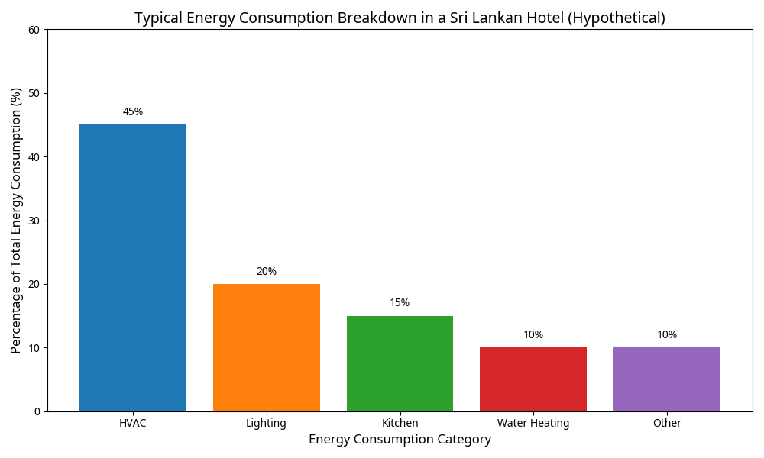

HVAC systems, particularly in coastal resorts, can account for up to 50% of a hotel's total electricity usage due to the high demand for cooling in a tropical climate. Lighting, while increasingly efficient with the adoption of LEDs, still represents a significant portion, especially in large resorts with extensive common areas and outdoor lighting. Kitchen operations, including refrigeration and cooking, also contribute substantially to the energy load.

The seasonal nature of tourism in Sri Lanka further complicates energy management. During peak seasons, energy demand spikes, placing immense pressure on both the hotel's internal infrastructure and the national grid. Conversely, during off-peak periods, hotels may operate at significantly reduced capacities, yet still maintain a baseline energy consumption for essential services. This variability necessitates flexible and scalable energy solutions that can adapt to fluctuating occupancy levels.

Technological Advancements in Renewable Energy for Tourism
The rapid evolution of renewable energy technologies offers new opportunities for the Sri Lankan tourism sector. Beyond traditional solar PV and biomass, several emerging technologies hold promise:

1. Advanced Battery Storage Systems
The integration of advanced battery storage systems, such as lithium-ion or flow batteries, can significantly enhance the effectiveness of solar PV installations. By storing excess energy generated during the day, hotels can utilize renewable power during evening peak hours, further reducing their reliance on the grid and enhancing energy security. This is particularly relevant for remote eco-lodges where grid stability may be an issue.

2. Small-Scale Wind Turbines
In certain coastal or hilly regions of Sri Lanka with consistent wind patterns, small-scale wind turbines can complement solar PV systems. These turbines can provide a reliable source of energy, especially during periods of low solar insolation, creating a more balanced and resilient renewable energy mix. Figure 3 shows a wind farm in Sri Lanka.

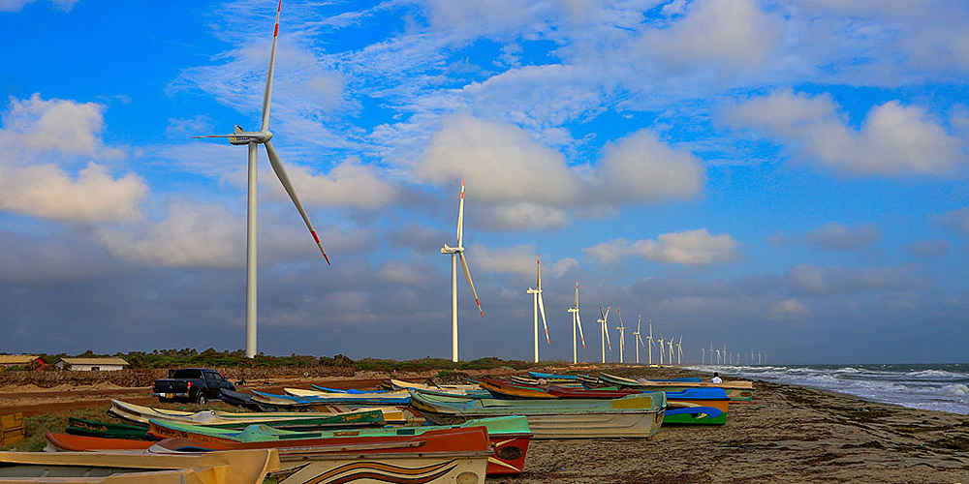

3. Geothermal Energy Potential
While still in the early stages of exploration in Sri Lanka, geothermal energy could potentially provide a stable and continuous source of renewable power for certain regions. Further research and development are needed to assess the feasibility and environmental impact of geothermal projects within the tourism sector.

4. Ocean Energy Technologies
As an island nation, Sri Lanka has vast potential for ocean energy, including wave and tidal power. While these technologies are still largely in the experimental phase globally, future advancements could provide a significant source of clean energy for coastal tourism developments.

Socioeconomic Impacts and Community Engagement
The transition to renewable energy and energy efficiency is not merely a technical challenge but also a social and economic one. Engaging with local communities and stakeholders is crucial for the success and sustainability of these initiatives.

1. Local Employment and Skill Development
The growth of the renewable energy sector in Sri Lanka creates a demand for skilled labor in installation, maintenance, and operation. By prioritizing local hiring and providing training programs, tourism businesses can contribute to community development and empower local residents. This fosters a sense of ownership and support for renewable energy projects.

2. Community-Based Renewable Energy Projects
Tourism establishments can collaborate with local communities to develop shared renewable energy projects, such as community solar farms. These initiatives can provide clean energy to both the hotel and the surrounding community, fostering social cohesion and promoting equitable access to sustainable energy.

3. Educational and Awareness Programs
Hotels can serve as platforms for educating both guests and local communities about the importance of renewable energy and energy efficiency. By showcasing their own sustainability initiatives and providing educational materials, tourism businesses can inspire others to adopt similar practices, creating a ripple effect of positive change.

Policy and Regulatory Framework in Sri Lanka
The success of the renewable energy transition in the tourism sector is heavily dependent on a supportive policy and regulatory framework. The Sri Lankan government has implemented several initiatives to promote renewable energy, including:

1. Net Metering and Net Accounting
These schemes allow consumers with renewable energy installations to export excess electricity to the national grid and receive credit or payment. This provides a significant financial incentive for hotels to invest in solar PV and other renewable technologies.

2. Tax Incentives and Subsidies
The government offers various tax incentives and subsidies for renewable energy projects, reducing the initial investment costs and improving the financial viability of these initiatives.

3. National Energy Policy and Strategies
The National Energy Policy and Strategies (2023-2030) provide a clear roadmap for the country's energy transition, setting ambitious targets for renewable energy generation and energy efficiency. This policy framework provides a stable and predictable environment for investments in the tourism sector.

Challenges and Barriers to Implementation
Despite the numerous benefits and supportive policies, several challenges and barriers still hinder the widespread adoption of renewable energy and energy efficiency in Sri Lanka's tourism sector:

1. High Initial Investment Costs
The upfront costs of renewable energy systems and energy-efficient technologies can be significant, especially for small and medium-sized enterprises (SMEs). Access to affordable financing and credit remains a major challenge for many tourism businesses.

2. Technical Expertise and Maintenance
The installation and maintenance of advanced renewable energy systems require specialized technical expertise, which may be limited in certain regions of Sri Lanka. Ensuring a reliable supply chain for components and spare parts is also crucial.

3. Grid Integration and Stability
Integrating large amounts of variable renewable energy into the national grid can present technical challenges related to grid stability and management. Further investments in grid infrastructure and smart grid technologies are needed to accommodate the growing share of renewables.

4. Awareness and Perception
While awareness of sustainability is growing, some tourism businesses may still perceive renewable energy as a risky or unproven investment. Overcoming these perceptions through successful case studies and clear communication of the benefits is essential.

Future Outlook and Recommendations
The future of Sri Lanka's tourism sector is inextricably linked to its ability to embrace sustainability and energy resilience. To accelerate the transition towards renewable energy and energy efficiency, the following recommendations are proposed:

1. Strengthen Financial Support Mechanisms
The government and financial institutions should develop tailored financial products, such as low-interest loans and green bonds, to support renewable energy investments in the tourism sector, particularly for SMEs.

2. Enhance Technical Capacity and Training
Investing in vocational training and educational programs to develop a skilled workforce in renewable energy technologies is crucial. This will ensure the long-term sustainability and reliability of renewable energy installations.

3. Promote Public-Private Partnerships
Collaborations between the government, private sector, and international organizations can facilitate the development of large-scale renewable energy projects and the sharing of best practices.

4. Foster Innovation and Research
Supporting research and development in emerging renewable energy technologies and energy-efficient solutions tailored to the Sri Lankan context will drive innovation and improve the effectiveness of sustainability initiatives.

5. Integrate Sustainability into Tourism Planning
Sustainability considerations, including energy efficiency and renewable energy, should be integrated into all levels of tourism planning and development, from national policies to individual hotel designs.

By implementing these recommendations and building upon the successes of pioneers like Jetwing Hotels and Heritance Ahungalla, Sri Lanka can transform its tourism sector into a global model of sustainability, ensuring a prosperous and resilient future for the nation and its people.

