Final Machine Learning Project Report
Using Customer Retail Dataset to Implement and Compare Models
Student Name: __________________________ Index No: __________________________

1. Project Title
Using customer retail dataset implement various models and compare them.

2. Project Objective
The objective of this project is to build and compare multiple Machine Learning models using a customer retail dataset. This project covers preprocessing, visualization, model training, prediction, evaluation, and comparison of algorithms.

3. Dataset Description
A customer retail dataset was used for this project. The dataset contains purchase-related details such as item quantity, unit price, and customer country. These values were used to predict whether a purchase is a high-value purchase or not.

4. Dataset Features Used
Feature | Description
Quantity | Number of items purchased by the customer.
UnitPrice | Price of one item.
Country | Country of the customer.

5. Preprocessing Steps
- Loaded the dataset using Pandas.
- Selected the required columns: Quantity, UnitPrice, and Country.
- Handled missing values using dropna().
- Encoded the Country column using LabelEncoder.
- Created the target column HighValuePurchase using Quantity x UnitPrice.
- Split the dataset into training and testing sets.

6. Machine Learning Models Used
- Logistic Regression
- Decision Tree Classifier
- K-Nearest Neighbors (KNN)

7. Evaluation Metrics
The models were evaluated using Accuracy Score and Confusion Matrix.

8. Results
Model | Accuracy
Logistic Regression | 0.9556
Decision Tree | 0.9667
KNN | 0.9333
According to the accuracy results, the best performing model for this dataset is Decision Tree.

9. Confusion Matrices
Logistic Regression
 | Predicted 0 | Predicted 1
Actual 0 | 46 | 3
Actual 1 | 1 | 40

Decision Tree
 | Predicted 0 | Predicted 1
Actual 0 | 48 | 1
Actual 1 | 2 | 39

KNN
 | Predicted 0 | Predicted 1
Actual 0 | 47 | 2
Actual 1 | 4 | 37

10. Visualizations
Customer Distribution Graph
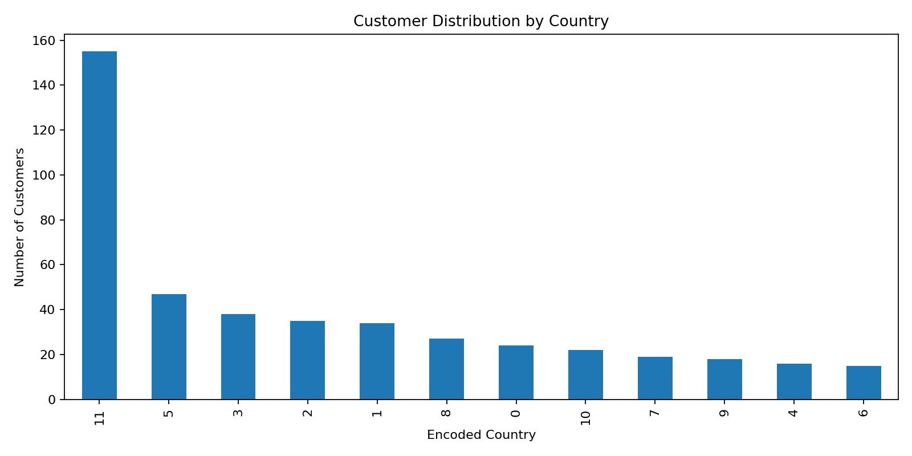
Model Accuracy Comparison Graph
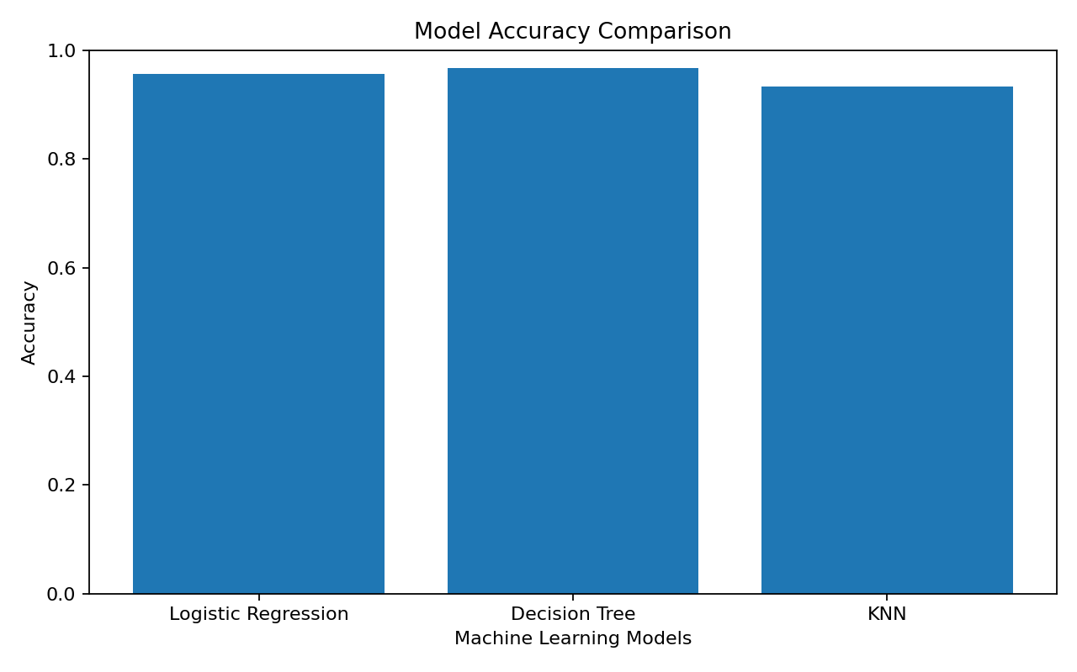

11. Conclusion
This project demonstrates how different Machine Learning algorithms perform on the same customer retail dataset. After preprocessing the data and training three supervised learning models, their accuracy values and confusion matrices were compared. The results show that model performance can vary depending on the algorithm, dataset, and selected features. Based on the sample dataset results, the best performing model was selected using the highest accuracy score.

12. Files Submitted
- Final_ML_Project.ipynb
- Final_ML_Project.py
- customer_retail_dataset.csv
- Final_ML_Project_Report.pdf / Final_ML_Project_Report.docx

