A DUAL-OBJECTIVE DECISION SUPPORT MODEL FOR SME CREDIT APPRAISAL IN SRI LANKAN DEVELOPMENT BANKING

A. A. V. ATHUKORALA

Master of Science in Information Technology

Department of Computing and Information Systems
NSBM Green University
Sri Lanka
September 2026

A DUAL-OBJECTIVE DECISION SUPPORT MODEL FOR SME CREDIT APPRAISAL IN SRI LANKAN DEVELOPMENT BANKING

A thesis submitted to NSBM Green University for the degree of
Master of Science in Information Technology

By
A. A. V. ATHUKORALA

Department of Computing and Information Systems
Faculty of Computing
NSBM Green University
Sri Lanka
September 2026

DECLARATION
I declare that the content of this thesis, titled A Dual-Objective Decision Support Model for SME Credit Appraisal in Sri Lankan Development Banking, is my own work, and that it does not incorporate without acknowledgement any material previously submitted for a degree or diploma at any university or other institution of higher learning.
Where the work of others has been used, it is acknowledged in the text and listed in the references. The datasets, source code and analysis scripts that produced every quantitative result reported here are included with this submission.

Signature: ...................................................
Name: A. A. V. Athukorala
Date: ...........................

I certify that this thesis was prepared under my supervision, and that it is of a standard suitable for examination.

Signature: ...................................................
Name: Dr. Pabudi Abeyrathne
Date: ...........................
Principal Supervisor
Senior Lecturer, Department of Computing and Information Systems
NSBM Green University

ACKNOWLEDGEMENT
I thank my supervisor, Dr. Pabudi Abeyrathne, for guidance throughout this research, and in particular for the latitude to revise the study's direction when the literature and the available data made the original scope untenable.
I am grateful to People's Bank for the appraisal instrument that forms the foundation of this work. The Project / Business Appraisal Report for SME Credit Facility is a carefully constructed document, and the analysis here rests entirely on the institutional expertise embedded in it.
I acknowledge the authors of the SBA National dataset for placing it in the public domain. The principal finding of this thesis is a caution about that dataset, and it could not have been made had they not published it. Making data open invites exactly this kind of scrutiny, and the field is better for it.
Finally, I thank the Faculty of Computing at NSBM Green University for the research environment in which this work was carried out.

ABSTRACT
Small and medium enterprises account for an estimated 75% of enterprises, 45% of employment and 52% of gross domestic product in Sri Lanka, yet access to formal credit remains a binding constraint. Appraisal at People's Bank uses a seven-section instrument requiring thirteen financial ratios, a competitive-forces analysis and nine developmental outcomes, then asks the officer to certify viability without stating how to combine that evidence.
This study formalises that instrument into a computable, explainable multi-criteria model, and establishes what public data can and cannot validate about such a model. The form was examined clause by clause and expressed as 49 criteria across seven dimensions and two objectives, each traceable to a numbered clause. Quantitative criteria map through piecewise-linear bands and qualitative criteria through a five-point linguistic scale represented as triangular fuzzy numbers. A working system implements it, scoring credit risk and development impact separately. Weights were elicited from eleven credit practitioners by the Best-Worst Method, and the scoring method was benchmarked against the SBA National dataset of 899,164 loan guarantees.
Practitioners weight forward-looking project viability above historic financial performance by more than two to one, inverting the emphasis of the source form. Scoring proved robust to that change: rank correlation against equal weighting is 0.90 for credit risk and 0.97 for development impact, and no appraisal moves two risk bands. Validation produced an unanticipated principal finding: whether a facility's term is an exact multiple of twelve, a property with no economic content, predicts default at an area under the curve of 0.889 in every approval year, and the artefact is present in the SBA's own published extracts.
An instrument-specific appraisal model cannot be validated against a dataset that lacks its variables: substituting proxies tests the proxies. Expert elicitation is therefore a defensible route to those weights, not a fallback.
Keywords: SME credit appraisal, multi-criteria decision analysis, fuzzy sets, decision support systems, data leakage, development banking

LIST OF ABBREVIATIONS
Abbreviation | Meaning
AHP | Analytic Hierarchy Process
AUC | Area Under the Receiver Operating Characteristic Curve
BWM | Best-Worst Method
CI | Confidence Interval
CR | Consistency Ratio
DSCR | Debt Service Cover Ratio
FOIA | Freedom of Information Act (United States)
FY | Fiscal Year
ISCR | Interest Service Cover Ratio
LIME | Local Interpretable Model-agnostic Explanations
MCDM | Multi-Criteria Decision Making
ROC | Receiver Operating Characteristic
ROI | Return on Investment
SBA | United States Small Business Administration
SHAP | SHapley Additive exPlanations
SME | Small and Medium Enterprise
TFN | Triangular Fuzzy Number
TOPSIS | Technique for Order Preference by Similarity to Ideal Solution

TABLE OF CONTENTS
DECLARATION ii
ACKNOWLEDGEMENT iii
ABSTRACT iv
LIST OF ABBREVIATIONS v
TABLE OF CONTENTS vi
LIST OF FIGURES xii
LIST OF TABLES xiv
1 INTRODUCTION 1
1.1 Background 1
1.2 The appraisal problem 1
1.3 Research questions 2
1.4 A note on the second objective 3
1.5 Scope and delimitations 3
1.6 Contributions 4
1.7 Structure 5
2 OBJECTIVES 7
2.1 General objective 7
2.2 Specific objectives 7
2.2.1 Derive a computable criteria model from the source instrument 7
2.2.2 Implement a scoring method for measured and judged inputs 7
2.2.3 Build a working decision-support system 7
2.2.4 Establish how far the model depends on its criterion weights 7
2.2.5 Evaluate the scoring method against realised loan outcomes 7
2.2.6 Determine whether the two objectives are separable in practice 8
2.2.7 Elicit criterion weights from credit practitioners 8
2.3 How the objectives answer the research questions 8
3 LITERATURE REVIEW 10
3.1 Scope and structure 10
3.2 Credit scoring: sixty years of weighted ratios 10
3.3 SME credit assessment 11
3.4 Variability in human credit judgement 12
3.5 Multi-criteria decision methods 13
3.5.1 Foundations 13
3.5.2 Best-Worst Method 14
3.5.3 Application to credit, and the nearest precedent 14
3.6 Non-financial objectives in lending 15
3.6.1 Social criteria in credit scoring 15
3.6.2 Development returns and credit risk 16
3.7 Explainability, regulation, and data quality 16
3.7.1 Why explanation is not optional 16
3.7.2 Leakage and reproducibility 17
3.7.3 The SBA National dataset 18
3.8 Research gap 19
4 METHODOLOGY 21
4.1 Research design 21
4.2 Research questions 21
4.3 Formalisation method (RQ1) 22
4.4 Scoring method 22
4.5 Weight elicitation (RQ2) 24
4.5.1 Method selection 24
4.5.2 Instrument 24
4.5.3 Analysis 25
4.5.4 Sampling and its limits 27
4.6 Empirical validation (RQ3) 27
4.6.1 The proxy problem, stated in advance 27
4.6.2 Protocol 27
4.6.3 Treatment of anomalous results 28
4.7 Ethical considerations 28
4.8 Limitations of the design 29
4.9 The artefact 30
4.10 Formalising a narrative instrument 32
4.10.1 The source 32
4.10.2 Method 32
4.11 Scoring method 33
4.11.1 Quantitative criteria 33
4.11.2 Qualitative criteria 33
4.11.3 Missing criteria 34
4.11.4 Critical criteria 34
4.12 System architecture 35
4.12.1 Reproducibility of stored appraisals 35
4.12.2 Deployment 36
4.13 Access control and the integrity of the audit trail 36
4.13.1 What this is not 37
5 RESULTS 38
5.1 The derived criteria model 38
5.2 The dual-objective structure 38
5.2.1 Rationale 38
5.2.2 Design decision 39
5.3 The completeness gate 39
5.3.1 A problem found by testing 39
5.3.2 Response 40
5.4 Explainability 41
5.5 Report generation 43
5.6 Verification 43
5.7 Status of the weights 44
5.8 Empirical evaluation: purpose and scope 44
5.9 Dataset 45
5.9.1 Outcome-derived fields 46
5.9.2 Right-censoring 46
5.10 A contaminated predictor 46
5.10.1 How the problem surfaced 46
5.10.2 The structure 47
5.10.3 Ruling out cohort composition 48
5.10.4 The mechanism is not established 49
5.10.5 The artefact is in the SBA's own records 50
5.10.6 Is twelve doing the work? 51
5.10.7 The contamination reaches the dataset's own documentation 52
5.11 Consequences for reported performance 53
5.12 Validation protocol matters independently 55
5.13 Calibration: ranking is not the same as being right 56
5.13.1 Why this matters more than the AUC result 57
5.14 What the models are worth to a lender 58
5.15 The expert scorecard: a negative result 58
5.16 How much do the weights matter? 59
5.16.1 Method 60
5.16.2 Results 60
5.16.3 An unanticipated structural finding 61
5.17 Are the two objectives independent? (RQ4) 62
5.17.1 The objectives are not independent 62
5.17.2 The practical case survives by a different route 63
5.17.3 Development impact is associated with higher default 64
5.18 Who the models work less well for 64
5.18.1 What can and cannot be tested 64
5.18.2 Results 65
5.18.3 A confound that had to be ruled out 66
5.19 What the models do with information the applicant did not supply 67
5.19.1 Method 67
5.19.2 The models reward withholding 67
5.19.3 The limit case 68
5.19.4 Why this matters for the artefact 69
5.20 Limitations 69
5.21 Summary 71
6 DISCUSSION AND CONCLUSIONS 73
6.1 Weight elicitation 73
6.1.1 The instrument 73
6.1.2 Respondents 73
6.1.3 Consistency 74
6.1.4 The weights 74
6.1.5 What the placeholders cost 75
6.2 Answers to the research questions 75
6.2.1 RQ1: can the instrument be formalised? 76
6.2.2 RQ2: what weights do practitioners assign, and how much do they matter? 77
6.2.3 RQ3: what can be established from public data? 77
6.2.4 RQ4: are the objectives separable? 78
6.3 Discussion 78
6.3.1 What the contamination finding means 78
6.3.2 What the negative result means 79
6.3.3 What temporal validation reveals 79
6.3.4 On the system 79
6.3.5 Who the models serve worst 80
6.4 Limitations 81
6.5 Future work 82
6.6 Conclusion 83
REFERENCES 84
APPENDICES 88
Appendix 1 The criteria model 88
Appendix 1.1 The full criteria listing 88
Appendix 1.2 Scoring anchors for the quantitative criteria 90
Appendix 2 The weight elicitation instrument 92
Appendix 2.1 Structure 92
Appendix 2.2 Participant information presented 92
Appendix 2.3 Data collected 93
Appendix 2.4 Comparison scale 93
Appendix 3 Reproducing the results 93
Appendix 4 Dataset 94
Appendix 5 Ethical considerations 95

LIST OF FIGURES
Figure 4.1: The opening screen of the weight elicitation instrument, as a practitioner receives it. The participation notice is shown before any question is asked, and the only identifier collected is a code the respondent chooses. 25
Figure 4.2: The model end to end. The bank's appraisal form is decomposed clause by clause into criteria; measured and judged inputs travel separate mappings into a single aggregation path governed by elicited weights; the two objectives are scored separately and never summed; and two gates stand between a score and a recommendation. 31
Figure 4.3: One dimension of an appraisal during entry. Each criterion carries the clause of the People's Bank form it derives from. Quantitative criteria take a value, qualitative criteria a point on the five-point scale, and unassessed criteria show a dash instead of a zero. 34
Figure 4.4: The sign-in screen. Appraisal records are restricted; the screen states that the criterion weighting study is not, so a practitioner arriving by mistake is told immediately that no account is needed. 37
Figure 5.1: The completeness gate refusing to recommend. A credit-risk score of 78.7 is displayed, and withheld from banding, because only 7% of the objective has been assessed. 41
Figure 5.2: A completed appraisal. The two objectives are scored and banded separately and are never combined. Each dimension's contribution is expressed in points of the objective score, and each criterion shows its entered value, its derived score, its contribution and the clause it comes from. 42
Figure 5.3: Default rate by exact contractual term, 2007 approvals. Terms that are multiples of twelve are shown in blue. 47
Figure 5.4: Left: the share of facilities at each value of Term modulo twelve, separately for those repaid and those charged off. Right: default rate within each approval year, for facilities whose term is a multiple of twelve and for the rest. 48
Figure 5.5: Discrimination achieved by the term-roundness boolean alone, computed separately within each approval year. 49
Figure 5.6: Discrimination with and without the Term field, under both validation protocols. The dashed line marks the level the roundness boolean reaches on its own. 55
Figure 5.7: Reliability diagrams under random and temporal validation. Marker area is proportional to the number of facilities in each bin. Under temporal validation the curve lifts above the diagonal, indicating systematic under-prediction of default. 57
Figure 5.8: Ranking stability and risk-band stability against the magnitude of the weight perturbation. Shaded bands show the range down to the fifth percentile across draws; the dotted line marks the level of disagreement practitioners plausibly exhibit. 61
Figure 5.9: The effect of withholding information about the same applicants. Left: mean assessed probability of default as fields are withheld, shaded across draws, with the thin horizontal line marking each model's assessment when nothing is withheld. Right: the share of all applicants converted from decline to approval. Both models converge on the ceiling, at which every applicant who would have been declined is approved. 68

LIST OF TABLES
Table 1.1: Structure of the thesis by chapter 6
Table 2.1: The specific objectives, the research question each serves and where its outcome is reported 9
Table 3.1: Taxonomy of leakage types, after Kapoor and Narayanan 18
Table 4.1: Research activities, the questions they address and their outputs 21
Table 4.2: The thresholds in the model, their values and their basis 23
Table 4.3: What each candidate exclusion threshold would have discarded 26
Table 4.4: Five-point linguistic scale and its triangular fuzzy numbers 33
Table 4.5: System architecture by layer, with the reason for each choice 35
Table 4.6: Application roles and permitted actions, against clause 7 of the form 36
Table 5.1: Criterion counts and source clauses by dimension 38
Table 5.2: Behavioural tests of the scoring engine and their outcomes 43
Table 5.3: The three validation claims and the evidence available for each 45
Table 5.4: Default rate by censoring status, 1990-2010 approvals 46
Table 5.5: Default rate by exact term in months, 2007 approvals 47
Table 5.6: Default rate and roundness AUC within each approval year 49
Table 5.7: Term roundness, SBA FOIA 7(a) against SBA National 50
Table 5.8: Share of terms divisible by each modulus, with the resulting AUC 52
Table 5.9: Discrimination under random and temporal validation, with intervals 54
Table 5.10: Paired DeLong tests of the leakage and protocol effects 54
Table 5.11: Brier score decomposed into reliability and resolution 56
Table 5.12: Expected cost per application at a 10:1 loss ratio 58
Table 5.13: Rank correlation and band stability under weight perturbation 60
Table 5.14: Leverage of a single criterion over its objective 61
Table 5.15: Association between the credit-risk and development-impact scores 62
Table 5.16: Agreement between the two objectives' risk bands 63
Table 5.17: Default rate by development-impact band 64
Table 5.18: Equal-opportunity ratios by attribute, with bootstrap intervals 65
Table 6.1: Profile of the eleven elicitation respondents 73
Table 6.2: Elicited weights for the six credit-risk dimensions 74
Table 6.3: Scoring under placeholder and elicited weights compared 75
Table 6.4: The research questions, the method used for each, the principal result and the contribution claimed 76
Table A.1: Criteria model summary by objective and dimension 88
Table A.2: Every criterion in the model, with its source clause, input type and weight 89
Table A.3: Scoring anchors for the quantitative criteria 90
Table A.4: Scale used for pairwise judgements 93
Table A.5: The analyses, in the order they run, and what each produces 93
Table A.6: Dataset filtering applied 94

1 INTRODUCTION

1.1 Background
Small and medium enterprises (SMEs) are reported to account for approximately 75% of active enterprises in Sri Lanka, 45% of employment and 52% of gross domestic product [1]. Those proportions carry a caveat that is rarely stated alongside them: Sri Lanka had no uniform SME definition before that framework was issued, so series spanning the change are not strictly comparable. The direction, however, is not in dispute. The sector is large, and its access to formal credit is persistently constrained. Documented supply-side barriers include the absence of formal accounting records, insufficient tangible collateral, non-submission of financial statements, and limited management capacity, with policy responses proposed around SME credit rating, credit guarantee schemes, and SME-friendly banking practice.
Most of that literature examines whether credit is available. This study examines something narrower and less studied: how a bank decides, once an application is in front of an officer.

1.2 The appraisal problem
People's Bank appraises SME credit using a Project / Business Appraisal Report for SME Credit Facility, a seven-section form with five annexures, in operational use. It is a thorough instrument. It requires thirteen financial ratios, three-to-five-year projections with debt service and interest service cover, a Porter's five-forces analysis of the applicant's market, technological and environmental risk assessments, and a nine-item table of economic contribution covering employment, women's participation, import substitution and foreign exchange earnings.
It is also, in large part, narrative. Clause 2.18 asks for written comments on profitability, liquidity, activity and gearing. Clause 3.2 asks for a description of management style. Clause 7 then asks the officer to certify that the project is "financially viable and technically feasible."
Between the evidence and the certification there is no stated procedure. The form specifies exhaustively what to consider and says nothing about how to weigh it.
Three consequences follow:
It is slow. Thirteen ratios, cover ratios, break-even and working capital computations are performed by hand for every application.
It is inconsistent. Two officers with the same file may reach different conclusions, because the method for combining the evidence lives in each officer's head rather than in the instrument. This is not speculation: Cortés, Duchin and Sosyura [2] show that officers' credit approvals move with their mood, instrumented by local sunshine, and that the effect is larger where decisions carry more discretion and reviews are less automated, which is exactly the regime this form operates in.
It is difficult to audit. A recommendation records a conclusion but not the reasoning that produced it. When a facility later performs badly, there is no record of which factors were weighed and how heavily.
None of this reflects poorly on the officers. It reflects an instrument that codifies what to look at without codifying how to judge it.

1.3 Research questions
- RQ1: How can the narrative, multi-section appraisal instrument used by a Sri Lankan state bank be formalised into a computable multi-criteria model without discarding the judgement it encodes?
- RQ2: What criterion weights do experienced credit practitioners assign to the criteria, and how far does the model's output depend on them?
- RQ3: What can and cannot be established about an instrument-specific appraisal model from publicly available credit data, and how does it compare with standard credit-scoring benchmarks?
- RQ4: Are credit risk and development impact separable objectives in practice, and what would a combined score conceal?
These differ from the questions in the original research proposal, for two reasons, both stated openly.
First, the literature review (Section 3.5.3) established that the contribution originally claimed, the application of fuzzy multi-criteria methods to SME credit scoring, is already published. The questions were revised, not restated in a form the literature no longer supports.
Second, the original RQ2 asked only what weights practitioners assign to the criteria. That question is worth answering, and Section 6.1 answers it from ten respondents. On its own, however, it leaves the more consequential question untouched: whether the answer changes anything. RQ2 was therefore widened to ask both what the weights are and how much the model's output depends on them. The widened form proved to be the useful one. The elicited weights differ sharply from the equal weighting used during development, yet the rankings they produce are almost the same, and a thesis that reported only the first half would have left that unsaid.

1.4 A note on the second objective
The bank's form scores nine developmental outcomes in clause 5 and disaggregates employment by gender in clause 3.4.1. These are not credit risk. A project can create employment, substitute imports and earn foreign exchange while remaining a weak credit; the reverse also holds.
Conventional credit scoring optimises one thing: the probability of repayment. Applying that framing to this instrument would mean deleting clause 5, discarding the developmental half of a state bank's mandate because it does not fit the model.
This study therefore scores two objectives and reports them separately, never combining them into a single figure. Prior work has scored social impact alongside credit risk (Section 3.6.1); what is done differently here is the refusal to aggregate. The refusal was originally justified on evidence that development and credit concerns are independent at appraisal (Section 3.6.2). Chapter 5 tests that premise and finds the two moderately associated, so the justification is rebuilt on what the data does support: the two objectives place the same facility in different risk bands 88.2% of the time, and a combined score would discard that disagreement rather than summarise it.

1.5 Scope and delimitations
In scope. One institution's appraisal instrument; a working system; weight elicitation from practitioners; empirical validation of the scoring machinery against public data with realised outcomes.
Out of scope. Automated credit decisioning. The system supports the officer and does not replace them. Validation against People's Bank's own historical outcomes, which were not accessible and are confidential. Field deployment. Any claim that the model generalises beyond the instrument it was derived from.
The central limitation, stated at the outset. No public dataset contains the criteria this model scores. Empirical validation therefore uses a proxy dataset and tests the scoring machinery, not the criteria tree. Chapter 5 reports what follows from that honestly, including a negative result.

1.6 Contributions
1. Contamination in a widely used benchmark dataset. In the National dataset published by the United States Small Business Administration (SBA), whether the Term field is an exact multiple of twelve predicts default at an area under the receiver operating characteristic curve (AUC) of 0.889 within every approval year, despite carrying no economic meaning. Excluding the field drops gradient-boosting temporal AUC from 0.946 to 0.608. The contamination is demonstrated; its mechanism is reported as unresolved, not asserted.
2. A methodological consequence: an instrument-specific appraisal model cannot be validated on a dataset lacking its variables. Substituting available proxies tests the proxies, not the model, as evidenced by a scorecard that failed to discriminate (Section 5.15).
3. A clause-traceable formalisation method taking a named state bank's production form to a 49-criterion computable model, transferable to comparable institutions.
4. A working system producing dual-objective, explainable assessments and exporting them in the bank's own report format.
5. A design finding: weight renormalisation over unassessed criteria allows a sparse appraisal to produce a confident score, requiring an explicit completeness gate (Section 5.3).
6. Evidence on objective separability: across 652,284 facilities the two objectives correlate moderately (r = +0.40) yet band the same facility differently 88.2% of the time, and development impact is positively associated with default. Reporting them separately preserves information a combined score would destroy (Section 5.17).
7. A calibration finding: reliability degrades roughly 700-fold across a temporal boundary while discrimination falls far less, so a scorecard can continue to rank while systematically mispricing risk (Section 5.13).
Contributions 1 and 2 are the substantial ones. Contributions 3 to 7 are real but incremental, and are described as such throughout.

1.7 Structure
Table 1.1 sets out what each of the remaining chapters contains. The two that carry the substantive results are Chapter 5, which reports the empirical work, and Chapter 6, which answers the research questions against it.
Table 1.1: Structure of the thesis by chapter
Chapter | Content
2 | Objectives: the general objective, and the seven specific objectives it decomposes into
3 | Literature review: credit scoring, SME finance, variability in human credit judgement, multi-criteria methods, non-financial objectives, and data leakage
4 | Methodology: design science, the formalisation procedure, Best-Worst elicitation, the validation protocol, ethics, and how the system was built
5 | Results: the criteria model and the system as built, then the empirical findings, including the contamination finding and a negative result
6 | Discussion and conclusions: the elicited weights, answers to the research questions, limitations, future work

A note on presentation. This thesis reports several things that did not work: a claimed contribution withdrawn after the literature review, a scorecard that failed to discriminate, a mechanism hypothesis tested and rejected, an independence premise that its own data overturns, and a source this thesis initially over-read. These are reported because a study that presents only its successes gives the reader no way to judge the reliability of any of them.

2 OBJECTIVES

2.1 General objective
To formalise the narrative SME credit appraisal instrument used by a Sri Lankan state bank into a computable, explainable multi-criteria decision-support model that assesses credit risk and development impact as separate objectives, and to establish what can and cannot be validated about such a model using available data.

2.2 Specific objectives

2.2.1 Derive a computable criteria model from the source instrument
Examine the People's Bank Project / Business Appraisal Report for SME Credit Facility clause by clause, classify each clause as directly computable, structured judgement, unstructured judgement or administrative, and derive a criteria model in which every criterion is traceable to a numbered clause of the original document.

2.2.2 Implement a scoring method for measured and judged inputs
Specify and implement an aggregation method handling quantitative measurements and linguistic judgements within a single scoring path, reporting per-criterion contributions that sum exactly to the score rather than approximating them after the fact.

2.2.3 Build a working decision-support system
Develop a system through which a credit officer can complete an appraisal, see the resulting assessment and its justification, record the institution's own sign-off chain, and export the result in the format the bank already uses.

2.2.4 Establish how far the model depends on its criterion weights
Determine, by systematic perturbation, how far the model's rankings and risk bands depend on the precise weight vector, and therefore what is at stake in setting those weights.

2.2.5 Evaluate the scoring method against realised loan outcomes
Benchmark the method against standard credit-scoring approaches on public data carrying realised outcomes, reporting confidence intervals and significance tests, and state explicitly what such an evaluation can and cannot establish about an instrument-specific model.

2.2.6 Determine whether the two objectives are separable in practice
Test whether credit risk and development impact behave as distinct objectives on a large population of facilities, and establish what a single combined score would conceal.

2.2.7 Elicit criterion weights from credit practitioners
Design, administer and analyse an instrument for eliciting criterion weights from credit practitioners, with a response burden realistic for working professionals, a measurable consistency criterion, and a stated rule for excluding inconsistent responses before aggregation.
The instrument, solver and analysis pipeline were built, verified and administered. Eleven practitioners completed the instrument, three of the eighty-eight level-responses were excluded for inconsistency, and the resulting weights govern every score the system now produces. Section 6.1 reports the elicitation in full, including what changed when the elicited weights replaced the equal weighting used during development. The recruited sample is drawn from state commercial banking alone, which Section 6.4 treats as a limitation on how far the weights generalise.

2.3 How the objectives answer the research questions
The seven specific objectives are not in one-to-one correspondence with the four research questions: RQ1 asks whether a narrative instrument can be formalised at all, and answering it takes a criteria model, a scoring method and a working system rather than any one of them. Table 2.1 sets each objective against the question it serves and the section reporting its outcome.
Table 2.1: The specific objectives, the research question each serves and where its outcome is reported
Objective | Serves | Outcome reported in
2.2.1 Derive a computable criteria model | RQ1 | Sections 4.10, 5.1
2.2.2 Implement a scoring method for measured and judged inputs | RQ1 | Section 4.11
2.2.3 Build a working decision-support system | RQ1 | Sections 4.12, 5.4, 5.5
2.2.4 Establish how far the model depends on its weights | RQ2 | Section 5.16
2.2.5 Evaluate the scoring method against realised outcomes | RQ3 | Sections 5.10 to 5.15
2.2.6 Determine whether the two objectives are separable | RQ4 | Section 5.17
2.2.7 Elicit criterion weights from credit practitioners | RQ2 | Section 6.1

This table contains the mapping from objective to research question, and the section in which each objective's outcome is reported. Three objectives serve RQ1 and two serve RQ2, because formalisation and weighting are each established by more than one piece of work; RQ3 and RQ4 are each answered by a single objective. No objective serves two questions, and no question is left without one, so the set is a partition of the work rather than a list of activities assembled after the fact.

3 LITERATURE REVIEW

3.1 Scope and structure
This review covers six bodies of work bearing on the research questions:
1. the statistical lineage of credit scoring, and what discrimination it achieves;
2. SME finance specifically, and why SMEs are harder to appraise than consumers;
3. variability in human credit judgement, the premise this study rests on;
4. multi-criteria decision methods, and their application to credit;
5. non-financial objectives in lending;
6. data quality and reproducibility in machine-learning-based science.
It closes (Section 3.8) by stating what this study adds, which, after examining the literature, is narrower than the research proposal supposed.

3.2 Credit scoring: sixty years of weighted ratios
Quantitative credit assessment begins with Altman [3], who applied multiple discriminant analysis to twenty-two financial ratios across sixty-six firms to produce the Z-score. Ohlson [4] replaced discriminant analysis with conditional logit, shifting the output from a classification to a probability, a change that matters here, because a probability can be checked for calibration while a class label cannot (Section 5.12).
Hand and Henley [5] reviewed the statistical methods then in use, and Thomas, Crook and Edelman [6] and Thomas, Edelman and Crook [7] provided the standard textbook treatments. The most useful modern reference point is Lessmann et al. [8], who benchmarked forty-one classifiers across seven real-world retail credit scoring datasets, updating Baesens et al. [9]. They report a tendency for homogeneous ensembles to outperform individual classifiers: the five best methods all belong to that family, with random forest giving the most accurate probability-of-default estimates. The picture is not uniform, however, and they note that several sophisticated techniques, including rotation forests and dynamic ensemble selection, predict less accurately than plain logistic regression.
Two implications for this study. First, the core idea here, combining weighted financial ratios into a score, is a sixty-year-old one, and any novelty claim must rest elsewhere. Second, Lessmann et al. establish what discrimination is realistically achievable on credit data, which is the yardstick that made the anomalous result in Chapter 5 recognisable as anomalous, with the caveat that their datasets are retail credit, not SME lending, so they bound expectations by analogy alone.

3.3 SME credit assessment
SMEs are harder than consumer credit. Financial statements are frequently unaudited or absent, trading histories are short, and collateral is thin. Beck and Demirgüç-Kunt [10] is the standard reference for access to finance as a binding growth constraint on SMEs internationally.
Berger and Udell [11] provide the framework this study sits inside. They identify nine distinct SME lending technologies: relationship lending, financial statement lending, trade credit, equipment lending, real-estate-based lending, leasing, factoring, small business credit scoring, and asset-based lending. They argue that credit availability depends on which are feasible in a given institutional setting. The People's Bank instrument is principally financial statement lending with substantial relationship and asset-based elements, and this study adds a scoring layer without discarding the relationship content.
Stein [12] explains why that is difficult. He distinguishes hard information, which can be credibly transmitted through a hierarchy, from soft information, which cannot, and shows that decentralised structures outperform where information is soft. An appraisal officer's judgement about management quality is soft information in exactly this sense.
This is the central tension of the present study. Formalising narrative appraisal is an attempt to harden soft information. Stein's analysis implies something is necessarily lost in that transformation. The design response, a five-point linguistic scale represented as fuzzy numbers rather than a forced crisp value (Section 4.11.2), is an attempt to lose less, not to avoid the loss.
Ciampi, Giannozzi, Marzi and Altman [13] provide the anchoring review: a systematic analysis of over a hundred articles on SME default prediction across thirty-four years, identifying five research streams and calling for work exploiting new data sources.
Sri Lanka is documented as finance-constrained. Reported supply-side barriers include absent formal records, insufficient tangible collateral, non-submission of financial statements and limited management capacity, with policy responses proposed around SME credit rating and credit guarantee schemes. This establishes the practical motivation but does not address the appraisal process, which is where this study is situated.

3.4 Variability in human credit judgement
This study is premised on manual appraisal being inconsistent. That premise should not rest on assertion, and it does not have to.
Cortés, Duchin and Sosyura [2] provide causal evidence. Using daily variation in local sunshine as an instrument for sentiment, they show that the mood of lower-level financial officers affects day-to-day credit decisions: positive sentiment raises approval rates, negative sentiment lowers them by a larger magnitude, and the resulting variation affects subsequent financial performance and produces real effects. Officers are measurably influenced by something with no bearing whatever on the borrower.
Two features matter here. The effects are stronger where decisions require more discretion and reviews are less automated, which describes the People's Bank instrument precisely, since clause 7 asks for a viability judgement with no stated procedure for reaching it. And the mechanism is ordinary human variability, not incompetence, which is why the response pursued here is to structure the judgement rather than remove the officer.
Their most directly relevant result is finer than the headline. Examining the reasons officers recorded for their decisions, they find that a loan with the same quantitative measures of risk is less likely to be rejected for subjective reasons on sunny days. It is not the arithmetic that moves; it is the judgemental residue around it, which is precisely the part of the People's Bank form that this study formalises, and precisely the part it leaves to the officer where it cannot be formalised.
The setting must be stated, because it is not this one. Their evidence comes from US residential mortgage applications in the confidential Home Mortgage Disclosure Act registry: standardised consumer lending, not SME appraisal, and not Sri Lanka. Nothing transfers automatically. What supports the transfer is the direction of their own cross-sectional result: the effect grows as decisions become more discretionary and less automated, and a narrative SME appraisal form completed by hand sits further along that dimension than a residential mortgage does. That is an argument, not an observation, and it is offered as one.
Related work reaches similar conclusions from other directions: studies of discretion in loan rate setting, and of loan officers' subjective judgement in microfinance, where risk classification rests on recollected professional experience instead of an explicit model. SharafEldin, Idrees and Ouf [14] similarly motivate their work by observing that traditional credit assessment "often relied on subjective judgment, leading to inconsistent decisions".
The premise is therefore supported by the literature. This study does not itself measure inter-rater reliability, which remains its most significant gap (Section 6.4); Cohen [15], Landis and Koch [16] and Krippendorff's α provide the instruments a proper measurement would use.

3.5 Multi-criteria decision methods

3.5.1 Foundations
Zadeh [17] introduced fuzzy sets, providing a representation for gradations of membership instead of binary classification, and later extended it to the linguistic variable [18], which is the construct the five-point scale in this study rests on. Saaty [19] gave the scaling method for priorities in a hierarchy and set it out in full as the Analytic Hierarchy Process (AHP) in Saaty [20], later defending it against criticism [21]. It derives priority weights from pairwise comparisons on a 1–9 scale, and remains the most widely used weighting method.
Fuzzy extensions followed. van Laarhoven and Pedrycz [22] gave the first fuzzy extension of Saaty's priority theory; Chang [23] proposed extent analysis for fuzzy AHP, and Chen [24] extended the Technique for Order Preference by Similarity to Ideal Solution (TOPSIS) to fuzzy group decision-making with linguistic ratings.
A caution that shaped this study's method choice. Chang's extent analysis is very widely used, but subsequent work shows it cannot recover true weights from a fuzzy comparison matrix and has produced a considerable number of misapplications. Adopting it uncritically would have been the path of least resistance; it is also documented to be wrong.

3.5.2 Best-Worst Method
Rezaei [25] introduced the Best-Worst Method (BWM), which derives weights from two comparison vectors — the best criterion against all others, and all others against the worst — requiring 2n−3 comparisons rather than AHP's n(n−1)/2. Anchoring every comparison to a fixed reference tends to produce more consistent responses. Rezaei [26] gave a linear formulation with a unique solution, which is the form implemented here (Section 4.5).
For this study's criteria tree the difference is decisive: 168 comparisons under pairwise AHP against 86 under BWM (Section 4.5.1). That is the difference between an hour of a practitioner's attention and fifteen minutes, and therefore between usable and unusable responses.

3.5.3 Application to credit, and the nearest precedent
Roy and Shaw [27] must be acknowledged plainly. They construct a multicriteria credit scoring model for SMEs using exactly the hybrid this study's proposal treated as novel: BWM to determine criteria weights, combined with a ranking method (TOPSIS) to score applicants. Their instrument has 30 subcriteria finalised by a panel of 12 experts — seven from banking and SME lending, five from SMEs that had obtained credit — and they validate it against a commercial rating agency's ratings on a real-life case study, reporting 90.32% accuracy and a Type-II error rate of 14.28% against the commercial model's 28.57%.
The implication is direct: applying BWM to SME credit scoring is not novel. An earlier draft of this research claimed the combination of fuzzy sets with multi-criteria decision making (MCDM) as its methodological contribution. The literature does not support that claim, and it is withdrawn here.
Two differences are worth stating precisely, because they cut in opposite directions and the honest positioning depends on both.
Roy and Shaw elicited their weights; this study did not (Section 6.1), which is the more serious gap of the two and is theirs to claim. Against that, their validation rests on 31 SMEs: an accuracy of 90.32% is 28 firms out of 31, and a Type-II rate of 14.28% is one or two misclassifications. A sample that size cannot separate a good model from a fortunate one. This study validates its scoring method on 652,284 facilities with realised outcomes, and reports that the expert-structured scorecard fails on them (Section 5.15).
They also aggregate. TOPSIS returns a single closeness coefficient, so development and credit considerations, where both are present, are resolved into one number. This study reports two and refuses to combine them.
Related work populates the space further: fuzzy BWM with fuzzy TOPSIS for sustainable credit scoring, fuzzy-BWM with TOPSIS-Sort-C for credit rating, fuzzy decision support systems for credit scoring, and fuzzy AHP combined with neural approaches for SME credit risk assessment. The method space is well occupied.
What remains open is not the method but its object: no located study formalises a specific, named, operational appraisal instrument of a state bank, with every criterion traceable to a numbered clause of that institution's own document.

3.6 Non-financial objectives in lending

3.6.1 Social criteria in credit scoring
Gutiérrez-Nieto, Serrano-Cinca and Camón-Cala [28] build a credit score system for socially responsible lending that evaluates social alongside financial aspects, quantifying a loan's impact on outcomes such as employment, education, environment and health, and using MCDM to combine them. Their system yields not only a score but an account of an application's strengths and weaknesses.
This narrows the novelty claim again: scoring social impact alongside credit risk has been done. Their method is AHP in its absolute-measurement mode, with social outcomes valued through Social Return on Investment, and it is demonstrated on a single real application: a bike courier company's loan request to a Spanish financial services cooperative, whose board supplied the preference weights. AHP was chosen, they report, largely because the algorithm was already available in a spreadsheet and the cooperative's analysts found it easy to use.
Two differences remain. The first is institutional grounding: the development criteria here are not selected by the researcher from a development framework but taken from clause 5 of an instrument a state bank already uses in production. The second is aggregation. Their system merges financial ratios and social indicators in one model to produce a single assessment; this study keeps the two objectives apart and never issues a combined figure, which Section 5.17 shows changes the answer for 88.2% of facilities.

3.6.2 Development returns and credit risk
Arvanitis, Stampini and Vencatachellum [29] examine ex-ante appraisal at the African Development Bank, and their result is the closest thing in the literature to a test of whether the two objectives need to be reported separately. They conclude that the variables weighed at appraisal, "whether they pertain to development or risk concerns, are rather independent from each other and no assumption should be made on one variable given information on the others".
What that conclusion rests on has to be stated precisely, because it is weaker than the wording suggests. Comparing development outcome ratings against credit risk ratings for the 109 operations that carried both, they find a positive but statistically non-significant relationship, a slope of 0.048 with a p-value of 0.49, and read it as showing the two factors to be "somewhat independent". A non-significant association in 109 observations is an absence of evidence, not evidence of absence: a sample that size cannot detect a moderate correlation, so the finding is consistent both with genuine independence and with a real association the study was underpowered to see. Their measured association is positive, which is worth carrying forward.
The distinction matters for how the non-aggregation design decision (Section 5.7) is justified. The strong reading — that the objectives are independent, so aggregating them destroys information — is not available on this evidence. The weaker and defensible reading is that no one has shown the two can be inferred from each other, and that a bank with a development mandate therefore has no warrant for collapsing them into one number. Section 5.17 tests the association directly on a sample large enough to resolve it.

3.7 Explainability, regulation, and data quality

3.7.1 Why explanation is not optional
Explainability in credit is a legal requirement, not a design preference. Under the U.S. Equal Credit Opportunity Act and Regulation B, creditors must state the specific principal reasons for adverse action; regulatory guidance holds that a creditor cannot excuse non-compliance on the grounds that its technology is too complex to interpret, nor satisfy the requirement by citing broad categories. Credit scoring is designated high-risk under the EU AI Act.
The technical response has been post-hoc explanation: Local Interpretable Model-agnostic Explanations, or LIME [30] fits an interpretable local surrogate around a prediction, and SHapley Additive exPlanations, or SHAP [31], assigns each feature a Shapley-value contribution with uniqueness guarantees.
This study takes a different route, and the distinction is worth stating. LIME and SHAP explain an opaque model after the fact. The model here is additive by construction, so per-criterion contributions are exact, not approximated, and they sum precisely to the score (Section 5.4). That is a stronger guarantee than a post-hoc method can offer, at the cost of the discrimination a flexible model might achieve, which Chapter 5 shows to be a real cost.

3.7.2 Leakage and reproducibility
Data leakage is the use, in training or evaluation, of information that would not be available at the moment a prediction is actually made. Its effect is not subtle: a model reading some trace of the answer scores well and the error is invisible in every conventional diagnostic, because the model really does predict the held-out data; the held-out data is simply contaminated too.
Kapoor and Narayanan [32] established the scale of the problem. Surveying prior reviews across machine-learning-based science, they find leakage in 17 fields, collectively affecting 294 papers, in some cases producing what they call wildly overoptimistic conclusions, and argue it is the largest single cause of irreproducibility in the area. They demonstrate the consequence directly in a reproducibility study of civil war prediction, where complex models had been reported as substantially outperforming older methods and the advantage does not survive correction.
Their contribution most relevant here is a taxonomy of eight leakage types, grouped into the three families shown in Table 3.1.
Table 3.1: Taxonomy of leakage types, after Kapoor and Narayanan
Family | Types | Character
L1 No clean train–test separation | no test set; preprocessing on train and test together; feature selection on both; duplicates across the split | Largely textbook errors, detectable by inspecting the pipeline
L2 Illegitimate features | the model uses a feature that should not be available, including, explicitly, a feature that is a proxy for the outcome variable | Requires domain judgement about each feature
L3 Test set not independent of training set | temporal leakage; non-independence between train and test; sampling bias | Shades into open research problems

The second family is the one this study runs into. L2 covers a model that uses a feature which should not be available, and names as an explicit sub-case a feature that is a proxy for the outcome variable. Their proposed remedy is a model info sheet: the researcher writes down, for each element of the design, why it is sound, including, for L2, an argument that every feature in the model is legitimately available.
The case in Chapter 5 is an instance of L2, in precisely the sub-case they name. It is also a case their remedy does not catch, and that is what makes it worth reporting and not merely classifying. The contaminated field is documented in the dataset's own codebook as a contractual term agreed at origination; it is economically meaningful, it is available at appraisal time under that definition, and an honest researcher completing a model info sheet would write a correct and convincing justification for including it. The leakage survives the check designed to catch it, and is detectable only by noticing that the shape of the field's relationship with the outcome is not one any economic mechanism could produce.
Chapter 5's finding therefore sits inside a documented, recurring failure mode and is not a curiosity peculiar to one dataset, and extends it by exhibiting a variety that passes the current best-practice defence.

3.7.3 The SBA National dataset
Li, Mickel and Taylor [33] introduced the SBA National dataset, 899,164 loan guarantees issued by the U.S. Small Business Administration between 1987 and 2014 with realised outcomes, as a teaching resource, built around a case assignment in which students take the role of a loan officer and decide whether to approve a facility. It has since become a widely used benchmark in small-business credit research, which is a heavier duty than it was designed for.
Their Table 1 is the dataset's codebook. Three of its fields are populated only after a loan has been charged off: ChgOffDate, "the date when a loan is declared to be in default"; ChgOffPrinGr, "charged-off amount"; and BalanceGross, "gross amount outstanding". Any model given them is reading the outcome rather than predicting it. They are dropped in this study, and the drop is asserted in code, not assumed.
The same table defines Term as "Loan term in months": the contractual term agreed at origination, legitimately available at appraisal time, and on that definition entirely proper to use. The searched literature reports Term, disbursement and approval amounts as significant predictors and uses them accordingly.
The dataset's own documentation goes further. In discussing the data, the authors derive a feature from Term: a RealEstate indicator set where the term reaches 240 months, on the reasoning that only real-estate-backed lending runs twenty years. They report a striking difference in default rates between the two groups. That derivation is economically well-motivated and is exactly what a careful analyst would do. Section 5.10.6 examines what the contrast actually rests on.
No located source reports that the field itself carries outcome information. Chapter 5 presents evidence that it does. This is stated as a finding the author has not found documented elsewhere, which is weaker than a claim of priority and is the appropriate claim given a non-exhaustive search.

3.8 Research gap
Consolidating, the following are not contributions of this study, contrary to the original proposal:
- combining weighted financial ratios into a credit score ([3], and sixty years of work after it);
- applying BWM or fuzzy MCDM to SME credit scoring ([27], and the surrounding literature in Section 3.5.3);
- scoring social or developmental impact alongside credit risk [28];
- observing that development banks appraise against two objectives [29].
What the literature leaves open, and what this study addresses, is set out below. The first is the substantial contribution and the most transferable; the remaining three are real but incremental, and are described as such throughout.
1. Contamination in a widely used benchmark dataset (Chapter 5), and the methodological point that follows: instrument-specific models cannot be validated on datasets lacking their variables. It sits within Kapoor and Narayanan's taxonomy, but the searched literature does not report it for this dataset.
2. Formalising a specific operational instrument. Existing models select criteria from theory or researcher judgement; none located derives a computable model clause by clause from a named state bank's production form, with traceability held as a design constraint.
3. Keeping dual objectives unaggregated. Prior dual-objective systems combine social and financial scores. This study reports them separately, never issues a combined figure, and, unlike the prior work, tests whether the separation is warranted (Section 5.17).
4. The Sri Lankan state-bank context, documented as finance-constrained but not studied at the level of appraisal process.

4 METHODOLOGY

4.1 Research design
This study follows Design Science Research [34]: knowledge is produced by building an artefact and evaluating it, not by testing hypotheses about existing phenomena. The process follows the six activities set out by Peffers et al. [35]: problem identification, objectives, design and development, demonstration, evaluation, and communication. The artefact is a dual-objective decision-support system for SME credit appraisal, together with the criteria model beneath it.
Five activities make up the design. Table 4.1 sets each against the research question it addresses, the method used, and where its output is reported.
Table 4.1: Research activities, the questions they address and their outputs
Activity | Addresses | Method | Output
Formalisation | RQ1 | Clause-by-clause derivation from the bank's form | 49-criterion model, working system
Weight elicitation | RQ2 | Best-Worst Method with eleven practitioners | Section 6.1
Weight sensitivity | RQ2 | Monte Carlo over perturbed weight vectors | Section 5.16
Empirical validation | RQ3 | Benchmarking against realised outcomes, with confidence intervals (CIs) and paired tests | Sections 5.10 to 5.15
Objective separability | RQ4 | Correlation and band agreement across 652,284 facilities | Section 5.17

Weight elicitation by Best-Worst Method is specified in Section 4.5 and was carried out; Section 6.1 reports the respondents, the consistency screening and the resulting weights.

4.2 Research questions
The questions were revised from the original proposal after the literature review established that the initially claimed contribution was already published (Section 3.5.3). The revised set:
- RQ1: How can the narrative, multi-section appraisal instrument used by a Sri Lankan state bank be formalised into a computable multi-criteria model without discarding the judgement it encodes?
- RQ2: What criterion weights do experienced credit practitioners assign to the criteria, and how far does the model's output depend on them?
- RQ3: What can and cannot be established about an instrument-specific appraisal model from publicly available credit data, and how does it compare with standard credit-scoring benchmarks?
- RQ4: Are credit risk and development impact separable objectives in practice, and what would a combined score conceal?

4.3 Formalisation method (RQ1)
The source instrument is the People's Bank Project / Business Appraisal Report for SME Credit Facility (Annexure I–V), an operational form in current use.
Each clause was classified as directly computable, structured judgement, unstructured judgement, or administrative, and criteria were derived accordingly (Section 4.10.2). One constraint governed the process:
No criterion may exist without a source clause.
Every criterion in the model records the clause it derives from. This is not documentation added afterwards; it is a constraint that shaped which criteria were admitted. Its purpose is twofold. It makes any score auditable back to the institutional document that authorises it, and it prevents the model from acquiring criteria the institution never adopted.
The resulting model is held as a single machine-readable file consumed by both the application and the analysis pipeline, so that no divergence between "the model in the paper" and "the model in the system" is possible.

4.4 Scoring method
Quantitative criteria map to 0–100 through piecewise-linear band anchors. Qualitative criteria are captured on a five-point linguistic scale represented as triangular fuzzy numbers, aggregated by fuzzy weighted average and defuzzified by centroid. Full specification in Section 4.11.
Three rules govern edge cases, each chosen deliberately:
1. Unassessed criteria are excluded and weights renormalised, never treated as zero, because an incomplete appraisal is not a bad one.
2. Below a completeness threshold, no recommendation is issued, because rule 1 alone allows a sparse file to produce a confident score (Section 5.3).
3. Critical criteria are evaluated on raw values and surfaced separately, so a debt service cover ratio (DSCR) below 1.0 cannot be averaged away.
Several numbers in the model are not derived from anything; they were chosen. Leaving that implicit would invite the reasonable objection that the results depend on values selected to produce them, so Table 4.2 states every threshold in the model, its value, and whether it follows from something or was set.
Table 4.2: The thresholds in the model, their values and their basis
Threshold | Value | Basis
Quantitative band anchors | Five points per criterion, listed in Appendix 1.2 | Design assumption. Anchors were placed at the values the source form and Sri Lankan SME lending practice already treat as boundaries, but their exact placement is a judgement
Risk band boundaries | 80, 65 and 50 | Design assumption, chosen so that the four bands correspond to the four recommendation actions the bank's own sign-off chain already distinguishes
Objective completeness floor | 60% | Design assumption, adopted in response to a defect found during verification (Section 5.3) rather than fixed in advance
Dimension completeness floor | 50% | Design assumption, set below the objective floor so that one thin dimension does not by itself suppress a recommendation
Critical criterion: DSCR | Below 1.0 | Definitional, not chosen: below 1.0 the projected cash flow does not cover the debt service it is being asked to fund
Consistency exclusion | Consistency ratio (CR) above 0.25 | Design choice. Section 4.5.3 reports what stricter and looser values would have excluded

This table contains the six thresholds that govern the model's output, the value each takes, and whether that value is derived or assumed. Only one is definitional. The other five are design assumptions, which is why the model's sensitivity to them is measured rather than argued: Section 5.16 perturbs the weights and the anchors together and reports how far rankings and bands move. Stating them here means a reader who disagrees with a value can see exactly what it controls, instead of finding it implied by a result.

4.5 Weight elicitation (RQ2)

4.5.1 Method selection
Classical pairwise AHP over this criteria tree requires 168 comparisons per respondent. At even ten seconds each that is close to an hour of sustained attention, and response quality degrades well before the end. Inconsistency introduced by fatigue would make the resulting weights unusable regardless of how carefully the instrument was designed.
The Best-Worst Method [25] requires 2n−3 comparisons per level, reducing the instrument to 86 comparisons, roughly fifteen minutes. Because every comparison is anchored to a fixed reference rather than a rotating partner, BWM also tends to yield more consistent responses. The linear formulation [26] is used, giving a unique solution.
The choice is a response to a real constraint on practitioner time, not a convenience.

4.5.2 Instrument
Elicitation is conducted through a web instrument forming part of the system, in eight sections: one comparing the six credit-risk dimensions, and one for the criteria within each of the seven dimensions.
For each section the respondent identifies the most important item, identifies the least important, then rates the best against each other item and each item against the worst, on the 1–9 scale.
Figure 4.1 shows the screen a practitioner meets first. It states the time the exercise takes and the number of comparisons before asking for anything, carries the participation and confidentiality notice in full, and collects only a self-chosen code, years of experience, institution type and role. There is no field for a name, and none for any borrower.

Figure 4.1: The opening screen of the weight elicitation instrument, as a practitioner receives it. The participation notice is shown before any question is asked, and the only identifier collected is a code the respondent chooses.
Nothing on the screen asks the respondent to commit before they know what they are agreeing to, which is the design response to a recruitment problem: a practitioner deciding in ten seconds whether to spend fifteen minutes.

4.5.3 Analysis
Each response is solved as a linear programme minimising the maximum deviation between stated ratios and derived weights, subject to weights summing to one. The optimal deviation ξ* divided by the consistency index for the stated best-to-worst value gives a consistency ratio comparable across respondents and level sizes.
The solver is verified against an independent optimiser. A weighting programme that silently returns the wrong answer would corrupt every result downstream of it, and property-based checks do not catch this: the worked example usually used to sanity-check a BWM implementation is perfectly consistent, so ξ* = 0 and the weights follow from normalisation alone. The optimiser is never exercised, and an error would surface only on inconsistent responses, which is every real response.
The implementation is therefore checked two further ways on deliberately inconsistent inputs. First, the maximum deviation is recomputed directly from the returned weights, written from the definition instead of from the programme's constraint matrix, and must equal the reported ξ*. Second, the same objective is minimised by sequential least-squares from forty random starts; because the programme is convex, no general-purpose optimiser can beat it, so a lower value found that way would prove the formulation wrong. Across three inconsistent cases the two agree to six decimal places, and the returned weights exhibit exactly the deviation reported. Both checks run as part of the solver's own test suite.
Responses with a CR above 0.25 are excluded, not averaged in. The number excluded is reported: silently discarding respondents would make the study unreproducible.
The threshold is a design choice and is treated as one. Table 4.3 reports what each candidate value would have discarded from the 88 level-responses collected.
Table 4.3: What each candidate exclusion threshold would have discarded
Threshold | Excluded | Retained
0.10 | 18 | 70
0.15 | 10 | 78
0.20 | 5 | 83
0.25 | 3 | 85
0.30 | 1 | 87

This table contains the number of level-responses that each candidate threshold would have excluded and retained. It is reported because the choice is consequential in one direction only: a stricter rule discards more of a sample that is already small, and at 0.10 it would discard a fifth of it. The observed distribution decides the question more cleanly than the argument does. The median level-response has a CR of 0.036, an order of magnitude inside any candidate threshold, and the upper tail is not continuous: the ratios run 0.183, 0.184, 0.188, 0.211, 0.214 and then jump to 0.293, 0.298 and 0.377. The 0.25 threshold falls in that gap, so it separates a tight cluster of consistent responses from three isolated outliers rather than cutting through a continuum. Any value between 0.22 and 0.29 would exclude the same three responses.
Surviving responses are aggregated by geometric mean, the standard aggregation for ratio-scale priority vectors, which preserves the ratio relationships that an arithmetic mean distorts.

4.5.4 Sampling and its limits
Respondents are credit and appraisal practitioners recruited through professional contact. This is purposive, non-probability sampling with a small n, and the resulting weights represent the judgement of those respondents, not of Sri Lankan credit practice generally. Chapter 6 reports the achieved sample and treats this as a primary limitation.

4.6 Empirical validation (RQ3)

4.6.1 The proxy problem, stated in advance
No public dataset contains the criteria this model scores. Access to the bank's own historical files was not available and would in any case be confidential.
Validation therefore uses the SBA National dataset as a proxy, and the resulting claim is correspondingly narrow: it tests the scoring machinery on observable financial and structural variables, not the criteria tree. This limitation is stated in advance rather than discovered afterwards, because it determines what Chapter 5 is entitled to conclude.

4.6.2 Protocol
- Outcome-derived fields are dropped and their absence asserted.
- Right-censored loans are excluded; only fully-matured facilities are analysed.
- Two validation protocols are run: random split, and temporal split (train on earlier cohorts, test on later). Both are reported, because random splitting places the same economic cycle on both sides and overstates performance.
- The unfitted expert scorecard is compared against logistic regression and gradient boosting [36], both trained on hundreds of thousands of labelled outcomes and fitted with scikit-learn [37].
- Metrics: area under the receiver operating characteristic (ROC) curve [38], Kolmogorov–Smirnov separation, average precision, the Brier score [39] under Murphy's decomposition [40], and F1 at the Youden-optimal threshold.
- Paired comparisons of AUC use DeLong's test [41], which accounts for the correlation induced by evaluating both models on identical cases.
- Interval estimates are stratified bootstrap percentile intervals [42], resampling positives and negatives separately.
The comparison is deliberately asymmetric. The scorecard never sees a default label; its bands were fixed from a priori reasoning before outcomes were inspected. The question is not whether it wins, which it will not, but how much discrimination an unfitted, explainable, expert-structured model retains. That ratio is what matters for institutions without clean historical default data, which is the common situation in Sri Lankan SME lending.

4.6.3 Treatment of anomalous results
An unexpectedly strong result is treated as a suspected defect until explained. This rule was applied during the study and is what produced the finding in Section 5.10: an AUC of 0.97 was investigated rather than reported, and proved to arise from contamination in a predictor. The rule is stated here because it is part of the method, not a lucky accident.

4.7 Ethical considerations
Human participants. The elicitation instrument collects a self-chosen participant code, years of experience, institution type and role. It collects no name and no customer information. The landing page states that participation is voluntary, may be stopped at any time, and that responses are used solely for academic research and reported only in aggregate.
Confidentiality of bank material. The source appraisal form is a blank template. No customer file, no borrower data and no internal credit policy document was accessed. The system was demonstrated using constructed cases, not real applications.
Consent and risk category. The elicitation was designed to sit in the minimal-risk, anonymous category. No direct or indirect personal identifier was collected, respondents were not asked about their own institution's cases, and no question could be answered with customer information. The participant information reproduced in Appendix 2.2 was presented in full before the first question, and a respondent who read it and continued gave consent by doing so; a respondent who stopped left no record behind. Because responses carry only a self-chosen code, a participant cannot be re-identified, which also means a withdrawal request after submission cannot be honoured — a limitation stated on the instrument itself rather than discovered afterwards.
Recruitment scale. Practitioner recruitment was constrained by the time available, and the achieved sample is small. That constraint is reported as a limitation in Section 6.4 and is not concealed by presenting the weights as more general than they are.
Research integrity. Every quantitative result reported in this thesis is produced by code in the accompanying repository and is regenerable from the raw data. No value is entered by hand. Where an experiment could not be run, the claim is withdrawn and the gap recorded as a limitation rather than filled with an estimate. Negative results, including a scorecard that failed to discriminate (Section 5.15), are reported as they occurred.

4.8 Limitations of the design
- The empirical validation uses a proxy dataset from a different jurisdiction; the qualitative criteria are not tested against outcomes at all.
- The fuzzy layer is not exercised by the validation, since all SBA-observable criteria are quantitative and enter as degenerate fuzzy numbers.
- Elicitation is small-n and purposive, so weights are not generalisable.
- There is no inter-rater reliability study. Establishing how much two officers disagree on the same file, and whether the system narrows that gap, would directly evidence the consistency claim motivating this research. It was not feasible within the time available and is the single most valuable extension.
- The system is evaluated for structural correctness, not field usability. No officer has used it on live applications.

4.9 The artefact
Following the design science paradigm, this study's primary artefact is a decision-support system for SME credit appraisal, together with the criteria model that underpins it. This chapter describes how a narrative appraisal instrument was formalised into a computable model, the design decisions taken along the way, and how each was verified.
The system is deliberately decision support, not automation. It does not approve loans and does not replace the appraisal officer. It computes what can be computed, structures what must be judged, and makes the resulting recommendation traceable. The officer still decides. This positioning is not modesty: automated credit decisioning faces regulatory constraints in most jurisdictions, and an instrument whose value lies in encoding institutional expertise would forfeit that value by discarding the expert.
Figure 4.2 sets out the whole model in one view, from the bank's form to the report an officer signs. The sections that follow take each stage of it in turn, and the figure is the map to read them against.
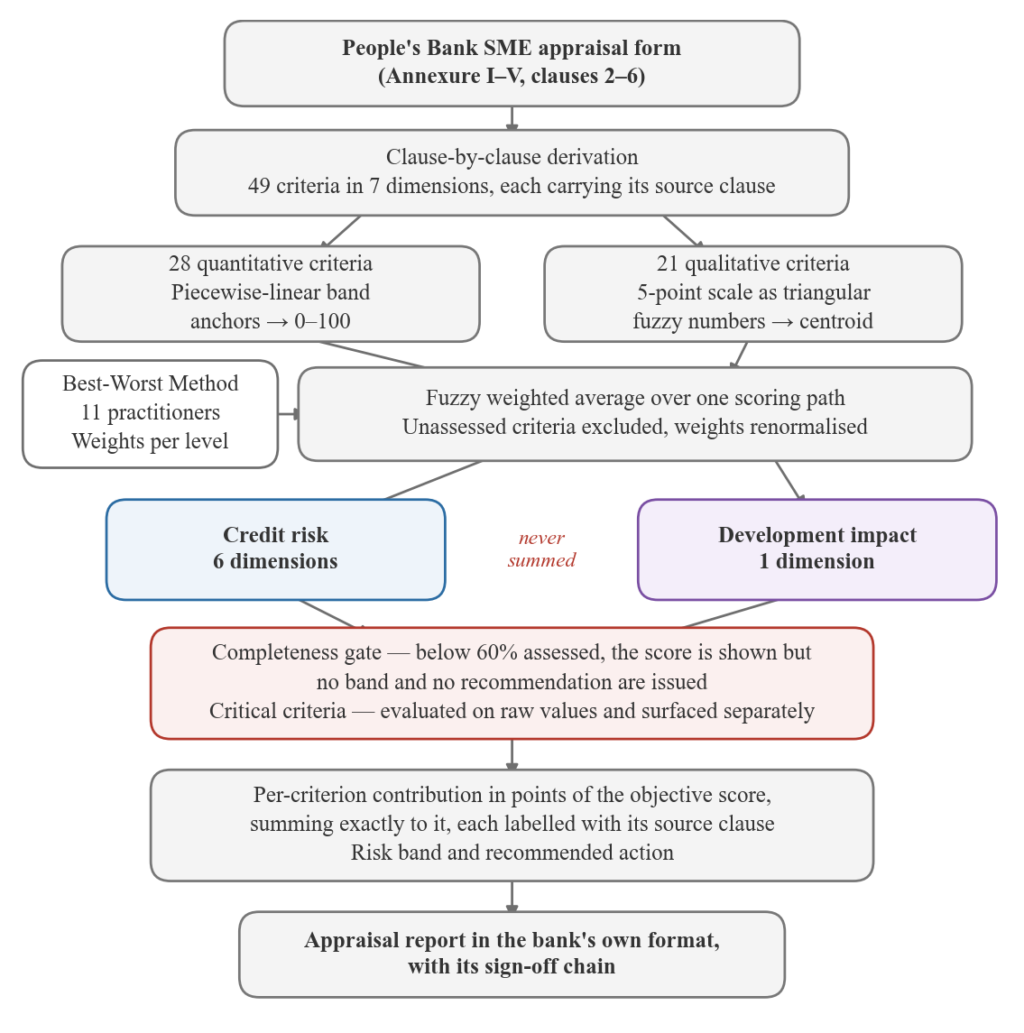
Figure 4.2: The model end to end. The bank's appraisal form is decomposed clause by clause into criteria; measured and judged inputs travel separate mappings into a single aggregation path governed by elicited weights; the two objectives are scored separately and never summed; and two gates stand between a score and a recommendation.
Three features of that diagram carry most of the design argument, and each is defended in its own section below. Quantitative and qualitative criteria are mapped differently but aggregated identically, so a judgement and a measurement can be combined without either being converted into the other (Section 4.11). The two objectives run in parallel to the end and are never added together, because a combined figure would conceal the disagreement between them (Section 5.2). And a score does not become a recommendation until it has passed the completeness gate, because weight renormalisation otherwise lets a nearly empty file produce a confident one (Section 5.3).

4.10 Formalising a narrative instrument

4.10.1 The source
The People's Bank Project / Business Appraisal Report for SME Credit Facility (Annexure I–V) is an operational form running to seven numbered sections plus five annexures. It is largely narrative. Clause 2.18 asks the officer to write comments on profitability, liquidity, activity and gearing. Clause 3.10.3 asks for a written assessment of five competitive forces. Clauses 3.11 and 3.12 ask for prose on technological and environmental risk. Clause 7 then asks the officer to certify that the project is "financially viable and technically feasible", with no stated procedure for combining any of the preceding material into that judgement.
This is the gap the artefact addresses. The form specifies what to consider exhaustively and how to weigh it not at all.

4.10.2 Method
Each clause of the form was examined and classified:
- Directly computable: the thirteen ratios of clause 2.17, the debt service cover, interest service cover (ISCR) and return on investment (ROI) series of clause 4, the cost-of-project structure of clause 3.7, the working capital computation of Annexure II. These become quantitative criteria with explicit thresholds.
- Judgement, but structured: clause 3.10.3 is already Porter's five forces; clause 5 is already a nine-item before/after table. These decompose naturally into criteria scored on a linguistic scale.
- Judgement, unstructured: management style (3.2), technological risk (3.11). These become single qualitative criteria.
- Administrative: addresses, registration numbers, signature blocks. These are captured by the system but carry no score.
The rule applied throughout: no criterion exists without a source clause. Every entry in the resulting model carries a ref field naming the clause it derives from. This constraint is what makes the model auditable, since any score can be traced to the institutional document that authorises it, and it prevents the common failure of a scoring model quietly acquiring criteria its users never agreed to.

4.11 Scoring method

4.11.1 Quantitative criteria
Each quantitative criterion carries a set of (raw value, score) anchors defining a piecewise-linear map onto 0–100. A DSCR of 0.8, for example, scores 0; 1.0 scores 25; 1.25 scores 50; 1.5 scores 75; and 2.0 scores 100. Values outside the anchor range clamp to the nearest endpoint.
Because interpolation simply follows the anchor sequence, a single implementation serves higher-is-better, lower-is-better and band-optimal criteria alike. Current ratio uses the third form: it peaks at 2.0 and declines above it, since a ratio of 8.0 signals idle working capital rather than strength.

4.11.2 Qualitative criteria
Qualitative criteria are captured on a five-point linguistic scale of Very Poor, Poor, Fair, Good and Excellent, represented as the triangular fuzzy numbers in Table 4.4.
Table 4.4: Five-point linguistic scale and its triangular fuzzy numbers
Code | Label | Triangular fuzzy number
VP | Very Poor | [0, 0, 25]
P | Poor | [0, 25, 50]
F | Fair | [25, 50, 75]
G | Good | [50, 75, 100]
E | Excellent | [75, 100, 100]

Figure 4.3 shows the scale as the officer meets it, in one dimension of a file part-way through entry. Both criterion types appear together: a quantitative one, where twelve years of sponsor experience maps to 85, and four qualitative ones on the five-point scale, where Good maps to 75. Two criteria are unassessed, and their scores read as a dash. The dimension scores 78.7 at 50% assessed, computed over what has been entered and not over what has not.

Figure 4.3: One dimension of an appraisal during entry. Each criterion carries the clause of the People's Bank form it derives from. Quantitative criteria take a value, qualitative criteria a point on the five-point scale, and unassessed criteria show a dash instead of a zero.
Fuzzy representation is used because appraisal judgements are linguistic and imprecise. An officer writing "management is sound" is not asserting 75.0; the triangular number carries that imprecision explicitly instead of discarding it.
Quantitative values enter as degenerate triangular fuzzy numbers (TFNs) of the form [x, x, x], so both criterion types flow through one aggregation path. Aggregation is the fuzzy weighted average; defuzzification is by centroid, which for a TFN reduces to the mean of its three points.

4.11.3 Missing criteria
A criterion left unassessed is excluded and the remaining weights renormalised, never treated as zero. Scoring an incomplete file as though the missing sections had scored nothing would misrepresent an unfinished appraisal as a bad one.
This choice creates a hazard addressed in Section 5.3.

4.11.4 Critical criteria
DSCR below 1.0 means projected cash flow does not cover debt service. Under most credit policies this is a knock-out, not a factor to be averaged.
The engine evaluates critical breaches against the raw value, not the derived score, and surfaces them as a separate list on the result. A weighted average cannot dilute them, and the interface displays them above the scores, not within them.

4.12 System architecture
Table 4.5 lists the technology used at each layer and the reason it was chosen. The pattern throughout is that the scoring engine runs where the officer is, so that a score changes as a figure is typed, while anything that must not be tampered with runs on the server.
Table 4.5: System architecture by layer, with the reason for each choice
Layer | Technology | Rationale
Interface | Next.js 16, React 19, TypeScript, Tailwind 4 | Engine runs client-side for live scoring
Persistence | Prisma 7, SQLite | No external services; one config change to PostgreSQL
Analysis | Python, pandas, scikit-learn, SciPy | No TypeScript equivalent for the empirical work
Model | A single machine-readable criteria file | Single source of truth for both stacks

The two stacks never communicate at runtime. The Python pipeline calibrates and validates, exporting weights as JSON; the web application consumes that JSON. The handoff is one-directional and inspectable.
The scoring engine is implemented twice, TypeScript for the product and Python for the analysis, which is a deliberate risk. Divergence between them would mean the thesis reporting numbers from one implementation while demonstrating a system running the other. Both read the same criteria file, and the arithmetic is verified against shared expectations.

4.12.1 Reproducibility of stored appraisals
An appraisal stores its inputs, its complete result document, and the model version that produced it, not merely a score column.
The criteria tree changes over time: elicitation replaced the placeholder weights, and bands may be revised. Without versioned storage, every historical recommendation would silently re-interpret under the current model, and an appraisal signed in March could not be explained in September. Storing the result document makes past decisions permanently reconstructible.

4.12.2 Deployment
The system was deployed to a public URL on the Vercel platform, with the SQLite development database replaced by a managed PostgreSQL instance. Nothing in the application changed: the persistence layer selects its driver from the connection string, so the same build runs against either.
Deployment was not a presentation exercise. The elicitation instrument had to reach practitioners who would complete it on a phone, in their own time, from a link in a message, and who would not install anything or create an account to do so. Section 6.1 reports ten completed responses; a locally-hosted instrument would have obtained none of them. The deployment is therefore part of the method, and it is what made the answer to RQ2 possible.
Two consequences follow for the artefact. First, the serverless execution model means a request may reach a process that has just started, so the connection pool is kept small and connections are retired quickly. Second, the platform's filesystem does not persist between invocations, which is why the file-backed database that serves local demonstration cannot serve the deployment, and why the driver is selected rather than assumed.

4.13 Access control and the integrity of the audit trail
An audit trail is only worth as much as the identity behind each entry.
An earlier iteration of the sign-off panel accepted a typed name. It recorded who claimed to have signed, which is no record at all: anyone could enter any name, and the trail would look complete while proving nothing. The system now authenticates users and takes the signatory from the session.
Roles map directly onto the sign-off chain in clause 7 of the form, as Table 4.6 sets out.
Table 4.6: Application roles and permitted actions, against clause 7 of the form
Role | Permitted
Officer | prepare an appraisal
Recommender | endorse
Head office | approve or decline
Administrator | all of the above, plus user administration

Three properties are enforced rather than merely displayed. The interface offers only the actions a user's role permits; the server re-checks the role before writing, so the restriction cannot be bypassed by calling the action directly; and an appraisal that has been approved or declined rejects further decisions; a correction is made by raising a new appraisal, never by rewriting a signed one.
Figure 4.4 shows the sign-in screen. It states on its face that the weighting study needs no account, so a practitioner who follows the study link and lands here by accident is not left thinking they must register to take part.
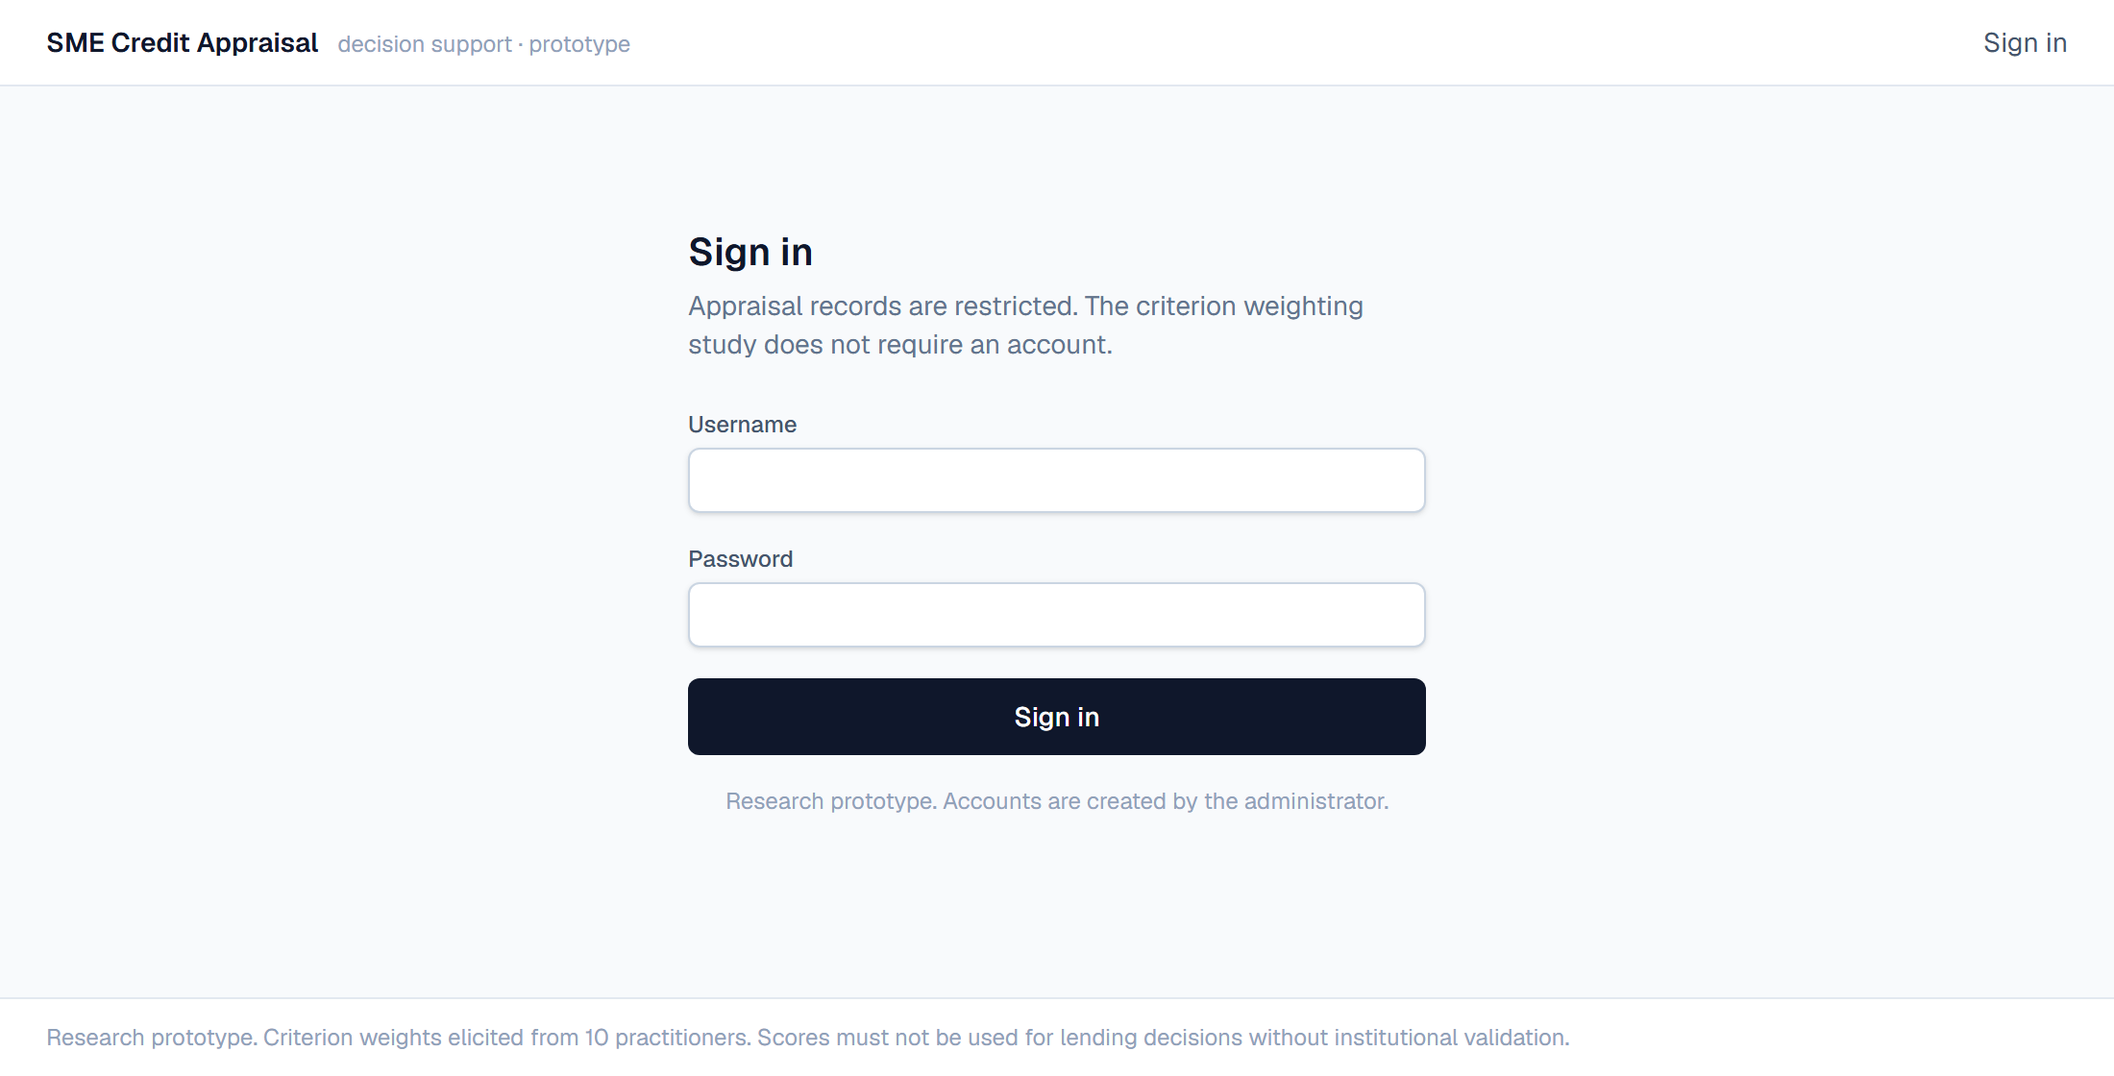
Figure 4.4: The sign-in screen. Appraisal records are restricted; the screen states that the criterion weighting study is not, so a practitioner arriving by mistake is told immediately that no account is needed.
The elicitation instrument is deliberately left public. Requiring accounts of practitioners completing a fifteen-minute voluntary study would collapse the response rate, and the instrument collects no name and no customer data, so there is nothing behind it to protect. The research instrument and the operational system have different threat models and are treated differently.

4.13.1 What this is not
Session cookies are HMAC-signed and passwords are hashed with scrypt, with no external authentication dependency, so the system runs without network access for demonstration purposes. It is not a production authentication system: there is no password reset, no multi-factor authentication, no account lockout, no rate limiting on sign-in attempts, and no password policy. A banking deployment would require all of these, along with penetration testing and an accessibility audit. These are recorded as limitations, not presented as complete.

5 RESULTS

5.1 The derived criteria model
The derivation produced forty-nine criteria across seven dimensions and two objectives. Table 5.1 gives the count for each dimension together with the clauses of the form it derives from. Six of the seven dimensions belong to credit risk; the seventh carries the whole of the development-impact objective, an asymmetry inherited from the source document that Section 5.16.3 shows to have consequences for weighting.
Table 5.1: Criterion counts and source clauses by dimension
Objective | Dimension | Criteria | Form clauses
Credit Risk | Borrower & Management Capacity | 6 | 2.8, 2.10, 3.2, 3.4
 | Credit History & Banking Conduct | 5 | 2.11, 2.14
 | Historic Financial Performance | 9 | 2.13, 2.15–2.18
 | Project Viability & Projections | 8 | 3.1.3, 3.7, 4
 | Market & Competitive Position | 7 | 3.10
 | Risk, Security & Compliance | 6 | 3.3, 3.5, 3.6, 3.11, 3.12, 6.5
Development Impact | Economic & Social Contribution | 8 | 5, 3.4.1
Total | 7 dimensions | 49

Twenty-eight criteria are quantitative and twenty-one qualitative. The model is held in a single machine-readable file as the single source of truth, consumed by both the web application and the analysis pipeline.

5.2 The dual-objective structure

5.2.1 Rationale
Clause 5 of the form, Economic Consideration, scores nine before/after outcomes: manpower, women's participation, local raw material usage, productive capacity, production, export sales, import substitution, value added, and foreign exchange earnings. Clause 3.4.1 separately disaggregates employment by gender.
These are not credit risk. A project can employ many people, substitute imports and earn foreign exchange while still being a poor credit; the reverse also holds. People's Bank is a state bank with a development mandate, and its appraisal form reflects that it is being asked to serve two objectives at once.
Mainstream credit scoring optimises a single objective: the probability of repayment. Applying that framing here would mean discarding clause 5 entirely, deleting the developmental half of the institution's own mandate because it does not fit the model.

5.2.2 Design decision
The model therefore carries two objectives and reports them separately. They are never combined into a single number.
This is enforced in the engine, not left to convention: a result record holds an array of objective results, and no code path produces an overall score. The interface presents them side by side; the exported report presents them as distinct sections with an explicit note that the trade-off is a matter for the approving authority.
The reason is that a weighted combination would destroy the information the structure exists to expose. A facility scoring 80 on credit and 40 on development and one scoring 60 on both are materially different propositions, and a combined score of 60 would render them identical. Making the divergence visible is the contribution; resolving it is a policy question that belongs to the bank, not to the model.
Verification of this behaviour appears in the test case of Section 5.6: the same application scored 80.2 on credit risk (band A) and 74.6 on development impact (band B).

5.3 The completeness gate

5.3.1 A problem found by testing
During verification, an appraisal with only seven of forty-nine criteria entered, 14% complete, returned a credit risk score of 73.7 and the recommendation "Band B: recommend with conditions."
The arithmetic was correct. Weight renormalisation (Section 4.11.3) had worked exactly as designed: the seven entered criteria carried the full weight, and they happened to score well. But the system was confidently recommending a facility on almost no information, and nothing in the output signalled that.
This is a genuine hazard of renormalisation, and it is not specific to this implementation. A sparse appraisal produces a plausible score while its evidential basis collapses, and the score itself gives no indication of the difference.

5.3.2 Response
An objective assessed below a completeness threshold (0.6) returns its score but no risk band and no recommendation. The result carries a sufficient flag and a list of outstanding criteria, and the interface tells the officer what is missing instead of offering a number to sign against.
Figure 5.1 shows the gate holding. Credit risk stands at 78.7, which on a complete file would be a comfortable Band B, and the system declines to say so: 7% of the objective has been assessed against the 60% required. The number is still shown, because hiding it would be its own kind of dishonesty, but no band and no recommendation accompany it.
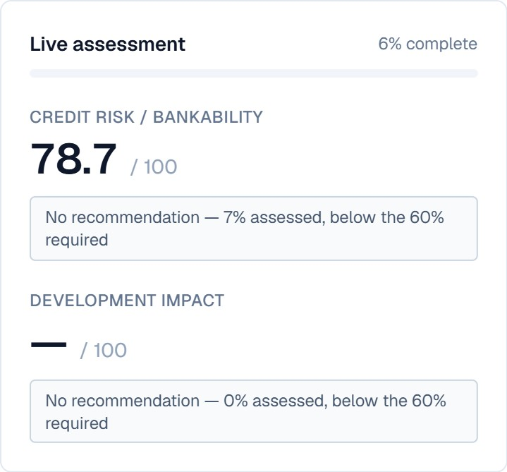
Figure 5.1: The completeness gate refusing to recommend. A credit-risk score of 78.7 is displayed, and withheld from banding, because only 7% of the objective has been assessed.
The gate is deliberately a refusal to answer, not a scoring adjustment. Discounting the score for incompleteness would have preserved the false impression that the system had an opinion. It does not; it has insufficient information, and saying so is the correct output.

5.4 Explainability
Each criterion's contribution is computed as its normalised weight times its score, expressed in points of the parent's score. Contributions sum exactly to the parent score, which is what makes the breakdown a decomposition rather than a decoration.
The interface presents, for each dimension: its score, its contribution to the objective, its completeness, and a table of constituent criteria showing raw value, derived score and contribution, each labelled with its source clause. An officer can therefore trace any recommendation from the headline score down to the clause of the bank's own form that produced it.
Figure 5.2 shows a completed appraisal. The two objectives are reported side by side and are never added together: the same facility scores 68.0 on credit risk, which bands B and carries a recommendation with conditions, and 26.0 on development impact, which bands D and carries a recommendation to decline. A single combined figure would have averaged those into a middling number that describes neither.
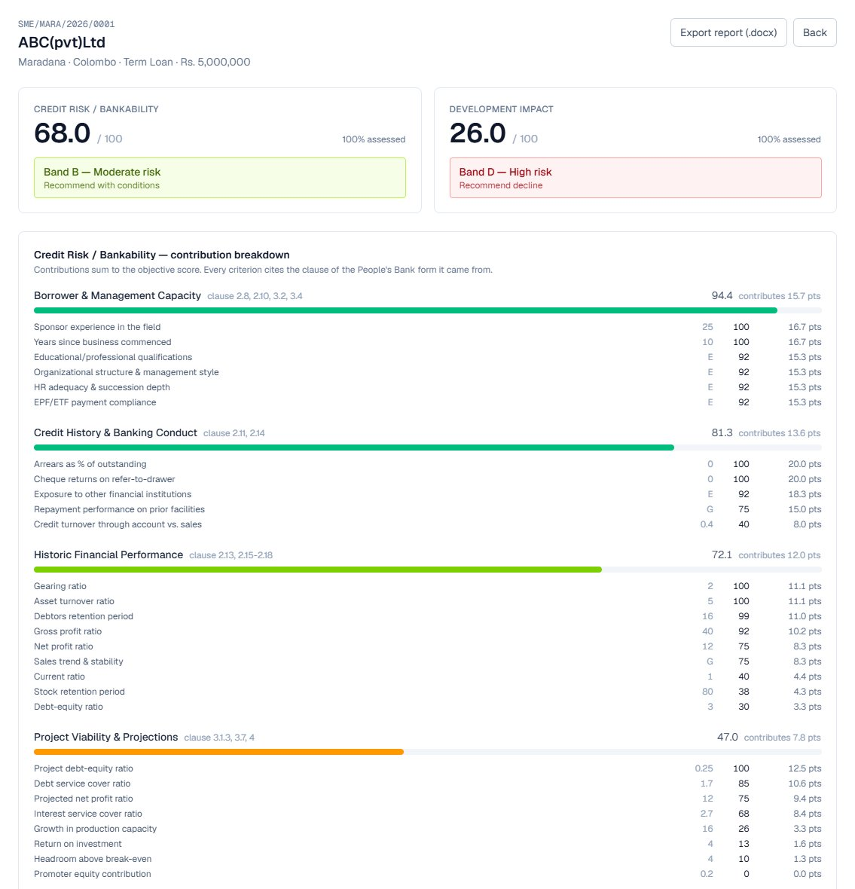
Figure 5.2: A completed appraisal. The two objectives are scored and banded separately and are never combined. Each dimension's contribution is expressed in points of the objective score, and each criterion shows its entered value, its derived score, its contribution and the clause it comes from.
Beneath the two objective scores, each dimension's contribution is given in points of the objective score, and every criterion shows the value entered, the score it mapped to, and the points it contributed. Borrower and management capacity scores 94.4 and contributes 15.7 points; project viability scores 47.0 and contributes 7.8. The contributions sum to the objective score exactly, so the breakdown accounts for the whole of it and not merely for the part that is convenient to explain.

5.5 Report generation
The system exports a completed appraisal as a Word document in the People's Bank format: Annexure I heading, clause-numbered sections, the scoring evidence, and the clause 7 signature blocks.
This closes the loop. The officer receives back the document the institution already uses, with no retyping and no change to the existing approval chain. A system that produced its own report format would require the bank to adopt new paperwork alongside new software; producing the incumbent document removes that barrier entirely.

5.6 Verification
The engine carries a structural test suite covering three cases: a sound manufacturing expansion, a thin startup with a DSCR breach, and a deliberately incomplete file. Table 5.2 lists the properties asserted and the result of each.
The suite covers the scoring engine, the validation schemas and the authorisation logic, 62 tests in total. Server Actions are reachable by direct POST, not only through the application's own forms, so every action validates its input before use, and validation failures report which field failed without echoing the submitted value back.
Table 5.2: Behavioural tests of the scoring engine and their outcomes
Check | Result
Strong case scores above weak on credit risk | pass
Strong case scores above weak on development impact | pass
Weak case flags a critical breach (DSCR 0.92) | pass
Strong case flags no breach | pass
Strong case reaches band A or B | pass
Weak case falls to band C or D | pass
Objectives reported separately, not merged | pass
Contributions sum to parent score | pass
Weight status correctly reflects the elicitation state | pass

The system was additionally verified end to end through the browser: all 49 criteria entered through the interface, producing credit risk 80.2 (band A) against development impact 74.6 (band B), persisted to the database, rendered with full contribution breakdown, and exported to a valid Word in bank format.
These are structural checks. They establish that the engine behaves as specified, not that its scores are accurate. Accuracy is the subject of Chapter 5, and the answer given there is heavily qualified.

5.7 Status of the weights
The model now carries an elicited state, recording eleven respondents, three level-responses excluded for inconsistency, and the date. Section 6.1 reports the elicitation; the weights themselves are in Section 6.1.4.
The state is machine-enforced rather than merely documented, and that mattered. While elicitation was outstanding the model carried the placeholder state, all criteria equally weighted within their level. The synchronisation script warned on every run, the interface displayed a standing notice, and the weight-derivation pipeline refused to mark the model elicited without usable responses. A claim check also fails the build if any chapter still describes the weights as placeholders once the model says otherwise, which is how the stale passages in this chapter were caught when elicitation completed.
The design principle is worth stating separately from this instance: a placeholder that is only described in prose will outlive the condition it describes, because nothing breaks when the condition changes.

5.8 Empirical evaluation: purpose and scope
The preceding sections presented a criteria tree of 49 criteria derived from the People's Bank Project / Business Appraisal Report for SME Credit Facility, and a scoring method that maps appraisal inputs onto two separate objectives. The rest of this chapter asks what can and cannot be established about that model from data.
The scope must be stated precisely, because the answer is narrower than the question a reader might expect.
The criteria tree is instrument-specific. It scores debt service cover, the competitive forces bearing on the applicant's market, management quality, environmental risk, and nine development outcomes. No public dataset contains those variables. Access to People's Bank's own historical files was not available within this study, and would in any case be confidential.
The validation is therefore split three ways, and Table 5.3 keeps the three claims separate: what is being validated, the evidence available for it, and where that evidence is reported.
Table 5.3: The three validation claims and the evidence available for each
Component | Evidence | Reported in
Scoring method (band mapping, weighted aggregation, defuzzification) | Real default outcomes, SBA National | Sections 5.10 to 5.12
Criterion weights | Expert elicitation, Best-Worst Method | Chapter 6
Full 49-criterion tree | Design contribution; not empirically validated | Section 5.20

The distinction matters. A claim that "the model was validated" would be false. What is validated here is the scoring machinery, on a proxy dataset, for the observable subset of criteria.
One point about how this chapter is written. Results are conventionally presented without interpretation, with the reading of them deferred to the discussion. The findings here form a chain, in which each experiment exists because the one before it ruled something out, and presenting them as a bare sequence of tables would leave the reader unable to follow why any of them was run. This chapter therefore carries the reasoning needed to make the next experiment intelligible, and no more. Every claim about what the findings mean for practice, for the literature and for the artefact is held back to Chapter 6.

5.9 Dataset
The SBA National dataset [33] records 899,164 loan guarantees issued by the U.S. Small Business Administration between 1987 and 2014, with realised outcomes in MIS_Status (P I F = paid in full, CHGOFF = charged off). It is the largest public dataset of small-business lending with ground truth, and is widely used in credit-scoring research and teaching.
After removing 1,997 records with no usable outcome, 897,167 remain, with an overall default rate of 17.56%.

5.9.1 Outcome-derived fields
Three fields are populated only after a loan has defaulted: ChgOffPrinGr (charged-off principal), ChgOffDate, and BalanceGross. A model given any of them reads the answer instead of predicting it. They are dropped in the data preparation step, and their absence is asserted before the prepared file is written.

5.9.2 Right-censoring
A loan approved in 2013 on a fifteen-year term cannot have defaulted by the 2014 data cut-off. Such loans appear to perform well only because insufficient time has elapsed.
Restricting to the 1990–2010 approval window of 847,980 loans and separating those whose full term elapsed before the cut-off gives the rates in Table 5.4.
Table 5.4: Default rate by censoring status, 1990-2010 approvals
Cohort | n | Default rate
Censored (term not yet elapsed) | 195,696 | 7.77%
Fully matured | 652,284 | 20.41%

The difference is large enough to dominate any model permitted to infer censoring status. All analysis below uses the 652,284 fully-matured loans. This biases the sample toward shorter terms in later years, which is noted as a limitation in Section 5.20.

5.10 A contaminated predictor

5.10.1 How the problem surfaced
Initial benchmarking produced a gradient-boosting AUC of 0.9726 under random splitting and 0.9461 under temporal splitting. Credit-scoring models on small-business data do not ordinarily discriminate this well. The result was treated as a symptom rather than an achievement.
Permutation importance showed the model to be, in substance, a function of a single variable: shuffling term in years cost 0.395 AUC, while no other feature cost more than 0.008. Yet Term as a monotone predictor reaches only 0.82. The discrimination was coming from a non-monotone structure in the variable.

5.10.2 The structure
Table 5.5 gives the default rate at each exact term value for 2007 approvals, which is where the shape of the relationship becomes visible.
Table 5.5: Default rate by exact term in months, 2007 approvals
Term (months) | n | Default rate
58 | 634 | 92.1%
59 | 663 | 86.7%
60 | 5,040 | 11.1%
61 | 641 | 92.2%
62 | 609 | 90.1%
63 | 674 | 81.0%
64 | 596 | 88.1%

A one-month difference in contractual term cannot produce an eight-fold change in default rate. Sixty months is not economically distinct from fifty-nine. Figure 5.3 plots the same relationship across the full range of terms, and the alternation is regular rather than noisy.
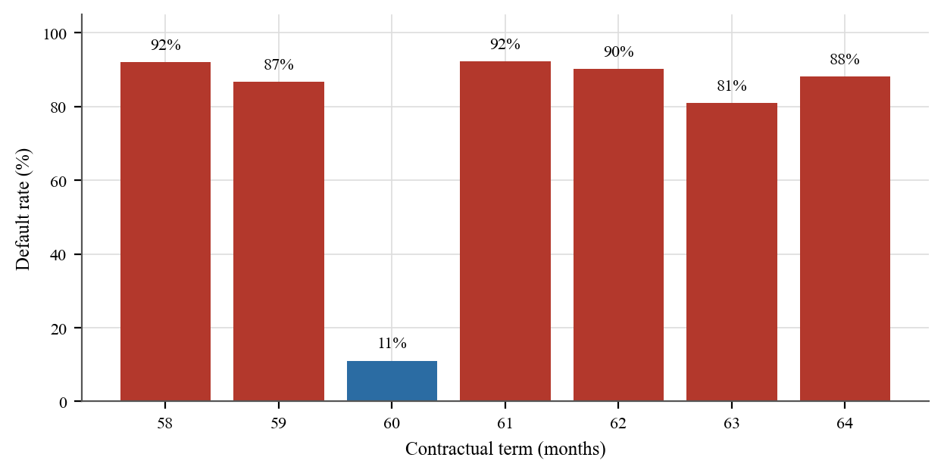
Figure 5.3: Default rate by exact contractual term, 2007 approvals. Terms that are multiples of twelve are shown in blue.
Only the sixty-month bar falls below 80%, and it is the only term in the range that is a multiple of twelve. The pattern is roundness. Across the 1990–2010 cohort:
- 86.4% of repaid loans have a term that is an exact multiple of twelve
- 8.5% of charged-off loans do
- Charged-off loans are distributed almost uniformly across Term mod 12 (7.7%–9.0% in each of the twelve residues, against 86.4% at residue zero for repaid loans)
The single boolean "is the term a multiple of twelve", a quantity with no economic content whatsoever, achieves AUC 0.8894. Figure 5.4 shows the distribution behind that figure: repaid facilities pile up at residue zero while charged-off facilities spread almost uniformly across the twelve residues.
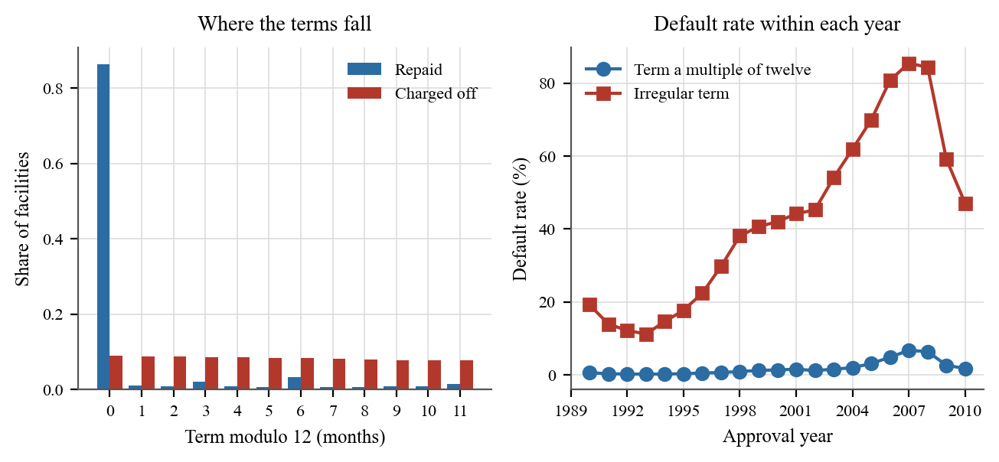
Figure 5.4: Left: the share of facilities at each value of Term modulo twelve, separately for those repaid and those charged off. Right: default rate within each approval year, for facilities whose term is a multiple of twelve and for the rest.
The two panels say different things about the same field. The left shows where the terms sit: repaid facilities are concentrated almost entirely at residue zero, while charged-off facilities are spread across all twelve residues at between 7.7% and 9.0% each. The right shows that the gap between the two groups is present in every approval year, and widens as the overall default rate climbs after 2003.

5.10.3 Ruling out cohort composition
Irregular-term loans became more common over the period, and so did defaults, so the association might be an artefact of pooling cohorts. It is not. Table 5.6 computes the association within each approval year separately.
Table 5.6: Default rate and roundness AUC within each approval year
Year | n | Default, round term | Default, irregular term | AUC
1990 | 14,859 | 0.6% | 19.2% | 0.859
1993 | 23,299 | 0.2% | 11.2% | 0.885
1997 | 37,718 | 0.6% | 29.8% | 0.888
2000 | 37,352 | 1.4% | 42.0% | 0.874
2003 | 58,000 | 1.6% | 54.1% | 0.893
2006 | 75,756 | 4.9% | 80.8% | 0.900
2007 | 71,649 | 6.7% | 85.5% | 0.899
2008 | 39,458 | 6.4% | 84.4% | 0.898

The association holds in every year, within a band of 0.859–0.900, and Figure 5.5 plots that year-by-year discrimination. Cohort composition is excluded.
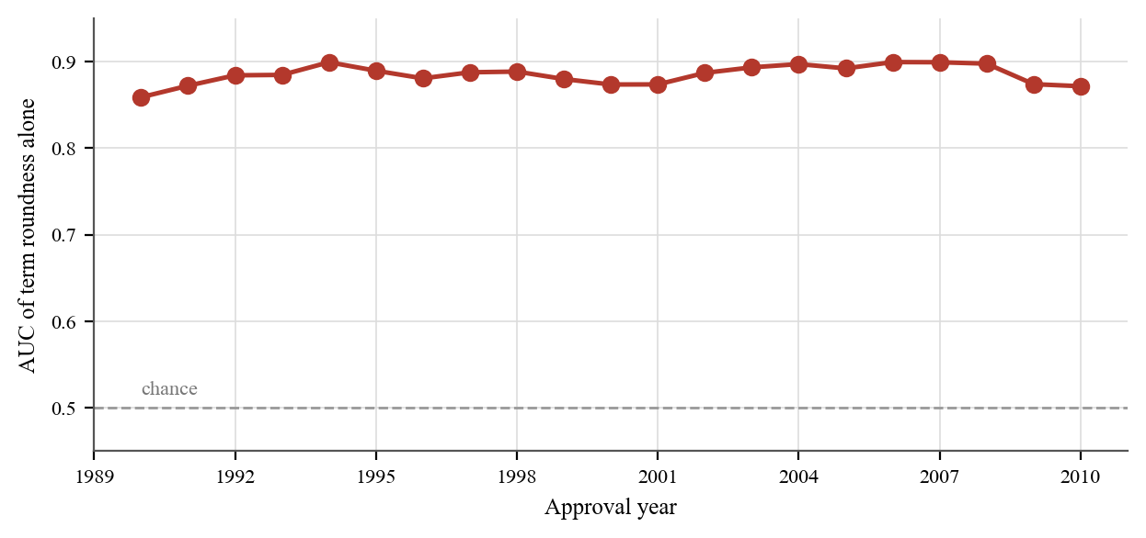
Figure 5.5: Discrimination achieved by the term-roundness boolean alone, computed separately within each approval year.
Discrimination stays between 0.8589 and 0.8995 across the whole twenty-one year period. A variable that is genuinely a cohort artefact would not hold a band that narrow across two recessions and a doubling of the default rate.

5.10.4 The mechanism is not established
The obvious explanation is that Term for defaulted loans has been overwritten with elapsed time to charge-off. This was tested and rejected. Among 156,266 charged-off loans with both disbursement and charge-off dates:
- correlation between Term and actual months to charge-off: 0.043
- proportion matching within ±3 months: 5.0%
Term is not survival time. That left three possibilities: the value is rewritten on restructuring, recomputed under some servicing convention, or introduced when this derivative file was assembled. The third would make the finding uninteresting, a packaging error in one upload rather than a property of the data, and Section 5.10.5 rules it out.
The dataset codebook documents Term as "loan term in months", the contractual term. The observed distribution is not consistent with that definition for charged-off loans. The contamination is established; the choice between the remaining two explanations is not. This study reports it accordingly and does not assert a mechanism it has not demonstrated.

5.10.5 The artefact is in the SBA's own records
The derivation hypothesis can be tested without contacting anyone. The SBA publishes loan-level extracts of the same programme under the Freedom of Information Act (FOIA), refreshed quarterly; the release used here is current to 30 June 2026. If the pattern appears there, the derivative did not create it.
It appears there. Table 5.7 compares the two files across the 603,665 resolved 7(a) facilities approved between fiscal years (FY) 2000 and 2009.
Table 5.7: Term roundness, SBA FOIA 7(a) against SBA National
 | SBA FOIA 7(a) | SBA National (derivative)
Repaid, term a multiple of twelve | 82.02% | 86.4%
Charged off, multiple of twelve | 8.46% | 8.5%
AUC of the roundness boolean | 0.8678 | 0.8894

and it holds in every approval year, between 0.8562 and 0.8808. The contamination is not an artefact of the derivative file. It is present in the authoritative publication, which removes one of the three candidate explanations and moves the finding from a problem with one dataset to a property of the records themselves.
Nor is it historical. The same release covers FY2010–FY2019, a decade lying entirely outside the derivative's coverage and now old enough to have resolved. Across 428,652 resolved facilities there the boolean reaches AUC 0.8815, with repaid facilities 86.44% round-termed against 10.15% for charge-offs, and every approval year falls between 0.8587 and 0.8904.
Taken together the two extracts span 1,032,317 resolved facilities across twenty consecutive approval years, FY2000 to FY2019, with the probe never leaving the range 0.8562 to 0.8904. This is not a defect in an old teaching file. It is a live property of loan data the SBA published in June 2026, and anyone building a model on the current release is exposed to it exactly as anyone using the 2014 derivative was.
This is not an independent replication and is not claimed as one. The SBA National dataset is itself built from SBA FOIA releases, so these are the same underlying loans at a different vintage, not a second source. What the comparison settles is where the artefact originates, not whether it recurs elsewhere.
The same release supplies a control. The 504 programme is a different facility type under the same agency, released in the same extract, and its terms are fixed by programme design: 95.5% are written at exactly 240 months. There the boolean discriminates at AUC 0.4997, indistinguishable from chance, and charged-off facilities are marginally more round-termed (99.85%) than repaid ones (99.80%).
That contrast is informative. In a programme where the term is set by the programme and effectively never varies, charged-off records retain their round terms. In 7(a), where the term is negotiated facility by facility, charged-off records overwhelmingly do not. Whatever produces the pattern acts on 7(a) records and not on 504 records, which is consistent with a servicing or restructuring process that touches the term field, and inconsistent with anything applied uniformly across the agency's data. It narrows the mechanism; it does not establish it, and the distinction is maintained here.

5.10.6 Is twelve doing the work?
The finding rests on one boolean, so the obvious challenge is whether twelve matters at all. If "multiple of two" or "multiple of five" discriminated equally well, this would not be about round contractual terms and the interpretation above would be wrong.
Twenty moduli were tested on the 651,501 matured facilities with a positive term. The strata overlap by construction — every multiple of twelve is also a multiple of six, four, three and two — so raw discrimination is reported alongside residual discrimination computed within the multiples of twelve and within the non-multiples separately, which strips out whatever a modulus inherits from twelve. Table 5.8 reports both for every modulus from two to twelve.
Table 5.8: Share of terms divisible by each modulus, with the resulting AUC
Modulus | Share divisible | Raw AUC
12 | 70.07% | 0.8859
6 | 74.39% | 0.8600
4 | 74.74% | 0.8109
3 | 80.24% | 0.7934
2 | 84.04% | 0.7125
7 | 34.90% | 0.6291
5 | 33.24% | 0.5856
13 | 2.23% | 0.4699
11 | 2.91% | 0.4660

Twelve is the strongest, and the ordering of its divisors (12 > 6 > 4 > 3 > 2) is exactly the dilution pattern expected if multiples of twelve are the carrier: each coarser modulus admits more non-annual terms and loses discrimination in proportion. The moduli that do not divide twelve behave quite differently. Eleven and thirteen sit at or below chance, at 0.4660 and 0.4699. It is not the case that any modulus would do.
One qualification, and it refines rather than threatens the finding. Within the facilities that are not multiples of twelve, "multiple of three" still reaches 0.5888 and "multiple of six" 0.5684. Some signal therefore attaches to quarter- and half-year terms independently of whole years. The pattern is roundness on a calendar grid, not annual roundness alone, which is if anything the more natural reading of a contractual convention.
(The 0.8859 here and the 0.8894 in Section 5.10.2 differ because this probe additionally excludes facilities with a term of zero. Both are produced by the same analysis.)

5.10.7 The contamination reaches the dataset's own documentation
Li, Mickel and Taylor [33], the paper that documents this dataset, derive a feature from Term themselves. They define a dummy RealEstate, set to 1 where Term ≥ 240 months, reasoning that only real-estate-backed loans run twenty years or more, and report those loans defaulting at 1.64% against 21.16% for the rest. The 1990–2010 cohort used here reproduces that closely: 1.45% against 20.69%.
If Term carries outcome information, a feature derived from it does too. Two explanations were tested.
Right-censoring: tested and rejected. A twenty-year loan approved after 1994 cannot mature before the 2014 cut-off, and indeed 87.6% of these facilities are censored. But restricting to the ones that did mature lowers their default rate, to 0.56%, against 1.57% for the censored. Censoring does not explain the contrast, and the hypothesis is recorded as refuted rather than dropped.
Roundness: the dominant factor, but not a simple confound. Term ≥ 240 requires a value at or above a multiple of twelve, and the group is 95.96% round-termed against 69.27% for the rest. Stratifying by roundness does not reduce the contrast so much as split it in two: among matured facilities the gap is 20.40 points unstratified, 2.51 points within round terms, and 50.32 points within irregular ones.
What actually dominates is roundness itself. Among matured facilities under 240 months, round terms default at 2.58% and irregular terms at 62.39%. The documented RealEstate contrast is largely a restatement of that, and the separation surviving inside the irregular stratum is real and unexplained here.
The point is not that Li, Mickel and Taylor made an error. Their paper documents a teaching dataset and derives a feature on entirely reasonable economic reasoning. The point is that a field carrying outcome information contaminates whatever is built from it, including the dataset's own documentation, and that nothing in the published description of either would let a reader detect it.

5.11 Consequences for reported performance
Two model specifications were run. The clean specification excludes Term and every feature derived from it; the contaminated specification adds them back, solely to quantify the inflation.
AUCs are reported with 95% stratified bootstrap confidence intervals (300 replicates, positives and negatives resampled separately so the interval reflects uncertainty in discrimination rather than in prevalence). Table 5.9 reports all four model-by-protocol combinations.
Table 5.9: Discrimination under random and temporal validation, with intervals
Model | Fitted | Random AUC [95% confidence interval] | Temporal AUC [95% CI]
Clean specification
Expert scorecard | no | 0.4144 [0.4111, 0.4175] | 0.5275 [0.5252, 0.5296]
Logistic regression | yes | 0.6745 [0.6722, 0.6774] | 0.4565 [0.4545, 0.4586]
Gradient boosting | yes | 0.7898 [0.7877, 0.7926] | 0.6076 [0.6053, 0.6097]
Contaminated specification
Logistic regression | yes | 0.8452 [0.8433, 0.8472] | 0.7854 [0.7839, 0.7869]
Gradient boosting | yes | 0.9726 [0.9718, 0.9732] | 0.9461 [0.9453, 0.9469]
Term-roundness probe | no | 0.8870 | 0.8965

The intervals do not overlap. Gradient boosting under the clean specification tops out at 0.7926 on a random split; the contaminated specification starts at 0.9718. On temporal validation the gap is wider still: [0.6053, 0.6097] against [0.9453, 0.9469]. With 195,000–275,000 test cases the estimates are precise enough that the leakage effect cannot be attributed to sampling variation.
Paired DeLong tests confirm this formally. Because the models are compared on identical cases, the paired test is the correct one; treating the AUCs as independent would overstate the uncertainty. Table 5.10 gives each comparison.
Table 5.10: Paired DeLong tests of the leakage and protocol effects
Comparison | Protocol | AUCs | p
Leakage effect, gradient boosting | random | 0.7898 vs 0.9726 | < 0.001
Leakage effect, gradient boosting | temporal | 0.6076 vs 0.9461 | < 0.001
Leakage effect, logistic regression | random | 0.6745 vs 0.8452 | < 0.001
Leakage effect, logistic regression | temporal | 0.4565 vs 0.7854 | < 0.001
Gradient boosting vs logistic, clean | both | — | < 0.001

Each row compares two models or two protocols on the same facilities, so the p-values are those of a paired test. Three observations follow.
The inflation is severe. Gradient boosting rises from 0.6076 to 0.9461 on temporal validation, 0.339 AUC obtained from a contaminated field.
The probe bounds the artefact. A single boolean with no economic meaning reaches 0.8870 and 0.8965. Any model on this dataset scoring in that region, having been given Term, is largely reproducing the artefact.
Tree models are more exposed than linear ones. Logistic regression, monotone in term, gains 0.33 AUC from contamination; gradient boosting, free to split on exact values, gains more and reaches further. Published results on this dataset using tree ensembles with the Term field should be read with this in mind. Figure 5.6 sets the four values side by side against the level the roundness boolean reaches on its own.
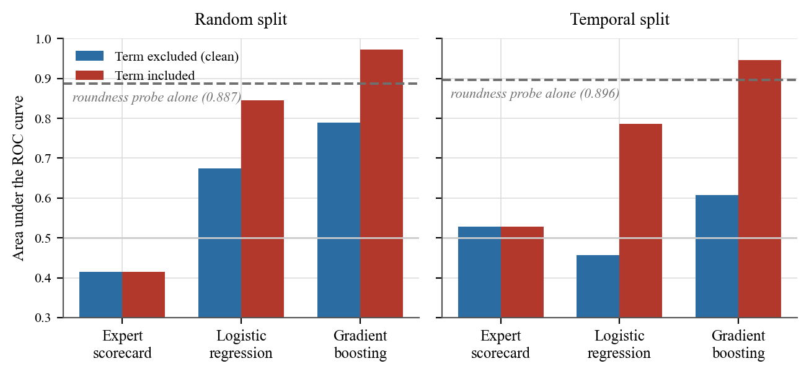
Figure 5.6: Discrimination with and without the Term field, under both validation protocols. The dashed line marks the level the roundness boolean reaches on its own.
The dashed line in each panel marks what the roundness boolean reaches on its own: 0.887 under random splitting and 0.8965 under temporal splitting. Under temporal validation every trained model sits below that line when the field is excluded and well above it when it is included, which places the gain in the field and not in the model that consumes it.

5.12 Validation protocol matters independently
Under the clean specification, gradient boosting scores 0.7898 on a random split and 0.6076 on a temporal split, a gap of 0.182 AUC. Random splitting places loans from the same economic cycle in both training and test sets, so the model is partly recalling conditions instead of generalising to unseen ones.
Logistic regression falls to 0.4565 temporally, below chance. Trained on 1990–2003 (9.1% default) and tested on 2004–2010 (35.9% default), the linear model does not merely lose accuracy; its ranking inverts. This is a substantive finding about credit-scoring practice: a linear scorecard fitted to a benign cycle can rank borrowers backwards in a stressed one.

5.13 Calibration: ranking is not the same as being right
AUC measures whether a model orders borrowers correctly. It says nothing about whether a predicted probability means what it says. A bank pricing risk, setting provisions, or reporting expected loss needs the second property, and a model can have the first without it.
Calibration is reported here as the Brier score [39] under Murphy's decomposition [40], Brier = reliability − resolution + uncertainty, where reliability measures how far predicted probabilities sit from observed rates (lower is better; zero is perfect) and resolution measures how far the model separates cases from the base rate (higher is better). Table 5.11 gives the decomposition for both models under both protocols.
Table 5.11: Brier score decomposed into reliability and resolution
Model | Protocol | Brier | Reliability | Resolution
Gradient boosting (clean) | random | 0.1319 | 0.00005 | 0.03003
Logistic regression (clean) | random | 0.1539 | 0.00091 | 0.00838
Gradient boosting (clean) | temporal | 0.2592 | 0.03705 | 0.00729
Logistic regression (clean) | temporal | 0.2882 | 0.05803 | 0.00121

Reliability degrades by roughly 700× for gradient boosting, from 0.00005 to 0.03705, and by 64× for logistic regression. Under random splitting the boosted model is almost perfectly calibrated: its reliability diagram sits on the diagonal. Under temporal validation the entire curve lifts above the diagonal, meaning the model systematically under-predicts default. At a predicted probability of 0.2 the observed default rate is approximately 0.45.
The mechanism is straightforward. The model is trained on 1990–2003 approvals defaulting at 9.1% and tested on 2004–2010 approvals defaulting at 35.9%. It has learned the base rate of a benign period and carries it into a stressed one. Figure 5.7 shows this directly: under temporal validation the curve lifts away from the diagonal, in the direction of under-prediction.
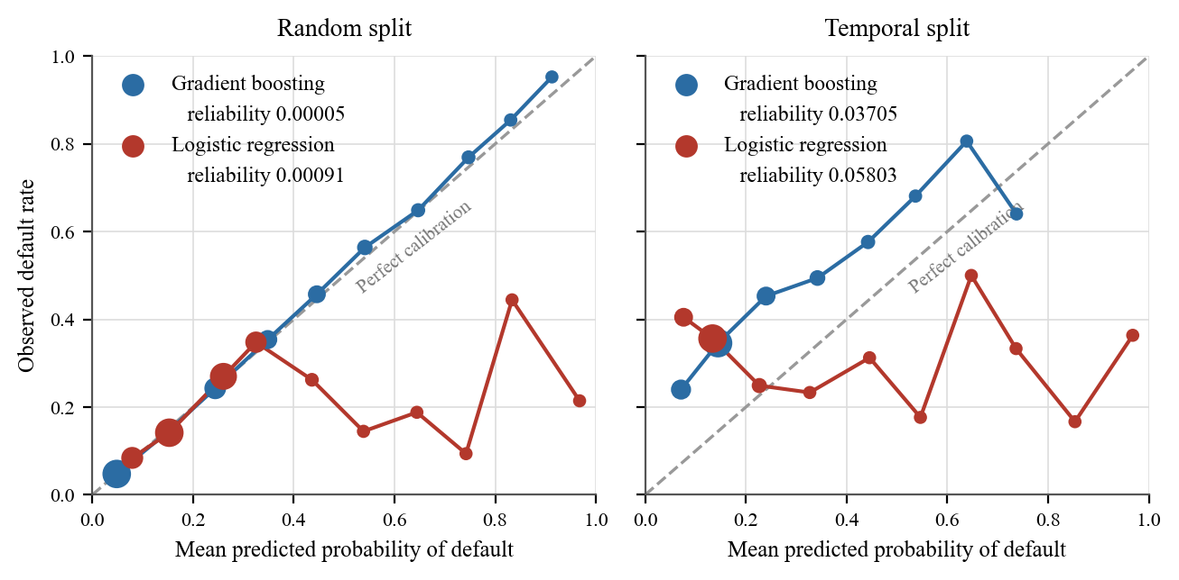
Figure 5.7: Reliability diagrams under random and temporal validation. Marker area is proportional to the number of facilities in each bin. Under temporal validation the curve lifts above the diagonal, indicating systematic under-prediction of default.
The shape is the finding. Under random splitting the gradient-boosting curve follows the diagonal closely, so a predicted 40% means an observed 40%. Under temporal splitting the same curve sits above the diagonal across the whole range: at every level of predicted risk, more facilities defaulted than the model said would.

5.13.1 Why this matters more than the AUC result
For a lender this is the more consequential finding. A model whose discrimination falls is visibly worse and invites scrutiny. A model that still ranks tolerably but prices a 45% risk as 20% produces provisions that are less than half what they should be, and does so while appearing to work.
Given Sri Lanka's recent macroeconomic volatility, the implication is direct: a scorecard calibrated on pre-crisis SME lending should not be assumed to carry its probability estimates into a stressed period. Recalibration on recent outcomes is a separate requirement from revalidation of discrimination, and the two are frequently conflated.
A caveat on scope. This concerns the trained benchmark models, not the criteria model this study proposes. The proposed model produces an ordinal band rather than a probability, and is therefore not calibrated in this sense at all, which is itself a limitation (Section 5.20) and the reason it must never be used to price a facility.

5.14 What the models are worth to a lender
AUC weights both error types equally; a lender does not. Approving a facility that charges off costs the loss given default; declining a sound one costs the margin forgone. The ratio between them determines where the cut-off belongs.
Expected cost is reported in units of one false positive, so a cost ratio of 10:1 means one bad approval costs as much as ten good declines. The ratio is swept, not assumed, because the right value is a policy question for the lender.
Two fixed policies provide the floor: approve everything, or decline everything. Table 5.12 reports the expected cost per application at a 10:1 ratio against the better of those two.
Table 5.12: Expected cost per application at a 10:1 loss ratio
Temporal split, 10:1 | Expected cost | vs best fixed policy
"Decline all" baseline | 0.6411 | —
Gradient boosting | 0.6455 | −0.7%
Logistic regression | 0.6475 | −1.0%
Expert scorecard | 0.6413 | −0.0%

Under temporal validation, 12 of 15 model/cost-ratio combinations fail to beat the better fixed policy. At the discrimination levels the clean specification achieves, AUC 0.6076 against a 35.9% default rate, none of these models earns its place economically on that cohort. Under random splitting, where discrimination is higher, the picture improves: gradient boosting saves 10.2% at a 2:1 ratio.
An important caveat. "Decline all" is a floor for comparison, not a strategy. A bank that declines every application has no business, so this is not a claim that lenders should stop lending. It is a claim that a model must clear a low bar before it is worth the process it adds, and on the stressed cohort these models do not clear it.
The finding is consistent with everything else in this chapter and is reported without softening.

5.15 The expert scorecard: a negative result
The a priori scorecard, whose bands were set from credit reasoning before any outcome was inspected, achieved AUC 0.4144 (random) and 0.5275 (temporal), at or below chance. It provides no reliable discrimination on this dataset.
This is reported as it stands. Three readings are available, and the evidence does not distinguish between the first two:
1. The proxies are inadequate. The scorecard was built from SBA-observable variables — guarantee share, franchise status, urban/rural — because the People's Bank criteria are absent. These are not what the appraisal form scores. The strongest legitimate criteria in the tree (DSCR, ISCR, security cover, management quality, market position) have no counterpart here.
2. The a priori bands are wrong. Domain reasoning about which direction each proxy should point may simply be mistaken. With the scorecard's individual features carrying univariate AUC between 0.51 and 0.63, an equal-weighted aggregate of several mis-signed weak proxies can land below chance.
3. The method itself does not work: not supported, since the same machinery discriminates when given informative inputs, and its arithmetic is verified against an independent implementation.
The methodological conclusion is the useful one, and it is stronger than the individual result:
An instrument-specific appraisal model cannot be validated against a dataset that does not contain its variables. Substituting available proxies for the intended criteria does not test the model; it tests the proxies.
This is why the criterion weights are established by expert elicitation (Chapter 6) rather than fitted to borrowed outcome data, and why that choice is a methodological requirement, not a fallback.

5.16 How much do the weights matter?
This analysis was carried out while the criteria model still carried placeholder weights, and that is ordinarily treated as blocking: no elicited weights, no reportable result. The question underneath — how much does the output depend on the weight vector at all? — was answerable without respondents, and answering it bounded the damage the placeholders could be doing.
It is retained here, unchanged, because elicitation has since been completed and Section 6.1.5 checks its prediction against the weights that actually arrived. A sensitivity analysis that is only reported after the answer is known is worth less than one that made a prediction first.

5.16.1 Method
Two thousand complete appraisals were simulated by drawing each criterion across its plausible range. The population is synthetic: the object of study is the model's mathematical behaviour, not any real portfolio, and no claim is made about real borrowers. Simulation is appropriate precisely because the question is about the model rather than the world.
Each weight was then perturbed multiplicatively by up to ±p and renormalised, at 10%, 25%, 50%, 75% and 100%, with 400 draws at each level. For every draw the whole population was rescored and compared against the equal-weight baseline on three measures: Spearman rank correlation, the proportion of cases keeping their risk band, and the largest score shift.

5.16.2 Results
Table 5.13 reports all three measures at each perturbation level, for both objectives.
Table 5.13: Rank correlation and band stability under weight perturbation
Perturbation | Credit risk ρ | Band unchanged | Development ρ | Band unchanged
±10% | 0.9971 | 97.6% | 0.9982 | 97.1%
±25% | 0.9822 | 94.0% | 0.9890 | 92.7%
±50% | 0.9314 | 88.2% | 0.9586 | 85.5%
±75% | 0.8517 | 82.2% | 0.9121 | 78.3%
±100% | 0.7547 | 76.1% | 0.8543 | 71.2%

At ±25%, a spread wider than experienced practitioners typically differ by, the ranking is essentially preserved (ρ ≈ 0.98–0.99) and roughly 93–94% of cases keep their risk band. Degradation beyond that is gradual, not abrupt; even at ±100%, where a weight may be scaled anywhere in [0, 2], rank correlation remains above 0.75. Figure 5.8 plots both measures against the magnitude of the perturbation.
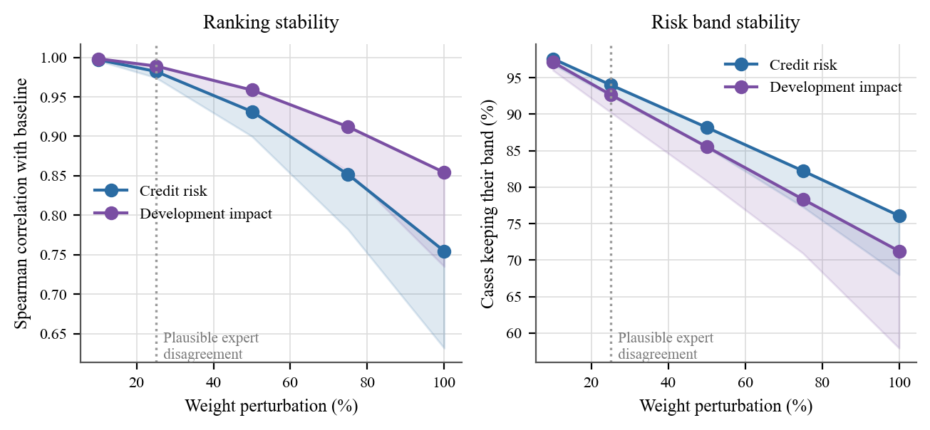
Figure 5.8: Ranking stability and risk-band stability against the magnitude of the weight perturbation. Shaded bands show the range down to the fifth percentile across draws; the dotted line marks the level of disagreement practitioners plausibly exhibit.
Interpretation. The model's conclusions do not hinge on the precise weight vector within the range over which experts plausibly disagree. This does not make elicitation optional: the weights still need to be defensible, and the 6–7% of cases whose band changes at ±25% are real appraisals that would receive a different recommendation. What it does is bound the distortion: results reported under placeholder weights are unlikely to be qualitatively wrong, and that can be stated rather than hoped.

5.16.3 An unanticipated structural finding
Estimating each criterion's influence separately, by doubling its weight within its dimension and measuring the shift, exposed an asymmetry in the tree itself, which Table 5.14 quantifies.
Table 5.14: Leverage of a single criterion over its objective
Objective | Dimensions | One criterion's share of the objective
Credit risk | 6 | 0.0185 – 0.0333
Development impact | 1 | 0.1250

A development-impact criterion carries roughly four to seven times the leverage of a credit-risk criterion over its own objective. Doubling employment generation moves the development score by 3.06 points and changes the risk band for 19.2% of cases; doubling account turnover, the most influential credit criterion, moves the credit score by 0.71 points and changes 5.1% of bands.
This is not an error. It follows directly from the source instrument: clause 5 of the People's Bank form is a single section of nine items, while the credit-risk material is spread across six sections. The tree faithfully reproduces that shape. But the consequence should be stated plainly: the development objective is materially more sensitive to individual weight choices than the credit objective, so elicitation error there carries more consequence, and the development weights deserve more respondents, not fewer.

5.17 Are the two objectives independent? (RQ4)
The model reports two scores and refuses to combine them. That decision was justified in Section 5.2.2 on Arvanitis, Stampini and Vencatachellum [29], who report that development and credit concerns in development-bank appraisal are "rather independent from each other".
As Section 3.6.2 sets out, their evidence is a positive but non-significant relationship — slope 0.048, p = 0.49 — across the 109 African Development Bank operations carrying both ratings. That is an underpowered null. A sample of 109 cannot distinguish independence from a moderate association, so the premise the design rests on has never actually been tested with the power to resolve it.
It can be here, on 652,284 small-business facilities with realised outcomes.

5.17.1 The objectives are not independent
Table 5.15 reports the association between the two scores on all 652,284 facilities.
Table 5.15: Association between the credit-risk and development-impact scores
Measure | Value
Pearson r | +0.4003
Spearman ρ | +0.4213
Shared variance (r²) | 0.1602

With n this large every correlation is statistically significant, so effect size is what carries meaning. An r of 0.40 is moderate, not negligible.
The two proxy scores do not draw on disjoint variables, which inflates this: NoEmp feeds both the credit criterion employees and the development criterion job creation rate, and GrAppv feeds both loan per employee and jobs per 100k. Recomputing with a development measure sharing no inputs with the credit score, raw jobs supported, gives r = +0.3563. The confound accounts for part of the association but not most of it.
This does not contradict Arvanitis et al.; it resolves them. Their estimate was positive too, slope 0.048, and simply could not be separated from zero in 109 observations. The direction found here is the same direction they measured, at a sample size that can actually detect it. The correct reading is not that the earlier study was wrong, but that a non-significant result in a small sample was carried forward, by this study among others, as though it had established independence. It had not.
What is contradicted is the strong form of the premise: that the objectives are independent and therefore that aggregation destroys information. On this population they are moderately associated, and that form of the argument is no longer available. Section 5.17.2 sets out why the design decision nevertheless stands, by a different route.

5.17.2 The practical case survives by a different route
Correlation describes average co-movement across a population. It does not say whether the two objectives agree about any particular facility, which is the question a combined score actually settles. Table 5.16 answers that question directly.
Table 5.16: Agreement between the two objectives' risk bands
Relationship between the two bands | Share of facilities
Same band | 11.8%
One band apart | 49.7%
Two or more bands apart | 38.4%
Disagree at all | 88.2%

An r of 0.40 leaves enormous scatter. The two objectives place the same facility in different risk bands 88.2% of the time, and more than a third differ by two bands or more.
That is the argument for reporting them separately, and it is stronger than the independence argument it replaces. A combined score would issue one number for the 88% of cases where the objectives disagree, making a strong-credit, weak-development facility indistinguishable from one that is middling on both. Whether the underlying scores correlate on average is beside the point; what a decision-maker needs is whether this application is one of the many where they diverge.

5.17.3 Development impact is associated with higher default
Table 5.17 gives the realised default rate within each development-impact band.
Table 5.17: Default rate by development-impact band
Development band | n | Default rate
Lowest | 326,491 | 10.80%
Middle | 162,746 | 29.77%
Highest | 163,047 | 30.32%

Facilities supporting more employment default substantially more, a spread of 19.5 percentage points.
Read this as association, not cause. It is very likely confounded: facilities creating more jobs tend to be larger, newer, and more expansionary, and each of those independently raises credit risk. Establishing a causal relationship would require controls this study has not applied, and the claim is not made.
But if the association holds under proper controls, it has a direct implication for a state bank with a development mandate: the developmental objective and the credit objective may genuinely pull against each other. Development-oriented lending would then carry a real and measurable credit cost.
That is precisely the trade-off the dual-objective design exists to surface. A model that averaged the two into one figure would report a middling score and conceal the fact that the institution is being asked to choose.

5.18 Who the models work less well for
The model card recorded, as a stated weakness, that no disparate-impact analysis had been performed, and that a credit model untested for disparate impact should not touch real applicants. This section closes as much of that gap as the data permits.

5.18.1 What can and cannot be tested
The SBA file records no legally protected characteristic. There is no race, sex, age, disability or marital-status field, and nothing that follows is a protected-attribute audit. Describing it as one would be false.
What the data does carry are the axes along which SME credit exclusion actually operates in development finance: rurality, firm size, firm age, sector, and facility size. These are proxies for credit access, not for protected class, and a model can be clean on every one of them and still discriminate unlawfully. The analysis is reported for what it is.
Two distinct quantities are measured and must not be conflated. The first is selection-rate disparity, whether a group is declined more often, assessed against the four-fifths rule, in the form Feldman et al. [43] formalise. On its own this is weak evidence, because the groups have genuinely different default rates and a model that declines a riskier group more often is doing its job. The second is error-rate disparity, which is Hardt, Price and Srebro's [44] equality-of-opportunity criterion: among borrowers who actually repaid, what share would have been declined. That measure has no base-rate defence. If creditworthy firms in one group are turned away at three times the rate of another, the model is worse for that group.
A single portfolio-wide threshold is applied, declining the riskiest 20%, because that is what a bank does, and it is the condition under which disparate impact arises. The temporal test cohort is used throughout: 275,487 facilities approved between 2004 and 2010, default rate 35.89%.

5.18.2 Results
The trained gradient booster fails the four-fifths rule on three of the five attributes; the expert scorecard fails on four of five. Table 5.18 reports the ratios. Intervals are 95% bootstrap percentiles over 400 resamples of the test cohort, with the decline threshold recomputed inside each resample.
Table 5.18: Equal-opportunity ratios by attribute, with bootstrap intervals
Attribute | Gradient boosting | Expert scorecard
Rurality | 0.325 [0.308, 0.344] (fails) | 0.183 [0.170, 0.209] (fails)
Firm size | 0.832 [0.820, 0.838] (passes) | 0.729 [0.711, 0.746] (fails)
Firm age | 0.993 [0.989, 0.997] (passes) | 0.711 [0.707, 0.714] (fails)
Sector | 0.773 [0.752, 0.783] (fails) | 0.731 [0.702, 0.758] (fails)
Facility size | 0.789 [0.785, 0.793] (fails) | 0.831 [0.828, 0.836] (passes)

Both measures are ratios of a minimum to a maximum across groups, and that structure is biased. Sampling noise pushes the observed minimum down and the maximum up, so a disparity ratio computed this way reads worse than reality even when no group is treated differently, and the smaller the groups, the worse it reads. This has to be quantified rather than asserted away, since one group here has only 752 members.
It was quantified by permuting the decisions: assigning the same volume of declines at random, holding group sizes fixed, and re-measuring. Under random assignment the ratio reads 0.973 to 0.999 across the five attributes. That is the floor the measure produces with no disparity present. The observed values — 0.325, 0.711, 0.729, 0.773, 0.789 — are nowhere near it, so the bias is real but far too small to account for the findings.
The identification is also stable. Resampling the cohort names the same group as worst-affected in 89% to 100% of draws, depending on the attribute; only sector under the gradient booster falls below 100%, at 89%. A disparity attached to a group that changed between resamples would be a statement about noise, and none of these are.
The error-rate disparities are the substantive finding. Under the gradient booster, 17.96% of micro-enterprises that repaid would have been declined, against 6.39% of firms with 100 or more employees, a ratio of 2.81. By facility size the gap is wider: 21.22% of creditworthy applicants in the smallest quartile declined, against 6.20% in the largest, a ratio of 3.42. Micro-firms and small facilities are precisely the segment that SME finance policy exists to serve, and they are the segment the model serves worst.
The scorecard's failure is sharper and less defensible. It would decline 36.11% of creditworthy agricultural borrowers, the highest rate of any sector, even though agriculture has the lowest default rate in the cohort at 19.19%. The model penalises most heavily the sector that performs best. This is not a base-rate artefact; it is the a priori bands mis-scoring a sector.
Discrimination is also unevenly distributed. The booster's within-group AUC ranges from 0.5468 in agriculture to 0.6424 in wholesale trade. The scorecard is worse than a coin toss inside several substantial groups: 0.4369 for wholesale trade (n = 18,018), 0.4874 for the upper-middle facility quartile (n = 68,881), 0.4955 for the largest quartile (n = 68,852). Within those groups its ranking is inverted: it is not merely uninformative but actively misleading.

5.18.3 A confound that had to be ruled out
The largest single disparity looked at first like the clearest finding and turned out not to be. Applicants whose rurality was not recorded are declined at 71.97% against 20.78% for urban and 13.74% for rural firms, with 64.14% of the creditworthy among them declined, while their default rate, 34.75%, sits slightly below the urban group's 37.70%. The natural reading is that the model punishes missing data.
That reading does not survive inspection. The group is confounded: its records are mostly 2004 approvals, carry a far higher SBA guarantee share (0.83 against 0.58), are larger, and are missing several other fields as well. Their decline rate is explained by those characteristics, not by the absent flag. The hypothesis was therefore tested directly, not inferred, and Section 5.19 reports what that test found, which is the opposite.

5.19 What the models do with information the applicant did not supply
Section 5.3 reported a completeness gate: the artefact refuses to return a band when too little of an objective has been assessed. It was introduced as a safety measure after testing found a 14%-complete appraisal being handed a recommendation. This section asks what the alternative actually does, and the answer is a stronger argument for the gate than the safety argument that motivated it.

5.19.1 Method
The question is causal, so it is answered by counterfactual instead of by comparing groups. Take the 201,566 test-cohort applicants whose records are complete, blank one field, and re-score the same applicant. Everything else is held fixed, so whatever moves is caused by the absence itself. The decline threshold is the same portfolio rule as Section 5.18: decline the riskiest 20%, which on these applicants falls at a predicted default probability of 0.2293. Section 5.19.3 shows the conclusion does not depend on that choice.

5.19.2 The models reward withholding
They do not penalise missing data. They reward it. For the gradient booster, withholding lowers assessed risk for 11 of the 14 fields. Withholding the rurality flag alone scores 97.7% of applicants as less risky than when they answered, dropping mean assessed default from 16.84% to 6.44%, and moves 19.84% of all applicants from decline to approval. Withholding whether the business is new does the same for 92.0% of applicants and flips 16.48%.
The mechanism is mundane and entirely general. A gradient booster sends missing values down whichever branch carried the greater training weight; the urban indicator was absent for about a third of training rows and those rows defaulted less often, so "not stated" is scored like a low-risk population.
The distinction matters because neither model treats absence as Rubin [45] would have it treated: as information about the mechanism that produced the gap. Median imputation, the standard alternative, fails differently rather than better. Under the logistic regression, withholding the SBA guarantee share scores 90.5% of applicants as less risky and flips 19.61% from decline to approval. It does not reward omission through a missingness branch; it silently asserts a value the applicant never gave. Figure 5.9 traces both models as fields are progressively withheld.
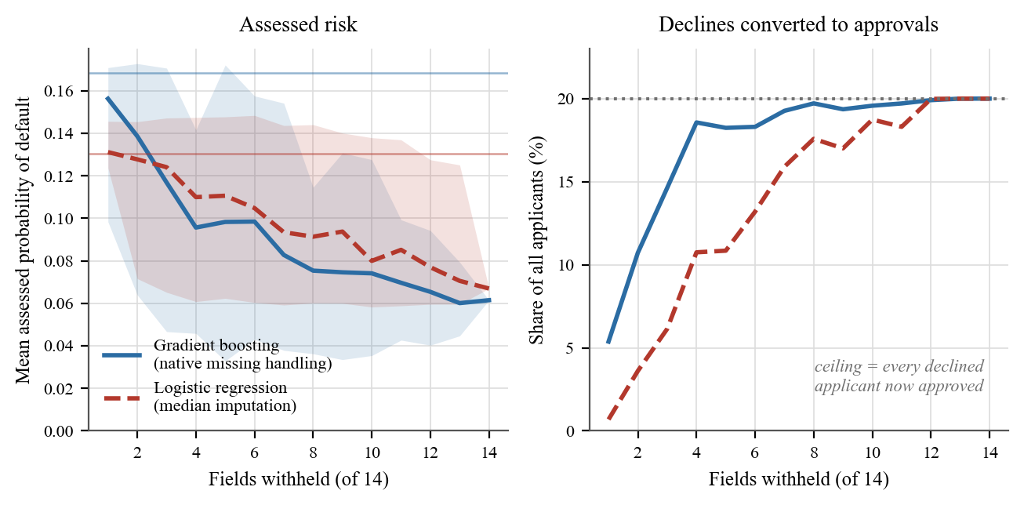
Figure 5.9: The effect of withholding information about the same applicants. Left: mean assessed probability of default as fields are withheld, shaded across draws, with the thin horizontal line marking each model's assessment when nothing is withheld. Right: the share of all applicants converted from decline to approval. Both models converge on the ceiling, at which every applicant who would have been declined is approved.
Both models behave the same way and differ only in pace. Assessed risk falls monotonically as fields are withheld, and on the right-hand panel both curves reach the ceiling once twelve of the fourteen fields are withheld, at which point every applicant who would have been declined has been approved.

5.19.3 The limit case
Withholding 7 of the 14 fields halves mean assessed risk. At the limit the result is unambiguous. An applicant who supplies nothing at all receives an assessed default probability of 0.0615 from the gradient booster, identical for every applicant, because nothing remains for the model to vary on.
This does not depend on where the decline threshold is placed, which is the obvious objection to a result reported under a single policy. That score sits at the 6.5th percentile of real applicants' scores. Supplying nothing therefore beats 93.5% of genuine applications, and remains an approval under any policy declining less than 93.5% of the portfolio. The logistic regression is worse: its no-information score of 0.0669 sits at the 3.9th percentile, giving a crossover at 96.1%.
No lender declines nine applicants in ten. Within the entire range of policies a bank might actually operate, an applicant who answers nothing is approved.

5.19.4 Why this matters for the artefact
The completeness gate was justified in Section 5.3 on safety grounds: a score computed from 14% of the evidence should not be presented as a recommendation. This analysis shows the weaker justification was the wrong one. A scoring model that answers regardless of how much it was told is not merely unreliable on thin evidence: it is exploitable, and in a direction that rewards the applicant for supplying less. Under a fixed threshold, omission is a dominant strategy.
Refusing to answer is not conservatism. It is the only response to insufficient evidence that cannot be gamed, and this is the empirical case for the design decision, not the a priori one.
Two qualifications. The counterfactual asks what the model does with a blank field, not what a bank's own process would do; a real institution would refuse an incomplete application at intake, and the vulnerability arises only where an automated score is taken at face value. And the specific numbers belong to these two models on this dataset. The direction, that absent information is scored as favourable rather than as unknown, follows from how both missing-value strategies work, and is not particular to either.

5.20 Limitations
Jurisdiction. SBA data reflects U.S. government-guaranteed small-business lending. Sri Lankan SME credit differs in legal environment, collateral practice, and macroeconomic volatility. Nothing here transfers directly.
The fuzzy layer is not exercised. Every SBA-observable criterion is quantitative, so each input enters as a degenerate triangular fuzzy number [x, x, x]. Centroid defuzzification returns x, and the fuzzy weighted average reduces exactly to an ordinary weighted mean. On this dataset the fuzzy machinery does no work. It is exercised only by qualitative criteria, which SBA data does not contain. What Sections 5.10 to 5.15 validates is band mapping and weighted aggregation, not fuzzy inference.
Maturity filtering biases composition. Restricting to fully-matured loans removes censoring but over-represents short-term facilities in later cohorts.
These results were computed under placeholder weights. All figures in this chapter use equal weights within each level, so they test structure, not the elicited model. Elicitation completed after the analyses were run (Section 6.1), and Section 6.1.5 measures the consequence directly: moving from the placeholder vector to the elicited one preserves the ranking (ρ = 0.91 credit, 0.97 development) and moves no case by two risk bands, though 13–16% move by one. Section 5.16 bounds it independently: within ±25% perturbation ρ ≈ 0.98 and ~94% of bands are unchanged. The limitation stands, but its magnitude is now measured rather than merely acknowledged.
The independence test uses thin development proxies. SBA data carries employment only; five of the nine items in clause 5 have no counterpart. Section 5.17 tests the employment dimension of development impact, not the whole objective.
The proposed model is not calibrated. It produces an ordinal risk band, not a probability of default. Section 5.13 shows that even trained probabilistic models lose calibration badly across time periods; the proposed model does not offer a probability to lose. It must not be used for pricing or provisioning.
The sensitivity analysis uses a simulated population. It characterises the model's response to weight change; it says nothing about how real Sri Lankan SME applications are distributed, and the two must not be confused.
The development objective is barely observable. Only CreateJob and RetainedJob proxy the development-impact objective. Five of the nine items in clause 5 of the People's Bank form — women's participation, local raw material usage, import substitution, value added, foreign exchange earnings — have no counterpart in SBA data. The development objective is a design contribution and is not empirically validated in this chapter.
Novelty of the contamination finding is not fully established. A literature search found no published report of it, but that search was not exhaustive and cannot support a claim of priority. The finding is reported as one the author is not aware of having been documented, which is a weaker and defensible claim.

5.21 Summary
1. Term in the SBA National dataset carries outcome information. Roundness alone predicts default at AUC 0.889 overall and 0.859–0.900 within every approval year, despite having no economic meaning.
2. Excluding it drops gradient-boosting temporal AUC from 0.9461 to 0.6076.
3. Right-censoring is a separate and independent hazard: censored loans default at 7.77% against 20.41% for matured loans.
4. Random splitting overstates performance by 0.182 AUC relative to temporal validation; a linear scorecard fitted to a benign cycle ranks backwards under stress.
5. The a priori expert scorecard shows no discrimination on SBA-observable proxies (AUC 0.41–0.53), supporting the conclusion that instrument-specific appraisal models require elicitation, not proxy-dataset fitting.
6. The model is robust to weight perturbation within the range experts plausibly disagree over (ρ ≈ 0.98 and ~94% band stability at ±25%), which bounds the distortion introduced by reporting under placeholder weights.
7. The criteria tree is structurally asymmetric: a development-impact criterion carries four to seven times the leverage of a credit-risk criterion over its objective, a direct consequence of clause 5 being one section of the source form.
8. The two objectives are not independent on this population (r = +0.40, or +0.36 with disjoint inputs), which partly contradicts the premise the non-aggregation design was justified on. They nonetheless band the same facility differently 88.2% of the time, which is the stronger argument for reporting them separately.
9. Development impact is positively associated with default (10.8% in the lowest band against 30.3% in the highest). Reported as association, not cause; if it survives proper controls, a development mandate carries a measurable credit cost.
10. At realistic cost ratios under temporal validation, none of the models beats the better fixed policy: discrimination at this level does not convert into economic value.
11. Calibration degrades far more sharply than discrimination across time periods: gradient-boosting reliability worsens roughly 700-fold (0.00005 to 0.03705), with the model systematically under-predicting default, pricing an observed 45% risk at 20%. For a lender this is the more consequential failure, because it is less visible than a fall in discrimination.
Findings 1 and 5 are the contributions of this chapter. Finding 1 is a caution to users of a widely-adopted benchmark; finding 5 justifies the methodological design of the study.

6 DISCUSSION AND CONCLUSIONS

6.1 Weight elicitation
The methodology in Section 4.5 specifies weight elicitation by Best-Worst Method. It was carried out, and this section reports it.

6.1.1 The instrument
- A web instrument implementing BWM across eight comparison levels (86 comparisons, approximately fifteen minutes), with a participation and confidentiality notice, collecting a self-chosen participant code, years of experience, institution type and role, and no name or customer information.
- A linear BWM solver [26], verified two ways on deliberately inconsistent inputs: the maximum deviation recomputed from the returned weights matches the reported ξ*, and an independent optimiser from forty random starts finds no better solution, agreeing to six decimal places (Section 4.5.3).
- An analysis pipeline computing per-respondent consistency ratios, excluding responses above CR 0.25, and aggregating by geometric mean.
The instrument was deployed publicly so that practitioners could complete it from their own device without an account, which is what made recruitment feasible.

6.1.2 Respondents
Eleven credit practitioners completed the instrument, above the five-to-eight range typical of published BWM studies. Table 6.1 summarises the sample by experience, role and institution.
Table 6.1: Profile of the eleven elicitation respondents
Respondents | 11
Experience | 1–12 years, median 8
Credit / appraisal officers | 4
Branch managers | 4
Regional or head-office credit | 2
Not stated | 1
Institution | State commercial bank (10); not stated (1)

Ten of the eleven give their institution as a state commercial bank and the eleventh did not state one, which is the setting the instrument comes from and also a limitation: these weights describe one segment of Sri Lankan SME lending, not the sector.

6.1.3 Consistency
Each respondent produced eight level-responses, giving 88 in total. Three were excluded for a consistency ratio above 0.25 and the remaining 85 retained. The exclusions are reported rather than absorbed: two fell in the borrower and management dimension and the credit conduct dimension from one respondent (CR 0.298 and 0.377), and one at the credit-risk objective level from another (CR 0.293).
Most responses were highly consistent, a majority of them at CR = 0.000, meaning the stated comparisons admit a weight vector that reproduces them exactly.

6.1.4 The weights
Table 6.2 gives the weights practitioners assign to the six credit-risk areas, each shown against the 0.1667 an equal weighting would give it.
Table 6.2: Elicited weights for the six credit-risk dimensions
Dimension | Weight | Multiple of equal weight
Project Viability & Projections | 0.2698 | 1.62
Borrower & Management Capacity | 0.2190 | 1.31
Credit History & Banking Conduct | 0.1594 | 0.96
Market & Competitive Position | 0.1423 | 0.85
Historic Financial Performance | 0.1073 | 0.64
Risk, Security & Compliance | 0.1023 | 0.61

The ordering is itself a finding. Forward-looking project viability outranks historic financial performance by more than two to one, which inverts the emphasis of an instrument whose longest section is the historic financial analysis. Security and compliance ranks last of the six, despite occupying a full clause of the form.
The model's weight status is now recorded as elicited, against eleven respondents, three exclusions and the date of elicitation. Every score the system produces is computed from these weights.

6.1.5 What the placeholders cost
Until elicitation completed, every scored result used equal weights within each level. Section 5.16 argued this mattered less than it appeared, on a simulation perturbing weights by up to ±25%.
The elicited weights fall outside that range. Within a level the ratio of largest to smallest reaches 3.57, and the largest departure from equal weighting is 87%, three and a half times the perturbation tested. The earlier reassurance was therefore about a narrower disturbance than the one that actually occurred.
It survives the test anyway. Table 6.3 scores the same 2,000 simulated appraisals under both vectors and compares the two rankings.
Table 6.3: Scoring under placeholder and elicited weights compared
 | Credit risk | Development impact
Spearman correlation | 0.8983 | 0.9671
Same risk band | 85.5% | 84.9%
Two or more bands apart | 0.0% | 0.0%
Mean absolute score shift | 2.04 | 2.38

No case moves two bands. Around 15% move one band. That is not nothing: those are appraisals that would carry a different recommendation. The ordering is nonetheless substantially preserved across a weight change far larger than the one Section 5.16 modelled.
This is a stronger result than the simulation it replaces, because it is not a simulation of possible weights. It is the placeholder vector against the elicited one, on identical cases.

6.2 Answers to the research questions
Each question is answered below in the same four steps: the answer, the evidence supporting it, what follows from it, and the limit on how far it can be taken. Table 6.4 states the four answers together first, so that the chapter's claims can be read against one another before each is argued at length.
Table 6.4: The research questions, the method used for each, the principal result and the contribution claimed
Question | Method | Principal result | Contribution claimed
RQ1 Can the instrument be formalised? | Clause-by-clause derivation from the source form, then implementation | 49 criteria across 7 dimensions, each traceable to a numbered clause; a working system | A traceable appraisal model, and the demonstration that the traceability constraint is affordable
RQ2 What weights do practitioners assign, and how much do they matter? | Best-Worst Method with eleven practitioners; Monte Carlo perturbation | Project viability weighted above historic performance by more than two to one; rankings stable, 13–16% of cases move one band | Elicited weights for a Sri Lankan state commercial bank, with their stability measured rather than assumed
RQ3 What can public data establish about an instrument-specific model? | Benchmarking against logistic regression and gradient boosting on 652,284 matured facilities | The scoring machinery is testable; the criteria tree is not. A predictor documented as economic proved to carry outcome information | A bounded account of what proxy validation can support, and a reusable contamination finding
RQ4 Are the two objectives separable? | Correlation and band agreement across the same population | The scores correlate at r = +0.40, and bands disagree often enough that a combined figure would conceal the disagreement | Evidence that separate reporting is warranted, against the study's own prior expectation of independence

This table contains, for each research question, the method used to answer it, the result that answer rests on, and the contribution claimed from it. The contributions are deliberately narrower than the results: RQ3 produced a finding about the SBA dataset that is useful beyond this study, but the contribution claimed is the account of proxy validation rather than the finding's priority, which Section 6.4 records as unestablished.

6.2.1 RQ1: can the instrument be formalised?
Yes, and the artefact demonstrates it. Forty-nine criteria across seven dimensions and two objectives, each traceable to a numbered clause of the People's Bank form. Twenty-eight quantitative criteria map through piecewise-linear bands; twenty-one qualitative criteria are captured on a five-point linguistic scale as triangular fuzzy numbers.
The working system scores, explains, and exports in the bank's own report format. Contributions decompose exactly to the score, so any recommendation is traceable to the clause that produced it.
What the formalisation does not do is preserve everything. Stein's [12] distinction between hard and soft information implies that hardening a judgement loses something, and the fuzzy linguistic scale mitigates that loss rather than avoiding it.

6.2.2 RQ2: what weights do practitioners assign, and how much do they matter?
Both halves are now answered.
What they assign. Eleven practitioners, 1–12 years' experience, produced the weights in Section 6.1.4. The ordering is the substantive result: forward-looking project viability outranks historic financial performance by more than two to one, and security and compliance ranks last of the six credit-risk areas. Three of 88 level-responses were excluded for inconsistency.
How much they matter. Less than the effort of eliciting them might imply, and the answer is now measured rather than simulated. The elicited weights depart from the placeholders by up to 87% within a level, three and a half times the ±25% Section 5.16 modelled, yet rank correlation between the two scorings is 0.8983 for credit risk and 0.9671 for development impact, no case moves two risk bands, and about 85% keep the same band (Section 6.1.5).
Three qualifications. The 15% that change band are real appraisals that would carry a different recommendation. Ten of the eleven respondents come from state commercial banking, and the eleventh did not state an institution, so these weights describe one segment, not the sector. And the criteria tree is structurally asymmetric: a development-impact criterion carries four to seven times the leverage of a credit-risk criterion, so elicitation error costs more on that side.

6.2.3 RQ3: what can be established from public data?
Less than hoped, and the reasons are themselves the contribution.
The scoring method could not be validated against the criteria tree, because no public dataset contains its variables. Substituting SBA-observable proxies produced a scorecard with no discrimination (AUC 0.4144 random, 0.5275 temporal), a negative result reported as it occurred (Section 5.15).
The attempt surfaced something more useful. The SBA National dataset's Term field carries outcome information: roundness alone predicts default at AUC 0.889 within every approval year, and excluding the field drops gradient-boosting temporal AUC from 0.9461 to 0.6076 (Sections 5.10 to 5.11). Confidence intervals do not overlap and paired DeLong tests give p < 0.001.
Two further hazards emerged. Calibration degrades roughly 700-fold across the temporal boundary, with models systematically under-predicting default (Section 5.13). And at realistic cost ratios, none of the models beats a fixed policy on the stressed cohort (Section 5.14).

6.2.4 RQ4: are the objectives separable?
Not independent, but they disagree constantly, and the second fact is what matters.
Across 652,284 facilities the two scores correlate at r = +0.40, or +0.36 with the shared-input confound removed. That is moderate, and it removes the strong form of the premise the design was justified on. It does not, however, overturn Arvanitis et al. [29]. Their estimate was also positive (slope 0.048) and merely non-significant in 109 observations; this study measures the same direction at a sample size able to resolve it (Section 5.17.1). What went wrong was the reading of that paper: an underpowered null carried forward as an established independence result. This thesis made that error before correcting it.
The practical case survives by a different route. The two objectives place the same facility in different risk bands 88.2% of the time, and 38.4% differ by two bands or more. A correlation of 0.40 leaves enormous scatter, and it is per-facility disagreement, not average co-movement, that a combined score destroys.
Additionally, development impact is positively associated with default (10.8% in the lowest development band against 30.3% in the highest). Reported as association, not cause, and likely confounded by facility size and business age. If it survives proper controls, a development mandate carries a measurable credit cost, exactly the trade-off the dual-objective design exists to surface.

6.3 Discussion

6.3.1 What the contamination finding means
The SBA National dataset is widely used in credit-scoring research and teaching. A model given Term and free to split on exact values inherits an artefact worth up to 0.34 AUC, and a meaningless roundness probe reaches 0.887 on its own.
The transferable lesson is about how anomalies are treated. The finding emerged only because an AUC of 0.9726 was investigated rather than reported. Had it been published it would have exceeded every benchmark it would have been compared against, which is precisely why it would not have been questioned.
Kapoor and Narayanan [32] found leakage affecting 294 papers across seventeen fields. This case is harder to catch than the textbook forms: the offending field is documented as legitimate, is available at prediction time under its documented meaning, and is economically meaningful. It is caught only by noticing that the shape of its relationship with the outcome is not one any economic mechanism could produce.

6.3.2 What the negative result means
Substituting available proxies for the intended criteria tests the proxies, not the model. Institutions without clean historical default data cannot fit a scorecard, and this study shows they cannot borrow someone else's dataset to validate one either. That narrows the options rather than closing them: expert elicitation remains available, and it is defensible precisely because it does not depend on outcome data the institution does not have. It is not equivalent to fitting on real outcomes, and nothing here shows it is. It is why the weights reported in Section 6.1 were elicited from practitioners rather than fitted to borrowed ones.

6.3.3 What temporal validation reveals
Logistic regression scored 0.4565 temporally, below chance. Trained on cohorts defaulting at 9.1% and tested on cohorts defaulting at 35.9%, its ranking inverted.
Calibration degraded further than discrimination. For a lender that is the more dangerous failure: falling discrimination is visible and invites scrutiny, whereas a model that still ranks tolerably while pricing a 45% risk at 20% under-provisions by more than half and appears to be working. Recalibration on recent outcomes is a separate requirement from revalidation of discrimination, and the two are routinely conflated. Given Sri Lanka's recent macroeconomic volatility, this is the most directly actionable result in the thesis.

6.3.4 On the system
Two design decisions proved more consequential than expected.
The completeness gate (Section 5.3) arose from a defect found in testing: a 14%-complete file produced a confident recommendation. Weight renormalisation keeps a sparse appraisal's score plausible while its evidential basis collapses. The gate is a refusal to answer rather than a score adjustment, because a discounted score would preserve the false impression that the system had an opinion.
That was a safety argument, and Section 5.19 shows it was the weaker of the two available. The stronger one is that the alternative is exploitable: both conventional models tested score a withheld field as favourable rather than as unknown, so under a fixed threshold an applicant improves their assessment by answering less. A design decision taken on cautionary grounds turned out to have an incentive justification that is harder to argue with.
Authenticated sign-off (Section 4.13) replaced a typed name. An audit trail of self-declared signatories records nothing; the signatory is now the authenticated user and roles are enforced server-side.

6.3.5 Who the models serve worst
Two findings sit outside the research questions and are reported because they bear directly on whether any of this should be deployed.
The first is that the artefact discriminates against the applicants it was designed to serve. The scorecard fails the four-fifths rule on four of five credit-access attributes, and would decline 36.11% of creditworthy agricultural borrowers, the worst rate of any sector, while agriculture has the lowest default rate in the cohort at 19.19%. The trained model is not much better: creditworthy micro-enterprises are declined at 2.81 times the rate of large firms, and the smallest facility quartile at 3.42 times the largest. Micro-firms, small facilities and agriculture are precisely the segments that SME and development finance exist to reach.
This has to be stated carefully. Barocas and Selbst [46] set out why disparate impact is a legal as well as a technical problem: a model can disadvantage a group whose defining attribute it never observes. That is the shape of what is found here. But these are credit-access proxies; the dataset records no protected characteristic, so no claim about lawful discrimination follows. Group default rates genuinely differ, so selection-rate gaps are not by themselves evidence of injustice, which is why the error-rate comparison, taken only over borrowers who actually repaid, is the one reported as the finding.
The second is that both conventional models reward applicants for withholding information (Section 5.19), which is the empirical case for the completeness gate discussed above.
Neither finding was sought. Both emerged from taking the model card's own list of untested risks seriously, and the first of them is a defect in this study's own artefact rather than in someone else's. It is reported for that reason: an appraisal instrument that penalises the best-performing sector is not ready to inform decisions, and saying so is more useful than not having looked.

6.4 Limitations
Empirical validation is on a proxy dataset from another jurisdiction. Nothing transfers directly to Sri Lankan SME credit.
The criteria tree is not empirically validated. No dataset contains its variables.
The elicited weights describe one segment, not the sector. Eleven practitioners completed the instrument, which is within the range published BWM studies rely on, but the sample is purposive rather than probabilistic: ten respondents work in state commercial banking and the eleventh did not state an institution. The weights in Section 6.1.4 are the judgement of those respondents. They are not a measurement of Sri Lankan credit practice, and nothing in this thesis licenses treating them as one.
Fairness is assessed only on credit-access proxies. The SBA file records no race, sex, age, disability or marital-status field. Passing, or failing, on rurality, firm size, sector and facility size establishes nothing about discrimination on protected characteristics, which remains untested and is a precondition for any deployment.
The fuzzy layer is not exercised by the validation. All SBA-observable criteria are quantitative and enter as degenerate fuzzy numbers, under which the fuzzy weighted average reduces exactly to a weighted arithmetic mean.
The development objective is thinly proxied. Only employment is observable; five of the nine clause-5 items have no counterpart. Section 5.17 tests the employment dimension, not the whole objective.
The development–default association is uncontrolled. Facility size and business age are plausible confounders and were not adjusted for.
No inter-rater reliability study. The premise that manual appraisal is inconsistent is supported from the literature [2] but not measured here. This remains the single most significant omission.
No field evaluation. No officer has used the system on live applications, so neither perceived usefulness [47] nor usability [48] has been measured. Structural correctness is established; fitness for the desk is not, and the two are not the same claim.
Novelty of the contamination finding is not established as priority. A literature search found no prior report, but was not exhaustive.

6.5 Future work
Measure the inconsistency. Have N officers appraise the same M files independently, compute inter-rater reliability, then repeat with the system. This directly tests the premise the research rests on and requires only practitioner time and constructed cases.
Broaden the elicitation. The instrument, solver and analysis pipeline are built, verified and now administered once. Re-administering them unchanged across development banks, licensed specialised banks and the non-bank sector would establish whether the ordering reported in Section 6.1.4 is a property of Sri Lankan credit judgement or of state commercial banking specifically. Because the instrument is fixed and the analysis is scripted, a second sample is directly comparable with the first rather than a fresh study.
Measure usability on the desk. A field evaluation with officers working real applications, instrumented with an established usability measure, would test what structural verification cannot: whether the explanation the system produces is the explanation an officer needs.
Control the development–default association. Adjust for facility size, business age and sector to determine whether the relationship in Section 5.17.3 is causal. If it is, it has direct policy implications for development lending.
Establish the contamination mechanism. Determining why Term behaves as it does, through SBA documentation or the agency itself, would convert a caution into a full account, and is publishable independently.
Validate on institutional data. With permission and anonymisation, even a few hundred historical files with outcomes would allow the criteria tree itself to be tested, not a proxy.

6.6 Conclusion
This study set out to formalise a Sri Lankan state bank's narrative SME appraisal instrument into an explainable, dual-objective decision-support system.
The artefact was built. A 49-criterion model was derived clause by clause from the People's Bank appraisal form and implemented in a working system that scores credit risk and development impact separately, decomposes every score into exact per-criterion contributions, withholds a recommendation when too little has been assessed, enforces the form's own sign-off chain, and exports its output in the bank's format.
The empirical work produced results the study did not set out to find. The most substantial contribution is not the model but a caution about the data others use to evaluate such models: the Term field in the widely used SBA National dataset carries outcome information, inflating gradient-boosting temporal discrimination by 0.34 AUC. Alongside it sit a negative result, an expert scorecard that failed to discriminate on proxy variables, and the methodological point that follows: instrument-specific appraisal models cannot be validated on datasets lacking their variables.
Two further findings emerged from asking questions the study could answer rather than the ones it could not. The model's output is robust to weight disagreement within the range experts plausibly exhibit, which bounds what the missing elicitation costs. And the two objectives, while moderately correlated, place the same facility in different bands 88.2% of the time, so reporting them separately preserves information that a combined score would destroy, even though the independence premise that originally justified the separation does not hold on this population. The design decision survives; the argument for it had to be rebuilt.
The claim this thesis does not make is that a better credit scoring model has been built. The evidence does not support it, and Chapter 3 establishes that the methods used are not themselves new. What it offers instead is a transferable method for formalising institutional appraisal instruments, a working artefact that implements it, and three findings about evaluation — contamination in a common benchmark, the limits of proxy validation, and the divergence between discrimination and calibration under temporal shift — that should change how others approach the same problem.

REFERENCES
[1] Ministry of Industry and Commerce, National Policy Framework for Small and Medium Enterprise (SME) Development. Colombo, Sri Lanka: Government of Sri Lanka, 2015.
[2] K. R. Cortés, R. Duchin and D. Sosyura, "Clouded judgment: the role of sentiment in credit origination," Journal of Financial Economics, vol. 121, no. 2, pp. 392-413, 2016.
[3] E. I. Altman, "Financial ratios, discriminant analysis and the prediction of corporate bankruptcy," Journal of Finance, vol. 23, no. 4, pp. 589-609, 1968.
[4] J. A. Ohlson, "Financial ratios and the probabilistic prediction of bankruptcy," Journal of Accounting Research, vol. 18, no. 1, pp. 109-131, 1980.
[5] D. J. Hand and W. E. Henley, "Statistical classification methods in consumer credit scoring: a review," Journal of the Royal Statistical Society Series A, vol. 160, no. 3, pp. 523-541, 1997.
[6] L. C. Thomas, J. N. Crook and D. B. Edelman, Credit Scoring and Credit Control. Oxford, U.K.: Clarendon Press, 1992.
[7] L. C. Thomas, D. B. Edelman and J. N. Crook, Credit Scoring and its Applications. Philadelphia, PA: SIAM, 2002.
[8] S. Lessmann, B. Baesens, H.-V. Seow and L. C. Thomas, "Benchmarking state-of-the-art classification algorithms for credit scoring: an update of research," European Journal of Operational Research, vol. 247, no. 1, pp. 124-136, 2015.
[9] B. Baesens, T. Van Gestel, S. Viaene, M. Stepanova, J. Suykens and J. Vanthienen, "Benchmarking state-of-the-art classification algorithms for credit scoring," Journal of the Operational Research Society, vol. 54, no. 6, pp. 627-635, 2003.
[10] T. Beck and A. Demirgüç-Kunt, "Small and medium-size enterprises: access to finance as a growth constraint," Journal of Banking & Finance, vol. 30, no. 11, pp. 2931-2943, 2006.
[11] A. N. Berger and G. F. Udell, "A more complete conceptual framework for SME finance," Journal of Banking & Finance, vol. 30, no. 11, pp. 2945-2966, 2006.
[12] J. C. Stein, "Information production and capital allocation: decentralized versus hierarchical firms," Journal of Finance, vol. 57, no. 5, pp. 1891-1921, 2002.
[13] F. Ciampi, A. Giannozzi, G. Marzi and E. I. Altman, "Rethinking SME default prediction: a systematic literature review and future perspectives," Scientometrics, vol. 126, pp. 2141-2188, 2021.
[14] M. A. SharafEldin, A. M. Idrees and S. Ouf, "A proposed framework for loan default prediction using machine learning techniques," International Journal of Advanced Computer Science and Applications, vol. 16, no. 6, pp. 412-425, 2025.
[15] J. Cohen, "A coefficient of agreement for nominal scales," Educational and Psychological Measurement, vol. 20, no. 1, pp. 37-46, 1960.
[16] J. R. Landis and G. G. Koch, "The measurement of observer agreement for categorical data," Biometrics, vol. 33, no. 1, pp. 159-174, 1977.
[17] L. A. Zadeh, "Fuzzy sets," Information and Control, vol. 8, no. 3, pp. 338-353, 1965.
[18] L. A. Zadeh, "The concept of a linguistic variable and its application to approximate reasoning - I," Information Sciences, vol. 8, no. 3, pp. 199-249, 1975.
[19] T. L. Saaty, "A scaling method for priorities in hierarchical structures," Journal of Mathematical Psychology, vol. 15, no. 3, pp. 234-281, 1977.
[20] T. L. Saaty, The Analytic Hierarchy Process. New York, NY: McGraw-Hill, 1980.
[21] T. L. Saaty, "An exposition of the AHP in reply to the paper 'Remarks on the Analytic Hierarchy Process'," Management Science, vol. 36, no. 3, pp. 259-268, 1990.
[22] P. J. M. van Laarhoven and W. Pedrycz, "A fuzzy extension of Saaty's priority theory," Fuzzy Sets and Systems, vol. 11, no. 1-3, pp. 229-241, 1983.
[23] D.-Y. Chang, "Applications of the extent analysis method on fuzzy AHP," European Journal of Operational Research, vol. 95, no. 3, pp. 649-655, 1996.
[24] C.-T. Chen, "Extensions of the TOPSIS for group decision-making under fuzzy environment," Fuzzy Sets and Systems, vol. 114, no. 1, pp. 1-9, 2000.
[25] J. Rezaei, "Best-worst multi-criteria decision-making method," Omega, vol. 53, pp. 49-57, 2015.
[26] J. Rezaei, "Best-worst multi-criteria decision-making method: some properties and a linear model," Omega, vol. 64, pp. 126-130, 2016.
[27] P. K. Roy and K. Shaw, "A multicriteria credit scoring model for SMEs using hybrid BWM and TOPSIS," Financial Innovation, vol. 7, no. 1, 2021.
[28] B. Gutiérrez-Nieto, C. Serrano-Cinca and J. Camón-Cala, "A credit score system for socially responsible lending," Journal of Business Ethics, vol. 133, no. 4, pp. 691-701, 2016.
[29] Y. Arvanitis, M. Stampini and D. Vencatachellum, "Balancing development returns and credit risks: project appraisal in a multilateral development bank," Impact Assessment and Project Appraisal, vol. 33, no. 3, pp. 195-206, 2015.
[30] M. T. Ribeiro, S. Singh and C. Guestrin, "'Why should I trust you?': explaining the predictions of any classifier," in Proc. 22nd ACM SIGKDD Int. Conf. Knowledge Discovery and Data Mining, 2016, pp. 1135-1144.
[31] S. M. Lundberg and S.-I. Lee, "A unified approach to interpreting model predictions," in Advances in Neural Information Processing Systems 30, 2017, pp. 4765-4774.
[32] S. Kapoor and A. Narayanan, "Leakage and the reproducibility crisis in machine-learning-based science," Patterns, vol. 4, no. 9, art. 100804, 2023.
[33] M. Li, A. Mickel and S. Taylor, "'Should this loan be approved or denied?': a large dataset with class assignment guidelines," Journal of Statistics Education, vol. 26, no. 1, pp. 55-66, 2018.
[34] A. R. Hevner, S. T. March, J. Park and S. Ram, "Design science in information systems research," MIS Quarterly, vol. 28, no. 1, pp. 75-105, 2004.
[35] K. Peffers, T. Tuunanen, M. A. Rothenberger and S. Chatterjee, "A design science research methodology for information systems research," Journal of Management Information Systems, vol. 24, no. 3, pp. 45-77, 2007.
[36] J. H. Friedman, "Greedy function approximation: a gradient boosting machine," Annals of Statistics, vol. 29, no. 5, pp. 1189-1232, 2001.
[37] F. Pedregosa et al., "Scikit-learn: machine learning in Python," Journal of Machine Learning Research, vol. 12, pp. 2825-2830, 2011.
[38] J. A. Hanley and B. J. McNeil, "The meaning and use of the area under a receiver operating characteristic (ROC) curve," Radiology, vol. 143, no. 1, pp. 29-36, 1982.
[39] G. W. Brier, "Verification of forecasts expressed in terms of probability," Monthly Weather Review, vol. 78, no. 1, pp. 1-3, 1950.
[40] A. H. Murphy, "A new vector partition of the probability score," Journal of Applied Meteorology, vol. 12, no. 4, pp. 595-600, 1973.
[41] E. R. DeLong, D. M. DeLong and D. L. Clarke-Pearson, "Comparing the areas under two or more correlated receiver operating characteristic curves: a nonparametric approach," Biometrics, vol. 44, no. 3, pp. 837-845, 1988.
[42] B. Efron, "Bootstrap methods: another look at the jackknife," Annals of Statistics, vol. 7, no. 1, pp. 1-26, 1979.
[43] M. Feldman, S. A. Friedler, J. Moeller, C. Scheidegger and S. Venkatasubramanian, "Certifying and removing disparate impact," in Proc. 21st ACM SIGKDD Int. Conf. Knowledge Discovery and Data Mining, 2015, pp. 259-268.
[44] M. Hardt, E. Price and N. Srebro, "Equality of opportunity in supervised learning," in Advances in Neural Information Processing Systems 29, 2016, pp. 3315-3323.
[45] D. B. Rubin, "Inference and missing data," Biometrika, vol. 63, no. 3, pp. 581-592, 1976.
[46] S. Barocas and A. D. Selbst, "Big data's disparate impact," California Law Review, vol. 104, no. 3, pp. 671-732, 2016.
[47] F. D. Davis, "Perceived usefulness, perceived ease of use, and user acceptance of information technology," MIS Quarterly, vol. 13, no. 3, pp. 319-340, 1989.
[48] J. Brooke, "SUS: a 'quick and dirty' usability scale," in Usability Evaluation in Industry, P. W. Jordan et al., Eds. London, U.K.: Taylor & Francis, 1996, pp. 189-194.

APPENDICES

Appendix 1 The criteria model
The complete criteria model is held as a single machine-readable file, consumed by both the decision-support system and the analysis pipeline, so that the model described in this thesis and the model the system runs cannot diverge. This appendix is generated from that file rather than transcribed from it, and so cannot describe a model the system does not implement.
Every criterion records the clause of the People's Bank Project / Business Appraisal Report for SME Credit Facility from which it derives. Table A.1 summarises the model by objective and dimension, and Table A.2 then lists every criterion in it.
Table A.1: Criteria model summary by objective and dimension
Objective | Dimension | Criteria | Source clauses
Credit Risk / Bankability | Borrower & Management Capacity | 6 | 2.8, 2.10, 3.2, 3.4
Credit Risk / Bankability | Credit History & Banking Conduct | 5 | 2.11, 2.14
Credit Risk / Bankability | Historic Financial Performance | 9 | 2.13, 2.15-2.18
Credit Risk / Bankability | Project Viability & Projections | 8 | 3.1.3, 3.7, 4
Credit Risk / Bankability | Market & Competitive Position | 7 | 3.10
Credit Risk / Bankability | Risk, Security & Compliance | 6 | 3.3, 3.5, 3.6, 3.11, 3.12, 6.5
Development Impact | Economic & Social Contribution | 8 | 5, 3.4.1
Total | 7 dimensions | 49

This table contains the seven dimensions of the model, the objective each belongs to, the number of criteria it carries and the clauses of the source form those criteria were derived from. 28 criteria are quantitative and 21 qualitative.

Appendix 1.1 The full criteria listing
Table A.2 gives every criterion in the model. Dimensions are abbreviated: BMC Borrower & Management Capacity; CHB Credit History & Banking Conduct; HFP Historic Financial Performance; PVP Project Viability & Projections; MCP Market & Competitive Position; RSC Risk, Security & Compliance; ESC Economic & Social Contribution.
Table A.2: Every criterion in the model, with its source clause, input type and weight
# | Dim | Criterion | Clause | Input | Weight %
1 | BMC | Sponsor experience in the field | 2.10 | Measured | 4.71
2 | BMC | Educational/professional qualifications | 2.8 | Judged | 2.69
3 | BMC | Organizational structure & management style | 3.2 | Judged | 5.48
4 | BMC | HR adequacy & succession depth | 3.4 | Judged | 3.39
5 | BMC | EPF/ETF payment compliance | 3.4.2 | Judged | 2.87
6 | BMC | Years since business commenced | 2.3 | Measured | 2.77
7 | CHB | Repayment performance on prior facilities | 2.11.1, 2.11.2 | Judged | 3.44
8 | CHB | Arrears as % of outstanding | 2.11 | Measured | 1.67
9 | CHB | Credit turnover through account vs. sales | 2.14.1 | Measured | 5.96
10 | CHB | Cheque returns on refer-to-drawer | 2.14.1 | Measured | 2.98
11 | CHB | Exposure to other financial institutions | 2.11.2 | Judged | 1.90
12 | HFP | Gross profit ratio | 2.17 | Measured | 0.70
13 | HFP | Net profit ratio | 2.17 | Measured | 1.33
14 | HFP | Current ratio | 2.17 | Measured | 1.60
15 | HFP | Debt-equity ratio | 2.17 | Measured | 1.30
16 | HFP | Gearing ratio | 2.17 | Measured | 1.26
17 | HFP | Asset turnover ratio | 2.17 | Measured | 1.07
18 | HFP | Stock retention period | 2.17 | Measured | 1.23
19 | HFP | Debtors retention period | 2.17 | Measured | 1.26
20 | HFP | Sales trend & stability | 2.13 | Judged | 0.97
21 | PVP | Debt service cover ratio (critical) | 4 | Measured | 4.96
22 | PVP | Interest service cover ratio | 4 | Measured | 2.55
23 | PVP | Return on investment | 4 | Measured | 3.34
24 | PVP | Projected net profit ratio | 4 | Measured | 3.43
25 | PVP | Project debt-equity ratio | 3.7.1 | Measured | 3.64
26 | PVP | Promoter equity contribution | 3.7 | Measured | 3.28
27 | PVP | Growth in production capacity | 3.1.3 | Measured | 3.23
28 | PVP | Headroom above break-even | 4 | Measured | 2.55
29 | MCP | Rivalry among competing sellers | 3.10.3 | Judged | 2.40
30 | MCP | Competitive force of potential entry | 3.10.3 | Judged | 2.12
31 | MCP | Power of buyers | 3.10.3 | Judged | 2.39
32 | MCP | Power of suppliers | 3.10.3 | Judged | 1.77
33 | MCP | Pressure from substitute products | 3.10.3 | Judged | 1.84
34 | MCP | Security of raw material supply | 3.10.2 | Judged | 2.27
35 | MCP | Distribution arrangements | 3.10.4 | Judged | 1.43
36 | RSC | Security cover (FSV / facility amount) | 6.5 | Measured | 2.21
37 | RSC | Technological risk | 3.11 | Judged | 1.90
38 | RSC | Environmental risk | 3.12 | Judged | 1.45
39 | RSC | Government approvals obtained & current | 3.6 | Judged | 1.59
40 | RSC | Insurance coverage adequacy | 3.3 | Judged | 1.60
41 | RSC | Realism of implementation schedule | 3.5 | Judged | 1.48
42 | ESC | Employment generation (manpower before/after) | 5.1, 3.4.1 | Measured | 12.48
43 | ESC | Women's participation in workforce | 5.2, 3.4.1 | Measured | 5.57
44 | ESC | Local raw material usage | 5.3 | Measured | 15.61
45 | ESC | Increase in productive capacity | 5.4, 5.5 | Measured | 15.77
46 | ESC | Export sales as % of turnover | 5.6 | Measured | 11.58
47 | ESC | Import substitution effect | 5.7 | Judged | 11.11
48 | ESC | Value added | 5.8 | Measured | 12.31
49 | ESC | Foreign exchange earnings | 5.9 | Judged | 15.57

This table contains all 49 criteria the system scores. For each it gives the dimension it belongs to, the clause of the source form it derives from, whether it takes a measured value or a judgement, and the weight it carries within its own objective — that is, its share of its dimension multiplied by that dimension's share of the objective, so the column sums to 100 for each objective separately rather than across both. The weights are the elicited ones reported in Section 6.1.4, not the equal weighting used during development. The one criterion marked critical is evaluated on its raw value and surfaced separately, so it cannot be averaged away by strong performance elsewhere.

Appendix 1.2 Scoring anchors for the quantitative criteria
Quantitative criteria map to 0–100 by linear interpolation between the anchors in Table A.3. Values below the lowest anchor take the lowest score and values above the highest take the highest, so the mapping is bounded at both ends. Linguistic criteria instead take one of five points, represented as the triangular fuzzy numbers Very Poor [0, 0, 25]; Poor [0, 25, 50]; Fair [25, 50, 75]; Good [50, 75, 100]; Excellent [75, 100, 100], and are defuzzified by centroid.
Table A.3: Scoring anchors for the quantitative criteria
# | Criterion | Unit | Direction | Anchors (value → score)
1 | Sponsor experience in the field | years | higher is better | 0 → 0; 2 → 25; 5 → 50; 10 → 75; 15 → 100
6 | Years since business commenced | years | higher is better | 0 → 0; 1 → 25; 3 → 50; 5 → 75; 10 → 100
8 | Arrears as % of outstanding | % | lower is better | 0 → 100; 2 → 75; 5 → 50; 10 → 25; 20 → 0
9 | Credit turnover through account vs. sales | ratio | higher is better | 0 → 0; 0.25 → 25; 0.5 → 50; 0.75 → 75; 1 → 100
10 | Cheque returns on refer-to-drawer | count | lower is better | 0 → 100; 1 → 75; 3 → 50; 6 → 25; 12 → 0
12 | Gross profit ratio | % | higher is better | 0 → 0; 10 → 25; 20 → 50; 30 → 75; 45 → 100
13 | Net profit ratio | % | higher is better | 0 → 0; 3 → 25; 7 → 50; 12 → 75; 20 → 100
14 | Current ratio | ratio | an interior band is best | 0.5 → 0; 1 → 40; 1.33 → 70; 2 → 100; 3.5 → 70
15 | Debt-equity ratio | ratio | lower is better | 0.5 → 100; 1 → 80; 2 → 55; 3 → 30; 4 → 0
16 | Gearing ratio | % | lower is better | 20 → 100; 40 → 75; 60 → 50; 75 → 25; 90 → 0
17 | Asset turnover ratio | × | higher is better | 0 → 0; 0.5 → 25; 1 → 50; 2 → 75; 3 → 100
18 | Stock retention period | days | lower is better | 15 → 100; 30 → 80; 60 → 55; 90 → 30; 150 → 0
19 | Debtors retention period | days | lower is better | 15 → 100; 30 → 80; 60 → 55; 90 → 30; 150 → 0
21 | Debt service cover ratio | × | higher is better | 0.8 → 0; 1 → 25; 1.25 → 50; 1.5 → 75; 2 → 100
22 | Interest service cover ratio | × | higher is better | 1 → 0; 1.5 → 25; 2 → 50; 3 → 75; 4 → 100
23 | Return on investment | % | higher is better | 0 → 0; 8 → 25; 15 → 50; 25 → 75; 35 → 100
24 | Projected net profit ratio | % | higher is better | 0 → 0; 3 → 25; 7 → 50; 12 → 75; 20 → 100
25 | Project debt-equity ratio | ratio | lower is better | 0.5 → 100; 1 → 80; 1.5 → 60; 2.33 → 35; 4 → 0
26 | Promoter equity contribution | % | higher is better | 10 → 0; 20 → 35; 30 → 60; 40 → 80; 50 → 100
27 | Growth in production capacity | % | higher is better | 0 → 0; 15 → 25; 35 → 50; 60 → 75; 100 → 100
28 | Headroom above break-even | % | higher is better | 0 → 0; 10 → 25; 25 → 50; 40 → 75; 60 → 100
36 | Security cover (FSV / facility amount) | ratio | higher is better | 0.5 → 0; 0.8 → 30; 1 → 55; 1.5 → 80; 2 → 100
42 | Employment generation (manpower before/after) | % increase | higher is better | 0 → 0; 10 → 25; 25 → 50; 50 → 75; 100 → 100
43 | Women's participation in workforce | % | higher is better | 0 → 0; 10 → 25; 25 → 50; 40 → 75; 50 → 100
44 | Local raw material usage | % | higher is better | 0 → 0; 25 → 25; 50 → 50; 75 → 75; 100 → 100
45 | Increase in productive capacity | % increase | higher is better | 0 → 0; 15 → 25; 35 → 50; 60 → 75; 100 → 100
46 | Export sales as % of turnover | % | higher is better | 0 → 0; 10 → 30; 25 → 55; 50 → 80; 75 → 100
48 | Value added | % | higher is better | 0 → 0; 15 → 25; 30 → 50; 50 → 75; 70 → 100

This table contains the band anchors for each of the 28 quantitative criteria, numbered as in Table A.2. The direction column records whether a larger measured value improves or worsens the score, which is not uniform: arrears and gearing score inversely, and one criterion is best in an interior band rather than at either extreme. The anchors are design assumptions, set from the thresholds the source form and Sri Lankan SME lending practice already use, and Section 5.16 reports how far the model's output moves when they and the weights are perturbed.

Appendix 2 The weight elicitation instrument
The instrument was built, verified and administered; eleven practitioners completed it and Section 6.1 reports the result. It is reproduced here so that the design can be assessed independently of its findings, and so that a later study can administer it unchanged and compare.

Appendix 2.1 Structure
Eight comparison levels: one comparing the six credit-risk dimensions, and one for the criteria within each of the seven dimensions. Under the Best-Worst Method each level of n items requires 2n − 3 comparisons, giving 86 in total against 168 under classical pairwise AHP.

Appendix 2.2 Participant information presented
This exercise asks how much weight the different parts of an SME credit appraisal should carry. It takes about 15 minutes and involves 86 quick comparisons. There are no right answers — the study is measuring experienced judgement, including where practitioners disagree. Participation and confidentiality. Participation is voluntary and you may stop at any point. Do not enter your name or any customer information. Responses are identified only by the code you choose below, are used solely for academic research, and are reported only in aggregate.

Appendix 2.3 Data collected
Participant code (self-chosen), years in credit or appraisal work, institution type, and role. No name and no customer information are collected.

Appendix 2.4 Comparison scale
Comparisons are made on the nine-point scale in Table A.4.
Table A.4: Scale used for pairwise judgements
Value | Meaning
1 | Equally important
3 | Moderately more important
5 | Strongly more important
7 | Very strongly more important
9 | Extremely more important

Even values represent intermediate judgements, so a respondent who finds one item somewhat more important than another but not clearly so has a value to express it with. The scale is the one Saaty defined for the Analytic Hierarchy Process and that the Best-Worst Method inherits unchanged.

Appendix 3 Reproducing the results
Every quantitative result in this thesis is produced by an analysis that can be re-run against the raw data. No value was entered by hand.
Table A.5 lists the analyses in the order they run, and the result each one produces. Each writes its output to a file from which the chapters draw their numbers, so a figure quoted in the text can always be traced back to the analysis that generated it.
Table A.5: The analyses, in the order they run, and what each produces
# | Analysis | Produces | Reported in
1 | Data preparation | The cleaned dataset, with outcome-derived fields removed | 5.9
2 | Contamination analysis | Evidence that the term field carries outcome information | 5.10
3 | FOIA replication | The same artefact in the SBA's own loan-level extracts | 5.10.5
4 | Modulus probe | Whether a twelve-month modulus is arbitrary | 5.10.6
5 | Real-estate probe | The feature the dataset documentation itself proposes | 5.10.7
6 | Benchmarking | Clean against contaminated model performance | 5.11
7 | Significance testing | Confidence intervals, paired DeLong tests, calibration | 5.11, 5.13
8 | Cost-sensitive evaluation | Expected cost against fixed policies | 5.14
9 | Weight sensitivity | The weight perturbation study | 5.16
10 | Objective independence | Separability of the two objectives | 5.17
11 | Subgroup analysis | Disparate impact, with bootstrap intervals | 5.18
12 | Missingness analysis | The effect of withholding a field | 5.19
13 | Weight derivation | Best-Worst Method weights from the elicitation responses | 6.1.4
14 | Elicited against placeholder | What changed when the elicited weights replaced equal ones | 6.1.5
15 | Figure generation | Every figure in the thesis | —
16 | Engine parity check | Agreement between the two implementations of the scoring engine | 4.12
17 | Solver self-test | The Best-Worst solver against a known-inconsistent input | 3.5.3

Two further checks guard the document itself. The first re-derives the load-bearing figures from the generated result files and compares each against what the chapters state, currently over ninety separate checks; a failure means a number in the thesis no longer matches the analysis that produced it, and the chapter is corrected rather than the check. The second runs the system's own unit tests, of which there are 105.

Appendix 4 Dataset
The SBA National dataset is public and is not reproduced here; it is distributed through the Kaggle dataset repository and is described by Li, Mickel and Taylor [33]. Table A.6 records the filtering applied to it before analysis, and the number of records surviving each stage.
Table A.6: Dataset filtering applied
Stage | Records
Raw dataset | 899,164
With a usable outcome | 897,167
Approval years 1990–2010 | 847,980
Fully matured before the 2014 cut-off | 652,284

Each stage removes records that would otherwise bias the estimate: those with no recorded outcome, those approved outside the window in which both the leakage and the benchmark results are computed, and those whose contractual term had not elapsed by the data cut-off. The 652,284 facilities that survive are the population every result in Chapter 5 is computed on.

Appendix 5 Ethical considerations
Source material. The appraisal instrument analysed is a blank template. No customer file, borrower record or internal credit policy document was accessed at any point, and the system was demonstrated using constructed cases.
Human participants. The elicitation instrument collects no name and no customer information. Participation was voluntary, participants identified themselves only by a code of their own choosing, and the responses are reported in aggregate. Eleven practitioners took part. What is stored is a participant code, years of experience, institution type, role, and the comparison judgements themselves; nothing in that record identifies a person or a borrower.
Research integrity. Every reported result is generated by code and is regenerable from the raw data. Where an experiment could not be run, the claim is withdrawn and the gap recorded as a limitation rather than filled with an estimate. Negative results are reported as they occurred, including a scorecard that failed to discriminate (Section 5.15), a hypothesis tested and rejected (Section 5.10.4), and an independence premise that the study's own data partly contradicts (Section 5.17.1).

