**DAY-3**

**CLASS_EXERCISE**

CLASS_EXERCISE_001:

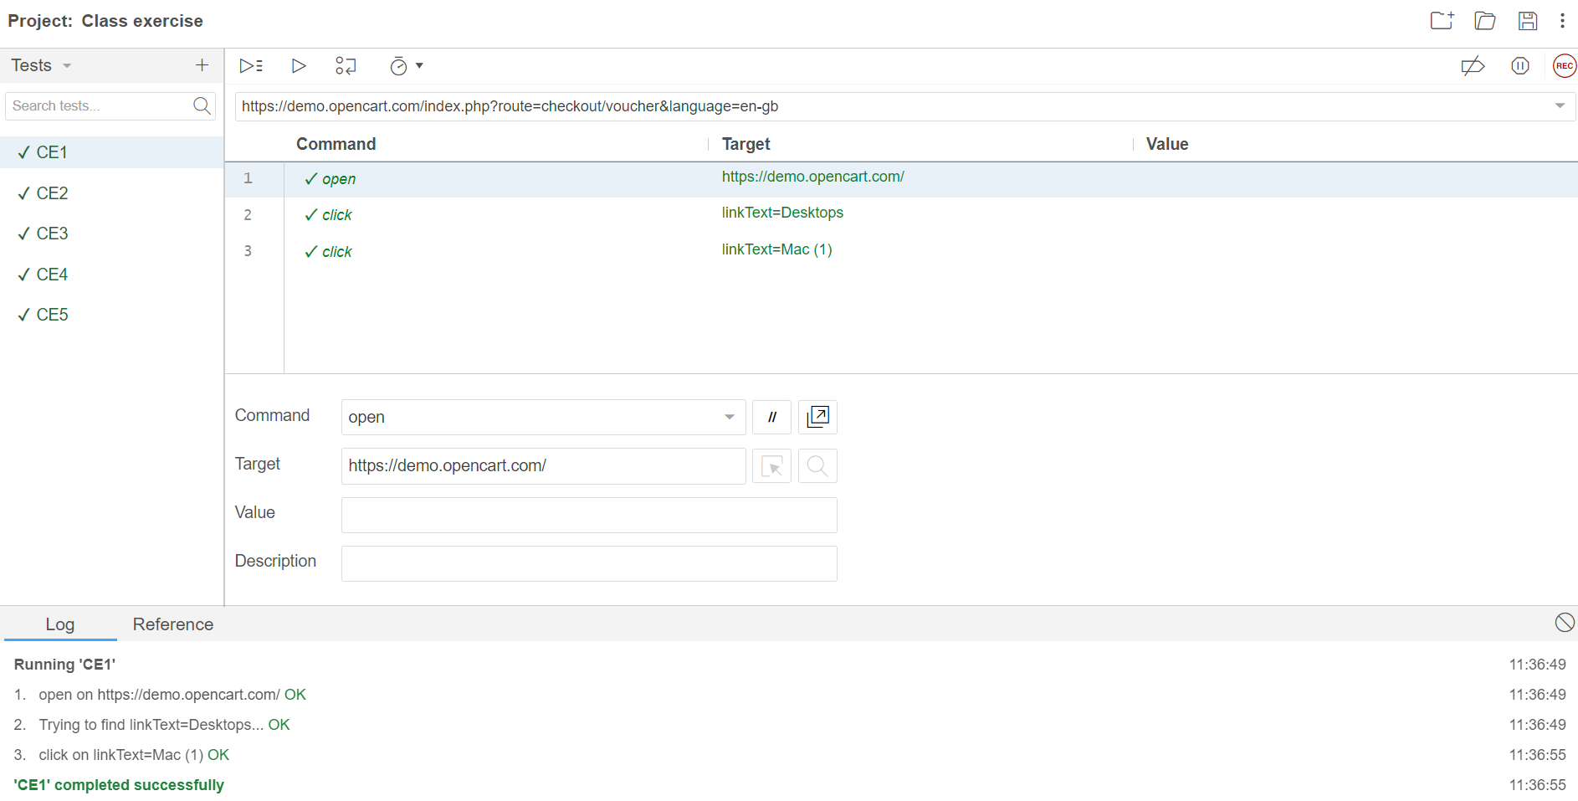

CLASS_EXERCISE_002:

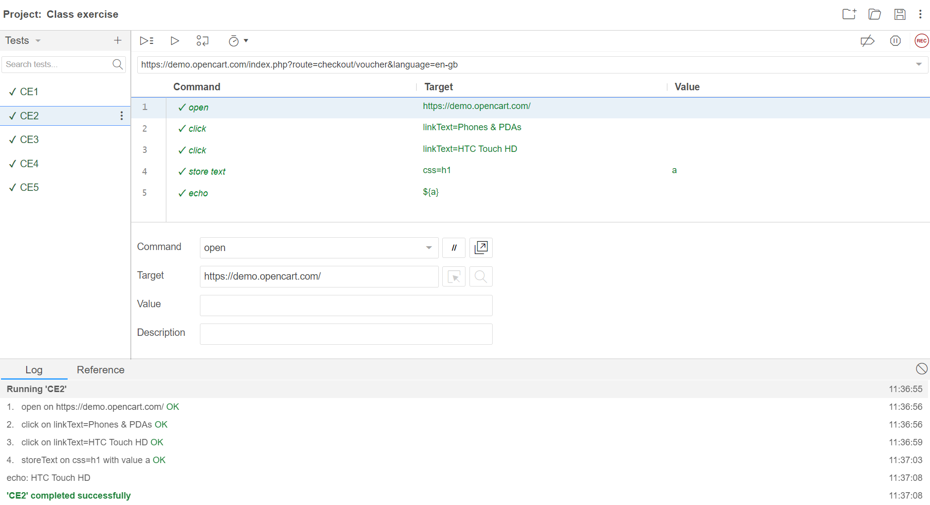

CLASS_EXERCISE_003:

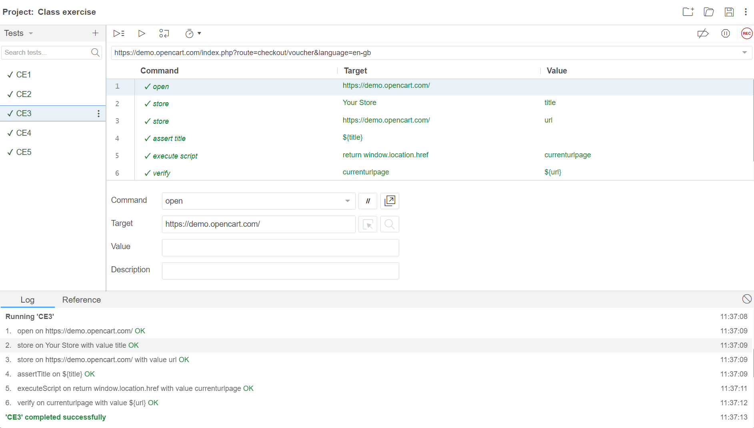

CLASS_EXERCISE_004:

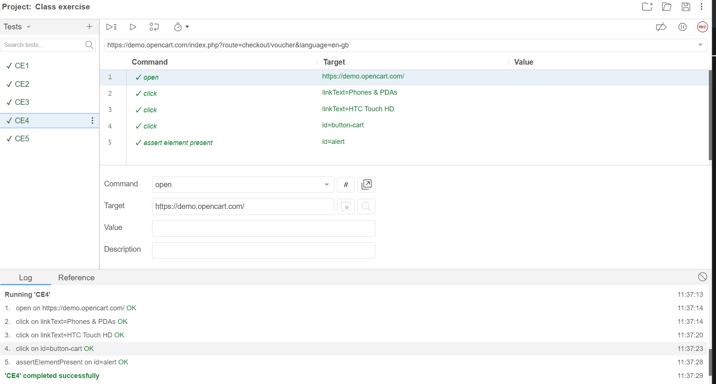

CLASS_EXERCISE_005:

