CLASS EXERCISE 1:

**package** com.Test.Test;

**import** org.openqa.selenium.WebDriver;

**import** org.openqa.selenium.chrome.ChromeDriver;

**import** org.openqa.selenium.chrome.ChromeOptions;

**import** org.testng.Assert;

**import** org.testng.annotations.Test;

**import** io.github.bonigarcia.wdm.WebDriverManager;

**public** **class** d71 {

@Test

**public** **void** f() {

ChromeOptions co=**new** ChromeOptions();

co.addArguments("--remote-allow-origins=*");

WebDriverManager.*chromedriver*().setup();

WebDriver d=**new** ChromeDriver(co);

d.get("https://demo.wpeverest.com/user-registration/guest-registration-form/");

String ctitle=d.getTitle();

String etitle="Guest Registration Form – User Registration";

Assert.*assertEquals*(ctitle,etitle);

}

}

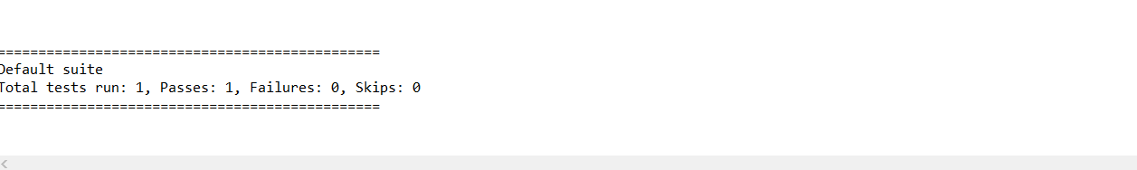

CLASS EXERCISE 2:

**package** com.Test.Test;

**import** org.testng.Assert;

**import** org.testng.annotations.Test;

**public** **class** d72 {

**int** a=20;

**int** b=10;

@Test(priority=1)

**public** **void** add() {

**int** c=a+b;

**int** d=30;

Assert.*assertEquals*(c, d);

System.***out***.println("Added");

}

@Test(priority=2)

**public** **void** subtract() {

**int** c=a-b;

**int** d=10;

Assert.*assertEquals*(c, d);

System.***out***.println("Subtracted");

}

@Test(priority=3)

**public** **void** multiply() {

**int** c=a*b;

**int** d=200;

Assert.*assertEquals*(c, d);

System.***out***.println("Multiplied");

}

@Test(priority=4)

**public** **void** divide() {

**int** c=a/b;

**int** d=2;

Assert.*assertEquals*(c, d);

System.***out***.println("Divided");

}

}

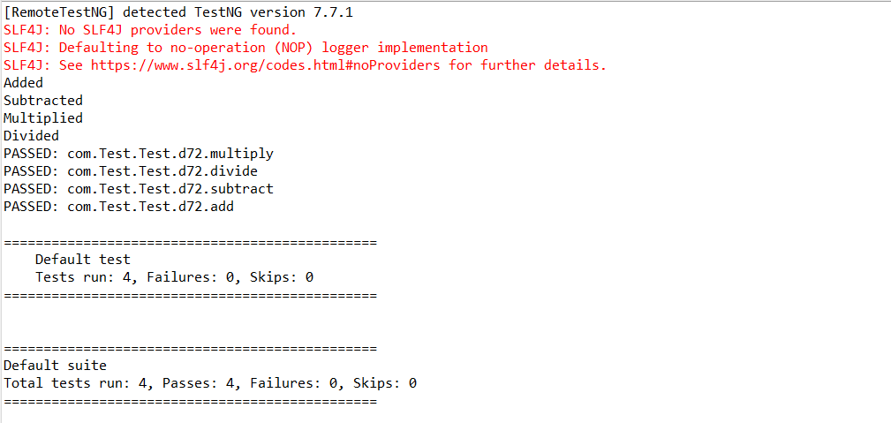

CLASS EXERCISE 3:

**package** com.Test.Test;

**import** org.testng.annotations.Test;

**import** io.github.bonigarcia.wdm.WebDriverManager;

**import** org.testng.annotations.BeforeMethod;

**import** org.openqa.selenium.By;

**import** org.openqa.selenium.WebDriver;

**import** org.openqa.selenium.chrome.ChromeDriver;

**import** org.openqa.selenium.chrome.ChromeOptions;

**import** org.testng.Assert;

**import** org.testng.annotations.AfterMethod;

**public** **class** d73 {

WebDriver d;

@Test

**public** **void** login() **throws** InterruptedException {

Thread.*sleep*(3000);

d.findElement(By.*xpath*("//*[@id=\"app\"]/div[1]/div/div[1]/div/div[2]/div[2]/form/div[1]/div/div[2]/input")).sendKeys("Admin");

d.findElement(By.*xpath*("//*[@id=\"app\"]/div[1]/div/div[1]/div/div[2]/div[2]/form/div[2]/div/div[2]/input")).sendKeys("admin123");

d.findElement(By.*xpath*("//*[@id=\"app\"]/div[1]/div/div[1]/div/div[2]/div[2]/form/div[3]/button")).click();

String et="Dashboard";

System.***out***.println(et);

Thread.*sleep*(3000);

String ct=d.findElement(By.*xpath*("//*[@id=\"app\"]/div[1]/div[1]/header/div[1]/div[1]/span/h6")).getText();

System.***out***.println(ct);

Assert.*assertEquals*(et, ct);

System.***out***.println("Logged in");

}

@BeforeMethod

**public** **void** beforeMethod() {

ChromeOptions co=**new** ChromeOptions();

co.addArguments("--remote-allow-origins=*");

WebDriverManager.*chromedriver*().setup();

d=**new** ChromeDriver(co);

d.get("https://opensource-demo.orangehrmlive.com/web/index.php/auth/login");

d.manage().window().maximize();

}

@AfterMethod

**public** **void** afterMethod() {

d.close();

}

}

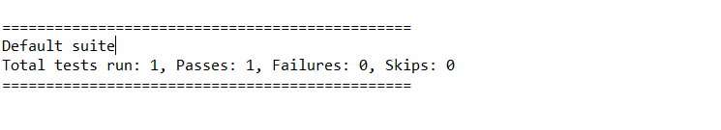

CLASS EXERCISE 4:

**package** com.Test.Test;

**import** org.openqa.selenium.By;

**import** org.openqa.selenium.WebDriver;

**import** org.openqa.selenium.chrome.ChromeDriver;

**import** org.openqa.selenium.chrome.ChromeOptions;

**import** org.testng.Assert;

**import** org.testng.annotations.Test;

**import** io.github.bonigarcia.wdm.WebDriverManager;

**public** **class** d74 {

WebDriver d;

@Test

**public** **void** login() **throws** InterruptedException {

ChromeOptions co=**new** ChromeOptions();

co.addArguments("--remote-allow-origins=*");

WebDriverManager.*chromedriver*().setup();

d=**new** ChromeDriver(co);

d.get("https://opensource-demo.orangehrmlive.com/web/index.php/auth/login");

d.manage().window().maximize();

Thread.*sleep*(3000);

d.findElement(By.*xpath*("//*[@id=\"app\"]/div[1]/div/div[1]/div/div[2]/div[2]/form/div[1]/div/div[2]/input")).sendKeys("Admin");

d.findElement(By.*xpath*("//*[@id=\"app\"]/div[1]/div/div[1]/div/div[2]/div[2]/form/div[2]/div/div[2]/input")).sendKeys("admin123");

d.findElement(By.*xpath*("//*[@id=\"app\"]/div[1]/div/div[1]/div/div[2]/div[2]/form/div[3]/button")).click();

String et="Dashboard";

System.***out***.println(et);

Thread.*sleep*(3000);

String ct=d.findElement(By.*xpath*("//*[@id=\"app\"]/div[1]/div[1]/header/div[1]/div[1]/span/h6")).getText();

System.***out***.println(ct);

Assert.*assertEquals*(et, ct);

System.***out***.println("Logged in");

}

@Test(dependsOnMethods="login")

**public** **void** logut() **throws** InterruptedException {

d.findElement(By.*xpath*("//*[@id=\"app\"]/div[1]/div[1]/header/div[1]/div[2]/ul/li/span")).click();

d.findElement(By.*xpath*("//*[@id=\"app\"]/div[1]/div[1]/header/div[1]/div[2]/ul/li/ul/li[4]/a")).click();

String et="Login";

System.***out***.println(et);

Thread.*sleep*(2000);

String ct=d.findElement(By.*xpath*("//*[@id=\"app\"]/div[1]/div/div[1]/div/div[2]/h5")).getText();

System.***out***.println(ct);

Assert.*assertEquals*(et, ct);

System.***out***.println("Logged out successfully");

}

}

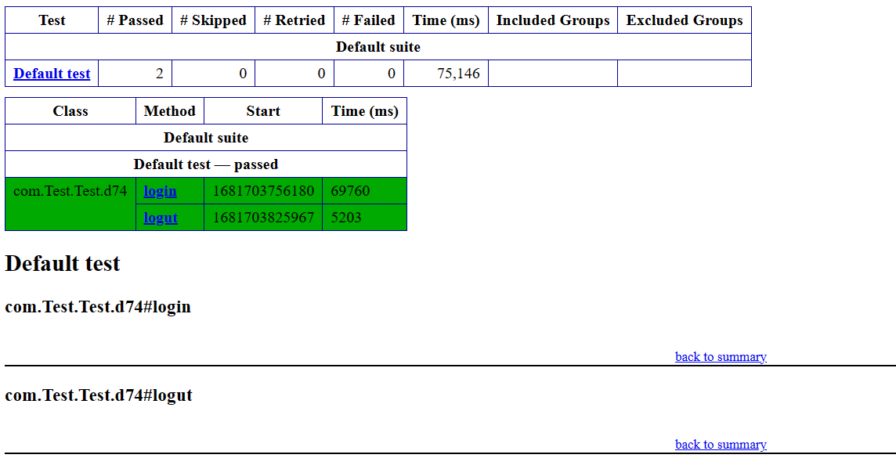

CLASS EXERCISE 5:

**package** com.Test.Test;

**import** org.testng.annotations.Test;

**import** io.github.bonigarcia.wdm.WebDriverManager;

**import** org.testng.annotations.BeforeMethod;

**import** java.util.concurrent.TimeUnit;

**import** org.openqa.selenium.By;

**import** org.openqa.selenium.WebDriver;

**import** org.openqa.selenium.chrome.ChromeDriver;

**import** org.openqa.selenium.chrome.ChromeOptions;

**import** org.testng.Assert;

**import** org.testng.annotations.AfterMethod;

**public** **class** d75 {

WebDriver d;

@Test(groups= {"SmokeTest"})

**public** **void** t1() {

String eurl="https://www.godaddy.com/en-in";

String curl=d.getCurrentUrl();

Assert.assertEquals(eurl,curl);

String etitle="Domain Names, Websites, Hosting & Online Marketing Tools - GoDaddy IN";

String ctitle=d.getTitle();

Assert.assertEquals(etitle, ctitle);

}

@Test(groups= {"RegressionTest"})

**public** **void** t2() {

d.manage().timeouts().implicitlyWait(10,TimeUnit.SECONDS);

d.findElement(By.xpath("//*[@id=\"id-631b049a-e9c0-4d24-8710-c504745206dd\"]/div[2]/div[1]/ul/li[1]/button")).click();

d.findElement(By.xpath("//*[@id=\"id-631b049a-e9c0-4d24-8710-c504745206dd\"]/div[2]/div[1]/ul/li[1]/div/div[2]/div[1]/ul/li[2]/a")).click();

}

@Test(groups= {"RegressionTest"})

**public** **void** t3() {

d.manage().timeouts().implicitlyWait(10,TimeUnit.SECONDS);

d.findElement(By.xpath("//*[@id=\"id-631b049a-e9c0-4d24-8710-c504745206dd\"]/div[2]/div[1]/ul/li[1]/button")).click();

d.findElement(By.xpath("//*[@id=\"id-631b049a-e9c0-4d24-8710-c504745206dd\"]/div[2]/div[1]/ul/li[1]/div/div[2]/div[1]/ul/li[2]/a")).click();

String et="GoDaddy Domain Search - Buy and Register Available Domain Names";

String ct=d.getTitle();

System.out.println(ct);

Assert.assertEquals(et,ct);

}

@BeforeMethod

**public** **void** beforeMethod() {

ChromeOptions co=**new** ChromeOptions();

co.addArguments("--remote-allow-origins=*");

WebDriverManager.chromedriver().setup();

d=**new** ChromeDriver(co);

d.get("https://www.godaddy.com/en-in");

d.manage().window().maximize();

}

@AfterMethod

**public** **void** afterMethod() {

d.close();

}

}

