**CLOUD COMPUTING: UE20CS351**

**Assignment 1 - Introduction to AWS Lambda with API Gateway**

**-SAHANA RAO**

**-Section: J**

**-PES1UG20CS588**

Lab Tasks and their corresponding screenshots:

# 1a: Lambda Function Created

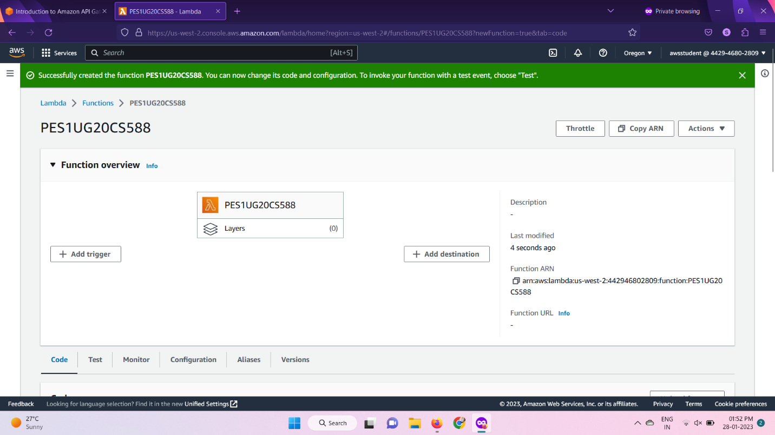

1b: API Gateway created; trigger added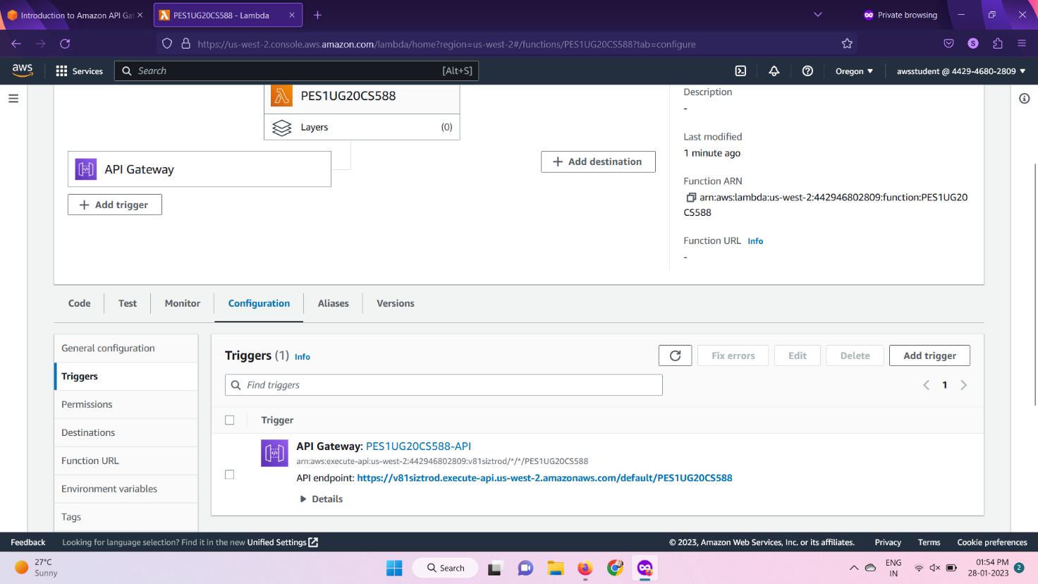

# 1c: Modified Lambda function

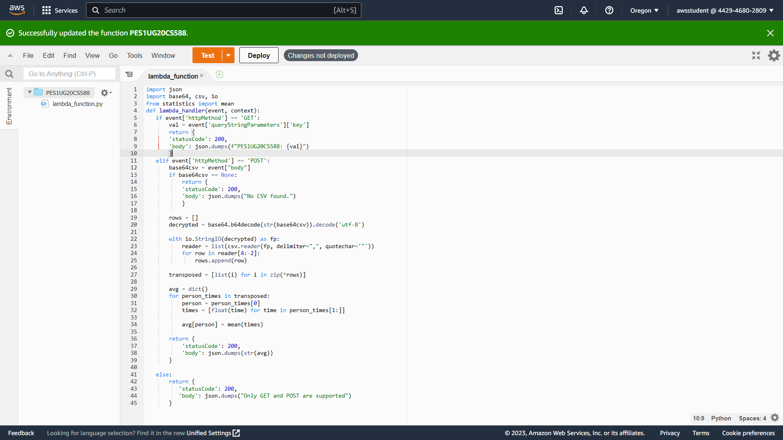

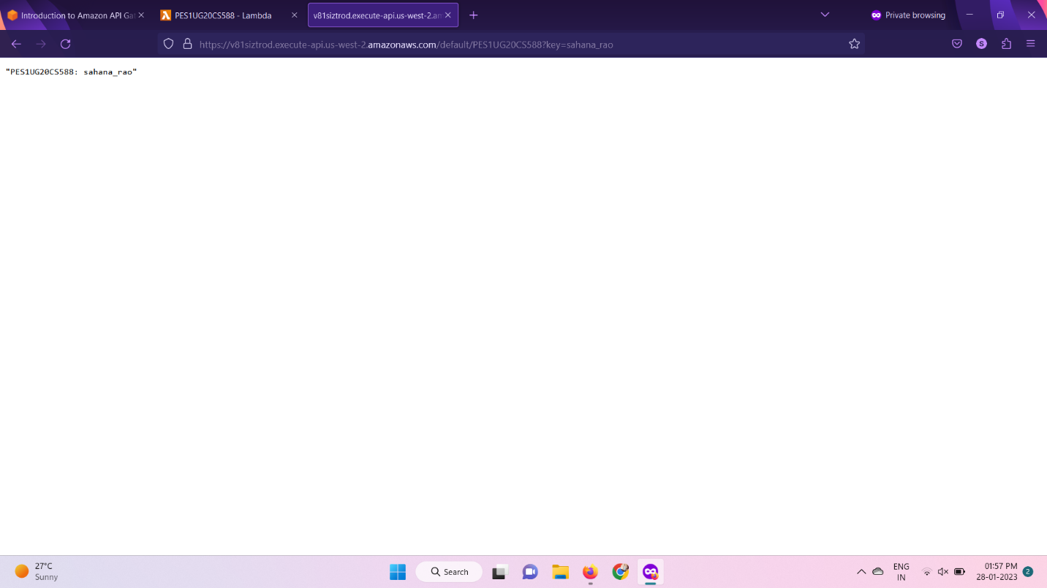

1d: Successful Postman GET request

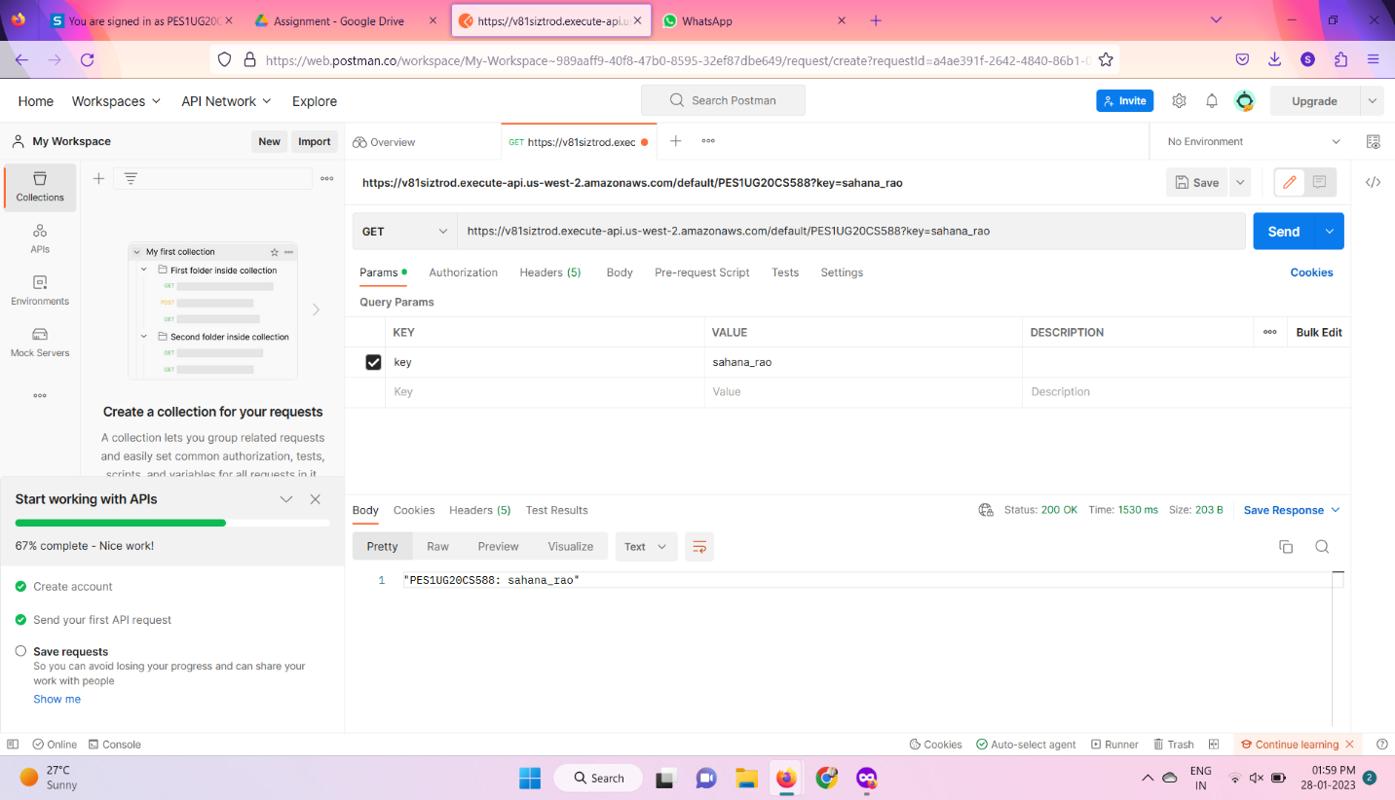1e: Successful Postman POST request

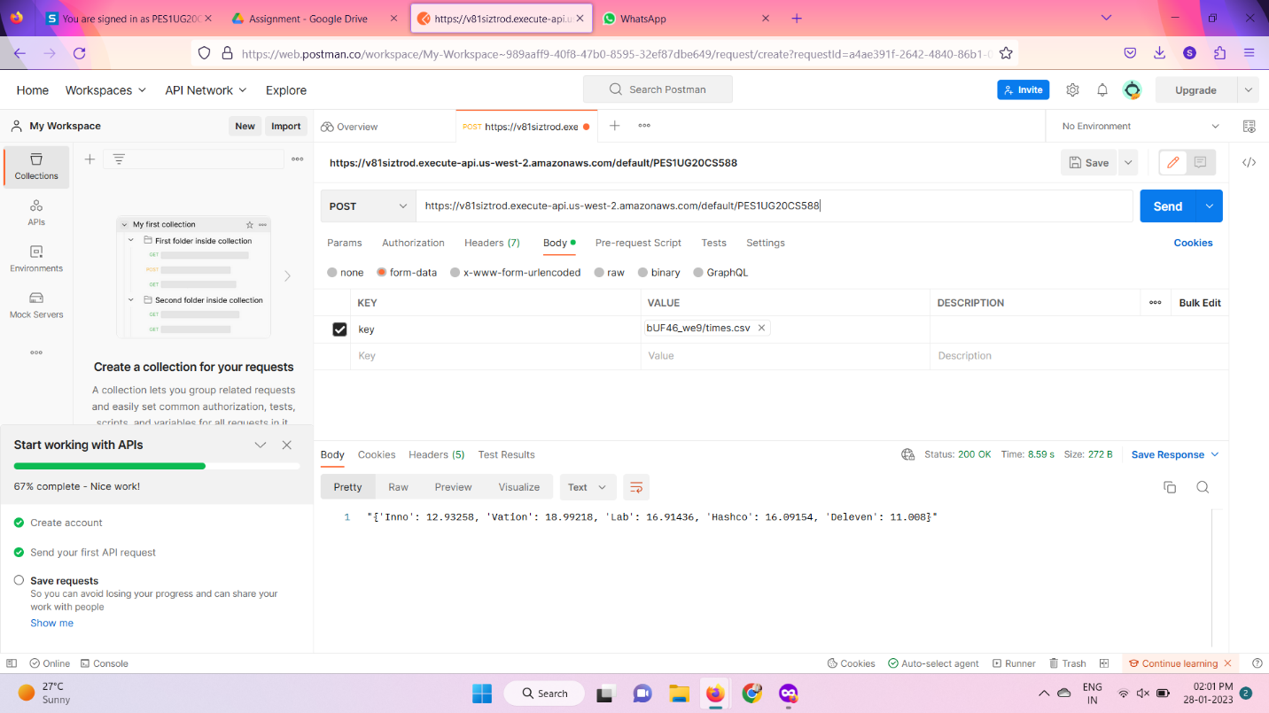

# 1f: Failed Postman **PUT**/DELETE/HEAD request

