**Assignment 4 - Introduction to Apache Zookeeper**

|  |  |  |
| --- | --- | --- |
| NAME: SAHANA RAO | SRN: PES1UG20CS588 | SECTION: J |

1a: Screenshot of Zookeeper Server having started.

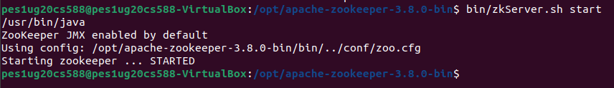

2a: Screenshot of Listing of the created ZNodes

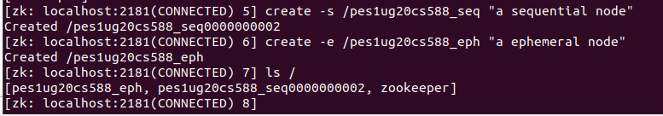

2b: Screenshot of Listing of the deleted ephemeral node

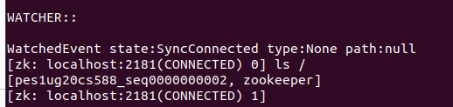

2c: Screenshot of Data and Metadata associated with the created sequential znode.

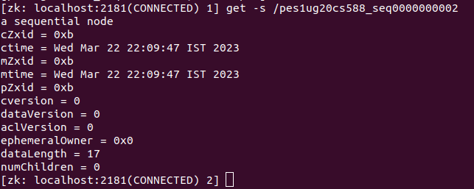

2d: Screenshot of Listing of all the children nodes

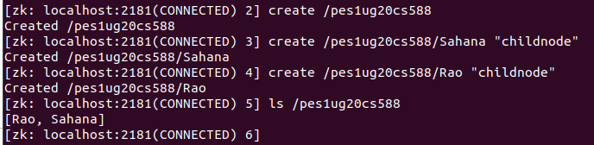

3a: Screenshot of each of the clients listing all the znodes

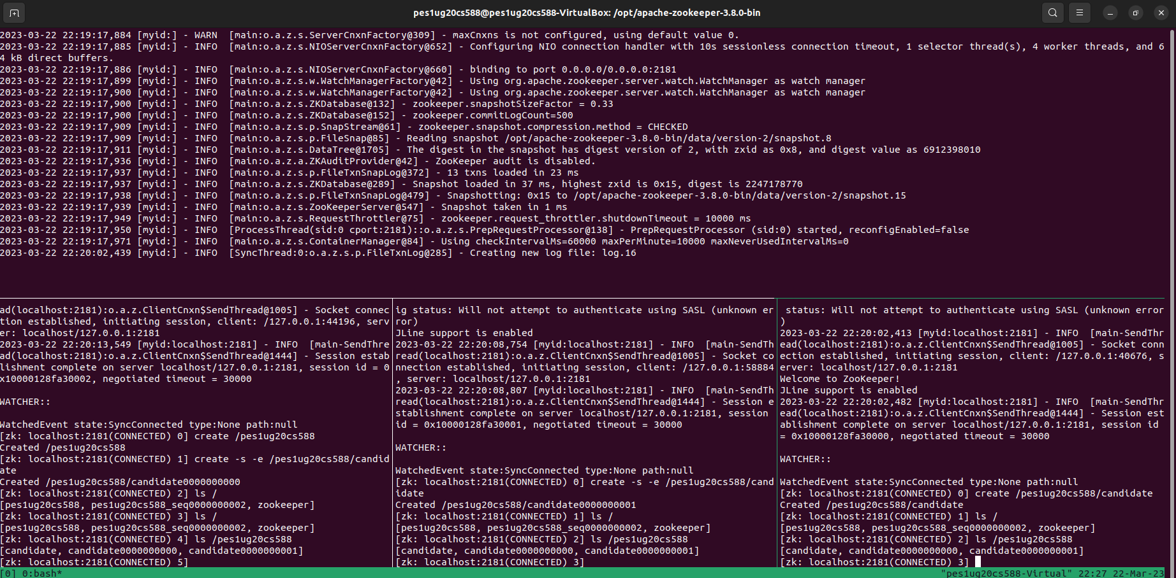

3b: Screenshot of the Watched Event and the Zookeeper Server logs.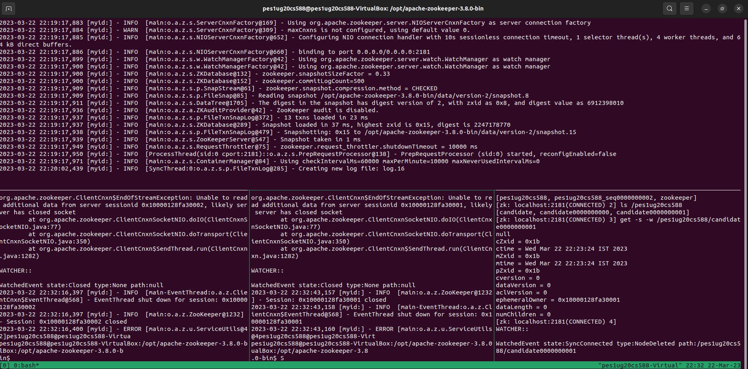

3c: Screenshot of the old leader coming back and having a new sequence number.

