**E3 : INTRODUCTION TO AMAZON DynamoDB**

|  |  |  |
| --- | --- | --- |
| NAME : SAHANA RAO | SRN : PES1UG20CS588 | SECTION : J |

● Screenshot 1a: Creation of table

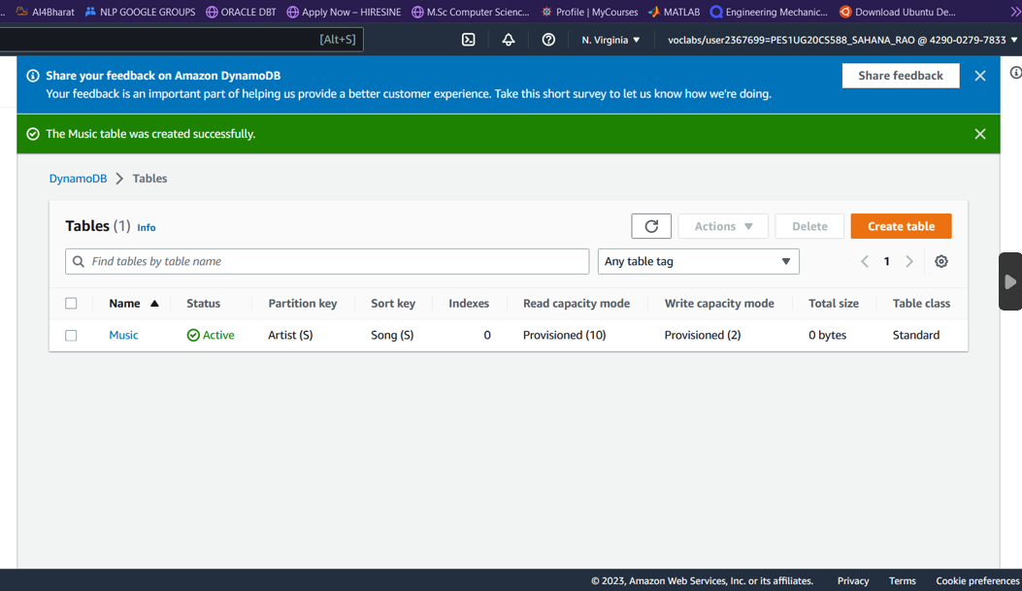

● Screenshot 2a: Show the inserted entries in table

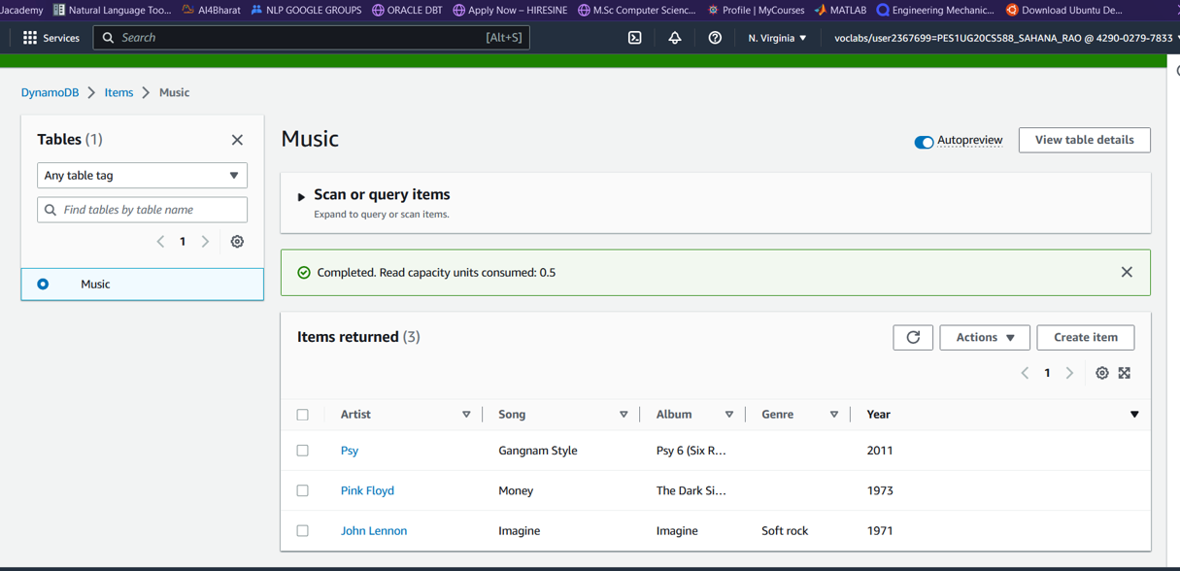

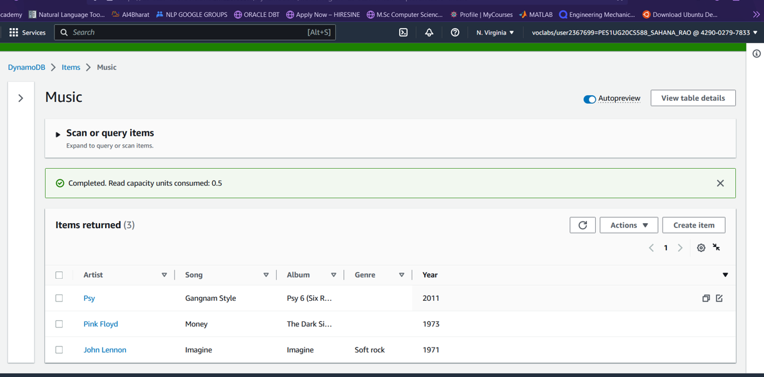

● Screenshot 3a: Show the entries post update

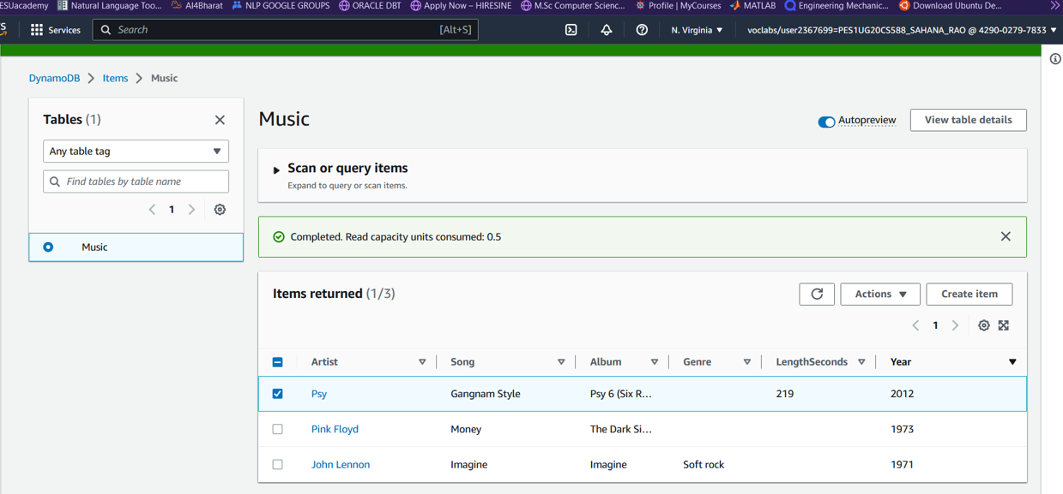

● Screenshot 4a: Result of the query Artist

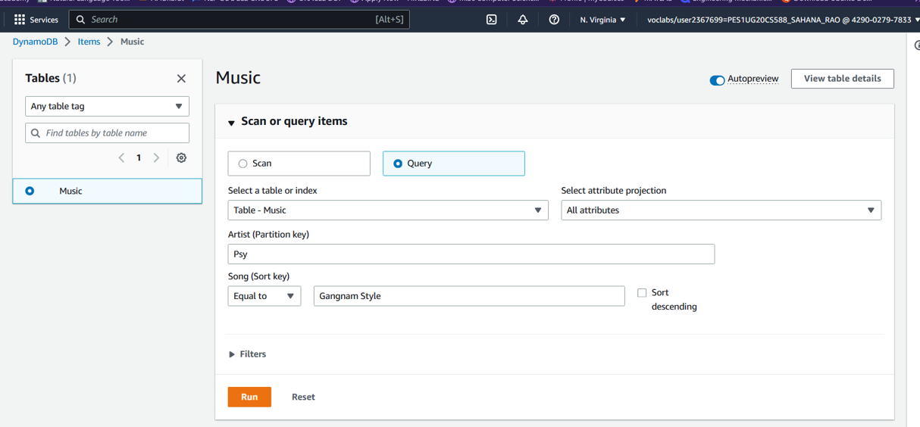

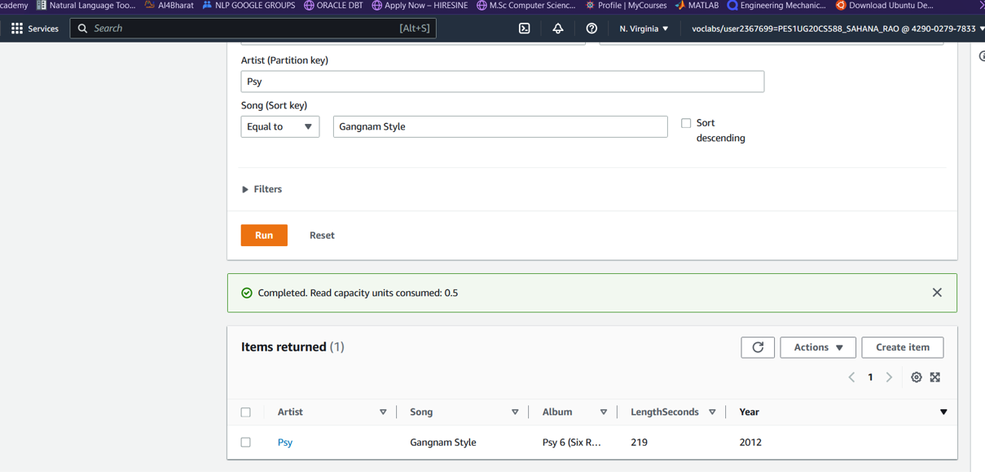

● Screenshot 4b: Result of Scan filter

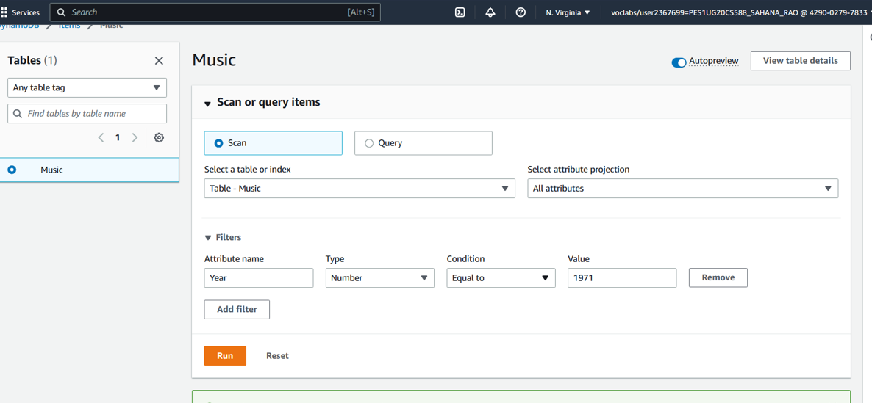

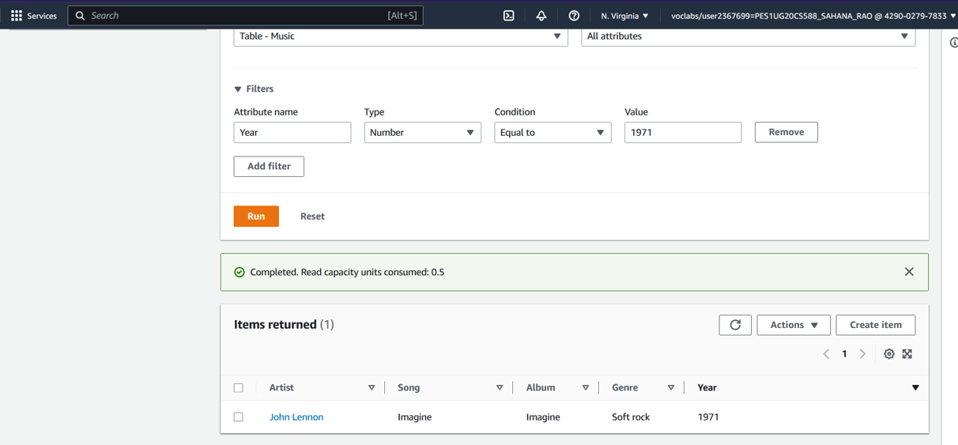

● Screenshot 5a: Data after deletion of an item from the table

