**Lab Experiment 4: The Raft Consensus Algorithm**

|  |  |  |
| --- | --- | --- |
| NAME: SAHANA RAO | SRN: PES1UG20CS588 | SECTION: J |

1a: Pyenv installed and local Python version changed to 3.7.2

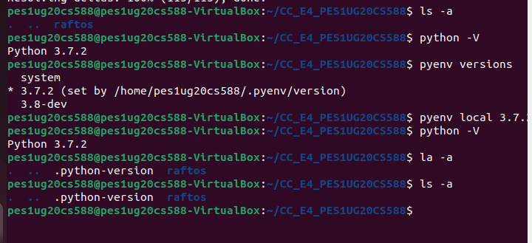

2a: Initial leader election has occurred, and first value has replicated.

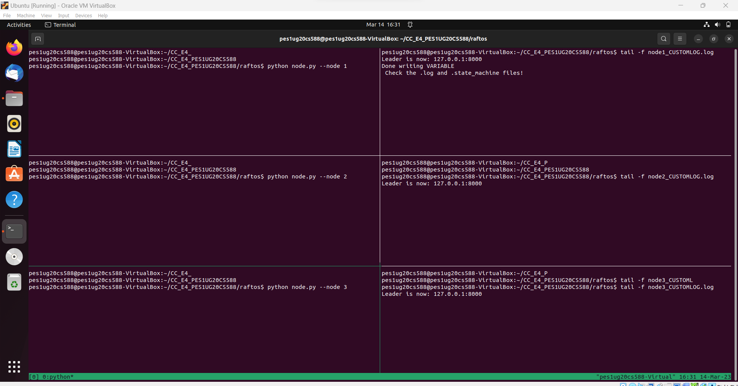

2b) Leader crashed, new leader elected, and second value replicated.

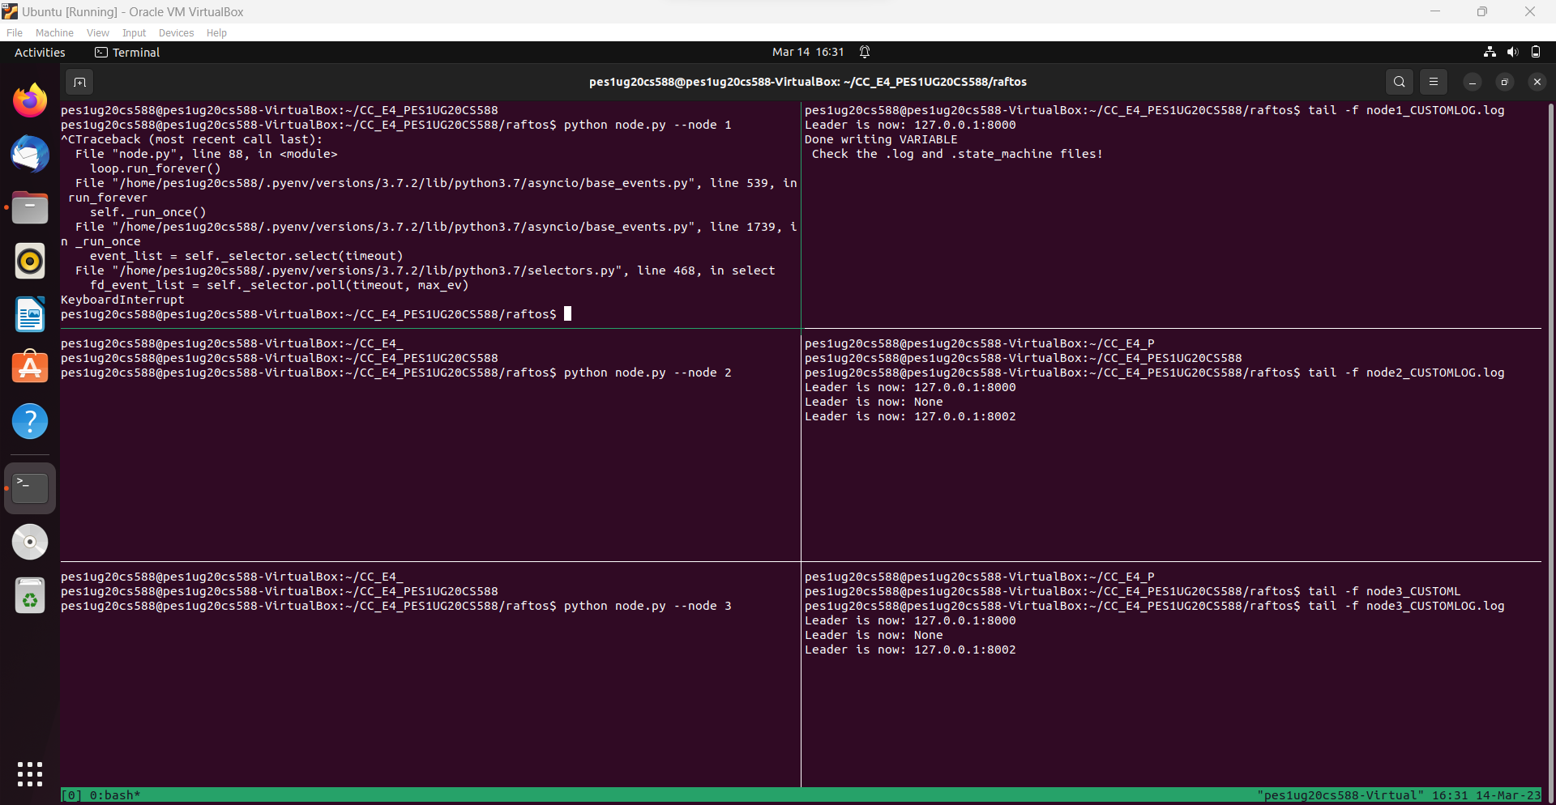

2c) Old leader comes back online, but becomes a follower instead and updates its old state

to its new state.

