**CLOUD COMPUTING – UE20CS351 LAB**

Experiment 2 - Docker on Linux/Windows/Mac OS

|  |  |  |
| --- | --- | --- |
| NAME: SAHANA RAO | SRN: PES1UG20CS588 | SECTION: J |

● 1a.jpg: Screenshot of running docker hello-world.

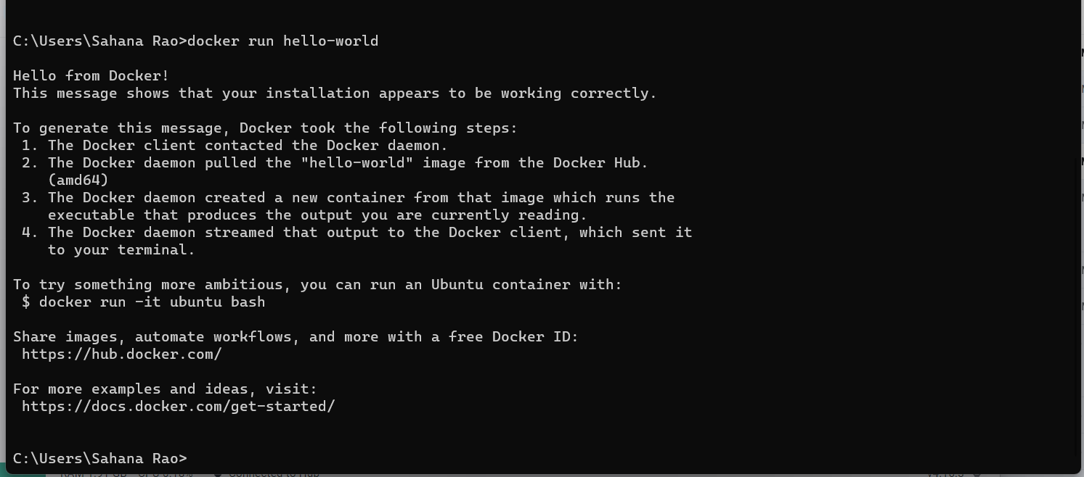

● 2a.jpg: Screenshot of C Program successfully run inside the container.

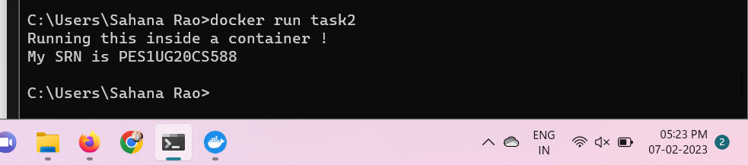

● 2b.jpg: Screenshot of the image pushed to Dockerhub.

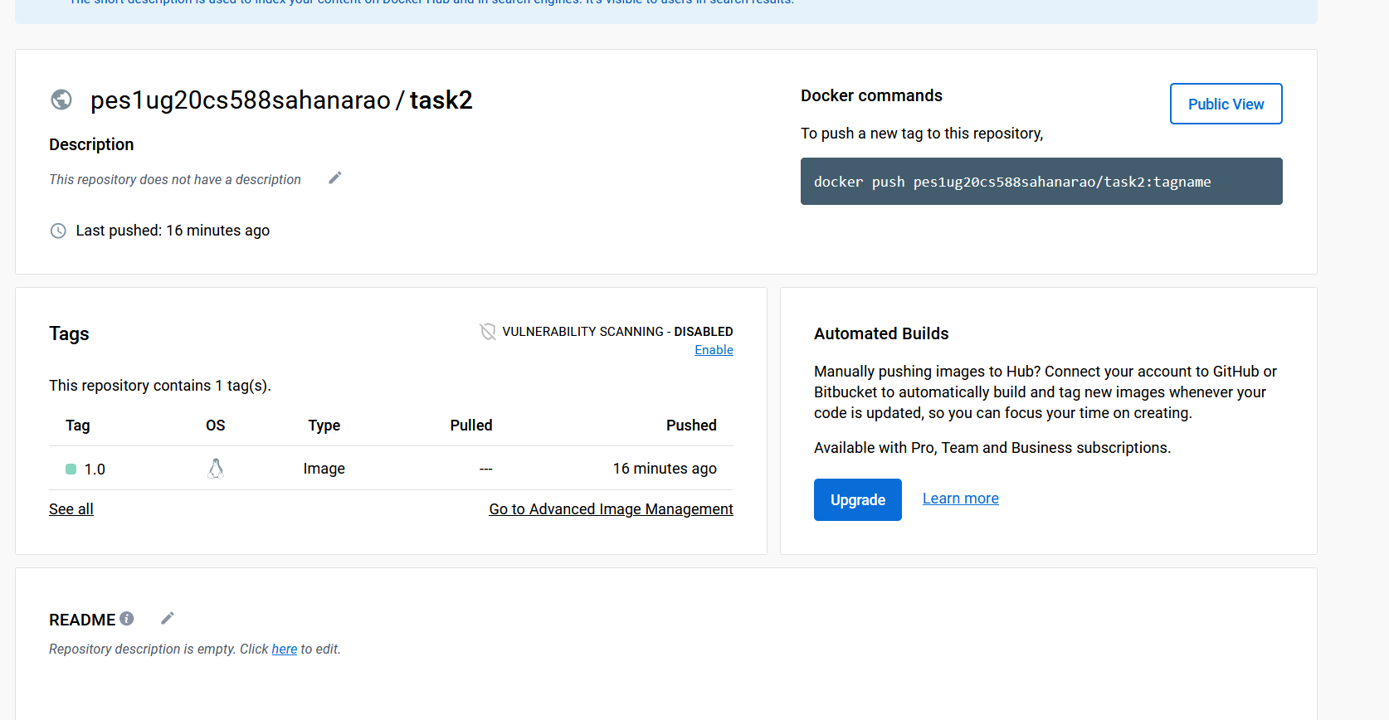

● 3a.jpg: Screenshot of docker container running nginx

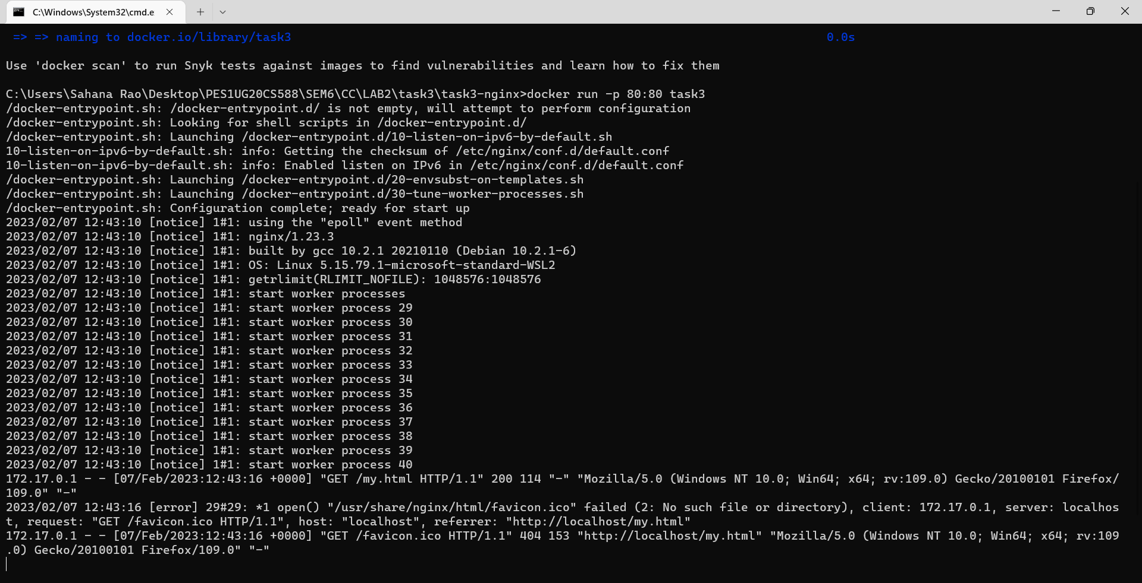

● 3b.jpg: Sample.html showing the web page on the browser.

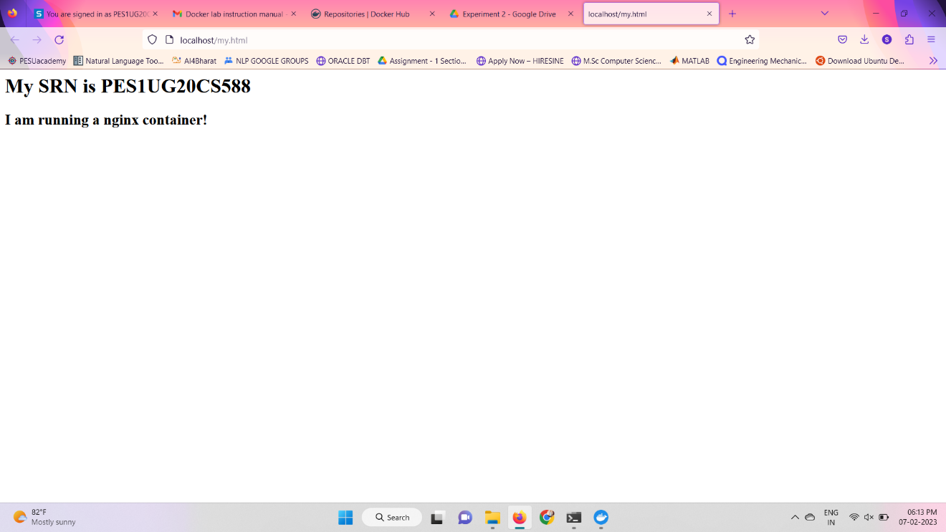

● 3c.jpg: Screenshot of python application successfully writing and reading from the MongoDB database

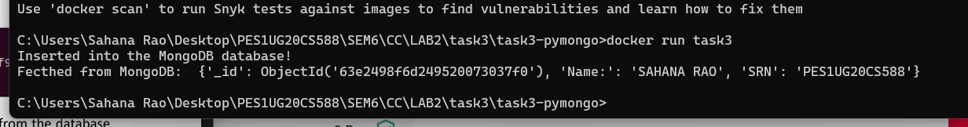

● 3d.jpg: Screenshot showing mongodb being run within the network

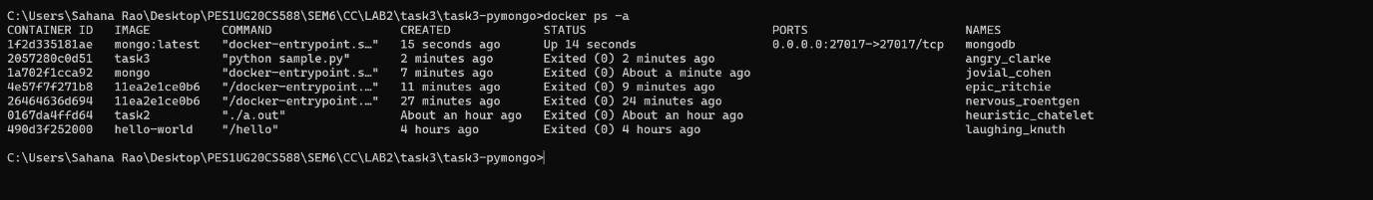

● 3e.jpg: Screenshot showing python file being run within the network and successfully writing and reading from MongoDB

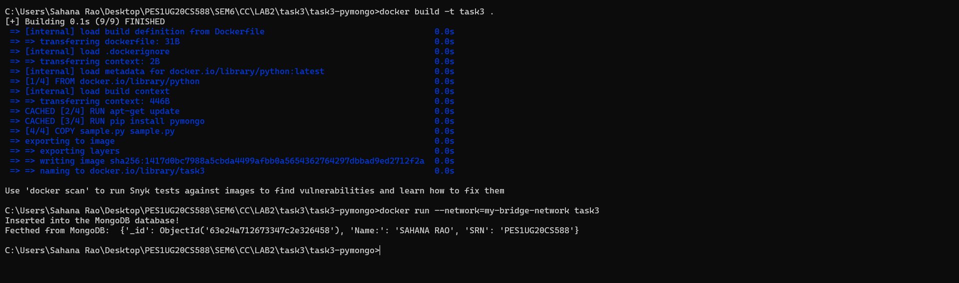

● 4a.jpg: Screenshot of python-mongodb application running as a docker-compose application

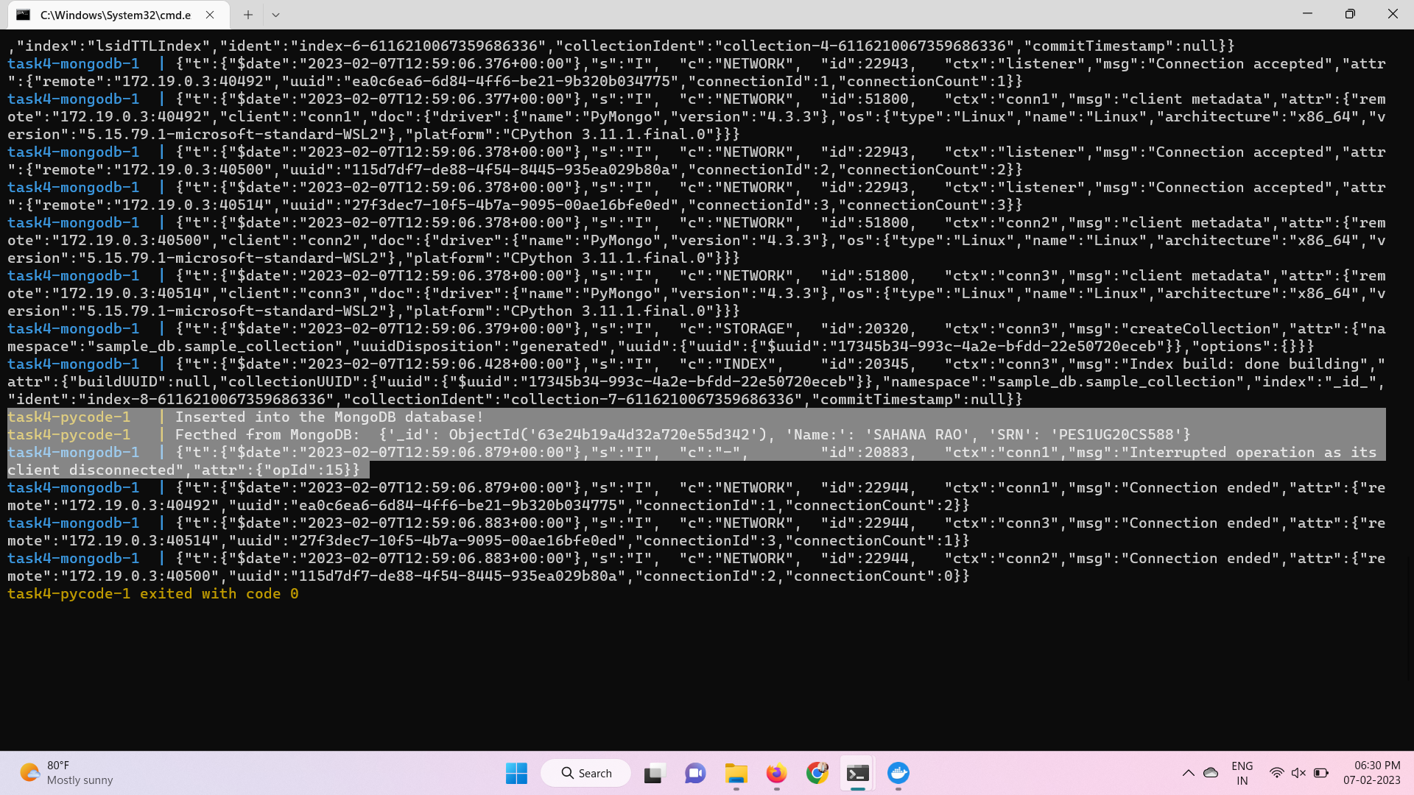

● 4b.jpg: Screenshot of 3 python application writes and reads from MongoDB after scaling the python application.