**CLOUD COMPUTING LAB-05**

|  |  |  |
| --- | --- | --- |
| NAME: SAHANA RAO | SRN: PES1UG20CS588 | SECTION: J |

**Screenshots:**

● user-1 added to the S3-Support Group.

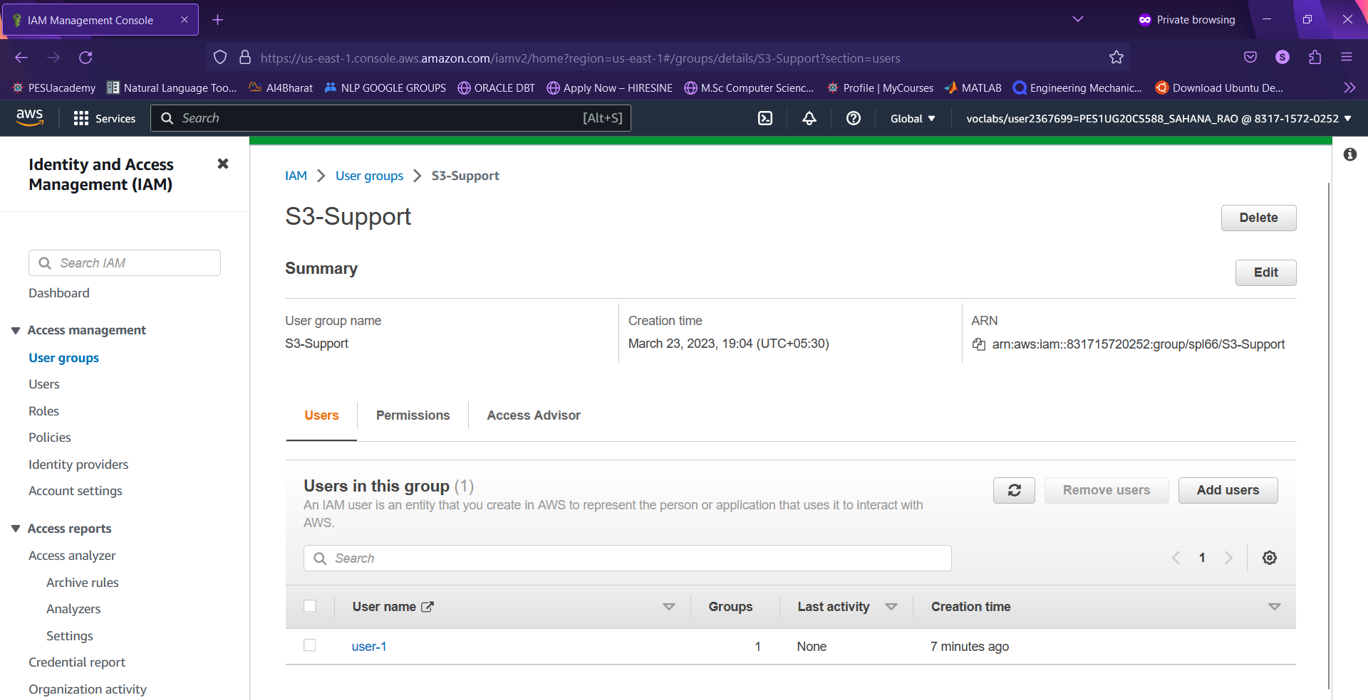

● user-2 added to the EC2-Support Group.

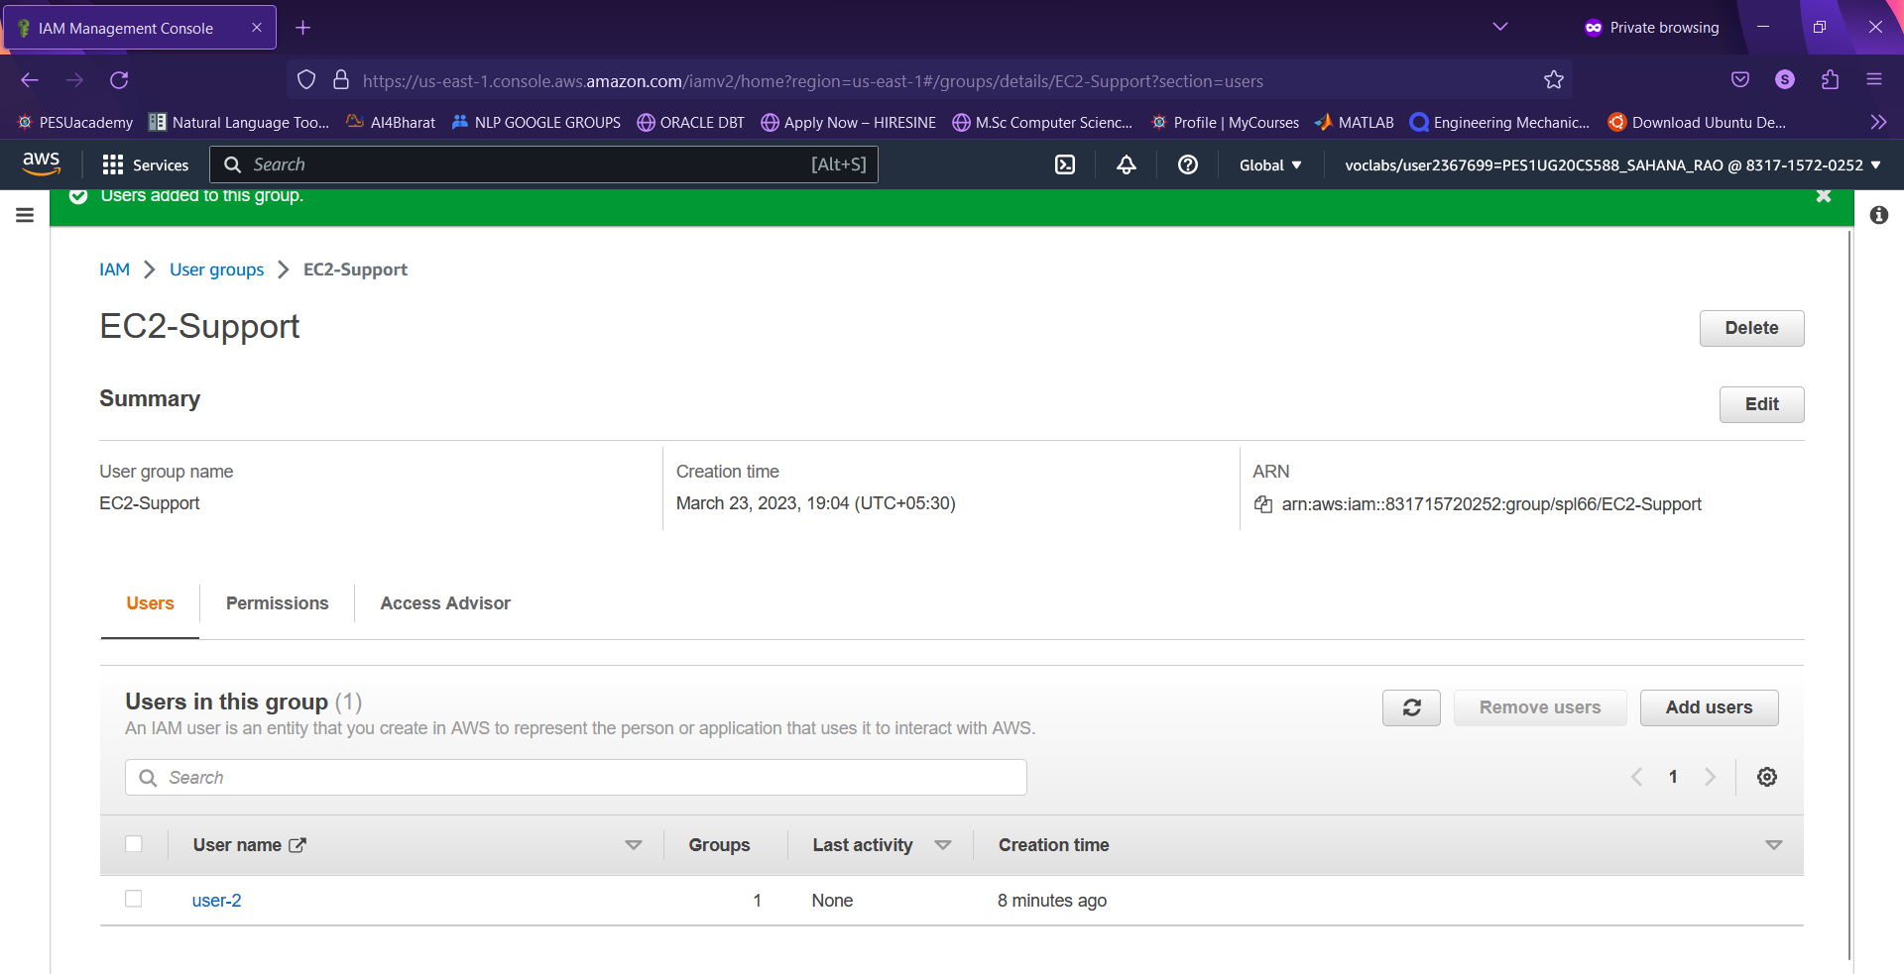

● user-3 added to the EC2-Support Group.

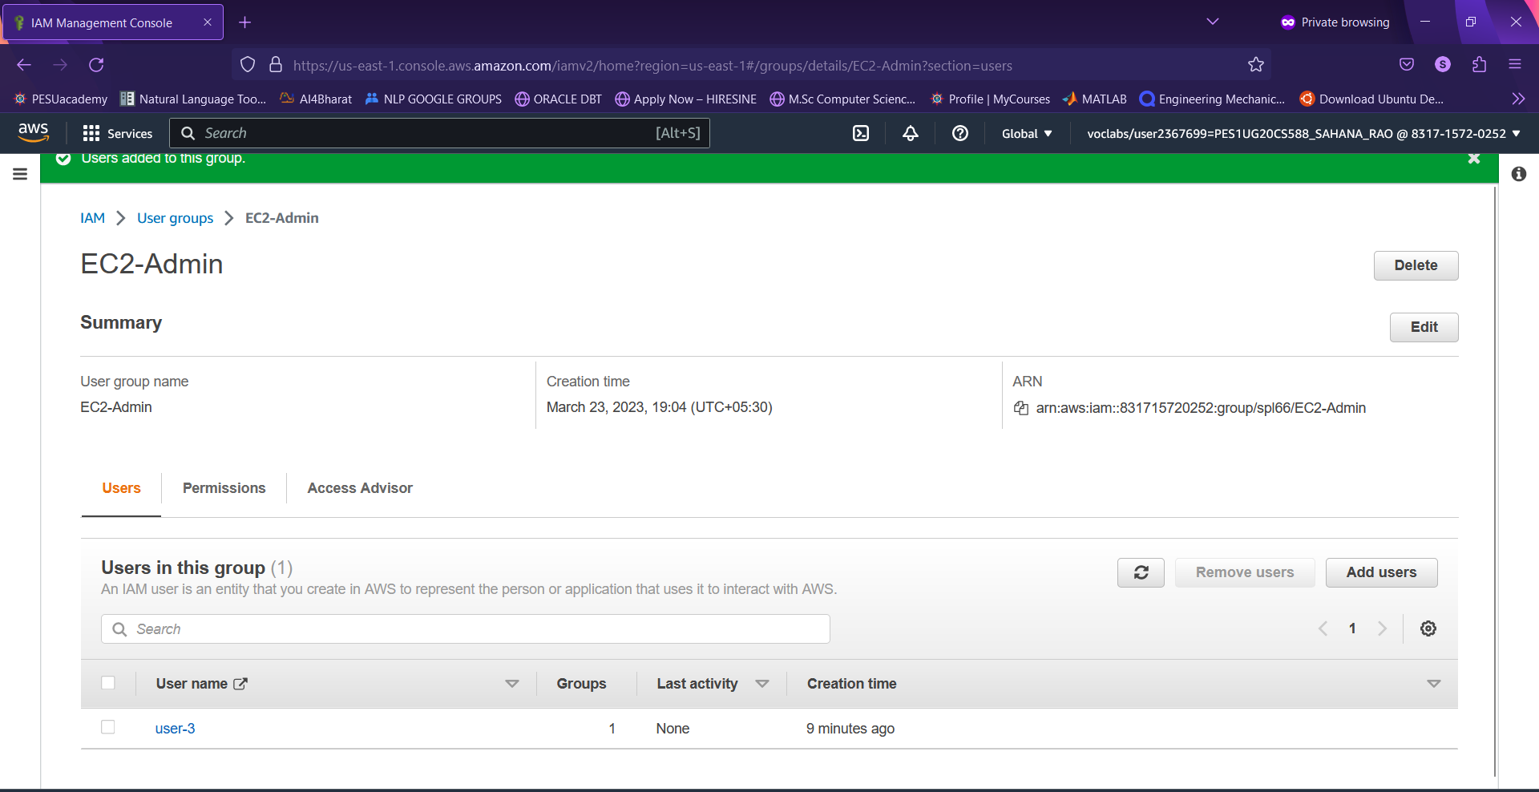

● View S3 buckets with user-1 role

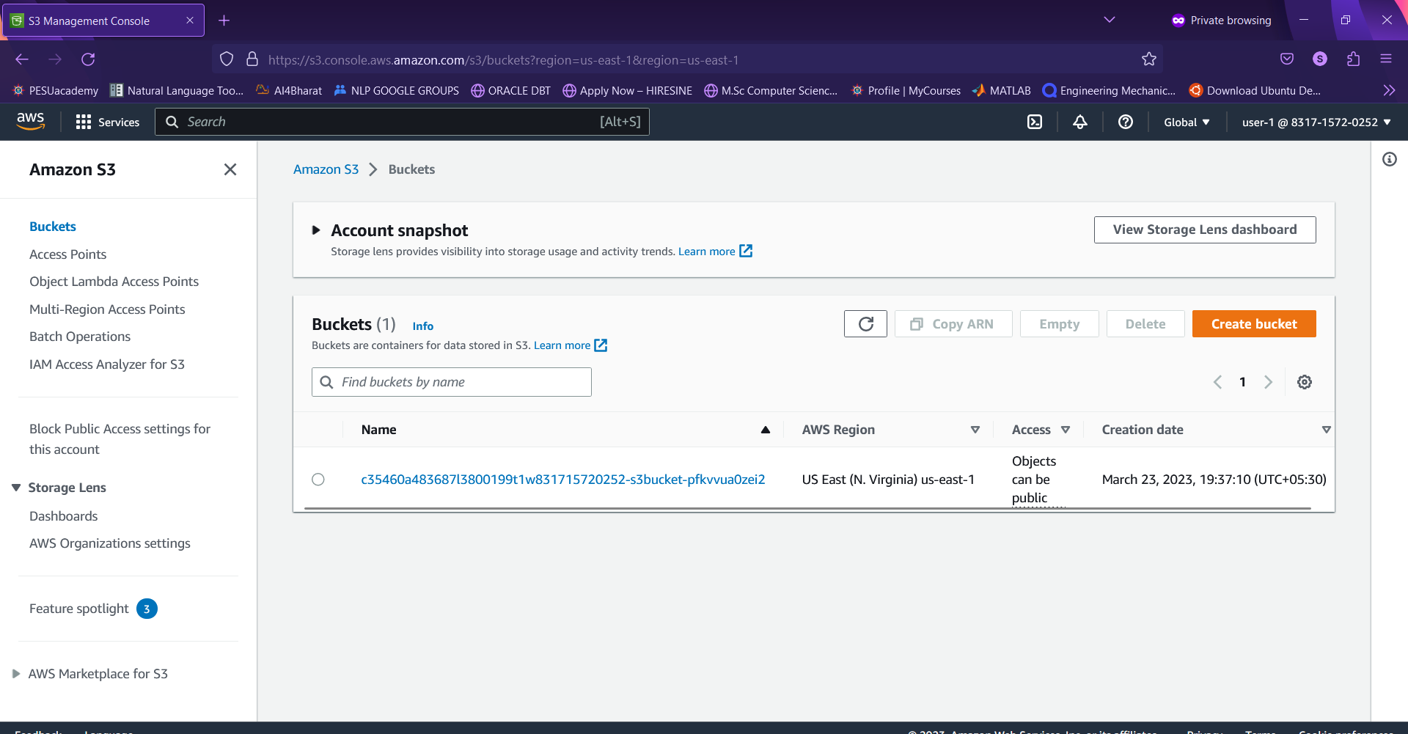

● EC2 instance dashboard with user-1 role (Not authorized)

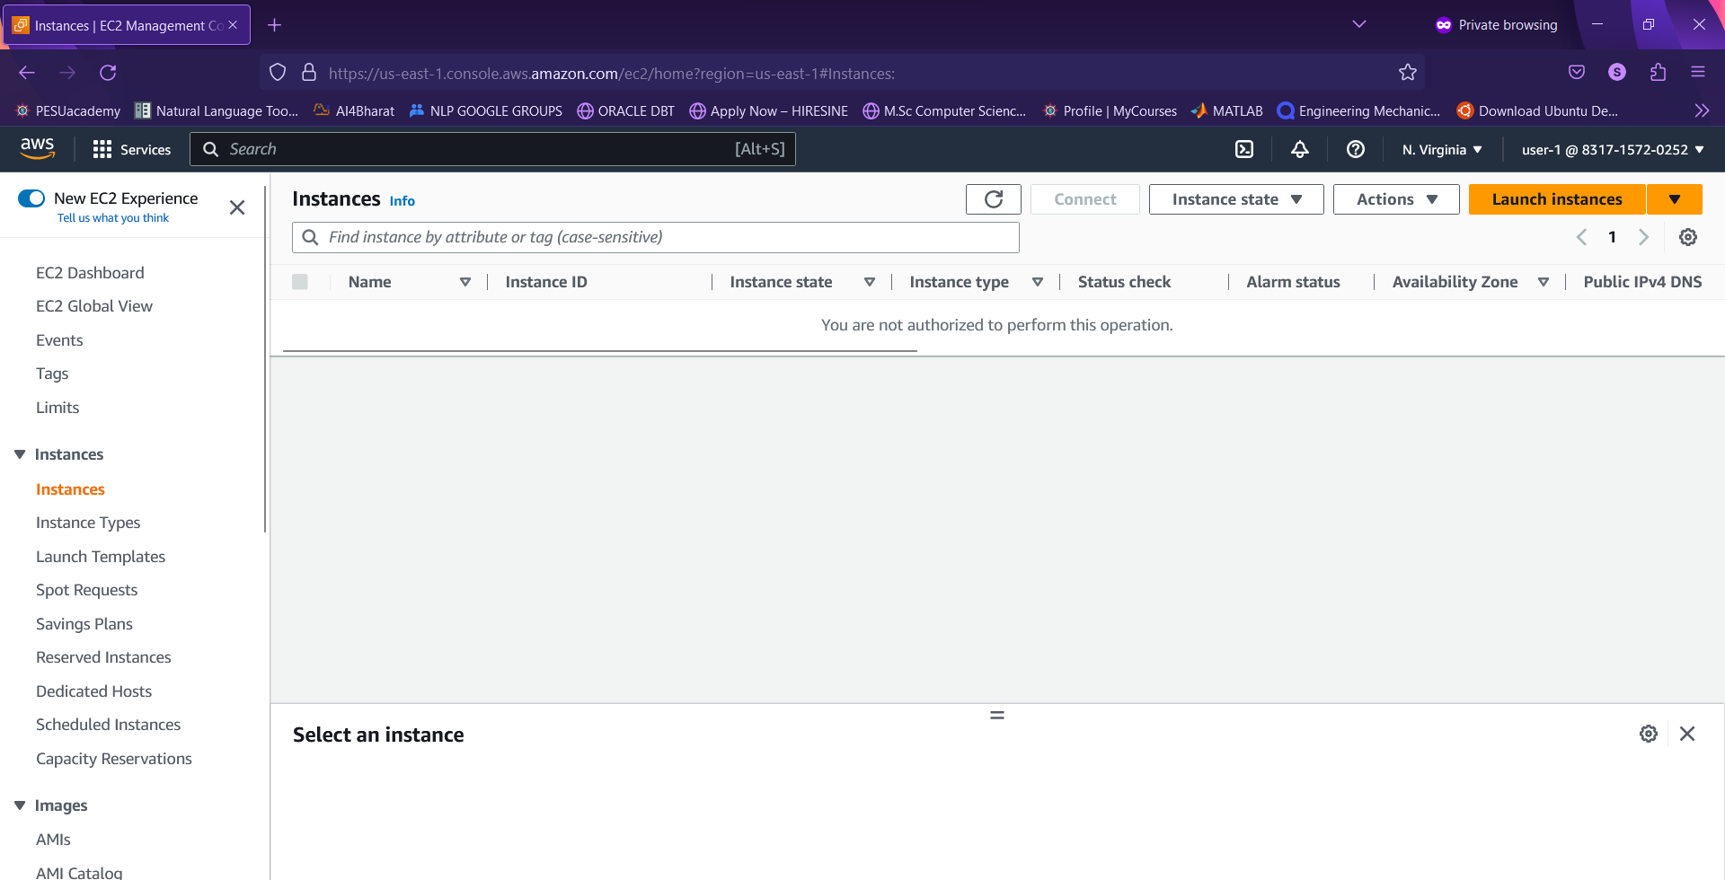

● Failure message when instance stopped with user-2 role

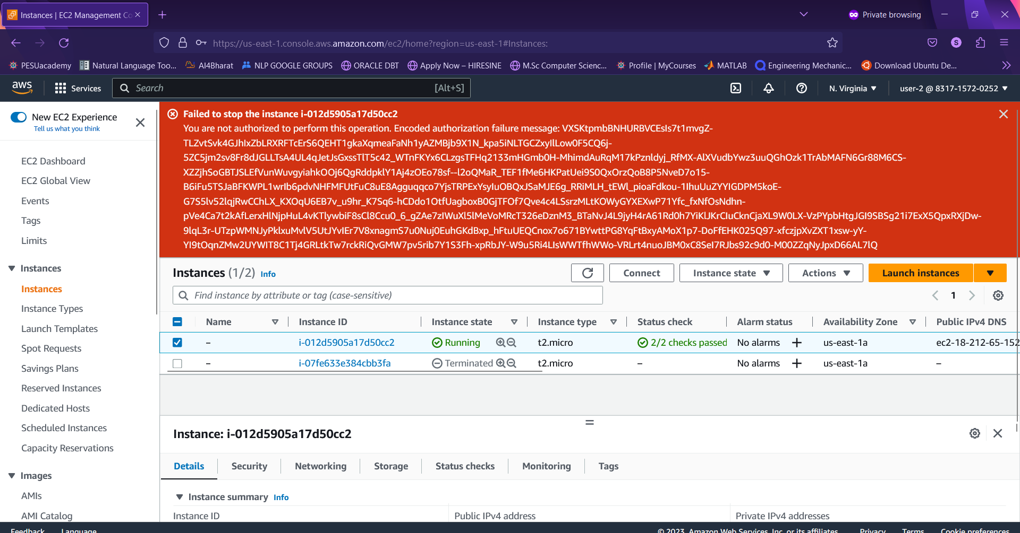

● Successful stoppage of E2 instance with user-3 role

