**DBT-ASSIGNMENT 1**

|  |  |  |
| --- | --- | --- |
| NAME: SAHANA RAO | SRN: PES1UG20CS588 | SECTION: J |

RELATIONAL SCHEMA

AIRPORT

|  |  |  |
| --- | --- | --- |
| AID | Name | City |

FLIGHT

|  |  |  |  |  |  |  |  |
| --- | --- | --- | --- | --- | --- | --- | --- |
| FID | Company | Source | Destination | ArrivalTime | DeptTime | Capacity | TimeOfFly |

Passenger

|  |  |  |  |  |  |
| --- | --- | --- | --- | --- | --- |
| SSN | Name | DOB | Age | Gender | Phone_no |

Ticket

|  |  |  |  |  |
| --- | --- | --- | --- | --- |
| TID | SSN | Fid | Class | SeatNo |

ER DIAGRAM:

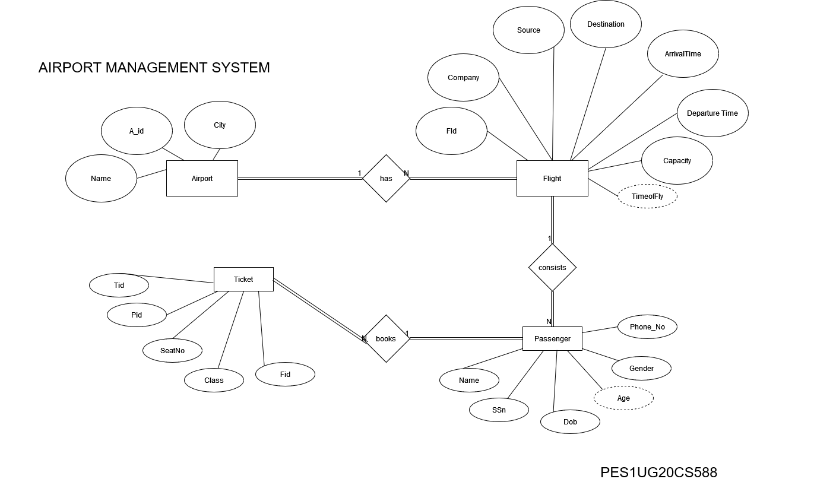

CREATION AND INSERTION OF VALUES:

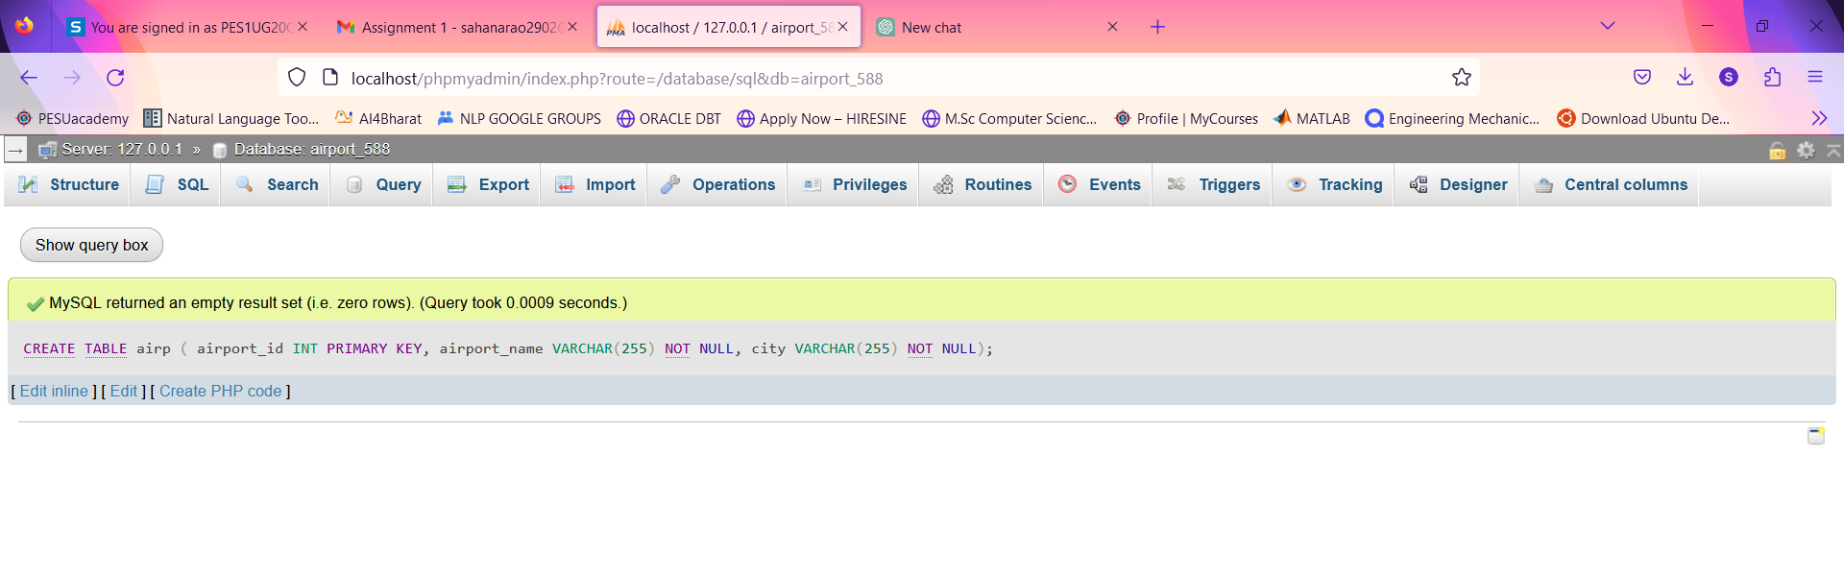

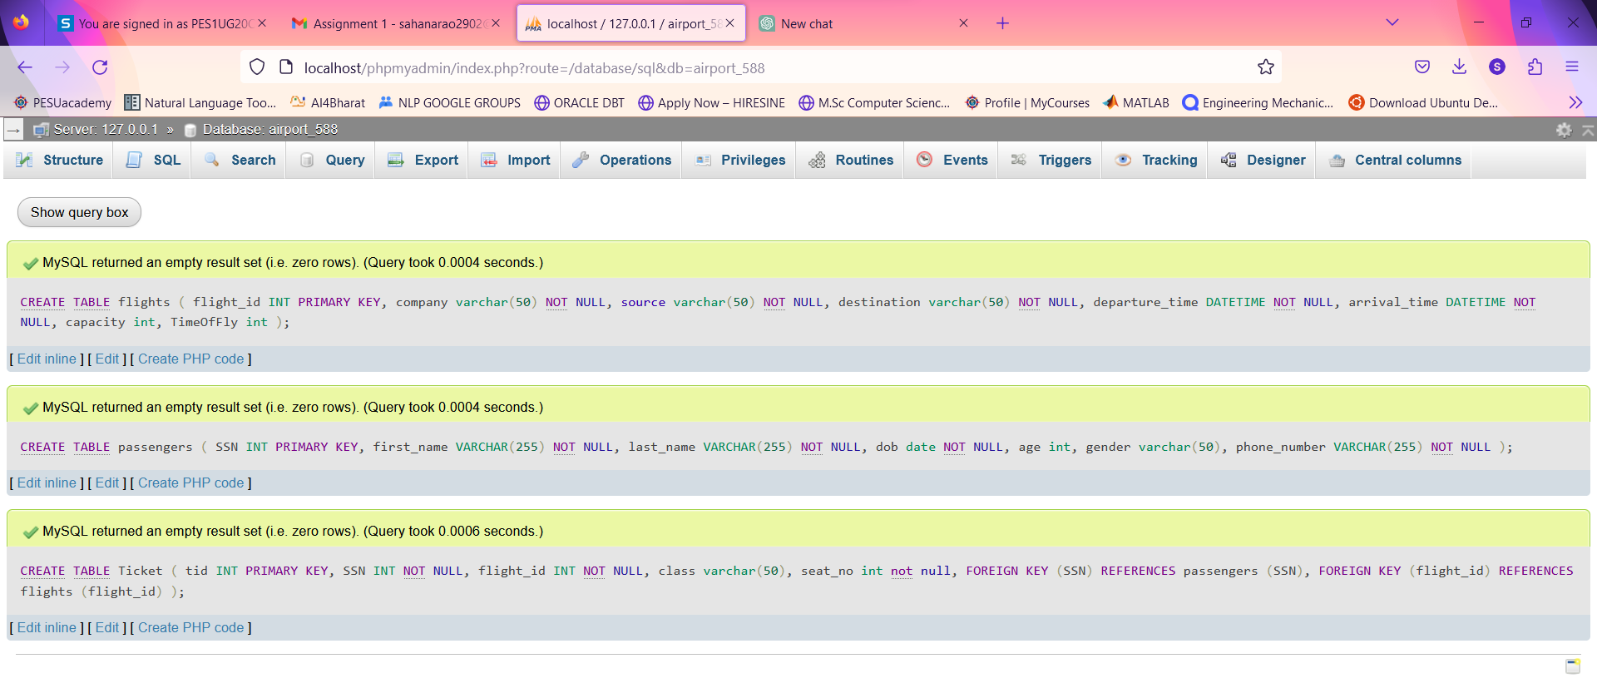

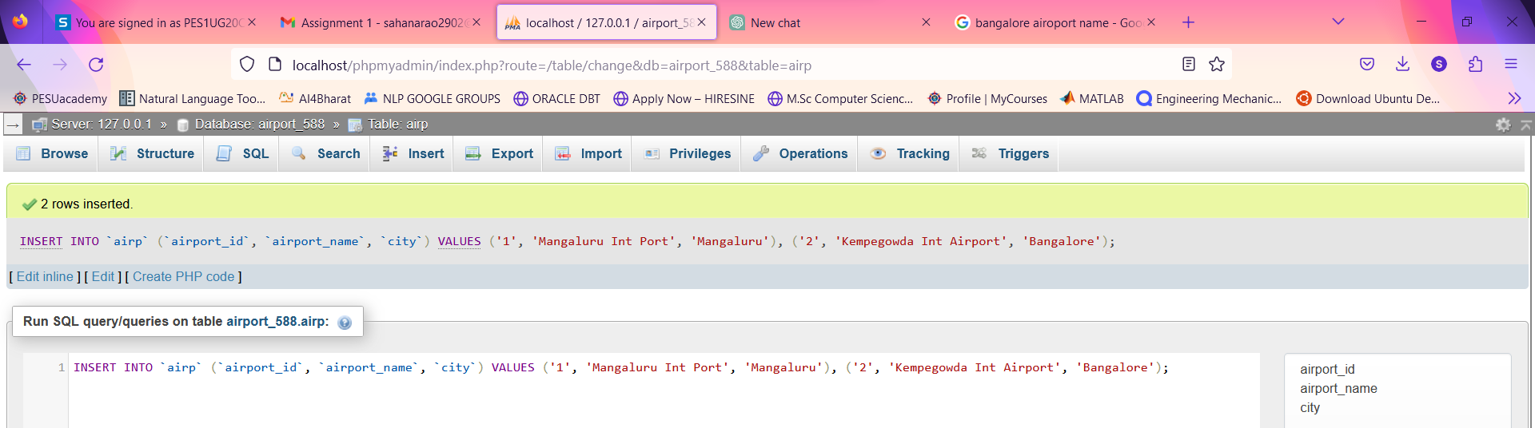

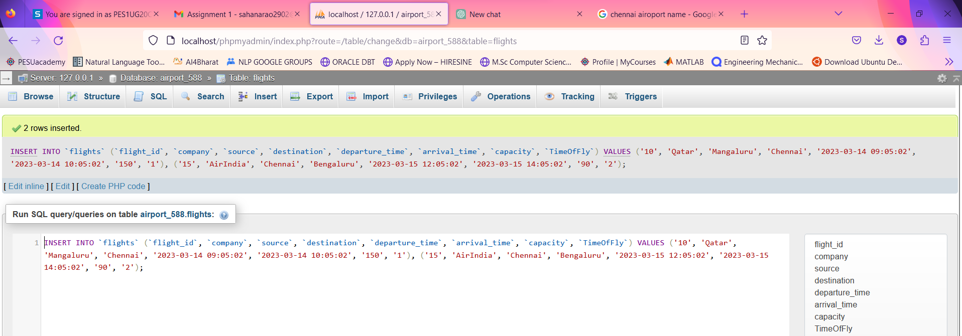

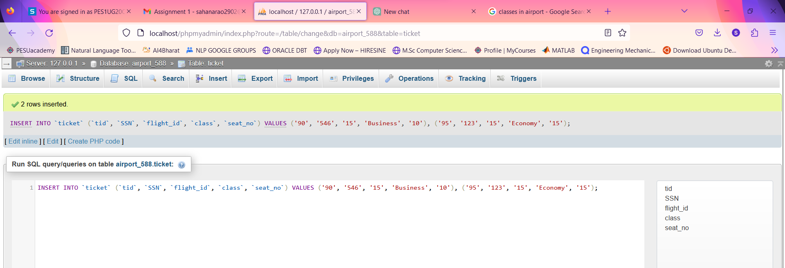

**QUERIES:**

Airport table:

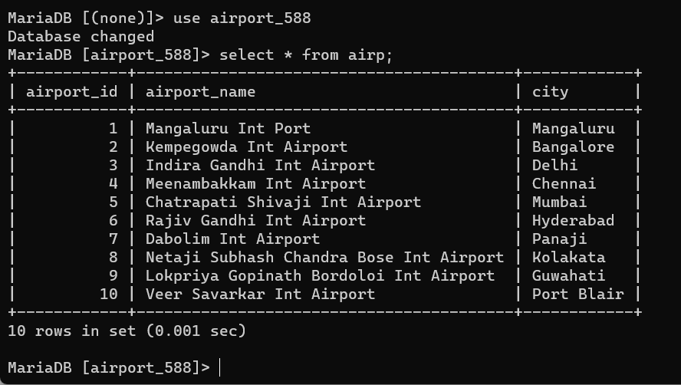

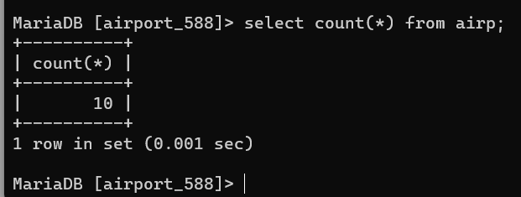

Ticket Table

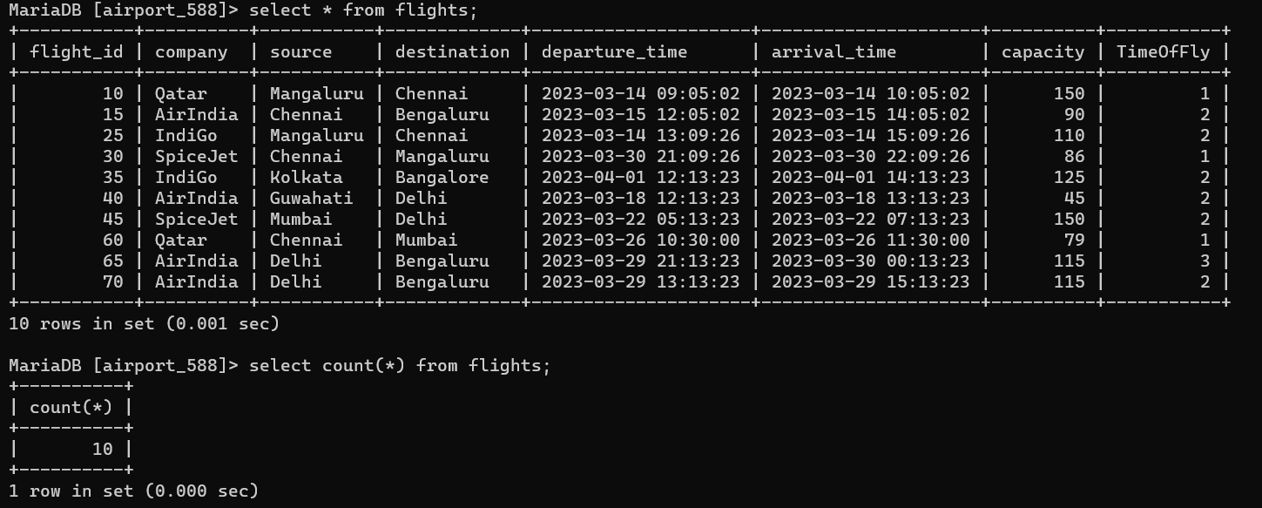

Passengers Table

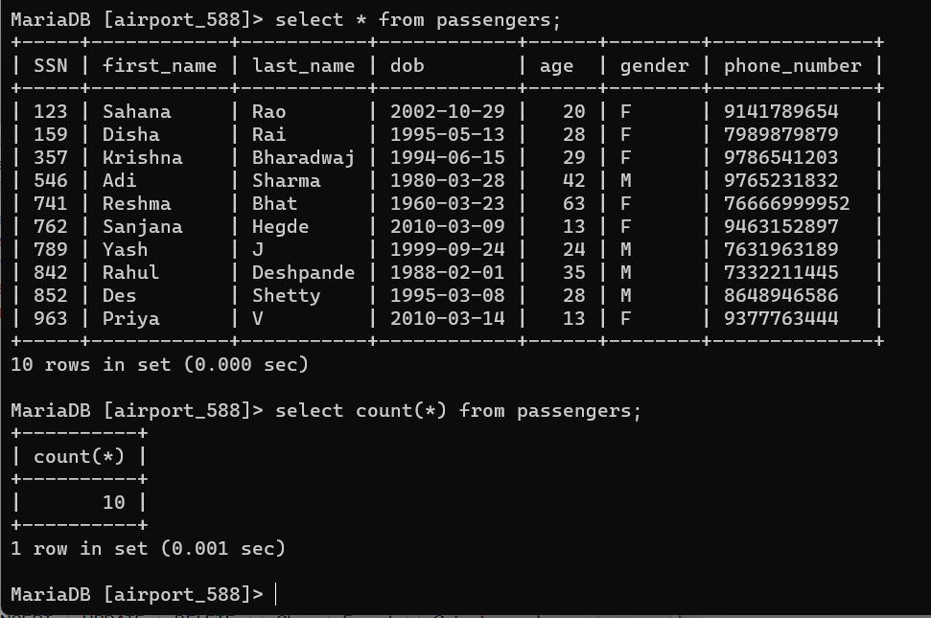

Flights Table

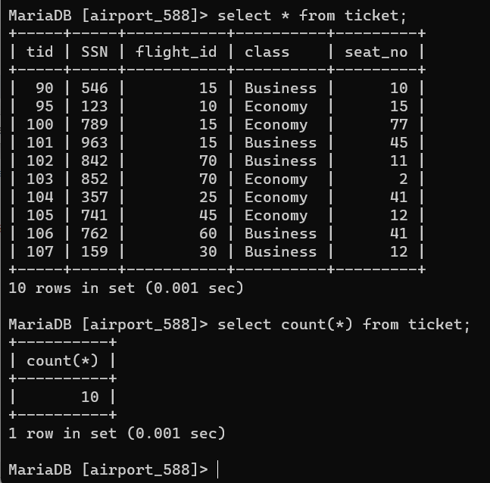

Explain without indexing

Table : passengers:

Display all passengers with first letter of first_name : ‘S’

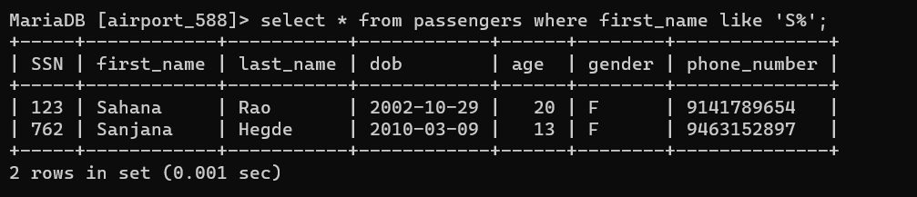

Using Explain keyword:

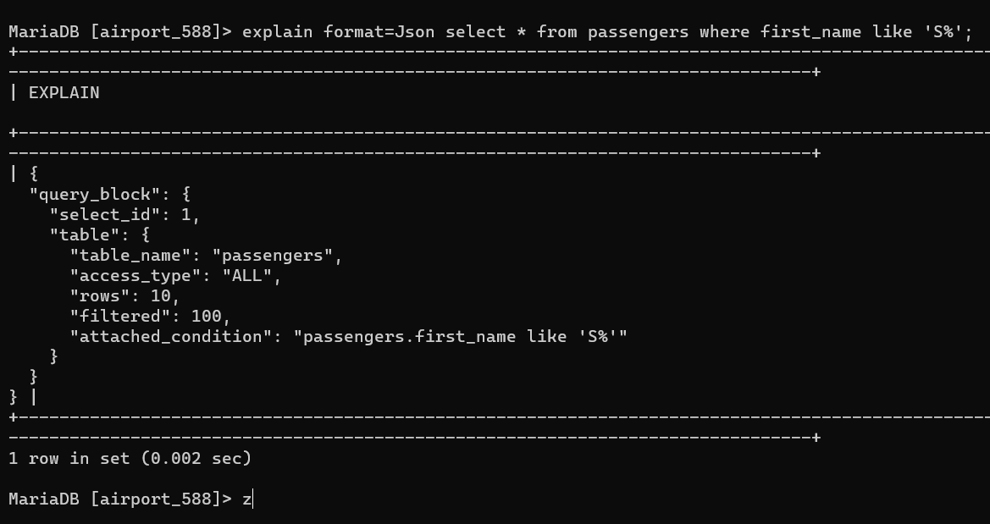

In the above query, all 10 rows are searched to obtain names starting from letter : S

Creating index on first name :

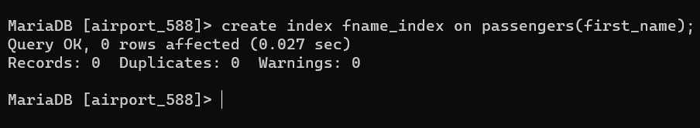

Running the query again:

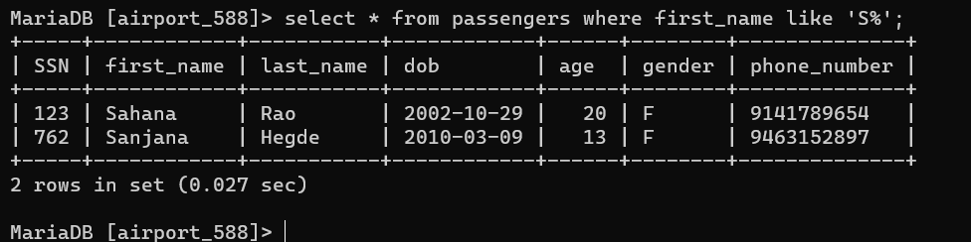

The output remains the same.

Analysing the same with ‘explain’:

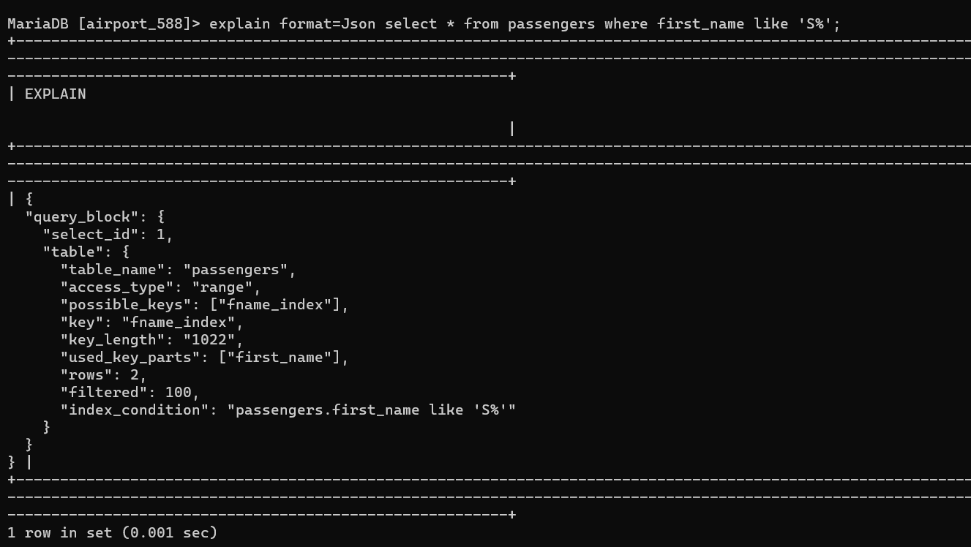

Note: the number of rows queried now reduces to 2.Thereby proving that indexing reduces time to query.

Table :

Display all the airport id’s and corresponding source name.

<<Joining two tables airp and flights>>

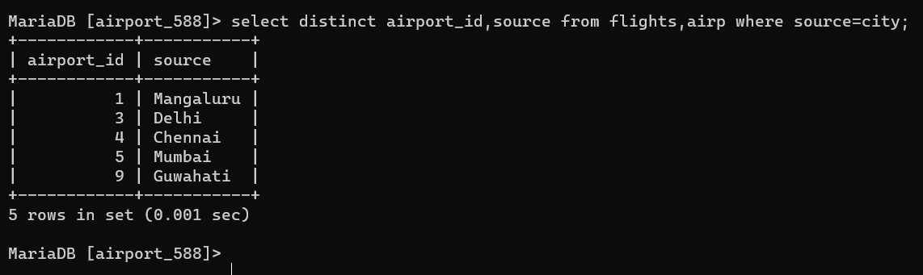

Using explain keyword:

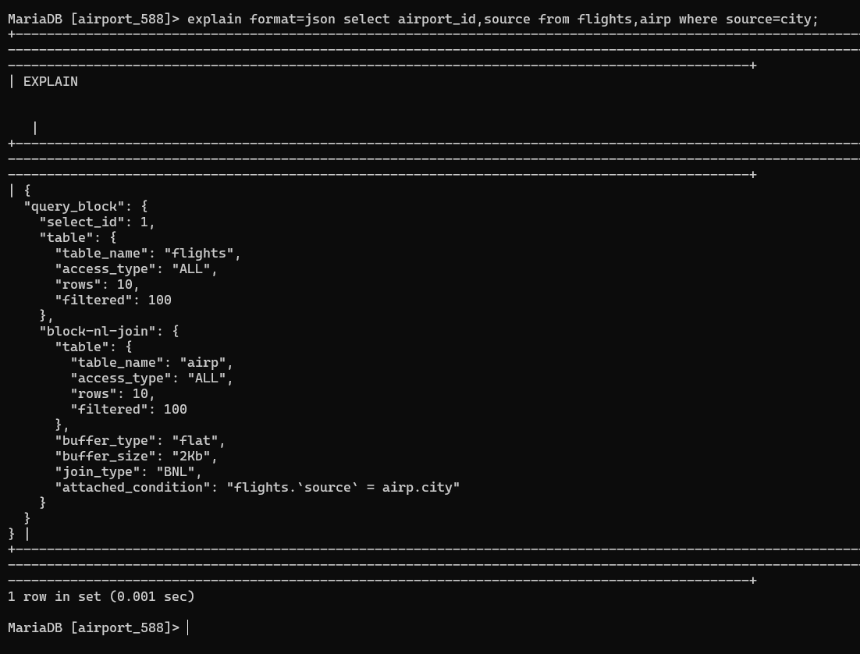

Note : total of 20 rows are observed

Creating index on city of airp table source of flights table:

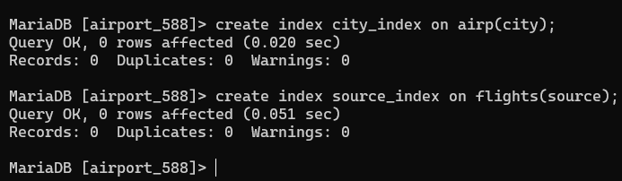

Running the query again:

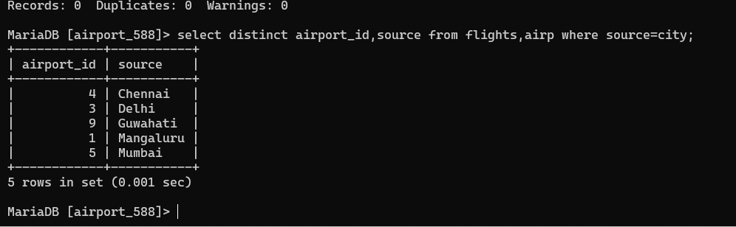

Output remains the same.

Checking with explain:

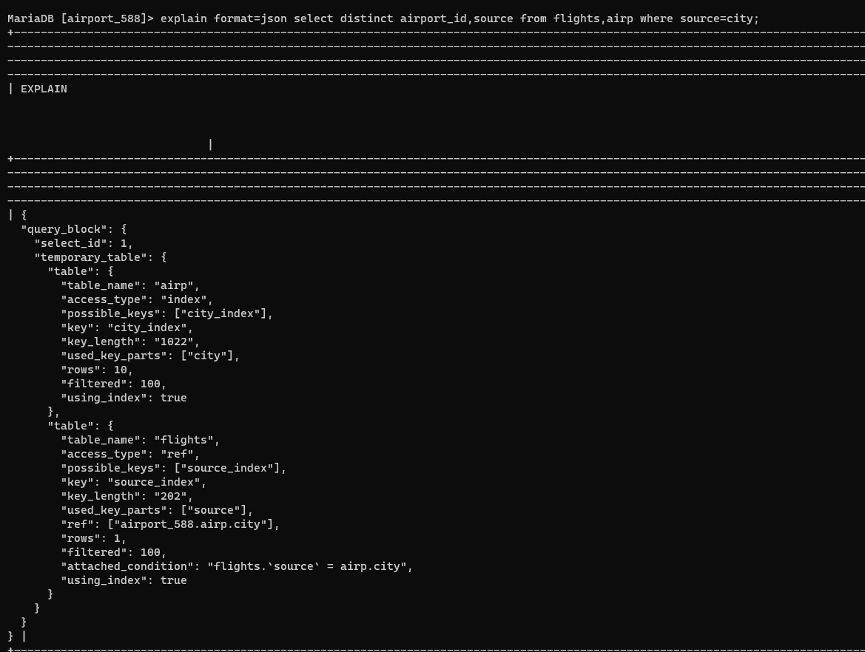

Do note that only one row is read from flights table rather than reading all 10 rows.

Hence, in the presence of index on the attribute, the search happens based on the index which proves to be faster over full table scan. It is more effective in the presence of large number of tuples.