**DESCRIPTION OF TEST CASES**

**Automated test cases written using mocha and chai where the script performs necessary actions named sample collection values and identifies if the test cases passed/failed at an end point of the application.**

**Movie tracker test database created in the same cluster of Mongo to test the unit test cases written.**

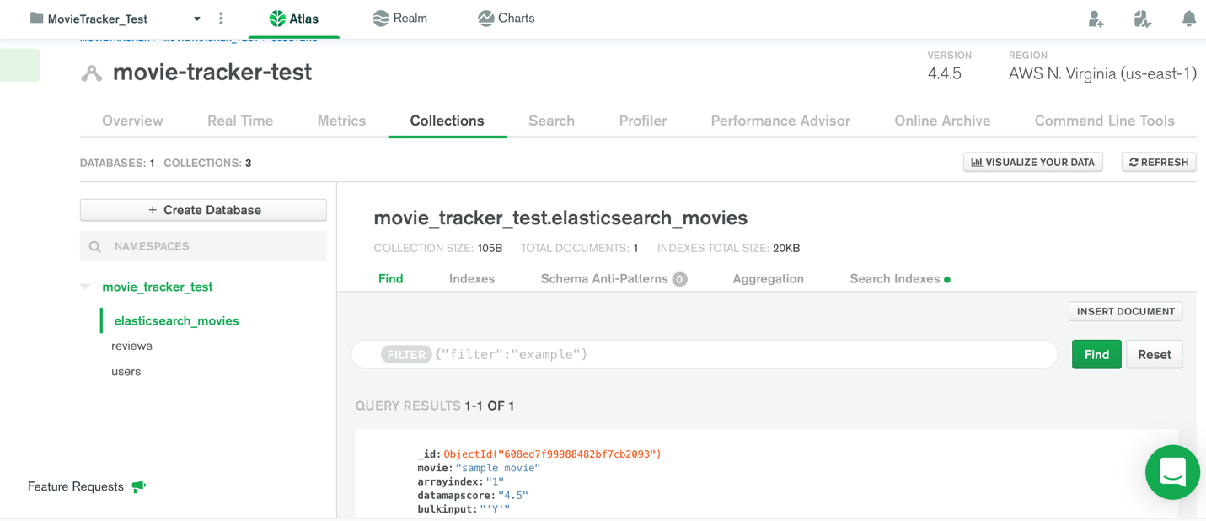

**API End points tested:**

1. **dairy_tests.js**

GET /users/:username/all --- Get all movie diary entries for a particular user  
POST /users/:username/diary --- Add a new diary entry for a user  
PUT /users/:username/diary/:title --- Edit a movie diary entry  
DELETE /users/:username/delete/:title --- Delete a movie diary entry for a user

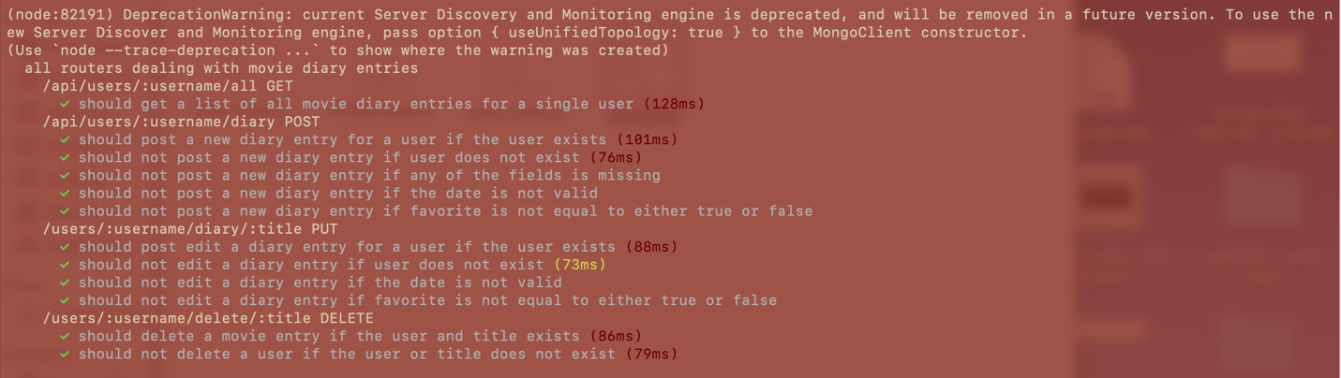

1. **user_tests.js**

GET /users --- Get all users  
GET /users/:username --- Get a particular user  
POST /users/:username/add--- Add a new user  
DELETE /users/:username--- Delete a user by username

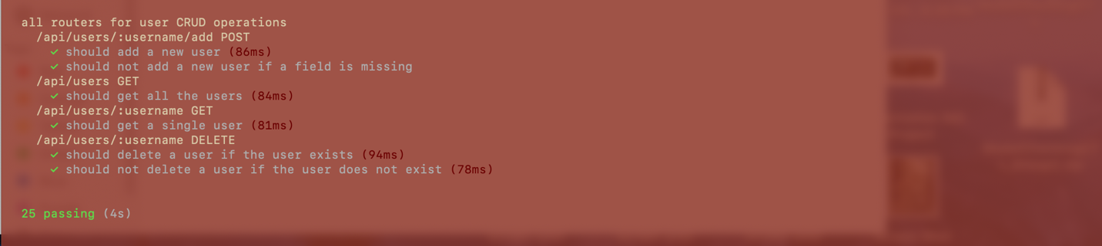

1. **review_tests.js**

GET /users/:username/reviews/all --- Get all movie reviews by a particular user  
POST /users/:username/review/:movieId--- Add a new movie review for a movieId  
PUT /users/:username/review/:id --- Edit a movie review  
DELETE /users/:username/review/:id--- Delete a movie review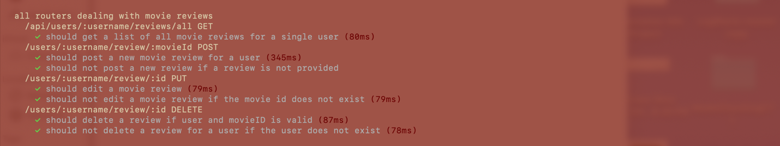

1. **es_tests.js**

GET /movies/:movieTitle/search --- Get all movies that match the search

GET /movies/:movieTitle/sort/all --- Do not bulkinput if name missing in ConfigES  
PUT /movies/:movieTitle/sort/:id --- assign a data map score and sort

POST /movies/:movies/search/all --- Post all movies matching search by map score

POST /movies/:movies/search --- Post null if movie list matches null

