EXPERIMENT – 3
CLASSIFICATION WITH DECISION TREES

AIM
To implement a Decision Tree classifier and evaluate its performance using Accuracy Score and Confusion Matrix on a real-world dataset.

ALGORITHM
- Import the necessary Python libraries.
- Load a classification dataset such as the Iris dataset.
- Separate the dataset into features and target values.
- Split the dataset into training and testing sets.
- Train a Decision Tree Classifier using sklearn.tree.
- Predict the target values for the test dataset.
- Evaluate the model using:
  - Confusion Matrix
  - Accuracy Score
- Visualize the Confusion Matrix.
- Visualize the trained Decision Tree.
- Display the results.
PROGRAM
from sklearn.datasets import load_iris
from sklearn.tree import DecisionTreeClassifier, plot_tree
from sklearn.model_selection import train_test_split
from sklearn.metrics import confusion_matrix, accuracy_score
import matplotlib.pyplot as plt
import seaborn as sns
iris = load_iris()
X = iris.data
y = iris.target
X_train, X_test, y_train, y_test = train_test_split(
X, y, test_size=0.3, random_state=42
)
dt_model = DecisionTreeClassifier(
criterion='gini',
random_state=0
)
dt_model.fit(X_train, y_train)
y_pred = dt_model.predict(X_test)
cm = confusion_matrix(y_test, y_pred)
acc = accuracy_score(y_test, y_pred)
print("Confusion Matrix:")
print(cm)
print("\nAccuracy Score:", acc)
plt.figure(figsize=(6, 4))
sns.heatmap(
cm,
annot=True,
cmap="Blues",
xticklabels=iris.target_names,
yticklabels=iris.target_names
)
plt.xlabel("Predicted")
plt.ylabel("Actual")
plt.title("Confusion Matrix")
plt.show()
plt.figure(figsize=(12, 8))
plot_tree(
dt_model,
filled=True,
feature_names=iris.feature_names,
class_names=iris.target_names
)
plt.title("Decision Tree Visualization")
plt.show()

OUTPUT

Confusion Matrix
Confusion Matrix:
[[19 0 0]
[ 0 13 0]
[ 0 0 13]]
Accuracy Score: 1.0

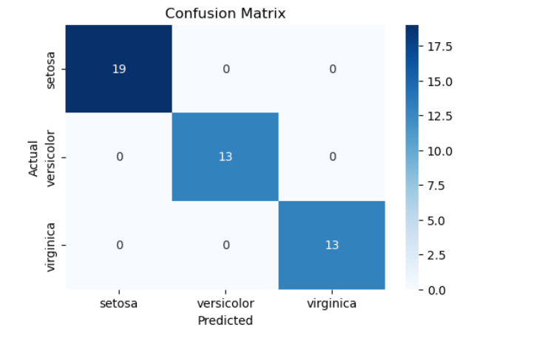

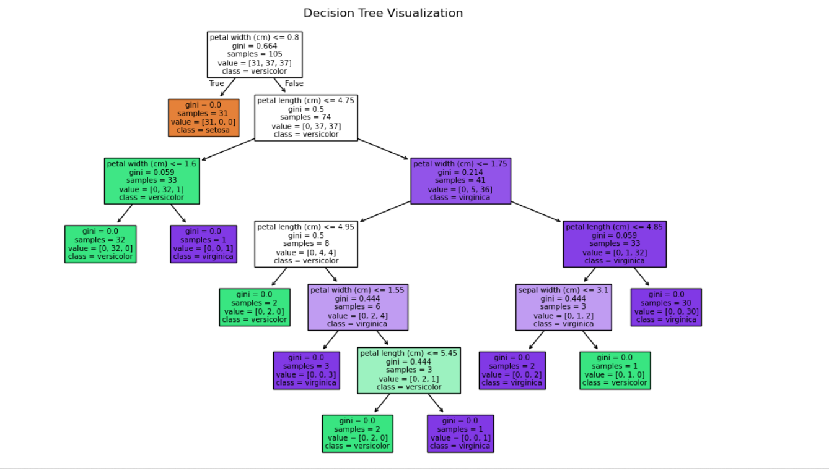

RESULT
The Decision Tree classification model was successfully implemented and tested using the Iris dataset. The model correctly classified the test samples into Setosa, Versicolor, and Virginica classes.
The model achieved an accuracy of 1.0 (100%), with no misclassified samples in the test dataset. The confusion matrix clearly represents the classification performance, while the decision tree visualization shows the decision-making process through a hierarchical structure of nodes and branches.
Thus, the Decision Tree classifier was successfully implemented and produced accurate and interpretable classification results.

