WEB TECHNOLOGY LAB

EXP NO: 7

AIM:
To develop an Online Help Desk Support System using HTML, CSS, and JavaScript that allows users to submit support tickets and view their status in a tabular format.

PROGRAM:

index.html

<!DOCTYPE html>
<html lang="en">
<head>
<meta charset="UTF-8">
<meta name="viewport" content="width=device-width, initial-scale=1.0">
<title>Online Help Desk Support System</title>
<style>
* { box-sizing: border-box; margin: 0; padding: 0; }
body { font-family: Arial, sans-serif; background: #f0f4f8; color: #333; }
header { background: #1565C0; color: white; padding: 16px 24px; }
header h1 { font-size: 22px; }
.container { max-width: 900px; margin: 30px auto; padding: 0 16px; }
.card { background: white; border-radius: 8px; padding: 24px;
box-shadow: 0 2px 6px rgba(0,0,0,0.1); margin-bottom: 24px; }
h2 { color: #1565C0; margin-bottom: 16px; font-size: 18px; }
label { display: block; margin-bottom: 4px; font-weight: bold; font-size: 14px; }
input, select, textarea {
width: 100%; padding: 10px; border: 1px solid #ccc;
border-radius: 5px; margin-bottom: 14px; font-size: 14px; }
textarea { height: 100px; resize: vertical; }
button { background: #1565C0; color: white; border: none;
padding: 10px 24px; border-radius: 5px; cursor: pointer; font-size: 14px; }
button:hover { background: #0D47A1; }
table { width: 100%; border-collapse: collapse; margin-top: 10px; }
th { background: #1565C0; color: white; padding: 10px; text-align: left; }
td { padding: 10px; border-bottom: 1px solid #ddd; font-size: 14px; }
.status { padding: 4px 10px; border-radius: 12px; font-size: 12px; font-weight: bold; }
.open { background: #FFF3E0; color: #E65100; }
.resolved { background: #E8F5E9; color: #2E7D32; }
.inprogress { background: #E3F2FD; color: #1565C0; }
#message { color: green; font-size: 14px; margin-top: 8px; }
</style>
</head>
<body>
<header><h1>Online Help Desk Support System</h1></header>
<div class="container">

<!-- Ticket Submission Form -->
<div class="card">
<h2>Submit a Support Ticket</h2>
<label for="name">Full Name</label>
<input type="text" id="name" placeholder="Enter your name">
<label for="email">Email Address</label>
<input type="email" id="email" placeholder="Enter your email">
<label for="category">Issue Category</label>
<select id="category">
<option value="">-- Select Category --</option>
<option>Hardware</option>
<option>Software</option>
<option>Network</option>
<option>Account Access</option>
<option>Other</option>
</select>
<label for="priority">Priority</label>
<select id="priority">
<option value="">-- Select Priority --</option>
<option>Low</option>
<option>Medium</option>
<option>High</option>
</select>
<label for="description">Issue Description</label>
<textarea id="description" placeholder="Describe your issue..."></textarea>
<button onclick="submitTicket()">Submit Ticket</button>
<p id="message"></p>
</div>

<!-- Ticket List -->
<div class="card">
<h2>Submitted Tickets</h2>
<table>
<thead>
<tr>
<th>Ticket ID</th><th>Name</th><th>Category</th>
<th>Priority</th><th>Status</th>
</tr>
</thead>
<tbody id="ticketTable"></tbody>
</table>
</div>
</div>

<script>
let tickets = [];
let ticketCount = 1;

function submitTicket() {
const name = document.getElementById('name').value.trim();
const email = document.getElementById('email').value.trim();
const category = document.getElementById('category').value;
const priority = document.getElementById('priority').value;
const desc = document.getElementById('description').value.trim();
const msg = document.getElementById('message');

if (!name || !email || !category || !priority || !desc) {
msg.style.color = 'red';
msg.textContent = 'Please fill in all fields.';
return;
}

const ticket = {
id: 'TKT-' + String(ticketCount++).padStart(3, '0'),
name, email, category, priority,
status: 'Open'
};

tickets.push(ticket);
renderTable();

msg.style.color = 'green';
msg.textContent = 'Ticket submitted successfully! ID: ' + ticket.id;

// Clear form
['name','email','category','priority','description'].forEach(id => {
document.getElementById(id).value = '';
});
}

function renderTable() {
const tbody = document.getElementById('ticketTable');
tbody.innerHTML = '';
tickets.forEach(t => {
const cls = t.status === 'Open' ? 'open' :
t.status === 'Resolved' ? 'resolved' : 'inprogress';
tbody.innerHTML += `<tr>
<td>${t.id}</td><td>${t.name}</td><td>${t.category}</td>
<td>${t.priority}</td>
<td><span class="status ${cls}">${t.status}</span></td>
</tr>`;
});
}
</script>
</body>
</html>

OUTPUT:
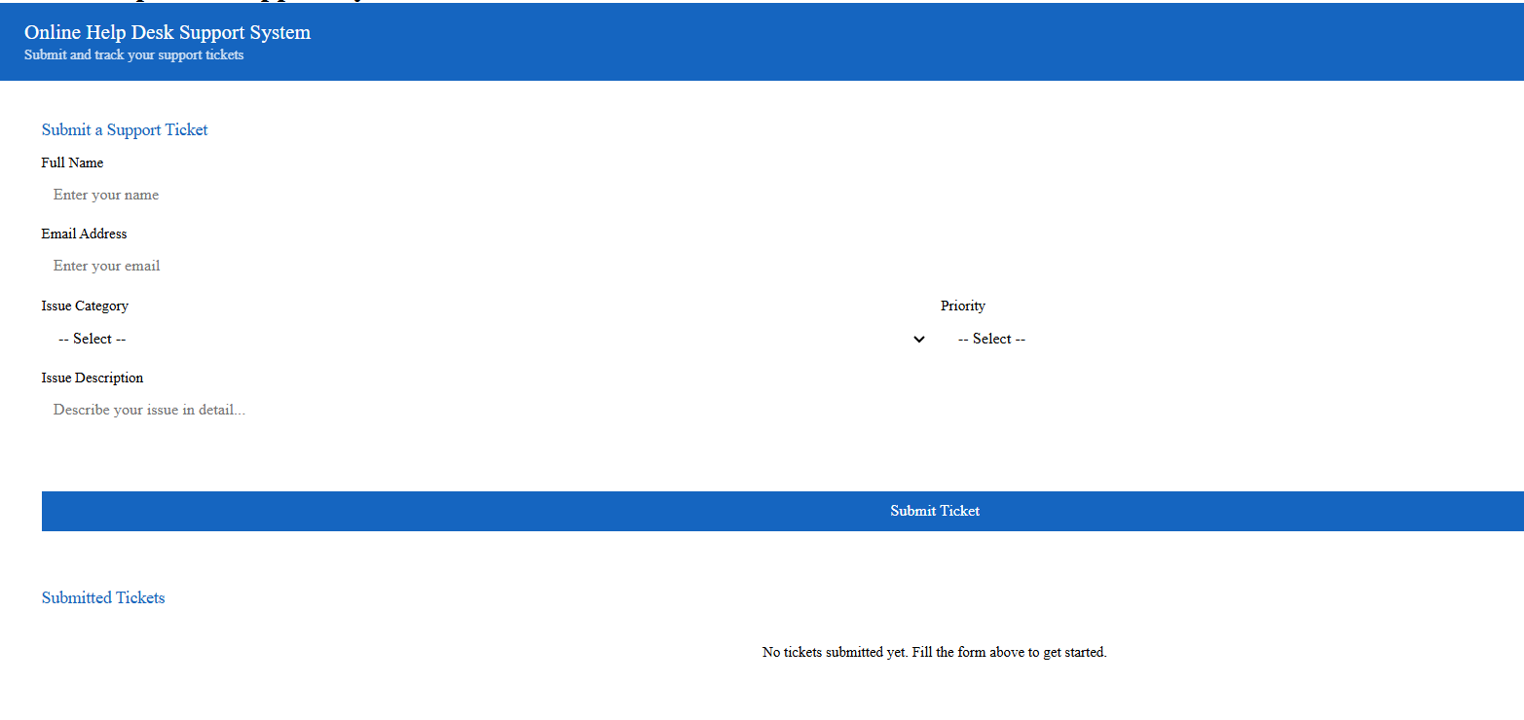

RESULT:
The Online Help Desk Support System was successfully developed and executed. Users can submit support tickets with category and priority, and view them in a dynamic status table using HTML, CSS, and JavaScript.

