**EDUCATION:**

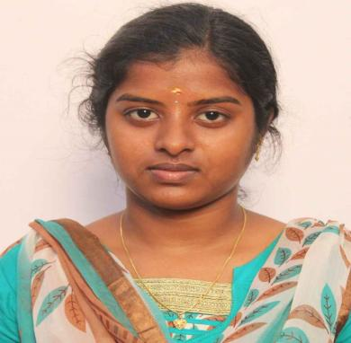

Sahana S

Master of Computer Application

6385237800

sahanahariraj18@gmail.com

TECHNICAL SKILLS:

* C, HTML, CSS, Visual studio basics
* MYSQL
* Ms Office

INTERNSHIPS:

* Mysql basics programming

Conducted by ERP in Holy Cross college(virtual).

* Java basics programming

Conducted by ERP in Holy Cross College(virtual).

* Business Analytics with Excel in simplilearn(virtual).

AREA OF INTEREST

* Web Development
* Graphical Designing
* Data analyst
* Research ability

INTERPERSONAL SKILLS

* Ability to work in a dynamic Environment .
* Quick learner, resourceful.
* Hard worker, creative with some self-confidence.

|  |
| --- |
|  |
|  |  |

Master of Computer Application

Holy Cross College

2022-20224 | 74%

Bachelor of Computer Application

Holy Cross College

2019-2022 |78%

Senior sec & sec grade

90% | 70%

**Certificate:**

* NPTEL online certificate for successfully Completing the course leadership with a consolidated score of 63%
* NPTEL online certificate for successfully completing for successfully completing the course stress Management with a consolidated score of 55%

Hhf **project experience:**

Vehicle number plate recognition:

* The system is placed in moving vehicle to detect accident and report in case of emergency.
* The purpose of this project is to detect number plate using image processing techniques

Paper presentation**: Done a paper Presentation**

Presenting the paper on

Implication of Digital world and social

Media on Girls” at national Conference

At Holy Cross College.