**EDUCATION:**

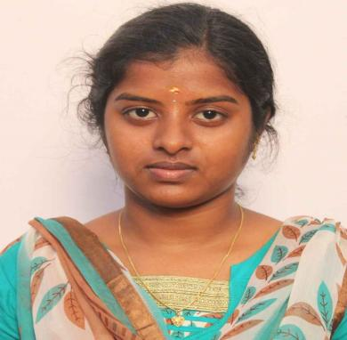

Sahana S

Master of Computer Application

6385237800

sahanahariraj18@gmail.com

**TECHNICAL SKILLS:**

* FRONT END:HTML, CSS.
* BACK END:MYSQL, JAVA BASICS.
* DATA ANALYTICS: POWERBI TOOL
* Ms Office.

**INTERNSHIPS:**

* Data analytics using Power Bi Intership in TANSAM.
* Mysql basics programming

Conducted by ERP in Holy Cross college(virtual).

* Java basics programming

Conducted by ERP in Holy Cross College(virtual).

* Business Analytics with Excel in simpliLearn (virtual).

**INTERPERSONAL SKILLS:**

* Ability to work in a dynamic Environment .
* Quick learner, resourceful.
* Hard worker, creative with some self-confidence.

**Language:**

- English

- Tamil

|  |
| --- |
|  |
|  |  |

**Master of Computer Application**

Holy Cross College

2022-20224 | 74%

**Bachelor of Computer Application**

Holy Cross College

2019-2022 |78%

**Senior sec & sec grade**

90% | 70%

**Certificate:**

NPTEL online certificate for successfully Completing the course leadership with a consolidated score of 63%.

NPTEL online certificate for successfully completing for successfully completing the course stress Management with a consolidate score of 54% .

Hhf **Project experience:**

**Vehicle number plate recognition:**

- The system is placed in moving vehicle to

detect accident and report in case of

emergency.

**-** The purpose of this project is to

Detect number plate using image processing processing techniques.

**Data analytics using Power Bi:**

* Create a visualized dashboard for Road Accident Analysis.

Paper presentation**: Done a paper Presentation:**

* Presenting the paper on National Level Conference.

Portfolio: