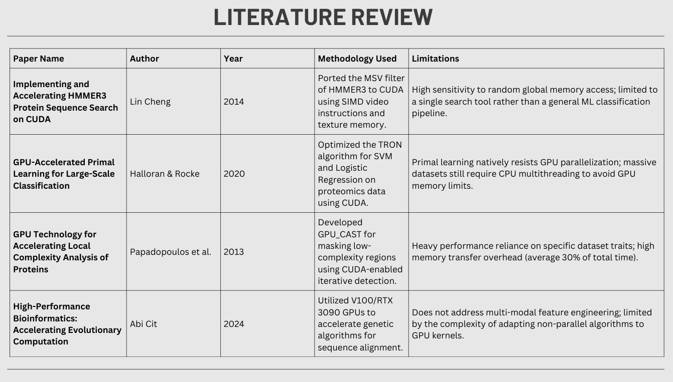
1. Accelerating HMMER3 Sequence Search on CUDA
- Author/Year: Lin Cheng (2014)
- Methodology (How they did it): Cheng focused on a specific tool called hmmsearch, which searches databases for protein families using statistical models (Hidden Markov Models). The most innovative part was porting the MSV filter—the first "gatekeeper" that decides if a sequence is worth analyzing—to the GPU. He used Texture Memory (a special type of GPU memory) to speed up how the computer looks up amino acid values and SIMD video instructions to perform multiple calculations at once.
- Results (What they achieved): The system achieved an average 2.5x speedup compared to a single-threaded CPU. When fully optimized with database sorting to balance the workload, performance jumped significantly, reaching up to 17.36 GCUPS (Giga Cell Updates Per Second).
- Limitations (The drawbacks): The main weakness is random memory access. If the GPU has to jump around too much to find data, it slows down drastically. Also, this work was a "single-tool" fix rather than a broad machine learning pipeline like yours.
2. GPU-Accelerated Primal Learning for Large-Scale Classification
- Author/Year: Halloran & Rocke (2020)
- Methodology (How they did it): These researchers focused on the "Math Engine" behind classification models like SVM (Support Vector Machines) and Logistic Regression. They optimized an algorithm called TRON, which is used to train these models on massive proteomics datasets. They used the cuSPARSE library to handle the heavy mathematical lifting on the GPU.
- Results (What they achieved): On half of their tested datasets, they achieved over a 10x speedup in training time. This is particularly helpful for "big data" where a CPU would take days to learn the patterns.
- Limitations (The drawbacks): The algorithm is "sequentially dependent." This means Step B cannot start until Step A is finished and the data is sent back to the CPU. Because of this "ping-pong" between the CPU and GPU, the GPU often sits idle waiting for instructions, which wastes its power.
3. GPU Technology for Local Complexity Analysis
- Author/Year: Papadopoulos et al. (2013)
- Methodology (How they did it): Proteins often have "boring" regions (Low Complexity Regions) that make sequence comparison tools give fake high scores. These researchers created GPU_CAST, a tool that iteratively scans sequences to find and "mask" these regions. It essentially compares every sequence against 20 different "simple" patterns (like a string of all 'A's).
- Results (What they achieved): They saw massive time savings. For example, in a large viral protein dataset, the execution time dropped from over 70,000 milliseconds to just 10,000 milliseconds.
- Limitations (The drawbacks): A major bottleneck was Memory Overhead. Moving data from the main computer memory to the graphics card took up 30% of the total time on average. Performance also changed wildly depending on the dataset—if a protein had no "boring" parts, the GPU was barely used.
4. Accelerating Evolutionary Computation with GPUs
- Author/Year: Abi Cit (2024)
- Methodology (How they did it): This paper explores using Evolutionary Algorithms (which mimic biological evolution to find the "best" answer) for protein structure prediction and alignment. They used high-end NVIDIA Tesla V100 and RTX 3090 GPUs to run these "survival of the fittest" simulations in parallel.
- Results (What they achieved): Across different tasks, they achieved speedups ranging from 9x to 12x. Most importantly, they proved that the GPU-accelerated versions were just as accurate as the slow CPU versions.
- Limitations (The drawbacks): Not all biological algorithms are "parallel-friendly." Some require massive mathematical rewrites to work on a GPU. Additionally, the high cost of the specialized hardware (RTX 3090/V100) makes it difficult for smaller labs to use this method.

