**PROACTIVE DISASTER MANAGEMENT FOR FIRE HAZARDS**

## A PROJECT REPORT

***Submitted by,***

**Ms. THANU SHREE M -20211CIT0034**

**Ms. SAHANA R PRASAD -20211CIT0066**

**Ms. SHREEJESWINI R KOLEKAR -20211CIT0072**

**Ms. ANANYA B R -20221LIN0002**

### *Under the guidance of,*

Dr. G.VENNIRA SELVI

***in partial fulfillment for the award of the degree of***

**BACHELOR OF TECHNOLOGY**

**IN**

**COMPUTER SCIENCE AND ENGINEERING, COMPUTER ENGINEERING, INFORMATION SCIENCE AND ENGINEERING Etc.**

**At**



**PRESIDENCY UNIVERSITY**

**BENGALURU**

**JANUNARY 2025**

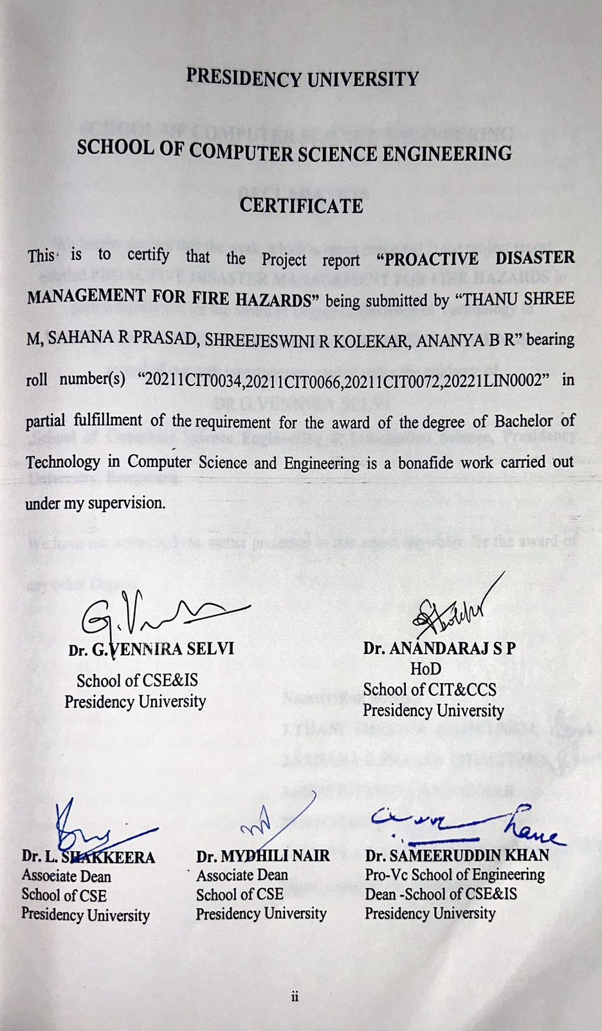

|  |  |
| --- | --- |
|  |  |

**ABSTRACT**

Fire hazards pose a significant threat to life, property, and the environment. Proactive disaster management is essential to mitigate these risks and minimize the impact of potential fire incidents. This report explores key components of proactive fire hazard management, including prevention, preparedness, response, and recovery. By implementing regular inspections, fire safety training, emergency response plans, and advanced fire detection and suppression systems, organizations and communities can significantly reduce the risk of fire-related disasters. Fire hazards pose a significant threat to life, property, and the environment. Proactive disaster management strategies are essential to mitigate these risks and minimize the impact of potential fire incidents. This report delves into key aspects of proactive fire hazard management, including prevention, preparedness, response, and recovery. Regular Inspections and Maintenance Conduct routine inspections of electrical systems, fire alarms, sprinklers, and other fire safety equipment to ensure their proper functioning. Fire Safety Training Educate employees and residents on fire safety procedures, including evacuation plans, use of fire extinguishers, and emergency contact numbers. Hazard Identification and Control Identify potential fire hazards, such as flammable materials, faulty wiring, and poor housekeeping practices, and implement measures to control them. Fire Safety Codes and Regulations Adhere to local, state, and national fire safety codes and regulations to ensure compliance. Emergency Response Plans Develop comprehensive emergency response plans that outline procedures for evacuation, fire suppression, and post-fire recovery. Fire Drills Conduct regular fire drills to familiarize occupants with evacuation routes and procedures. Emergency Equipment Ensure adequate availability and maintenance of fire extinguishers, fire alarms, and other essential fire safety equipment. Communication Systems Establish effective communication systems, including alarms, public address systems, and emergency notification systems. Early Detection and Alarm Systems Implement advanced fire detection and alarm systems to detect fires early and trigger timely alerts. Rapid Response Teams: Train and equip fire response teams to respond quickly and effectively to fire emergencies. By adopting a proactive Disaster Management approach, organizations and communities can significantly reduce the risk of fire hazards, protect lives, and minimize property damage. The importance of a multi-faceted strategy that encompasses prevention, preparedness, response, and recovery.

**ACKNOWLEDGEMENT**

First of all, we indebted to the **GOD ALMIGHTY** for giving me an opportunity to excel in our efforts to complete this project on time.

We express our sincere thanks to our respected dean **Dr. Md. Sameeruddin Khan**, Pro-VC, School of Engineering and Dean, School of Computer Science Engineering & Information Science, Presidency University for getting us permission to undergo the project.

We express our heartfelt gratitude to our beloved Associate Deans **Dr. Shakkeera L and Dr. Mydhili Nair,** School of Computer Science Engineering & Information Science, Presidency University, and Dr. ANANDARAJ S P, Head of the Department, School of Computer Science Engineering & Information Science, Presidency University, for rendering timely help in completing this project successfully.

We are greatly indebted to our guide **Dr.** G.VENNIRA SELVI**.** and Reviewer **Dr./Mr.Ms. PRIYANKA**, School of Computer Science Engineering & Information Science, Presidency University for his/her inspirational guidance, and valuable suggestions and for providing us a chance to express our technical capabilities in every respect for the completion of the project work.

We would like to convey our gratitude and heartfelt thanks to the PIP2001 Capstone Project Coordinators **Dr. Sampath A K, Dr. Abdul Khadar A and Mr. Md Zia Ur Rahman,** department Project Coordinators “DR.SHARMASTH VALI Y” and Git hub coordinator **Mr. Muthuraj.**

We thank our family and friends for the strong support and inspiration they have provided us in bringing out this project.

**THANU SHREE M**

**SAHANA R PRASAD**

**SHREEJESWINI R KOLEKAR**

**ANANYA B R**

**LIST OF TABLES**

|  |  |  |  |
| --- | --- | --- | --- |
| **Sl. No.** | **Table Name** | **Table Caption** | **Page No.** |
| 1 | Table 1.1 | Literature Survey | 5 |

**LIST OF FIGURES**

|  |  |  |  |
| --- | --- | --- | --- |
| **Sl. No.** | **Figure Name** | **Caption** | **Page No.** |
| 1  2  3 | Figure 1.1  Figure 1.2  Figure 1.3 | **SYSTEM DESIGN AND IMPLEMENTATION**  **System Components and Block Diagram**  **MODEL OUTPUT** | 5  8  12 |

**TABLE OF CONTENTS**

|  |  |  |
| --- | --- | --- |
| **CHAPTER NO.** | **TITLE** | **PAGE NO.** |
|  | **ABSTRACT ACKNOWLEDGMENT**  **LIST OF TABLES**  **LIST OF FIGURES** | **i**  **ii** |
| 1. | **INTRODUCTION** | 1 |
|  | 1.1 TYPES OF FIRE HARZADS |  |
|  | 1.2 FIRE SPREAD DYNAMICS |  |
|  | 1.2.1 PROACTIVE MEASURES FOR FIRE SAFETY |  |
|  | 1.2.2.1 FIRE PREVENTION |  |
|  | 1.2.2.2 FIRE PREPAREDNESS |  |
| 2. | **LITERATURE REVIEW** | **11** |
|  | 2.1 ADVANTAGES AND LIMITS |  |
|  | 2.2 . DISADVANTAGES |  |
|  |  |  |

3. 3.1 **RESEARCH GAPS OF EXISTING METHODS 16**

4. 4.1 **PROPOSED METHODOLOGY** 17

5. 5.1 **OBJECTIVE 19**

6. 6.1 SYSTEM DESIGN 21

6.2 IMPLEMENTION

7. 7.1 **BLOCK DIAGRAM AND COMPONENTS**

8. 8.1 TIMELINE 24

9. 9.1 **OUTCOMES**  25

10. 10.1 **RESULTS AND DISCUSSIONS** 27

11. 11.1 **CONCLUSION** 28

12. 12.1 **REFERENCES**  29

12.1.1 **APPENDIX A** :PSUEDOCODE 30

12.1.2 **APENDIX B**: ENCLOSURES 31

**CHAPTER-1**

**INTRODUCTION**

In today's world, fire hazards pose a significant threat to both life and property. Traditional reactive approaches to fire safety are no longer sufficient to address the complexities of modern buildings and infrastructure. Proactive disaster management, which emphasizes prevention, preparedness, and mitigation, is essential to effectively combat fire hazards. Fire, a silent threat, can wreak havoc in an instant. Its destructive power can lead to significant loss of life, property, and critical infrastructure. While reactive measures are crucial during a fire incident, a proactive approach is essential to minimize risks and mitigate potential damages. Proactive disaster management for fire hazards involves a comprehensive strategy that emphasizes prevention, preparedness, response, and recovery. By implementing effective fire safety measures, conducting regular drills, and establishing robust emergency response plans, organizations can significantly reduce the impact of fire incidents. Fire hazards pose a significant threat to life and property, necessitating a proactive approach to disaster management. This involves implementing comprehensive strategies to prevent fires, mitigate their impact, and ensure swift and effective response in case of an emergency. By prioritizing fire safety measures, conducting regular inspections, and training personnel, organizations can significantly reduce the risk of fire-related incidents and minimize potential losses. Additionally, developing well-coordinated emergency response plans and conducting drills can enhance preparedness and facilitate efficient evacuation and rescue operations. Proactive disaster management for fire hazards is not merely a compliance requirement but a crucial investment in safeguarding lives and assets. Proactive disaster management for fire hazards is a comprehensive approach that involves implementing preventive measures, conducting regular inspections, and training personnel to minimize the risk of fires and ensure swift and effective responses in case of an incident. This strategy encompasses a wide range of activities, including conducting thorough fire safety assessments to identify potential risks, installing advanced fire detection and suppression systems, maintaining proper housekeeping practices to eliminate fire hazards, and providing regular fire safety training to employees. Additionally, conducting regular fire drills helps familiarize personnel with emergency procedures and ensures their preparedness in case of a real fire emergency. By adopting a proactive approach to fire safety, organizations can significantly reduce the likelihood of fires, protect lives, and minimize property damage. Fire hazards pose a significant threat to lives, infrastructure, and ecosystems, with their frequency and intensity increasing due to climate change, population growth, and urbanization. Traditionally, fire hazard management has been reactive, focusing on response and recovery after an incident. However, this approach often leads to substantial economic losses, environmental degradation, and human casualties. In contrast, proactive disaster management emphasizes prevention, preparedness, and mitigation strategies aimed at minimizing the occurrence and impact of fire hazards. This paradigm shift requires a multi-faceted approach that integrates technological innovations, community engagement, policy frameworks, and ecological management. Early warning systems, predictive analytics, and real-time monitoring are crucial tools in detecting and addressing fire risks before they escalate. Additionally, effective land-use planning, controlled burns, and the creation of defensible spaces around vulnerable areas can significantly reduce fire hazards. Public awareness and education campaigns also play a critical role in fostering a culture of preparedness, encouraging individuals and communities to adopt fire-resistant practices. The proactive management of fire hazards is not just a technical challenge but a collaborative effort involving governments, emergency services, environmental agencies, and local communities. By shifting focus from reaction to prevention, societies can enhance their resilience to fire disasters, protect critical ecosystems, and safeguard human life and property in the face of an increasingly volatile environment. Fire hazards pose a significant threat to communities, ecosystems, and infrastructure worldwide, making proactive disaster management a critical component of modern safety and resilience strategies. Unlike reactive approaches that focus on response and recovery after a fire incident, proactive disaster management emphasizes prevention, preparedness, and risk mitigation. The increasing frequency and intensity of fire hazards, driven by factors such as climate change, urbanization, and deforestation, highlight the urgent need for comprehensive strategies that address the root causes and vulnerabilities associated with fire outbreaks. Proactive measures include early warning systems, community education, risk assessments, and land-use planning to reduce the likelihood and impact of fire events. Moreover, the integration of technology, such as satellite monitoring, remote sensing, and predictive modeling, has enhanced the ability to detect and respond to fire risks in real-time. Collaborative efforts between government agencies, emergency services, non-governmental organizations, and local communities further strengthen the effectiveness of proactive disaster management by ensuring that resources, knowledge, and responsibilities are shared across multiple stakeholders. In addition, building resilience through fire-adapted communities, implementing fire-resistant infrastructure, and enforcing strict regulatory frameworks are essential in minimizing the economic, social, and environmental consequences of fire hazards. Ultimately, a proactive approach to fire hazard management not only saves lives and reduces property damage but also contributes to the long-term sustainability and safety of communities in fire-prone regions.

**1.1Understanding Fire Hazards**

**1.1.1Types of Fire Hazards:**

* **Structural Fire Hazards**: Weak building materials, poor design, and inadequate fireproofing can contribute to rapid fire spread.
* **Fuel Load Hazards:** Excessive accumulation of combustible materials, such as furniture, paper, and chemicals, increases the risk of fire ignition and intensity.
* **Ignition Source Hazards:** Faulty electrical wiring, open flames, and smoking materials are common causes of fires.
* **Human Factors:** Carelessness, negligence, and intentional acts of arson can lead to devastating fires.

**1.1.2Fire Spread Dynamics:**

* **Fire Growth:** The initial stage of a fire, characterized by rapid flame development and heat release.
* **Fire Spread**: The progression of fire from one area to another, influenced by factors like wind, ventilation, and fuel load.
* **Smoke and Toxic Gas Production:** The generation of harmful byproducts that can cause injury or death.

**1.2 Proactive Measures for Fire Safety**

**1.2.1 Fire Prevention:**

* **Regular Fire Safety Inspections**: Conducting routine inspections to identify and eliminate potential hazards.
* **Fire Safety Training:** Educating building occupants on fire prevention, evacuation procedures, and the use of fire extinguishers.
* **Fire Alarm Systems**: Installing and maintaining reliable fire alarm systems to detect and alert occupants in case of fire.
* **Fire Suppression Systems:** Implementing sprinkler systems and other automatic suppression technologies to contain and extinguish fires.

**1.2.2 Fire Preparedness:**

* **Emergency Response Plans:** Developing comprehensive plans that outline procedures for evacuation, fire fighting, and emergency medical response.
* **Fire Drills:** Conducting regular fire drills to familiarize occupants with evacuation routes and emergency procedures.
* **Fire Extinguisher Training:** Providing training on the proper use of fire extinguishers to enable occupants to respond to small fires.

**CHAPTER-2**

**LITERATURE SURVEY**

**Advantages and Limitations:**

* Risk Reduction: Proactive measures help identify and mitigate fire hazards before they escalate, significantly lowering the risk of incidents.
* Cost Efficiency: Investing in prevention and preparedness can save costs associated with disaster response, recovery, and property damage.
* Community Resilience: Enhancing public awareness and education fosters a culture of preparedness, enabling communities to respond more effectively in emergencies.
* Improved Response Times: With proactive planning and resource allocation, emergency services can respond faster to incidents, minimizing damage and casualties.
* Environmental Protection: Proactive strategies, such as controlled burns and vegetation management, can help maintain healthy ecosystems and reduce wildfire risks.
* Regulatory Compliance: Adhering to fire safety regulations and building codes ensures that structures are designed to withstand potential fire hazards.

**Disadvantages:**

* Resource Intensive: Implementing proactive measures often requires significant investment in time, training, and funding, which may strain local resources.
* Public Resistance: Some communities may be resistant to change or unaware of the importance of proactive measures, making education efforts challenging.
* Uncertain Effectiveness: Predicting fire hazards can be complex, and proactive measures may not always prevent incidents, leading to skepticism about their value.
* Over-Reliance on Prevention: A focus on proactive measures might lead to complacency in emergency response capabilities, reducing preparedness for actual events.
* Equity Issues: Not all communities have equal access to resources for implementing proactive strategies, which can lead to disparities in fire safety.
* Ongoing Maintenance: Proactive strategies require continuous evaluation and adjustment, which can be difficult to sustain over time.

**LITERATURE SURVEY:**

|  |  |  |  |  |  |
| --- | --- | --- | --- | --- | --- |
| Sl. No. | Title of the Paper | Authors | Technology/Concept Used | Results/Findings | Limitations/Challenges |
| 1. | Fire extinguishing robot | Kasiviswanadham Yadlapalli | When robot detects fire it communicates with microcontroller (Arduino MEGA) and the robot will move towards the fire affected area. | •Reliable and economical  •It reduces the time delay  •Sensors have long life time and less cost. | •By making it GPS enabled  •A CO2 booster can be attached  •Speech Assisted technologies |
| 2. | Development of Fire Fighting Robot (QRob) | Mohd Aliff  Nor Samsiah Sani  Azavitra Zaina | CONTROL PROGRAMMING | •Ability to detect location of fire automatically  •Avoid hitting any obstacle  •Compact structure | •The QRob will not react when the sensor not activate and the QRob will react when the sensor activates as well.  •This sensor OFF when fire was not detected and DC motor and Ultrasonic Sensor ON |
| 3. | Automatic Fire Extinguisher Robot Using IoT | Dr. S. Bharathidasan,  P. Kiruba Shankar,  K. Naveen  M. Pradeep  J. Vinoth | -IOT sensors , PIR Motion Detection, IR Sensing, FIR Sensor, OBJECT SENSING | •Faster response times  •Reduced damage to property, and  •Improved safety | •Ensuring the robot is reliable and safe  • Integrating it with existing fire safety systems, and managing the data and connectivity required for IoT functionality |
| 4. | Automatic Fire Fighting Robot | Abhilash Dhumatkar | - wireless camera is used for making live demonstration | • Human control required is less.  • Maintenance cost is less.  • Easily repairable. • Improved safety. | •Remotely controlled and live video buffering |
| 5. | SOUND FIRE EXTINGUISHER ROBOT CONTROLLED BY SPEECH | Shekhar Mahadik | The sound fire extinguisher robot operates as per the command received by android application through Bluetooth module HC05.  For this 89S52 microcontroller is integrated with the system which makes it possible to operate the vehicle via the android application | •Use of sound eliminates the disadvantages of water and chemical fire extinguishers.  • Less weight and compact size | •More latency  •Not reliable |
| 6. | AUTOMATIC IC FIRE EXTINGUISHER ROBOT | B.Swetha Sam | used to extinguish the fire during fire accidents  Amplifier, Compar Recognition using MATLAB, IC 741 Thermocouple. rator, Human Specifications, | •Used an Obstacle Avoid direction when it sees an obstacle.  •High dynamic range camera for h to move in the direction with intensity of the fire  •The Obstac programmed using ATmega 16[6] Mi AVR Studios  •Alerts the rescuer by rin when it identifies a human signalling th in danger and needs some help. | •System and its principle on a human loss during vast fire the human rescue operations Humanoid Robot  •Avoid accidents and wars, where cannot be performed. |
| 7. | Development and Implementation of Arduino microcontroller-based Dual Mode Fire Extinguishing Robot | Joyal Raju  Johaan Varkey Paul  Sheik Mohammed S  Georgy Abel John |  | •Detect a flame, locate it and extinguish the fire immediately before it poses a threat to anything around it.  • To reduce the risk of losing life in such situations, firefighting robots can be used automatic robot is designed to avoid further spreading of the fire that could lead to possible human causalities or damage to property. | •robot is simulated and analyzed using Proteus. The hardware of dual mode robot is implemented and tested. |
| 8. | Autonomous Fire Detecting and Extinguishing Robot Hazards | Mukul Diwanji  Saurabh Hisvankar  Chhaya Khandelwal | •Technology has made it possible to design simple and efficient firefighting systems. Modern firefighting systems use inert gases such as Nitrogen with water mist to extinguish fire. Robots were designed to locate a fire before it creates havoc. . Robots have attained immense popularity due to progress in the fields of computing and nano technologies, such as Arduino Uno board 2. IR-based Flame Sensors (Three units) 3. (SG90)Servo Motor 4. Motor Driver L293D 5. Robot Chasis of Metal 6. Breadboard 7. DC Motors (Two units) 8. Wheels (Two units) 9. Castor Wheel 10. 12V DC Pump 11. 5V Relay 12. 4V 1.5Ah Lead Acid Battery 13. Switch and Connecting wires 14. Container for keeping Water 15. Silicon pipe for water delivery | •Used to control the fire from spreading the initial stage of an incident of fire.  •By using such robots the work of fire detection and extinguishing missions can be carried out without placing the life of fire fighters at a stake and dangerous conditions. | •Creating prototype fire detecting and extinguishing robot.  •Large scope of improvisation by interfacing GSM modules with the G.P.S to the Arduino UNO board.  •G.S.M. module will alert the nearest fire station by sending the text through the location traced by the G.P.S.  •The capabilities of flame sensors are limited. The distance limited for water delivery action is up to 50 to 60 cms. The terrain and topography. More suitable for residential purposes due to its structure and design |
| 9. | FIRE FIGHTING ROBOT using IOT | PRAMOD BN HEMALATHA KN Poornima BJ  , Harshitha R PRAMOD GN | The designed fire fighting robot consists of Microcontroller ATMEGA328, immoderate sonic sensor, Gas sensor, IR module, Motor, Water pump, Servo motor,power supply. and is having one Android phone. | •The small controller may be a reliable instrument to regulate the hearth device. applicable to totally different sizes of fireplace device and high controlling capability over them. The simple style of its permit’s minimum of maintenance work. The price performance relationship is price effective. | •Coordination among mobile agents, techniques for detecting and avoiding obstacles. It will be both interesting and challenging to put all this together into a practical, autonomous firefighting services. |
| 10. | An Analytical Study of Various Methods Used  Autonomous FireExtinguishing RoboT | Swarnalata Bollavarapau  Neil K. Samuel Maneesh Shankar Nihaar Shah | • UV sensors  •Hamamatsu UV sensor that is mounted onto the Trekker sweeping sensor brackets. Hamamatsu UV TRON Flame Detector Lightweight Low current consumption Operates as high sensitivity UV Sensor d) Narrow spectral sensitivity of 185 to 260 nm makes it solar blind | •Most efficient  •Detection of source of the fire and the motion of the robot towards the source of fire | •Robot in dealing with a fire accident.  •Non electrical sources  •Helps to avoid collisions  •Avoid obstacle that might come in its path  •Highly desirable  •Detects the presence of fire within its range it should be able to overcome obstacles and move through uneven terrains. |

**CHAPTER-3**

**RESEARCH GAPS OF EXISTING METHODS**

Despite significant advancements in fire hazard management, still exhibit notable research gaps that hinder their overall efficacy and scalability. One critical gap lies in the integration of real-time data and predictive analytics for early detection and rapid response to fire outbreaks. Many current systems rely heavily on historical data and static risk models, which fail to account for dynamic variables such as sudden weather changes, human activities, and evolving land-use patterns. Additionally, while technological innovations like remote sensing, drones, and IoT-based sensors have shown promise in enhancing fire monitoring, their widespread implementation remains limited due to high costs, lack of infrastructure in remote areas, and insufficient interoperability between different platforms. Furthermore, there is a pressing need for more robust community engagement strategies, as many fire management programs overlook the importance of local knowledge and participation in hazard mitigation efforts. Current approaches often emphasize top-down solutions, which may not adequately address the specific vulnerabilities and resilience capacities of local communities, particularly in marginalized or rural regions. Another significant research gap involves the development of comprehensive multi-hazard risk assessment frameworks that consider the cascading effects of fire hazards on other critical infrastructure, ecosystems, and socio-economic systems. Most existing models tend to focus narrowly on fire suppression and immediate containment, neglecting the long-term impacts on environmental sustainability, public health, and economic recovery. Lastly, regulatory and policy frameworks for fire management are often outdated and fail to keep pace with emerging risks driven by climate change, urbanization, and deforestation, highlighting the urgent need for adaptive governance mechanisms that can facilitate more flexible, data-driven, and context-specific interventions. Addressing these gaps through interdisciplinary research, technological innovation, and inclusive policy-making is essential to building resilient communities and ecosystems capable of withstanding the increasing frequency and severity of fire-related disasters.

1. **Traditional Fire Safety Measures:**

* Briefly describe traditional fire safety practices like fire drills, fire alarms, and fire extinguishers.
* Discuss the limitations of these methods in preventing and mitigating large-scale fires.

1. **Modern Fire Safety Technologies:**

* Discuss advanced technologies like sprinkler systems, smoke detectors, and fire suppression systems.
* Analyze the limitations and challenges associated with these technologies, such as maintenance costs, false alarms, and limited effectiveness in certain scenarios.

1. **Risk Assessment and Management:**

* Briefly explain the concept of fire risk assessment and management.
* Discuss the potential shortcomings of existing risk assessment methodologies, such as their reliance on historical data and their inability to account for emerging fire hazards.

1. **Research Gaps**

**Lack of Comprehensive Risk Assessment Frameworks:**

* Highlight the need for frameworks that consider a wider range of fire hazards, including those associated with emerging technologies and climate change.
* Discuss the importance of incorporating human factors and behavioral aspects into risk assessments.

1. **Limited Integration of Technology and Human Factors:**

* Emphasize the need for seamless integration of fire safety technologies with human behavior and decision-making processes.
* Discuss the importance of user-friendly interfaces and effective training for occupants.

1. **Insufficient Data and Analysis:**

* Highlight the lack of standardized data collection and analysis methods for fire incidents.
* Discuss the need for data-driven insights to inform fire safety policies and practices.

1. **Challenges in Public Awareness and Education:**

* Discuss the importance of effective public awareness campaigns and education programs.
* Highlight the need for tailoring fire safety messages to different target audiences.

**CHAPTER-4**

**PROPOSED MOTHODOLOGY**

The proposed methodology for a fire extinguishing robot using Arduino Uno with GPS and GSM for alerts involves creating an autonomous robot capable of detecting and extinguishing fires in its surroundings while sending real-time notifications. The robot will be powered by an Arduino Uno, which will serve as the central controller, interfacing with a flame sensor to detect the presence of fire. Upon detecting fire, the robot will activate a water pump or a servo-controlled nozzle to suppress the flames. The robot's movement will be managed through an L298 motor driver, controlling DC motors that drive the robot's wheels, allowing it to navigate toward the fire. The GPS module will provide the robot's location in terms of latitude and longitude, which is crucial for tracking and pinpointing the fire's location. The GSM module will be responsible for sending SMS alerts to a predefined phone number, notifying emergency personnel or the user about the fire's occurrence and the robot's location. Additionally, IR sensors can be integrated for obstacle avoidance, enabling the robot to navigate through complex environments safely. The robot will continuously monitor its environment for fire, move towards it, extinguish it, and send location-based alerts via SMS, ensuring prompt action and efficient firefighting. This methodology combines automation, safety, and real-time communication, providing a reliable solution for fire detection and suppression.

**1. Risk Assessment and Identification:**

**Comprehensive Fire Safety Audit:** Conduct a thorough audit to identify potential fire hazards, including:

* Flammable materials storage and handling
* Electrical wiring and equipment
* Heating, ventilation, and air conditioning (HVAC) systems
* Building construction materials and design
* Human factors (e.g., smoking, careless disposal of materials)

**Hazard Mapping:** Create detailed maps highlighting high-risk areas within the facility.

**Risk Prioritization:** Prioritize risks based on their potential impact and likelihood of occurrence.

**2. Fire Prevention Measures:**

**Fire Safety Infrastructure:**

* Install and maintain adequate fire detection and alarm systems.
* Ensure proper installation and maintenance of fire suppression systems (e.g., sprinklers, fire extinguishers).
* Provide adequate emergency exits and signage.

**Fire Safety Training:**

* Conduct regular fire safety training for all employees, covering topics such as:
* Fire prevention measures
* Evacuation procedures
* Use of fire extinguishers
* Emergency response protocols

**Regular Inspections and Maintenance:**

* Implement a routine inspection and maintenance program for fire safety equipment and systems.
* Conduct regular fire drills to test emergency response plans.

**3. Emergency Response Planning:**

**Emergency Response Plan:** Develop a comprehensive emergency response plan that outlines procedures for:

* Fire detection and alarm activation
* Evacuation procedures
* Fire suppression and containment
* Emergency medical response
* Post-fire recovery and damage assessment.

**Emergency Response Team:** Establish a dedicated emergency response team responsible for coordinating and executing the emergency response plan.

**Emergency Communication:** Implement effective communication systems to facilitate timely and accurate information sharing during emergencies.

**4. Continuous Improvement and Monitoring:**

* **Regular Reviews and Updates:** Conduct periodic reviews of the fire safety plan to identify areas for improvement.
* **Incident Investigation and Learning:** Analyze fire incidents to identify root causes and implement corrective actions.
* **Stay Updated on Regulations and Best Practices:** Keep abreast of the latest fire safety regulations and industry best practices.

**Additional Considerations:**

* **Fire Safety Culture:** Foster a strong fire safety culture within the organization by emphasizing the importance of fire prevention and response.
* **Collaboration with Local Fire Departments:** Establish a strong working relationship with local fire departments to ensure coordinated response efforts.
* **Insurance Coverage:** Ensure adequate insurance coverage to mitigate financial losses in case of a fire incident.

**CHAPTER-5**

**OBJECTIVES**

The primary objective is to minimize the risk, impact, and occurrence of fire-related disasters through comprehensive preparedness, mitigation, and prevention strategies. This approach emphasizes anticipating potential fire hazards, identifying vulnerable areas, and implementing measures to reduce the likelihood of fires before they occur. It involves a multi-faceted framework that integrates advanced risk assessment tools, real-time monitoring systems, and predictive analytics to forecast fire outbreaks and their potential impact on communities, ecosystems, and critical infrastructure. Key components include the development and enforcement of fire safety regulations, land-use planning to prevent the spread of wildfires, and the establishment of community-based education and awareness programs to foster a culture of preparedness. Proactive fire management also involves the strategic allocation of resources for fire suppression, ensuring that firefighting teams are well-equipped and trained to respond rapidly to emergencies. Collaboration between government agencies, non-governmental organizations, and local communities is essential to build resilience and enhance the capacity to manage fire hazards effectively. By adopting a proactive approach, the overall goal is not only to protect lives and property but also to safeguard environmental resources, reduce economic losses, and promote sustainable development in fire-prone regions. This holistic and forward-thinking strategy underscores the importance of continuous improvement, leveraging technological advancements, and fostering a collaborative effort to create safer, more resilient societies in the face of fire hazards.

**1.Prevention and Mitigation:**

**Identify and Eliminate Hazards:**

* Conduct regular fire safety inspections to identify potential hazards.
* Implement corrective actions to eliminate or mitigate identified hazards.

**Fire Safety Education and Training:**

* Train employees and occupants on fire prevention, detection, and response procedures.
* Conduct regular fire drills to ensure preparedness and familiarity with evacuation routes.

**Building Codes and Standards:**

* Adhere to local, state, and national building codes and fire safety standards.
* Ensure proper design, construction, and maintenance of fire protection systems.

**Fire Protection Systems:**

* Install and maintain effective fire detection and alarm systems.
* Install and maintain fire suppression systems, such as sprinklers and fire extinguishers.
* Regularly inspect and test fire protection systems to ensure functionality.

**Emergency Response Planning:**

* Develop and maintain a comprehensive fire emergency response plan.
* Establish clear communication channels and procedures for emergency situations.
* Designate responsible personnel for coordinating emergency response efforts.

**Risk Assessment and Management:**

* Conduct regular risk assessments to identify potential fire hazards and vulnerabilities.

* Develop and implement risk mitigation strategies to minimize the impact of fires.

**2.Preparedness and Response:**

**Emergency Response Teams:**

* Establish and train emergency response teams to handle fire incidents effectively.
* Equip response teams with necessary firefighting equipment and personal protective equipment.

**Emergency Evacuation Procedures:**

* Develop and practice evacuation plans to ensure safe and orderly evacuation of occupants.
* Clearly mark and maintain evacuation routes and exits.
* Conduct regular evacuation drills to familiarize occupants with procedures.

**Emergency Communication Systems:**

* Implement reliable communication systems to facilitate timely and effective communication during emergencies.
* Establish emergency contact numbers and procedures for reporting fires and coordinating response efforts.

**Coordination with Local Authorities:**

* Establish strong relationships with local fire departments and emergency services.
* Coordinate with authorities on emergency response plans and procedures.

**3. Recovery and Restoration:**

**Damage Assessment and Salvage Operations:**

* Conduct prompt damage assessments to determine the extent of fire damage.
* Implement salvage operations to minimize further damage and protect valuable assets.

**Insurance and Claims Processing:**

* Maintain adequate insurance coverage to protect against fire-related losses.
* Work with insurance providers to expedite claims processing and facilitate recovery efforts.

**Business Continuity Planning:**

* Develop and implement business continuity plans to minimize disruptions and facilitate recovery.
* Identify critical functions and develop contingency plans to maintain operations during and after a fire.

**Post-Incident Review and Lessons Learned:**

* Conduct thorough post-incident reviews to identify lessons learned and areas for improvement.
* Implement corrective actions to prevent similar incidents in the futur

**CHAPTER-6**

**SYSTEM DESIGN & IMPLEMENTATION**

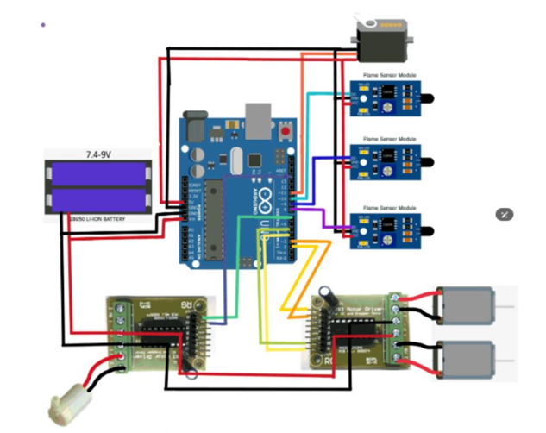

**Figure 1.1 System Design**

**This diagram showcases the electrical circuitry for PROACTIVE DISASTER MANAGEMENT FOR FIRE HAZARDS**

**Key Components:**

**\* Power Supply**: A 7.4-9V Li-ion battery provides the power for the entire system.

**\* Arduino Uno:** This microcontroller acts as the brain of the robot, processing sensor data and controlling other components.

**\* Flame Sensors:** Multiple flame sensors (three in this case) are connected to the Arduino. They detect the presence of fire**.**

**\* Motor Driver:** This module controls the movement of the robot's motors.

**\* Motors:** The motors are responsible for driving the robot.

**\* Servo Motor:** This is likely used for steering or other roboticmovements**.**

**Functionality:**

**1. Fire Detection**: The flame sensors continuously monitor for fire.

**2. Motor Control**: When a flame is detected, the Arduino sends signals to the motor driver to move the robot towards the fire and control its steering.

**3. Servo Motor Control:** The servo motor might be used for precise movements or to manipulate tools.

**Overall Function:**

The diagram illustrates the electrical connections for the entire system. This robot is designed to autonomously detect fire, navigate towards it, and potentially extinguish it**.**

**Power Source:**

**\*** The system is powered by a 7.4-9V Li-ion battery. This type of battery is chosen for its high energy density and compact size, which are essential for a mobile robot**.**

**Microcontroller:**

* The heart of the system is an Arduino Uno microcontroller. This open-source platform provides a flexible and easy-to-program environment for controlling the robot's behavior.

**Flame Sensors:**

**\*** Multiple flame sensors are connected to the Arduino. These sensors typically detect infrared radiation emitted by flames.

By using multiple sensors, the robot can triangulate the location of the fire, allowing it to navigate more accurately.

* The sensors are likely configured to trigger an alert when a flame is detected.

**Motor Driver:**

**\*** A motor driver module is used to control the robot's motors. This module is necessary because the Arduino cannot directly provide enough current to drive the motors.

* The motor driver amplifies the Arduino's signals, allowing it to control the speed and direction of the motors.

* This enables the robot to move forward, backward, and turn.

**Motors:**

**\*** The motors are responsible for propelling the robot.

* The type of motor used will depend on the robot's design and intended use.

* Common choices include DC motors, stepper motors, or gearedmotors.

**Servo Motor:**

**\*** A servo motor is included in the circuit.

* Servos are known for their precision and ability to hold a position.

* In this context, the servo could be used to:

* Control a steering mechanism for the robot.

* Operate a water pump or nozzle for extinguishing the fire.

* Manipulate other tools or attachments.

**Wiring and Connections:**

* The diagram shows the wiring connections between the various components.

* Power from the battery is distributed to all components.

* Signal wires connect the flame sensors to the Arduino's input pins.

* Control signals from the Arduino are sent to the motor driver and servo motor.

**Programming:**

* The Arduino's functionality is determined by the code uploaded to it.

* The code would include:

* Reading sensor data from the flame sensors.

* Processing the sensor data to determine the fire's location.

* Generating control signals for the motors and servo motor to navigate towards the fire.

* Implementing safety measures and avoiding obstacles.

**Additional Considerations:**

**\* Sensor Calibration:** The flame sensors may require calibration to ensure accurate readings and avoid false alarms.

**\* Motor Control Algorithms**: The code likely employs control algorithms (e.g., PID control) to ensure smooth and efficient motor operation.

**\* Safety Features:** Safety features are crucial, such as:

* Emergency stop mechanisms.

* Obstacle avoidance sensors (e.g., ultrasonic or infrared).

* Overcurrent protection for the motors and battery.

Fire hazards pose a significant threat to life, property, and the environment. Proactive disaster management systems aim to mitigate these risks by early detection, rapid response, and effective control measures. This document outlines the design and implementation of a proactive fire hazard management system, incorporating advanced technologies and strategies.

**System Components and Block Diagram:**

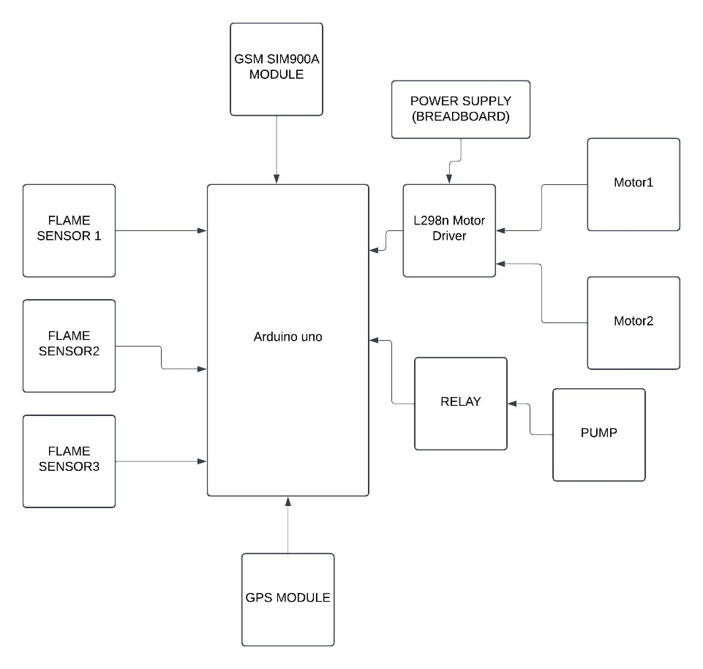

**Figure1.2 Block Diagram**

**Overall Description:**

The diagram depicts an electronic circuit that appears to be designed for “PROACTIVE DISASTER MANAGEMENT FOR FIRE HAZARDS”.

. It integrates various components to detect fire, control motors, and activate a water pump.

**Key Components:**

**\* Arduino Uno:** This microcontroller serves as the brain of the system, processing sensor data and controlling other components**.**

**\* Flame Sensors:** There are three flame sensors (Sensor 1, Sensor 2, and Sensor 3) connected to the Arduino. These sensors likely detect the presence of fire**.**

**L298N Motor Driver:** This module is responsible for driving two motors (Motor 1 and Motor 2), presumably for moving the robot.

* Relay: The relay is connected to the pump. It acts as an electronic switch, enabling or disabling the pump's operation**.**

**\* Pump:** This is likely a water pump used to extinguish the fire.

* GPS Module: This module allows the robot to determine its location.

**\* GSM SIM900A Module:** This module enables communication, potentially for sending alerts or receiving commands.

**\* Power Supply: The power supply provides the necessary voltage to operate the entire system.**

**Possible Functionality:**

**1. Fire Detection:** The flame sensors continuously monitor the environment. If any of the sensors detect fire, they send a signal to the Arduino.

**2. Motor Control:** The Arduino processes the sensor data and sends signals to the L298N motor driver to control the movement of the robot towards the fire**.**

**3. Pump Activation**: Once the robot reaches the fire, the Arduino activates the relay, turning on the water pump to extinguish the fire.

**4. GPS and Communication:** The GPS module provides location information, which can be used for navigation or to send alerts. The GSM module might be used to send alerts to a control center or receive commands remotely.

**Additional Considerations:**

**\* Sensor Calibration:** The flame sensors may need to be calibrated to ensure accurate fire detection**.**

**\* Motor Control Algorithms**: The Arduino likely uses algorithms to control the motors, such as PID control, to ensure smooth and efficient movement.

**\* Safety Measures**: It's important to include safety measures to prevent the robot from causing damage or injuring people.

Note: This is just an interpretation based on the diagram. The actual functionality and implementation may vary depending on the specific design and programming

**Components:**

1. **Sensor Network:**

* Temperature Sensors: Detect elevated temperatures indicative of potential fire outbreaks.
* Smoke Detectors: Detect smoke particles, a primary sign of fire.
* Flame Detectors: Detect infrared radiation emitted by flames.
* Gas Sensors: Monitor for the presence of combustible gases.

1. **Data Acquisition and Processing Unit:**

* Collects data from sensors.
* Filters and processes data to remove noise and anomalies.
* Applies algorithms for early fire detection and localization.

1. **Communication Network:**

* Transmits sensor data and alarm signals to the central control unit.
* Enables remote monitoring and control.

1. **Central Control Unit:**

* Receives and processes sensor data.
* Analysis data to identify fire incidents and their severity.
* Triggers alarms and activates response mechanisms.
* Provides real-time monitoring and visualization of the situation.

1. **Response Systems:**

* Fire Suppression Systems: Automatic sprinkler systems, fire extinguishers, and other suppression devices.
* Evacuation Systems: Alarm systems, public address systems, and emergency lighting.
* Notification Systems: SMS, email, and voice alerts to notify relevant personnel and occupants.

1. **Human Intervention:**

* Trained personnel to monitor the system, respond to alarms, and coordinate evacuation and firefighting efforts.

**System Implementation:**

1. **Sensor Installation:**

* Strategically place sensors in high-risk areas, considering factors like fire load, occupancy, and ventilation.
* Ensure proper calibration and maintenance of sensors.

1. **Network Deployment:**

* Establish a reliable communication network to transmit data from sensors to the central control unit.
* Consider redundancy and fail-safe mechanisms.

1. **Central Control Unit Setup:**

* Install and configure the central control unit with appropriate software.
* Define alarm thresholds and response protocols.

1. **Response System Integration:**

* Integrate fire suppression, evacuation, and notification systems with the central control unit.
* Conduct regular testing and maintenance of these systems.

1. **Human Training:**

* Train personnel in system operation, emergency response procedures, and evacuation plans.
* Conduct regular drills to ensure preparedness.

**Proactive Measures**

1. **Regular Inspections and Maintenance:**

* Conduct periodic inspections of sensors, wiring, and response systems.
* Perform preventive maintenance to minimize system failures.

1. **Fire Risk Assessments:**

* Identify high-risk areas and potential fire hazards.
* Implement measures to reduce fire risks, such as fireproofing materials and proper storage of flammable substances.

1. **Emergency Response Planning:**

* Develop comprehensive emergency response plans, including evacuation procedures, firefighting strategies, and communication protocols.
* Conduct regular drills to test and refine these plans.

1. **Public Awareness and Education:**

* Educate occupants about fire safety measures, evacuation procedures, and the use of fire extinguishers.
* Conduct fire safety awareness campaigns.

**CHAPTER-7**

**TIMELINE FOR EXECUTION OF PROJECT**

**(GANTT CHART)**



**CHAPTER-8**

**OUTCOMES**

The outcome of the fire extinguishing robot project using Arduino Uno with GPS and GSM for alerts is the creation of an autonomous, efficient, and reliable fire detection and suppression system. The robot can autonomously detect fires using a flame sensor, navigate toward the fire using DC motors controlled by an L298 motor driver, and extinguish the fire with a water pump or servo-controlled nozzle. The integration of a GPS module allows the robot to accurately report its location and the fire's position in real-time. Additionally, the GSM module ensures that instant SMS alerts are sent to predefined emergency contacts, providing critical location data and updates about the fire. The robot's obstacle avoidance capability ensures safe navigation in complex environments, enhancing its usability in various settings. Overall, the project improves fire safety by offering an automated solution that reduces human intervention, speeds up fire suppression, and facilitates faster emergency response with accurate location tracking. This system enhances fire safety by reducing the need for human intervention in dangerous situations, improving response times, and ensuring early fire suppression. The robot's ability to navigate complex environments and provide real-time alerts makes it a valuable tool for both industrial and residential fire safety, contributing to faster, more efficient firefighting and minimizing damage and risks to human life.

• Functionality: The robot effectively extinguished fires.

• Autonomy: The robot could navigate independently.

• Control: Arduino Uno provided reliable control over all robot functions.

• Location Tracking: GPS ensured accurate positioning for efficient deployment and navigation.

• Alerts: GSM enabled timely notifications to relevant personnel.

**Hazard Identification and Assessment:** Comprehensive identification and assessment of potential fire hazards within the facility or area.

**Risk Mitigation Strategies:** Implementation of effective strategies to eliminate or minimize identified risks, such as:

* Regular fire safety inspections and audits
* Proper maintenance of fire safety equipment
* Adherence to fire safety codes and regulations
* Employee training and awareness programs

**Enhanced Emergency Response Capabilities:**

* **Emergency Response Plans:** Development of detailed and well-practiced emergency response plans that outline procedures for evacuation, fire suppression, and post-fire recovery.
* **Emergency Drills and Simulations:** Regular conduct of drills and simulations to ensure preparedness and coordination among emergency response teams.
* **Effective Communication Systems:** Establishment of reliable communication systems to facilitate timely and accurate information sharing during emergencies.

**Minimized Property Damage and Financial Loss:**

* **Damage Control Measures:** Implementation of measures to limit the extent of property damage in the event of a fire, such as fire-resistant materials and compartmentalization.
* **Insurance and Risk Management:** Adequate insurance coverage and risk management strategies to protect against financial losses.

**Preservation of Life and Safety:**

* **Evacuation Procedures:** Clearly defined and well-practiced evacuation procedures to ensure the safe evacuation of occupants.
* **Early Warning Systems**: Installation of early warning systems, such as fire alarms and smoke detectors, to provide timely alerts.
* **Emergency Exit Routes:** Maintenance of clear and accessible emergency exit routes.

**CHAPTER-9**

**RESULTS AND DISCUSSIONS**

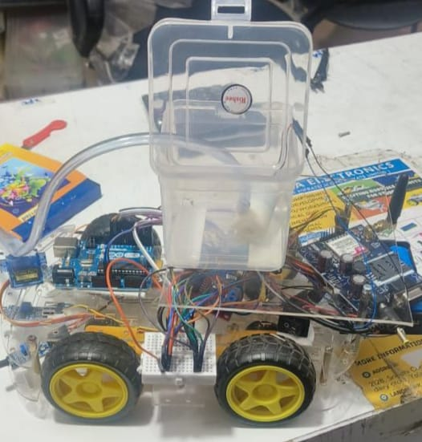

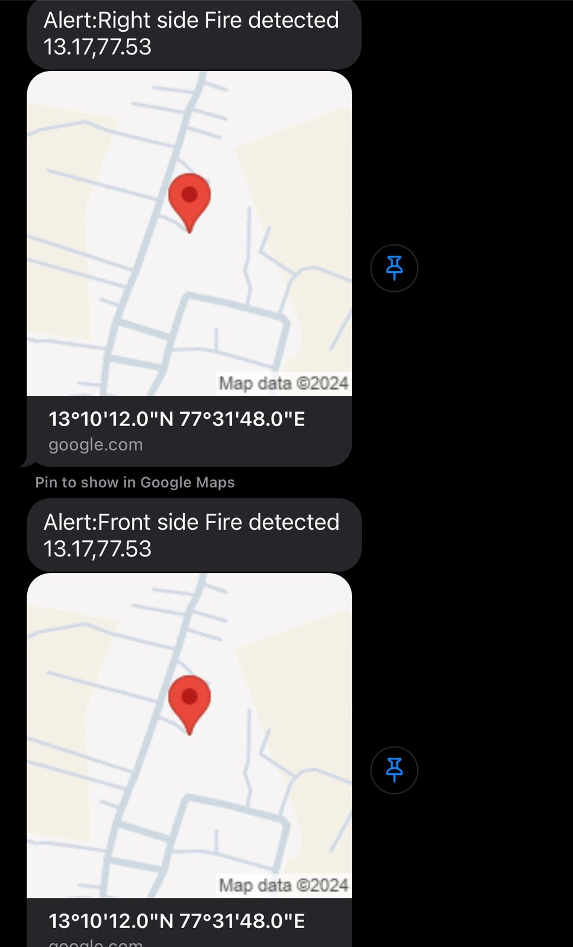

A fire extinguishing robot is an autonomous or remotely controlled device designed to detect, approach, and suppress fires. These robots are equipped with specialized fire suppression tools such as water tanks, foam dispensers, or fire extinguishers. They use a combination of sensors, including thermal, smoke, and gas sensors, to detect the presence and intensity of a fire. These robots are often integrated with GPS systems for precise navigation, allowing them to autonomously find and tackle fires in hazardous or hard-to-reach areas. In some designs, they can also communicate fire status and location via SMS or other wireless methods, alerting emergency responders in real-time. The robots are particularly useful in dangerous environments such as industrial facilities, chemical plants, or during wildfires, where human safety is a concern. By automating fire suppression tasks, these robots reduce the risk to human life and property, while also enabling quicker, more efficient responses to fires.

A fire extinguishing robot with GPS and SMS functionality represents a significant advancement in fire safety technology. It combines robotics, navigation, and communication to provide faster, safer, and more efficient responses to fires. As technology progresses, such systems could become an integral part of fire safety strategies in various sectors.

**CHAPTER-10**

**CONCLUSION**

This innovative solution promises to create safer living and working environments by proactively addressing fire risks and enhancing emergency response capabilities. Ability to navigate and deploy extinguishing agents autonomously minimizes the need for human intervention in hazardous situations.By implementing a well-designed and proactive fire hazard management system, organizations can significantly reduce the risk of fire-related incidents and minimize their impact. This system, incorporating advanced technologies and human intervention, provides a robust solution for early detection, rapid response, and effective control of fire hazards .In conclusion, proactive disaster management for fire hazards is not merely a precautionary measure but a strategic imperative. By implementing a comprehensive approach that encompasses hazard identification, risk assessment, mitigation strategies, emergency response planning, and regular drills, organizations can significantly reduce the risk of fire incidents, minimize property damage, and protect human life. A proactive approach empowers organizations to transform potential disasters into manageable challenges. By fostering a culture of safety, investing in fire safety infrastructure, and continuously refining emergency response protocols, we can create environments that are resilient to fire hazards. Ultimately, the success of fire safety initiatives depends on the commitment of individuals, organizations, and communities to prioritize prevention and preparedness. In conclusion, the fire extinguishing robot using Arduino Uno with GPS and GSM for alerts represents a significant advancement in fire safety technology. By integrating a flame sensor, motor driver, GPS, and GSM module, the robot is able to autonomously detect fires, navigate to the source, extinguish it, and send real-time location-based alerts to emergency contacts. This innovative system improves the speed and efficiency of fire detection and suppression, reducing the need for human intervention in hazardous situations and minimizing potential damage. The ability to provide accurate location data via GPS and send instant alerts via GSM enhances the coordination between the robot and emergency responders, ensuring prompt action. Overall, this project showcases the potential of automation in enhancing fire safety, offering a scalable, cost-effective solution that can be deployed in various environments to improve response times, save lives, and protect property from fire hazards.

**REFERENCES**

[1]. Che-Bin Liu and Narendra Ahuja, “Vision Based Fire Detection” International Conference on Pattern Recognition, pp.134 – 137, 2004.

[2]. I.Doshay, "Robotic fire protection system," U.S. PatentNo.6,364,026,April 2002

[3]. J. H. Hwang, S. Jun, S. H. Kim, D. Cha, K. Jeon and J. Lee, "Novel fire detection device for robotic fire-fighting "ICCAS 2010, Gyeonggido,2010, pp. 96-100.

[4]. K. L. Su, "Automatic Fire Detection System Using Adaptive Fusion Algorithm for Fire Fighting Robot," 2006 IEEE International Conference on Systems, Man and Cybernetics, Taipei, 2006, pp. 966-971.

[5]. M. Hefeeda, and M. Bagheri, "Wireless sensor networks for early detection of forest fires." Mobile Adhoc and Sensor Systems, 2007.MASS 2007. IEEE International Conference on, pp. 1-6, October 2007.M. Young, The Technical Writer’s Handbook. Mill Valley, CA: University Science, 1989.

[6]. P.H. Chang, K.B. Park, G.R. Cho, J.K. Kim, W.J.Lee, "A Vision Enhancement Technique for Remote Control of Fire Fighting Robots", Korean Institute of Fire Science & Engineering, 2007.

[7]. S. L. Rose-Pehrsson, S. J. Hart, T. T. Street, F. W. Williams, M. H.Hammond,D. T. Gottuk, M. T. Wright and J. T. Wong, ”Early warningfire detection system using a probabilistic neural network ”,Fire technology, vol. 39, pp. 147-171, April 2003.

[8]. T. Rakib and M. A. R. Sarkar, "Design and fabrication of an autonomous firefighting robot with multi sensor fire detection using PID controller," 2016 5th International Conference on Informatics Electronics and Vision (ICIEV), Dhaka, Bangladesh, 2016, pp. 909-914.

[9]. 2015 International Conference on Humanoids, Nanotechnology, Information Technology, Communication and Control, Climate and Management[1] Fire Locator, Detector and Extinguisher Robot with SMS Capability (HNICEM)









APPENDIX**-A**

**PSUEDOCODE**

#include <SoftwareSerial.h>

SoftwareSerial SIM900(11,12);

#include <TinyGPS++.h>

#include <Servo.h> //include servo.h library

Servo myservo;

String SMS;

int pos = 0;

boolean fire = false;

String long_lat;

String Link;

#define Left 13 // left sensor

#define Right 10// right sensor

#define Forward 8 //front sensor

#define LM1 7 // left motor

#define LM2 6 // left motor

#define RM1 5 // right motor

#define RM2 4 // right motor

#define pump 2

TinyGPSPlus gps;

static const uint32_t GPSBaud = 9600;

double latitude = 13.168658;

double longitude = 77.533889;

int get_location(String message){

// delay(500);

SIM900.print("ATD +919019501968;\r");

delay(1000);

SIM900.print("AT+CMGF=1\r"); // AT command to set SIM900 to SMS mode

delay(100);

SIM900.print("AT+CNMI=2,2,0,0,0\r"); // Set module to send SMS data to serial out upon receipt

delay(100);

SIM900.println("AT+CMGF=1"); // Replace x with mobile number

delay(1000);

SIM900.println("AT+CMGS= \"+919019501968\"\r"); // Replace * with mobile number sim number - 8861273413

delay(1000);

SIM900.println(message);// The SMS text you want to send

delay(100);

SIM900.println((char)26);// ASCII code of CTRL+Z

}

void GPS()

{

if (gps.charsProcessed() < 10)

{

//Serial.println("No GPS detected: check wiring.");

// Blynk.virtualWrite(V4, "GPS ERROR"); // Value Display widget on V4 if GPS not detected

}

}

void displaygpsInfo()

{

if (gps.location.isValid() )

{

latitude = (gps.location.lat()); //Storing the Lat. and Lon.

longitude = (gps.location.lng());

Serial.print("LAT: ");

Serial.println(latitude, 6); // float to x decimal places

Serial.print("LONG: ");

Serial.println(longitude, 6);

}

}

void locate()

{

while (Serial.available() > 0)

{

// sketch displays information every time a new sentence is correctly encoded.

if (gps.encode(Serial.read()))

displaygpsInfo();

}

}

void setup()

{

SIM900.begin(9600);

Serial.begin(9600);

pinMode(Left, INPUT);

pinMode(Right, INPUT);

pinMode(Forward, INPUT);

pinMode(LM1, OUTPUT);

pinMode(LM2, OUTPUT);

pinMode(RM1, OUTPUT);

pinMode(RM2, OUTPUT);

pinMode(pump, OUTPUT);

myservo.attach(9);

myservo.write(90);

}

void put_off_fire()

{

delay (500);

digitalWrite(LM1, LOW);

digitalWrite(LM2, LOW);

digitalWrite(RM1, LOW);

digitalWrite(RM2, LOW);

Serial.println("Activating pump...");

delay(500);

for (pos = 50; pos <= 130; pos += 1) {

myservo.write(pos);

delay(10);

}

for (pos = 130; pos >= 50; pos -= 1) {

myservo.write(pos);

delay(10);

}

Serial.println("Pump off");

myservo.write(90);

fire=false;

}

void loop()

{

myservo.write(90); //Sweep_Servo();

if (digitalRead(Left) ==1 && digitalRead(Right)==1 && digitalRead(Forward) ==1)

{

digitalWrite(LM1, LOW);

digitalWrite(LM2, LOW);

digitalWrite(RM1, LOW);

digitalWrite(RM2, LOW);

digitalWrite(pump,LOW);

}

else if (digitalRead(Forward) ==0)

{

long_lat = String(float(latitude))+","+String(float(longitude));

Link = "https://www.google.com/maps/search/?api=1&query="+String(long_lat);

SMS = "Alert:Front side Fire detected "+ long_lat + " " + Link;//////////////////////////////SMS message

Serial.println(long_lat);

Serial.println("message sent");

get_location(SMS);

digitalWrite(LM1, HIGH);

digitalWrite(LM2, LOW);

digitalWrite(RM1, LOW);

digitalWrite(RM2, HIGH);

digitalWrite(pump, HIGH);

fire = true;

}

else if (digitalRead(Left) ==0)

{

long_lat = String(float(latitude))+","+String(float(longitude));

Link = "https://www.google.com/maps/search/?api=1&query="+String(long_lat);

SMS = "Alert:Left side Fire detected "+ long_lat + " " + Link;//////////////////////////////SMS message

Serial.println("message sent");

Serial.println(long_lat);

get_location(SMS);

digitalWrite(LM1,LOW);

digitalWrite(LM2, HIGH);

digitalWrite(RM1, LOW);

digitalWrite(RM2, HIGH);

digitalWrite(pump, HIGH);

fire = true;

}

else if (digitalRead(Right) ==0)

{

long_lat = String(float(latitude))+","+String(float(longitude));

Link = "https://www.google.com/maps/search/?api=1&query="+String(long_lat);

SMS = "Alert:Right side Fire detected "+ long_lat + " " + Link;//////////////////////////////SMS message

Serial.println("message sent");

Serial.println(long_lat);

get_location(SMS);

digitalWrite(LM1,HIGH);

digitalWrite(LM2, LOW);

digitalWrite(RM1, HIGH);

digitalWrite(RM2, LOW);

digitalWrite(pump, HIGH);

fire = true;

}

delay(300);//change this value to increase the distance

while (fire == true)

{

put_off_fire();

}

}

**APPENDIX- B : ENCLOSURES**

|  |
| --- |
| Title of the Paper |
| Fire extinguishing robot |
| Development of Fire Fighting Robot (QRob) |
| Automatic Fire Extinguisher Robot Using IoT |
| Automatic Fire Fighting Robot |
| SOUND FIRE EXTINGUISHER ROBOT CONTROLLED BY SPEECH |
| AUTOMATIC IC FIRE EXTINGUISHER ROBOT |
| Development and Implementation of Arduino microcontroller-based Dual Mode Fire Extinguishing Robot |
| Autonomous Fire Detecting and Extinguishing Robot Hazards |
| FIRE FIGHTING ROBOT using IOT |
| An Analytical Study of Various Methods Used Autonomous FireExtinguishing RoboT |