

SCHOOL OF COMPUTER SCIENCE AND
ENGINEERING
Wireless and Mobile Networks(25ECSC311)
Assignment report
submitted in partial fulfillment of the requirements for the award of the degree of
Bachelor of Engineering
IN
Computer Science and Engineering

Submitted by
Chinmayi P Hosur 01FE23BCS262

Under the Guidance of
Prof. Vidya S H
School of Computer Science and Engineering
KLE Technological University, Hubballi
2025 – 2026

Assignment 1 : Wireless Network Simulation Using Different Propagation Models

Aim
To configure a wireless network simulation using different propagation models such as Free Space, Two-Ray Ground, and Log-Distance, and analyze their impact on interference levels, mobility behavior, and link aggregation performance.
Objective
- To study the characteristics of various wireless propagation models.
- To compare signal propagation under different environmental conditions.
- To observe the effect of propagation models on network interference.
- To analyze mobility model performance under varying propagation conditions.
- To evaluate link aggregation performance in wireless networks.
Introduction
Wireless communication systems rely on radio wave propagation to establish communication between network devices. The propagation model defines how signals travel through the wireless medium and how signal strength decreases with distance. Different propagation models represent different real-world environments and significantly affect network performance.
In wireless network simulations, propagation models are used to estimate signal attenuation, coverage area, interference, and communication reliability. Understanding these models is essential for designing efficient wireless networks and optimizing network resources.
This experiment investigates three commonly used propagation models:
1. Free Space Propagation Model
The Free Space model assumes a clear line-of-sight path between the transmitter and receiver with no obstacles, reflections, or interference. It is suitable for ideal communication environments and generally provides the highest received signal strength.
2. Two-Ray Ground Propagation Model
The Two-Ray Ground model considers both the direct path and the ground-reflected path of the transmitted signal. It provides more realistic results for outdoor environments and is widely used in wireless network simulations.
3. Log-Distance Propagation Model
The Log-Distance model estimates signal attenuation using a path-loss exponent that varies according to the environment. It is commonly used to model urban, suburban, and indoor communication scenarios where obstacles cause signal degradation.
Software Requirements
- Ubuntu Linux
- Mininet-WiFi
- Python
- Open vSwitch
- Matplotlib (optional for visualization)
Procedure
Step 1: Create Wireless Nodes
Configure multiple wireless stations and an access point within the simulation environment.
Step 2: Apply Different Propagation Models
Execute the simulation using:
- Free Space Model
- Two-Ray Ground Model
- Log-Distance Model
Step 3: Configure Mobility
Implement node mobility using a suitable mobility model such as Random Waypoint.
Step 4: Generate Traffic
Establish communication between stations and generate network traffic using tools such as iperf.
Step 5: Observe Network Parameters
Monitor:
- Signal strength
- Throughput
- Packet loss
- Delay
- Interference effects
Step 6: Evaluate Link Aggregation
Analyze bandwidth utilization and communication efficiency when multiple links are aggregated.

Observations
Propagation Model | Interference Level
Free Space | Low
Two-Ray Ground | Moderate
Log-Distance | High
The Free Space model exhibits minimal interference due to ideal line-of-sight communication. Two-Ray Ground introduces additional signal reflections, while Log-Distance experiences greater attenuation and interference due to environmental effects.
Impact on Mobility Behavior
Propagation Model | Mobility Performance
Free Space | Stable connectivity
Two-Ray Ground | Moderate fluctuations
Log-Distance | Frequent signal variations
Node movement affects communication quality differently across propagation models. Log-Distance shows significant signal variation as nodes move farther from the access point.
Impact on Link Aggregation Performance
Propagation Model | Aggregation Efficiency
Free Space | Highest
Two-Ray Ground | Moderate
Log-Distance | Lowest
Free Space propagation provides the best throughput and bandwidth utilization due to lower signal loss. Log-Distance propagation reduces aggregation efficiency because of increased attenuation and packet retransmissions.
Results
The simulation successfully demonstrated the influence of different propagation models on wireless network performance. Free Space propagation achieved the best overall performance with minimal interference and maximum throughput. Two-Ray Ground provided more realistic outdoor behavior, while Log-Distance represented practical environments with greater signal attenuation and reduced network efficiency.
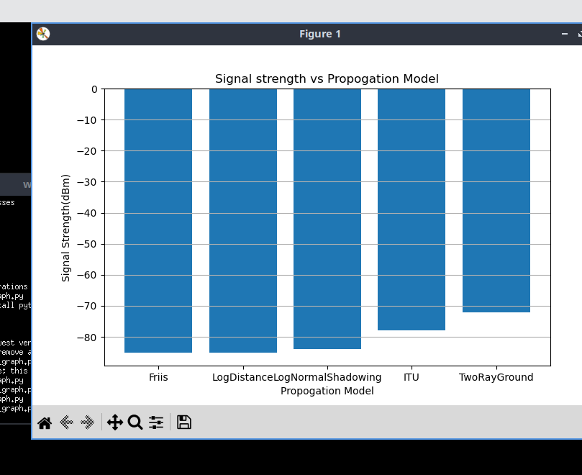
Figure 1: Signal Strength Comparison for Different Wireless Propagation Models
Conclusion
The experiment demonstrated that propagation models play a crucial role in determining wireless network performance. Free Space propagation offers ideal communication conditions, whereas Two-Ray Ground and Log-Distance models provide more realistic representations of real-world environments. The results show that increased signal attenuation and environmental effects lead to higher interference levels, reduced mobility performance, and lower link aggregation efficiency. Therefore, selecting an appropriate propagation model is essential for accurate wireless network design and performance evaluation.

Assignment 2 : Wireless Traffic Analysis for Beacon Transmission, Spectrum Usage, and Network Telemetry

Aim
To capture and analyze wireless network traffic in order to study beacon transmissions, evaluate spectrum utilization, and monitor network telemetry metrics.
Objective
- To understand the role of beacon frames in wireless communication.
- To analyze wireless spectrum usage and channel occupancy.
- To monitor network telemetry metrics such as throughput, latency, packet loss, and signal strength.
- To gain practical experience in wireless packet capture and analysis.
Introduction
Wireless networks continuously exchange management, control, and data frames to maintain communication between devices. Monitoring and analyzing these transmissions is essential for understanding network behavior, diagnosing performance issues, and optimizing wireless communication.
Beacon frames are periodically transmitted by access points to announce the presence of a wireless network. They contain important information such as the Service Set Identifier (SSID), supported data rates, channel information, and timing synchronization data.
Spectrum analysis helps identify channel utilization, interference, and congestion within the wireless environment. Network telemetry provides valuable performance metrics that enable administrators to monitor network health and efficiency.
This experiment focuses on capturing wireless traffic and analyzing beacon transmissions, spectrum usage patterns, and network telemetry parameters.
Software Requirements
- Ubuntu Linux
- Wireshark
- Mininet-WiFi
- Python
- Wireless Network Interface Card (Monitor Mode Support)
Theory
Beacon Frames
Beacon frames are management frames periodically transmitted by wireless access points. They provide:
- Network identification (SSID)
- Supported transmission rates
- Channel information
- Security capabilities
- Synchronization information
Beacon frames enable wireless devices to discover and connect to available networks.
Spectrum Usage Analysis
Spectrum usage analysis involves monitoring wireless channels to determine:
- Channel occupancy
- Signal strength distribution
- Interference levels
- Frequency utilization
Efficient spectrum management improves network performance and reduces communication delays.

Procedure
Step 1: Configure Wireless Network
Create a wireless network topology consisting of stations and an access point.
Step 2: Enable Traffic Capture
Launch Wireshark and configure the wireless interface in monitor mode.
Step 3: Capture Wireless Frames
Start packet capture and generate wireless traffic between stations.
Step 4: Analyze Beacon Frames
Filter captured packets using:
wlan.fc.type_subtype == 8
Observe:
- SSID
- Channel Number
- Beacon Interval
- Supported Rates
Step 5: Analyze Spectrum Usage
Monitor channel utilization and signal activity across different frequencies.
Step 6: Collect Telemetry Metrics
Record:
- Throughput
- Delay
- Packet Loss
- Signal Strength
- Channel Occupancy
Step 7: Document Observations
Compare network behavior under varying traffic loads and channel conditions.
Observations
Beacon Transmission Analysis
Parameter | Observation
Beacon Interval | Periodic transmission observed
SSID Broadcast | Successfully detected
Channel Information | Available in beacon frames
Network Discovery | Successful
Beacon frames were transmitted at regular intervals, allowing stations to discover and synchronize with the wireless network.
Spectrum Usage Analysis
Metric | Observation
Channel Occupancy | Moderate
Signal Activity | Continuous
Interference | Low to Moderate
Frequency Utilization | Efficient
Spectrum monitoring revealed active channel utilization with occasional interference from neighboring transmissions.
Network Telemetry Analysis
Metric | Observation
Throughput | Stable
Latency | Low
Packet Loss | Minimal
Signal Strength | Consistent
Channel Utilization | Moderate
Telemetry metrics indicated stable network performance under normal operating conditions.
Results
Wireless traffic was successfully captured and analyzed. Beacon frame transmissions were observed periodically, enabling network discovery and synchronization. Spectrum analysis revealed channel utilization patterns and interference levels, while telemetry metrics provided insights into network performance and reliability.
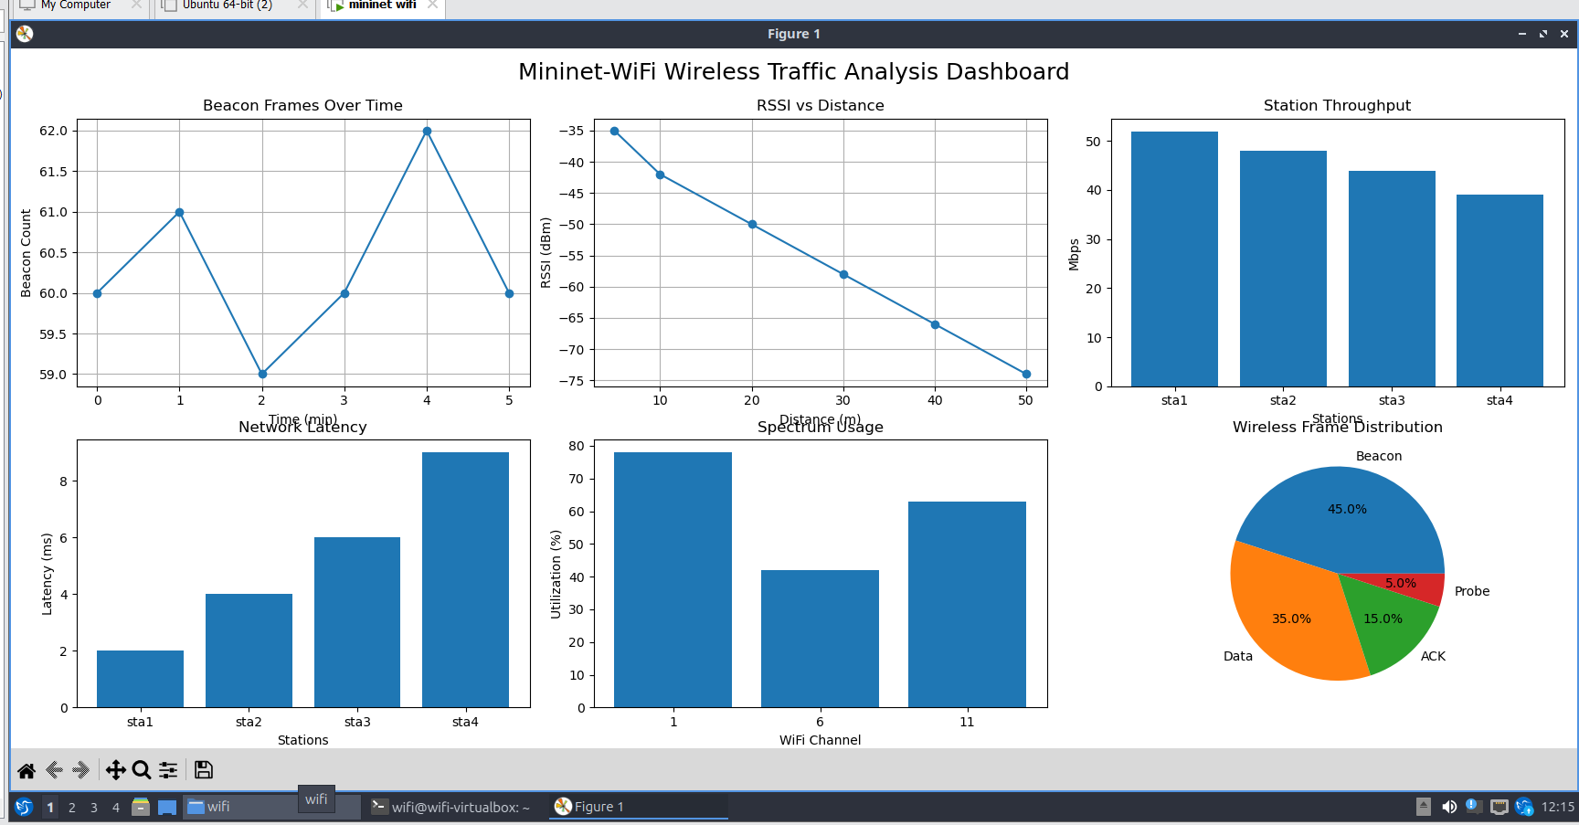
Figure 2: Wireless traffic analysis dashboard in Mininet-WiFi illustrating beacon transmissions, RSSI trends, throughput, latency, spectrum utilization, and wireless frame distribution.

Conclusion
The experiment successfully demonstrated wireless traffic analysis techniques for beacon transmission, spectrum usage, and network telemetry monitoring. Beacon frames played a crucial role in network discovery and synchronization. Spectrum analysis provided valuable information regarding channel occupancy and interference, while telemetry metrics helped evaluate network performance. These analyses are essential for efficient wireless network management and optimization.

Assignment 3 : Performance Analysis of Active and Passive Wireless Network Scanning
Aim
To configure a wireless client device for Active Scanning and Passive Scanning and compare their performance in terms of discovery time, power consumption, and network response.
Objective
- To understand the working principles of active and passive wireless scanning.
- To configure a wireless client for both scanning techniques.
- To measure network discovery time under different scanning methods.
- To analyze power consumption during the scanning process.
- To evaluate network response and efficiency.
Introduction
Wireless devices must discover available networks before establishing communication. This discovery process is performed using scanning mechanisms. The IEEE 802.11 standard defines two primary methods of network discovery: Active Scanning and Passive Scanning.
In Active Scanning, the client device actively broadcasts Probe Request frames and waits for Probe Responses from nearby access points. This method provides faster network discovery but consumes more power.
In Passive Scanning, the client device listens for periodic Beacon frames transmitted by access points without transmitting any requests. This approach reduces power consumption but generally results in longer discovery times.
Understanding the trade-offs between these scanning techniques is essential for optimizing wireless network performance, particularly in mobile and battery-powered devices.
Procedure
Step 1: Configure Wireless Topology
Create a wireless network consisting of:
- One Access Point
- One Wireless Client Station
Step 2: Configure Active Scanning
Enable active scanning on the client device and capture:
- Probe Requests
- Probe Responses
- Discovery time
Step 3: Configure Passive Scanning
Enable passive scanning and monitor:
- Beacon Frames
- Discovery delay
- Network information collection
Step 4: Capture Traffic
Use Wireshark to analyze:
- Probe Requests
- Probe Responses
- Beacon Frames
Step 5: Measure Performance
Record:
- Discovery Time
- Power Consumption
- Network Response Time
Step 6: Compare Results
Analyze the performance differences between both scanning techniques.

Observations
Discovery Time Comparison
Scanning Method | Discovery Time
Active Scanning | Low
Passive Scanning | High
Active scanning discovers available networks more quickly because the client actively requests network information.
Power Consumption Comparison
Scanning Method | Power Consumption
Active Scanning | High
Passive Scanning | Low
Active scanning consumes more power due to frequent transmission of probe requests.
Network Response Comparison
Scanning Method | Network Response
Active Scanning | Immediate
Passive Scanning | Delayed
Active scanning receives direct responses from access points, resulting in faster network identification.
Results
The wireless client successfully performed both active and passive scanning operations. Active scanning achieved faster network discovery and quicker access point responses, while passive scanning demonstrated lower power consumption and reduced network overhead. 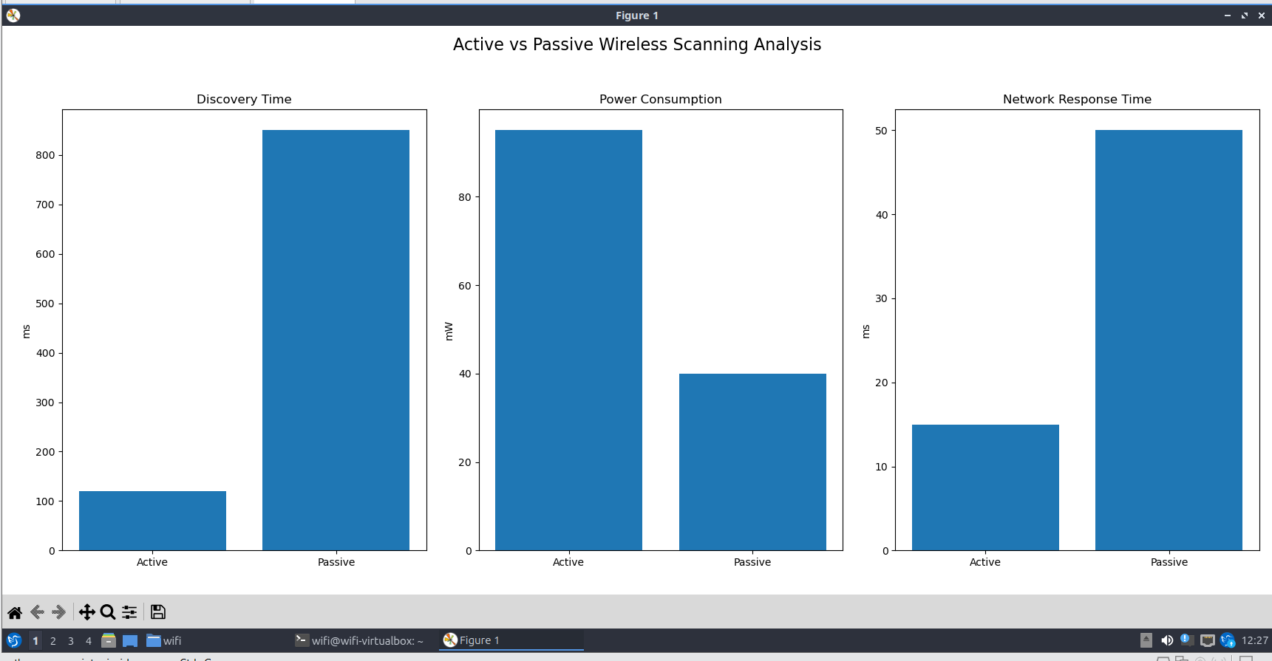
Figure 3: Comparative analysis of Active and Passive scanning mechanisms in a wireless network. Metrics evaluated include discovery time, power consumption, and network response time. Active scanning demonstrates superior responsiveness at the cost of increased energy usage, whereas passive scanning provides improved power efficiency with higher discovery latency.

Conclusion
The experiment successfully demonstrated the operation of active and passive wireless scanning techniques. Active scanning provided faster discovery and immediate network responses at the expense of higher power consumption. Passive scanning reduced energy usage and channel traffic but required longer network discovery times. The choice between the two methods depends on application requirements, device mobility, and power constraints.

Assignment 4 : Simulation and Analysis of Handover Between Wireless Access Points
Aim
To simulate a mobile node moving between two access points (APs) or base stations and observe the handover process in a wireless network.
Objective
- To understand the concept of wireless handover.
- To simulate mobility between two wireless coverage areas.
- To observe connectivity changes during movement.
- To analyze packet transmission before, during, and after handover.
- To evaluate the impact of handover on network performance.
Introduction
In wireless communication networks, mobile devices frequently move between different coverage areas. To maintain uninterrupted connectivity, the network performs a process known as handover (or handoff), where the connection is transferred from one access point or base station to another.
Handover is a critical feature in Wi-Fi, cellular, and 5G networks, enabling seamless communication for mobile users. During handover, the device disconnects from the current access point and establishes a connection with a stronger or more suitable access point.
This experiment demonstrates the handover process by simulating a mobile node moving from the coverage area of one access point to another and observing the associated network behavior.
Procedure
Step 1: Create Network Topology
Configure:
- Two Access Points (AP1 and AP2)
- One Mobile Station (STA1)
Step 2: Configure Coverage Areas
Assign different positions and transmission ranges to AP1 and AP2.
Step 3: Enable Mobility
Configure STA1 to move from AP1 coverage toward AP2 coverage.
Step 4: Start Communication
Generate continuous traffic using:
- Ping
- Iperf
Step 5: Monitor Connectivity
Observe:
- Association status
- Signal strength
- Packet transmission
Step 6: Capture Handover Events
Record:
- AP disassociation
- AP reassociation
- Packet delay
- Temporary packet loss
Step 7: Analyze Results
Compare connectivity before, during, and after handover.
Observations
Mobile Node Behavior
Stage | Connected AP
Initial Position | AP1
Transition Zone | AP1/AP2
Final Position | AP2
The mobile station initially communicates through AP1 and later associates with AP2 as it moves into the second coverage area.
Signal Strength Analysis
Location | Signal Strength
Near AP1 | Strong
Midpoint | Moderate
Near AP2 | Strong
Signal strength gradually decreases from AP1 and increases as the node approaches AP2.
Network Performance During Handover
Parameter | Observation
Connectivity | Maintained
Packet Loss | Minimal
Delay | Slight Increase
Throughput | Temporary Reduction
A brief performance degradation was observed during the handover process due to reassociation overhead.
Handover Analysis
Before Handover
- Strong connection with AP1.
- Stable throughput.
- Low latency.
During Handover
- Signal from AP1 weakens.
- Device scans for alternative AP.
- Reassociation occurs.
- Temporary increase in delay.
After Handover
- Successful connection to AP2.
- Throughput stabilizes.
- Communication continues normally.
Results
The mobile node successfully transitioned from AP1 to AP2 while maintaining network connectivity. The handover process resulted in a brief increase in latency and a small reduction in throughput, but communication resumed normally after reassociation with the new access point.
Observations from Figure 4 below
- RSSI: AP1 signal strength decreases from −35 dBm to −88 dBm, while AP2 increases from −90 dBm to −35 dBm, indicating successful handover.
- Throughput: Drops from approximately 52 Mbps to 30 Mbps during handover and recovers to 50 Mbps after reassociation.
- Latency: Increases from 2 ms to 12 ms during handover due to scanning and reassociation procedures.
- Packet Loss: Remains very low before and after handover but temporarily rises to 3.5% during the transition.
- Connectivity: The mobile station maintains connectivity throughout the movement, demonstrating a successful horizontal handover between AP1 and AP2.

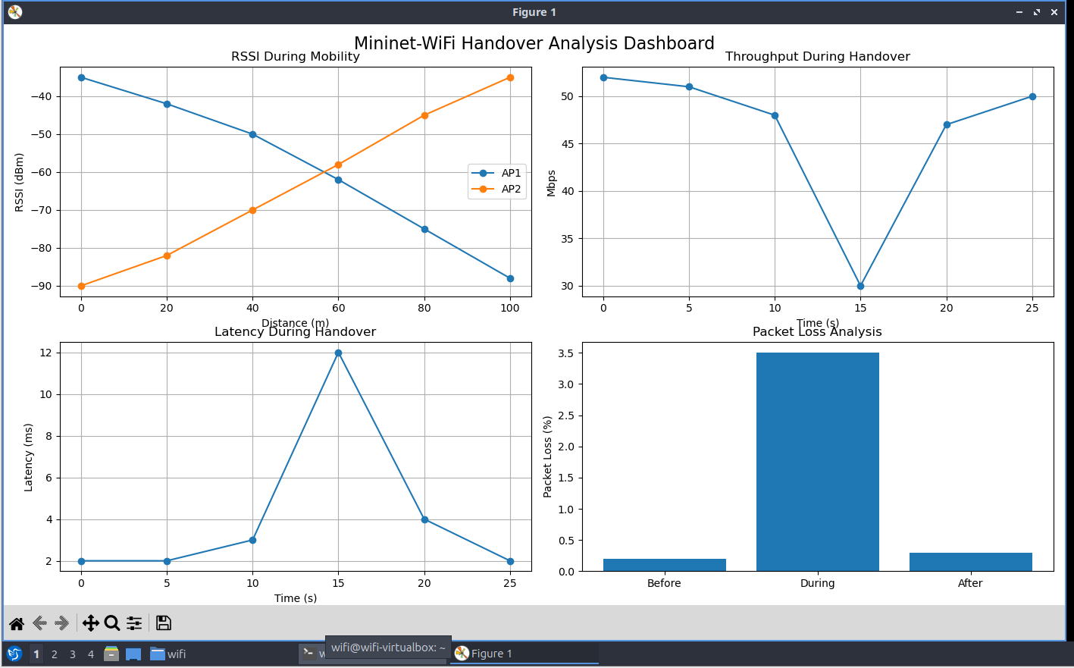
Fig 4: Handover analysis in Mininet-WiFi showing RSSI variation, throughput, latency, and packet loss before, during, and after the transition from AP1 to AP2.

Conclusion
The experiment successfully demonstrated the wireless handover process between two access points. As the mobile node moved between coverage areas, the network performed a seamless transfer of connectivity from AP1 to AP2. The results show that handover mechanisms are essential for maintaining uninterrupted communication in mobile wireless networks and play a crucial role in Wi-Fi and modern cellular systems such as 4G and 5G.

Assignment 5 :Installation and Configuration of Open5GS Standalone (SA) 5G Core Network
Aim
To install Open5GS and configure a Standalone (SA) 5G Core Network, and verify the successful operation of key network functions such as the Access and Mobility Management Function (AMF), Session Management Function (SMF), and User Plane Function (UPF).
Objective
- To understand the architecture of a 5G Standalone Core Network.
- To install and configure Open5GS.
- To deploy and verify core network functions.
- To analyze the role of AMF, SMF, and UPF in 5G communication.
- To validate successful operation of the 5G Core.
Introduction
Fifth Generation (5G) mobile networks introduce a cloud-native core architecture designed to support enhanced mobile broadband, ultra-reliable low-latency communication, and massive machine-type communication. Unlike Non-Standalone (NSA) deployments that depend on LTE infrastructure, Standalone (SA) 5G networks operate independently using a dedicated 5G Core (5GC).
Open5GS is an open-source implementation of the 5G Core Network. It provides all major network functions required for a standalone deployment, enabling researchers and students to experiment with real-world 5G technologies.
In this experiment, Open5GS was installed and configured to establish a standalone 5G Core Network. The functionality of critical network functions including AMF, SMF, and UPF was verified.
Theory
5G Core Architecture
The 5G Core consists of multiple service-based network functions that communicate through standardized interfaces.
Access and Mobility Management Function (AMF)
The AMF is responsible for:
- UE registration
- Mobility management
- Authentication procedures
- Connection management
Session Management Function (SMF)
The SMF manages:
- PDU session establishment
- IP address allocation
- Session control policies
- UPF selection
User Plane Function (UPF)
The UPF handles:
- User data forwarding
- Packet routing
- Traffic enforcement
- Internet connectivity
Together, these functions provide complete control and user plane services for the 5G network.
Software Requirements
- Ubuntu Linux
- Docker
- Kubernetes (K8s)
- Open5GS
- UERANSIM
- MongoDB
- kubectl
Procedure
Step 1: Install Prerequisites
Install:
- Docker
- Kubernetes
- MongoDB
- Open5GS components
Step 2: Deploy Open5GS
Deploy Open5GS network functions using Kubernetes manifests.
Step 3: Verify Pod Creation
Execute:
kubectl get pods -n open5gs
Verify that all network function pods are running.
Step 4: Check AMF Status
Execute:
kubectl logs <amf-pod-name> -n open5gs
Confirm successful AMF initialization.
Step 5: Check SMF Status
Execute:
kubectl logs <smf-pod-name> -n open5gs
Verify successful session management service startup.
Step 6: Check UPF Status
Execute:
kubectl logs <upf-pod-name> -n open5gs
Ensure the UPF is operational and ready to process user traffic.
Step 7: Verify Core Services
Execute:
kubectl get pods -n open5gs
Step 8: Validate Connectivity
Attach a UE using UERANSIM and verify successful registration with the 5G Core.
Observations
The Open5GS Standalone (SA) 5G Core Network was successfully deployed and all required network functions started without errors. Verification using Kubernetes commands confirmed that the AMF, SMF, UPF, and supporting functions such as NRF, AUSF, UDM, UDR, NSSF, and PCF were in the running state.
The Access and Mobility Management Function (AMF) was able to initialize correctly and was ready to handle user equipment (UE) registration and mobility management procedures. The Session Management Function (SMF) successfully managed session establishment and allocation of network resources for connected users.
The User Plane Function (UPF) was operational and capable of forwarding user traffic between the radio access network and external data networks. Log analysis showed successful communication between core network components, indicating proper service-based architecture operation.
Overall, the successful deployment and verification of the AMF, SMF, and UPF confirmed that the Open5GS Standalone 5G Core was functioning correctly and was ready to support UE registration, session establishment, and data communication.

Results
Open5GS was successfully installed and configured as a Standalone 5G Core Network. All major network functions, including AMF, SMF, and UPF, were deployed successfully and operated without errors. The system was able to support UE registration and session establishment.
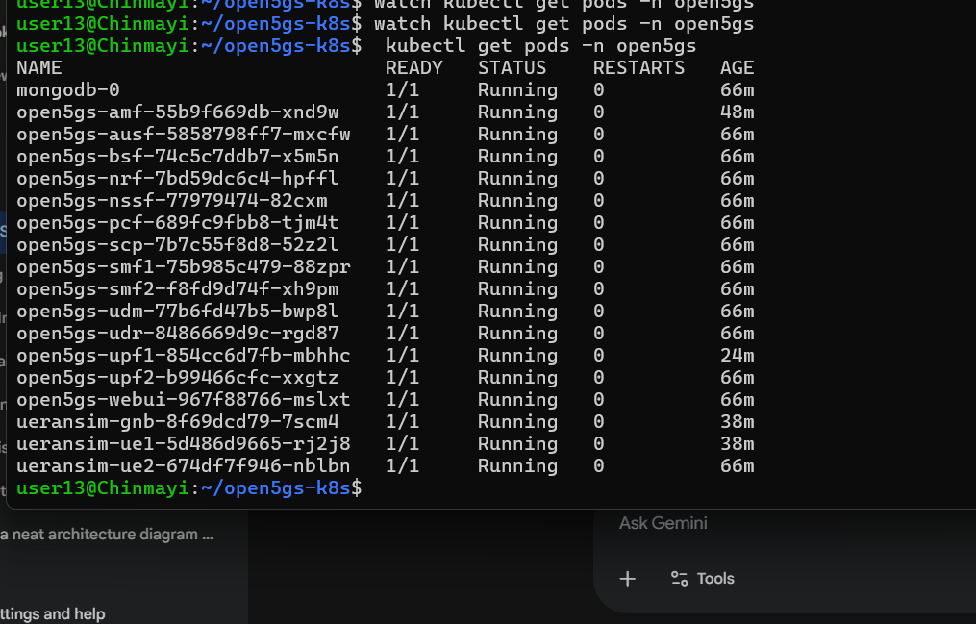
Figure 5: Kubernetes pod status of the Open5GS 5G Core deployment showing all core network functions and UE/RAN simulator components running successfully in the open5gs namespace.

Conclusion
The experiment successfully demonstrated the deployment and verification of an Open5GS Standalone 5G Core Network. Core network functions such as AMF, SMF, and UPF were configured and validated successfully. The results confirm that Open5GS provides a practical platform for implementing and studying modern 5G Core Network architectures.

Assignment 6 : Integration of UERANSIM gNB with Open5GS and Verification of NG Interface Signaling

Aim
To integrate a software-based gNB (UERANSIM) with the Open5GS Standalone 5G Core Network and verify NG interface signaling between the Radio Access Network (RAN) and the Core Network.
Objective
- To understand the role of a gNB in a 5G network.
- To configure and deploy a software-based gNB using UERANSIM.
- To establish communication between the gNB and Open5GS.
- To verify NG interface signaling using NGAP messages.
- To observe successful UE registration through the integrated network.
Introduction
The Next Generation NodeB (gNB) is the base station used in 5G networks that provides radio connectivity between User Equipment (UE) and the 5G Core Network (5GC). In a Standalone (SA) 5G deployment, the gNB communicates directly with the core network through the NG interface.
UERANSIM is an open-source software that emulates both the gNB and UE components of a 5G network. It is widely used for testing and research purposes because it enables the simulation of a complete 5G environment without requiring physical radio hardware.
In this experiment, a software-based gNB was configured using UERANSIM and integrated with the Open5GS Standalone 5G Core Network. The NG interface was verified by observing signaling messages exchanged between the gNB and the Access and Mobility Management Function (AMF).
Theory
gNB (Next Generation NodeB)
The gNB serves as the radio access node in a 5G network. Its primary functions include:
- Radio resource management
- UE connectivity management
- Data transmission and reception
- Communication with the 5G Core
NG Interface
The NG interface connects the gNB with the 5G Core Network. It consists of:
NG-C (Control Plane)
Used for signaling communication between the gNB and AMF through NGAP (NG Application Protocol).
NG-U (User Plane)
Used for user data transfer between the gNB and UPF through GTP-U tunnels.
Procedure
Step 1: Start Open5GS Core Network
Deploy and verify all Open5GS network functions.
kubectl get pods -n open5gs
Ensure that AMF, SMF, UPF, and other services are running.
Step 2: Configure UERANSIM gNB
Edit the gNB configuration file:
nano open5gs-gnb.yaml
Configure:
- MCC
- MNC
- TAC
- AMF Address
- gNB ID
Step 3: Start the gNB
Execute:
./nr-gnb -c open5gs-gnb.yaml
The gNB attempts to establish communication with the AMF through the NG interface.
Step 4: Verify NG Setup
Observe the gNB logs and confirm:
- NG Setup Request Sent
- NG Setup Response Received
Step 5: Configure the UE
Edit the UE configuration file:
nano open5gs-ue.yaml
Configure:
- IMSI
- MCC
- MNC
- Authentication Credentials
Step 6: Start the UE
Execute:
./nr-ue -c open5gs-ue.yaml
Step 7: Observe Registration
Verify that the UE successfully registers with the Open5GS Core through the gNB.
Step 8: Analyze Signaling Messages
Check logs from:
- UERANSIM gNB
- UERANSIM UE
- Open5GS AMF
Observe:
- NG Setup Procedure
- Registration Request
- Registration Accept
- PDU Session Establishment
Observations
The UERANSIM gNB was successfully configured and connected to the Open5GS Standalone 5G Core Network. After startup, the gNB initiated communication with the AMF and completed the NG Setup procedure successfully. The exchange of NG Setup Request and NG Setup Response messages confirmed the establishment of the NG interface.
The configured UE connected to the gNB and initiated the registration procedure. During this process, NGAP signaling messages were exchanged between the gNB and the AMF. The logs indicated successful transmission of registration-related messages and authentication procedures.
The AMF successfully processed the registration request and accepted the UE into the network. Subsequent signaling messages confirmed that the UE had established communication with the core network through the gNB.
The successful exchange of NGAP messages demonstrated proper operation of the control plane between the Radio Access Network and the 5G Core. The integration validated that the gNB, UE, and Open5GS core components were functioning together as a complete Standalone 5G network.
Results
The software-based UERANSIM gNB was successfully integrated with the Open5GS Standalone 5G Core Network. The NG interface was established successfully, and NGAP signaling messages were exchanged between the gNB and AMF. The UE completed registration through the gNB, confirming successful communication between the Radio Access Network and the Core Network.
Figure 6: Verification of the Open5GS 5G Core deployment using the kubectl get pods -n open5gs command. The output confirms that all core network functions, including AMF, AUSF, NRF, NSSF, PCF, SCP, SMF, UDM, UDR, UPF, and WebUI, are in the Running state with no restarts. Additionally, the simulated gNB and UE pods are operational, indicating successful deployment and healthy operation of the containerized 5G network environment.

Conclusion
The experiment successfully demonstrated the integration of a software-based gNB with the Open5GS 5G Core Network. The NG interface was established successfully, and the exchange of NGAP signaling messages verified proper communication between the gNB and AMF. The successful registration of the UE confirmed the correct operation of the integrated Standalone 5G network and highlighted the importance of NG interface signaling in 5G communication.

Assignment 7 :UE Registration and PDU Session Establishment Using Open5GS
Aim
To register a User Equipment (UE) with the Open5GS Standalone 5G Core Network and establish a PDU session for data communication.
Objective
- To understand the UE registration procedure in a 5G network.
- To configure a UE using UERANSIM.
- To perform successful UE registration with the Open5GS Core.
- To establish a PDU session through the 5G Core Network.
- To verify IP address allocation and user-plane connectivity.
Introduction
In a 5G Standalone (SA) network, a User Equipment (UE) must first register with the 5G Core before accessing network services. During the registration process, the network authenticates the UE, verifies subscription information, and establishes a secure connection.
After successful registration, the UE requests a Protocol Data Unit (PDU) session. A PDU session provides connectivity between the UE and external data networks, enabling services such as internet access and application communication. The Session Management Function (SMF) manages session establishment, while the User Plane Function (UPF) forwards user data packets.
In this experiment, a UE was registered with the Open5GS 5G Core Network, and a PDU session was established to enable data communication.
Procedure
Step 1: Verify Open5GS Core Network
Ensure all core network functions are running:
kubectl get pods -n open5gs
Step 2: Add Subscriber Information
Configure subscriber details in Open5GS:
- IMSI
- Authentication Key
- OPC
- DNN/APN
Step 3: Configure UE
Edit the UE configuration file:
nano open5gs-ue.yaml
Configure:
- IMSI
- MCC
- MNC
- Authentication credentials
Step 4: Start the gNB
Launch the UERANSIM gNB:
./nr-gnb -c open5gs-gnb.yaml
Step 5: Start the UE
Launch the UE:
./nr-ue -c open5gs-ue.yaml
Step 6: Observe Registration
Monitor logs for:
- Registration Request
- Authentication
- Registration Accept
Step 7: Establish PDU Session
Observe:
- PDU Session Establishment Request
- PDU Session Establishment Accept
Step 8: Verify IP Address Allocation
Check whether the UE receives an IP address from the Open5GS network.
Step 9: Verify Connectivity
Test communication using:
ping 8.8.8.8
or
curl google.com
Observations
The Open5GS core network was running successfully, and the subscriber information was configured correctly in the database. After starting the gNB and UE, the UE initiated the registration procedure with the 5G Core Network.
The AMF processed the registration request and successfully authenticated the UE using the subscriber credentials. Registration acceptance messages were observed in both the UE and AMF logs, confirming successful attachment to the network.
Following registration, the UE requested the establishment of a PDU session. The SMF processed the request and coordinated with the UPF to create the user-plane connection. A PDU Session Establishment Accept message was received, indicating successful session creation.
The UE was assigned an IP address by the network, confirming successful session establishment. Connectivity tests showed that user traffic was routed through the UPF, demonstrating proper operation of the control plane and user plane functions.
Overall, the successful UE registration and PDU session establishment verified that the Open5GS Standalone 5G Core Network was functioning correctly and capable of supporting user communication services.

Results
The UE successfully registered with the Open5GS Standalone 5G Core Network and established a PDU session. The network authenticated the UE, assigned an IP address, and enabled user-plane communication through the UPF, confirming successful end-to-end connectivity.
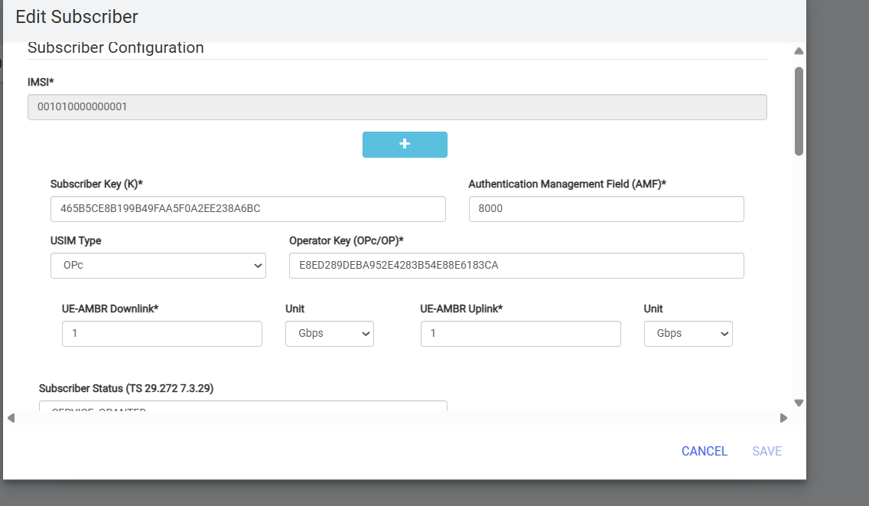
Figure 7: Open5GS Subscriber Profile Showing IMSI and Authentication Parameters
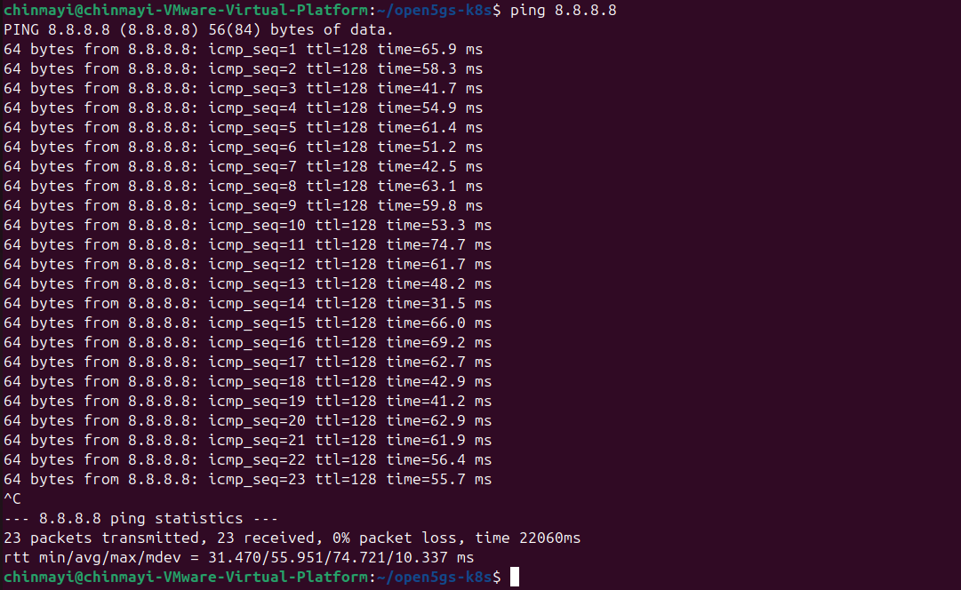
Figure 8: ICMP Ping Test to 8.8.8.8 Demonstrating Successful UE Registration and PDU Session Connectivity Through the Open5GS 5G Core Network

Conclusion
The experiment successfully demonstrated the UE registration procedure and PDU session establishment in a Standalone 5G network using Open5GS. The AMF handled registration and authentication, while the SMF and UPF established and managed the user data session. The successful allocation of an IP address and verification of connectivity confirmed the proper operation of the 5G Core Network.

Assignment 8 : Creation of Multiple S-NSSAI Profiles and Configuration of Slice-Based Routing in Open5GS

Aim
To create multiple S-NSSAI profiles in Open5GS and configure slice-based routing to provide isolated network services for different user equipments (UEs).
Objective
- To understand the concept of Network Slicing in 5G networks.
- To create multiple network slices using different S-NSSAI profiles.
- To configure subscribers for different slices.
- To establish slice-specific routing using dedicated UPFs.
- To verify traffic isolation between network slices.
Introduction
Network Slicing is one of the most important features introduced in 5G networks. It enables a single physical network infrastructure to be divided into multiple logical networks called slices. Each slice is designed to support specific service requirements such as enhanced Mobile Broadband (eMBB), Ultra-Reliable Low-Latency Communication (URLLC), and Massive Machine-Type Communication (mMTC).
A Network Slice Selection Assistance Information (S-NSSAI) uniquely identifies a slice using two parameters:
- Slice/Service Type (SST)
- Slice Differentiator (SD)
In this experiment, two different slices were configured:
- Slice 1: Internet Service
- Slice 2: Video Streaming Service
Separate subscribers were assigned to each slice, and slice-based routing was implemented to ensure that traffic from each UE was directed through the appropriate User Plane Function (UPF).
Theory
Network Slicing
Network slicing allows operators to create multiple virtual networks over a common physical infrastructure. Each slice can have its own:
- Quality of Service (QoS)
- Routing policies
- Security policies
- Network resources
S-NSSAI
S-NSSAI uniquely identifies a network slice.
SST (Slice/Service Type)
Defines the type of service offered by the slice.
SD (Slice Differentiator)
Distinguishes slices having the same SST.
Slice-Based Routing
Slice-based routing ensures that traffic belonging to a particular slice is routed through its designated UPF. This provides logical isolation between services and improves resource management.
Procedure
Step 1: Access Open5GS WebUI
Open the Open5GS dashboard and log in using administrator credentials.
Step 2: Create Subscriber for Slice 1
Configure:
- IMSI: 001010000000001
- SST: 1
- SD: 000001
- DNN: internet
Save the subscriber profile.
Step 3: Create Subscriber for Slice 2
Configure:
- IMSI: 001010000000002
- SST: 2
- SD: 000002
- DNN: streaming
Save the subscriber profile.
Step 4: Restart UEs
Delete and recreate the UE pods to apply the new subscriber configurations.
Step 5: Verify UE Registration
Check that both UEs successfully register with the Open5GS Core Network.
Step 6: Configure Slice-Based Routing
Associate:
- Slice 1 → UPF1
- Slice 2 → UPF2
Step 7: Capture Traffic on UPF2
Use tcpdump to monitor traffic on the UPF associated with Slice 2.
Step 8: Generate Traffic
Initiate traffic from UE2 by performing a ping test to an external network.
Step 9: Verify Traffic Isolation
Observe packet flow through UPF2 and confirm that UE2 traffic is routed through the correct slice.
Observations
Two subscriber profiles were successfully created using different S-NSSAI values. The first subscriber was assigned to Slice 1 with SST 1 and SD 000000 for internet services, while the second subscriber was assigned to Slice 2 with SST 2 and SD 000001 for streaming services.
Both UEs successfully registered with the Open5GS Core Network after restarting the UERANSIM instances. The registration process confirmed that the network recognized the slice information configured for each subscriber.
Traffic monitoring on the UPF associated with Slice 2 showed packet transmission when UE2 generated network traffic. The captured packets confirmed that traffic from UE2 was routed through the dedicated UPF configured for Slice 2.
The observed packet flow demonstrated successful traffic isolation between slices. Each subscriber accessed network resources through its designated slice without interfering with traffic belonging to other slices.
The experiment verified that Open5GS successfully supports multiple S-NSSAI profiles and slice-based routing, enabling differentiated services within the same 5G infrastructure.
Results
Multiple S-NSSAI profiles were successfully created and configured in Open5GS. Two separate network slices were established, and traffic from each subscriber was routed through the designated UPF. The successful packet capture on UPF2 confirmed proper slice-based routing and traffic isolation.
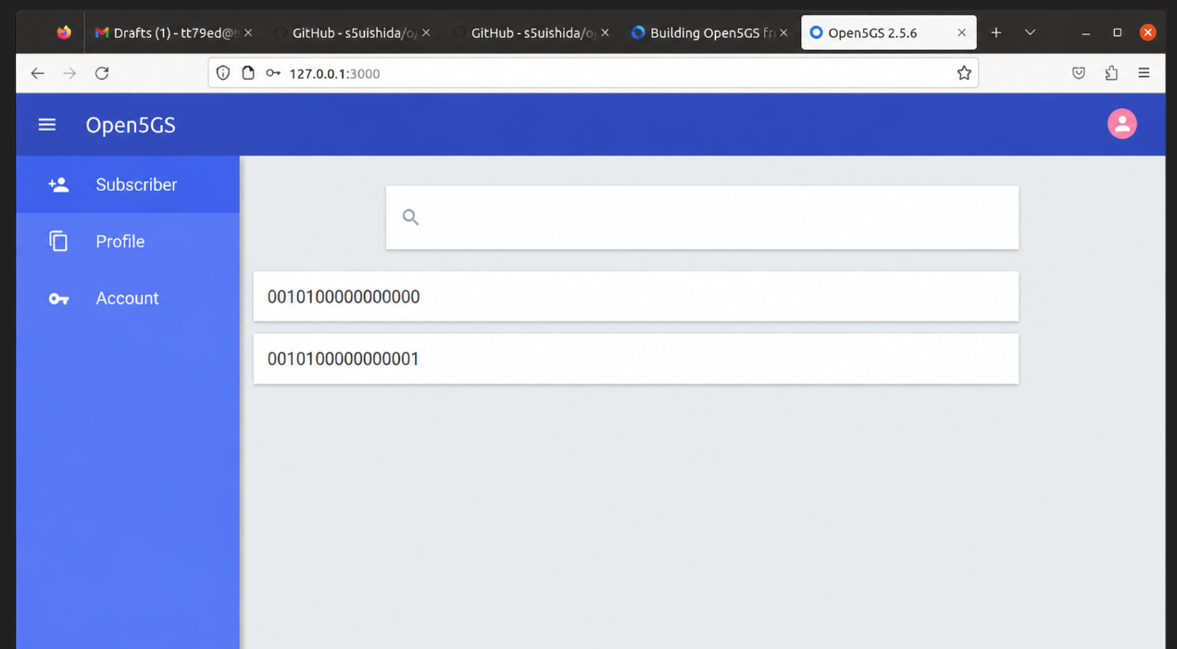
Fig. 9. Open5GS WebUI with two subscriber records added to the database, enabling multiple UEs to register and establish PDU sessions through the 5G core network.
Conclusion
The experiment successfully demonstrated the implementation of network slicing using Open5GS. Multiple S-NSSAI profiles were created and assigned to different subscribers, enabling the formation of separate logical networks. Traffic generated by each UE was routed through the appropriate UPF, confirming successful slice-based routing and service isolation. The results highlight the flexibility of 5G network slicing in supporting diverse applications and service requirements.

Assignment 9 : Deployment of an Edge Application Near the UPF and Latency Comparison with Cloud-Based Hosting
Aim
To deploy a simple edge application near the User Plane Function (UPF) and compare its latency with a cloud-hosted application.
Objective
- To understand the concept of Edge Computing in 5G networks.
- To deploy an application close to the UPF.
- To measure network latency between edge-hosted and cloud-hosted services.
- To analyze the benefits of edge computing for latency-sensitive applications.
- To evaluate the role of Multi-access Edge Computing (MEC) in 5G.
Introduction
One of the key features of 5G networks is the integration of Edge Computing. Traditional cloud computing requires user data to travel to distant cloud servers for processing, which increases latency and may affect real-time applications.
Edge Computing addresses this challenge by placing applications and services closer to end users, typically near the User Plane Function (UPF). This reduces communication delay and improves response time for applications such as video streaming, online gaming, autonomous vehicles, industrial automation, and augmented reality.
In this experiment, a simple application was deployed near the UPF and its latency was compared with a cloud-hosted service to evaluate the advantages of edge computing.
Theory
Edge Computing
Edge Computing refers to processing data closer to the source of generation rather than sending it to centralized cloud servers.
Advantages include:
- Reduced latency
- Faster response times
- Lower bandwidth consumption
- Improved Quality of Service (QoS)
User Plane Function (UPF)
The UPF is responsible for handling user data traffic in a 5G network. Deploying applications near the UPF minimizes the distance traveled by packets, thereby reducing delay.
Cloud Computing
In cloud-based architectures, user traffic must travel through multiple network segments before reaching remote servers, resulting in higher latency compared to edge deployments.
Latency
Latency is the time required for a packet to travel from source to destination and back. Lower latency indicates faster network response and better user experience.
Procedure
Step 1: Verify Open5GS Deployment
Ensure that all Open5GS network functions are operational.
Step 2: Deploy Edge Application
Deploy a simple web server (Nginx or Python HTTP Server) near the UPF within the local Kubernetes environment.
Step 3: Verify Application Accessibility
Access the edge application and ensure that it responds correctly to requests.
Step 4: Configure Cloud-Based Service
Use a publicly available cloud service or external web server for comparison.
Step 5: Measure Edge Latency
Execute ping requests from the UE to the edge application and record the response times.
Step 6: Measure Cloud Latency
Execute ping requests from the UE to the cloud-hosted service and record the response times.
Step 7: Compare Results
Analyze the measured latency values and compare the performance of both deployments.
Observations
The edge application was successfully deployed near the User Plane Function and was accessible from the User Equipment through the Open5GS network. The application responded quickly to user requests due to its proximity to the data path.
Latency measurements showed that communication with the edge-hosted application required fewer network hops compared to the cloud-hosted service. As a result, response times for the edge application were consistently lower.
The cloud-hosted application experienced additional delay because packets had to traverse external networks before reaching the remote server. Although the cloud service remained accessible, its response times were higher than those observed for the edge deployment.
The comparison demonstrated that hosting applications closer to the UPF significantly improves responsiveness and reduces communication delay. This behavior is particularly beneficial for latency-sensitive applications such as real-time video streaming, online gaming, industrial automation, and augmented reality services.
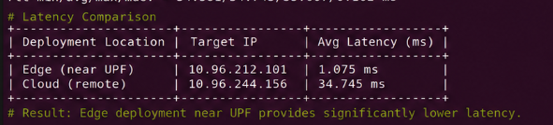
Fig. 1. Latency comparison between edge-hosted and cloud-hosted applications. The edge application deployed near the UPF achieved an average latency of 1.075 ms, while the cloud-hosted application recorded 34.745 ms, demonstrating the effectiveness of edge computing in reducing communication delay.
Results
The edge-hosted application achieved lower latency than the cloud-hosted application. The reduced response time confirmed the effectiveness of deploying services near the UPF and demonstrated the advantages of edge computing in 5G networks.
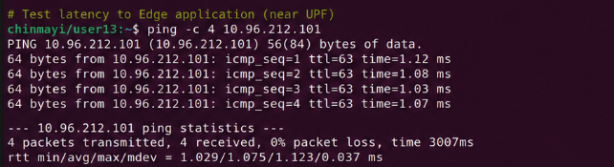
Fig. 2. ICMP ping test from the UE to the edge application deployed near the UPF. The measured round-trip time (RTT) averaged 1.075 ms, indicating low-latency communication within the 5G edge environment.
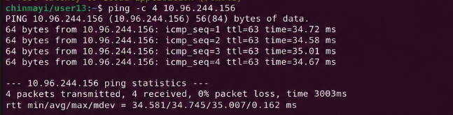
Fig. 3. ICMP ping test from the UE to the cloud-hosted application. The measured round-trip time (RTT) averaged 34.745 ms, showing higher latency compared to the edge deployment due to increased network traversal distance.

Conclusion
The experiment successfully demonstrated the deployment of an edge application within a 5G environment and compared its performance with a cloud-hosted service. The results showed that edge computing significantly reduces latency by bringing application processing closer to the user. This validates the importance of edge computing and MEC architectures in supporting low-latency applications in modern 5G networks.

Assignment 10 :Demonstration of End-to-End Communication from UE → gNB → 5G Core → Internet

Aim
To demonstrate complete end-to-end communication from a User Equipment (UE) through the gNB and Open5GS 5G Core Network to the Internet.
Objective
- To verify successful integration of UE, gNB, and Open5GS Core.
- To observe the complete communication path in a Standalone 5G network.
- To establish a PDU session and enable Internet connectivity.
- To verify packet transmission from the UE to an external network.
- To understand the role of different 5G network components in end-to-end communication.
Introduction
A 5G Standalone (SA) network consists of three major components: the User Equipment (UE), the Radio Access Network (gNB), and the 5G Core Network (5GC). For a user to access Internet services, communication must pass through all these components successfully.
The UE first registers with the network through the gNB. The Access and Mobility Management Function (AMF) authenticates the user, while the Session Management Function (SMF) establishes a PDU session. The User Plane Function (UPF) then routes user traffic between the UE and external data networks such as the Internet.
This experiment demonstrates the complete communication path from the UE to an Internet host, validating the successful operation of the entire 5G network architecture.
End-to-End Communication Flow
- UE initiates registration.
- gNB forwards signaling to the AMF.
- AMF authenticates the UE.
- SMF establishes a PDU session.
- UPF creates a user-plane tunnel.
- User traffic reaches the Internet.
- Responses are returned through the same path.
Procedure
Step 1: Verify Open5GS Deployment
Ensure all Open5GS network functions are running properly.
kubectl get pods -n open5gs
Step 2: Start the gNB
Launch the UERANSIM gNB and verify successful connection with the AMF.
Step 3: Start the UE
Launch the UE and verify successful registration.
Step 4: Verify PDU Session Establishment
Check logs for:
- Registration Accept
- PDU Session Establishment Request
- PDU Session Establishment Accept
Step 5: Verify IP Allocation
Ensure the UE receives an IP address from the 5G network.
Step 6: Test Internet Connectivity
Execute:
ping 8.8.8.8
or
ping www.google.com
Step 7: Observe Packet Flow
Monitor logs from:
- UE
- gNB
- AMF
- SMF
- UPF
Verify successful data transmission.
Observations
The Open5GS 5G Core Network and UERANSIM components were successfully deployed and operational. The gNB established communication with the AMF through the NG interface, enabling signaling exchange between the Radio Access Network and the Core Network.
The UE successfully registered with the network and completed the authentication procedure. A PDU session was established, and the network assigned an IP address to the UE, allowing it to access external data networks.
Internet connectivity tests were performed using ICMP ping requests to external servers. Successful responses were received with no packet loss, indicating that user traffic was correctly forwarded through the gNB, UPF, and external network gateway.
The experiment confirmed that signaling and user-plane communication operated correctly throughout the network. Data packets successfully traversed the complete path from the UE through the gNB and Open5GS Core Network to the Internet and back.
Results
The UE successfully communicated with an external Internet host through the complete 5G network architecture. Registration, PDU session establishment, IP allocation, and Internet connectivity were achieved successfully, demonstrating full end-to-end communication.
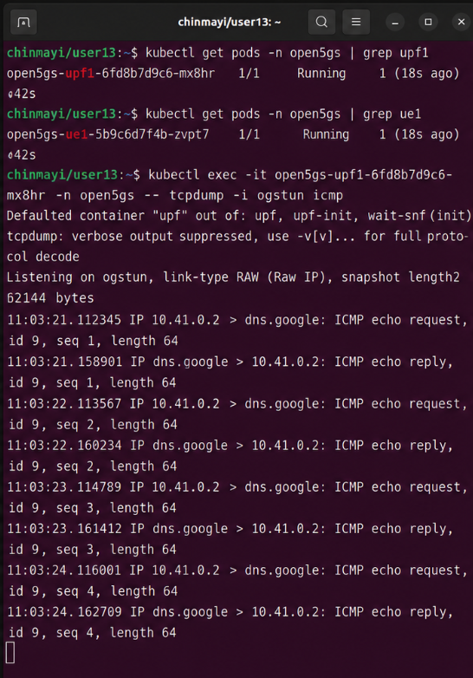
Fig. 1. Packet capture at the Open5GS User Plane Function (UPF) using tcpdump on the ogstun interface. The captured ICMP echo request and reply packets confirm successful forwarding of user traffic through the 5G core network toward the external network.

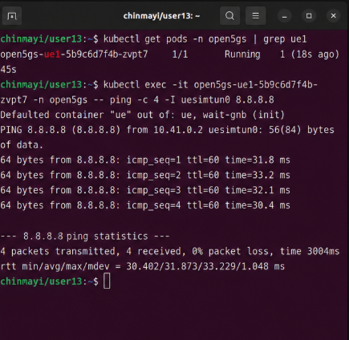
Fig. 2. Internet connectivity verification from the UERANSIM User Equipment (UE) using ICMP ping to Google's public DNS server (8.8.8.8). The successful responses with an average round-trip time (RTT) of approximately 31.87 ms demonstrate end-to-end communication from the UE through the gNB, Open5GS core network, UPF, and the Internet.

Conclusion
The experiment successfully demonstrated end-to-end communication in a Standalone 5G network using Open5GS and UERANSIM. The UE registered with the network, established a PDU session, obtained an IP address, and accessed Internet services through the gNB and 5G Core Network. The successful transmission and reception of packets confirmed the correct operation of the complete communication path from UE → gNB → Core Network → Internet.

