Introduction to SQL

1. Creation of database:

Create database database_name;

Ex: create database student1;

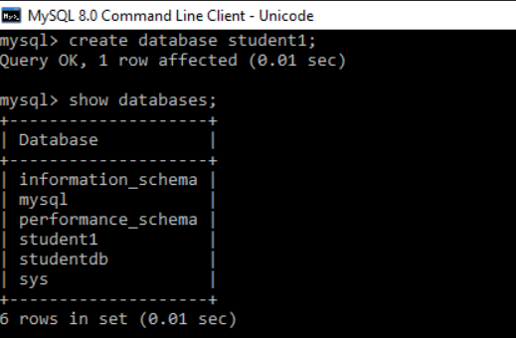

1. To use the database:

use student1;

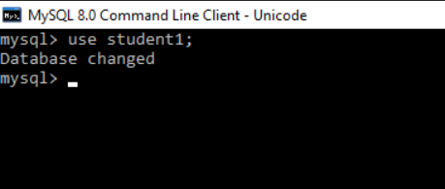

**Data Definition Language:**

1. Create: is used to create the table.

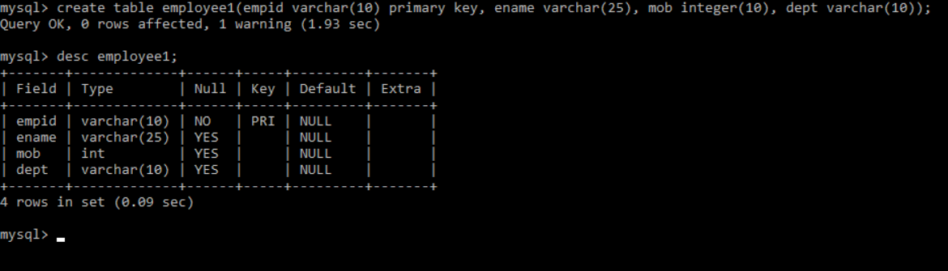

1. Alter: is used to add columns to existing column.

In this example salary is added to the employee1 table using alter command.



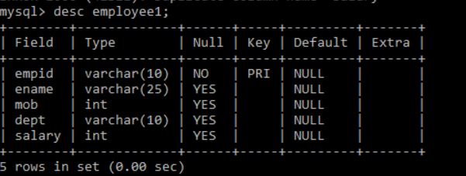

1. drop: This is used to delete complete table or database.

->Droping database

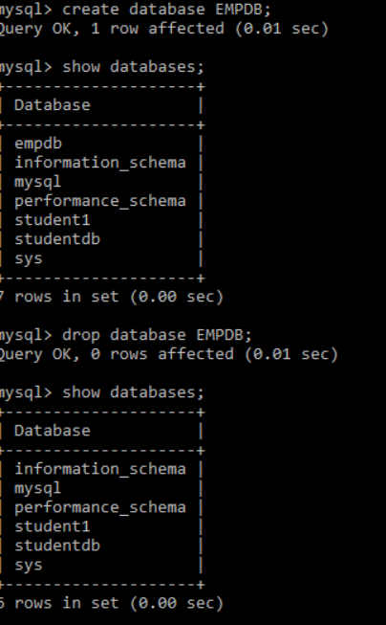

->Droping tables:

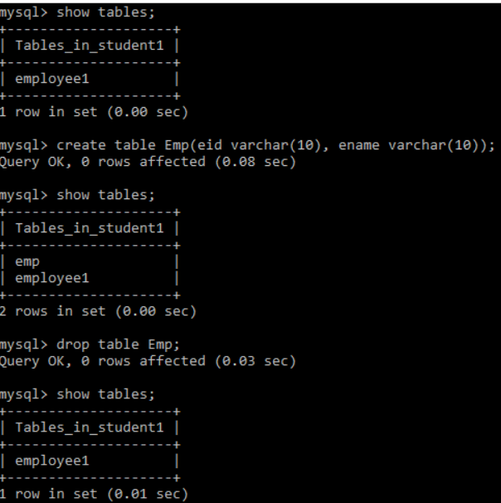

**Data Manipulation Language:**

1. Insert: is to inserting the values into table:

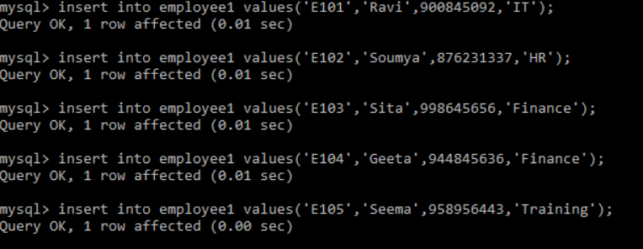

1. Update: is used to update the value.

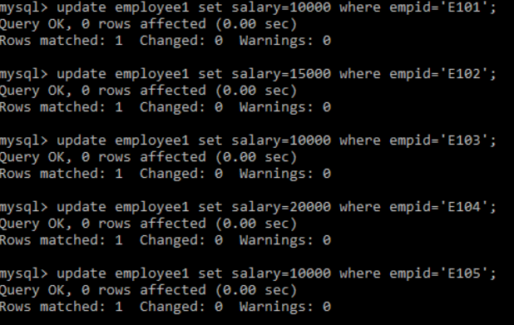

1. Delete: Is used to delete existing record from table.

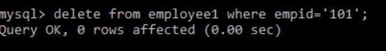

**Data Query Language**

1. Select: is used for select the tables.

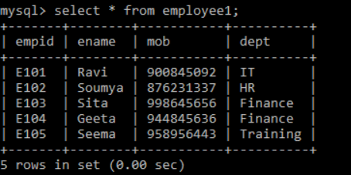

**Aggregate Functions**

1. Count()

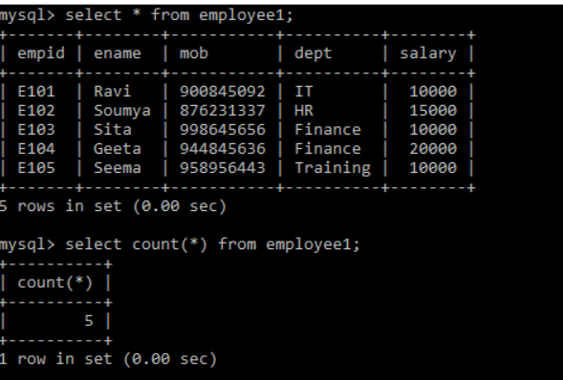

1. Avg()

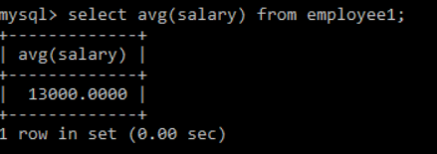

1. Sum()

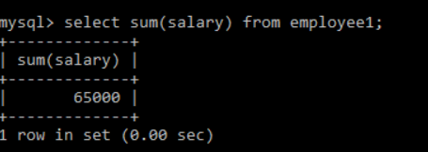

1. Max()

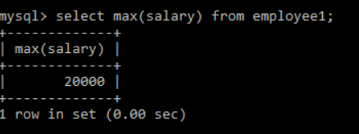

1. Min()

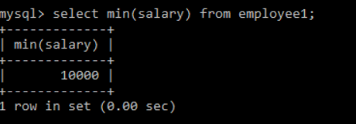

**Order By**: is used to sort the result in ascending or descending order.

->Ascending Order(by default)

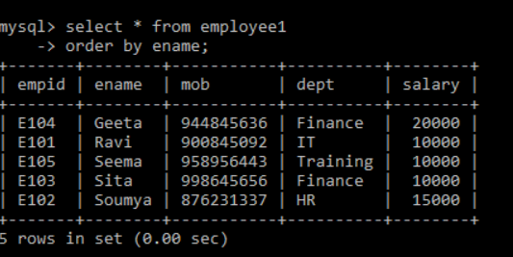

->Descending Order

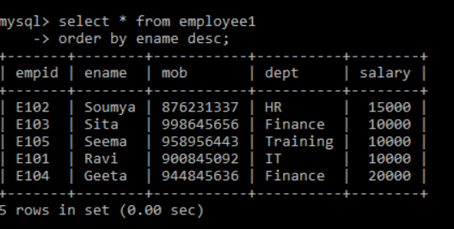

**Group by:** It groups rows that have same values into summary rows.

