**Assignment 1**

Students:

|  |  |  |
| --- | --- | --- |
| Regdno | Name | Branch |
| 0001 | Ram | CSE |
| 0002 | Hari | MTECH |
| 0003 | Pradeep | EEE |
| 0004 | Deepak | ETC |

1. Write down the SQL command which will show Regdno of Pradeep.

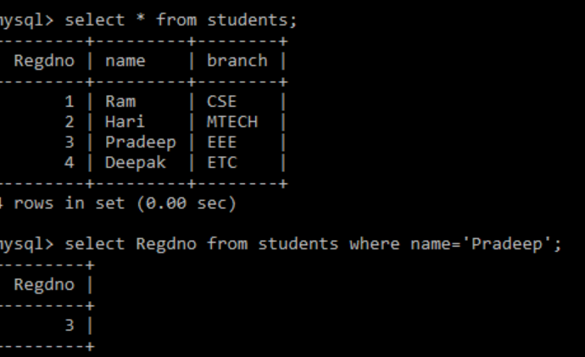

1. Write down the SQL command which will show the name and branch column.

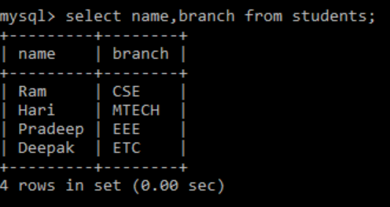

1. Write a SQL command which will count the number of rows existing in students table

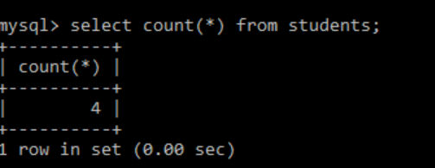

1. To add another column in the student table as “address”

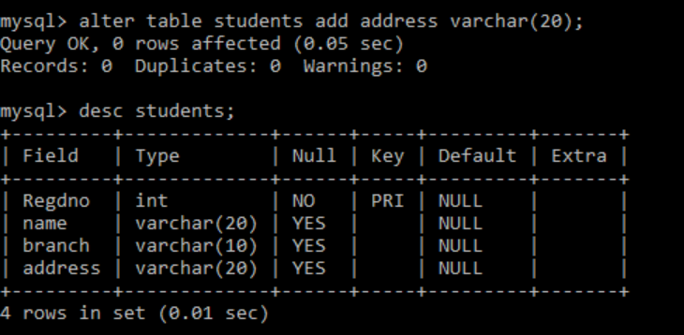

------------------------------------------------------------------------------------------------------------------------------------------

**Assignment 2**

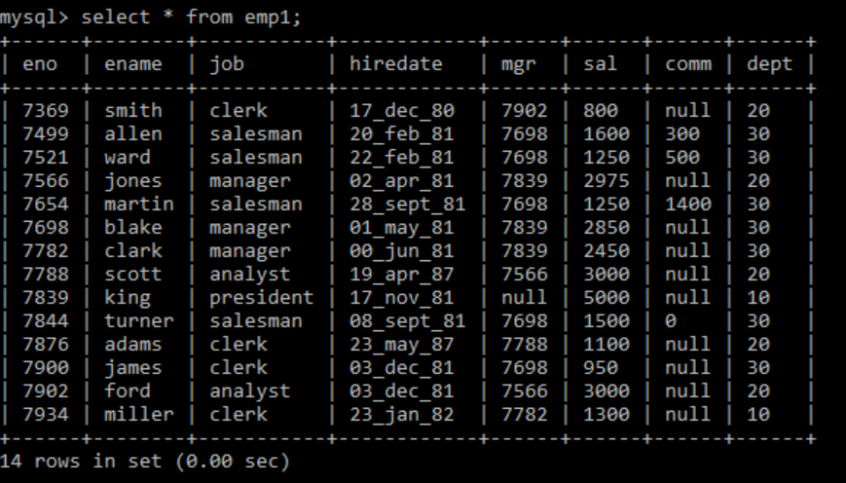

1. Select the employees in department 30

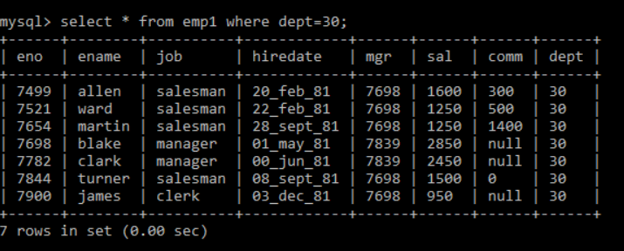

1. List the names, numbers and departments of all clerks.

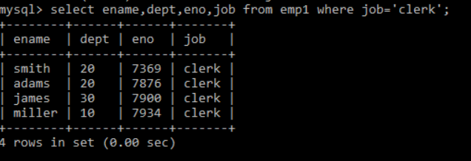

1. Find the department numbers and names of employees of all department where department no greater than 20.

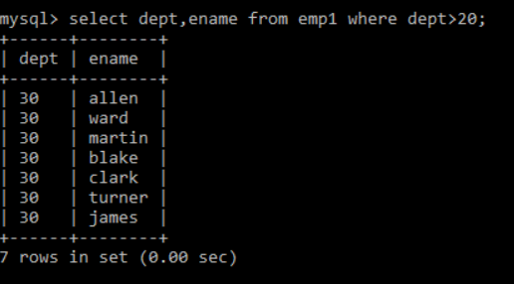

1. Find employees whose commission is greater than their salaries.

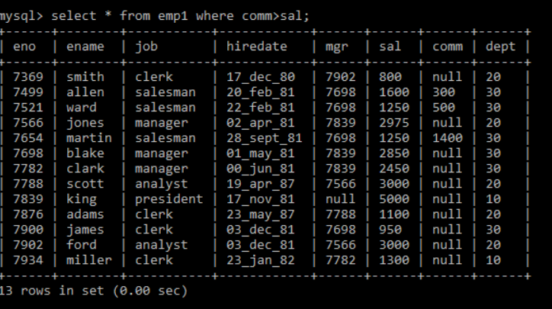

1. Find employees whose commission is greater than 60% of their salaries.

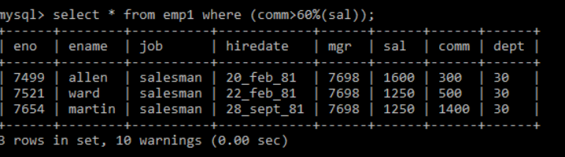

1. List name, job, salary of all employees in department 20 who earn more than 2000/-.

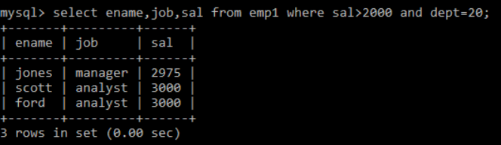

1. Find all salesman in department 30 whose salary is greater than 1500/-.

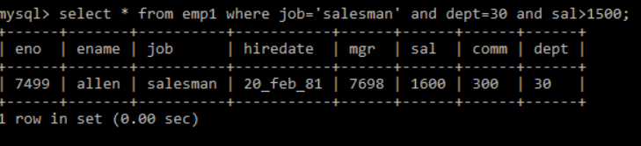

1. Find all employees whose designation is either manager or president.

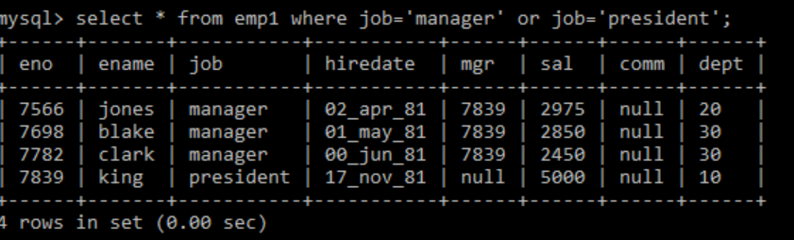

1. Find all managers who are not in department 30.

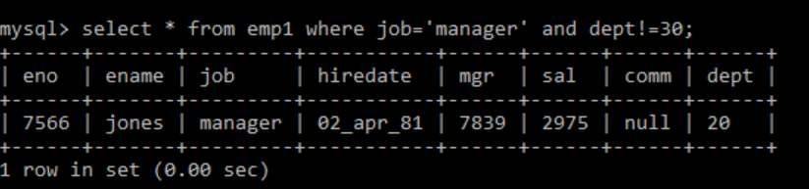

1. Find all details of managers and clerks in dept 10.

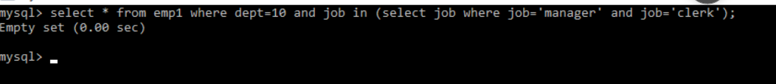

1. Find the details of all manager (in any dept) and clerks in dept 20.

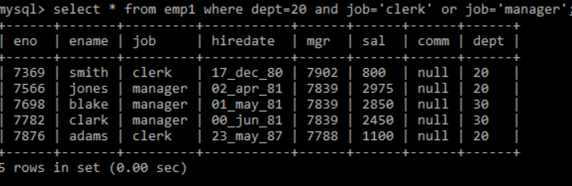

1. Find the details of all managers in dept 10 and all clerks in dept 20 and all employees who are neither managers nor clerks but whose salary is more than or equal to 2000/-.

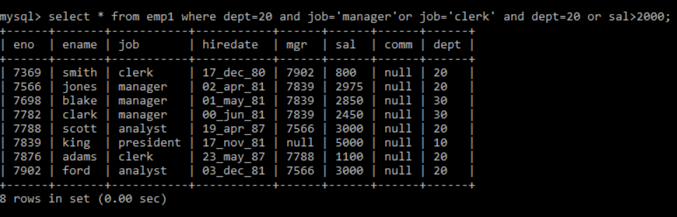

1. Find the names from anyone in dept 20 who is neither manager nor clerk

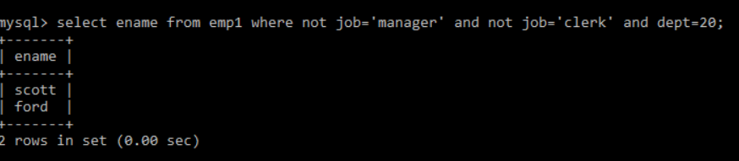

1. Find the names of employees who earn between 1200/- and 1400/-.

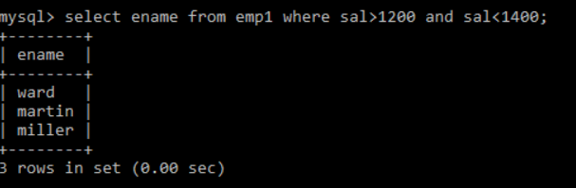

1. Find the names who are clerks, analyst or salesman.

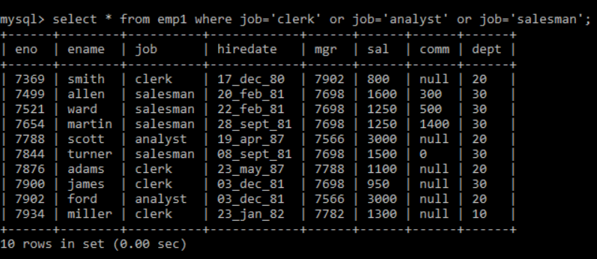

1. Find the names who are not clerks, analyst or salesman.

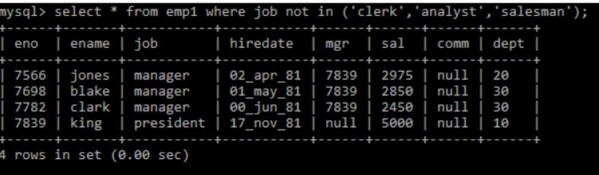

1. Find the employees who do not receive commission.

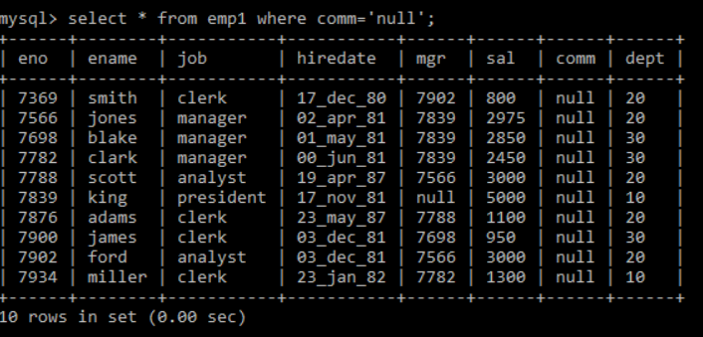

1. Find the different jobs of employees receiving commission.

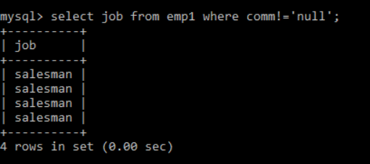

1. Find the employees who do not receive commission or whose commission is less than 100/-.

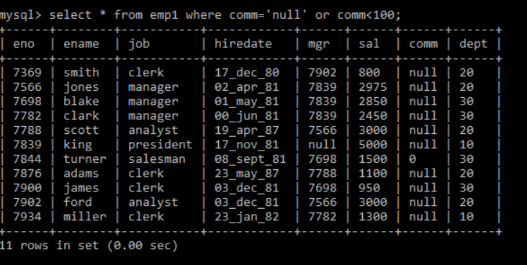

1. Find all employees whose total earning is greater than 2000/-.

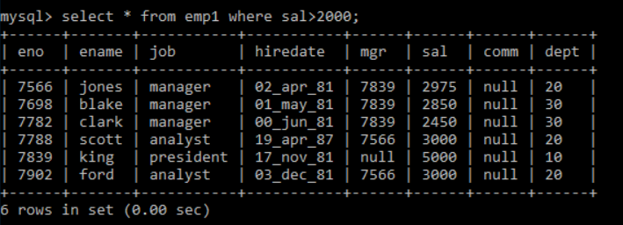

1. Find all the employees whose name begins or ends with’m’.

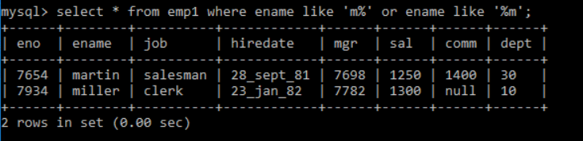

1. Find all the employees whose names are upto 15 character long and have letter ‘r’ as the third character of their names.



1. Find the managers hired in the year 2003.



1. Display the names of all employees replacing ‘a’ with ‘A’.

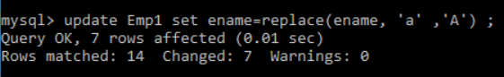

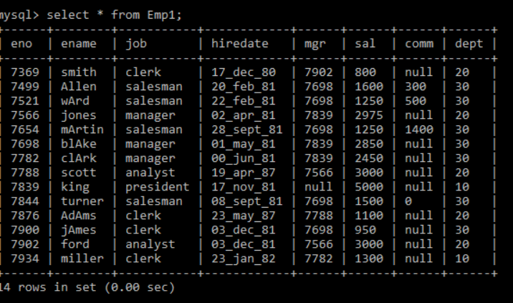

1. Display the names of all employee and position where the string ‘Ar’ occurs in the name.

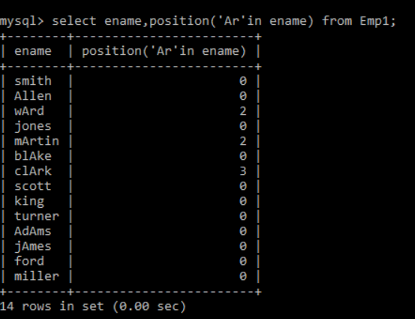

1. Show the salary of all employees , rounding it to the nearest Rs. 1000.

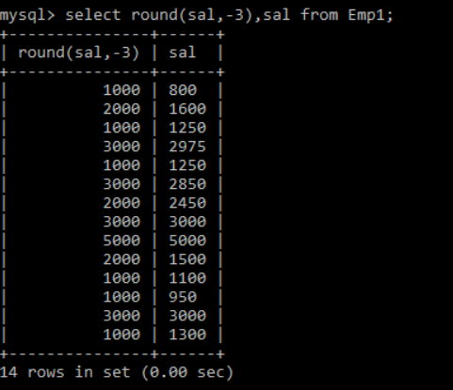

1. Display the details of all employees sorted on the names.

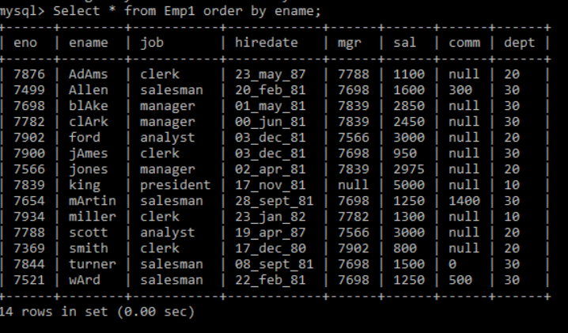

1. Display the names, jobs, and salaries of employees sorting on job.

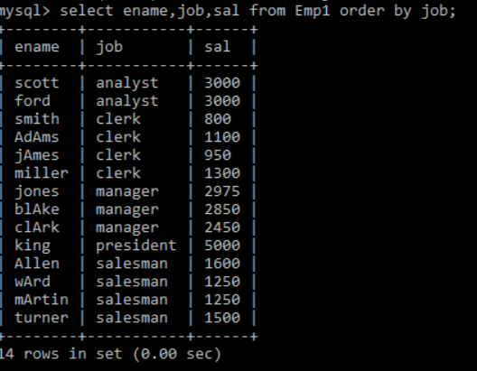

1. Display the names,jobs and salaries of employees sorting on descending order of job and within job sorted on salary.

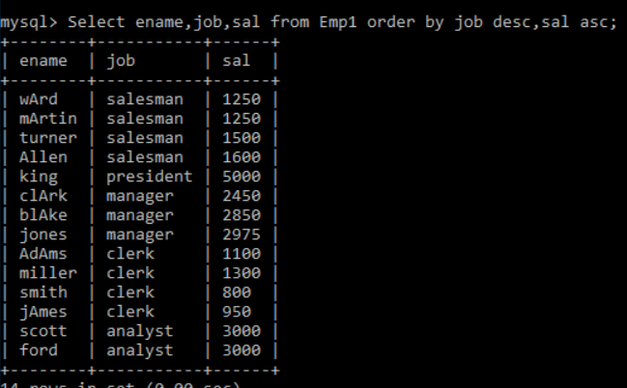

1. List the employees, names, dept and sal for those employees who are earning 0 commission or commission is null. Sort the output in the order of dept.

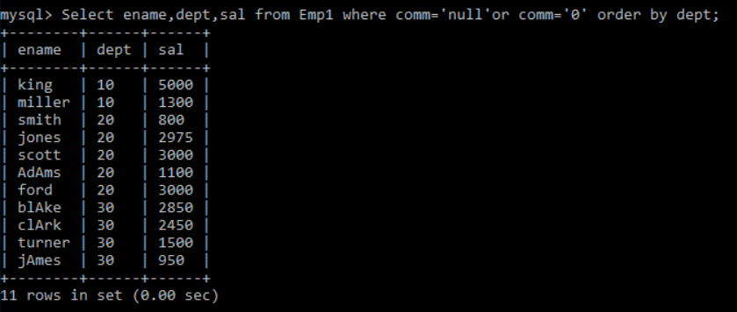

1. List the employees names, dept for those who have joined in 2003. Sort the output in the order of joining date.

