**Project Team A**

**Transcendental function: logb (x)**

**SAHANA ANANTHA (40085533)**

**Brief understanding about logarithmic function**:

A logarithmic answer the question “How many of this number do we multiply to get that number?”.

Example: How many 2s must we multiply to get 8?

Ans: 2 × 2 × 2 = 8, so we had to multiply 3 of the 2s to get 8

We say the logarithm of 8 with base 2 is 3

In fact, these two things are the same:

2 × 2 × 2 = 8 is equivalent to log2 (8) = 3

**Definition**: A logarithm is an exponent which indicates to what power a base must be raised to produce a given number.

The logarithm of x in the base b is written logb (x) and is defined as,

logb (x) = y if and only if by = x, where x > 0 and b > 0, b ≠ 1

logb (x) = y logarithmic form

by = x exponential form

For example: if we plot a graph for y = log2 x

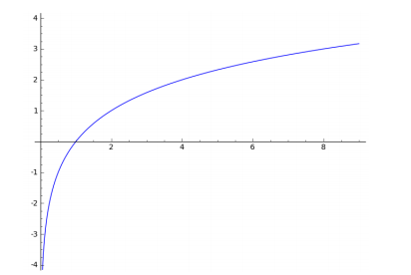

**Domain and Codomain of logarithmic function:**

The domain of the function is positive real numbers. The codomain that is the function takes all the real values from -∞ to ∞