**ABSTRACT**

**EATERIE FINDER**

**PURPOSE:**

**EXISTING SYSTEM:**

At present scenario, many apps are being developed which provides best way to search for and discover great places to eat at or order .Consider, “Zomato ” as an example, which is easy-to-use social restaurant finder app that lets us to explore all dining options in the city.

But, these sort of apps are confined to opulent restaurants which are not quite affordable to wide range of people especially college students. On top of that, these foodie bays are geographically far away to the people who stay in remote areas and there is less chance of probability of being nearer to colleges and thus leads to lot of overhead in travelling due to traffic in most of the cases.

**PROPOSED SYSTEM:**

In order to solve such ambiguities, this app is intended to develop which helps us to discover local hotels and eateries that are reasonable, relatively unknown and most importantly where the fresh and delicious food is available to soothe the hunger. These type of services turn down people going to expensive restaurants which in turn supports and enhances the growth of local business and paves them a way to earn their own fortune.

This **“Eaterie Finder”** application allows users especially college going students to track the local places to hang out with their friends and enjoy a good appetite within their budget.

**SOFTWARE SPECIFICATIONS:**

* **OPERATING SYSTEM:** Android 4.4V(Kitkat**)**
* **DATABASE**: SQLLite
* **API S:** Google maps

**FEATURES/MODULES:**

* **REGISTRATION:**

Users can sign up after filling the details in the respective fields provided in the registration form.

REGISTER

Name

Email-Id

Password

SIGN UP

* **LOGIN:**

Users can access the app through Email-Id and password generated during registration.

LOGIN

Email-Id



Password



LOGIN

* **EATERIE ENTRY:**

Users can long press the location of restaurant in the map that enables a bookmark of the corresponding eatery.

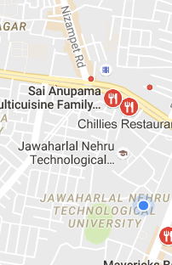

* **SEARCH:**

Foodies can search any kind of restaurant like coffee shops, local outlets, pizzerias, canteens, dhabas, hotels and many more which are situated around current location. Users can view menus, pictures, phone numbers, directions, user reviews, and all the other information you need to choose one among many by selecting the relevant bookmark .

search

