Collection Framework

- Collection is an interface which extends interable interface and before java 8, interface contains only abstract methods and not static methods whereas Collections is an class which extends Object class contains only static methods.

- Using Collections we can do all operations which we are performing on data like searching, sorting, manipulating, insertion and deletion.

- Collection: Single unit of objects(groups), Framework: predefined architecture which contains classes and interfaces.

- Collection framework represents a unified architecture for sorting and manipulating a group of objects which has Interfaces and its implementations(classes), Algorithm.

- Java Collection framework interfaces like List, Set, Queue, Deque and classes like ArrayList, Vector, Linked List, PriorityQueue, HashSet, LinkedHashSet, TreeSet.

- Collections classes allows heterogenous data and the size of collections are dynamic in nature(we can expand or shrink)
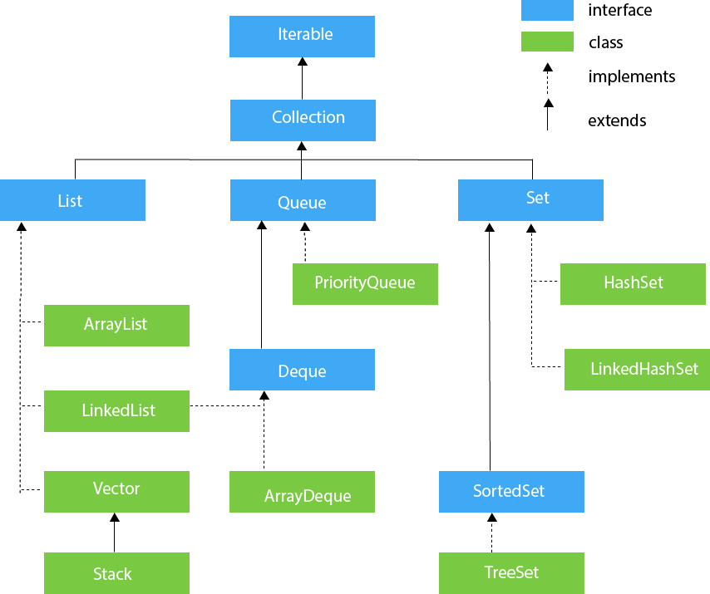

HIERARCHY OF COLLECTION FRAMEWORK
(The java.util package contains all the classes and interfaces for the Collection framework.)
- Collection interface provides soo many methods to insert and manipulate data (add(), addAll(), remove(), removeAll() etc).

- Iterator interface provides the facility of iterating the elements in a forward direction only.

- There are only three methods in the Iterator interface(
hasNext() - returns true if the iterator has more elements otherwise it returns false. Next() - returns the element and moves the cursor pointer to the next element.
remove() - removes the last elements returned by the iterator.)

- Iterable interface is the root interface for all Collection classes. There fore, all sub classes of Collection framework will implements Collection interface and Collection interface extends Iterable interface.

- Iterable interface contains only one method
Iterator<T> iterator()
<> - Generics – used for type safety(We can restrict the heterogenous data)

- The Collection interface is the interface which is implemented by all the classes in the collection framework. It declares the methods that every collection will have like Boolean add ( Object obj), Boolean addAll ( Collection c), void clear(), etc. which are implemented by all the subclasses of Collection interface.

- List interface is the child interface of Collection interface.(List will extends Collection interface)

- It inhibits a list type data structure in which we can store the ordered collection of objects.
- It can have duplicate values.
- Allows null values.
- List interface is implemented by the classes ArrayList, LinkedList, Vector, and Stack.
- ArrayList: -> is an class(implements List interface)
-> uses dynamic array to store data
-> allows duplicate elements of different datatypes
-> maintains insertion order
-> non-synchronized hence not thread safe(two or more threads trying to access the same methods at the same time)
- LinkedList: -> is an class(implements List interface)
-> uses doubly linked list to store the data
-> allows duplicate elements
-> maintains insertion order

-> non-synchronized hence not thread safe
-> the manipulation is fast because no shifting is required.
- Vector: -> is an class(implements List interface)
-> uses dynamic array to store elements
-> synchronized hence thread safe
-> similar to ArrayList
->contains many methods that are not part of Collection Framework.
- Stack: -> is an subclass of Vector class(extends Vector class)
-> uses last-in-first-out data structure
-> contains all of the methods of Vector class and also provides its methods like boolean push(), boolean peek(), boolean push(object o), which defines its properties.
14) Queue interface is the child interface of Collection interface(Queue will extends Collection interface)
- maintains the first-in-first-out order
- defined as an ordered list that is used to hold the elements which are about to be processed.
- There are various classes like PriorityQueue, Deque, and ArrayDeque which implements the Queue interface.
- PriorityQueue : -> doesnot allow null value to store
-> It holds the elements or objects which are to be processed by their priorities.
-> is an class(implements Queue interface)
-> remove() Retrieves and removes the head of this queue. This method throws an exception if this queue is empty. - NoSuchElementException - if the queue is empty
-> poll() Retrieves and removes the head of this queue, or returns null if this queue is empty.
-> peek() Retrieves, but does not remove, the head of this queue, or returns null if this queue is empty.
-> element() Retrieves, but does not remove, the head of this queue. This method differs from peek only in that it throws an exception if this queue is empty.
15) DeQue interface extends the Queue interface.
- Deque stands for a double-ended queue which enables us to perform the operations at both the ends.
- In Deque, we can remove and add the elements from both the side.
- ArrayDeque : -> class implements Deque interface.
: -> Unlike queue, we can add or delete the elements from both the ends.
: -> ArrayDeque is faster than ArrayList and Stack and has no capacity restrictions.
16) Set interface extends Collection interface.
- present in java.util package
- unordered set of elements which doesn't allow us to store the duplicate items.
- Allows one null value.
- Set is implemented by HashSet, LinkedHashSet, and TreeSet.
- HashSet : -> is a class which implements Set interface
: -> represents the collection uses hash table for storage
: -> hashing is used to store elements.
: -> It will not allows duplicate elements(unique).
- LinkedHashSet : -> represents LinkedList implementation of Set interface.
: -> extends HashSet class and implements Set interface.
: -> no duplicates allowed(unique).
: -> allows null values.
: -> insertion order preserved.
16) SortedSet interface extends Set interface.
- Alternate for Set interface provides sorting or ordering of the elements.
- Elements sorted in increasing or ascending order also provides additional methods which can supports natural ordering of elements.
- TreeSet : -> is a class implements Set interface.
: -> uses tree for storage
: -> duplicate elements are not allowed(allows unique)
: -> access and retrieval time of TreeSet is quite fast.
: -> stores elements in ascending order.

Notes:
- sync
- upcasting and downcasting
- custom collection implementation
- thread deadlock
- join()
- differences between collections classes

Map Interface
- Doesnot allow duplicate keys but can use duplicate values.
- HashMap and LinkedHashMap allow null keys and values, but TreeMap doesn't allow any null key or value.
- Map can't be traversed, so you need to convert it into Set using keySet() or entrySet() method.

HashMap | HashMap is the implementation of Map, but it doesn't maintain any order.
LinkedHashMap | LinkedHashMap is the implementation of Map. It inherits HashMap class. It maintains insertion order.
TreeMap | TreeMap is the implementation of Map and SortedMap. It maintains ascending order.
- Map.Entry interface.
Entry is the subinterface of Map. So we will be accessed it by Map.Entry name.
It returns a collection-view of the map, whose elements are of this class. It provides methods to get key and value.
- HashMap
Java HashMap contains values based on the key.
Java HashMap contains only unique keys.
Java HashMap may have one null key and multiple null values.
Java HashMap is non synchronized.
Java HashMap maintains no order.
The initial default capacity of Java HashMap class is 16 with a load factor of 0.75.
- LinkedHashMap
Java LinkedHashMap contains values based on the key.
Java LinkedHashMap contains unique elements.
Java LinkedHashMap may have one null key and multiple null values.
Java LinkedHashMap is non synchronized.
Java LinkedHashMap maintains insertion order.
The initial default capacity of Java HashMap class is 16 with a load factor of 0.75.
- TreeMap
Java TreeMap contains values based on the key. It implements the NavigableMap interface and extends AbstractMap class.
Java TreeMap contains only unique elements.
Java TreeMap cannot have a null key but can have multiple null values.
Java TreeMap is non synchronized.
Java TreeMap maintains ascending order.
Comparable Interface
Java Comparable interface is used to order the objects of the user-defined class.
This interface is found in java.lang package and contains only one method named compareTo(Object). It provides a single sorting sequence only, i.e., you can sort the elements on the basis of single data member only
compareTo()
public int compareTo(Object obj): It is used to compare the current object with the specified object. It returns
- positive integer, if the current object is greater than the specified object.
- negative integer, if the current object is less than the specified object.
- zero, if the current object is equal to the specified object.
Collections class
Collections class provides static methods for sorting the elements of collections. If collection elements are of Set or Map, we can use TreeSet or TreeMap.
However, we cannot sort the elements of List. Collections class provides methods for sorting the elements of List type elements.
public void sort(List list): It is used to sort the elements of List. List elements must be of the Comparable type.
Comparator Interface

Method | Description
public int compare(Object obj1, Object obj2) | It compares the first object with the second object.
public boolean equals(Object obj) | It is used to compare the current object with the specified object.
public boolean equals(Object obj) | It is used to compare the current object with the specified object.

Comparable vs Comparator
Comparable | Comparator
1) Comparable provides a single sorting sequence. In other words, we can sort the collection on the basis of a single element such as id, name, and price. | The Comparator provides multiple sorting sequences. In other words, we can sort the collection on the basis of multiple elements such as id, name, and price etc.
2) Comparable affects the original class, i.e., the actual class is modified. | Comparator doesn't affect the original class, i.e., the actual class is not modified.
3) Comparable provides compareTo() method to sort elements. | Comparator provides compare() method to sort elements.
4) Comparable is present in java.lang package. | A Comparator is present in the java.util package.
5) We can sort the list elements of Comparable type by Collections.sort(List) method. | We can sort the list elements of Comparator type by Collections.sort(List, Comparator) method.

Note:
- Anonymous class: Anonymous classes enable you to make your code more concise. They enable you to declare and instantiate a class at the same time. They are like local classes except that they do not have a name. Use them if you need to use a local class only once.

