Sahana Dilli babu

Module1 Assignment Screenshot

1. Assignment 1(screenshot)

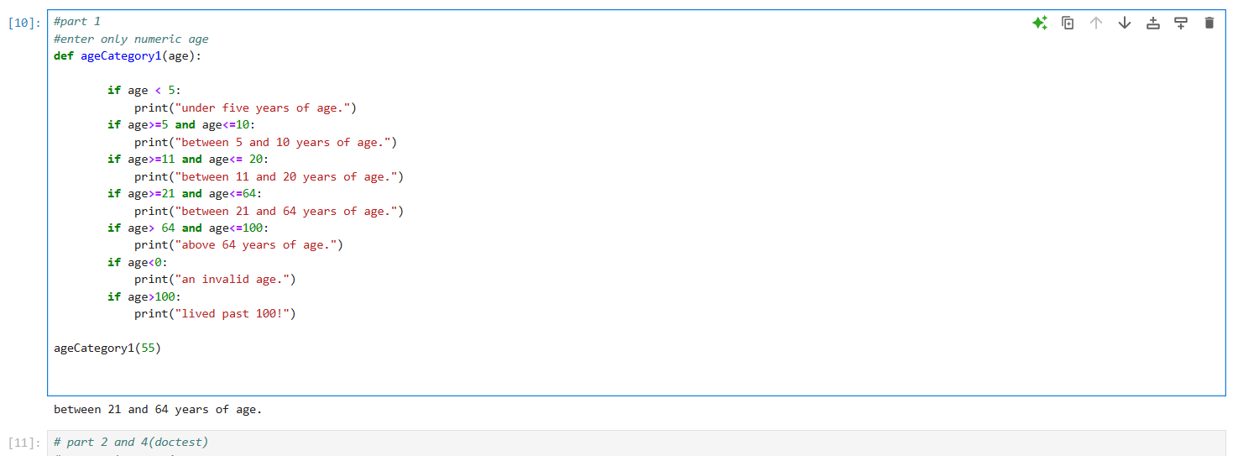

1. Assignment 2

1. Assignment 3 (screenshot)

